Jenkins-04

1) Setup Jenkins CICD pipeline using freestyle job using Docker containers using below code.
Source Code: https://github.com/betawins/hiring-app.git
stages:
- Git Clone
- SonarQube Integration
- Maven Compilation
- Nexus Artifactory
- Slack Notification
- Deploy On tomcat

Service | Port
Jenkins | 8080
SonarQube | 9000
Nexus Artifactory | 8081
Tomcat | 8082

Overview & Architecture
This guide walks you through setting up a complete Jenkins CI/CD pipeline using Docker containers on AWS EC2 instances. Each service runs as a separate Docker container for stability and easy management.
Pipeline Stages:
1. Git Clone — Pull source code from GitHub
2. SonarQube — Static code quality analysis
3. Maven Compilation — Build and package the application
4. Nexus Artifactory — Store build artifacts
5. Slack Notification — Send build status alerts
6. Deploy on Tomcat — Deploy WAR to Tomcat server
EC2 Setup (4 separate instances):
Instance | Purpose | Type | Port
EC2-1 | Jenkins | t3.large (free tier) | 8080
EC2-2 | SonarQube | t3.large | 9000
EC2-3 | Nexus | t3.large | 8081
EC2-4 | Tomcat | t3.micro (free tier) | 8082

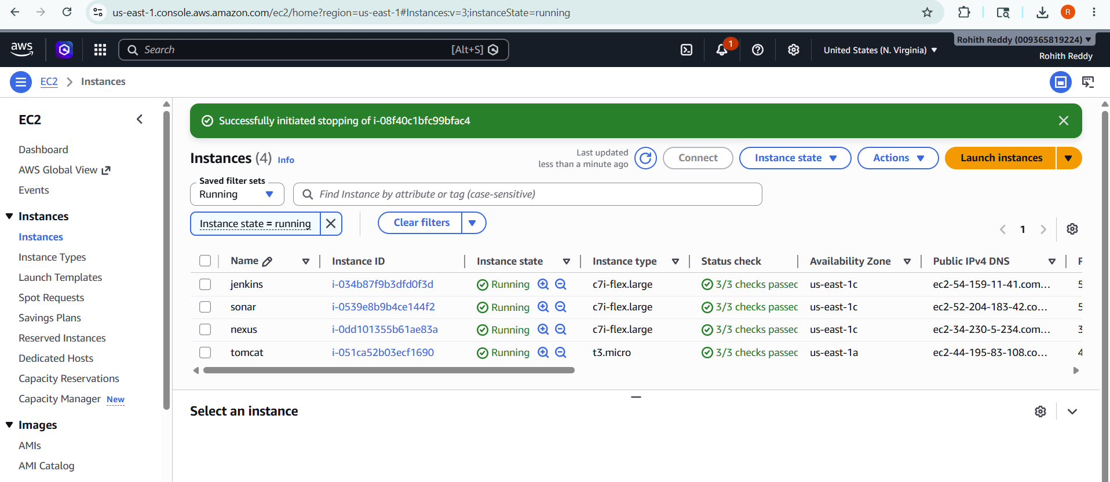

Phase 1 — Launch EC2 Instances
Launch 4 EC2 instances from AWS Console. Use Amazon Linux 2 for all instances.

AWS Console Steps
7. Go to EC2 → Launch Instance
8. AMI: Amazon Linux 2
9. Security Group: Open ports 22, 8080, 9000, 8081, 8082 (All Traffic from 0.0.0.0/0 for practice)
10. Launch and name each: jenkins-server, sonarqube-server, nexus-server, tomcat-server

Phase 2 — Install Docker on All 4 Instances
SSH into EACH instance and run these exact commands. Do this for all 4 instances one by one.

Docker Installation (Run on each EC2)
sudo yum update -y
sudo yum install docker -y
sudo systemctl start docker
sudo systemctl enable docker
sudo usermod -aG docker ec2-user
newgrp docker

# Verify docker is working:
docker --version

📌 Note: Run 'newgrp docker' after usermod so the group change applies immediately without logout.

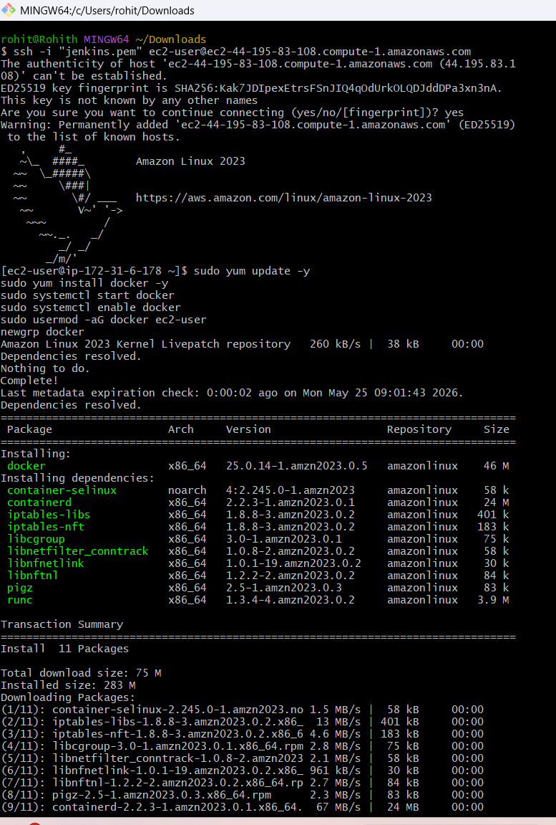

Phase 3 — Jenkins Setup

Step 1: Start Jenkins Container
SSH into jenkins-server and run:
docker run -d \
--name jenkins \
-p 8080:8080 \
-p 50000:50000 \
-v jenkins_home:/var/jenkins_home \
-v /var/run/docker.sock:/var/run/docker.sock \
--restart always \
jenkins/jenkins:lts
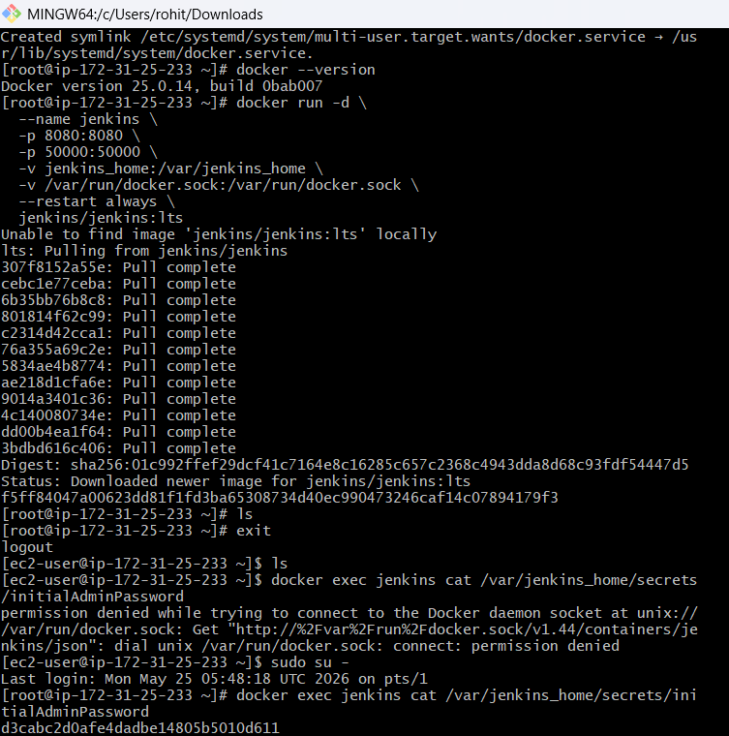

Step 2: Unlock Jenkins
# Get initial admin password:
docker exec jenkins cat /var/jenkins_home/secrets/initialAdminPassword

13. Open http://<jenkins-IP>:8080 in browser
14. Paste the password from above command
15. Click 'Install suggested plugins' and wait
16. Create admin user and remember the credentials
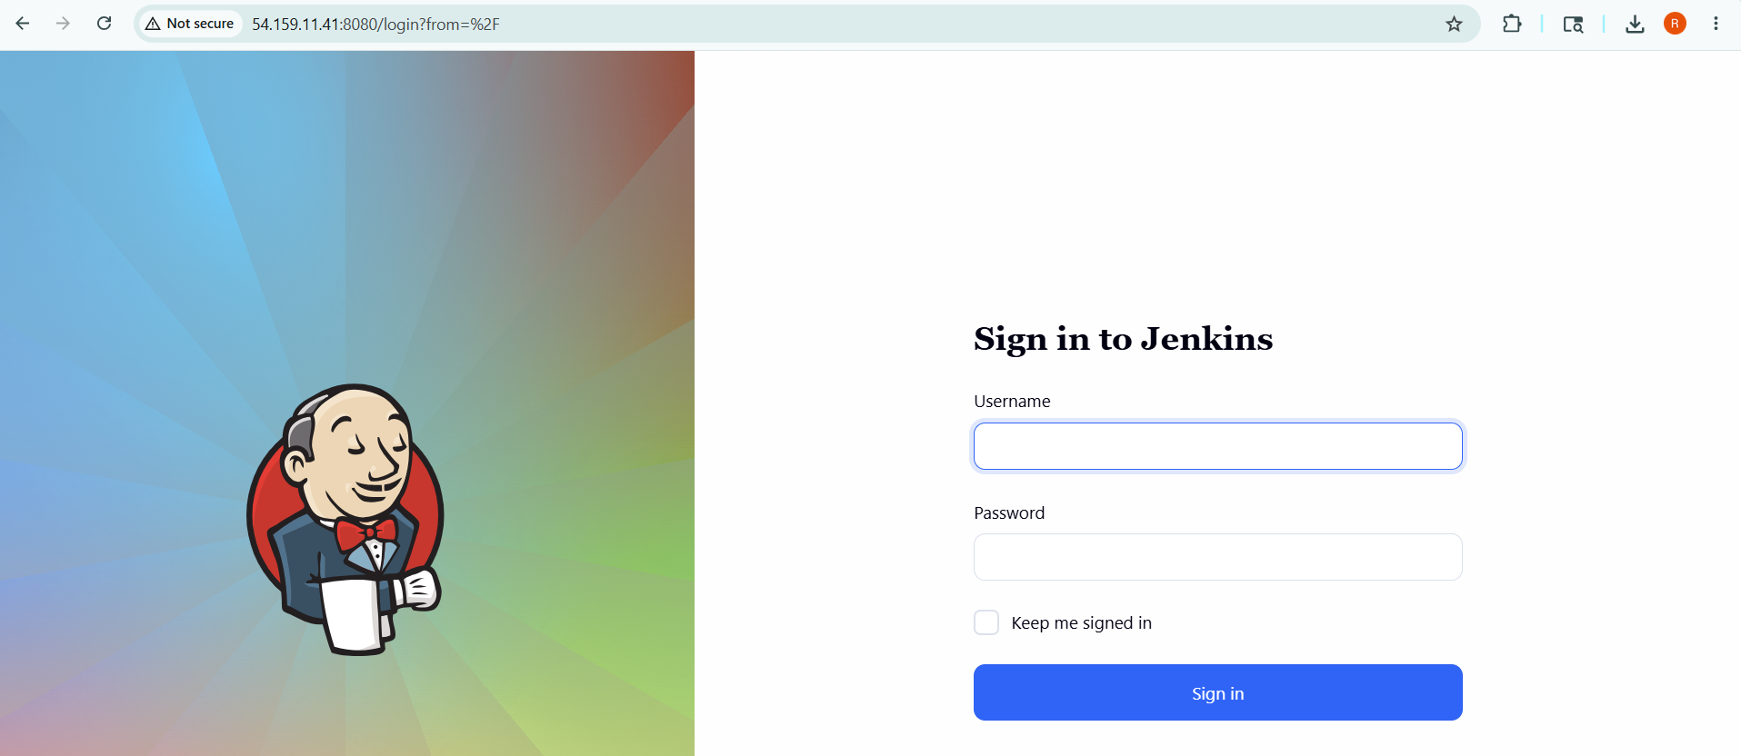

Step 3: Install Required Plugins
Go to Manage Jenkins → Plugins → Available plugins
Search and install each plugin:
• SonarQube Scanner
• Nexus Artifact Uploader
• Slack Notification
• Deploy to container
• Maven Integration
After installing all, click Restart Jenkins and log back in.

Step 4: Install Maven Inside Jenkins Container
# Get inside Jenkins container as root:
docker exec -it --user root jenkins bash

# Go to /opt directory:
cd /opt

# Download Maven:
curl -O https://downloads.apache.org/maven/maven-3/3.9.6/binaries/apache-maven-3.9.6-bin.tar.gz

# Check file size (should be 8-9 MB):
ls -lh apache-maven-3.9.6-bin.tar.gz

# Extract:
tar -xzf apache-maven-3.9.6-bin.tar.gz

# Rename:
mv apache-maven-3.9.6 maven

# Verify:
ls /opt/maven

# Exit container:
exit

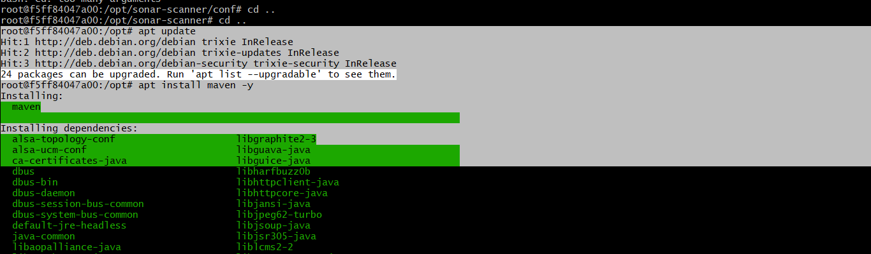

Step 5: Configure Maven in Jenkins
17. Go to Manage Jenkins → Tools
18. Scroll to Maven installations → Add Maven
19. Name: maven
20. MAVEN_HOME: /opt/maven
21. UNCHECK 'Install automatically'
22. Click Save
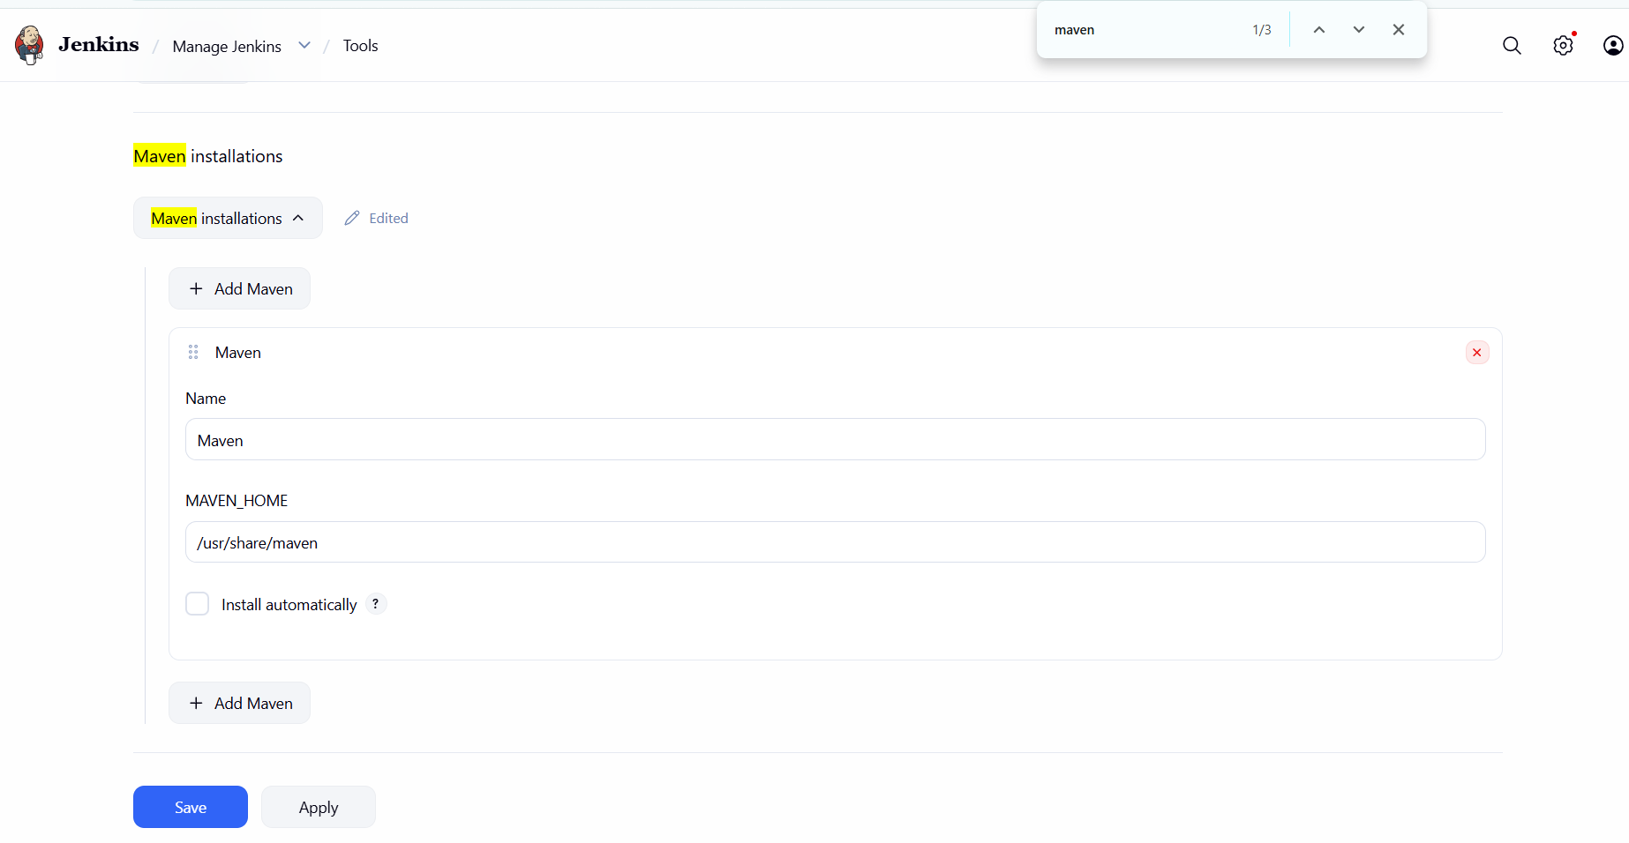

Phase 4 — SonarQube Setup

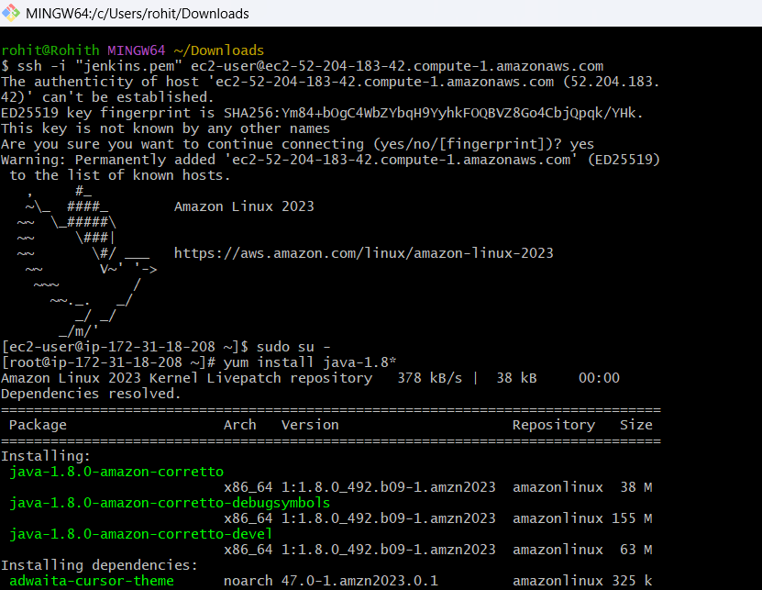

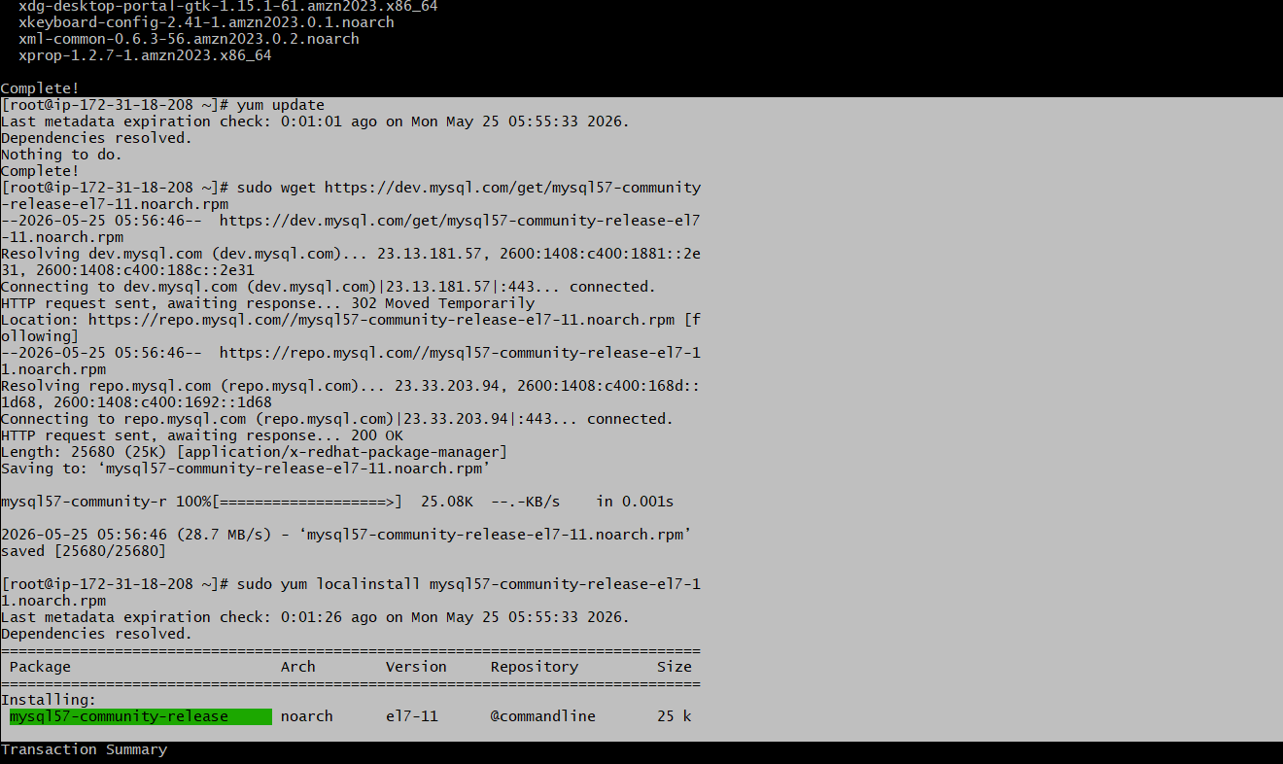

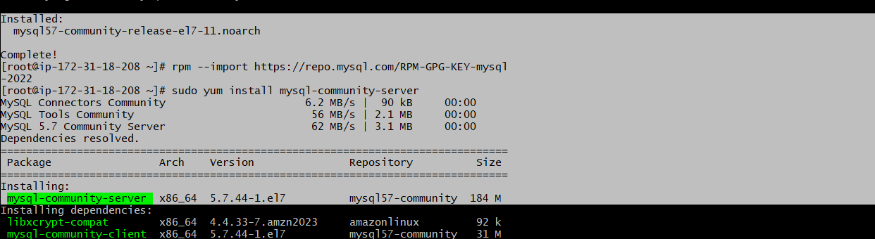

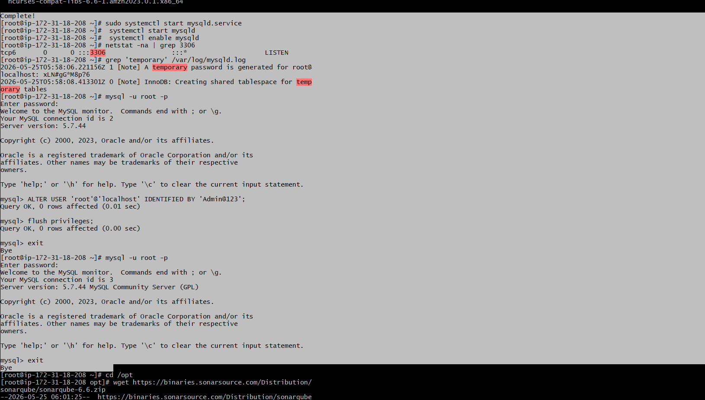

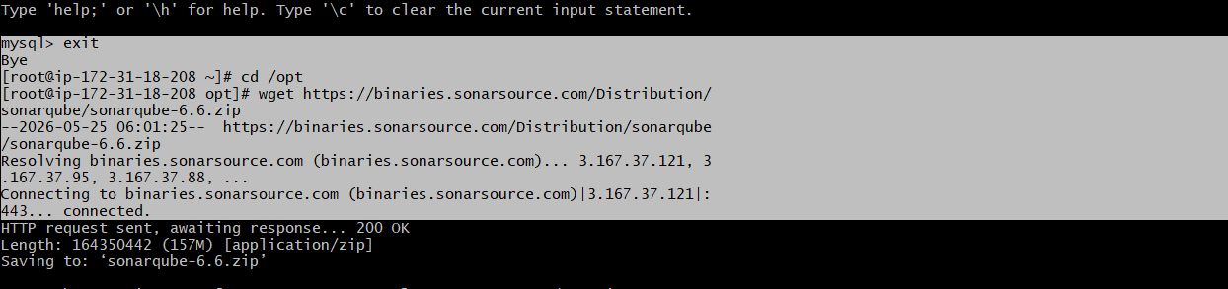

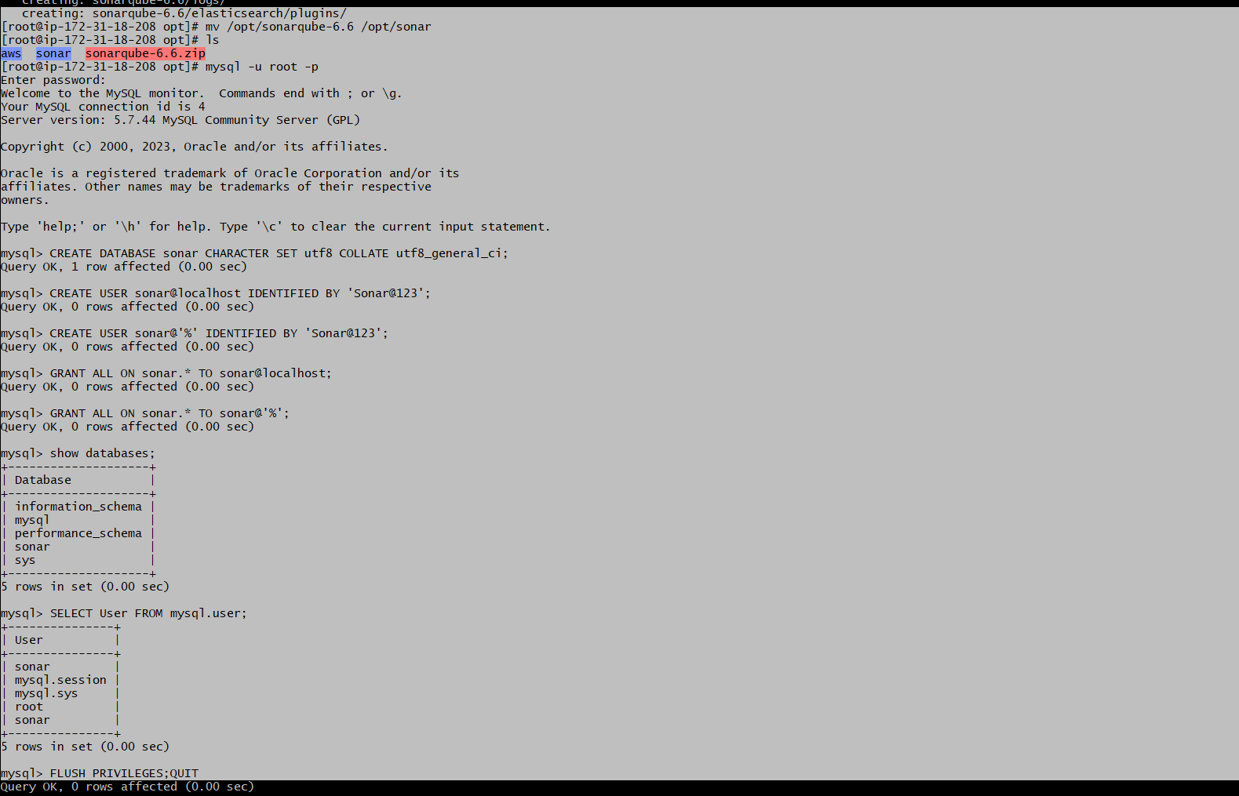

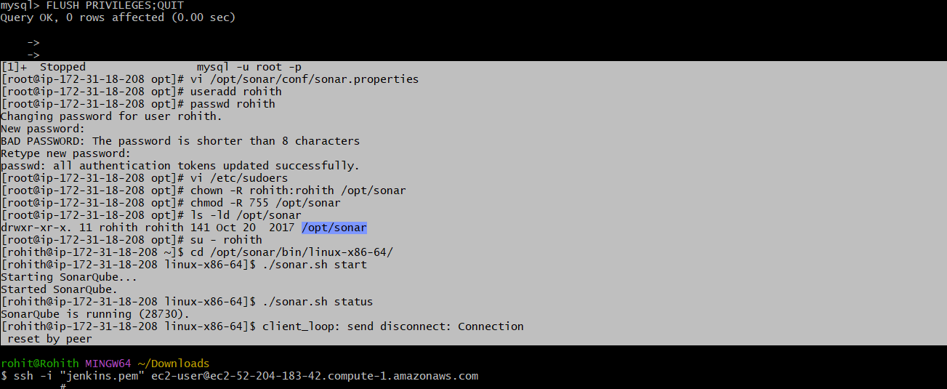

Or get using Docker

Step 1: Start SonarQube Container
SSH into sonarqube-server and run:
# Required kernel setting — SonarQube will NOT start without this:
sudo sysctl -w vm.max_map_count=262144
echo 'vm.max_map_count=262144' | sudo tee -a /etc/sysctl.conf

# Start SonarQube container:
docker run -d \
--name sonarqube \
-p 9000:9000 \
-e SONAR_ES_BOOTSTRAP_CHECKS_DISABLE=true \
-v sonar_data:/opt/sonarqube/data \
-v sonar_logs:/opt/sonarqube/logs \
--restart always \
sonarqube:community

📌 Note: SonarQube takes 2-3 minutes to fully start. Wait before opening browser.

Step 2: Configure SonarQube
23. Open http://<sonarqube-IP>:9000
24. Login: admin / admin
25. Change password to: admin123
26. Go to My Account (top right) → Security
27. Token name: jenkins-token → Click Generate
28. COPY THE TOKEN — you will not see it again!

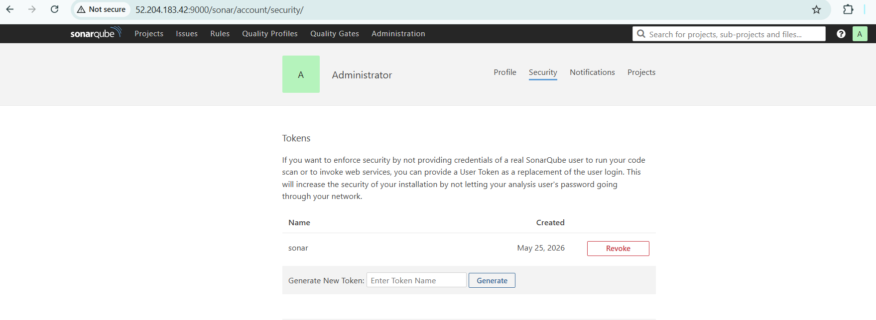

Token format example:
sqa_9431a4abaaf4798fce41396067afc5c19d199437
Save this somewhere safe before moving on.

Step 3: Install SonarQube Scanner on Jenkins EC2
SSH into jenkins-server and run:
# Get inside Jenkins container:
docker exec -it --user root jenkins bash

cd /opt

# Download Sonar Scanner (use this exact URL):
curl -O https://binaries.sonarsource.com/Distribution/sonar-scanner-cli/sonar-scanner-cli-3.2.0.1227-linux.zip

# Install unzip if not available:
apt-get install -y unzip

# Extract:
unzip sonar-scanner-cli-3.2.0.1227-linux.zip

# Rename:
mv sonar-scanner-3.2.0.1227-linux sonar-scanner

# Verify:
ls /opt/sonar-scanner/bin/

exit
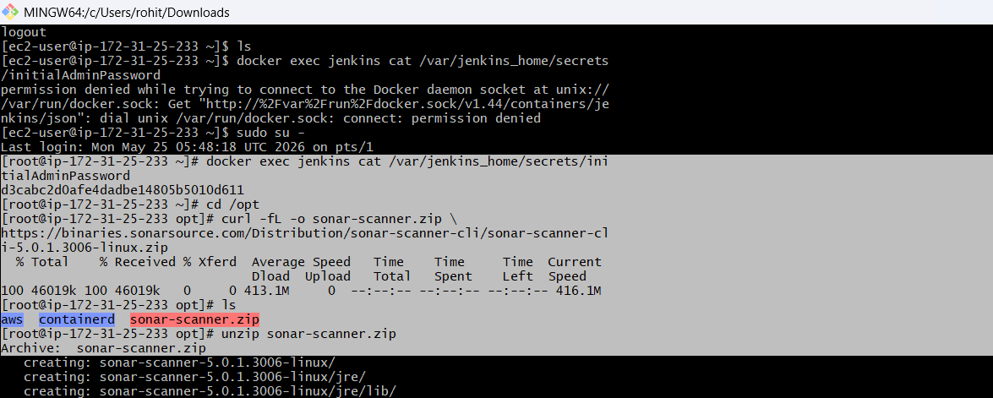

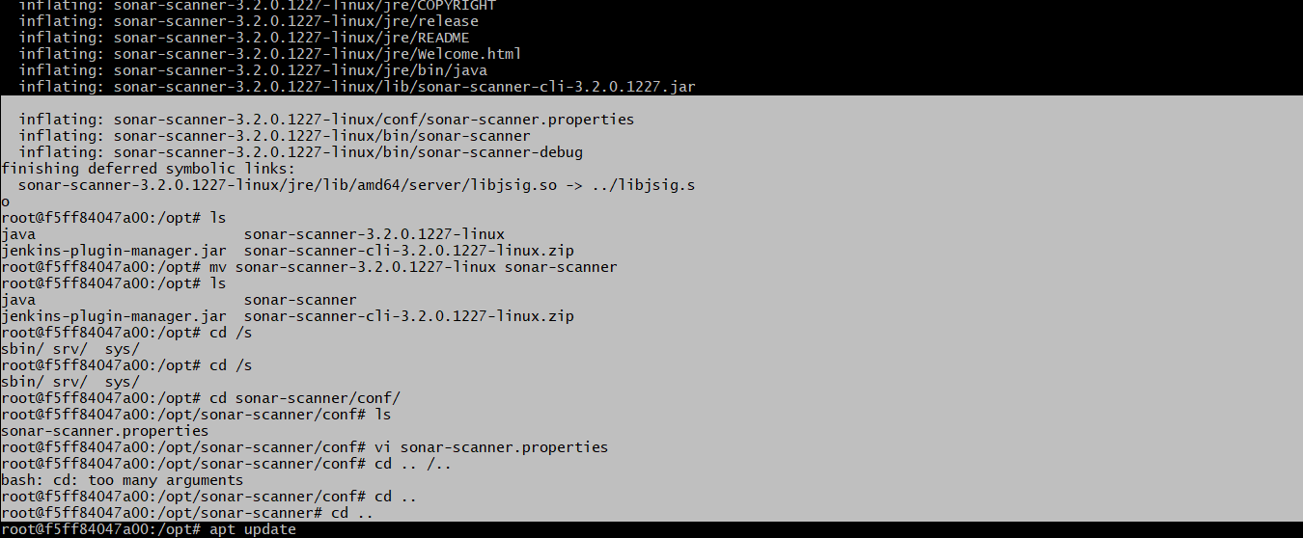

Step 4: Configure SonarQube Scanner in Jenkins
29. Go to Manage Jenkins → Tools
30. Scroll to SonarQube Scanner installations → Add SonarQube Scanner
31. Name: SonarQube-Scanner
32. SONAR_RUNNER_HOME: /opt/sonar-scanner
33. UNCHECK Install automatically
34. Click Save

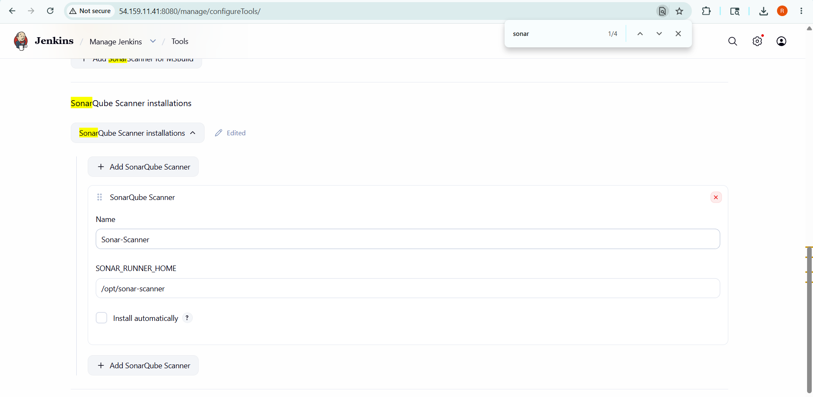

Step 5: Add SonarQube Server in Jenkins
35. Go to Manage Jenkins → Credentials → Global → Add Credentials
36. Kind: Secret text
37. Secret: <your sonar token>
38. ID: sonar-token → Click Create
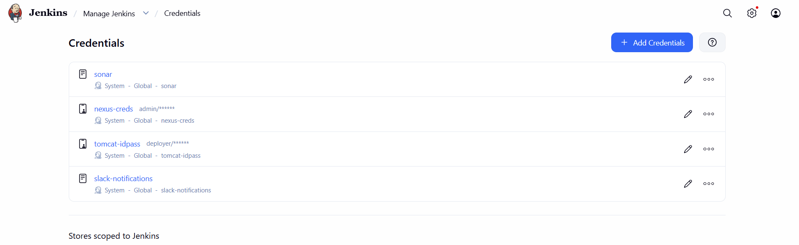
39. Go to Manage Jenkins → System
40. Scroll to SonarQube servers
41. Check: Enable injection of SonarQube server configuration
42. Click Add SonarQube
43. Name: SonarQube
44. Server URL: http://<sonarqube-IP>:9000
45. Server authentication token: select sonar-token
46. Click Save
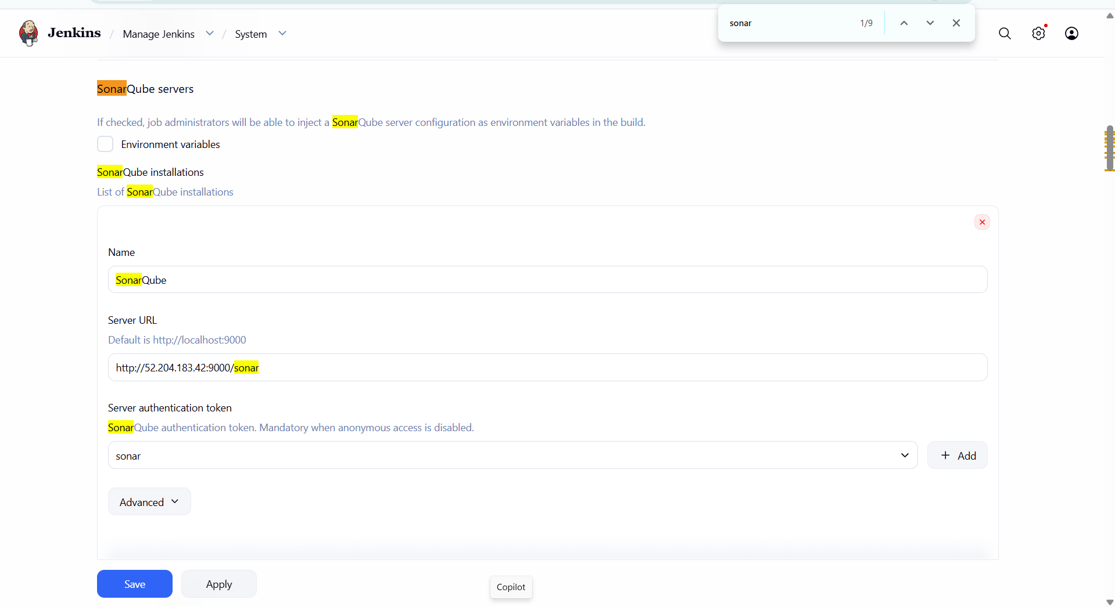

Phase 5 — Nexus Setup

Step 1: Start Nexus Container
SSH into nexus-server and run:
docker run -d \
--name nexus \
-p 8081:8081 \
-v nexus_data:/nexus-data \
--restart always \
sonatype/nexus3

📌 Note: Nexus takes 3-4 minutes to start. Wait before opening browser.

Step 2: Configure Nexus
# Get initial admin password:
docker exec nexus cat /nexus-data/admin.password

47. Open http://<nexus-IP>:8081
48. Login: admin / <password from above command>
49. Set new password to: admin123
50. When asked about anonymous access: select Disable anonymous access

Step 3: Create Repository
51. Click gear icon (Settings) → Repositories → Create repository
52. Select: maven2 (hosted)
53. Name: hiring-app-repo
54. Version policy: Snapshot
55. Deployment policy: Allow redeploy
56. Click Create repository

Step 4: Add Nexus Credentials in Jenkins
57. Go to Jenkins → Manage Jenkins → Credentials → Global → Add Credentials
58. Kind: Username with password
59. Username: admin
60. Password: admin123
61. ID: nexus-creds
62. Click Create

Phase 6 — Tomcat Setup

Step 1: Start Tomcat Container
SSH into tomcat-server and run:
docker run -d \
--name tomcat \
-p 8082:8080 \
--restart always \
tomcat:9.0

# Wait 10 seconds then copy manager app:
sleep 10
docker exec tomcat cp -r /usr/local/tomcat/webapps.dist/manager /usr/local/tomcat/webapps/
docker exec tomcat cp -r /usr/local/tomcat/webapps.dist/ROOT /usr/local/tomcat/webapps/

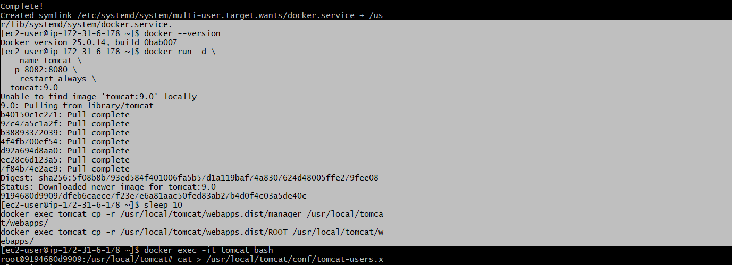

Step 2: Configure Tomcat Users
# Get inside tomcat container:
docker exec -it tomcat bash

# Add users:
cat > /usr/local/tomcat/conf/tomcat-users.xml << 'EOF'
<?xml version="1.0" encoding="UTF-8"?>
<tomcat-users>
<role rolename="manager-gui"/>
<role rolename="manager-script"/>
<role rolename="manager-jmx"/>
<role rolename="manager-status"/>
<user username="deployer" password="deployer"
roles="manager-gui,manager-script,manager-jmx,manager-status"/>
<user username="admin" password="admin123"
roles="manager-gui,manager-script,manager-jmx,manager-status"/>
</tomcat-users>
EOF

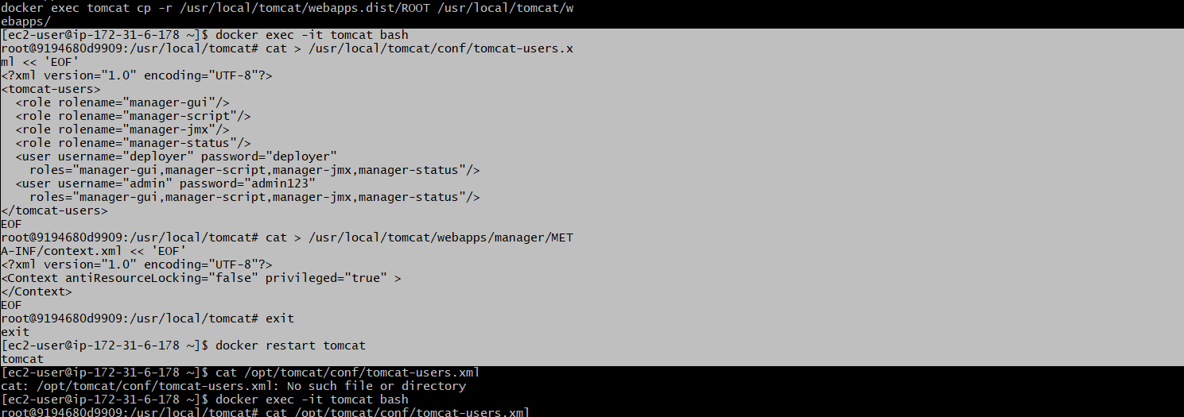

Step 3: Fix 403 Access Denied Error
# Still inside tomcat container — remove IP restriction:
cat > /usr/local/tomcat/webapps/manager/META-INF/context.xml << 'EOF'
<?xml version="1.0" encoding="UTF-8"?>
<Context antiResourceLocking="false" privileged="true" >
</Context>
EOF

# Exit container:
exit

# Restart Tomcat:
docker restart tomcat

Verify: Open http://<tomcat-IP>:8082/manager/html
Login: deployer / deployer — You should see the Tomcat Manager page.

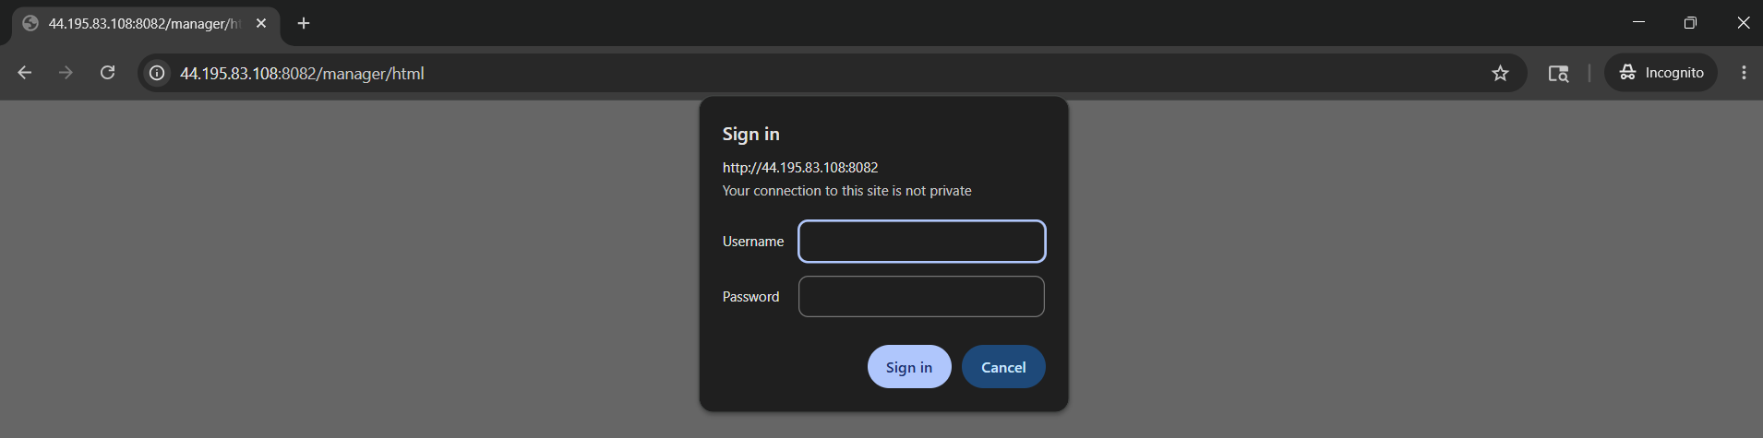

Step 4: Add Tomcat Credentials in Jenkins
63. Go to Jenkins → Manage Jenkins → Credentials → Global → Add Credentials
64. Kind: Username with password
65. Username: deployer
66. Password: deployer
67. ID: tomcat-creds
68. Click Create
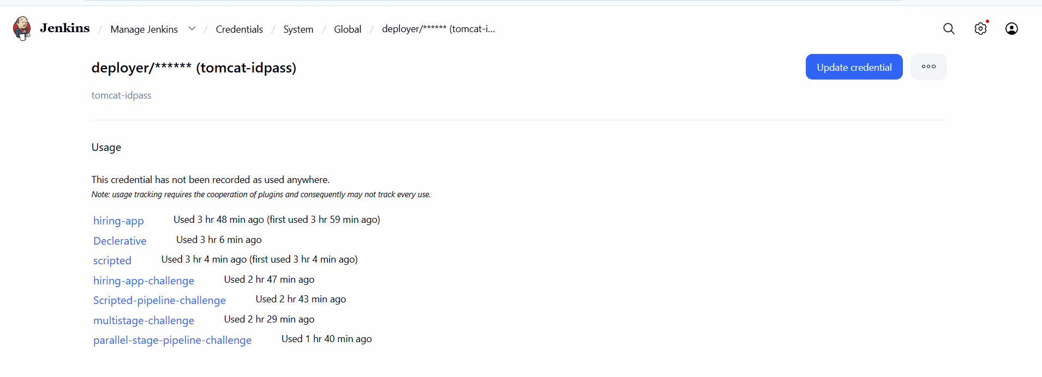

Phase 7 — Create Freestyle Job (Part 1)
Source: https://github.com/betawins/hiring-app.git | Branch: main

Create the Job
69. Jenkins → New Item
70. Name: hiring-app-freestyle
71. Select: Freestyle project → OK

Source Code Management Tab
• Select: Git
• Repository URL: https://github.com/betawins/hiring-app.git
• Branch: */main
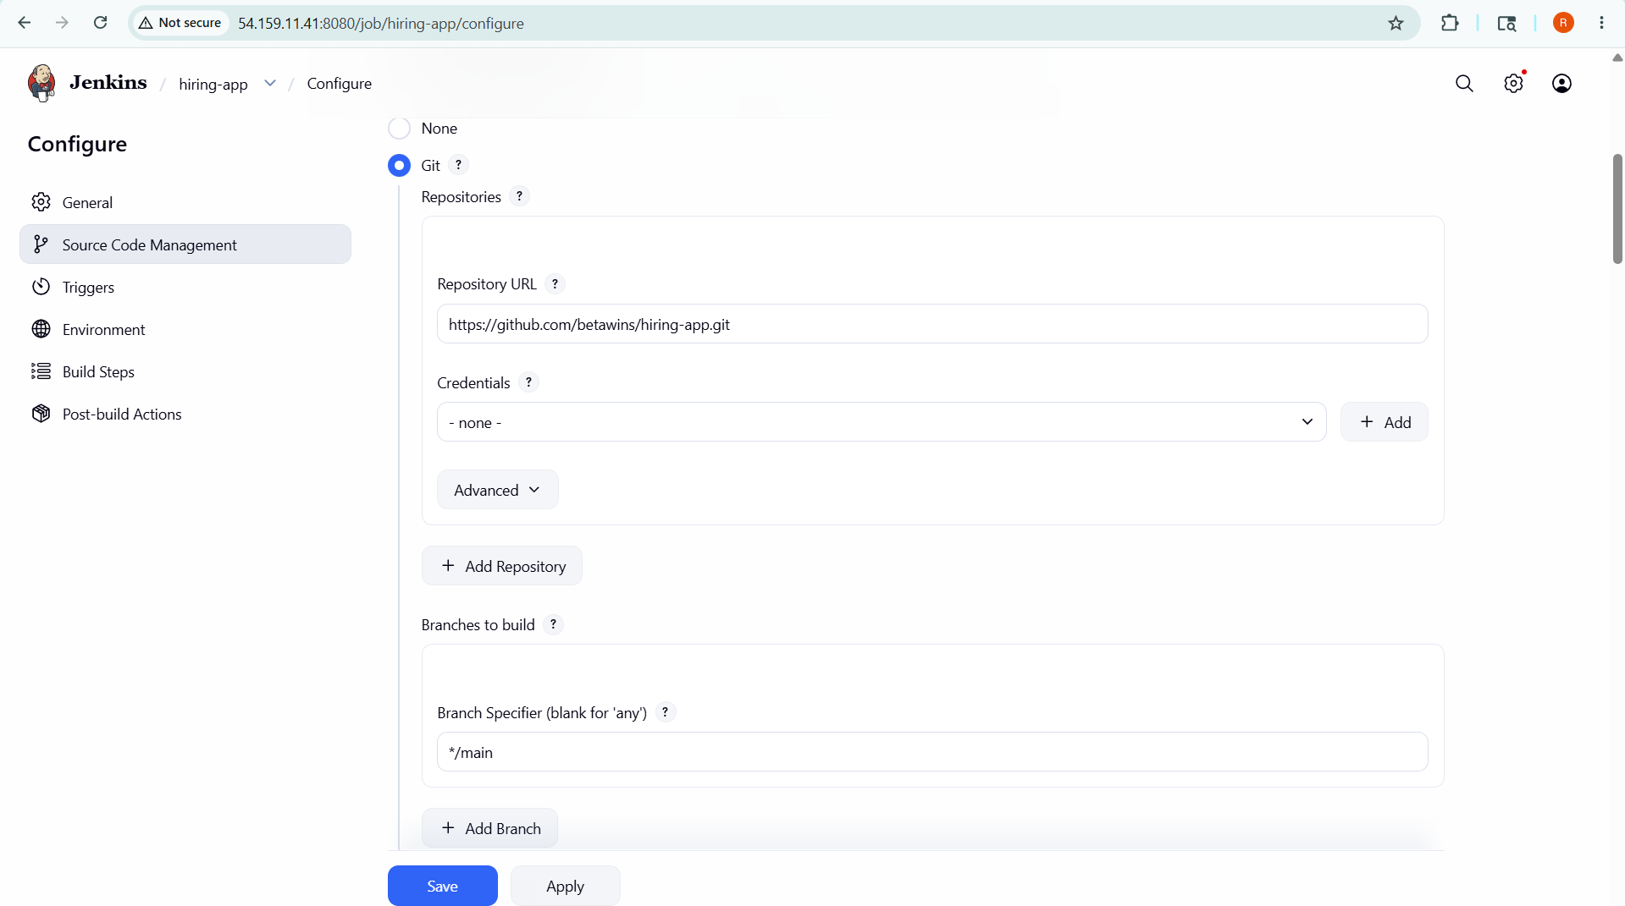

Build Steps — Add in this exact order

Build Step 1: SonarQube Analysis (Execute Shell)
sonar.projectKey=Test
sonar.sources=.

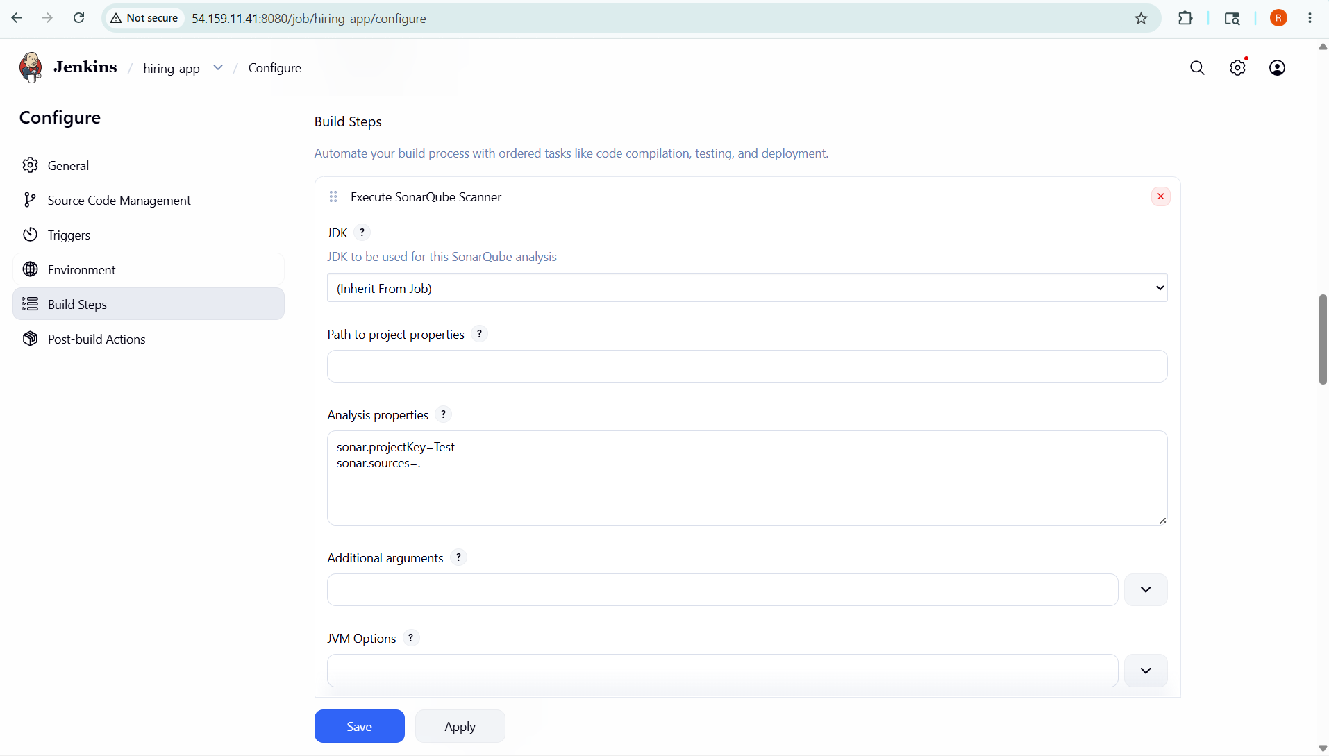

Build Step 2: Maven Compilation
• Click Add build step → Invoke top-level Maven targets
• Maven version: maven
• Goals: clean package
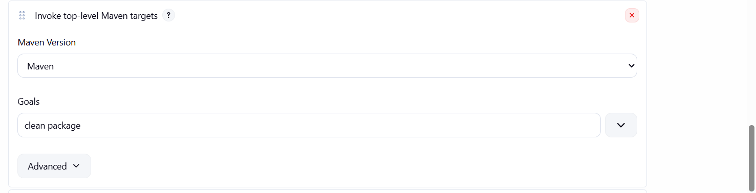

Build Step 3: Nexus Artifact Uploader
• Click Add build step → Nexus Artifact Uploader
• Nexus Version: NEXUS3
• Protocol: HTTP
• Nexus URL: <nexus-IP>:8081
• Credentials: nexus-creds
• GroupId: com.example
• Version: 1.0
• Repository: hiring-releases
• ArtifactId: hiring
• Type: war
• File: target/hiring.war
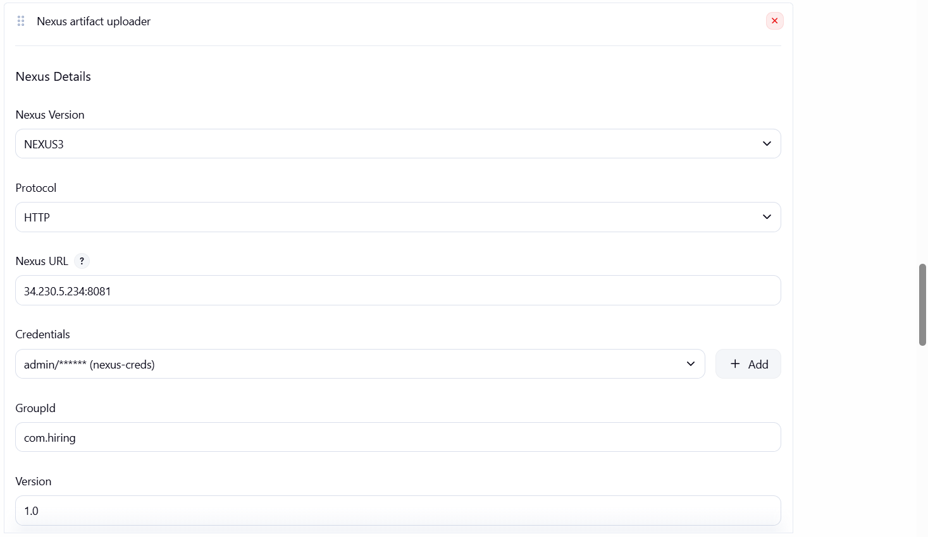
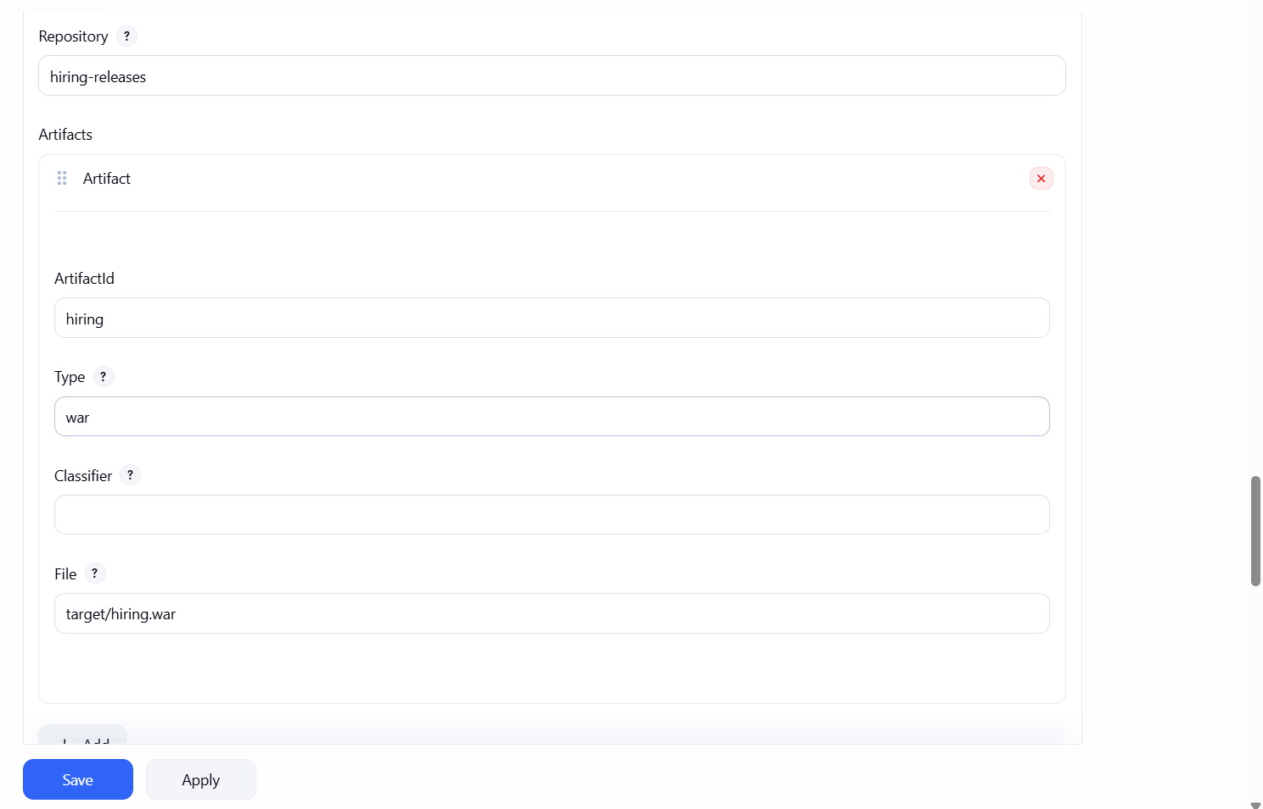

Post-build Actions — Add in this order

Post-build 1: Deploy to Tomcat
• Add post-build action → Deploy war/ear to a container
• WAR/EAR files: target/*.war
• Context path: hiring-app
• Container: Tomcat 9.x
• Credentials: tomcat-creds
• Tomcat URL: http://<tomcat-IP>:8082
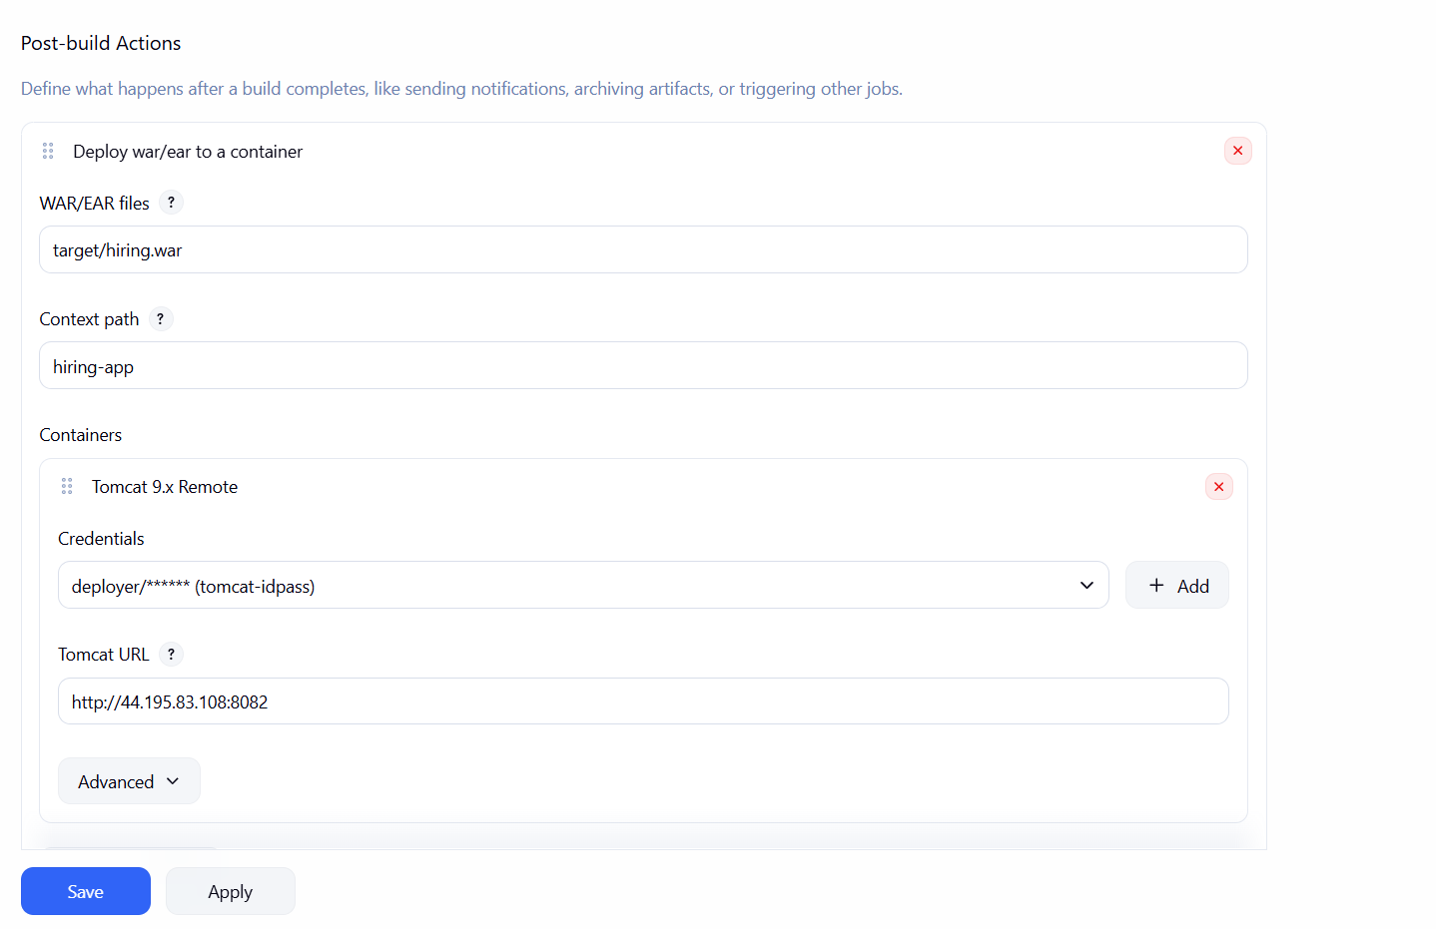

Post-build 2: Slack Notifications
• Add post-build action → Slack Notifications
• Check: Notify Build Start, Notify Success, Notify Every Failure
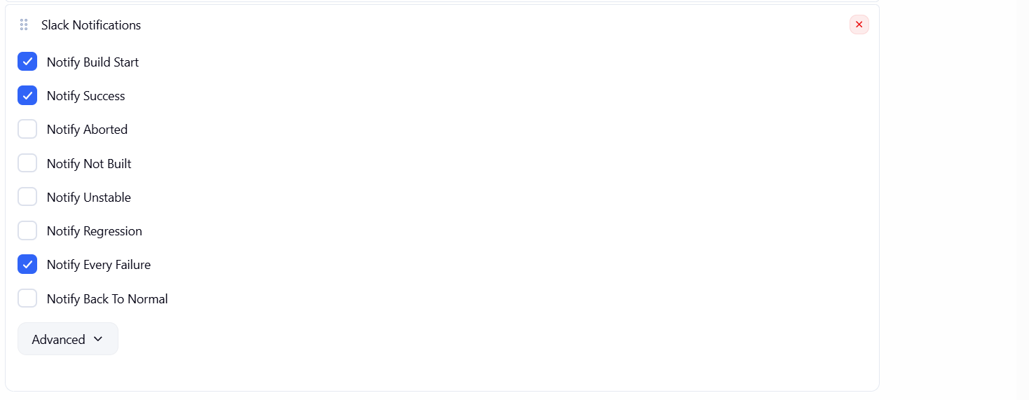

Click Save → Build Now
After successful build, your app will be at: http://<tomcat-IP>:8082/hiring-app
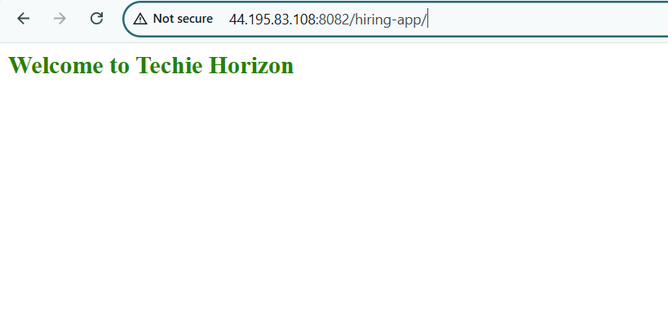

2) Setup a Jenkins CICD pipeline using Declarative pipeline using feature-1.1 branch.
Source Code: https://github.com/betawins/sabear_simplecutomerapp/tree/feature-1.1
stages:
- Git Clone
- SonarQube Integration
- Maven Compilation
- Nexus Artifactory
- Slack Notification
- Deploy On tomcat

Create Pipeline Job
72. Jenkins → New Item
73. Name: declarative
74. Select: Pipeline → OK
75. Scroll to Pipeline section → Pipeline script
76. Paste the script below → Save → Build Now

Pipeline Overview

The pipeline consists of the following stages:
- Clean Workspace
- Clone Code
- Maven Build
- Nexus Upload
- Deploy to Tomcat
- Slack Notification (Post actions)

Pipeline Script Explanation

1 Agent and Tools
agent any

tools {
maven 'Maven'
}
- Runs pipeline on any available Jenkins agent
- Uses configured Maven installation

2 Clean Workspace
stage('Clean Workspace') {
steps {
cleanWs()
}
}
- Cleans previous build files
- Ensures fresh execution

3 Clone Code
stage('Clone Code') {
steps {
git branch: 'master',
url: 'https://github.com/rohithreddy8327/sabear_simplecutomerapp.git'
}
}
Note (Important for your answer):
- As per question, branch should be:
branch: 'feature-1.1'
- You used your forked repo (correct approach)

4 Build using Maven
stage('Build using Maven') {
steps {
sh 'mvn clean install'
}
}
- Compiles code
- Runs tests
- Generates .war file

5 Publish to Nexus
stage('Publish to Nexus')
What happens here:
- Extracts:
  - version
  - artifactId
  - groupId
- Removes -SNAPSHOT
- Uploads .war file to Nexus repository
Key Concept:
- Artifact versioning
- Central repository storage

6 Deploy on Tomcat
stage('Deploy On Tomcat')
- Fetches WAR file from target directory
- Deploys application to Tomcat server
- Uses Jenkins credentials

7 Slack Notifications
post {
success { ... }
failure { ... }
}
- Sends notification on:
  - Success ✅
  - Failure ❌
- Includes:
  - Job name
  - Build number
  - Build URL

Pipeline Script
pipeline {
agent any

tools {
maven 'Maven'
}

stages {

stage('Clean Workspace') {
steps {
cleanWs()
}
}

stage('Clone Code') {
steps {
git branch: 'master',
url: 'https://github.com/rohithreddy8327/sabear_simplecutomerapp.git'
}
}

stage('Build using Maven') {
steps {
sh 'mvn clean install'
}
}

stage('Publish to Nexus') {
steps {
script {

def version = sh(
script: "mvn help:evaluate -Dexpression=project.version -q -DforceStdout",
returnStdout: true
).trim()

def artifactId = sh(
script: "mvn help:evaluate -Dexpression=project.artifactId -q -DforceStdout",
returnStdout: true
).trim()

def groupId = sh(
script: "mvn help:evaluate -Dexpression=project.groupId -q -DforceStdout",
returnStdout: true
).trim()

def releaseVersion = version.replace("-SNAPSHOT", "")
def artifactPath = "target/${artifactId}-${version}.war"

echo "Uploading Artifact: ${artifactPath}"

nexusArtifactUploader(
nexusVersion: 'nexus3',
protocol: 'http',
nexusUrl: '34.230.5.234:8081',
repository: 'hiring-releases',
groupId: groupId,
version: releaseVersion,
credentialsId: 'nexus-creds',
artifacts: [[
artifactId: artifactId,
classifier: '',
file: artifactPath,
type: 'war'
]]
)
}
}
}

stage('Deploy On Tomcat') {
steps {
script {
def warFile = sh(
script: "ls target/*.war | head -1",
returnStdout: true
).trim()

echo "Deploying WAR: ${warFile}"

deploy adapters: [
tomcat9(
credentialsId: 'tomcat-idpass',
path: '',
url: 'http://44.195.83.108:8082/manager/html'
)
],
contextPath: 'hiring',
war: warFile
}
}
}
}

post {
success {
slackSend(
tokenCredentialId: 'slack-notifications',
channel: 'C0B4JQ1P4BB',
color: 'good',
message: ":white_check_mark: SUCCESS: Job=${env.JOB_NAME} Build=#${env.BUILD_NUMBER} | ${env.BUILD_URL}"
)
}
failure {
slackSend(
tokenCredentialId: 'slack-notifications',
channel: 'C0B4JQ1P4BB',
color: 'danger',
message: ":x: FAILED: Job=${env.JOB_NAME} Build=#${env.BUILD_NUMBER} | ${env.BUILD_URL}"
)
}
}
}

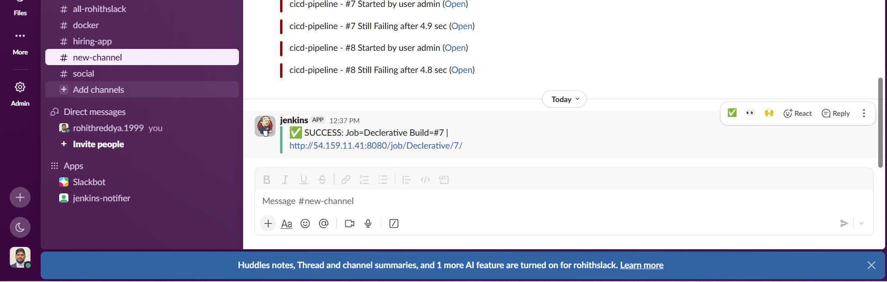

3) Setup a Jenkins CICD pipeline using Scripted pipeline using feature-1.1 branch.

Source Code: https://github.com/betawins/sabear_simplecutomerapp/tree/feature-1.1
stages:
- Git Clone
- SonarQube Integration
- Maven Compilation
- Nexus Artifactory
- Slack Notification
- Deploy On tomcat

Create Pipeline Job
. Jenkins → New Item
. Name: scripted
. Select: Pipeline → OK
. Scroll to Pipeline section → Pipeline script
. Paste the script below → Save → Build Now

Pipeline Script
node {

// Tool setup
def mvnHome = tool name: 'Maven', type: 'maven'
env.PATH = "${mvnHome}/bin:${env.PATH}"

try {

stage('Clean Workspace') {
cleanWs()
}

stage('Clone Code') {
git branch: 'master',
url: 'https://github.com/rohithreddy8327/sabear_simplecutomerapp.git'
}

stage('Build using Maven') {
sh 'mvn clean install'
}

stage('Publish to Nexus') {

def version = sh(
script: "mvn help:evaluate -Dexpression=project.version -q -DforceStdout",
returnStdout: true
).trim()

def artifactId = sh(
script: "mvn help:evaluate -Dexpression=project.artifactId -q -DforceStdout",
returnStdout: true
).trim()

def groupId = sh(
script: "mvn help:evaluate -Dexpression=project.groupId -q -DforceStdout",
returnStdout: true
).trim()

def releaseVersion = version.replace("-SNAPSHOT", "")
def artifactPath = "target/${artifactId}-${version}.war"

echo "Uploading Artifact: ${artifactPath}"

nexusArtifactUploader(
nexusVersion: 'nexus3',
protocol: 'http',
nexusUrl: '34.230.5.234:8081',
repository: 'hiring-releases',
groupId: groupId,
version: releaseVersion,
credentialsId: 'nexus-creds',
artifacts: [[
artifactId: artifactId,
classifier: '',
file: artifactPath,
type: 'war'
]]
)
}

stage('Deploy On Tomcat') {

def warFile = sh(
script: "ls target/*.war | head -1",
returnStdout: true
).trim()

echo "Deploying WAR: ${warFile}"

deploy adapters: [
tomcat9(
credentialsId: 'tomcat-idpass',
path: '',
url: 'http://44.195.83.108:8082/manager/html'
)
],
contextPath: 'hiring',
war: warFile
}

stage('Success Notification') {
slackSend(
tokenCredentialId: 'slack-notifications',
channel: 'C0B4JQ1P4BB',
color: 'good',
message: ":white_check_mark: SUCCESS: Job=${env.JOB_NAME} Build=#${env.BUILD_NUMBER} | ${env.BUILD_URL}"
)
}

} catch (Exception e) {

stage('Failure Notification') {
slackSend(
tokenCredentialId: 'slack-notifications',
channel: 'C0B4JQ1P4BB',
color: 'danger',
message: ":x: FAILED: Job=${env.JOB_NAME} Build=#${env.BUILD_NUMBER} | ${env.BUILD_URL}"
)
}

throw e
}
}

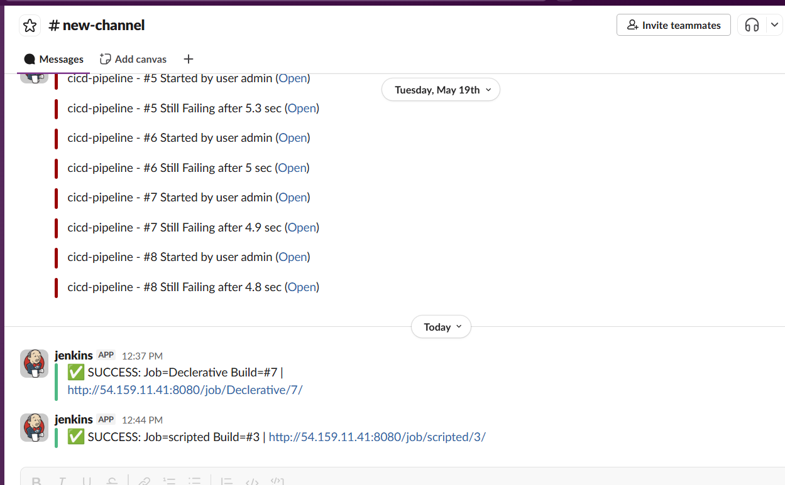

4) Write sample skeleton of pipelines.

1. Declarative Pipeline Skeleton (Basic Structure)

Key Sections to Remember
• pipeline { } — mandatory outer block
• agent — where the pipeline runs (any, none, docker, label)
• environment — define env variables
• options — timeout, retry, disableConcurrentBuilds
• stages { stage { steps } } — the build steps
• post { } — success, failure, always, unstable

pipeline {
agent any

tools {
maven 'Maven'
}

environment {
APP_NAME = 'sample-app'
}

stages {

stage('Checkout') {
steps {
echo 'Cloning repository...'
}
}

stage('Build') {
steps {
echo 'Building application...'
}
}

stage('Test') {
steps {
echo 'Running tests...'
}
}

stage('Deploy') {
steps {
echo 'Deploying application...'
}
}
}

post {
success {
echo 'Build Successful'
}
failure {
echo 'Build Failed'
}
}
}

2. Scripted Pipeline Skeleton

Key Differences from Declarative
• Starts with node { } not pipeline { }
• Error handling via try/catch (not post { })
• No built-in structure — full Groovy freedom
• No pre-run validation — errors found at runtime only
• Can use loops, conditionals, functions anywhere

node {

try {

stage('Checkout') {
echo 'Cloning repository...'
}

stage('Build') {
echo 'Building application...'
}

stage('Test') {
echo 'Running tests...'
}

stage('Deploy') {
echo 'Deploying application...'
}

stage('Success') {
echo 'Build Successful'
}

} catch (Exception e) {

stage('Failure') {
echo 'Build Failed'
}

throw e
}
}

5) Create a parameterized job in Jenkins.

Source Code: https://github.com/betawins/spring3-mvc-maven-xml-hello-world-1.git
1. Objective
The objective of this task is to create a parameterized job in Jenkins that allows users to dynamically select a branch during build execution.

2. Introduction
A parameterized job allows users to pass input values such as branch name at runtime instead of hardcoding them. This makes the job flexible and reusable.

3. Step-by-Step Configuration

Step 1: Create a New Job
- Go to Jenkins Dashboard
- Click on New Item
- Enter job name
- Select Freestyle Project
- Click OK

Step 2: Enable Parameterized Job
- Check: This project is parameterized

Step 3: Add String Parameter
- Click Add Parameter → String Parameter
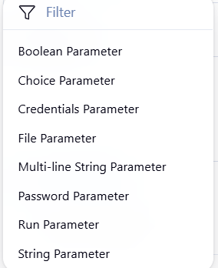
Here are simple one-line examples for each Jenkins parameter type:
Boolean Parameter: DEBUG = true (enable or disable debug mode)
Choice Parameter: ENV = dev / test / prod (select environment)
Credentials Parameter: CREDENTIALS_ID = my-github-creds (use stored credentials)
File Parameter: Upload config.yaml (pass a file to the job)
Multi-line String Parameter:
MESSAGE = This is line 1
This is line 2
Password Parameter: PASSWORD = ****** (secure input like API key)
Run Parameter: BUILD = Select build #123 of another job
String Parameter: BRANCH = main (simple text input)

- Configure:
  - Name: BRANCH
  - Default Value: master
  - Description: Enter branch name to build

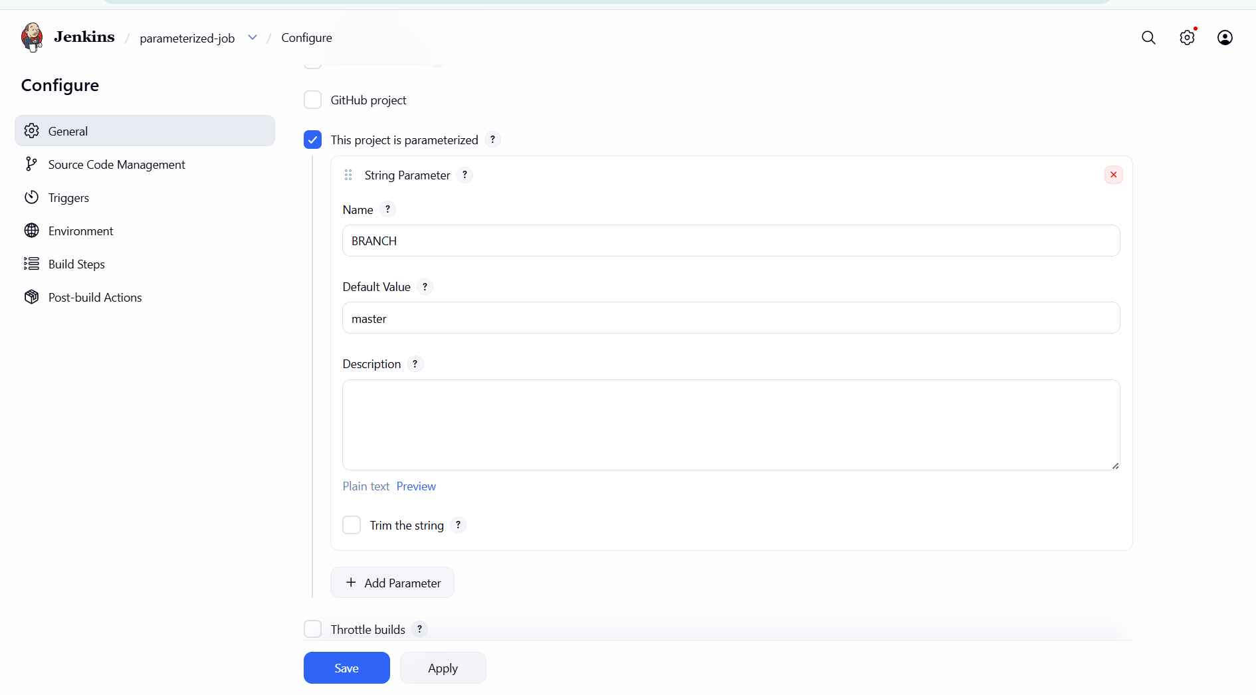

Step 4: Configure Source Code Management
- Select Git
- Repository URL:
https://github.com/rohithreddy8327/spring3-mvc-maven-xml-hello-world-1.git

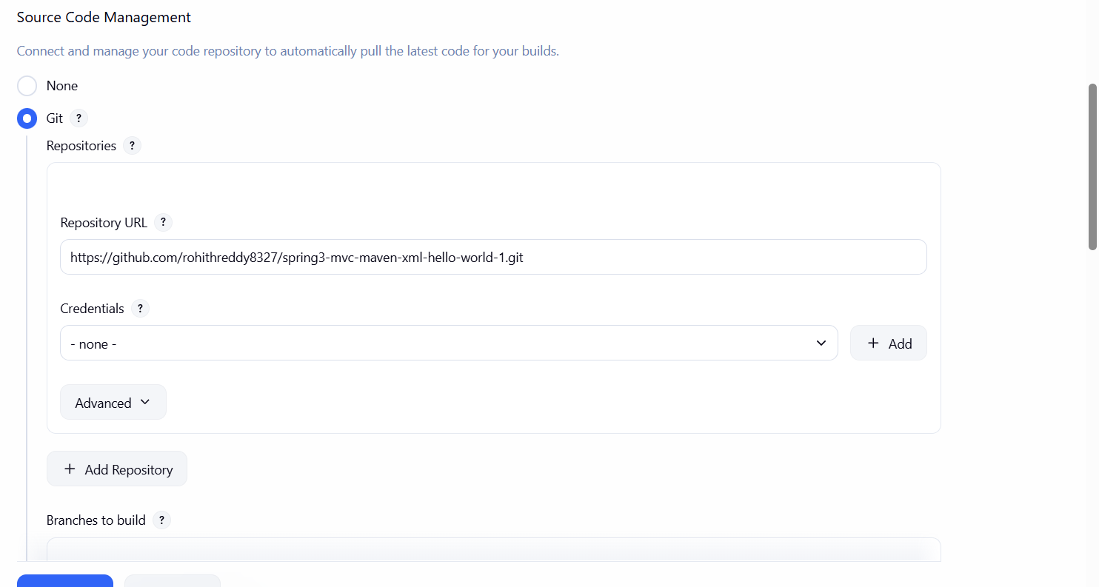

Step 5: Configure Branch Specifier
*/${BRANCH}
👉 This is the MOST IMPORTANT STEP
It links your parameter to Git.
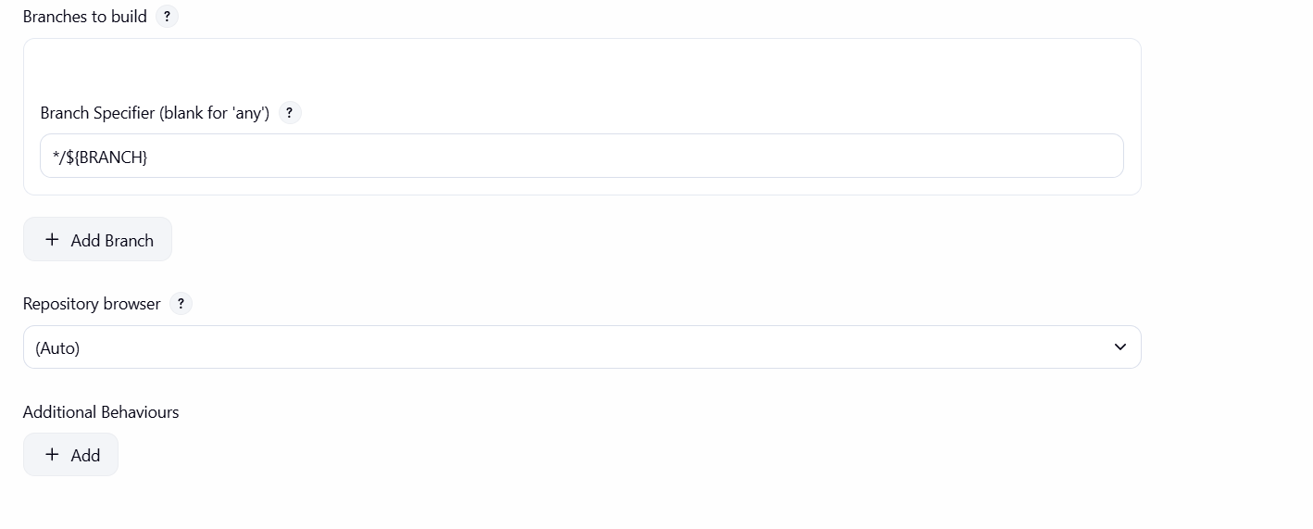

Step 6: Build Step Configuration
- Select: Invoke top-level Maven targets
- Maven Goals:
clean package

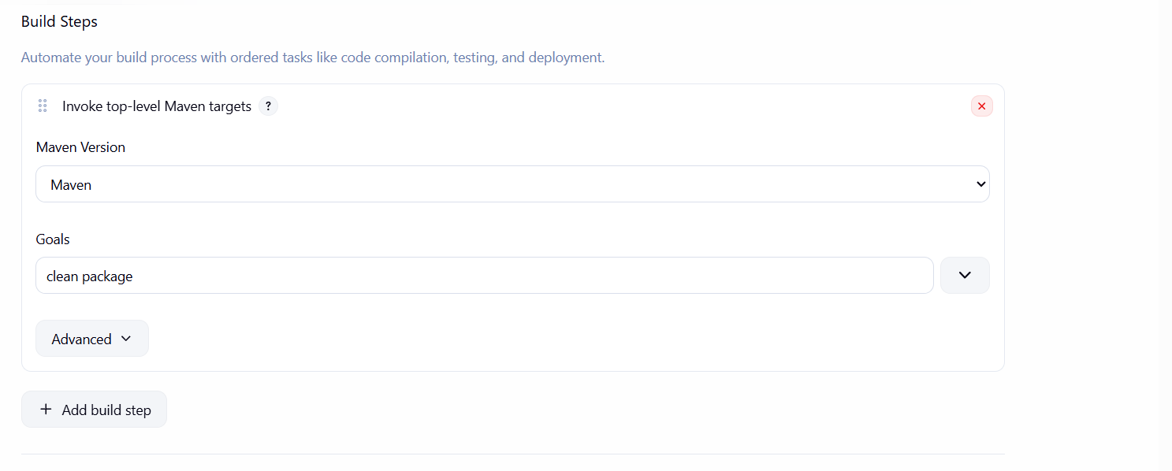

Step 7: Save and Execute Job
- Click Save
- Click Build with Parameters
- Enter branch name (example: master)
- Click Build
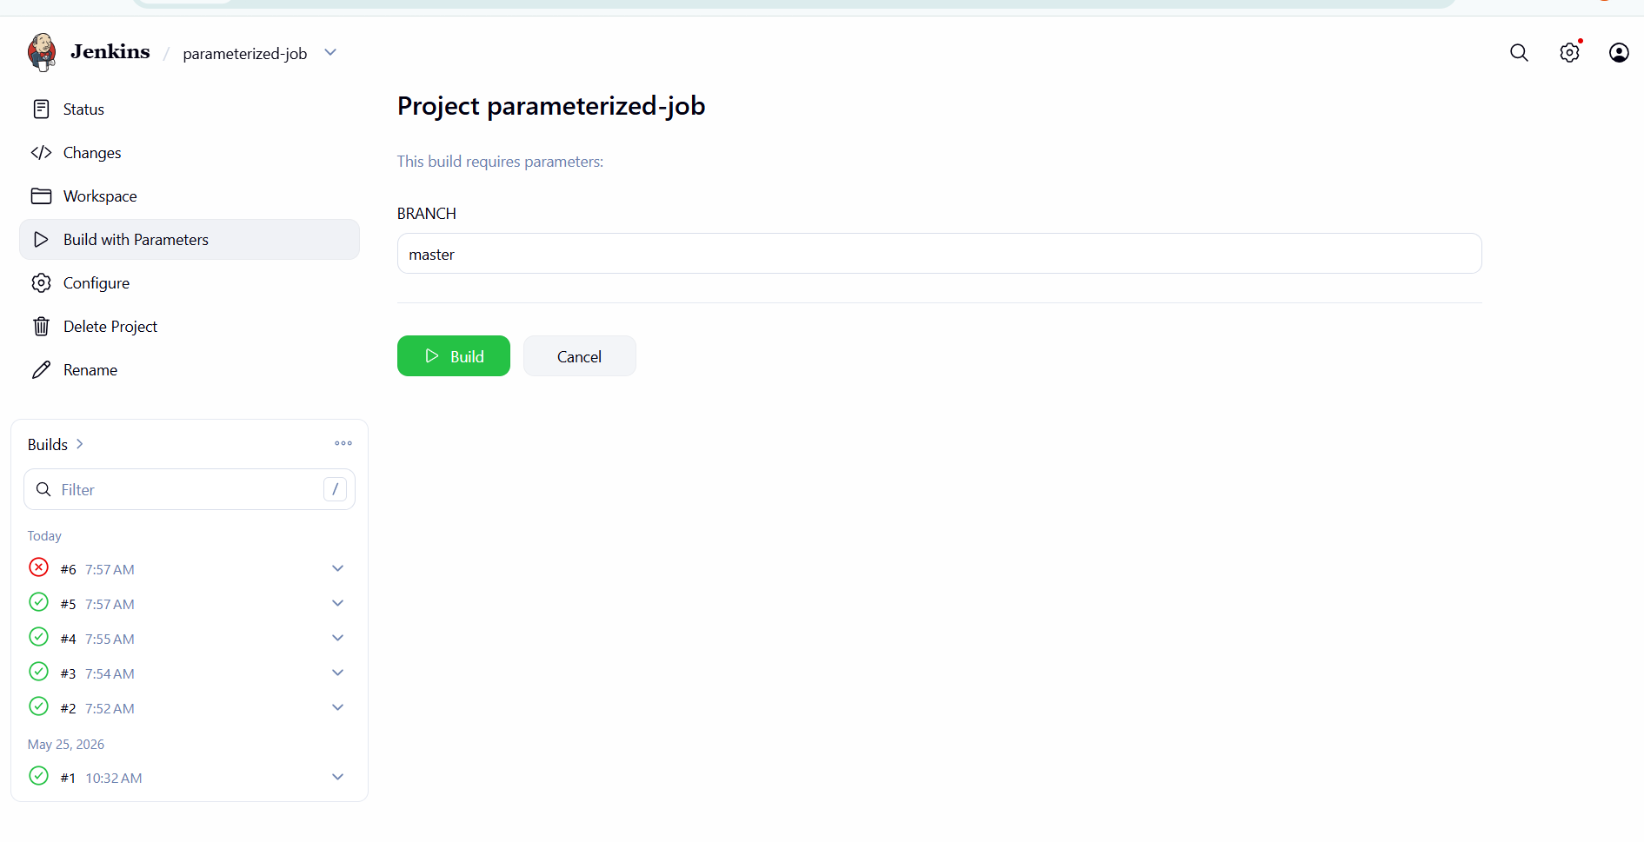

4. Execution Flow
- User enters branch name
- Jenkins replaces ${BRANCH}
- Code is cloned from selected branch
- Maven builds the project
- Artifact is generated
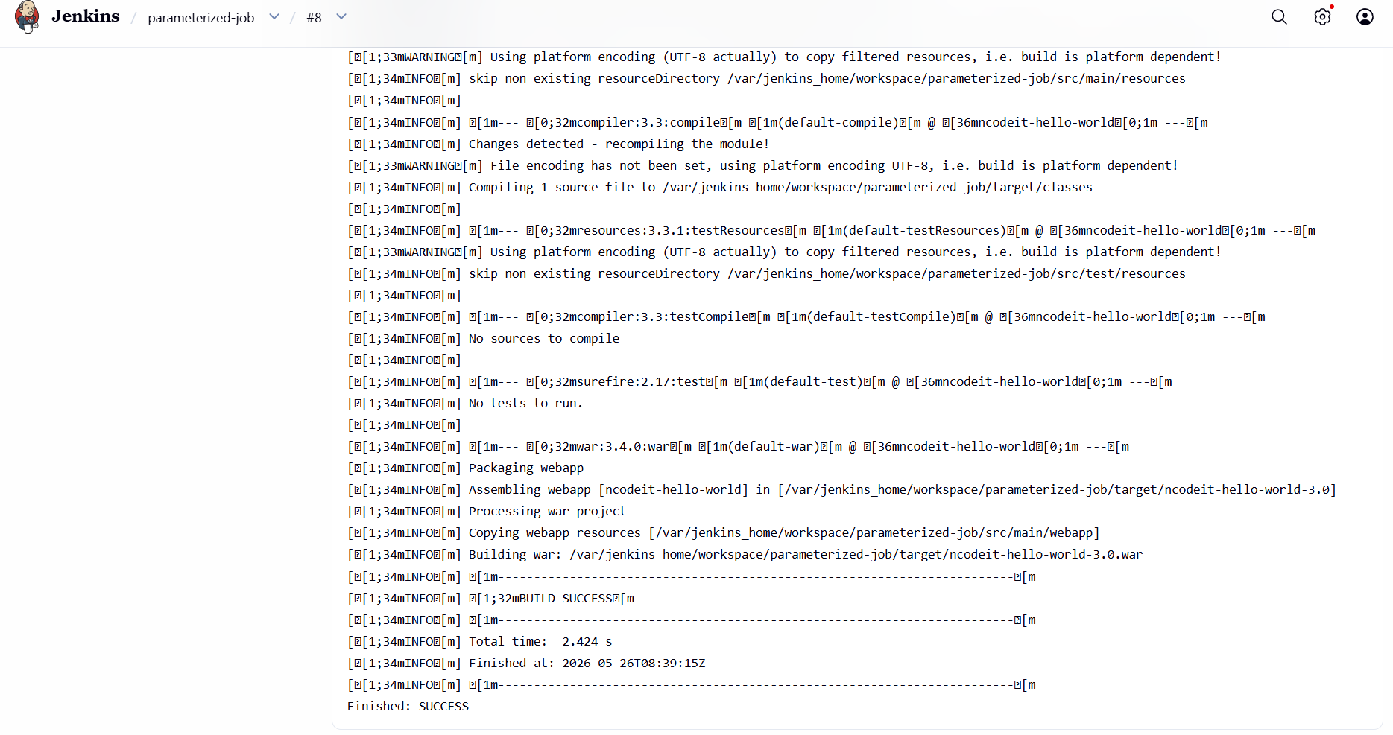

6) Setup one slave machine for Jenkins.

Launched two EC2 instances to act as Jenkins agents (agent-1, agent-2).
Installed required dependencies (Java 21 and fontconfig) on both agent machines.
Created a dedicated jenkins user on each agent for running builds.
Configured .ssh directory for jenkins user with proper permissions.
Verified Java installation on both agents to ensure Jenkins compatibility.
Logged into Jenkins controller and ensured jenkins user setup.
Created .ssh directory on controller for SSH communication.
Generated SSH key pair (id_rsa, id_rsa.pub) on controller as jenkins user.
Copied public key from controller and added it to agents’ authorized_keys.
Set correct permissions for SSH keys on both controller and agents.
Added agents’ host keys to controller’s known_hosts file to avoid prompts.
Verified password-less SSH connectivity from controller to both agents.
Configured both agents in Jenkins UI as Permanent Nodes.
Set SSH credentials and connection details for each agent.
Verified agents are online and jobs are successfully executed on them.

