Jenkins-03

1. Create one Jenkins job using the below code and create three stages.
- stage1: Git clone to download the source code.
- stage2: Sonarqube Integration to check the quality of code.
- stage3: Slack Integration to send the alerts to slack.
Source Code: https://github.com/betawins/VProfile-1.git

Stage 1 – Git Clone
The first pipeline stage clones the source code repository into the Jenkins workspace so subsequent stages can operate on it.

Steps in Jenkins (Freestyle Job):
· Go to Jenkins Dashboard → New Item.
· Name the job (e.g., profile) and select Freestyle Project.
· Under Source Code Management, select Git.
· Paste the public repository URL. No credentials needed for public repos.
· Click Save and then Build Now.

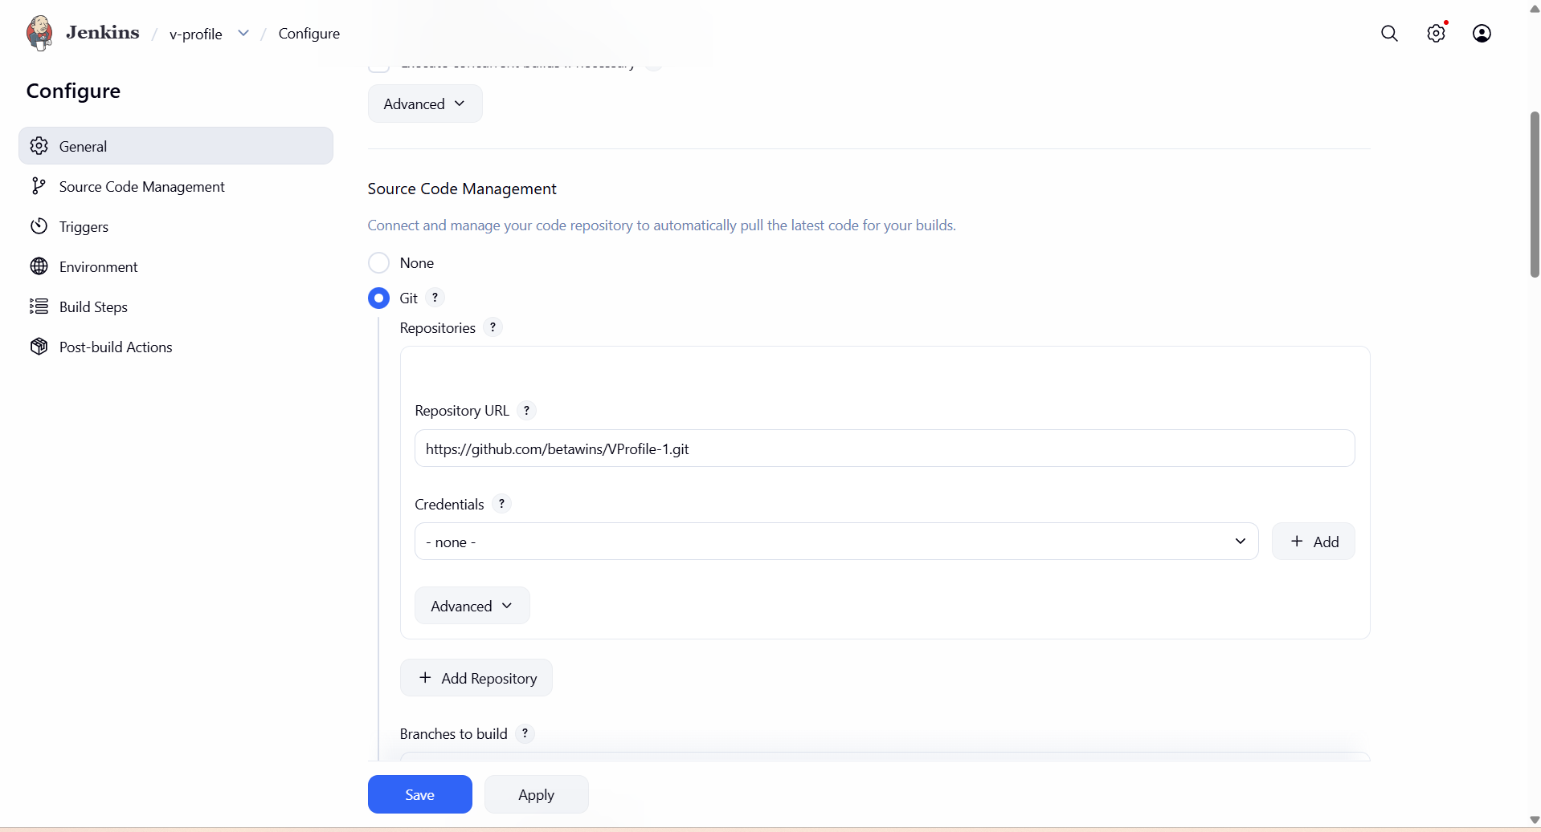
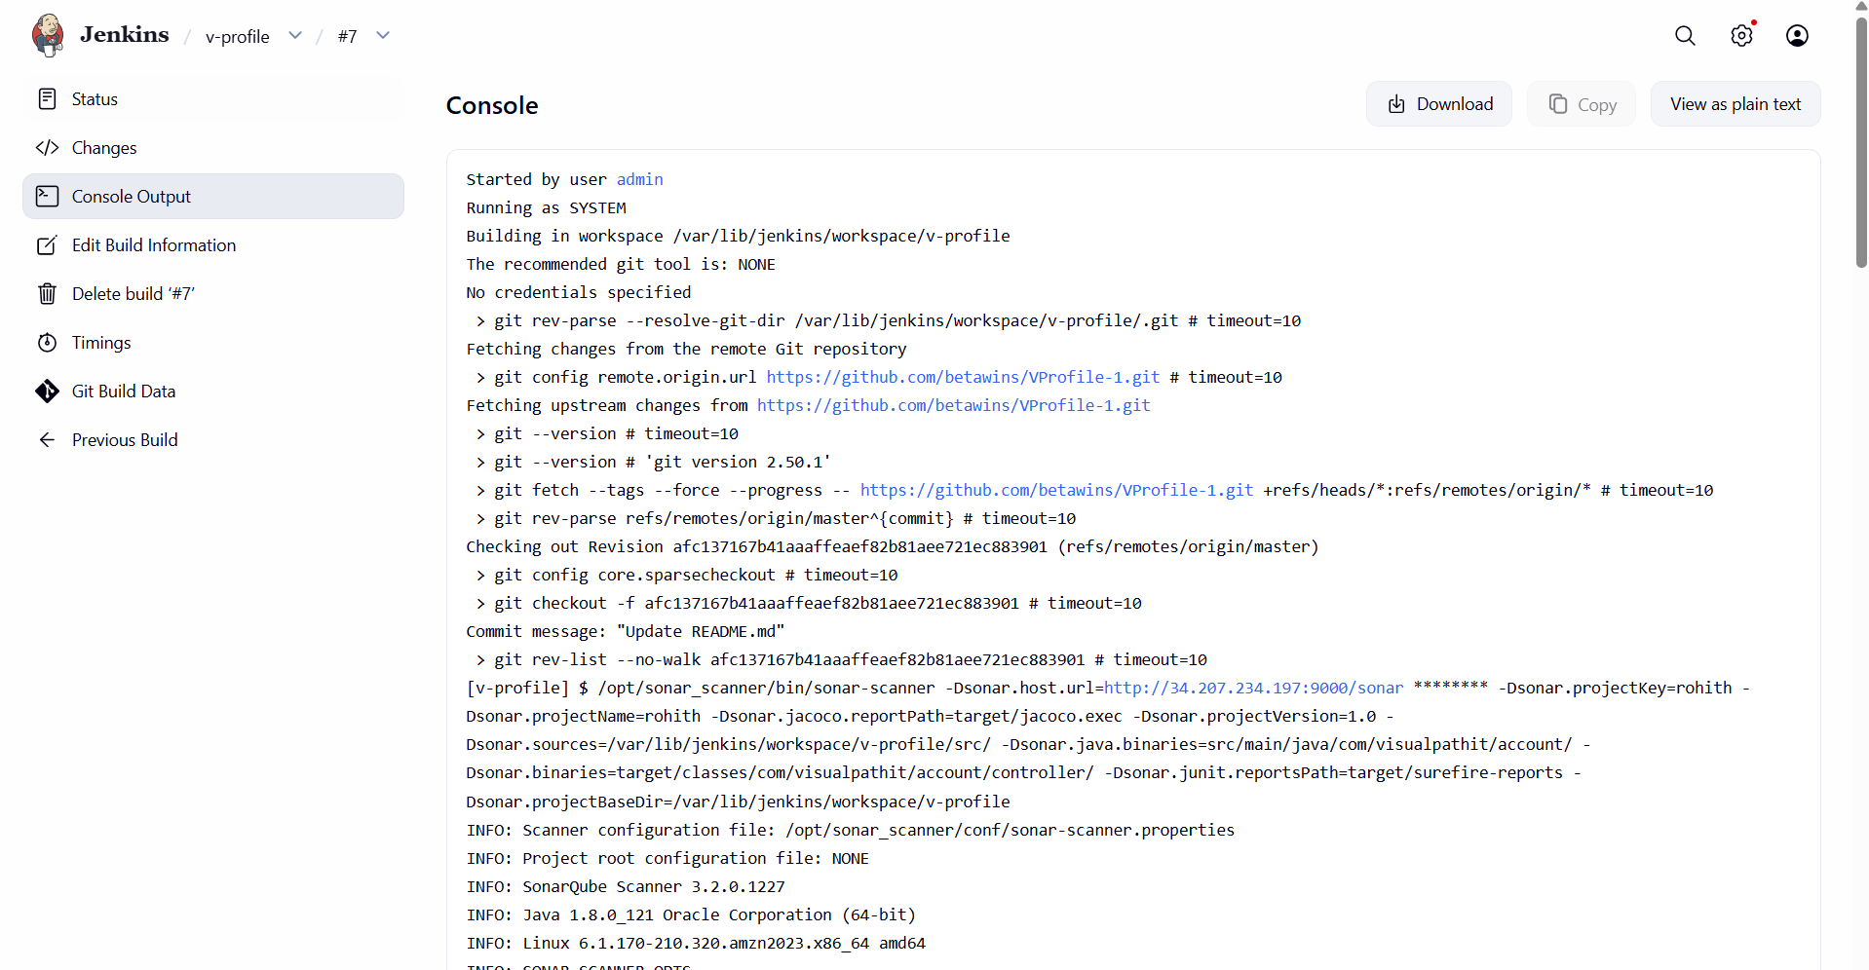

Stage 2 – SonarQube Installation and integration

SonarQube Installation

Prerequisites for SonarQube Server
· EC2 instance: t2.large (minimum)
· Storage: At least 20 GB
· Java: Version 1.8 installed
· MySQL 5.7: Used to store generated reports

Step 1 – Install Java 1.8
yum install java-1.8.0-openjdk -y

Step 2 – Install and Configure MySQL 5.7
· Download the MySQL 5.7 RPM and import its GPG key.
· Install MySQL and start the service:
systemctl start mysqld
systemctl status mysqld # Port: 3306
· Retrieve the temporary root password from /var/log/mysqld.log
· Log in and change the password:
mysql -u root -p
ALTER USER 'root'@'localhost' IDENTIFIED BY 'Admin@123';
FLUSH PRIVILEGES;
· Create the sonar database and users:
CREATE DATABASE sonar;
CREATE USER 'sonar'@'localhost' IDENTIFIED BY 'Sonar@123';
CREATE USER 'sonar'@'%' IDENTIFIED BY 'Sonar@123';
GRANT ALL PRIVILEGES ON sonar.* TO 'sonar'@'localhost';
GRANT ALL PRIVILEGES ON sonar.* TO 'sonar'@'%';
FLUSH PRIVILEGES;

Step 3 – Download and Configure SonarQube
cd /opt
wget <sonarqube-6.6-zip-url>
unzip sonarqube-6.6.zip
mv sonarqube-6.6 sonar
· Edit /opt/sonar/conf/sonar.properties and configure:
· sonar.jdbc.username=sonar
· sonar.jdbc.password=Sonar@123
· sonar.jdbc.url (uncomment the MySQL line)
· sonar.web.host=0.0.0.0
· sonar.web.context=/sonar (optional path prefix)

Step 4 – Start SonarQube
Important: SonarQube cannot run as the root user. Use a non-root user and ensure directory ownership is correct.
chown -R ec2-user:ec2-user /opt/sonar
su - ec2-user
cd /opt/sonar/bin/linux-x86-64
./sonar.sh start
./sonar.sh status
· Access SonarQube at: http://<server-ip>:9000/sonar
· Default credentials: admin / admin
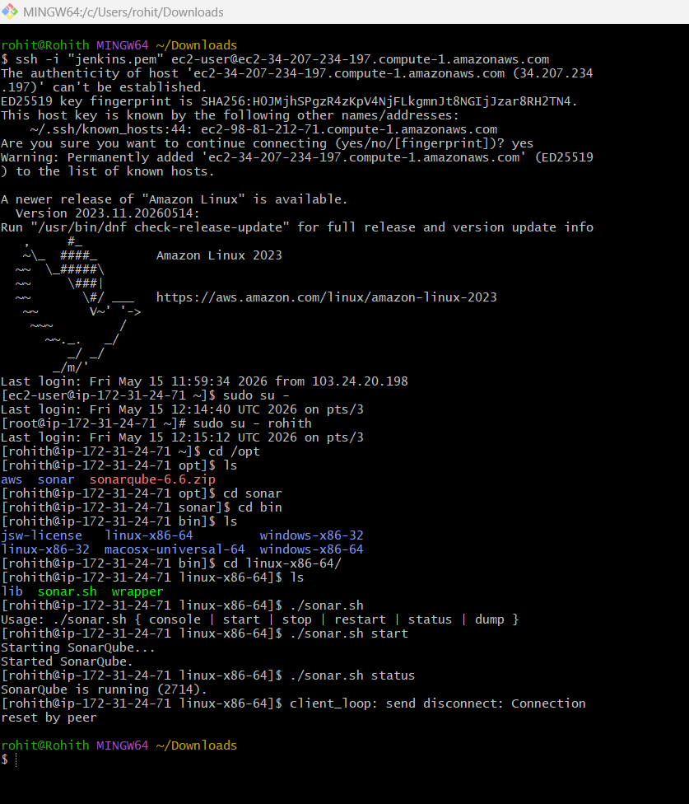
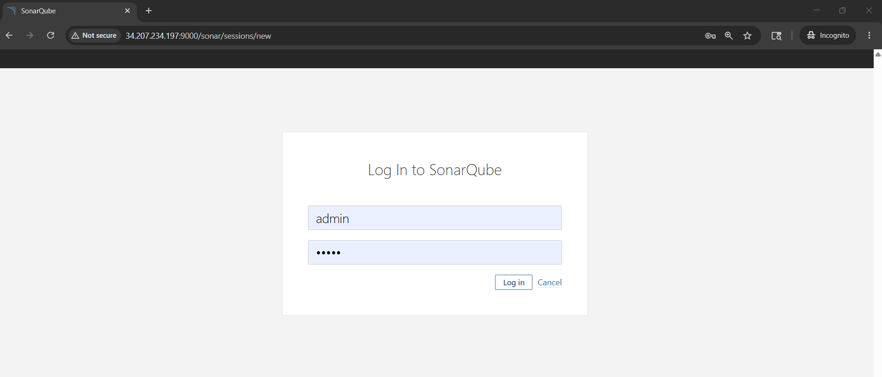

Integrating SonarQube with Jenkins

Step 1 – Install the SonarQube Scanner Plugin in Jenkins
· Dashboard → Manage Jenkins → Plugins → Available Plugins
· Search for 'SonarQube Scanner' and install it.
· After installation, a new build step 'Execute SonarQube Scanner' becomes available.
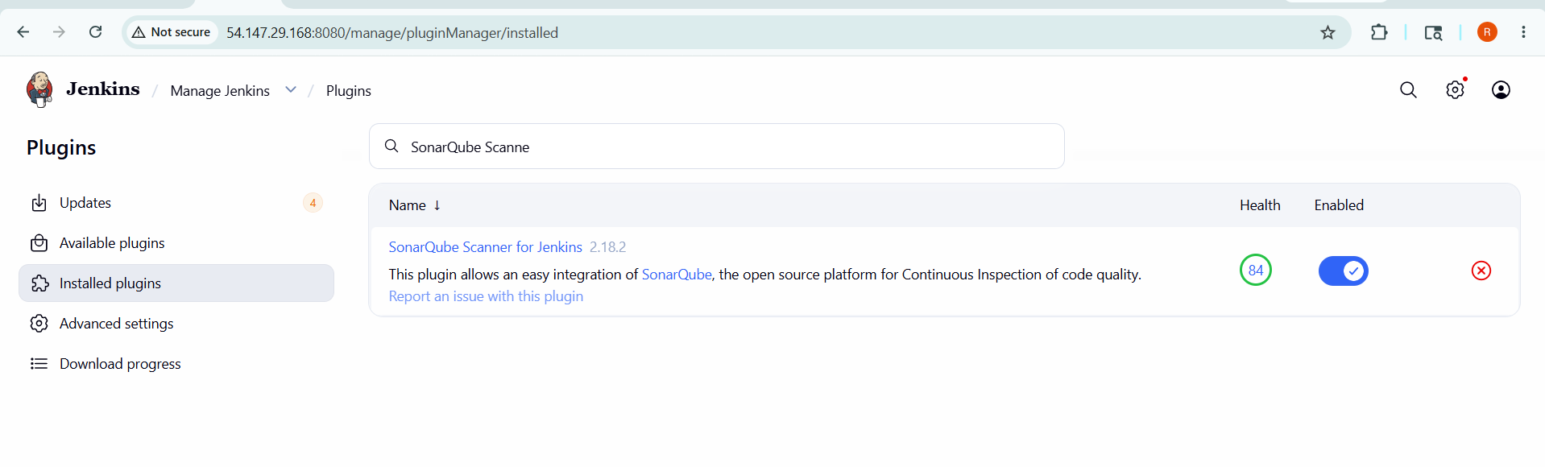

Step 2 – Generate an Authentication Token in SonarQube
· Log into SonarQube → My Account → Security → Generate Tokens
· Copy the generated token.

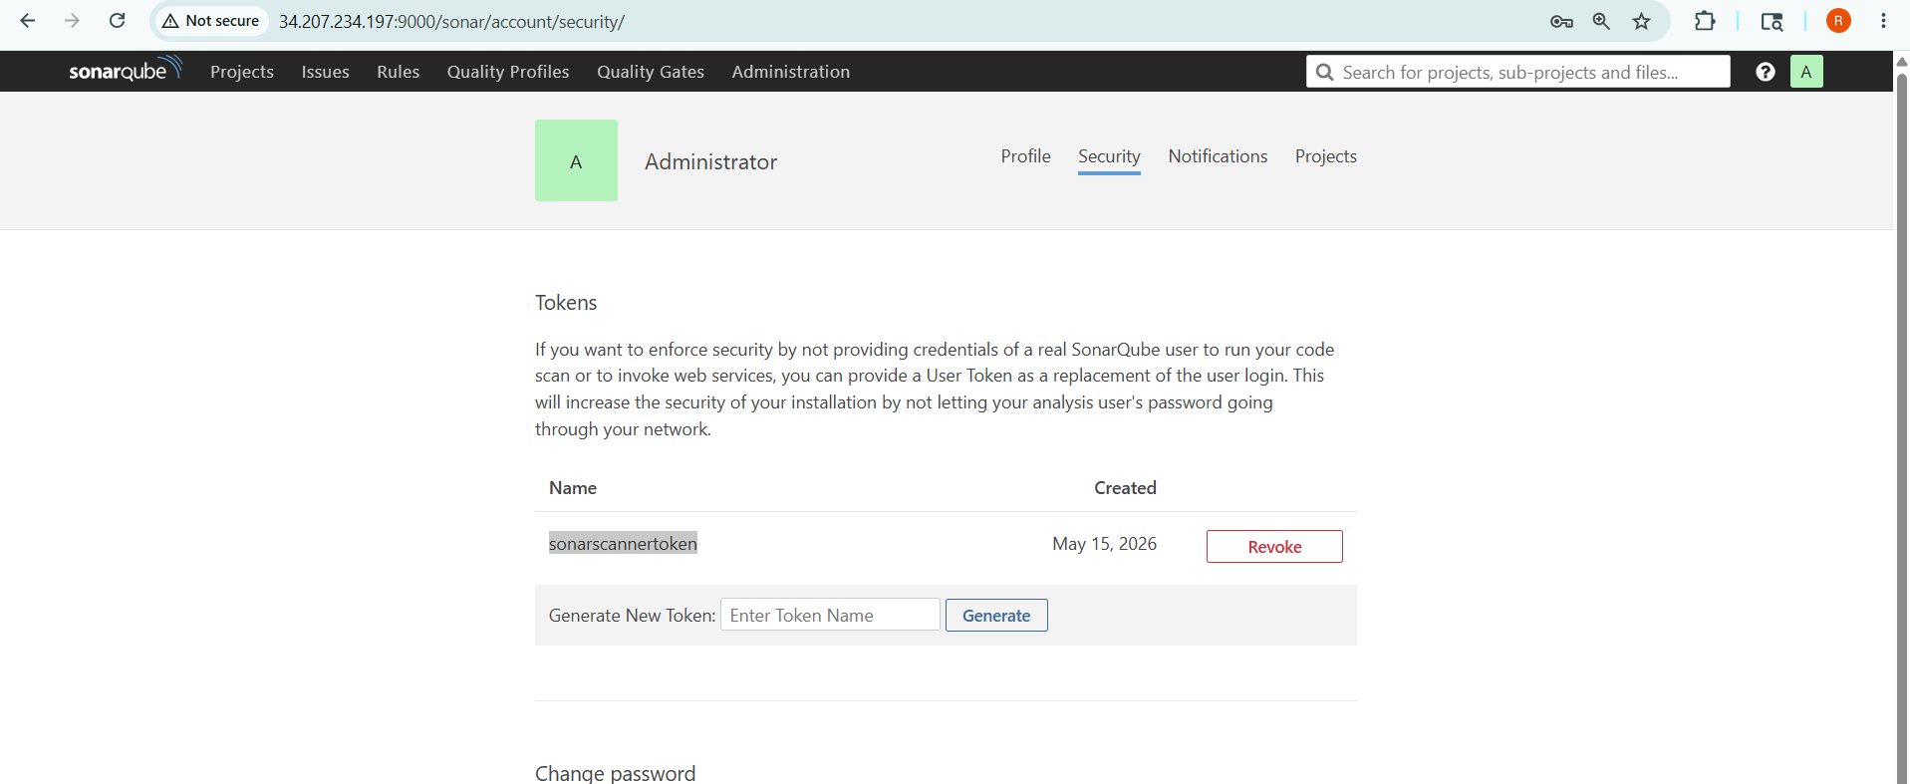

Step 3 – Add Token as Jenkins Credential
· Manage Jenkins → Credentials → Global → Add Credentials
· Kind: Secret Text | Secret: <paste token> | ID: sonarqube-server
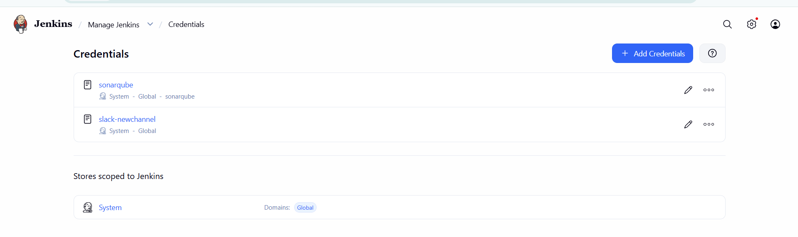

Step 4 – Configure SonarQube Server in Jenkins
· Manage Jenkins → System → SonarQube Servers
· Name: sonarqube-server
· Server URL: http://<sonarqube-ip>:9000/sonar (or /9002 if Docker)
· Authentication Token: select the credential created above → Save

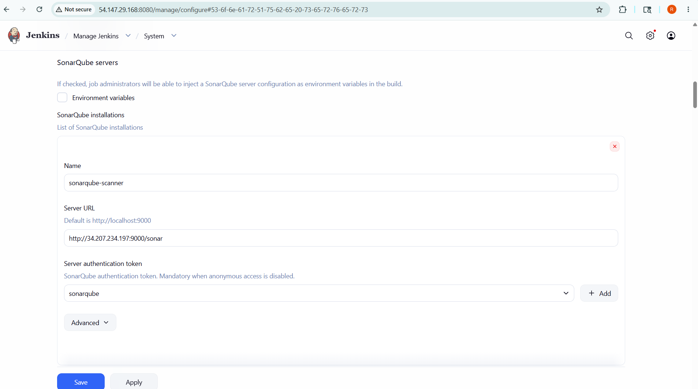

Step 5 – Install SonarQube Scanner on Jenkins Server
cd /opt
wget <sonar-scanner-zip-url>
unzip sonar-scanner-<version>.zip
mv sonar-scanner-<version> sonar-scanner
· Edit /opt/sonar-scanner/conf/sonar-scanner.properties:
sonar.host.url=http://<sonarqube-server-ip>:9000/sonar
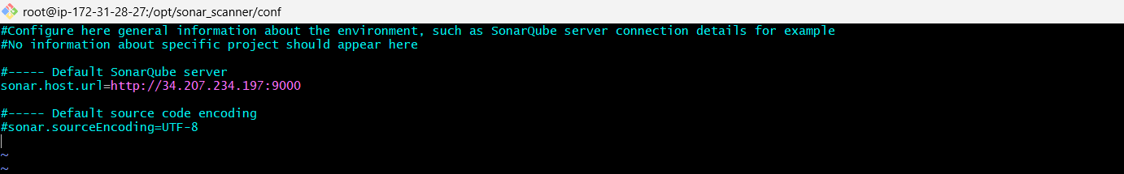
· Register the scanner path in Jenkins: Manage Jenkins → Global Tool Configuration → SonarQube Scanner → Add
· Name: sonar-scanner | SONAR_RUNNER_HOME: /opt/sonar-scanner

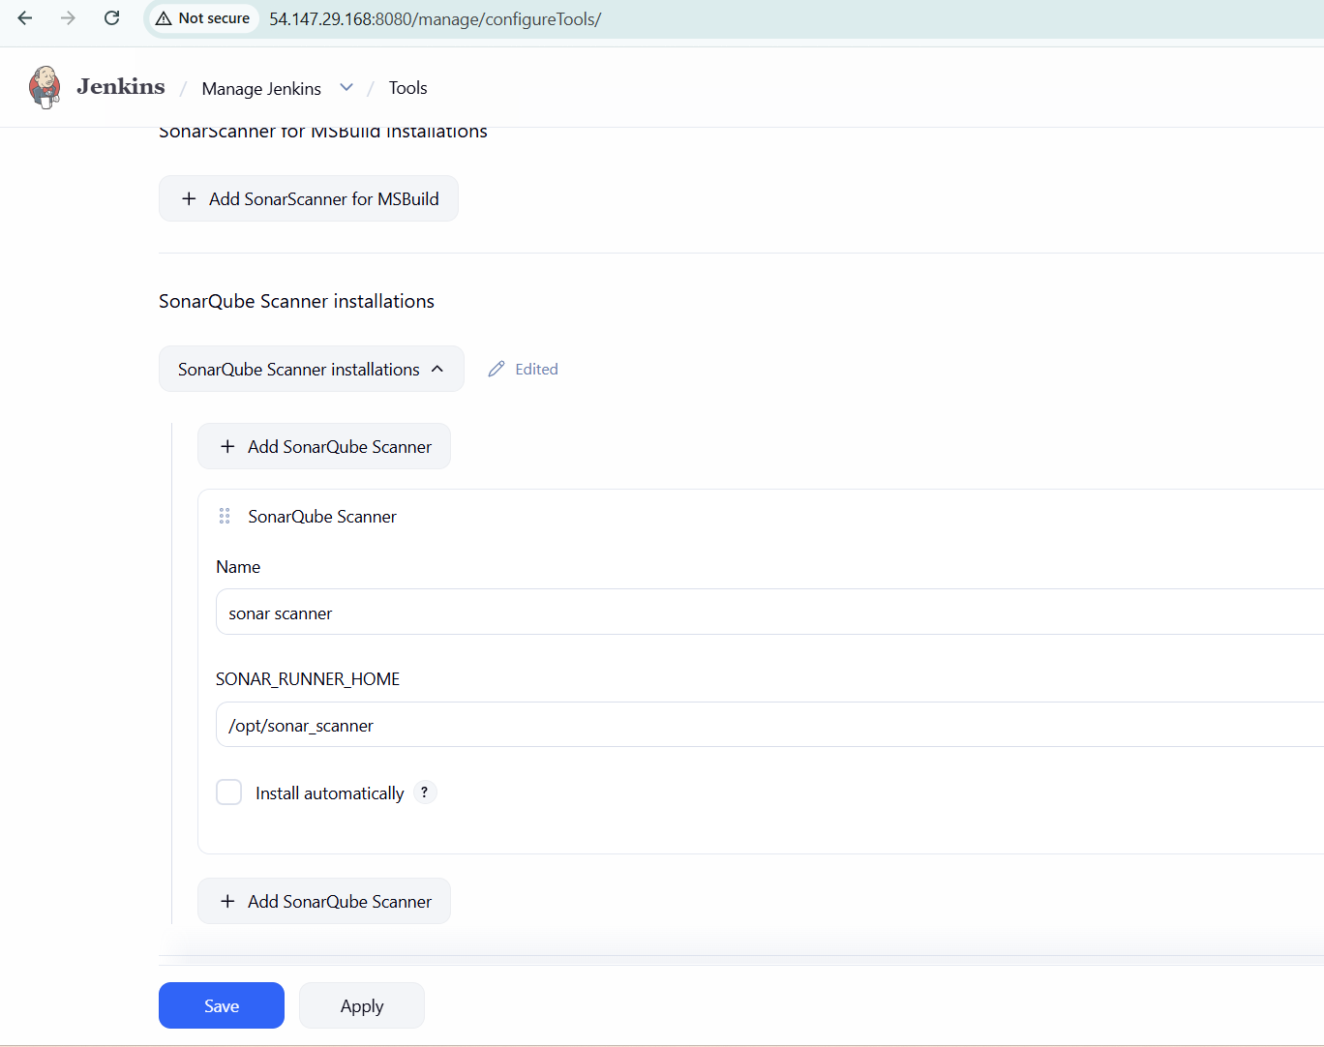
Important: Always install the scanner manually and specify the path. Do NOT use 'Install Automatically' — this downloads the latest version and can break pipelines if the version is incompatible with your code.

Step 6 – Add SonarQube Analysis Step to the Jenkins Job
· Open the job → Configure → Build Steps → Add Build Step → Execute SonarQube Scanner
· In the Analysis Properties box, paste the project's sonar settings (from the repository's README.md or from the developer):
sonar.projectKey=<project-key>
sonar.projectName=<project-name>
sonar.projectVersion=1.0
sonar.sources=src
sonar.java.binaries=target/classes
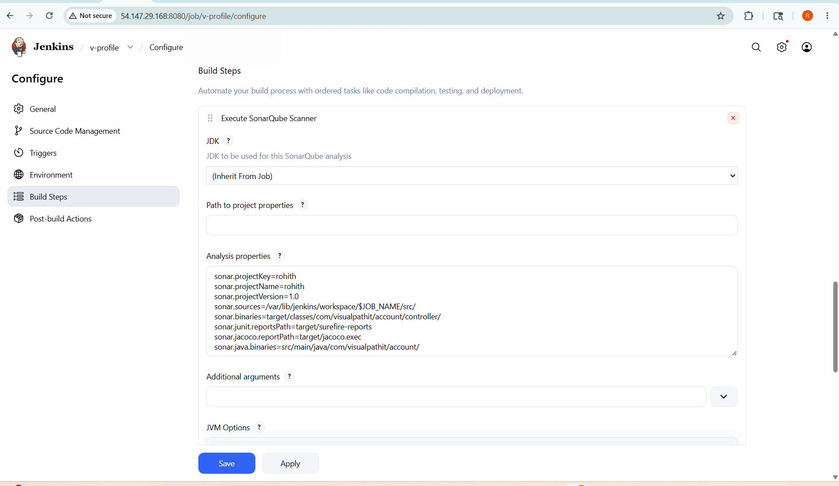
· Save and run the job. Reports will be pushed to the SonarQube dashboard.

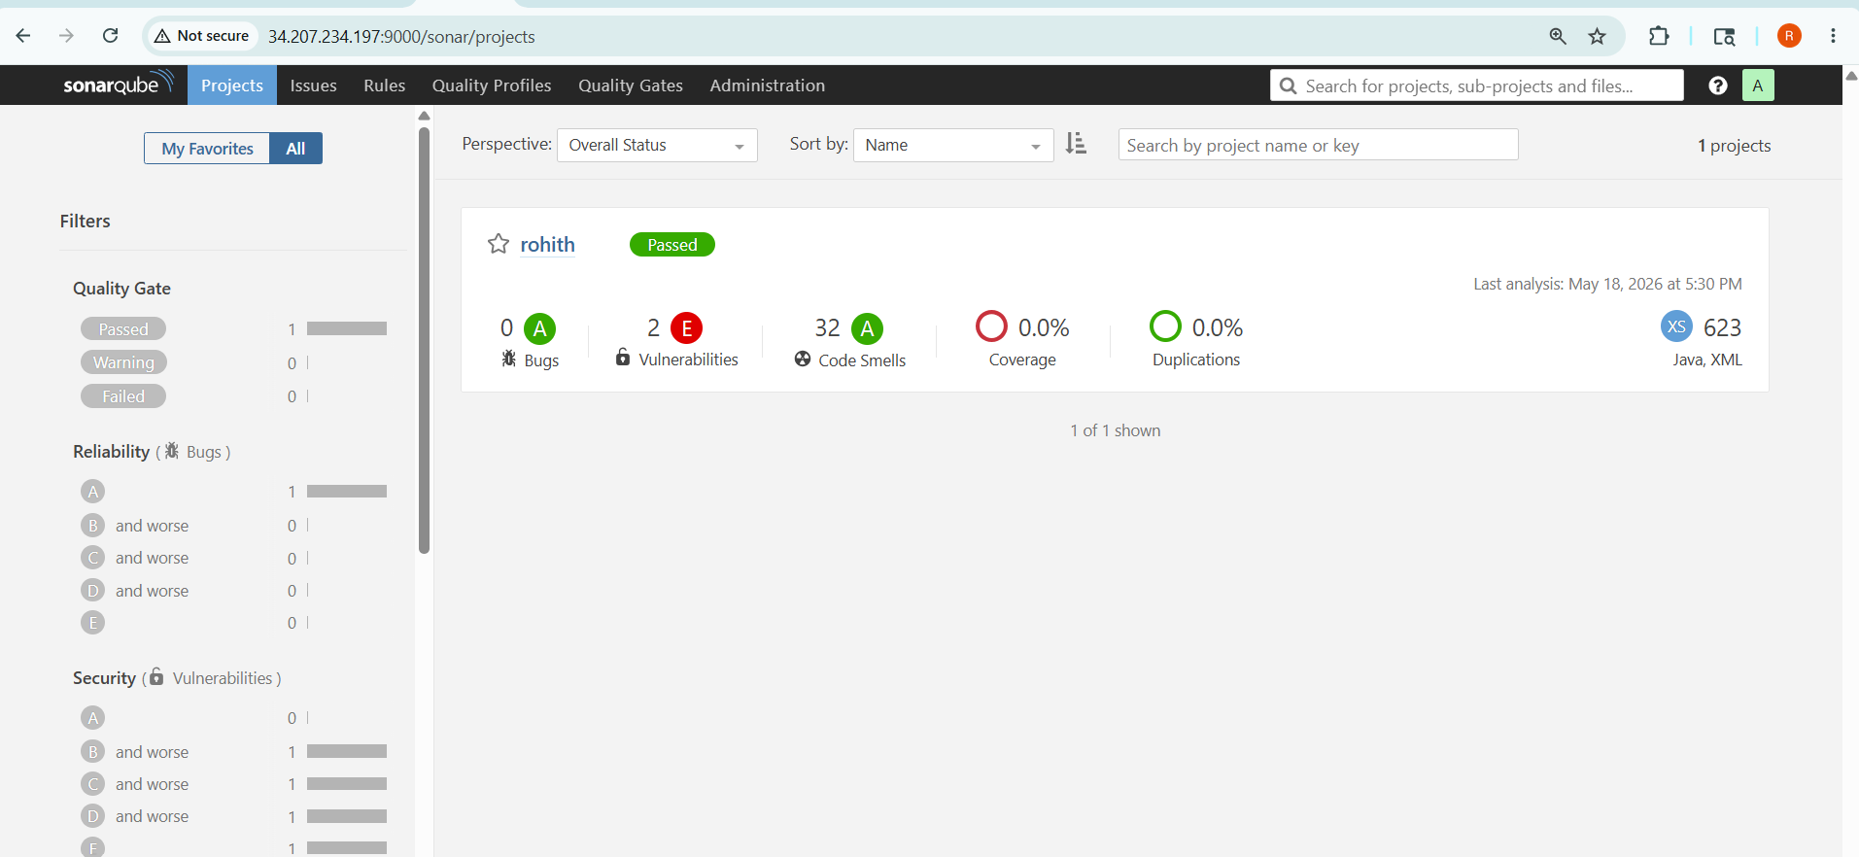

Stage 3 – Slack Integration

Created Slack Workspace & Channel
Created a channe in Slack to receive build notifications.

Installed Slack Plugin in Jenkins
Navigated to Manage Jenkins → Plugin Manager and installed Slack Notification Plugin.

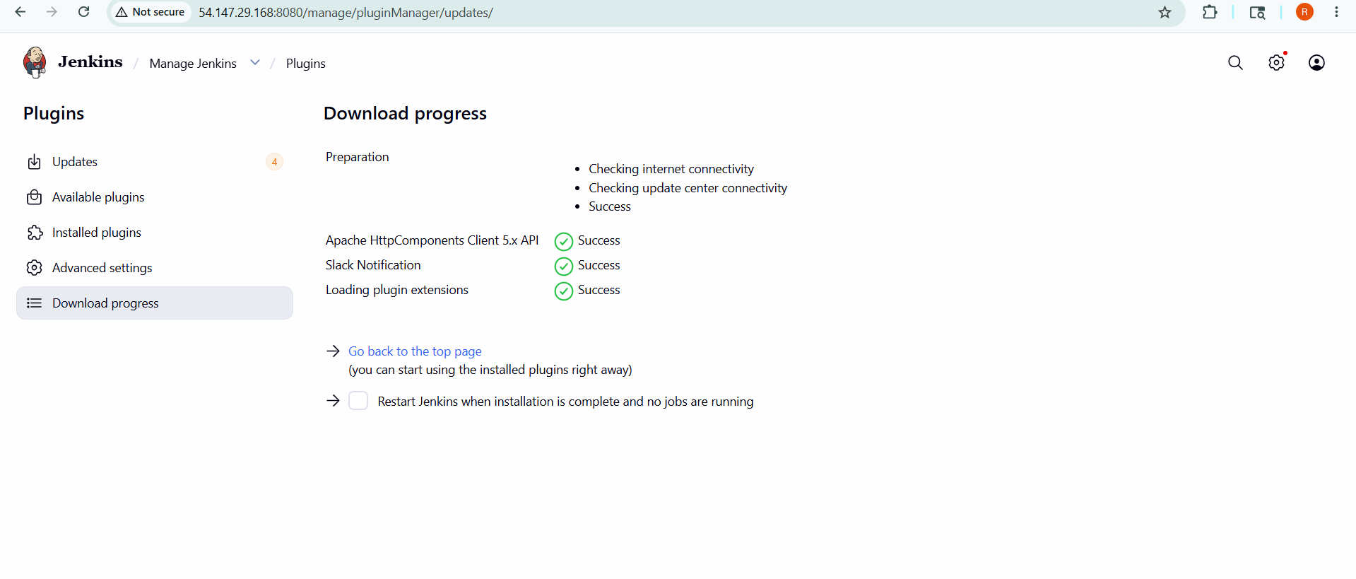

Generated Slack Webhook URL
In Slack, configured Incoming Webhooks and copied the webhook URL for integration.

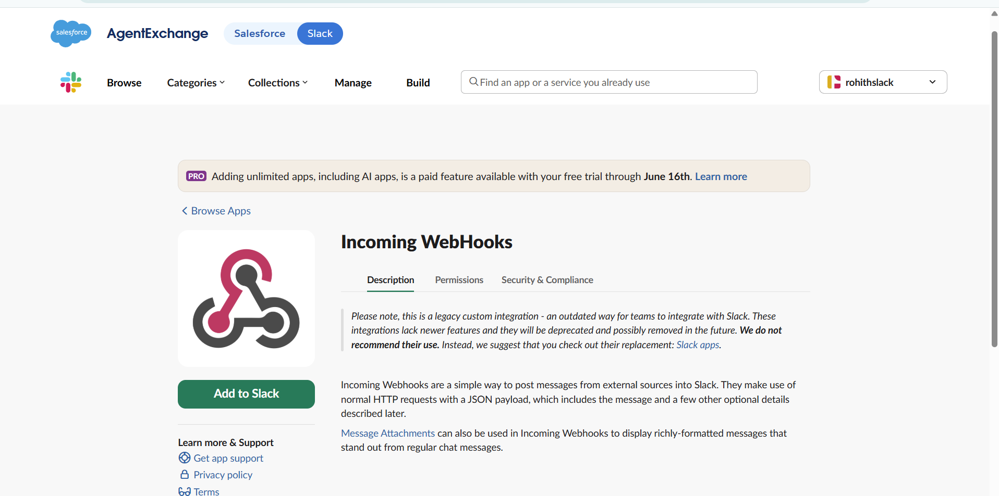

Configured Slack in Jenkins
Went to Manage Jenkins → Configure System and added Slack details:

Workspace URL

Channel name

Credential (Webhook URL)

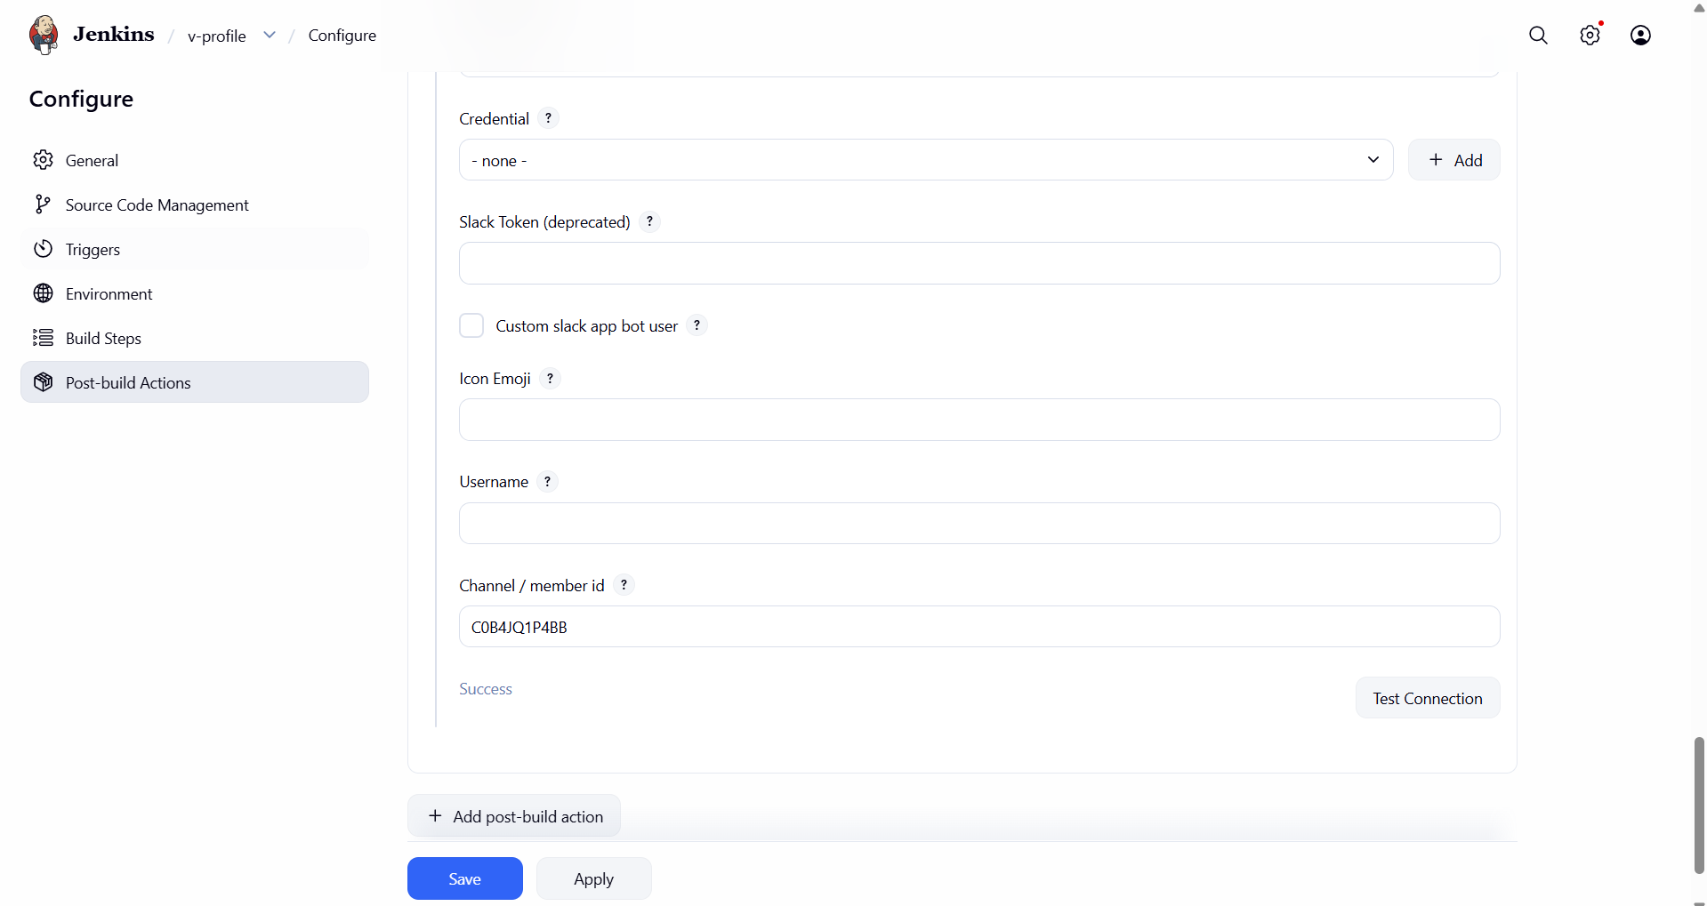

Integrated Slack in Job
In Jenkins job configuration:

Enabled Post-build Actions

Selected Slack Notifications

Chose triggers (Success, Failure, etc.)

Tested Notification
Ran the job and verified that build status messages were successfully sent to Slack channel.

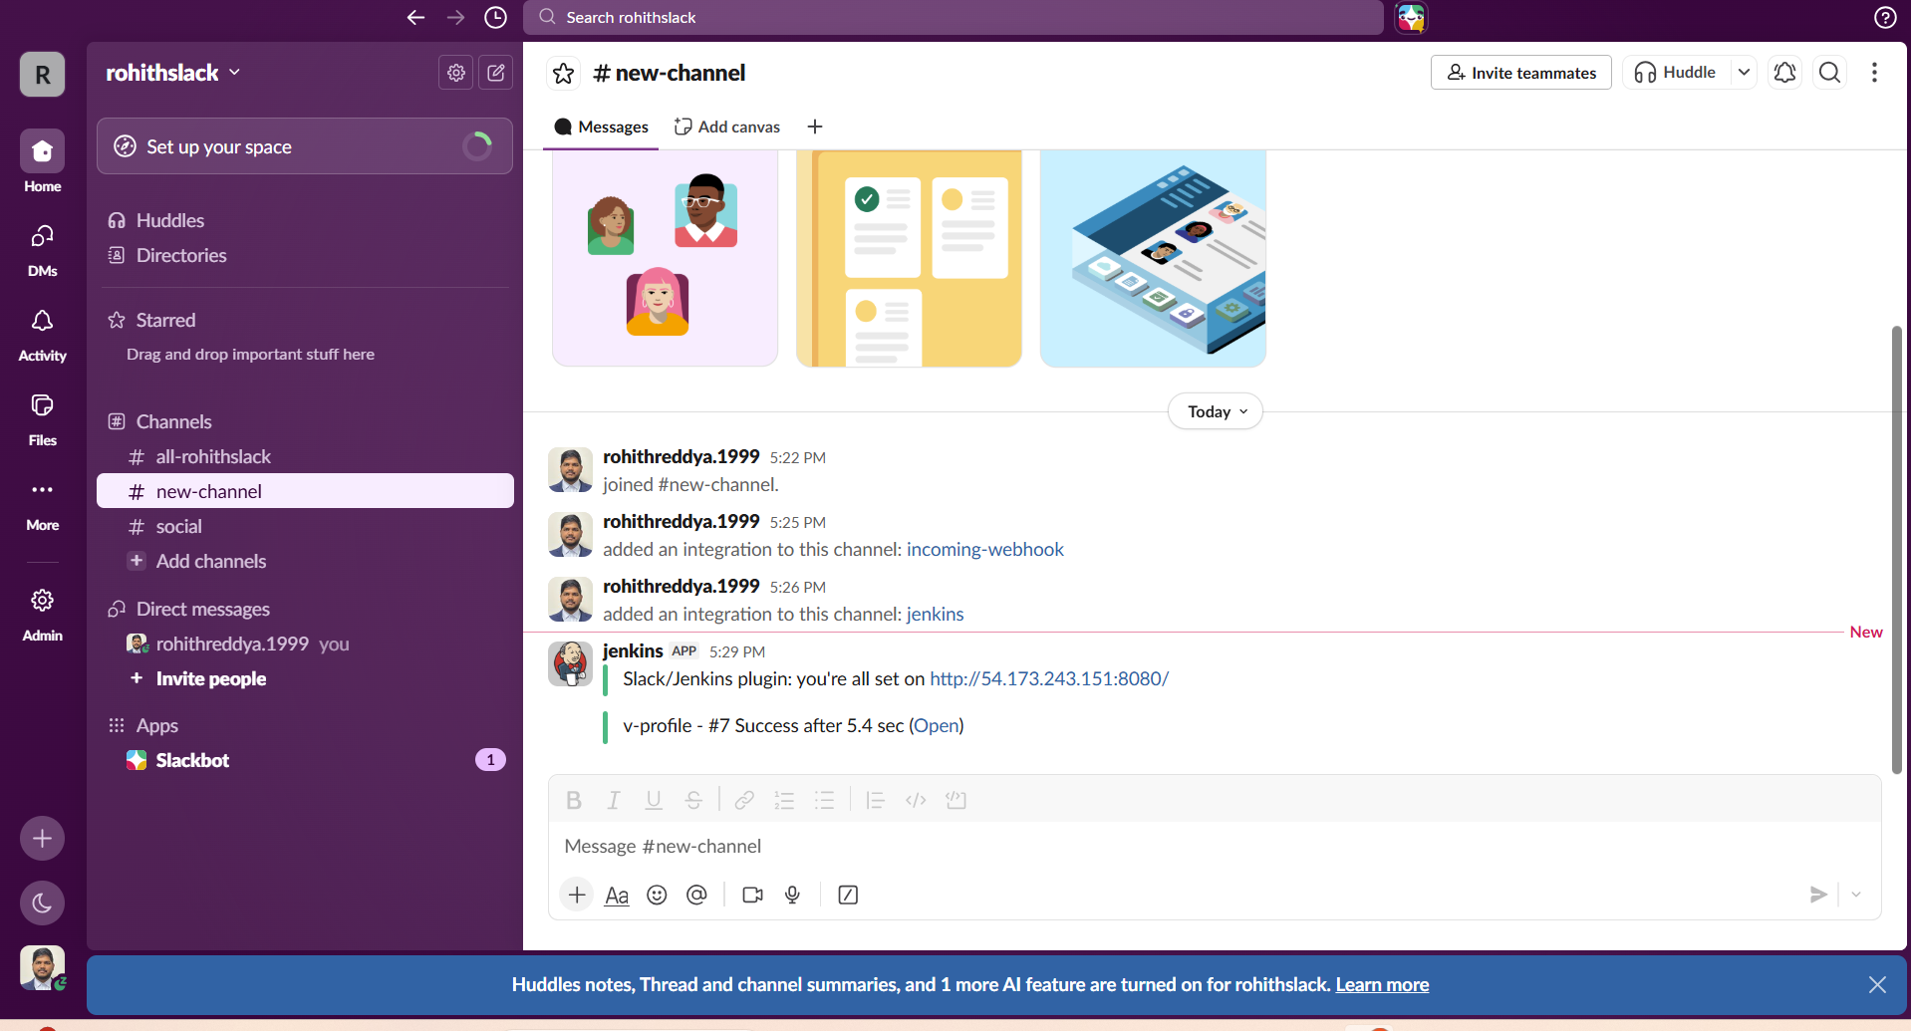



2. Create one Jenkins job using the below code and create three stages.
- stage1: Git clone to download the source code.
- stage2: Sonarqube Integration to check the quality of code.
- stage3: Slack Integration to send the alerts to slack.
Source Code: https://github.com/betawins/hiring-app.git

Go to Jenkins Dashboard → New Item.
· Name the job (e.g., profile) and select Freestyle Project.
· Under Source Code Management, select Git.
· Paste the public repository URL. No credentials needed for public repos.
·

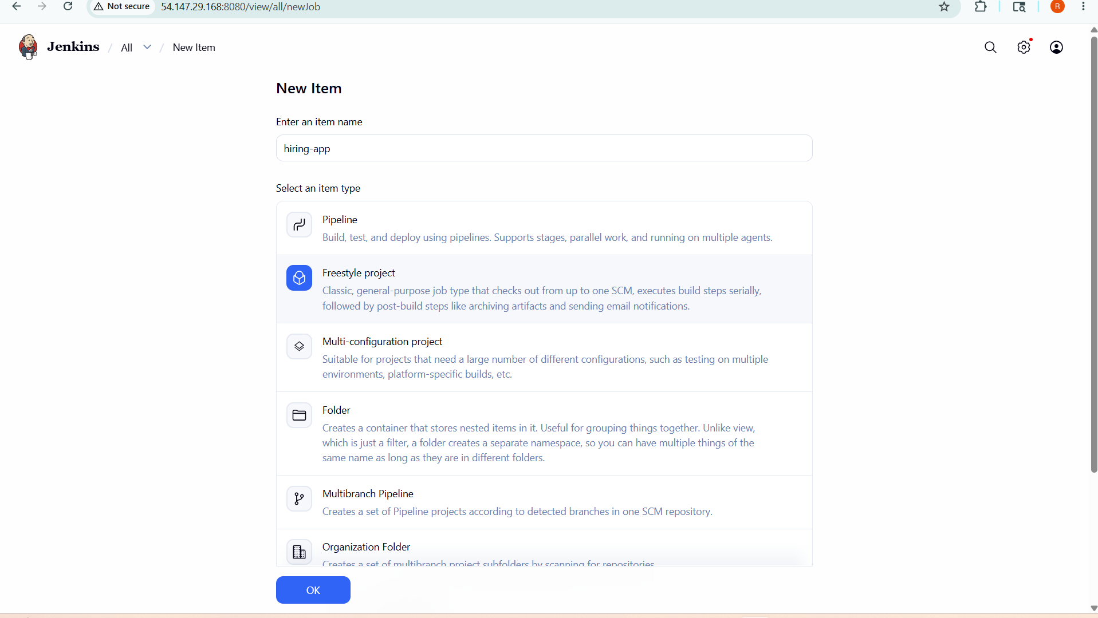

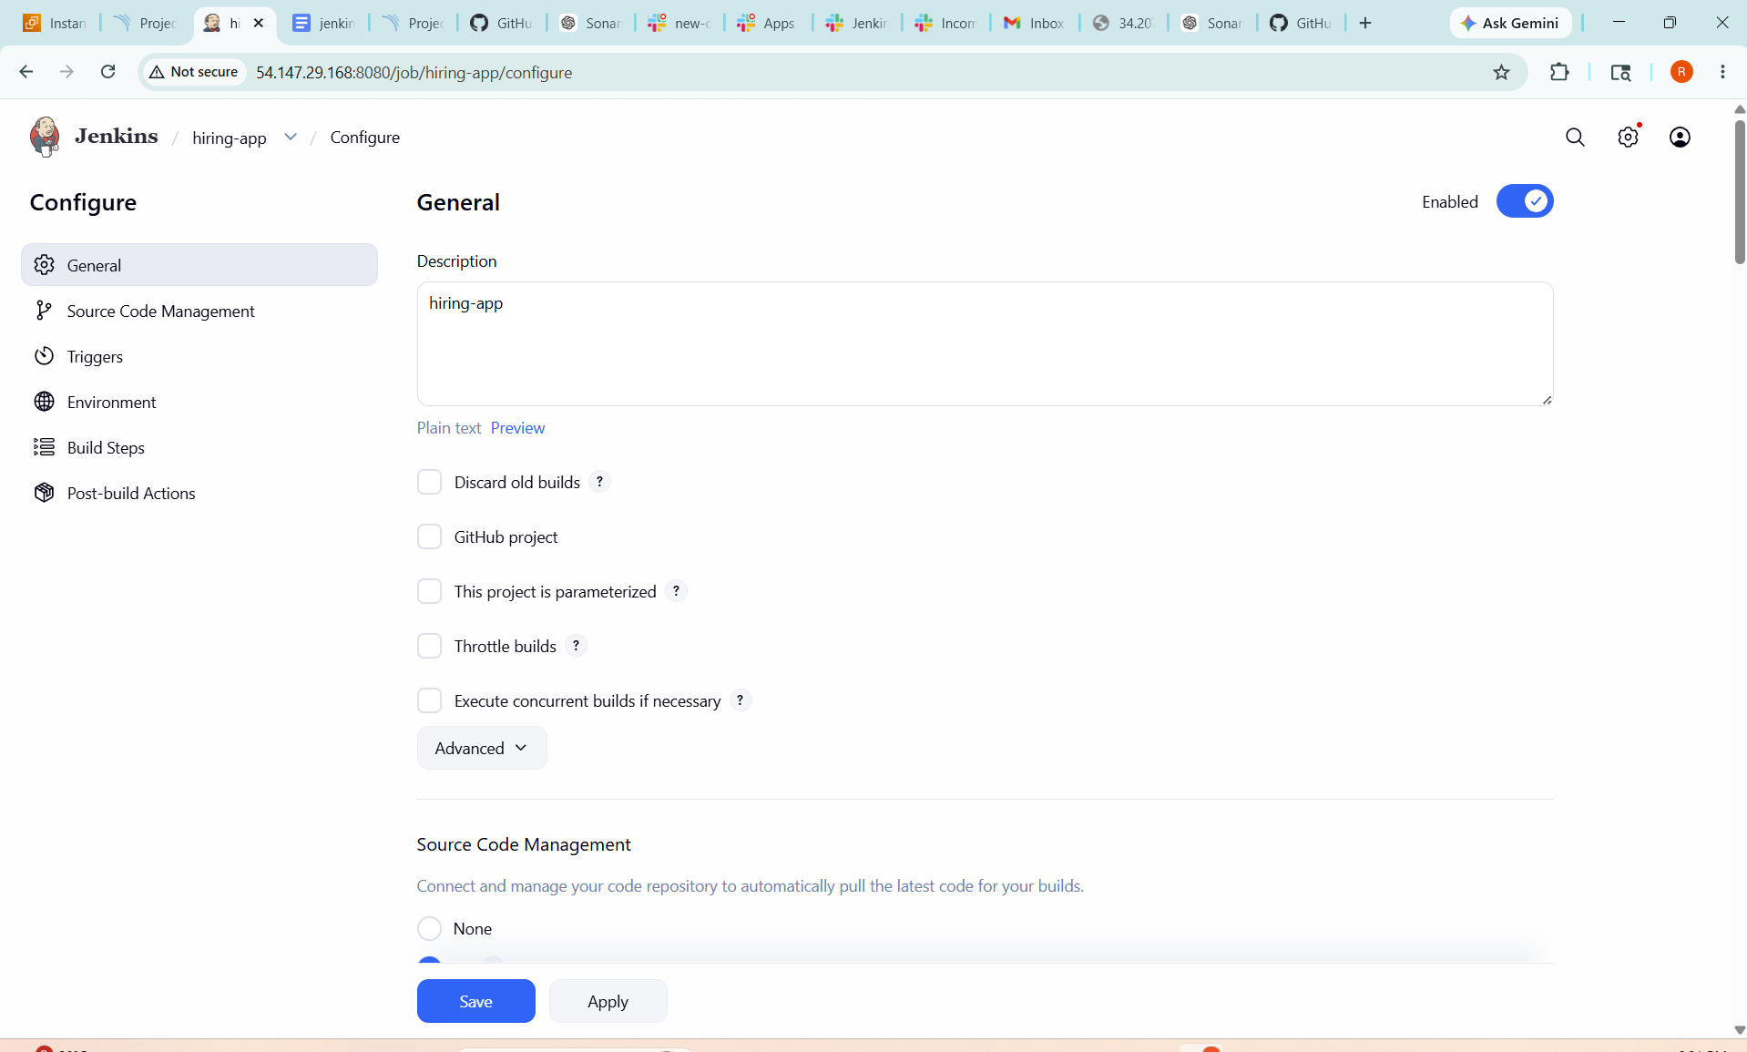

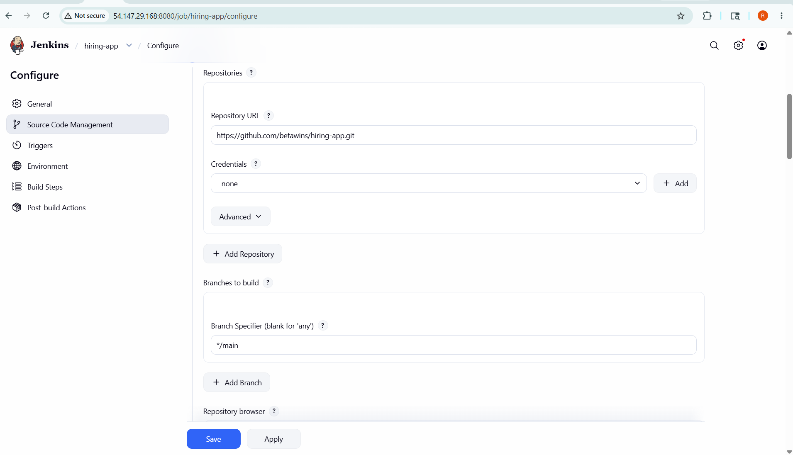

· Open the job → Configure → Build Steps → Add Build Step → Execute SonarQube Scanner
· In the Analysis Properties box, paste the project's sonar settings (from the repository's README.md or from the developer):
sonar.projectKey=Test
sonar.sources=/var/lib/jenkins/workspace/$JOB_NAME/src/

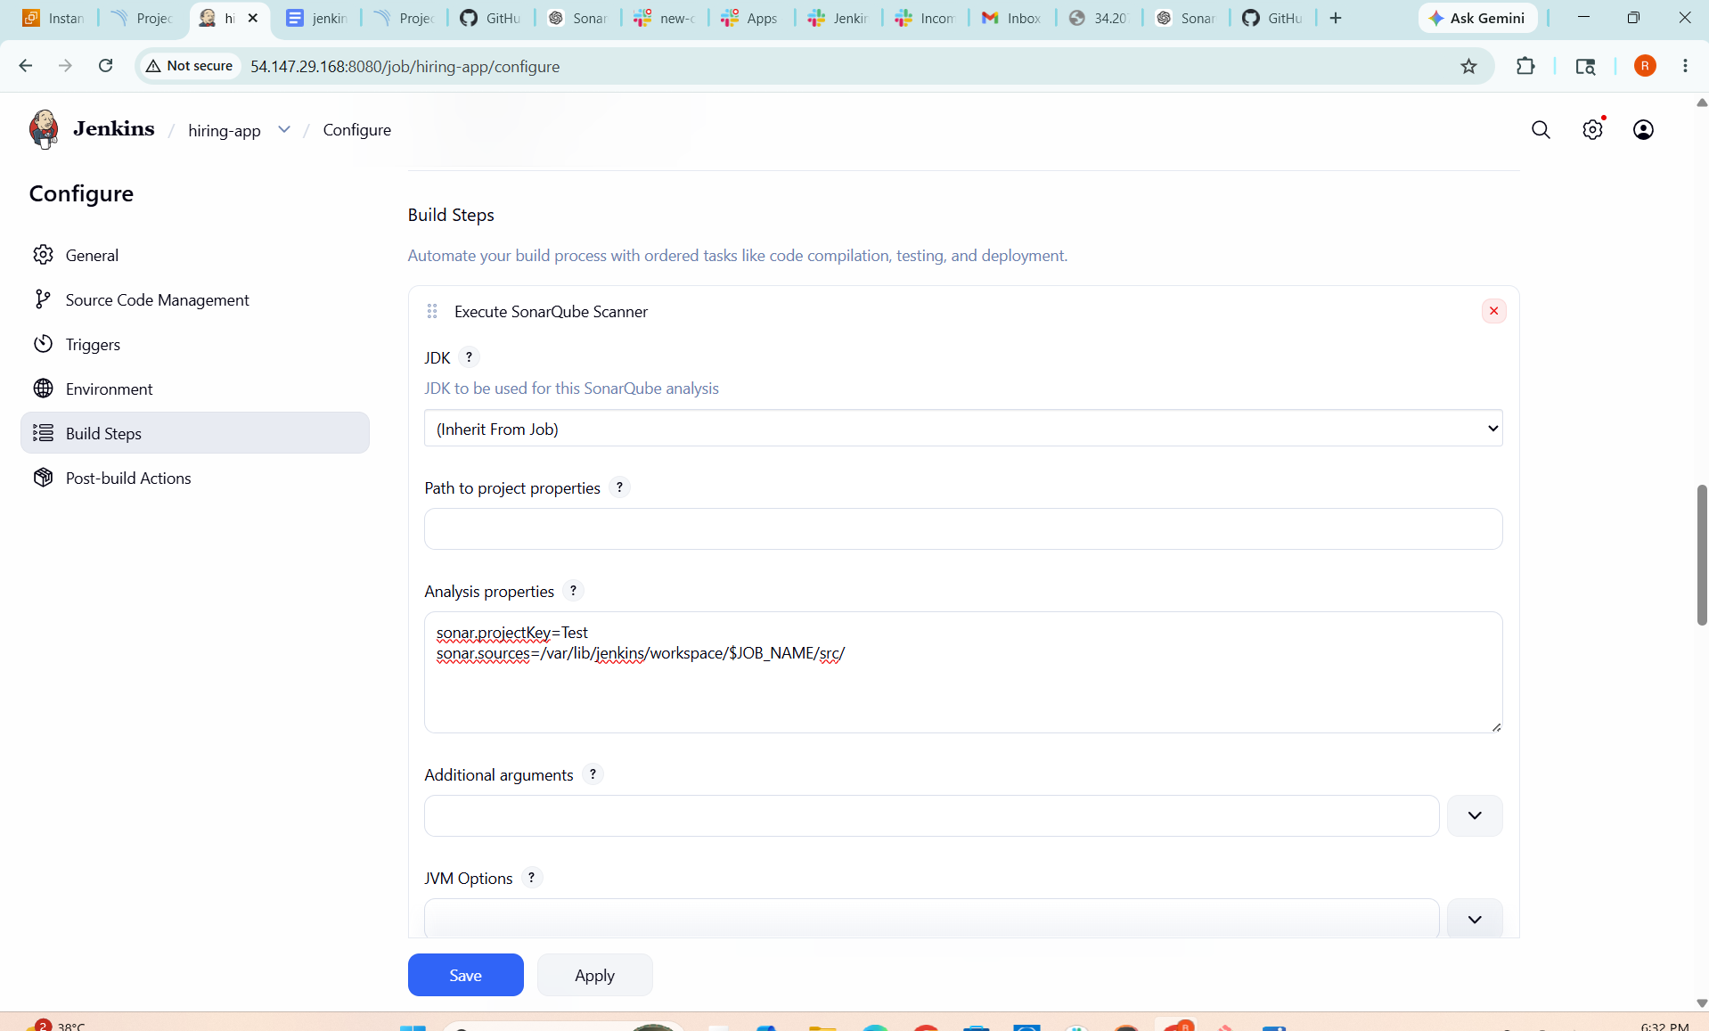

Integrated Slack in Job
In Jenkins job configuration:

Enabled Post-build Actions

Selected Slack Notifications

Chose triggers (Success, Failure, etc.)

Tested Notification
Ran the job and verified that build status messages were successfully sent to Slack channel.

