Task on VPC Transit Gateway & VPC Endpoint

- Create one VPC, with 1 public subnet and 1 private subnet.
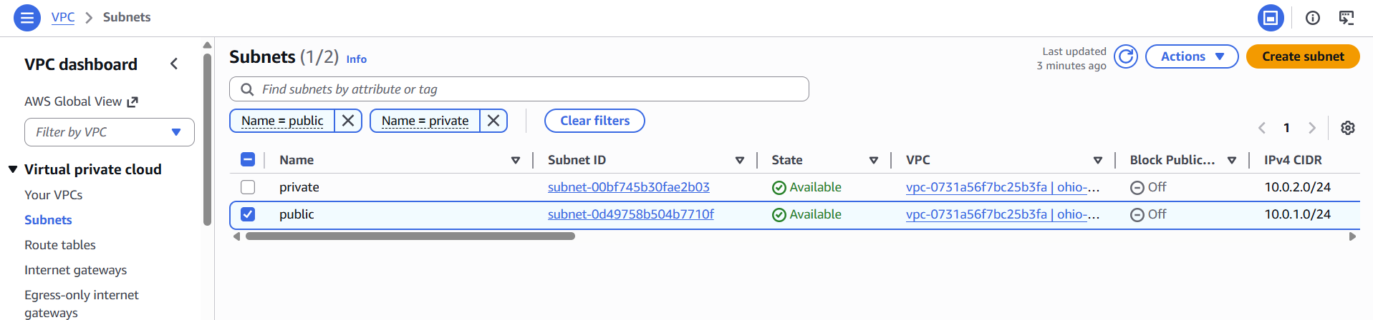

- Created a VPC with CIDR block 10.0.0.0/16
- Created one public subnet (10.0.1.0/24) and one private subnet (10.0.2.0/24)
- Enabled auto-assign public IP for public subnet
- Created and attached an Internet Gateway
- Configured route tables for public and private subnets
- Public subnet has internet access, private subnet is isolated

- Enable VPC peering for cross-region.
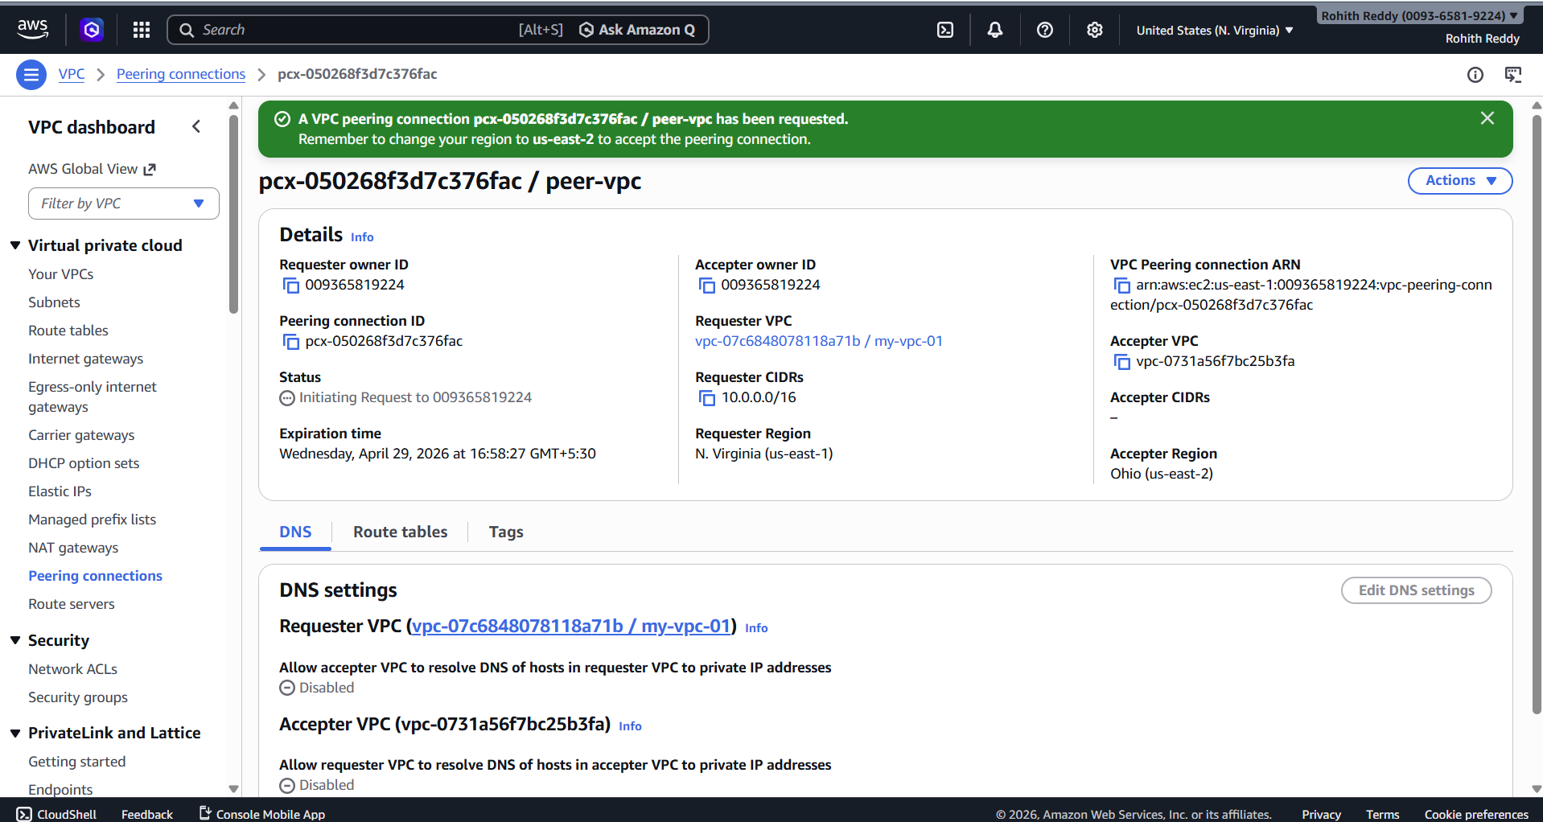

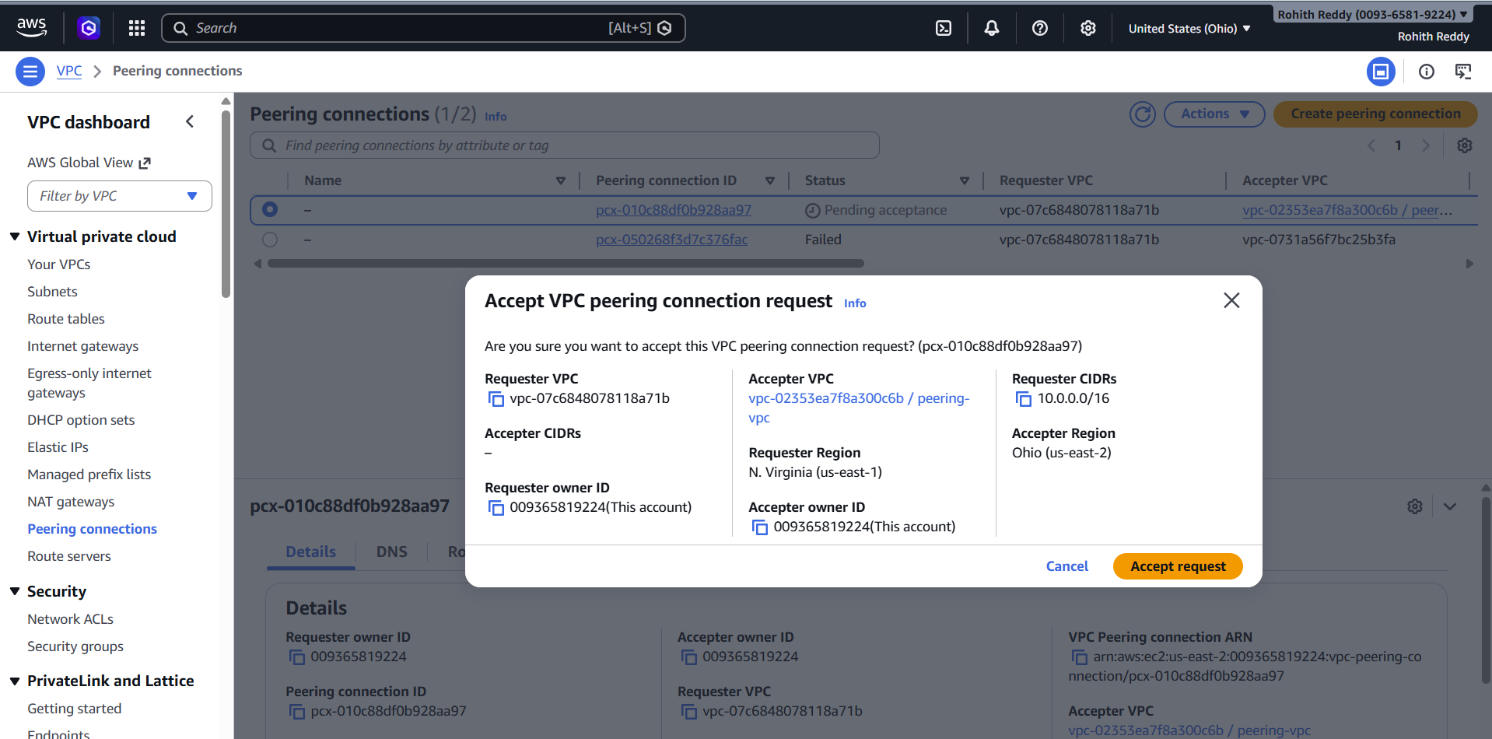

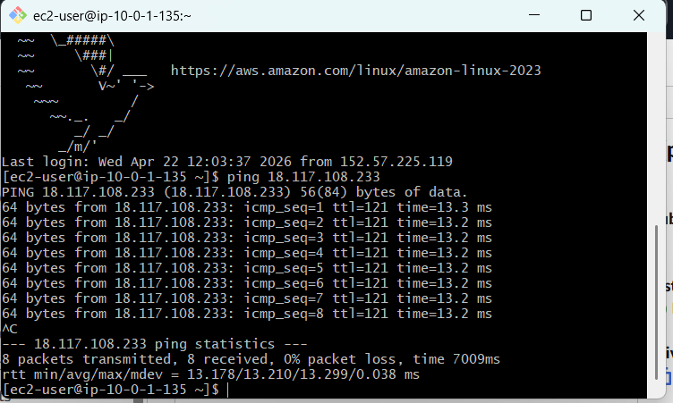

Created a VPC in a different AWS region
Established cross-region VPC peering connection
Accepted the peering request in the peer region
Updated route tables in both VPCs
Configured security groups to allow communication
Verified connectivity between VPCs

- Enable VPC peering for cross-account (you can collaborate with your friend to do this task).

Established VPC peering between two AWS accounts
Created peering request using account ID and VPC ID
Accepted peering request in the peer account
Updated route tables in both accounts
Configured security groups to allow communication
Verified connectivity between instances

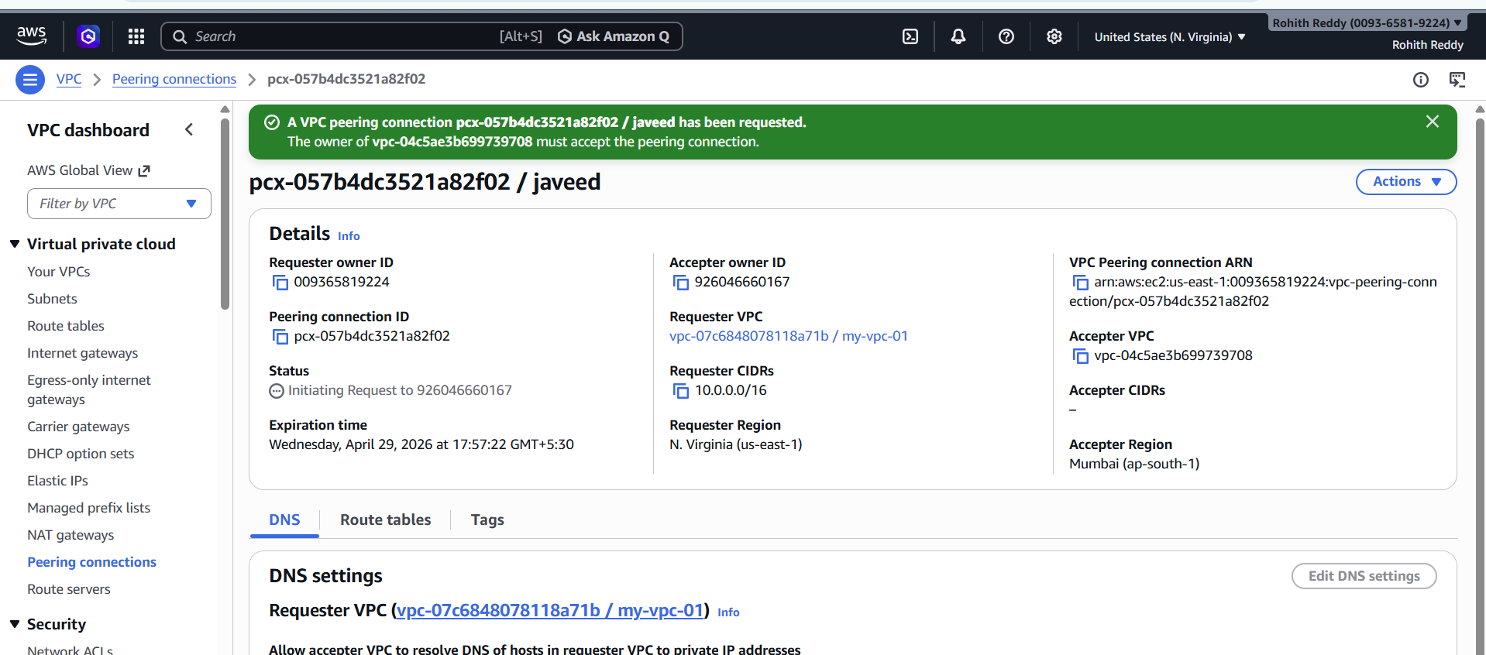

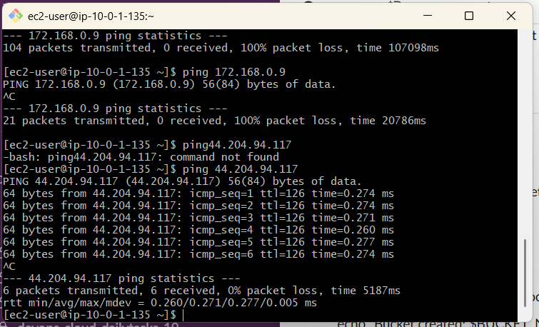

- Set up a VPC Transit Gateway.

Created a Transit Gateway for centralized VPC connectivity
Attached VPCs to the Transit Gateway
Configured Transit Gateway route tables
Updated VPC route tables to route traffic via TGW
Enabled communication between multiple VPCs
Tested connectivity using private IPs
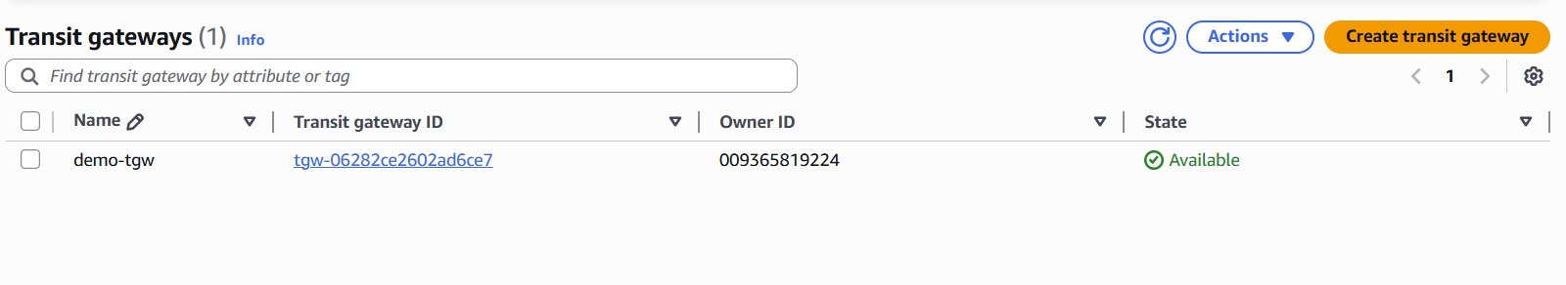

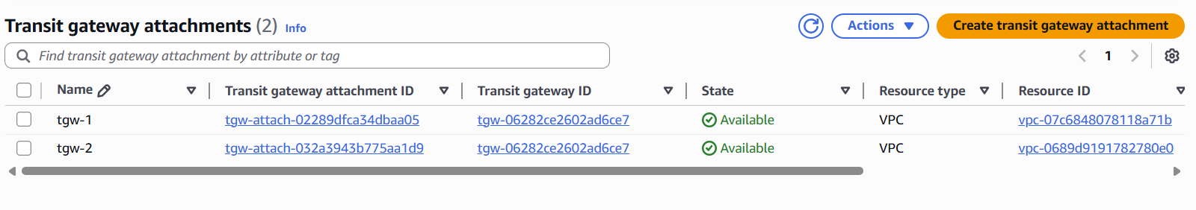

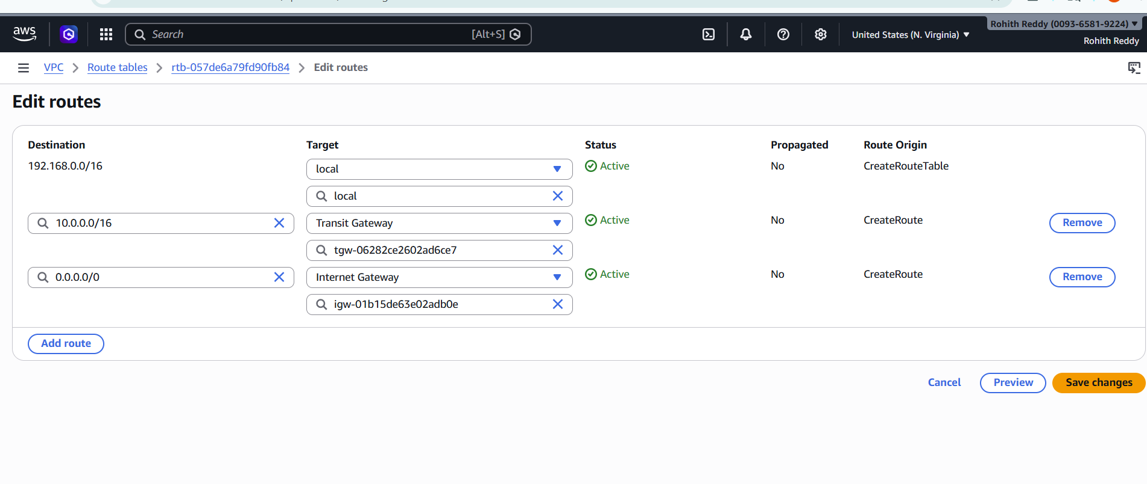

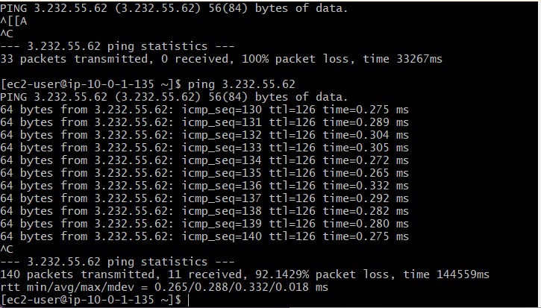

- Set up a VPC Endpoint.
Created a VPC Endpoint for Amazon S3
Configured endpoint within the VPC
Associated endpoint with private route table
Enabled private access to S3 without internet gateway
Verified route table entries for endpoint
Ensured secure communication within AWS network

