NimbusEdge Technologies
Routing Protocol Failures Case Study
Network Outage Incident – March 18, 2024

Introduction
NimbusEdge Technologies experienced a multi-site network outage on March 18, 2024. The incident affected six enterprise clients and lasted approximately 9 hours and 13 minutes, resulting in a breach of the contracted 99.9% availability SLA. Four routing environments were involved: RIP v2 at Chennai HQ, IGRP on the Bengaluru–Pune–Hyderabad regional network, OSPF during the core-backbone migration, and BGP for dual-ISP connectivity.

Q1. RIP v2 — Chennai HQ Campus

a) Understanding of Case
At Chennai HQ, NimbusEdge added a new Delivery department subnet while the campus was using RIP v2. The NOC Change Log records changes for the Delivery subnet and the addition of a temporary VLAN gateway chain. The added gateway path increased the distance to the Delivery subnet beyond RIP’s usable 15-hop limit.
The technical trigger was the Delivery subnet becoming a 16-hop destination. RIP treated that route as unreachable. Because there was no physical link failure and the monitoring system did not adequately monitor silent routing anomalies, the problem was not detected immediately. Client support tickets eventually exposed the connectivity problem.

b) Application of Concepts
RIP uses hop count as its routing metric and supports a maximum of 15 usable hops. The sequence was: the Delivery subnet was introduced; the temporary gateway chain increased the routing distance; the route reached 16 hops; RIP uses metric 16 to represent an unreachable route; the route was therefore not usable for forwarding; and traffic to the Delivery subnet failed.
15 hops → usable route
16 hops → unreachable (RIP infinity)

c) Analysis
The lack of an automatic alert shows a structural monitoring limitation rather than only a human mistake. RIP is a simple distance-vector protocol with a hard 15-hop limit. A route reaching metric 16 can become unreachable without producing a physical interface-down event. The RCA identified a monitoring gap: NimbusEdge monitored link-down events but did not adequately monitor silent route withdrawals, unreachable routes or routing-state failures. Thus the routing problem could remain invisible until users reported it.

d) Solution Design
The preferred long-term solution is to migrate Chennai HQ from RIP v2 to OSPF, together with a clean VLAN/subnet design. If RIP were temporarily retained, the topology would need to keep all destinations within 15 hops, but this would not scale well. RIP was originally reasonable because Chennai HQ was a small and stable campus: it is simple to configure and maintain. However, growth exposed its hop-count limitation. OSPF is more suitable for the growing enterprise design and aligns with NimbusEdge’s broader routing migration.

e) Clarity
Problem: Delivery subnet became a 16-hop RIP destination. Reason: RIP metric 16 means unreachable. Impact: Delivery connectivity failed without an immediate physical-link alert. Recommendation: migrate the campus to OSPF and monitor routing-state changes.

Q2. IGRP — Bengaluru–Pune–Hyderabad Regional Link

a) Understanding of Case
An ISP-side fault degraded the Bengaluru–Pune fiber link. The link experienced reduced effective bandwidth and increased delay. The topology shows a 2 Mbps Bengaluru–Pune link and a healthier regional route involving Pune–Hyderabad. Although an alternate path existed, IGRP continued using the degraded path longer than expected. The business effect was severe application latency rather than an immediate total loss of connectivity.

b) Application of Concepts
IGRP uses a composite metric that can consider bandwidth, delay, reliability and load. Under the traditional default settings, bandwidth and delay are the main active terms.
Bandwidth component = 10,000,000 / bandwidth in kbps.
2 Mbps = 2000 kbps → 10,000,000 / 2000 = 5000.
8 Mbps = 8000 kbps → 10,000,000 / 8000 = 1250.
Thus, the 8 Mbps link has a better bandwidth component. Increased delay on the degraded Bengaluru–Pune link would further worsen its composite metric. The case does not provide exact delay values for every link, so an exact end-to-end composite metric should not be invented.

c) Analysis
This incident is primarily a convergence/reconvergence problem rather than a failure of the IGRP metric concept itself. IGRP can respond to bandwidth and delay changes, but the updated information must be calculated, propagated and acted upon quickly. The RCA specifically identifies metric recalculation lag and slow propagation of route updates. Therefore, routing decisions did not change quickly enough to match the real-time degradation.

d) Solution Design
NimbusEdge should migrate the regional segment to OSPF as part of its wider routing modernization. OSPF provides faster convergence, link-state information, hierarchical design and better scalability. IGRP was originally more capable than RIP for this regional network because it considered a richer composite metric rather than only hop count. However, the incident demonstrated that a sophisticated metric does not guarantee fast convergence.

e) Clarity
2 Mbps link bandwidth component = 5000. 8 Mbps link bandwidth component = 1250. Lower metric is preferred, and increased delay makes the degraded path less attractive. Recommendation: move the regional routing design toward OSPF and validate convergence after major changes.

Q3. OSPF — Core Backbone Migration

a) Understanding of Case
NimbusEdge was migrating the core backbone to a multi-area OSPF design. The NOC Change Log records a March 8 OSPF change for the Core Backbone–Hyderabad segment. During the migration, the Hyderabad router was configured with an incorrect OSPF Area ID. The incorrect Area ID prevented the expected OSPF adjacency from forming with the Chennai backbone router. Because the physical link remained up, normal link-state monitoring did not immediately identify the routing failure. The result was a routing black hole affecting Hyderabad until the configuration was corrected.

b) Application of Concepts
OSPF neighbor formation requires agreement on important interface parameters, including Area ID, Hello and Dead intervals, authentication where configured, and network/subnet information. In this incident, the critical violated requirement was the Area ID.
Before: Chennai backbone = Area 0; Hyderabad = incorrect Area ID; adjacency does not form.
After: Chennai backbone = Area 0; Hyderabad = intended regional Area 3; adjacency can form and routing information can be exchanged.

c) Analysis
The fault was harder to detect than a physical link failure because the interface could remain physically UP while OSPF was unable to form a neighbor relationship. Physical failure produces an interface-down event; this routing failure produced a live link with no usable OSPF adjacency. The RCA also identified a process gap: insufficient change validation and peer review during concurrent migration and onboarding activity allowed a transcription error to reach production.

d) Solution Design
Technical fix: correct the Hyderabad router’s Area ID and verify the OSPF neighbor relationship, learned OSPF routes and end-to-end reachability. Suggested verification objectives are to check the Area ID, confirm the neighbor reaches FULL state, verify expected OSPF routes, and perform ping/traceroute tests.
Process safeguard: use peer review and an OSPF migration checklist covering Area ID, Hello/Dead timers, authentication, subnet mask, neighbor state and end-to-end connectivity. Multi-area OSPF is justified because it provides fast convergence, hierarchical scalability, link-state accuracy and better control for a multi-site enterprise network.

e) Clarity
Before: Chennai backbone Area 0; Hyderabad incorrect Area ID; adjacency not formed; routing black hole. After: Chennai backbone Area 0; Hyderabad correct regional Area ID; adjacency reaches FULL; routing information is exchanged normally.

Q4. BGP — ISP Peering and Failover

a) Understanding of Case
NimbusEdge used ISP-A as the primary external connection and ISP-B as the secondary connection. During the incident, the ISP-A link failed. The expected behaviour was for BGP to stop using the failed ISP-A path and select the available ISP-B path. Instead, the expected automatic failover did not occur. A senior engineer had to manually force traffic toward ISP-B. The RCA attributes the failure to a LOCAL_PREF/AS-PATH policy problem that had not been tested end-to-end for a live failover scenario.

b) Application of Concepts
LOCAL_PREF is used within an autonomous system to influence outbound path selection; a higher LOCAL_PREF is normally preferred. AS-PATH length also influences BGP route selection, while MED can influence path selection in appropriate interconnection scenarios. The likely policy problem was that the preferred-path policy did not produce the intended change when ISP-A failed. The RCA specifically identifies LOCAL_PREF/AS-PATH policy as the problem. MED should not be treated as the main mechanism for local outbound failover between unrelated ISPs.

c) Analysis
BGP failover is especially important because it controls connectivity between autonomous systems and can affect the organization’s entire external connectivity. An untested BGP policy is risky because a configuration can be syntactically valid but operationally wrong. The failure chain was: untested policy → ISP-A failure → automatic failover fails → external connectivity is disrupted → client services are degraded/unavailable → prolonged incident impact → 99.9% SLA breach → formal client escalation and SLA breach notice.

d) Solution Design
NimbusEdge should configure ISP-A as the preferred normal path and ISP-B as the lower-preference backup. When ISP-A becomes unavailable, its routes should be withdrawn or become unusable so that BGP selects ISP-B. Conceptually: ISP-A = higher LOCAL_PREF; ISP-B = lower LOCAL_PREF. On ISP-A failure, the ISP-A path becomes unavailable and ISP-B is selected.
The exact vendor-specific commands and AS numbers are not provided in the case, so they should not be invented. NimbusEdge should perform a quarterly BGP failover test during a controlled maintenance window, verifying primary preference, deliberate ISP-A failure, route withdrawal, ISP-B selection, end-to-end connectivity and restoration. BGP is correct for dual-ISP redundancy because it is the inter-domain routing protocol used between autonomous systems.

e) Clarity
Before: ISP-A primary; ISP-B backup; ISP-A fails; policy does not automatically select ISP-B; manual intervention is required. After: ISP-A high preference; ISP-B lower preference; ISP-A fails; ISP-A path becomes unavailable; ISP-B is automatically selected.

Overall Conclusion
The NimbusEdge outage was a cascading incident involving four different routing environments. RIP v2 failed when the Delivery subnet reached metric 16; IGRP reconverged too slowly after regional-link degradation; an incorrect OSPF Area ID prevented the Hyderabad adjacency; and an untested BGP failover policy prevented automatic movement to ISP-B. The incident shows that protocol selection, configuration validation, monitoring of routing state, peer review and regular failover testing must work together.
Segment | Protocol | Main Failure | Impact
Chennai HQ | RIP v2 | 16-hop route treated as unreachable | Delivery subnet inaccessible
Regional links | IGRP | Slow metric/reconvergence after degradation | Severe application latency
Core backbone | OSPF | Incorrect Area ID prevented adjacency | Hyderabad routing black hole
ISP peering | BGP | Untested LOCAL_PREF/AS-PATH failover policy | ISP-A failure did not automatically move traffic to ISP-B

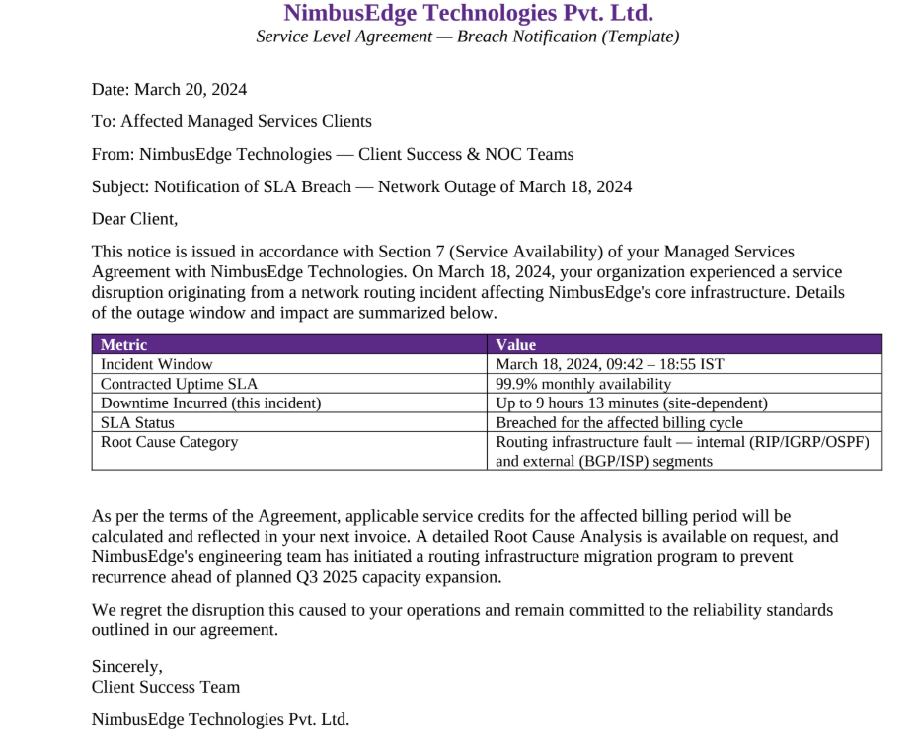

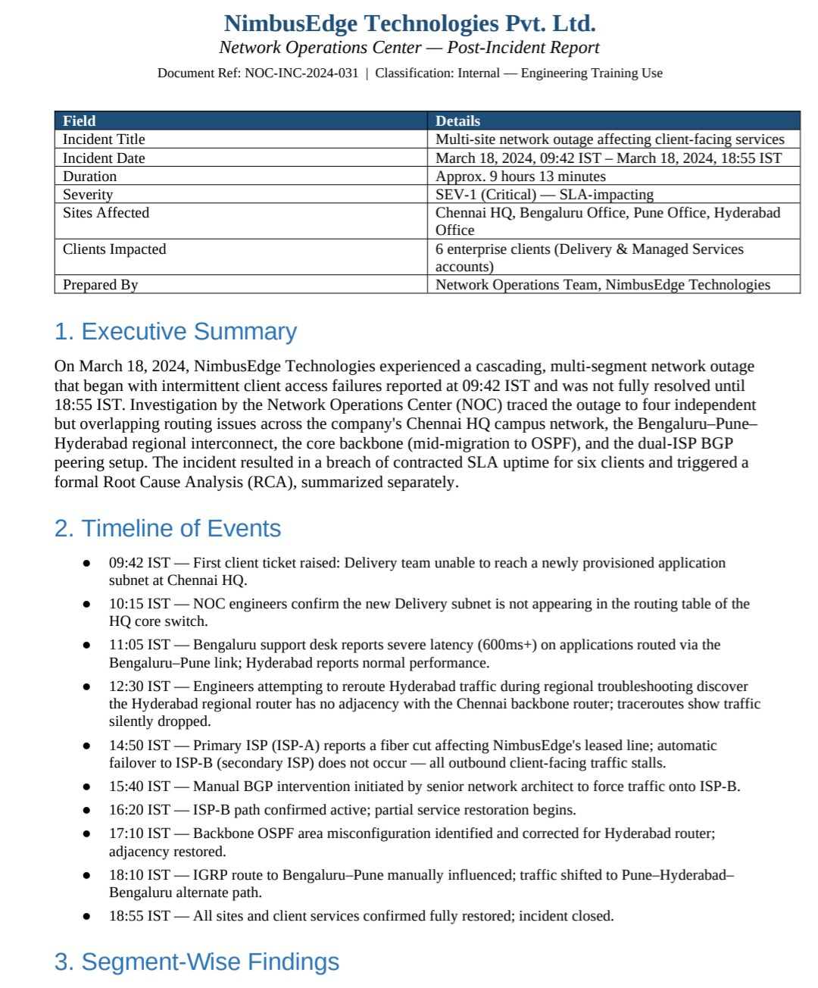

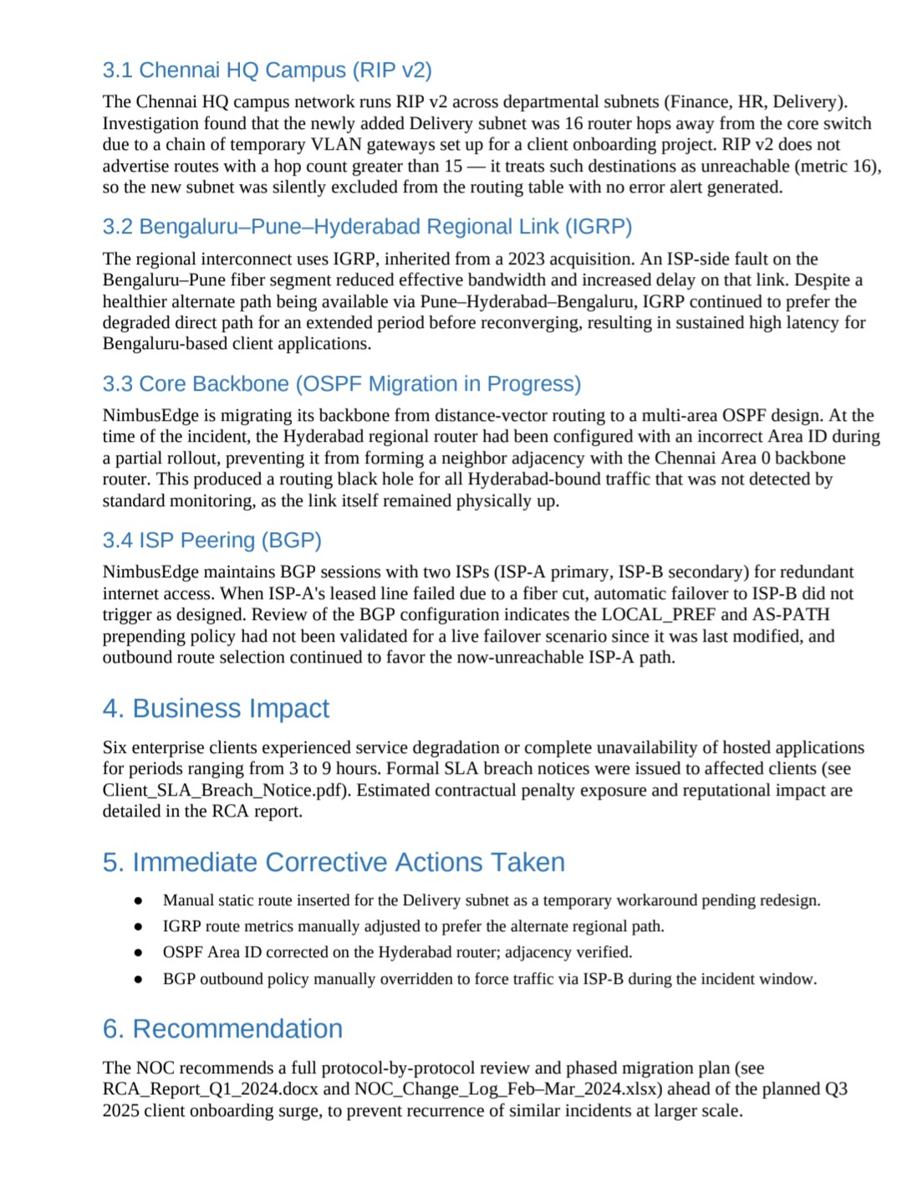

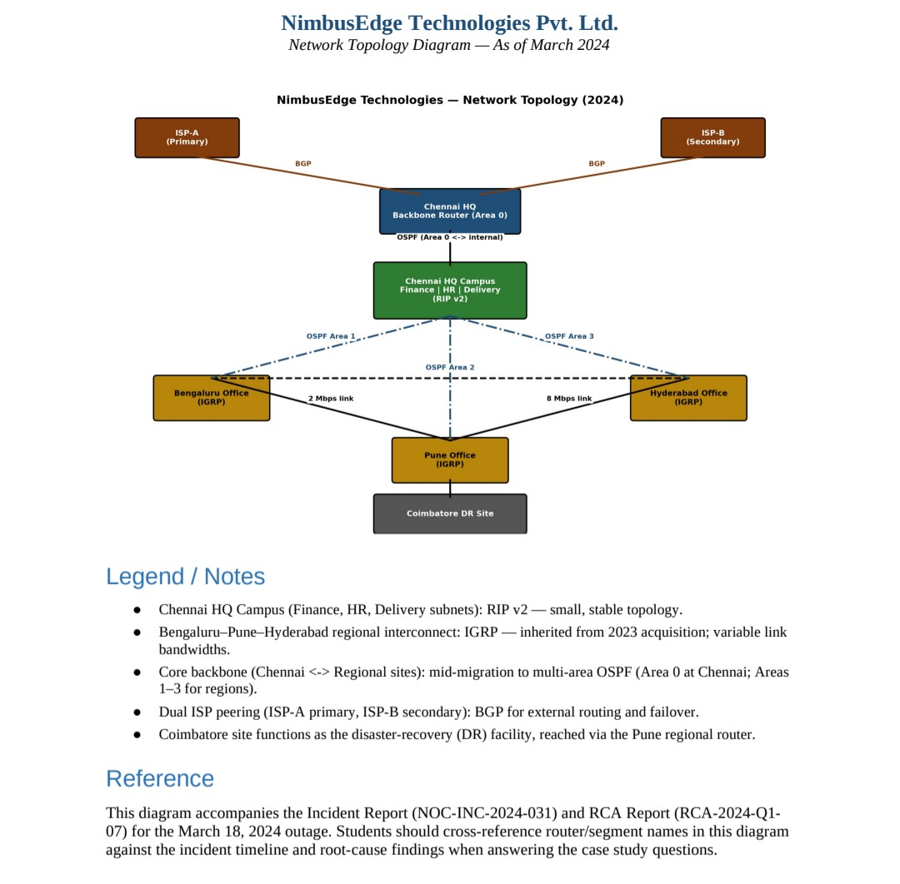

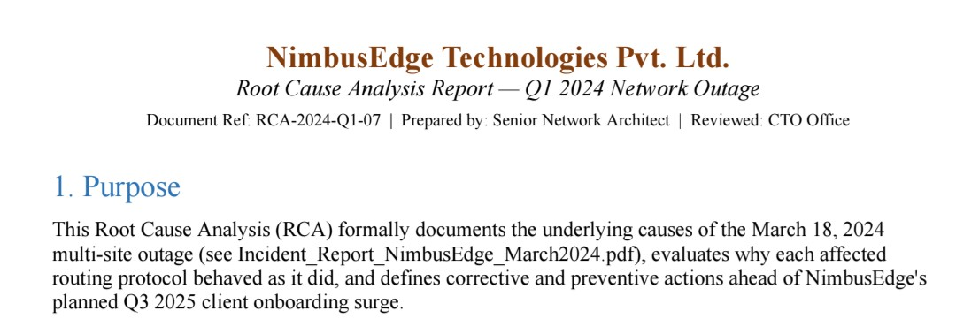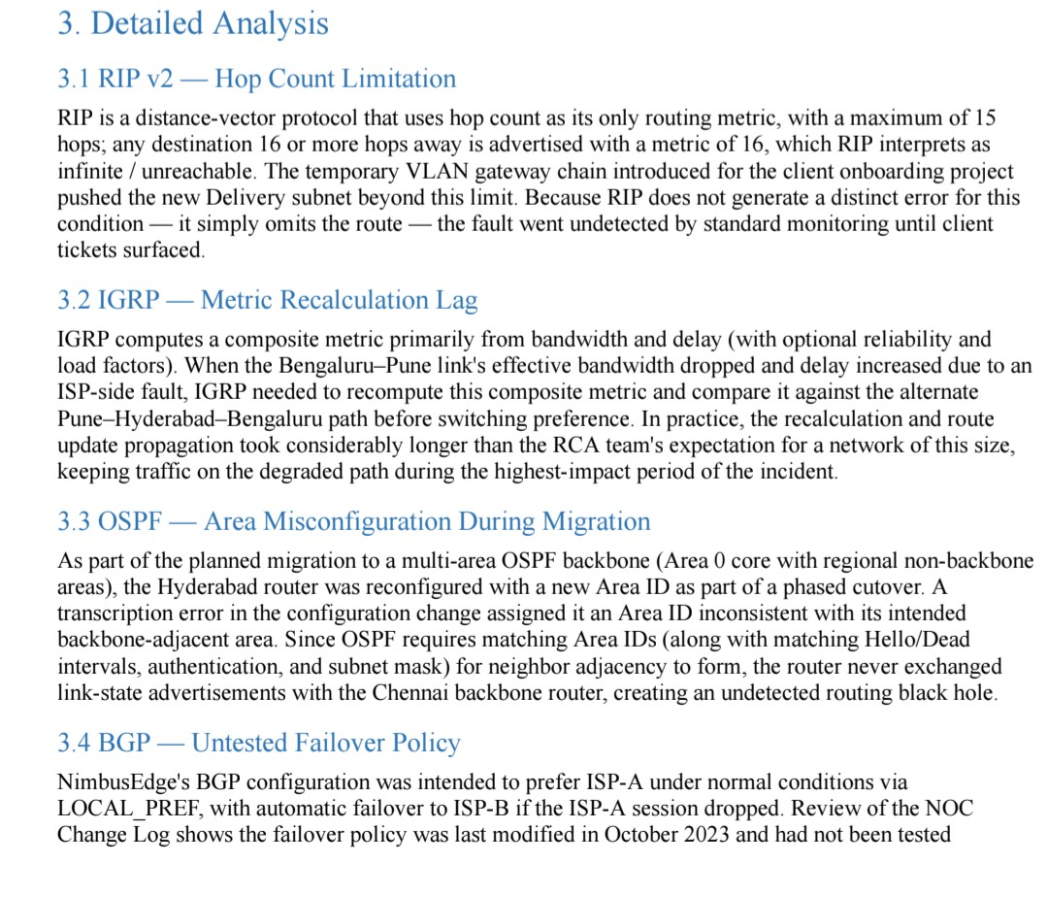

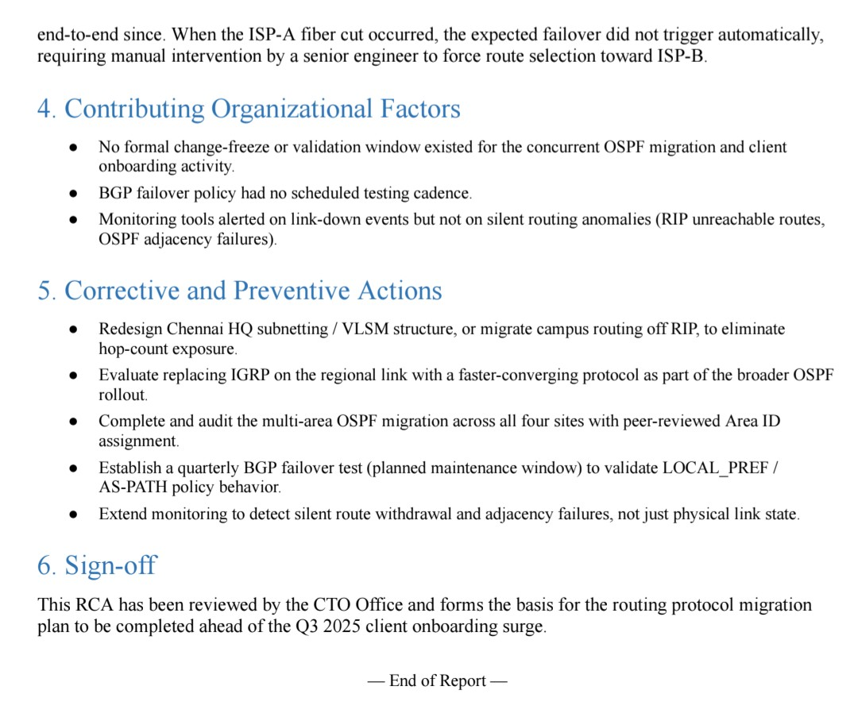

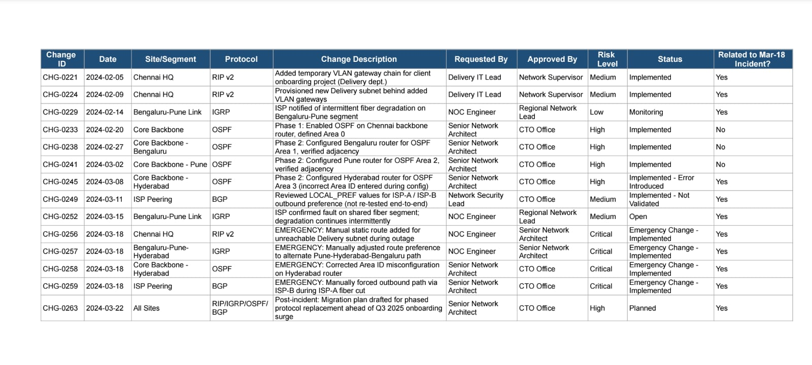

Questions:
Q1. RIP — Chennai HQ Campus
a) Understanding of Case (25): Referring to the Incident Report and NOC Change Log, summarize
what happened to the Delivery department subnet in March 2024. Identify all the key issues involved —
the change that caused it, the specific technical trigger, and why it went undetected until client tickets
were raised.
b) Application of Concepts (25): Apply RIP v2&#39;s hop-count and convergence rules to explain, step by
step, exactly why the 16-hop Delivery subnet was excluded from the routing table. Reference the
specific metric value RIP assigns to an unreachable route.
c) Analysis (20): Analyse why this fault produced no automatic alert, and what this reveals about a
structural limitation of distance-vector protocols like RIP (as opposed to a one-off human error).
Connect this to the monitoring gap noted in the RCA report.
d) Solution Design (20): Propose a solution — either a redesigned addressing/subnetting scheme that
keeps all subnets within RIP&#39;s hop limit, or a justified protocol alternative. Explain why your solution is
feasible for NimbusEdge&#39;s Chennai HQ specifically, and justify why RIP was a reasonable original
choice for this segment (small, stable campus network) even though it failed here.
e) Clarity (10): Present your answer with clear structure — a brief problem statement, your technical
reasoning, and your recommendation, each clearly separated.

Q2. IGRP — Bengaluru–Pune–Hyderabad Regional Link
a) Understanding of Case (25): Referring to the RCA Report and Network Topology Diagram,
summarize the sequence of events on the regional link — the ISP-side fault, the available alternate path,
and the business impact (latency) that resulted.
b) Application of Concepts (25): Apply IGRP&#39;s composite metric formula (bandwidth and delay) to the
link conditions given (2 Mbps Bengaluru–Pune vs. the healthier Pune–Hyderabad–Bengaluru alternate).
Show how IGRP should have recalculated preference toward the alternate path.
c) Analysis (20): Analyse why IGRP&#39;s actual reconvergence lagged the real-time link degradation.
Distinguish between a metric-calculation issue and a convergence-speed issue, and explain which one
this incident represents, with reasoning.
d) Solution Design (20): Propose a solution — tuning IGRP parameters, or migrating this segment to a
faster-converging protocol — and justify your choice against NimbusEdge&#39;s regional network scale.
Explain what advantage IGRP was originally expected to provide over RIP here, and why that advantage
failed under real conditions.
e) Clarity (10): Structure your answer with a clear metric calculation (shown explicitly), followed by
reasoning and recommendation.

Q3. OSPF — Core Backbone Migration
a) Understanding of Case (25): Referring to the Network Topology Diagram, Incident Report, and
NOC Change Log, identify exactly which configuration change caused the Hyderabad router&#39;s adjacency
failure, and trace how this created a routing black hole undetected by standard monitoring.
b) Application of Concepts (25): Apply OSPF&#39;s neighbor adjacency requirements (matching Area ID,
Hello/Dead intervals, authentication, subnet mask) to pinpoint which requirement was violated and how
that specific mismatch prevents adjacency formation.
c) Analysis (20): Analyse why this fault was harder to detect than a physical link failure. Evaluate the
organizational/process gap (e.g., absence of change validation) identified in the RCA that allowed a
single transcription error to go live.
d) Solution Design (20): Propose both a technical fix (correct Area ID assignment/verification
procedure) and a process-level safeguard (e.g., peer review, adjacency verification checklist) to prevent
recurrence. Justify why NimbusEdge is migrating to multi-area OSPF in the first place — what specific
benefits (fast convergence, hierarchical scalability, link-state accuracy) it offers over the RIP/IGRP
setup it replaces.
e) Clarity (10): Use a clear before/after description of the router&#39;s configuration state, supported by
reference to the topology diagram.

Q4. BGP — ISP Peering and Failover
a) Understanding of Case (25): Referring to the RCA Report and Client SLA Breach Notice,
summarize the ISP-A failure event, the expected failover behaviour, and what actually happened,
including the manual intervention required.
b) Application of Concepts (25): Apply BGP path attribute concepts (AS-PATH, LOCAL_PREF,
MED) to identify the likely policy misconfiguration that prevented automatic failover to ISP-B.
c) Analysis (20): Analyse why an untested failover policy is a higher risk in BGP specifically compared
to interior protocols, and evaluate the business consequence chain from this single policy gap to the
formal SLA breach notice issued to clients.
d) Solution Design (20): Propose a corrected BGP policy configuration that ensures automatic failover,
and a testing/validation cadence to prevent this recurring. Justify why BGP — rather than an interior
gateway protocol — is the necessary and correct choice for NimbusEdge&#39;s dual-ISP redundancy
architecture.
e) Clarity (10): Present the failover logic clearly, ideally with a simple before/after policy comparison.

