Mini Project: RAG-Based Conversational QA Bot using Flowise

📌 Overview
This mini project demonstrates how to build a Retrieval-Augmented Generation (RAG) based conversational question-answering system using Flowise. The solution enables users to upload structured documents (Excel) and query them through a chatbot interface powered by embeddings and vector search.

📌 Objective
To design and implement a lightweight RAG workflow that:
- Converts Excel-based FAQs or knowledge into vector embeddings
- Stores embeddings in a vector database
- Retrieves relevant chunks based on user queries
- Generates accurate responses using an LLM

📌 Tech Stack
- Flowise AI
- Conversational Retrieval QA Chain
- Hugging Face Inference Embeddings
- Upstash Vector Store
- Recursive Text Splitter
- Excel Document Loader

📌 Architecture Flow
User Query → Embedding Search → Relevant Chunk Retrieval → LLM Response

📌 Implementation Steps

Step 1: Choose the Chat Model
Select an appropriate chat model within Flowise to handle natural language queries.
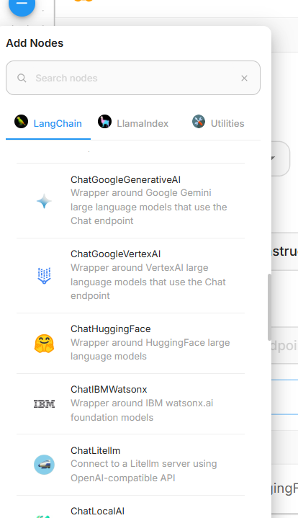
Step 2: Configure Conversational Retrieval QA Chain
Use the Conversational Retrieval QA chain to combine document retrieval with conversational context handling.

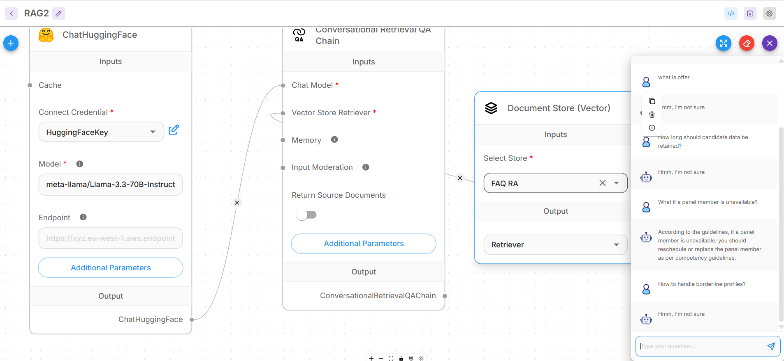
Step 3: Create Document Store Workflow
- Create a document store and assign a name
- Add a document loader and select Excel (MS Excel)

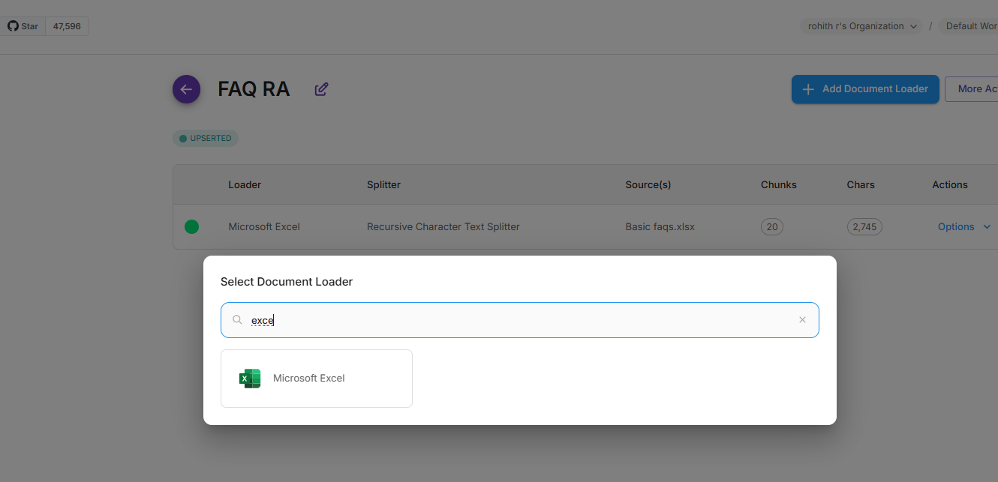

Step 4: Upload the Excel File
Upload the Excel file containing FAQs or recruiting-related knowledge.
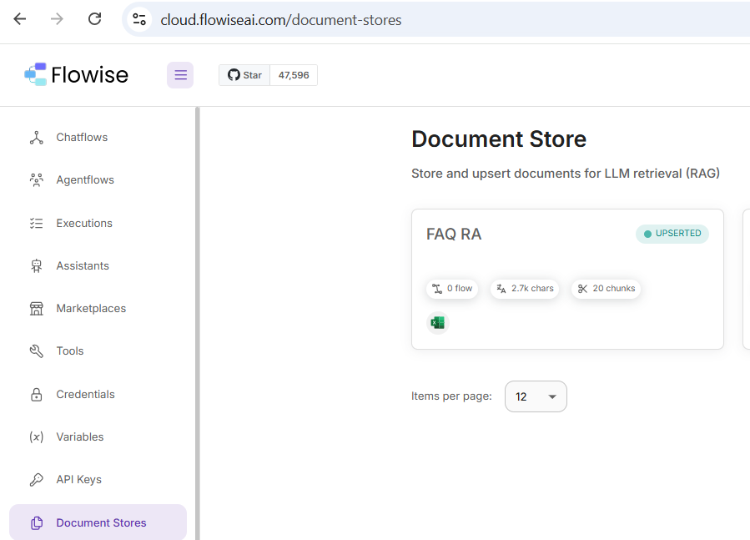
Step 5: Configure Text Splitter
- Choose Recursive Text Splitter
- Chunk size: 400
- Overlap: 50
This ensures optimal context retention while staying within free-tier limits.

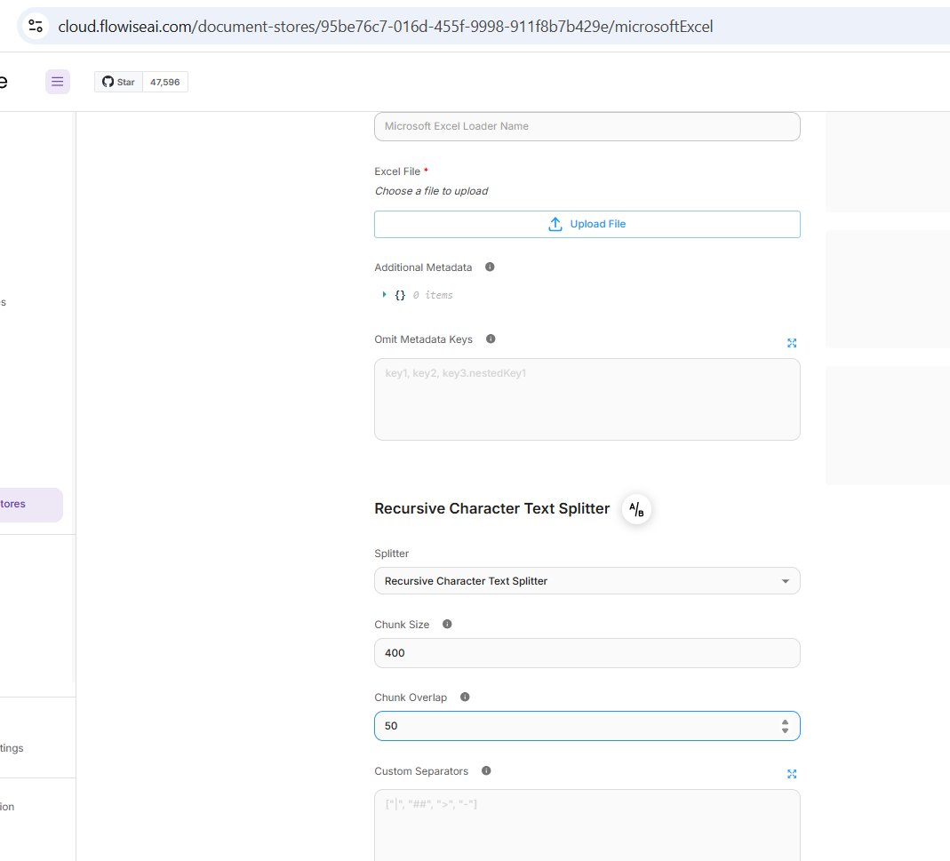
Step 6: Upsert Chunks into Vector Store
- Select Hugging Face Inference Embeddings
- Configure Upstash Vector Store credentials
- Upsert document chunks into the vector database
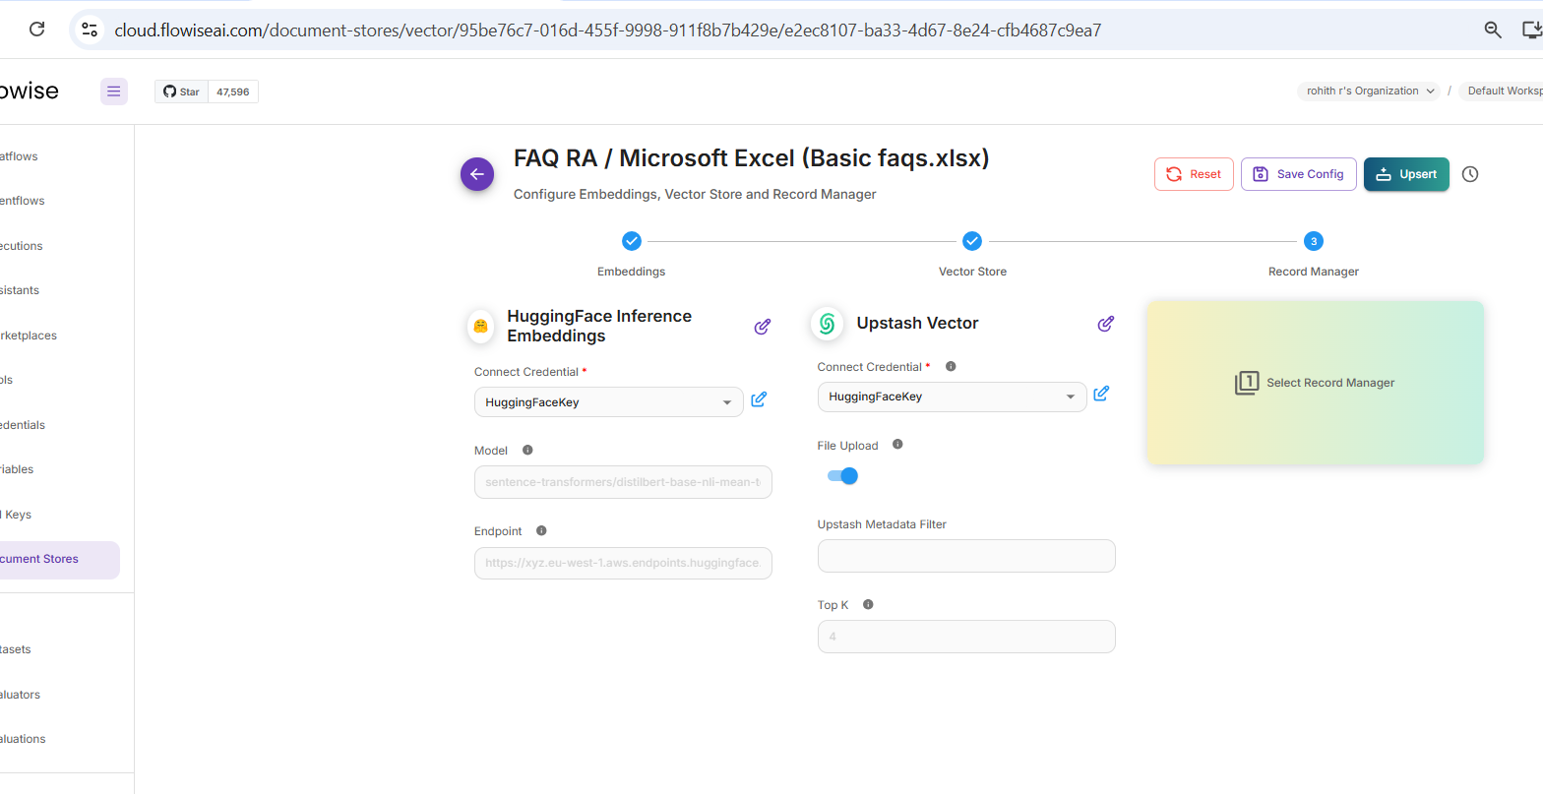
Step 7: Connect Components
Link the document store, retriever, QA chain, and chat model.

Step 8: Test the Bot
Ask questions related to the uploaded data. The bot retrieves relevant context and responds accurately.

📌 Key Use Cases
- ATS / HRIS functional support bot
- Internal knowledge base assistant
- FAQ automation
- L1/L2 support reduction

📌 Outcome
This project showcases a practical, low-cost RAG implementation suitable for enterprise support scenarios. It highlights how structured data can be transformed into an intelligent conversational assistant with minimal setup.

