Analyzing and Improving Business Performance from Purchase and Sales patterns for Northwind traders

Rohith Vaddepally

TABLE OF CONTENTS
1. Abstract 4
2. Introduction 4
3. Literature Review 5
3.1 Business Intelligence and Analytics use 5
3.1.1 Related Study 5
3.2 Statistical Hypothesis Testing 7
3.1.2 Related Study 8
4. Hypothesis Development 9
5. Research Methodology 11
5.1 Data Collection 11
5.2 Data Exploration & Extraction 11
5.3 Data Pre-Processing 13
5.3.1 DATE Table 13
5.3.2 Calculated Columns 14
5.3.3 Measures 15
5.4 Data Modelling 15
5.5 Data Analysis and Visualizations 16
5.6 Hypothesis Testing 22
5.6.1 Choosing the right statistical test 22
5.6.2 Two Sample T-test 23
5.6.2 (a) Data for Testing 23
5.6.2 (b) Calculating Mean and Mean difference 24
5.6.2 (c) Data Normality 25
5.6.2 (d) Hypothesis construction & Testing 26
5.6.3 One-way ANOVA test 28
5.6.3 (a) Data for Testing 29
5.6.3 (b) Distribution plot and Quantile plot 30
5.6.3 (c) Hypothesis construction & Testing 30
5.7 Ethics 32
6. Statistical Analysis and Results 32
7. Conclusions 34
8. References 38
9. Appendix 41

1. Abstract
This Academic research paper discusses the application of Data Analytics and Hypothesis testing to improve the business performance for the Northwind traders. Data Analytics in business i.e., Business Analytics aims to provide data and other information on the company’s business operations, which are used to improve performance and make strategic decisions (Online Manipal, 2022). Technological tools like MySQL, Microsoft power BI and programming languages like Python and Structured query language (SQL) is used to improve the performance of Northwind traders which is a fictitious company which contains the sales and purchase data. The database is found on a website called Geeks Engine which was later imported into MySQL tool (Geeks Engine, 2023).
This paper begins by introducing Northwind traders and its challenges in managing its data which include purchase and sales orders, inventory, customer, and employee information. This project presents the data analytic techniques in to get the insights into its operations. Firstly, SQL is used to extract the tables in the form of different queries from the database, and directly imported into the Power BI through a localhost connection for creating the visualizations and business intelligence dashboards. Advanced analytics are carried out in Jupyter notebook using Python programming language, including Hypothesis Testing. Hypothesis testing is a statistical technique used to validate the assumptions or hypotheses. Two Sample T-test and One-way ANOVA Tests are done on different hypotheses related to sales, profit, and product cost. The results can lead to significant improvements in efficiency, profitability and reduce costs.

2. Introduction
As the world becomes smarter and bigger especially in the business world, handling data at different levels is an advantage to the business and applying analytics and statistics to it can increase the ability to compete with the others. There are no standard questions that company could ask itself without knowing what is happening inside. But a company understanding their customer buying patterns, sales and purchase transactions could be a great place to start to improve the business performance. Business using data will see $430 billion in productivity benefits over competitors who are not using the data (Marr, 2021). Applying analytics will result in the good insights and companies making better statistical decisions. Data Analytics and statistical analysis can strengthen the business in supply chain management (Gunasekaran et al., 2017), customer relationship management (Phillips-Wren and Hoskisson, 2015) and in marketing unit firms (Sáenz, Ortiz de Guinea and Peñalba-Aguirrezabalaga, 2022). This project and this research paper discusses and improvements in the business for the Northwind Traders which is a food distributing company.
Food industry is the fastest growing business sector in the world. Applying Data Analytics and statistical decision making into it can improve supply chain transparency (Sykes, 2019) and this project discusses this with the Data Analytics and statistics. Data Analytics can impact the food distributing company at different levels like product promotion, pricing of the products, Forecasting of the revenue generated, and analysing the company’s trends.
The main research question (or) the purpose of this study is how to improve business performance by analysing the sales and purchase patterns for the Northwind Traders. Northwind is a fictitious company which contains the sales and purchase data. The database is found on a website called Geeks Engine which was later imported into MySQL tool (Geeks Engine, 2023). Although the entire idea is to improve the business for the Northwind Traders, this research focusses on the following research questions. Such as:
- Data Analysis with Microsoft Power BI:

- What are Total Gross sales, Total Net sales, and % Profit Margin by each year, quarter, month, week, and weekday in the years 2020, 2021, and 2022?
- Who are the top ten customers in terms of their Net sales, Profit, and % profit margin?
- What is top Category Gross sale value and Product Gross sale value?
- Which Category has the highest Net sales and Profit and what is the value of it?
- What are the countries which has highest number of orders and revenue generated from them in all three years?
- Which cities are most affecting the highest profit generated countries?
- Do the orders play a pivotal role in generating more revenue for the company?
- What are working department and employee statistics monthly in the company?
- Is it the employees operating from the USA processing more orders and generating more revenue or the employees operating from the UK?
- What are the comparison statistics of the current period and previous period at the same time?
- Where would the company be in the next three years in terms of orders, sales, and profit? Or forecasting for the next three years.
Hypothesis testing (HT) is a very powerful statistical technique which can make data driven decisions after the Exploratory Data Analysis (EDA). The real value of Hypothesis Testing in business is that it allows professionals to test their theories and assumptions before putting them into actions (Stobierski, 2021). The best part of the Hypothesis testing is to make assumptions according to the business requirements as Null Hypothesis (H₀) and Alternate Hypothesis (H_{a}) and derive conclusions from them. At this point the business would stand only on these hypotheses.
- Statistical Hypothesis testing with Python Programming: Assumptions for a problem are entirely made from the insights of the dashboards in Power BI.
1. Is there any significant difference in the profit generated between the years 2020, 2021, and 2022?
2. Does the Product cost for an order have any significant difference between different countries? If so, on which customers?
This study will use MySQL to manage, manipulate, and extract data from the database. Extracted data will be sent to Microsoft Power BI to visualize the data and get insights from the graphs or charts. Lastly Hypothesis testing is used with Python programming language to draw conclusions on different assumptions made for the testing. Although this is a fictional data from Microsoft, this study will provide valuable information data analytics and the decision-making business world.
Overall, this study provides significance to the project and provides some suggestions at the end of Why it happened the way it happened with the help of Analytics and Statistics. Next, this paper is organised as follows. Section 3 gives a detailed description of relevant literature. Section 4 contains Hypothesis Development. Section 5 is about the Research Methodology. Section 6 follows Statistical analysis & results and section 7 is conclusions.
3. Literature Review
This part of the paper is divided into two sections, and they are:
- Business Intelligence and Analytics use.
- Statistical Hypothesis Testing.

3.1 Business Intelligence and Analytics use:
Business Intelligence systems first appeared in mid-1950’s, they were used for various kinds of operations data manipulation, real time analysis, ad hoc query answering, and creating dashboards (Božič and Dimovski, 2019). Business intelligence (BI) is part of Data Analytics where it can act as collecting, storing, and optimize performance and it helps to make sense to the data and provides actionable insights to drive business growth (Rana, 2021). The number one tool that comes to mind when everyone thinks of is Microsoft Power BI. Microsoft Power BI can offer benefits like financial visibility and improved business decisions. Power BI is used to access the data quickly, getting valuable insights, Interactivity within the data through relational data model. By making sense to the complicated data, you have more understanding of what is working, and what isn’t (canvas Intelligence, 2022). Business Intelligence covers many sectors like Competitive Intelligence, Consumer Intelligence, Industry intelligence, Commodity Intelligence, and Operational Intelligence (Kumar and Babu, 2019). In this project, Power BI is used to address sales trends, employee performance, comparative analysis, and forecasting in the Northwind traders’ company to visualize in different dashboards. Therefore, Data Analytics and Business Intelligence is used to deliver better business information overall.
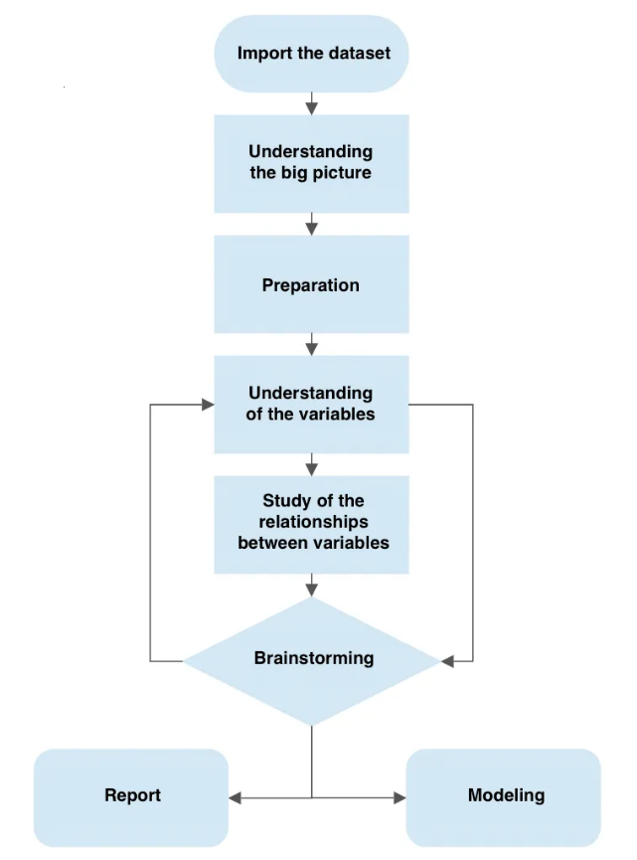
Figure 1: Microsoft Power BI Framework for EDA. (D’Agostino, 2022)

3.1.1 Related Study
Search terms used are “Data Analytics” OR “Business Intelligence” OR “Power BI” OR “Data visualization” AND “Food Traders” in ‘Science Direct’.
Title, Abstract, and author specified keywords: Business
Filters: Only “Research Articles” and “Review Articles”.
Note: These below works are only related to Data Analytics, Business Intelligence and not Hypothesis Testing which is covered later.
Table 1: Related works of Data Analytics and Business Intelligence.
S.NO | Research Paper Title | Notes
1 | Organization business intelligence and decision making using big data analytics (Niu et al., 2021) | This paper proposes a framework of optimised data management using big data analytics (ODM-BDA) which is not directly useful for this academic study, but it speaks about how Business intelligence and data analytics is useful in decision which is helpful for this academic study. Mainly this paper discusses about the big data analytics but not related to food trading industry.
2. | A hybrid big data analytical approach for analysing customer patterns through an integrated supply chain network (Wang, Tsai and Ciou, 2020). | This paper discusses about how big data technologies can assist the major supply chain companies in their decision-making process. In the second stage, it discusses identification of ordering behaviours and patterns which is very suitable for this academic study.
3. | How to improve firm performance using big data analytics capability and business strategy alignment (Akter et al., 2016) | This paper discusses about planning, investment, co-ordination, connectivity, technical knowledge, and business knowledge etc. to enhance the firm performance. Mainly it speaks about how big data analytics can do it.
4. | Supply chain management professionals’ proficiency in big data analytics: Antecedents and impact on performance (Schoenherr, 2023). | This article discusses quality and cost performance implications in the organization and how data analytics is used for analysis and improvement.
5. | Evaluating the impact of big-data analytics usage on the decision-making quality of organizations (Li et al., 2022). | This research study investigates about big data analytics and its capabilities on quality decision making.

3.2 Statistical Hypothesis Testing:
Statistical analysis in business can help perform accurate market analysis (Bender, 2023). Using hypothesis testing, user can determine how one element affects another by examining the statistical significance of their relationship. Carefully analysing the statistics of a company, can bring a huge difference to the revenue. The real potential of Hypothesis testing in business is that it allows professionals to test their theories and assumptions before putting them into actions (Stobierski, 2021). The statistical analysis knowledge is used to evaluate the current system and predicts in making alternative decisions on the critical parameters that affect the key performance indicators of the system (Long, 2018).
The user or the management can only start thinking if the hypotheses is tested and the results can be turned into recommendations for the management. In this academic study for the Northwind Traders, statistical analysis is used to increase the profit. Great Statistician John Tukey said, “The best thing about a statistician is that you get to play in everyone’s backyard” (Frost, 2020). For Northwind traders’ data assumptions are made to address the loopholes in the sales patterns, order patterns, product cost for an entire order, customer buying patterns etc.
Below is the idea of a flowchart about how to make questions for the hypothesis testing.

What is customer looking for? Is it the low-priced products or the quantity or the discounts?

Identifying customer behavior
Which season does the company have highest sales?

Which category has the highest orders and sales?
Increase Sales
Understanding the periods
Increase Profit
Recognizing the top sold products
Which region is doing the major business?
Understanding the inventory or goods
Recognizing where the goods are sold to

Figure 2: Flowchart of how to increase the profit for a business.

3.2.2 Related Study:
Search terms used are “Hypothesis Testing” OR “ANOVA” OR “T-test” in ‘Science Direct’.
Title, Abstract, and author specified keywords: Business
Filters: Only “Research Articles” and “Review Articles”.
Note: These below works are only related to Statistical Hypothesis testing with the T-Test and ANOVA.
Table 2: Related works of Statistical Hypothesis testing.
S.NO | Research Paper Title | Notes
1. | The impact of supply chain concentration on integration and business performance (Chen et al., 2023). | This article mainly speaks about supplier integration and customer integration and their positive effects on business performance and give a comprehensive view for achieving integration in supply chain business.
2. | From Dynamic Capabilities to ERP enabled business improvements: The mediating effect of the implementation project (Bernroider, Wong and Lai, 2014) | This research article explores the idea of Enterprise Resource planning (ERP) implementation in Business and how decision making directly impacts business capabilities and improvements.
3. | Goal Alignment in process Improvement (Lepmets, McBride and Ras, 2012) | This article explores the idea of process improvement should improve an organization’s ability to achieve business targets.

This academic study implements Hypothesis testing from the insights of exploratory data analysis in Power BI. In other words, questions and assumptions are made from the visuals created in Power BI.
Steps for Hypothesis testing (Atmakuri, 2020):
- Hypotheses are stated i.e., Null Hypothesis (H₀) and Alternate Hypothesis (H_{a}).
- Set the significance value ($∝=0.05$).
- Calculate the test statistic (P-value).
- Decide based on P-value and $∝$ value (0.05).
- Draw the conclusions.

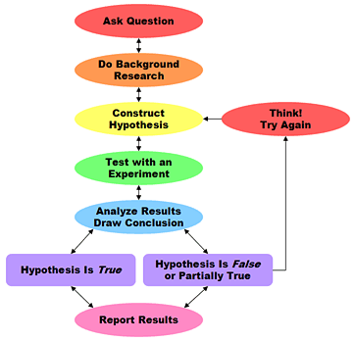
Figure 3: Hypothesis testing framework after EDA.

4. Hypothesis Development
Hypothesis Development is a crucial part of the experimental research study. From the review of the Literature is evident that hypotheses for the statistical analysis is developed based upon the insights from the Power BI. In any Business, here for Northwind Net sales, Gross Sales, Profit, and product Cost play an important role and these were the main components to form a Hypotheses.
Profit: Hypothesis development is a critical process that businesses can use to improve profitability. Dealing with profit can influence marketing strategies, Operational improvements, and new business opportunities. In this project, this hypothesis is development in the question why it is happening the way it is happening with the profit with different quarters in the years 2020, 2021, and 2022.
H1: Is there any significant difference in profit generated between 2020,2021, and 2022?
H1a: Is there any significance difference in profit generated between Quarter 3 of 2020 & Quarter 3 of 2021.
H1b: Is there any significance difference in profit generated between Quarter 4 of 2020 & Quarter 4 of 2021.
H1c: Is there any significance difference in profit generated between Quarter 1 of 2021 & Quarter 1 of 2022.
H1d: Is there any significance difference in profit generated between Quarter 2 of 2021 & Quarter 2 of 2022.
Note: The testing is done only within these quarters in these years because this is the only data available.
Product Cost: Dealing with product cost can determine factors like production processes which can lead to reductions in production costs and improved profitability in businesses. It can also help the business in cost saving opportunities related to product materials. This question evolved in the process of data analysis that is revenue generated completely depended on the Orders? And do the customers really consider about the product cost while buying the product.
H2: Do the Product cost for an order have any significance difference between customers from different countries in all three years?
H2a: Is there any significance difference in Product cost between different countries.
H2b: Is there any significance difference in Product cost between the customers in the country USA.
H2c: Is there any significance difference in Product cost between the customers in the country GERMANY.

H2a
H1a
Product Cost
Profit
Data Driven Decision Making
H1b
H2b
H1c
H1d
H2c

Increasing Revenue

Figure 4: Conceptual Model

5. Research Methodology
This study aims to investigate the sales patterns from the data analysis with Business Intelligence and test the hypotheses with Python programming language to make appropriate decisions to improve the performance. This study follows ‘Experimental’ approach where the different assumptions are tested with Two Sample T-test and One-way ANOVA test (Nahm et al., 2006). This methodology will outline steps to provide insights of the data and make good decisions from them. No real data is analysed or tested here. The data is collected in the form of a relational database where is manipulated and extracted to Microsoft Power BI in the form of the SQL queries (Geeks Engine, 2023). Data Analysis is done in the Power BI and based on the insights questions and assumptions are made to statistically test it. It is clearly stated in the below research design [Figure 4].

Data manipulation & Data Analysis & Hypotheses
extraction Visualizations stating and testing.
Hypothesis Testing with Python
Queries Data insights
Power BI
MYSQL

Figure 5: Research design

The key steps of the methodology are given below.
- Data Collection
- Data Exploration & Extraction.
- Data Pre-processing.
- Data Modelling.
- Data analysis and visualizations.
- Hypothesis Testing.
- Ethics

5.1 Data Collection:
This study uses fictional sample database which was originally created by Microsoft and used as a basis for tutorials in a variety of a database products for decades (Yugabyte, 2022). Northwind database contains 8 tables as the following:
- Categories: Contains product Category information.
- Customers: Contains customer information.
- Employees: Contains employee information who works at Northwind organization.
- Order_Details: Contains order information with OrderID and ProductID.
- Orders: Contains each order information.
- Products: Contains product information.
- Shippers: Contains Shipper information of who delivered the orders to the customers.
- Suppliers: Contains supplier information from where the products are originally coming from.

5.2 Data Exploration & Extraction:
The data or the tables is exported into the PowerBI from MySQL server using a local server connection between MySQL and PowerBI (stackoverflow, 2022). The table name, SQL query, attributes and rows contained in the table are mentioned in the below table 3.

Table 3: Data extraction from MySQL to PowerBI.
S.No | Column Name | SQL Query | Notes
1 | Categories | SELECT *  FROM categories; | Categories table contains 4 attributes with 8 records in it. Data is exported into the PowerBI with the beside query using a local server connection between MySQL and PowerBI (stackoverflow, 2022).
2 | Customers | SELECT *  FROM customers; | Customers table contains 11 attributes and 91 records in it. Data is exported into the PowerBI with beside query.
3 | Employees | SELECT *  FROM employees; | Employess table contain 16 attributes and 9 records in it. Data is exported into the PowerBI with the beside query.
4 | Products | SELECT p.ProductID,  p.ProductName,  p.SupplierID,  p.CategoryID,  p.QuantityPerUnit,  MIN(od.UnitPrice) AS UnitPrice,  p.UnitsInStock,  p.UnitsOnOrder,  p.ReorderLevel,  p.Discontinued  FROM products p  JOIN order_details od  ON p.ProductID = od.ProductID  GROUP BY p.ProductID; | Products table contains 10 attributes and 77 records in it. Data is exported into the PowerBI with the beside query. Here, unit price column in the table order_details is swapped with the unit price column in the Products table to avoid data discrepancies and flow of storytelling.
5 | Shippers | SELECT *  FROM shippers; | Shippers table contains 3 attributes and 3 records in it. Data is exported into the PowerBI with the beside query.
6 | Suppliers | SELECT *  FROM suppliers; | Shippers table contains 3 attributes and 3 records in it. Data is exported into the PowerBI with the beside query.
7 | Orders | SELECT o.OrderID,  o.CustomerID,  o.EmployeeID,  o.OrderDate,  o.RequiredDate,  SUM(p.UnitPrice) AS unit_price_per_order,  SUM(od.Quantity) AS quantity_per_order,  SUM(od.Quantity * p.UnitPrice) AS sales  FROM orders o  LEFT JOIN order_details od  ON o.OrderID = od.OrderID  LEFT JOIN products p  ON od.ProductID = p.ProductID  GROUP BY o.OrderID; | Orders table contain 8 attributes and 830 records in it. Data is exported into the PowerBI with the beside query.
8 | Orders Shipping Details | SELECT o.OrderID,  o.ShippedDate,  o.ShipVia,  o.Freight,  o.ShipName,  o.ShipAddress,  o.ShipCity,  o.ShipRegion,  o.ShipPostalCode,  o.ShipCountry  FROM orders o; | This table contains 10 attributes and 830 records in it. Data is exported into the PowerBI with the beside query. Here, this table originally came from the orders table and this has only the shipping details of those orders.
9 | Order Details | SELECT od.ID AS OrderDetailID, od.OrderID,  od.ProductID,  p.ProductName,  p.UnitPrice,  od.Quantity,  od.Discount  FROM northwind.order_details od  LEFT JOIN products p  ON od.ProductID = p.ProductID; | This table contains 7 attributes and 2000 records in it. Data is exported into the PowerBI with the beside query. Here, the unit price column is swapped with the unit price column in products table to avoid data discrepancies.

5.3 Data Pre-Processing
Data Pre-processing is an essential step in building a quality visual in Power BI (Van Der Merwe, 2019). In this academic project, before data analysis and creating visuals a little pre-processing in done to play with the data and created a new table with Dates, new measures, and new calculated columns.
5.3.1 DATE table: Firstly, created a Date table using DAX formulae (Data Camp, 2022) which can be seen in the below screenshot.
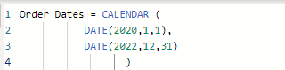
Figure 6: Screenshot of Date DAX Formulae.

Same as that, created different columns for Year, Quarter, Month, Weekday, Weekday number and Week number and DAX formulae are given below.
YEAR = YEAR('Order Dates'[Date])
MONTH = FORMAT('Order Dates'[Date],"mmmm")
QUARTER = "Q" & FORMAT('Order Dates'[Date],"Q")
Week Day = FORMAT('Order Dates'[Date],"dddd")
Week No = WEEKNUM('Order Dates'[Date],2)
Week Day No = WEEKDAY('Order Dates'[Date],2)
5.3.2 Calculated Columns: On the second hand, also created some calculated columns for few tables to get some insights from the data which will be covered in the data analysis section. The calculated columns that are created are given below with their formulas.
Net Sales = 'Order Details'[Quantity] * 'Order Details'[UnitPrice] * (1-'Order Details'[Discount])
Product Cost = 'Order Details'[Quantity] * RELATED(Products[UnitPrice])
Gross Sales = 'Order Details'[Quantity] * 'Order Details'[UnitPrice]
Profit = 'Order Details'[Net Sales] - 'Order Details'[Product Cost]

5.3.3 Measures: Based on the above calculated columns, measures using DAX expressions are also created in different tables. The measures that are created are given below with their formulas.
Total Gross Sales = SUM('Order Details'[Gross Sales])
Total Net Sales = SUM('Order Details'[Net Sales])
Total Product Cost = SUM('Order Details'[Product Cost])
Total Profit = [Total Net Sales] - [Total Product Cost]
% Profit Margin = DIVIDE([Total Profit],[Total Net Sales],0)
Quantity sold = SUM(Orders[quantity_per_order])
Total Orders = COUNT(Orders[OrderID])
Total Unit Price = SUM(Orders[unit_price_per_order])

5.4 Data Modelling: The data models which specify the data structure, attributes, and relationships is abstract data (Kumar, 2022). To create a data model, multiple entities or tables must be related to each other. The data model used in this project is Entity-relationship model. After pre-processing steps data model is created in power BI and the screenshot is given below.
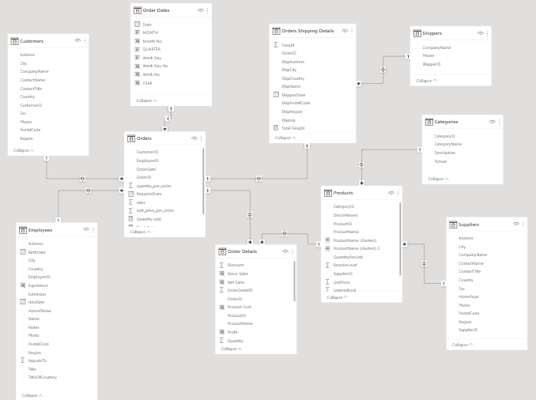
Figure 7: Screenshot of the Northwind Data model.
In this above data model, Many-to-Many relationship is totally avoided because it can cause data duplications in returned datasets, which can create in correct results (SiSence, 2021) and only followed One-to-one cardinality and one-to-many cardinality.
The above data model is in Snowflake Schema to normalize the denormalized data in the star schema. Snowflake schemas are less prone to data integrity issues and are easier to maintain and utilize less space (Keboola, 2022). Below is the table which explains the table type.
Table 4: Data model table type
S No. | Table | Table Type
1. | Orders | Fact
2. | Order Details | Dimension
3. | Employees | Dimension
4. | Customers | Dimension
5. | Order Dates | Dimension
6. | Order Shipping Details | Dimension
7. | Products | Dimension
8. | Shippers | Dimension
9. | Categories | Dimension
10 | Suppliers | Dimension

5.5 Data Analysis and Visualizations
The next step is to do data analysis and create visuals based upon the research questions. By enhancing the quality of businesses' information systems and assisting executives in making data-driven choices, data analytics with Power BI fosters the discovery of information and the democratisation of data (Estape, 2022). With the help of data analytics engaging, interactive visuals are created to the best of my ability. Most of the data analysis is done in the Power BI but statistical analysis with Hypothesis testing in the later part of the paper.
These visuals are created based on the research questions that are discussed in Introduction section.
RQ 1: What are Total Gross sales, Total Net sales, and % Profit Margin by each year, quarter, month, week, and weekday in the years 2020, 2021, and 2022?
To answer this question, using Power BI a bar chart is created which has date on the X-axis and Total Gross Sales, Total Sales, and % Profit Margin on the Y-axis. The year 2021 stands the highest with Total Net Sales of £0.65M, Total Gross Sales of £0.70M and 14.94% of Profit margin. This could be because of there are a greater number of orders 408 than in 2020 & 2022.
Table 5: Orders, Total Net Sales, Total Gross Sales, and % Profit margin for the years 2020,2021,2022.
Year | 2020 | 2021 | 2022
Orders | 152 | 408 | 270
Total Net Sales | £0.26M | £0.65M | £0.44M
Total Gross Sales | £0.28M | £0.70M | £0.47M
% Profit Margin | 13.19% | 14.94% | 14.95%

Below are the screenshots of the visuals created to answer the Research Question 1.
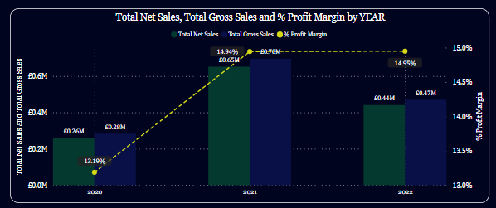
Figure 8: Screenshot of Total Net Sales, Total Gross sales, & % Profit Margin by Year.

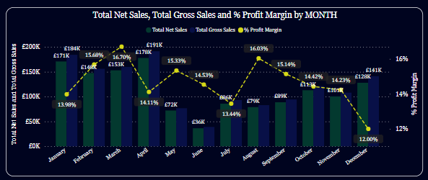
Figure 9: Screenshot of Total Net Sales, Total Gross sales, & % Profit Margin by Month in all three years.
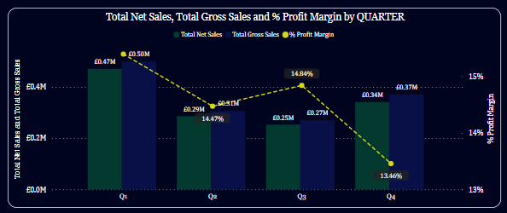
Figure 10: Screenshot of Total Net Sales, Total Gross sales, & % Profit Margin by Quarter in all three years.
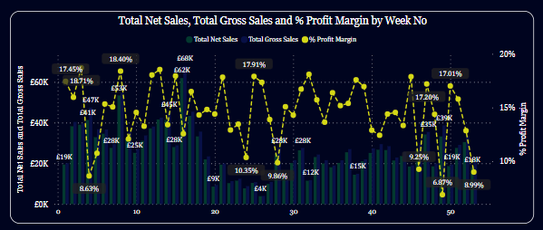
Figure 11: Screenshot of Total Net Sales, Total Gross sales, & % Profit Margin by Week No. in all three years.
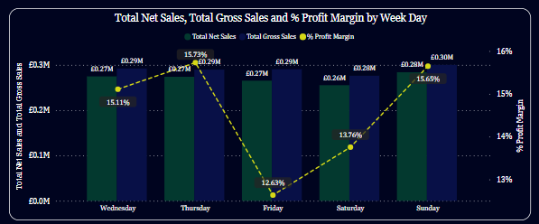
Figure 12: Screenshot of Total Net Sales, Total Gross sales, & % Profit Margin by Weekday in all three years.

RQ 2: Who are the top ten customers in terms of their Net sales, Profit, and % profit margin?
The top ten customers for the Northwind traders are Save-a-lot Markets, Ernst Handel, QUICK-Stop, Hungry Owl All-night Grocers, HILARION-Abastos, Rattlesnake Canyon Grocery, White Clover markets, Hanari Carnes, Koniglich Essen, Supremes Delices where they have created most sales and generated more profit over the last three years when compared with other customer. Below the screenshot of the visual of top 10 customers in terms Total profit generated.

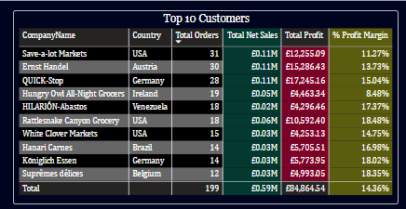
Figure 13: Top 10 customers for Northwind Traders
RQ 3: What is top Category Gross sale value and Product Gross sale value?
The top Category Gross value and Product Gross value are single values, and the values are the highest gross sale of that category type and product type.

- Top Category Gross Sale value: £309.13K
- Top Product Gross Sale Value: £164.16K

RQ 4: Which Category has the highest Net sales and Profit and what is the value of it?
Beverage’s category has the highest Net Sales of £288.34K and Profit of £41.03K. It could be because, there are more customers who runs beverage’s company and there are more orders in this category.
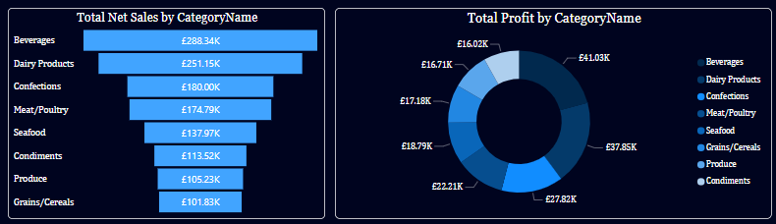
Figure 14: Screenshot of Power BI Visual of Total Net Sales and Total Profit by Category Name.

RQ 5: What are the countries which has highest number of orders and revenue generated from them in all three years?
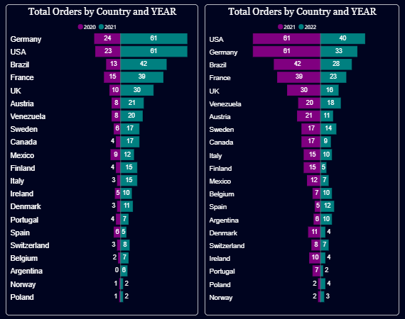
Figure 15: Screenshot of Power BI visual of Orders by Country and Year
The countries Germany, USA, Brazil, France, and UK has the highest orders in the years 2020, 2021, and 2022. It is clearly explained in the below table.

Table 6: Total Orders by top 5 countries and year.
Country/Year | 2020 | 2021 | 2022
USA | 23 | 61 | 33
Germany | 24 | 61 | 33
Brazil | 13 | 42 | 28
France | 15 | 30 | 23
UK | 10 | 30 | 16

The top five revenue generated countries in past three years are USA, Germany, Austria, Brazil, and France.
Table 7: Net Sales by top 5 countries.
Country | USA | Germany | Austria | Brazil | France
Net Sales | £2,62,689.24 | £2,39,626.79 | £1,37,273.51 | £1,14,637.36 | £89,242.32

RQ 6: Which cities are most affecting the highest profit generated countries?
The cities ‘Cunewalde’ from ‘Germany’, ‘Graz’ from ‘Austria’, ‘Boise’ from USA, ‘London’ from ‘UK’, and ‘Cork’ from ‘Ireland’ are the most affecting the highest profit generated countries. The cities and their revenue made shown in the below table.
Table 8: Net Sales by top 5 Cities.
City | Cunewalde | Graz | Boise | London | Cork
Net Sales | £1,14,639.86 | £1,11,362.43 | £1,08,703.29 | £56,679.73 | £52,623.64

RQ 7: Do the orders play a pivotal role in generating more revenue for the company?
Normally, the main component of the revenue for a company is quantity sold * product cost (Hayes, 2023). This happens in most of the business when buying capacity influence the revenue. Here in Northwind most of the time orders play a vital role in generating more revenue but in a scenario comparing Mexico in past three years have made 28 orders and made a Gross sale of £25,650.71 and Canada made 30 orders and made Gross sales of £61,900.15. This explains that in some situations Product cost is also making a huge impact in revenue.
Table 9: Impact on revenue in % on different components.
Component | Impact on Revenue %
Number of orders | 70%
Product Cost for an order | 30%

RQ 8: What are the employee statistics monthly in each working department in the company?
To answer this question a matrix visual in created in Power BI with each working department and employees working in it by each month and Gross Sales in all three years. In Sales department, the Sales Representatives made the highest Gross sales of £10,37,304.13. Here, the visual is designed in three colours such as blue, green, and red. The target for each employee is set to £10,000 (green). The employees who fall into £7,000 to £10,000 (blue) will need to improve a little bit to reach the target. The employees who into less than £7,000 (red) has shown the lowest performance.
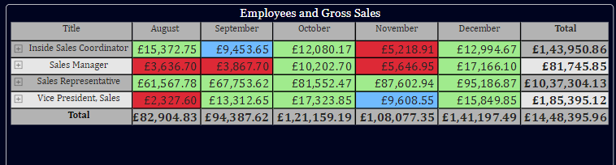
Figure 16: Screenshot of Employee Job role by Gross Sales.

RQ 9: Is it the employees operating from the USA processing more orders and generating more revenue or the employees operating from the UK?
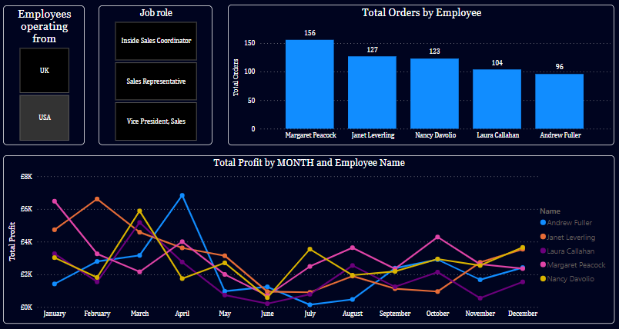
As per the beside figure 17, there are more employees working in USA than in the UK. The employees in the USA processed more orders than in the UK hence, generated more profit. This might because the Vice President of the company is operating from the USA and most of the customers of Northwind are from USA.
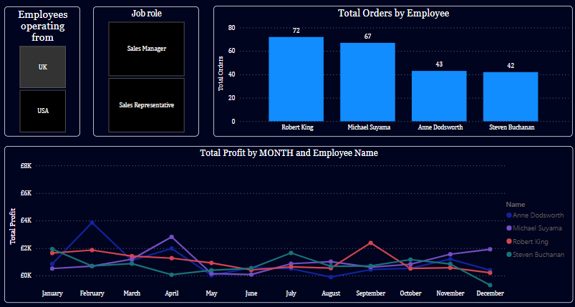
Figure 17: Employees operating from USA & UK.
RQ 10: What are the comparison statistics of the current period and previous period at the same time?
To answer this question please refer the appendix section and refer the Power BI file attached to this project. For these four different charts are created for Year, Monthly, Weekday, Week No. and stats of the current period and previous period at the same time.

RQ 11: Where would the company be in the next three years in terms of orders, sales, and profit? Or forecasting for the next three years.
The trend of Orders, Gross Sales, and Profit is going up in the next 3 years. Using Power BI forecasting visual is created and the stats are shown below in the table.
Table 9: Forecasting Orders, Gross sales, and profit for the next three years.
Future years | 2023 | 2024 | 2025
Orders | 380 | 455 | 529
Gross Sales | £6,45,529.23 | £7,64,147.38 | £8,82,765.54
Profit | £93,862.73 | £1,13,382.95 | £1,32,903.16

5.6 Hypothesis Testing
The next step in the methodology is testing the Hypothesis by making the assumptions based on the research questions. Statistical hypothesis testing is also confirmatory data analysis, is often used to decide whether experimental results contain enough information to cast doubt on conventional wisdom (Dubois, 2023). Hypothesis testing is common in statistics as a method of making decisions using data. In this academic study, Hypotheses are testing to identify the nuances and to know why it happened the way it happened. As the above-mentioned conceptual model Figure 4 the two research questions are formed on how Profit and Product cost are influencing the revenue.
Research questions formed based on the data analysis are:
H1: Is there any significant difference between the profit generated in the years 2020, 2021, 2022?
H2: Do the Product cost for an order have any significance difference between customers from different countries in all three years?
5.6.1 Choosing the right Statistical test:
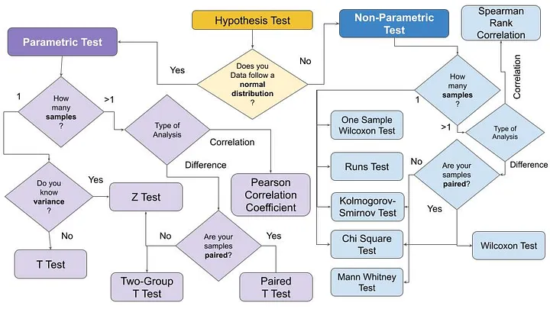
Figure 18: Classification of parametric tests and non-parametric tests. Taken from Hypothesis test explained (Lo Duca, 2021)

The selection and usage of statistical tests is explained in the above figure 18.

5.6.2 Two Sample T-Test:
To answer the first hypothesis (H1) Two sample independent T-test is chosen because the question is to find out the statistical difference in the means of two groups. Two groups contain Quantitative data and comparison is done on their means as the data is normally distributed in all the sample groups.
Predictor variable: Categorical

Outcome Variable: Quantitative

How many groups are compared: 2 (Independent Samples)

Two Independent sample t-test

Figure 19: Why choose Two -Independent sample t-test for H1.

5.6.2 (a) Data for Testing:
The data is primarily exported from the Power BI to the Anaconda Jupyter Notebook as a CSV file. Python Programming language is used for testing the hypotheses. Below is the screenshot of first 10 rows of the data. But they are grouped with their respective quarters of the years.
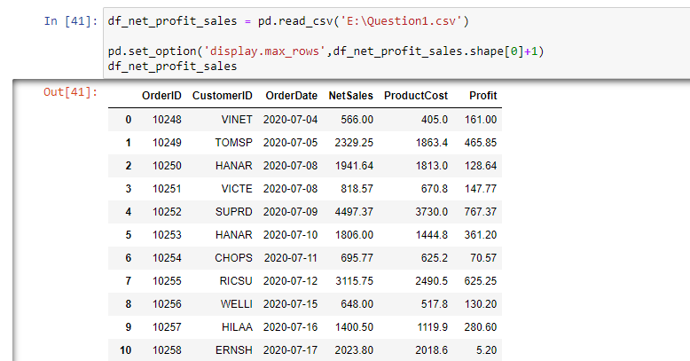
Figure 20: Screenshot of H1 data.

Grouping Quarters Q3 with years 2020 & 2021
Extracting the data of only Q3 of 2020 & 2021 into a new data frame.
q3_2020 = df_net_profit_sales[(df_net_profit_sales['quarter']==3) & (df_net_profit_sales['year']==2020)]
q3_2021 = df_net_profit_sales[(df_net_profit_sales['quarter']==3) & (df_net_profit_sales['year']==2021)]
Grouping Quarters Q4 with years 2020 & 2021
q4_2020 = df_net_profit_sales[(df_net_profit_sales['year']==2020) & ((df_net_profit_sales['month']==10)|(df_net_profit_sales['month']==11)|(df_net_profit_sales['month']==12))]
q4_2021 = df_net_profit_sales[(df_net_profit_sales['year']==2021) & ((df_net_profit_sales['month']==10)|(df_net_profit_sales['month']==11)|(df_net_profit_sales['month']==12))]
Grouping Quarters Q1 with years 2021 & 2022
q1_2021 = df_net_profit_sales[(df_net_profit_sales['year']==2021) & ((df_net_profit_sales['month']==1)|(df_net_profit_sales['month']==2)|(df_net_profit_sales['month']==3))]
q1_2022 = df_net_profit_sales[(df_net_profit_sales['year']==2022) & ((df_net_profit_sales['month']==1)|(df_net_profit_sales['month']==2)|(df_net_profit_sales['month']==3))]
Grouping Quarters Q2 with years 2021 & 2022
q2_2021 = df_net_profit_sales[(df_net_profit_sales['year']==2021) & ((df_net_profit_sales['month']==4)|(df_net_profit_sales['month']==5)|(df_net_profit_sales['month']==6))]
q2_2022 = df_net_profit_sales[(df_net_profit_sales['year']==2022) & ((df_net_profit_sales['month']==4)|(df_net_profit_sales['month']==5)|(df_net_profit_sales['month']==6))]

5.6.2 (b) Calculating the Mean and mean difference:
Table 10: Mean and mean differences of two groups
Groups | Mean (${\overline{x}}_{1}, {\overline{x}}_{2}$) | Mean Difference ($\overline{x},-{\overline{x}}_{2}$)
Q3 with years 2020 & 2021  Q4 with years 2020 & 2021  Q1 with years 2021 & 2022 | ${\overline{x}}_{1}=$219.9958571428571  ${\overline{x}}_{2}=$215.76097087378642  ${\overline{x}}_{1}=$230.8818292682927  ${\overline{x}}_{2}=$225.23516666666674  ${\overline{x}}_{1}=$277.08326086956527  ${\overline{x}}_{2}=$258.74912087912094 | $\overline{x},-{\overline{x}}_{2}=$-4.234886269070671  $\overline{x},-{\overline{x}}_{2}=$-5.6466626016259625  $\overline{x},-{\overline{x}}_{2}=$18.334139990444328
Q2 with years 2021 & 2022 | ${\overline{x}}_{1}=$243.76333333333324  ${\overline{x}}_{2}=$213.36818181818182 | $\overline{x},-{\overline{x}}_{2}=$30.39515151515141

5.6.2 (c) Data Normality:
For every group profit is normally distributed with all the quarters in the years 2020,2021, and 2022. It is shown in the below distribution plot by their mean values.
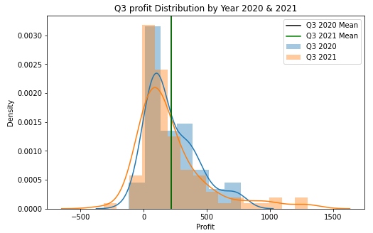
Figure 21: Q3 Profit distribution plot by year 2020 & 2021.

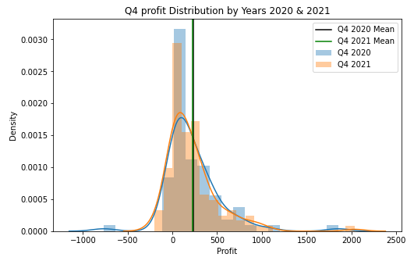
Figure 22: Q4 Profit distribution plot by year 2020 & 2021.

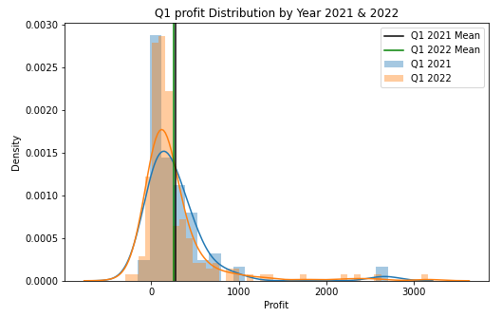
Figure 23: Q1 Profit distribution plot by year 2021 & 2022.

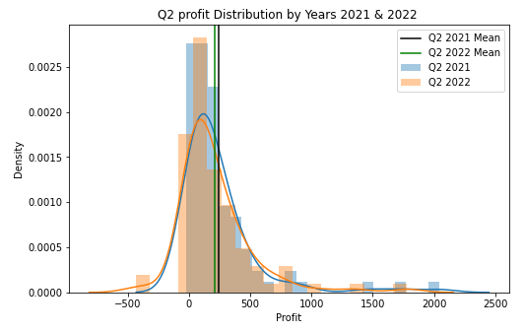
Figure 24: Q2 Profit distribution plot by year 2021 & 2022.
5.6.2 (d) Hypothesis construction & testing:
H1a: Is there any significance difference in profit generated between Quarter 3 of 2020 & Quarter 3 of 2021.
$H_{0}$ (Null Hypothesis) = The profit generated of the Q3 2020 is at least equal to the profit generated in Q3 2021.
$$H_{0}= u_{1}≤u_{2}$$
$H_{a}$ (Alternate Hypothesis) = The profit generated of the Q3 2021 is greater than the profit generated in Q3 2020
$$H_{a}= u_{2}>u_{1}$$
α (Significance value) = 0.05
Significance level is assumed at 5% confidence level. The objective here is to verify if the null hypothesis can be rejected not. In general, rejecting the Null hypothesis does not mean that the alternate hypothesis is accepted but, in some cases, rejecting the Null hypothesis can imply that the alternate hypothesis is accepted. When the test is done if the P- Value is less the alpha value then the Null hypothesis is rejected, and the P-value is greater than the alpha value then it is said that the test fails to reject the Null hypothesis and it implies that there is a statistical significance. In jupyter notebook, T-test is performed, and P-value is mentioned in the below figure.
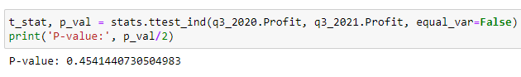
H1b: Is there any significance difference in profit generated between Quarter 4 of 2020 & Quarter 4 of 2021.
$H_{0}$ (Null Hypothesis) = The profit generated of the Q4 2020 is at least equal to the profit generated in Q4 2021.
$$H_{0}= u_{1}≤u_{2}$$
$H_{a}$ (Alternate Hypothesis) = The profit generated of the Q4 2021 is greater than the profit generated in Q4 2020
$$H_{a}= u_{2}>u_{1}$$
α (Significance value) = 0.05
In Jupyter notebook, T-test is performed, and P-value is mentioned in the below figure.
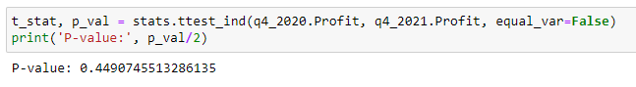
H1c: Is there any significance difference in profit generated between Quarter 1 of 2021 & Quarter 1 of 2022.
$H_{0}$ (Null Hypothesis) = The profit generated of the Q1 2021 is at least equal to the profit generated in Q1 2022.
$$H_{0}= u_{1}≤u_{2}$$
$H_{a}$ (Alternate Hypothesis) = The profit generated of the Q1 2022 is greater than the profit generated in Q1 2021.
$$H_{a}= u_{2}>u_{1}$$
α (Significance value) = 0.05
In Jupyter notebook, T-test is performed, and P-value is mentioned in the below figure.
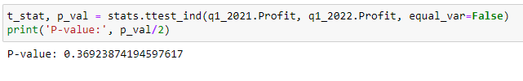
H1d: Is there any significance difference in profit generated between Quarter 2 of 2021 & Quarter 2 of 2022.
$H_{0}$ (Null Hypothesis) = The profit generated of the Q2 2021 is at least equal to the profit generated in Q2 2022.
$$H_{0}= u_{1}≤u_{2}$$
$H_{a}$ (Alternate Hypothesis) = The profit generated of the Q2 2022 is greater than the profit generated in Q2 2021.
$$H_{a}= u_{2}>u_{1}$$
α (Significance value) = 0.05
In Jupyter notebook, T-test is performed, and P-value is mentioned in the below figure.
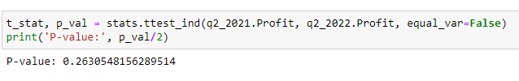

5.6.3 One-way ANOVA Test:
To answer the second question (H2) One-way ANOVA Test is chosen because the question is to find the statistical difference in the means of more than two groups. Groups contain both qualitative and quantitative data i.e. numerical and categorical values.

Predictor variable: Categorical

Outcome Variable: Quantitative

How many groups are compared: >2

How many outcome variable: 1

One-way ANOVA Test

Figure 25: Why choose One-way ANOVA t-test for H2.
5.6.3 (a) Data for testing:
The data is exported to the Jupyter notebook from Power BI through a CSV file. Below is the screenshot of the data with first 10 rows.
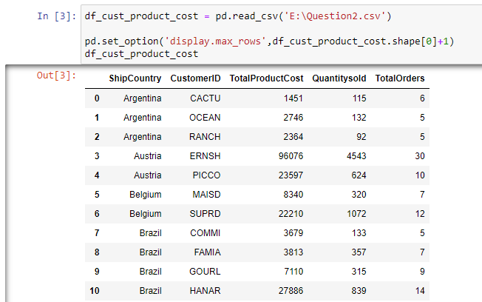
Figure 26: Screenshot of H2 data.

Data summary (ShipCountry groupby column):
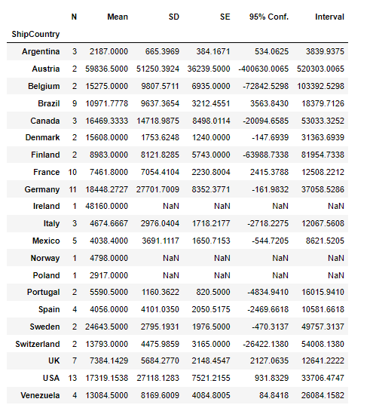
Figure 27: Screenshot of H2 data summary.
The above data summary mainly contains the number of observations of each country and their mean values.
5.6.3 (b) Distribution plot and quantile plot:
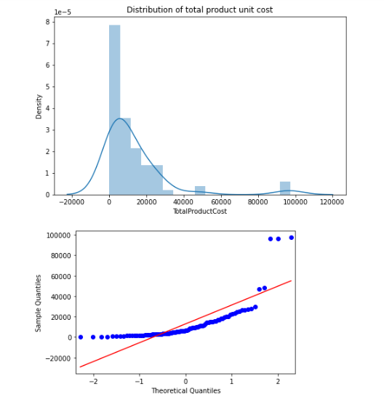
Figure 28: Normality plots for H2.
In the above distribution plot and q-q plot, the numerical data for the column TotalProductCost is normally distributed.

5.6.3 (c) Hypothesis construction & testing:
H2a: Is there any significance difference in Product cost between different countries
$H_{0}$ (Null Hypothesis) = There is no significant difference in product cost between all the countries.
$$H_{o}= u_{2}=u_{1}= u_{3}……..u_{n}$$
$H_{a}$ (Alternate Hypothesis) = The is a significant difference in product cost between all the countries.
$H_{a}= u_{1} ≠u_{2}≠ u_{3}$…..$u_{n}$
α (Significance value) = 0.05
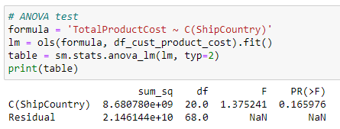
Figure 29: ANOVA Test for H2a.
From the above ANOVA test, we can see that F-Statistic is 1.375241 and P-Value is 0.16597. Now finding the F-Critical value.
stats.f.ppf(q=1-0.05, dfn=20, dfd=68) = 1.72684430722177
H2b: Is there any significance difference in Product cost between all the customers in the country USA
$H_{0}$ (Null Hypothesis) = There is no significant difference in product cost between all the customers in USA
$$H_{o}= u_{2}=u_{1}= u_{3}……..u_{n}$$
$H_{a}$ (Alternate Hypothesis) = The is a significant difference in product cost between all the customers in USA.
$H_{a}= u_{1} ≠u_{2}≠ u_{3}$…..$u_{n}$
α (Significance value) = 0.05

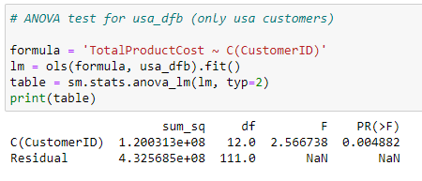
Figure 30: ANOVA Test for H2b.
From the above ANOVA test, we can see that F-Statistic is 2.566738 and P-Value is 0.004882. Now finding the F-Critical value.
stats.f.ppf(q=1-0.05, dfn=12, dfd=111) = 1.8403981346888174

H2c: Is there any significance difference in Product cost between all the customers in the country GERMANY.
$H_{0}$ (Null Hypothesis) = There is no significant difference in product cost between all the customers in GERMANY.
$$H_{o}= u_{2}=u_{1}= u_{3}……..u_{n}$$
$H_{a}$ (Alternate Hypothesis) = The is a significant difference in product cost between all the customers in GERMANY.
$H_{a}= u_{1} ≠u_{2}≠ u_{3}$…..$u_{n}$
α (Significance value) = 0.05
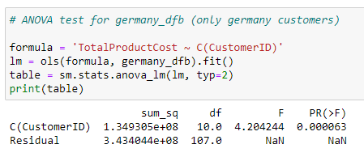
Figure 31: ANOVA Test for H2c.
From the above ANOVA test, we can see that F-Statistic is 4.204244 and P-Value is 0.000063. Now finding the F-Critical value.
stats.f.ppf(q=1-0.05, dfn=10, dfd=107) = 1.9203098769827758

5.7 Ethics

Ethical considerations for this project are data collection, industry name, names of the people and prevention of unethical, illegal actions. Northwind data used in this project is a fiction data used by Microsoft. All the company name and individual names used are all fictional and does not affect others. This project has been given ethical clearance by Teesside university SCEDT Research Ethics Committee in February 2023. Overall, this project is risk free and have ethical clearance.

6. Statistical Analysis & Results
In the below tables, results of both Two Sample T-test and One-way ANOVA test are shown:
Table 11: Two Sample T-test
S NO. | Hypothesis | P-Value | Results (P Value vs 0.05) | Explanation
1. | Is there any significance difference in profit generated between Quarter 3 of 2020 & Quarter 3 of 2021. | 0.4541440730504983 | P-value > significance value | As the p value is greater than the $∝$ value (significance value) we fail the reject the null hypothesis. so, we cannot say with 95% confidence that there is any significant difference between the Q3 2020 & Q3 2021 generated profit without being due to a random chance.
2. | Is there any significance difference in profit generated between Quarter 4 of 2020 & Quarter 4 of 2021. | 0.4490745513286135 | P-value > significance value | The p-value is 0.4490745513286135 which is greater than $∝$ value (significance value). So, we have failed to reject the null hypothesis and with 95% confidence it cannot be said that the profit generated of Q4 2021 is greater than in Q4 2020 without being due to a random chance.
3. | Is there any significance difference in profit generated between Quarter 1 of 2021 & Quarter 1 of 2022. | 0.36923874194597617 | P-value > significance value | As the P-value is greater than the alpha value, we fail to reject the Null hypothesis and cannot say with 95% confidence that Q1 2022 profit generated is greater than the Q1 2021 profit.
4. | Is there any significance difference in profit generated between Quarter 2 of 2021 & Quarter 2 of 2022. | 0.2630548156289514 | P-value > significance value | As the P-value is greater than the alpha value, we fail to reject the Null hypothesis and cannot say with 95% confidence that Q2 2022 profit generated is greater than the Q2 2021 profit.

Table 12: One-way ANOVA test

S NO. | Hypothesis | P-Value | F-Statistic | F-Critical Value | Results | Explanation
1. | Is there any significance difference in Product cost between different countries. | 0.165976 | 1.375241 | 1.726844 | P-value > $∝$  F-statistic < F-Critical value | As the P-value is greater than the significance value (0.05) we failed to reject the Null hypothesis. So, cannot say with 95% confidence that product cost is not equal for all the countries.  Our F-critical value at significance level= 5%, degrees of freedom(numerator)=20 and degrees of freedom(denominator)=68 is 1.72684430722177.  By this it is confirmed that we failed to reject the Null Hypothesis.
2. | Is there any significance difference in Product cost between all the customers in the country USA | 0.004882 | 2.566738 | 1.84039 | P-value < $∝$  F-statistic > F-Critical value | As the P-value is less than the significance value (0.05) we reject the Null hypothesis. So, with 95% confidence that product cost is not equal for all the customers in USA.  Our F-critical value at significance level= 5%, degrees of freedom(numerator)=12 and degrees of freedom(denominator)=111 is 1.8403981346888174.  By this it is confirmed that we reject the Null Hypothesis.
3. | Is there any significance difference in Product cost between all the customers in the country GERMANY. | 0.000063 | 4.204244 | 1.92030 | P-value < $∝$  F-statistic > F-Critical value | As the P-value is very less than the significance value (0.05) we reject the Null hypothesis. So, with 95% confidence that product cost is not equal for all the customers in Germany.  Our F-critical value at significance level= 5%, degrees of freedom(numerator)=10 and degrees of freedom(denominator)=107 is 1.9203098769827758.  By this it is confirmed that we reject the Null Hypothesis.

7. Conclusions
From the above results, in the first hypothesis Two sample T-test have failed to reject the null hypothesis and with 95% it cannot be said that profit generated in Q3 2021 is greater than Q3 2020. In the below bar plot, it is evident that Q3 2021 profit is more than the Q3 2020 and it can be said that orders in Q3 2021 are more than Q3 2020 and more net sales are made. But the average profit generated is almost same with difference of £3.07 per order with their respective orders.
The number of orders in Q3 2021(103 orders) are more than the orders in Q3 2020(70 orders), but the average profit generated in the Q4 in both the years is almost same.
AVG profit in Q3 2020 for 82 orders: £83.24.
AVG profit in Q3 2021 for 120 orders: £86.81.
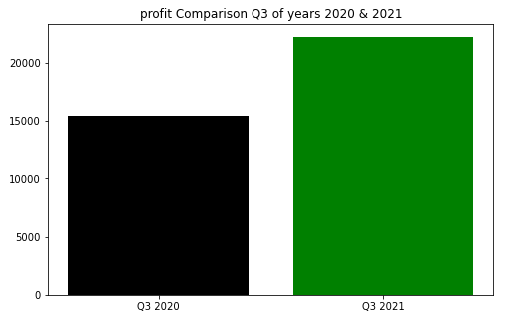
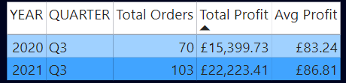
Figure 32: Profit comparison Q3 of years 2020 & 2021.
Finally, testing shows that there is no statistically significant difference in profit generated Q3 2020 and Q3 2021. In Q3 2021, there is more profit generated because of more orders but not due to a random chance.

From the second hypothesis test, the P-value is higher than the alpha value and following the testing rules and considering it as insignificant and it failed to reject the null hypothesis and with 95% confidence it cannot be said that the profit generated of Q4 2021 is greater than in Q4 2020 without being due to a random chance. The number of orders in Q4 2021(120 orders) are more than the orders in Q4 2020(82 orders), but the average profit generated in the Q4 in both the years is almost same.
AVG profit in Q4 2020 for 82 orders: £86.06.
AVG profit in Q4 2021 for 120 orders: £87.47.
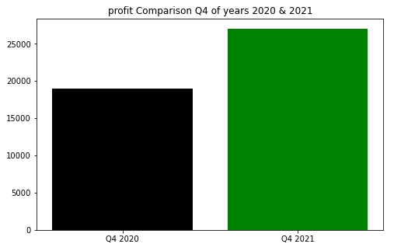
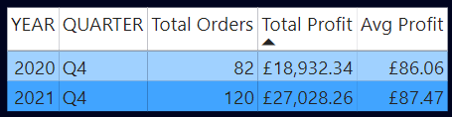
Figure 33: Profit comparison Q4 of years 2020 & 2021.
This shows that there is no significant difference in Q4 of both years and most priced products were sold in Q4 2020 with even a smaller number of orders than Q4 2021.

The number of orders in Q1 2021(92 orders) are more than the orders in Q1 2022(182 orders), but the average profit generated in the Q1 in both the years is almost same which in fact 2021 is higher than the 2022.
AVG profit in Q1 2021 for 92 orders: 105.77
AVG profit in Q1 2022 for 182 orders: 104.19
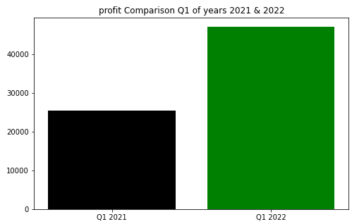

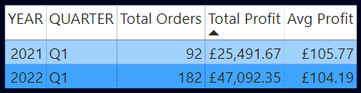
Figure 34: Profit comparison Q1 of years 2021 & 2022.
This test is the proof that product cost plays an important role in the profit irrespective of the orders. With the two sample T-test there is not much evidence supporting the alternate hypothesis as the average profit generated in Q1 2021 is greater than the Q1 2022.

The P-value is higher than the alpha value and following the testing rules and considering it as insignificant and we have failed to reject the null hypothesis and with 95% confidence it cannot be said that the profit generated of Q2 2022 is greater than in Q2 2021 without being due to a random chance.
The number of orders in Q2 2021(93 orders) are more than the orders in Q2 2022(88 orders), but the average profit generated in the Q2 in both the years are
AVG profit in Q2 2021 for 93 orders: £89.60
AVG profit in Q2 2022 for 88 orders: £78.56.
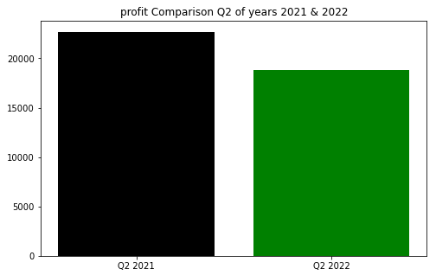
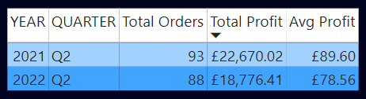
Figure 35: Profit comparison Q2 of years 2021 & 2022.
With the One-way ANOVA test. Based on our overall findings, there is no statistical significance difference in product cost on different countries. It can be seen in the first One-way ANOVA test that is performed above and F-Statistic and P-value justifies it. But the countries like USA, Germany, Austria are in the top with their Profit, Gross & Net sales, and as well as Product cost. Proper conclusions cannot be made with this.
To dig deeper, taken the top two countries like USA & Germany and performed a one-way ANOVA test on Customer level with the total product cost. This time it is found that there is a statistical difference between the customers in USA & Germany on their product cost. This time P-value and F-statistic proves it that the company QUICK-Stop from Germany and Save-a-lot markets from USA have more orders compared to other countries resulting in more Net Sales and profit.
Suggestions: Northwind traders should more focus on selling their products to the customers in the USA and Germany especially to the companies like QUICK-Stop & Save-a-lot markets with more offers and discounts as they have product buying cost is higher compared to other companies.

8. References
Online Manipal (2022) 5 ways how business analytics can help your business grow. Available at: https://www.onlinemanipal.com/blogs/how-business-analytics-help-business-grow (Accessed: 2 March 2023).
Geeks Engine (2023) What is Northwind Traders database. Available at: https://www.geeksengine.com/article/northwind.html (Accessed: 1 February 2023).
Bernard Marr (2021) why-every-business-needs-a-data-and-analytics-strategy. Available at: https://bernardmarr.com/why-every-business-needs-a-data-and-analytics-strategy (Accessed: 1 April 2023).
Gunasekaran, A. et al. (2017) 'Big data and predictive analytics for supply chain and organizational performance', Journal of Business Research, 70, pp. 308-317. Available at: https://doi.org/10.1016/j.jbusres.2016.08.004.
Phillips-Wren, G. and Hoskisson, A. (2015) 'An analytical journey towards big data', Journal of Decision Systems, 24(1), pp. 87-102. Available at: https://doi.org/10.1080/12460125.2015.994333.
Sáenz, J., Ortiz de Guinea, A. and Peñalba-Aguirrezabalaga, C. (2022) 'Value creation through marketing data analytics: The distinct contribution of data analytics assets and capabilities to unit and firm performance', Information & Management, 59(8), pp. 103724. Available at: https://doi.org/10.1016/j.im.2022.103724.
Geeks Engine (2023) What is Northwind Traders database. Available at: https://www.geeksengine.com/article/northwind.html (Accessed: 1 February 2023).
Nathan Sykes (2019) the-impact-of-data-analytics-in-the-food-industry. Available at: https://www.thedigitaltransformationpeople.com/channels/analytics/the-impact-of-data-analytics-in-the-food-industry/ (Accessed: 01 February 2023).
Tim Stobierski (2021) A Beginner’s guide to hypothesis testing in business. Available at: https://online.hbs.edu/blog/post/hypothesis-testing#:~:text=The%20real%20value%20of%20hypothesis,to%20implement%20a%20broader%20strategy. (Accessed: 01 February 2023).
Tarana Rana (2021) How Business intelligence improves your sales & increases revenue. Available at: https://www.kwixand.com/post/how-business-intelligence-improves-your-sales-increases-revenue. (Accessed: 10 February 2023).
Canvas Intelligence (2022) 5 ways Business Intelligence can drive revenue. Available at: https://www.canvasintelligence.com/5-ways-business-intelligence-can-drive-revenue. (Accesses: 10 February 2023).
Pavan Kumar, C.S. and Dhinesh Babu, L.D. (2019) 'Review on Big Data and Its Impact on Business Intelligence', Information Systems Design and Intelligent. Applications. Springer Singapore.
Božič, K. and Dimovski, V. (2019) 'Business intelligence and analytics use, innovation ambidexterity, and firm performance: A dynamic capabilities perspective', The Journal of Strategic Information Systems, 28(4), pp. 101578. Available at: https://doi.org/10.1016/j.jsis.2019.101578.
Andrea D’Agostino (2022) Exploratory Data Analysis in python-A step-by-step process. Available at: https://towardsdatascience.com/exploratory-data-analysis-in-python-a-step-by-step-process. (Accessed: 12 February 2023).
Niu, Y. et al. (2021) 'Organizational business intelligence and decision making using big data analytics', Information Processing & Management, 58(6), pp. 102725. Available at: https://doi.org/10.1016/j.ipm.2021.102725.
Wang, S., Tsai, Y. and Ciou, Y. (2020) 'A hybrid big data analytical approach for analyzing customer patterns through an integrated supply chain network', Journal of Industrial Information Integration, 20, pp. 100177. Available at: https://doi.org/10.1016/j.jii.2020.100177.
Akter, S. et al. (2016) 'How to improve firm performance using big data analytics capability and business strategy alignment?', International Journal of Production Economics, 182, pp. 113-131. Available at: https://doi.org/10.1016/j.ijpe.2016.08.018.
Schoenherr, T. (2023) 'Supply chain management professionals’ proficiency in big data analytics: Antecedents and impact on performance', Transportation Research Part E: Logistics and Transportation Review, 169, pp. 102972. Available at: https://doi.org/10.1016/j.tre.2022.102972.
Jeremy Bender (2023) Perform market analysis. Available at https://www.businessnewsdaily.com/6000-statistical-analysis.html. (Accessed: 01 March 2023).
Long, Q. (2018) 'Data-driven decision making for supply chain networks with agent-based computational experiment', Knowledge-Based Systems, 141, pp. 55-66. Available at: https://doi.org/10.1016/j.knosys.2017.11.006.
Jim Frost (2020) ‘Hypothesis Testing- An Intuitive guide for making data driven decisions/ Jim Frost-1st ed. Author’s website: statisticsbyjim.com.
Chen, M. et al. (2023) 'The impact of supply chain concentration on integration and business performance', International Journal of Production Economics, 257, pp. 108781. Available at: https://doi.org/10.1016/j.ijpe.2023.108781.
Bernroider, E.W.N., Wong, C.W.Y. and Lai, K. (2014) 'From dynamic capabilities to ERP enabled business improvements: The mediating effect of the implementation project', International Journal of Project Management, 32(2), pp. 350-362. Available at: https://doi.org/10.1016/j.ijproman.2013.05.006.
Lepmets, M., McBride, T. and Ras, E. (2012) 'Goal alignment in process improvement', Journal of Systems and Software, 85(6), pp. 1440-1452. Available at: https://doi.org/10.1016/j.jss.2012.01.038.
Nahm, A.Y. et al. (2006) 'Time-based manufacturing improves business performance—results from a survey', International Journal of Production Economics, 101(2), pp. 213-229. Available at: https://doi.org/10.1016/j.ijpe.2005.01.004.
Geeks Engine (2023) What is Northwind Traders database. Available at: https://www.geeksengine.com/article/northwind.html (Accessed: 1 February 2023).
YugabyteDB (2022). Northwind Sample database. Available at: https://docs.yugabyte.com/preview/sample-data/northwind/ (Accessed: 2 February 2023).
Stackoverflow (2022). When importing data into Power BI from SQL Server, how do you dynamically change a value used in the SQL query? Available at: https://stackoverflow.com/questions/71478949/when-importing-data-into-power-bi-from-sql-server-how-do-you-dynamically-change. (Accessed: 01 March 2023)
Data Camp (2022). How to create Date table in Power BI tutorial. Available at: https://www.datacamp.com/tutorial/how-to-create-date-tables-in-power-bi-tutorial. (Accessed at: 05 March 2023)
Edward Van Der Merwe (2019). Data Preparation-Basics. Available at: https://databear.com/data-preparation-part-1-the-basics/ (Accessed at: 05 March 2023)
Krishnan Kumar (2022). Introduction to data modelling in Power BI. Available at: https://k21academy.com/microsoft-azure/data-analyst/data-modeling-in-power-bi/. (Accessed at: 08 March 2023)
SiSence (2021). Many to many relationships. Available at: https://docs.sisense.com/win/SisenseWin/many-to-many-relationships.htm#:~:text=The%20problem%20with%20many%2Dto,many%2Dto%2Dmany%20relationships. (Accessed at: 10 March 2023)
Keboola (2022). Star Schema vs snowflake schema and 7 critical differences. Available at: https://www.keboola.com/blog/star-schema-vs-snowflake-schema#:~:text=On%20one%20hand%2C%20star%20schemas,maintain%2C%20and%20utilize%20less%20space. (Accessed at: 10 March 2023)
Nurio Emilio Estape (2022). 6 Reasons why you do Data Analytics with Power BI. Available at: https://blog.bismart.com/en/data-analytics-with-power-bi#:~:text=Data%20analytics%20with%20Power%20BI%20promotes%20the%20discovery%20of%20information,executives%20make%20data%2Ddriven%20decisions. (Accessed at: 15 March 2023)
Adam Hayes (2023). What is Revenue? Definition, Formulae, Calculation, and Example. Available at: https://www.investopedia.com/terms/r/revenue.asp#:~:text=The%20main%20component%20of%20revenue,multiplied%20by%20the%20sales%20price. (Accessed at: 01 April 2023)
Dubois, Sirah. "The Importance of Hypothesis Testing" sciencing.com, https://sciencing.com/the-importance-of-hypothesis-testing-12750921.html. 5 May 2023.
Anjelica Lo Duca (2021). Hypothesis tests explained. Available at: https://towardsdatascience.com/hypothesis-tests-explained-8a070636bd28. (Accessed at: 10 April 2023).

9. Appendix
Screenshots of the Power BI reports and QR Code. This project starts with MYSQL, then Power BI, and then Jupyter Notebook.
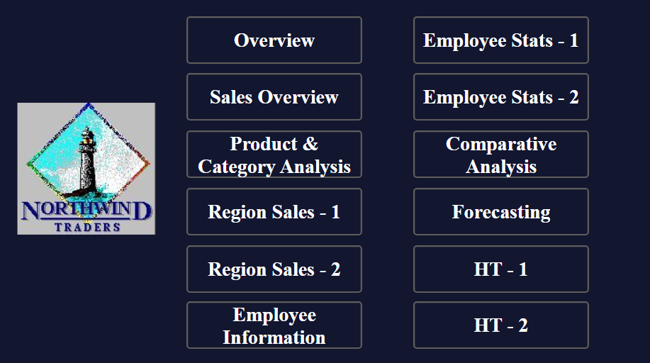
Figure 36: Screenshot of Home dashboard.
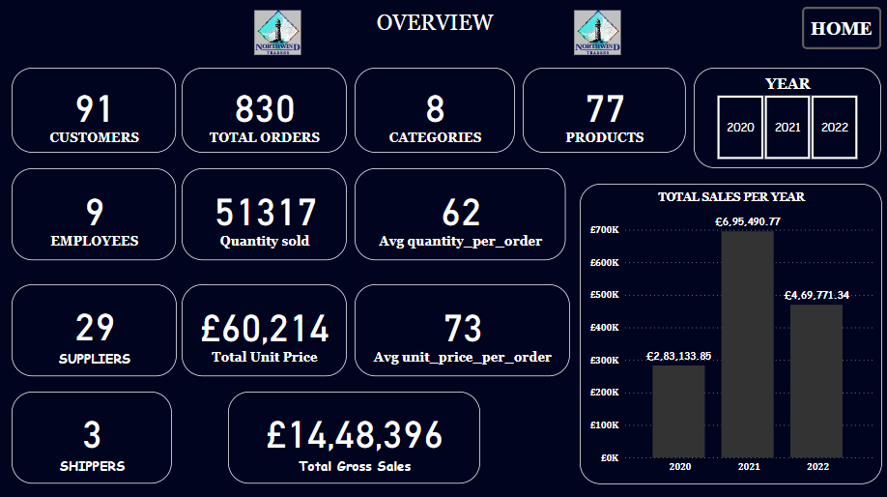
Figure 37: Screenshot of Overview dashboard.
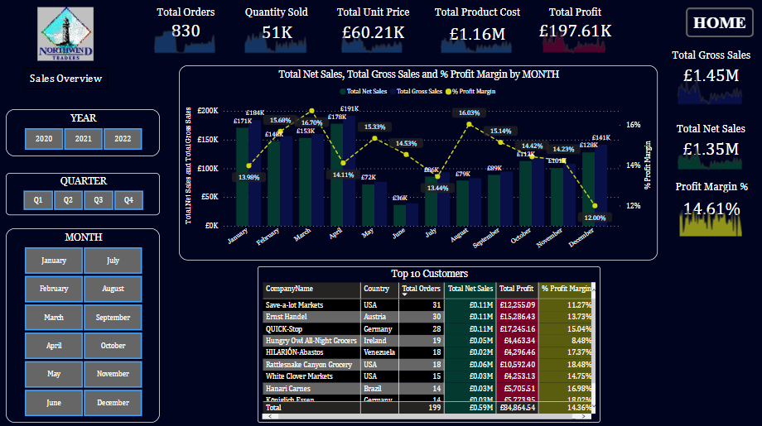
Figure 38: Screenshot of Sales Overview dashboard.
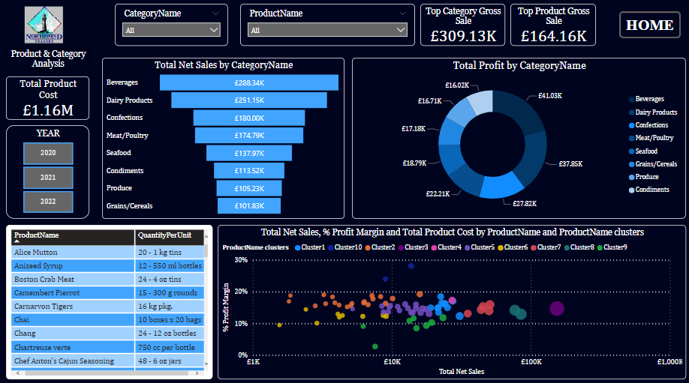
Figure 39: Screenshot of Product and Category Analysis dashboard.
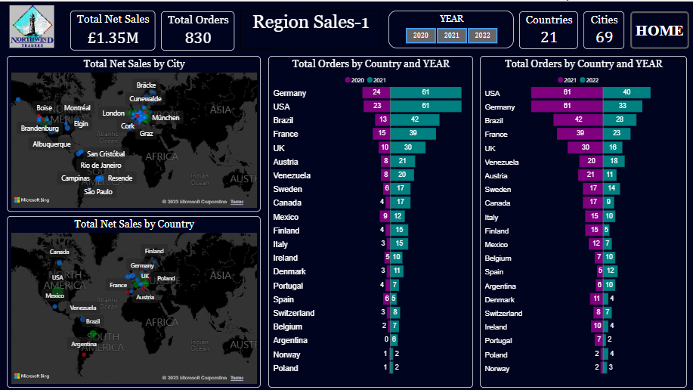
Figure 40: Screenshot of Region Sales-1 dashboard.
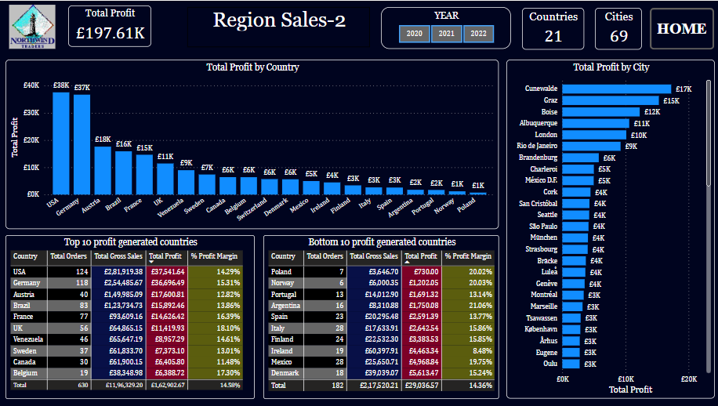
Figure 41: Screenshot of Region Sales-2 dashboard.
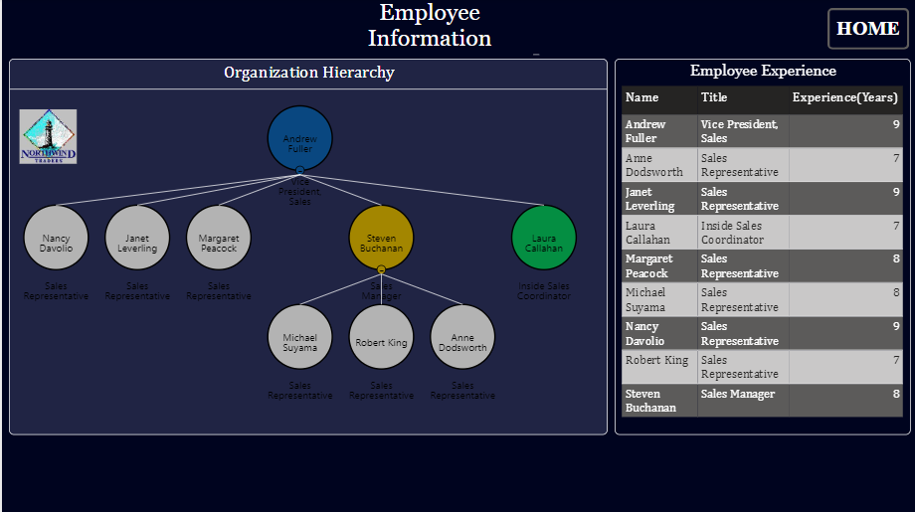
Figure 42: Screenshot of Employee Information dashboard.
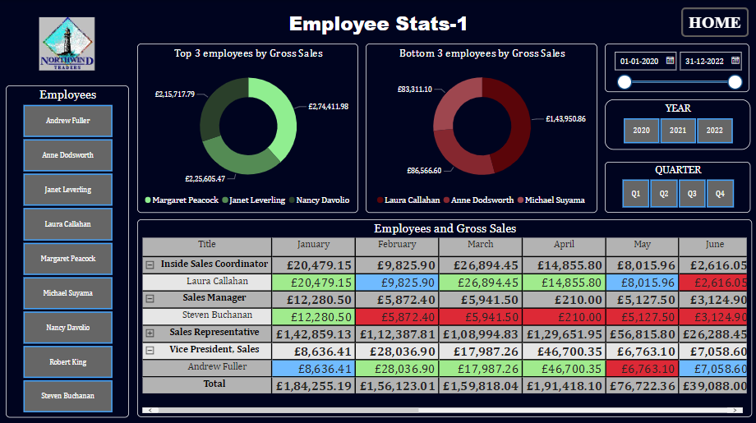
Figure 43: Screenshot of Employee Stats-1 dashboard.
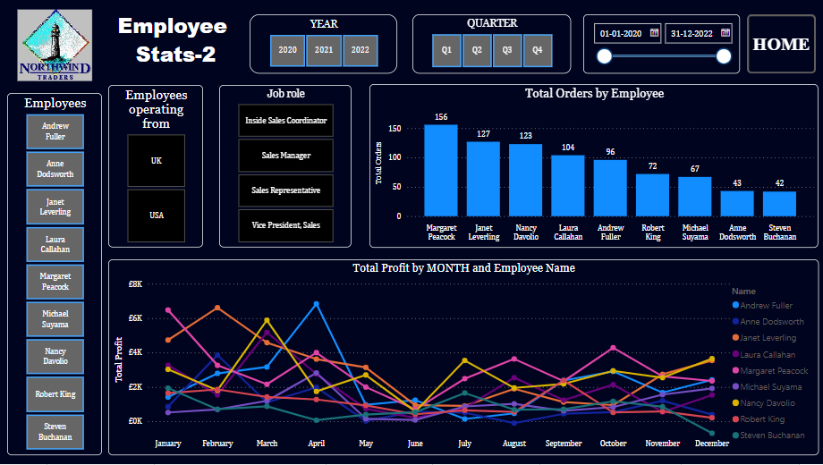
Figure 44: Screenshot of Employee Stats-2 dashboard.
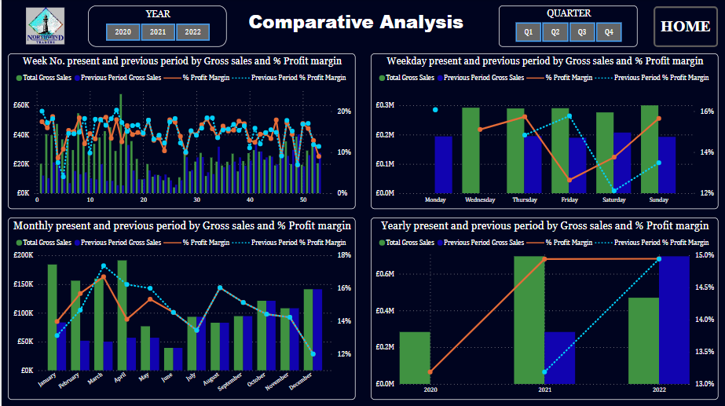
Figure 36: Screenshot of Comparative Analysis dashboard.
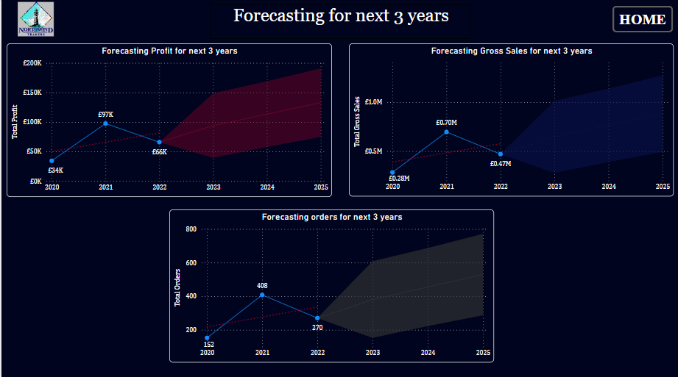
Figure 36: Screenshot of Forecasting dashboard.

The Power BI file is published into Power BI service My workspace. Can access it with the below QR code.


