**SECURE DIGITAL TICKET PASS USING QR CODE TECHNOLOGY**

**What’s the Problem Statement:** Government Of Rajasthan needs an innovative solution for the problem that they are facing while issuing bus passes.

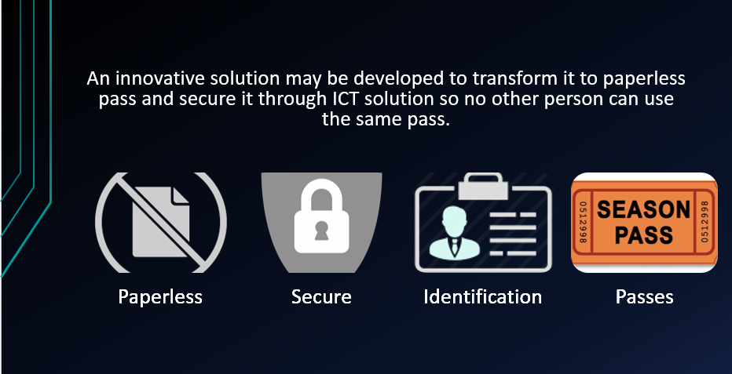

**Problems in Current System:** For creating the pass the citizen has to face a lot of difficulties as the procedure is mostly offline. Such as it is not paperless, ticket counters are not available 24*7,long queues and many more.

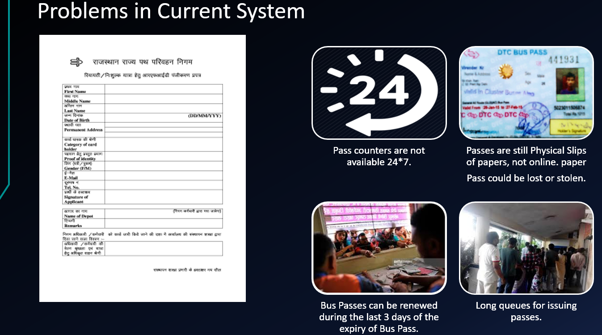

**What’s New & Extra Features In Our App:** We have included many extra features in this app. The main difference between current procedure and our design is explained below.

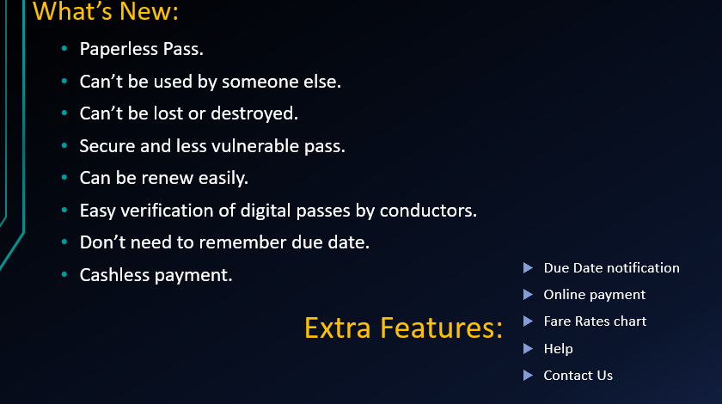

**Methodology:** Development Of Our Idea.

* We have developed a mobile application of secure ticket digital passes in which we are using QR code technology.
* For this application, there are two types of user :
  1. Bus Conductor
  2. Passenger
* A QR code will be generated for each passenger in the application who registered in it and this QR code will be unique.
* This QR code will be used to access the database which contains all the information of each passenger like name, profile photo, validity of pass etc.
* For Bus Conductors, we have provided a QR code scanner app. The use of this application to scan the QR code of passenger.
* After Scanning, it will send request to server to fetch information of respective passenger from database.
* Server will give response to this request and name, photo, origin, destination and whether the pass of passenger is valid or not will be displayed.

**Architecture:** As you can see in this architecture the process of our app.

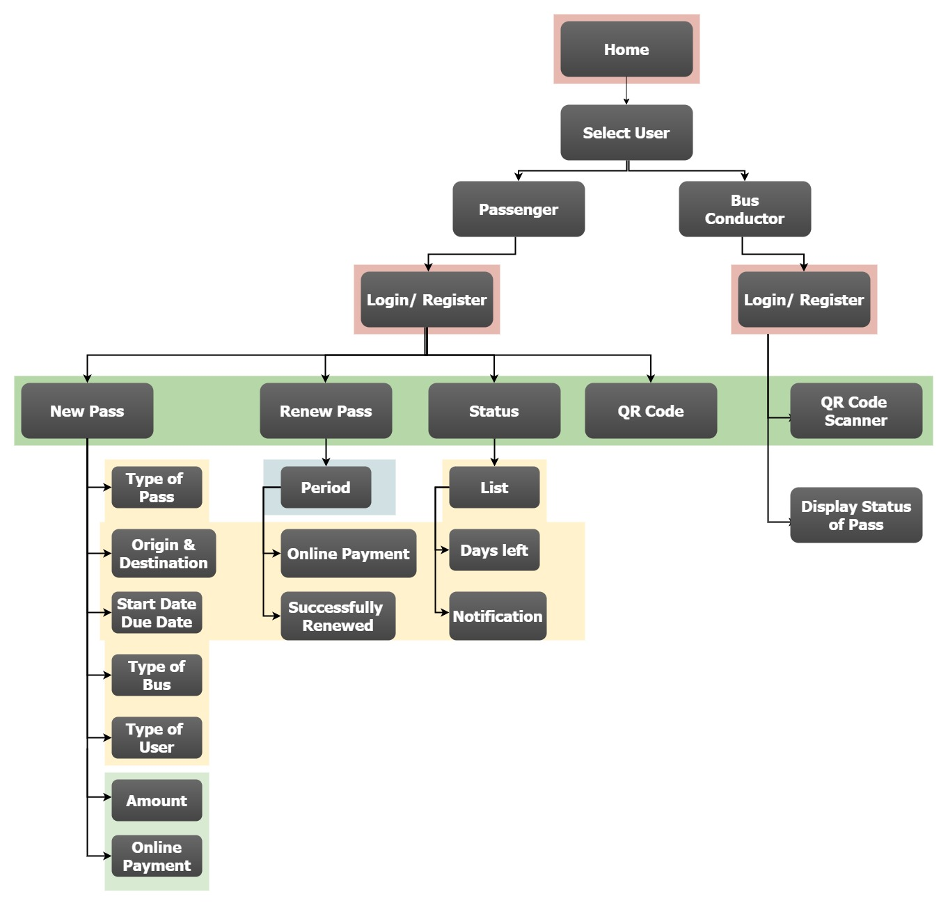

**Technology Stack:** These are the technologies that we have used for building this app.

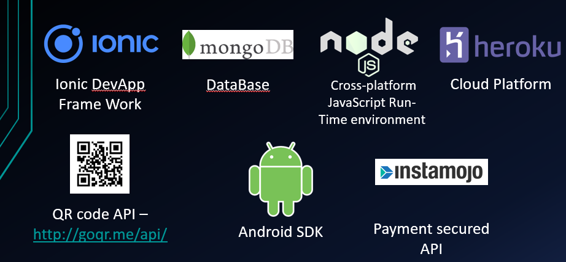

**User Experience – Passenger:** This is how passenger will experience when he opens the app. He has to choose plan, upload the necessary documents, then make a payment, his information will be uploaded in our database, then administrator will cross verifies the documents whether the information of the given person is correct or not. If the documents are correct then administrator will provide qrcode to the passenger.

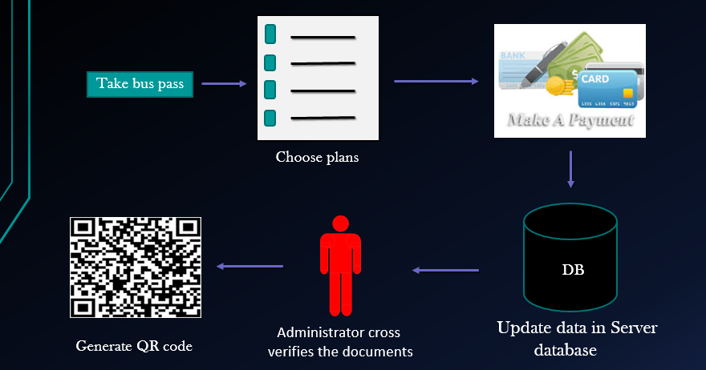

**User Experience - Conductor:** This is how conductor will experience when he opens the app, he just have to scan the QR code of the passenger and query will be searched in our database, if the passenger exists then his information will be shown in the conductor’s app.

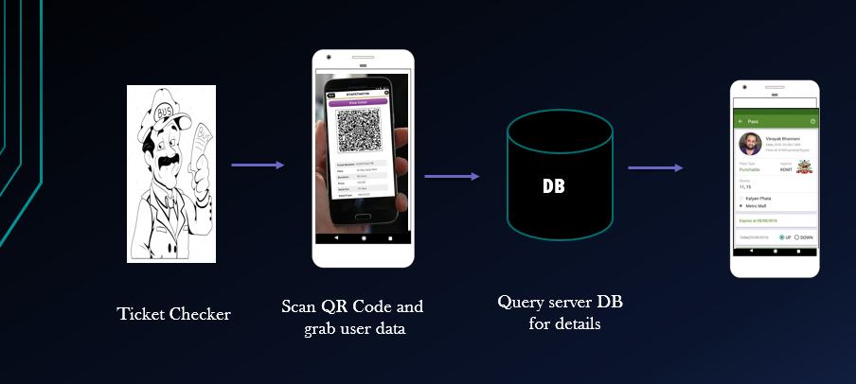

**Our Approach and Implementation:** This is what we have developed yet. User just have to click enter, if there is a new user then he must have register first. But For now use username “waff” and password”waff”.

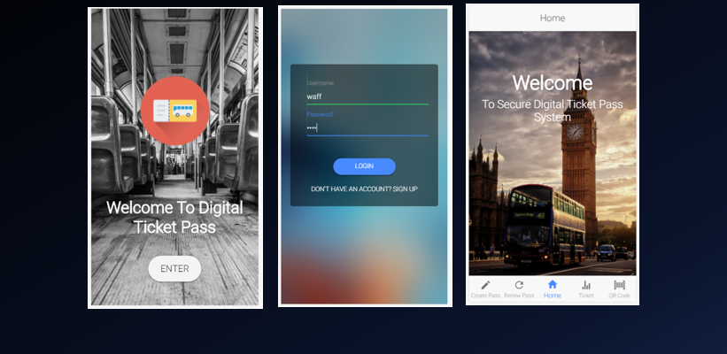

**Applying for Pass:** For applying for the pass user have to fill the form which will contains his data as you can see I the screenshot , then he has to upload four necessary documents for the pass and also a digital signature. After uploading it the user just has to make payment .Then it will proceed for further process.

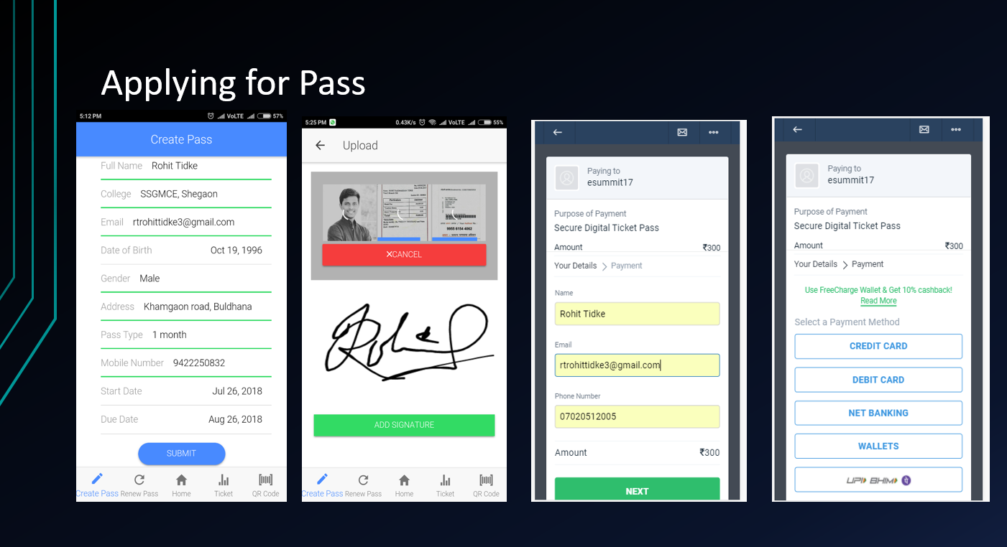

**Pass Generation and Verification:** After cross verification through the administrator QR code of the user will be generated. As you can see in the first screenshot. And the second screenshot is of the conductor app, from here he can verify whether the pass of the particular person is valid or not.

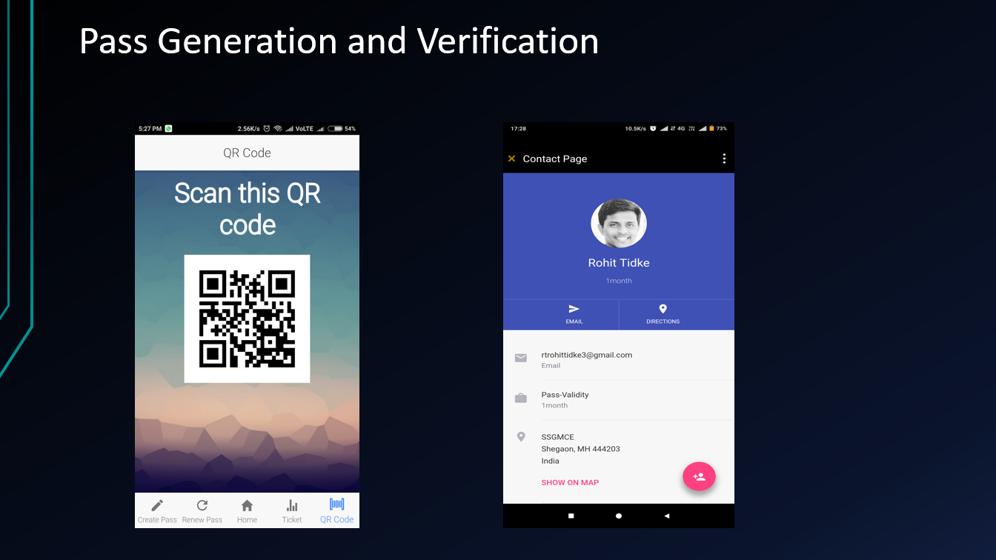

**Point to Point Ticket :** Even if someone doesn’t want a pass and just a simple ticket from one point to other then we have included that feature in our app as well. The working though is same as above.

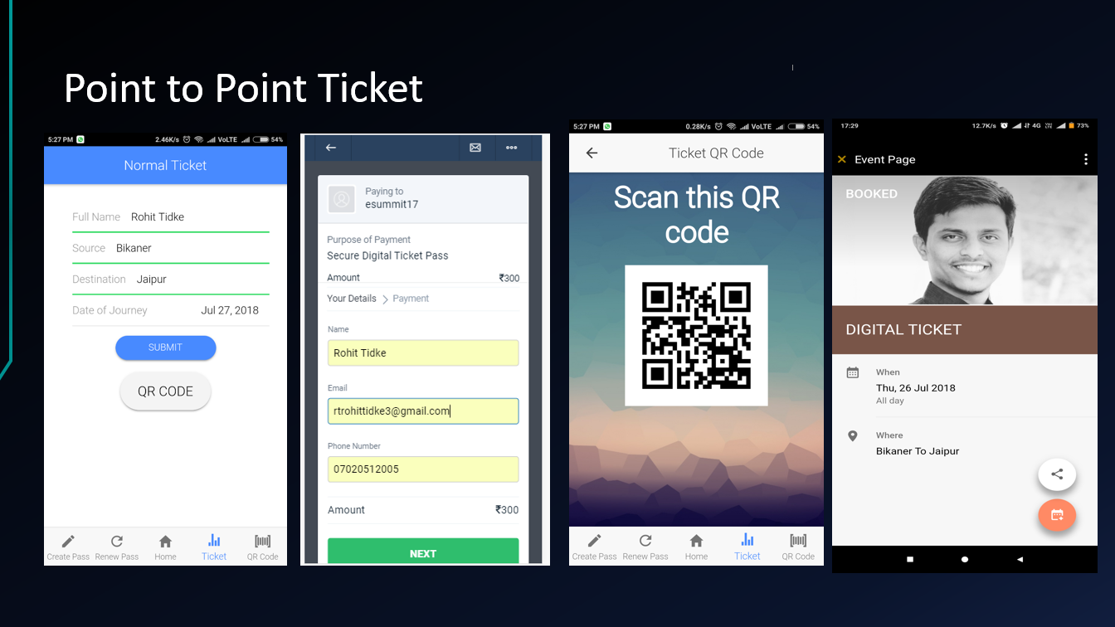

**Report Generation:** We have created a intelligent system for the administrator which shows the no. of scans of the QR code, and it also shows the location of the user from where he has scanned the QR code.

**1 For DIGITAL TICKET:**

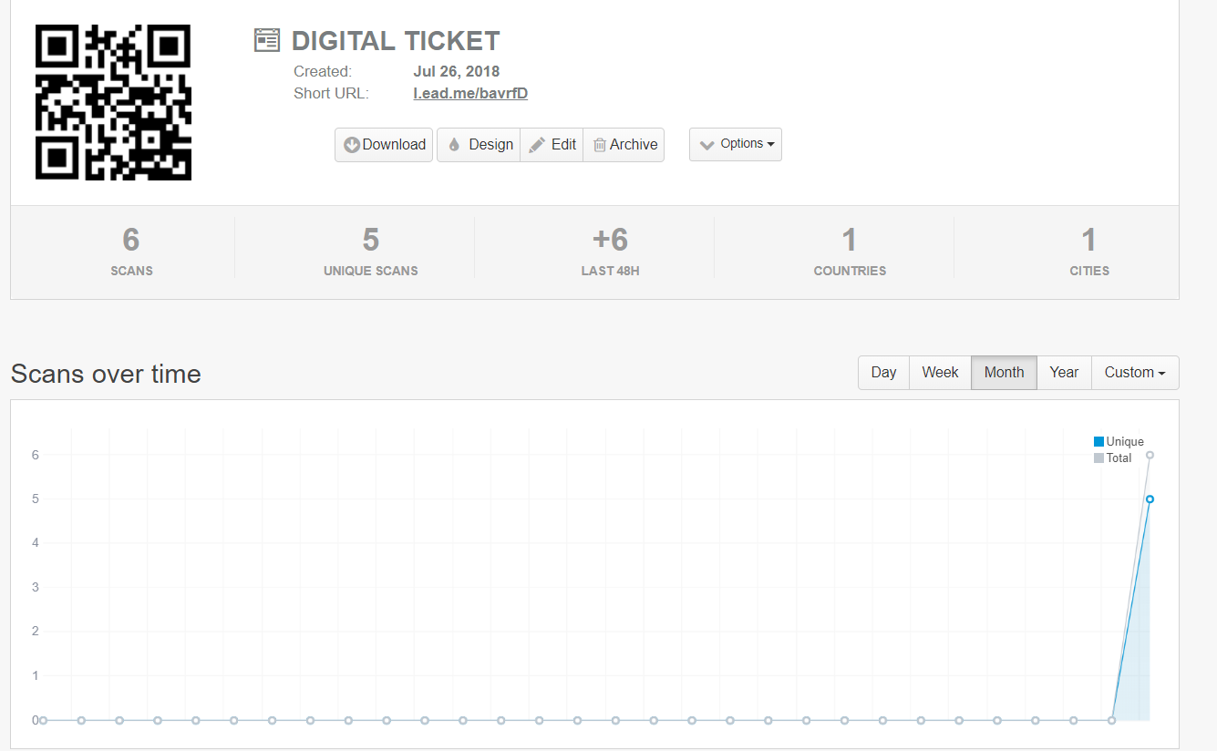

**2. FOR DIGITAL PASS:**

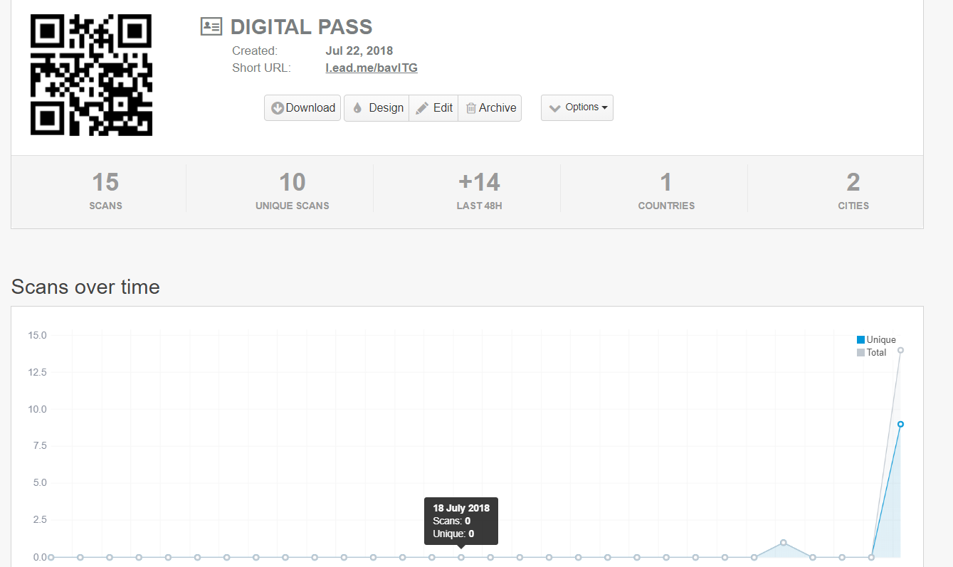

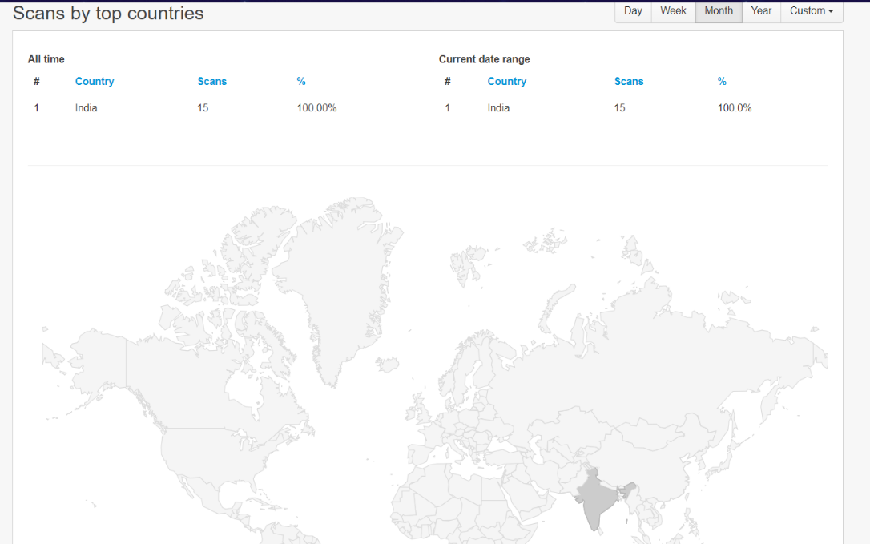

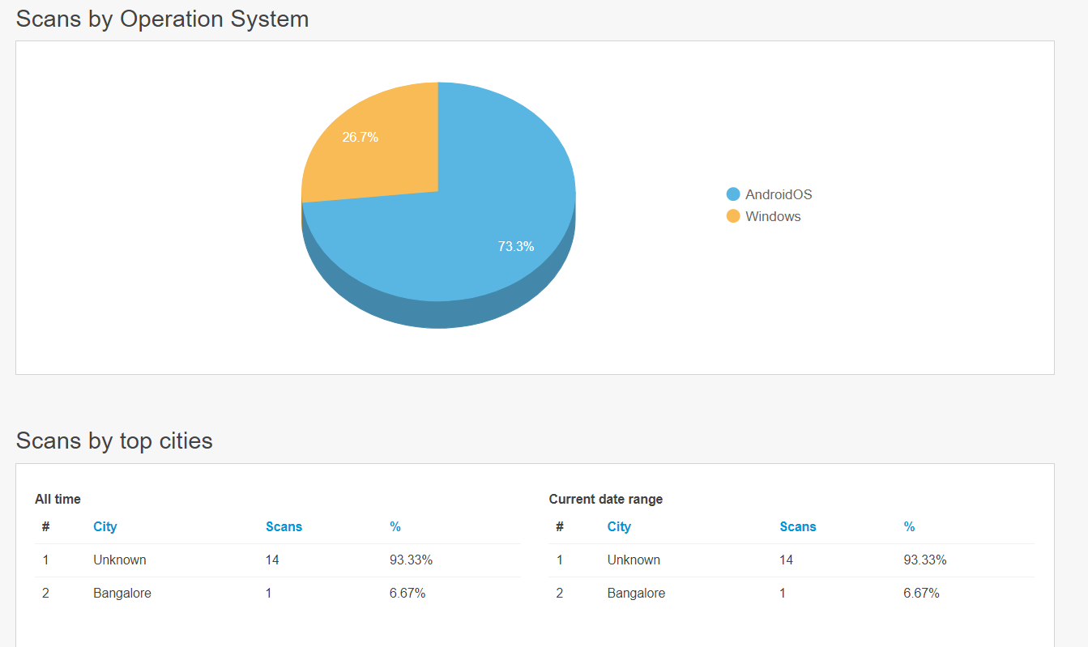

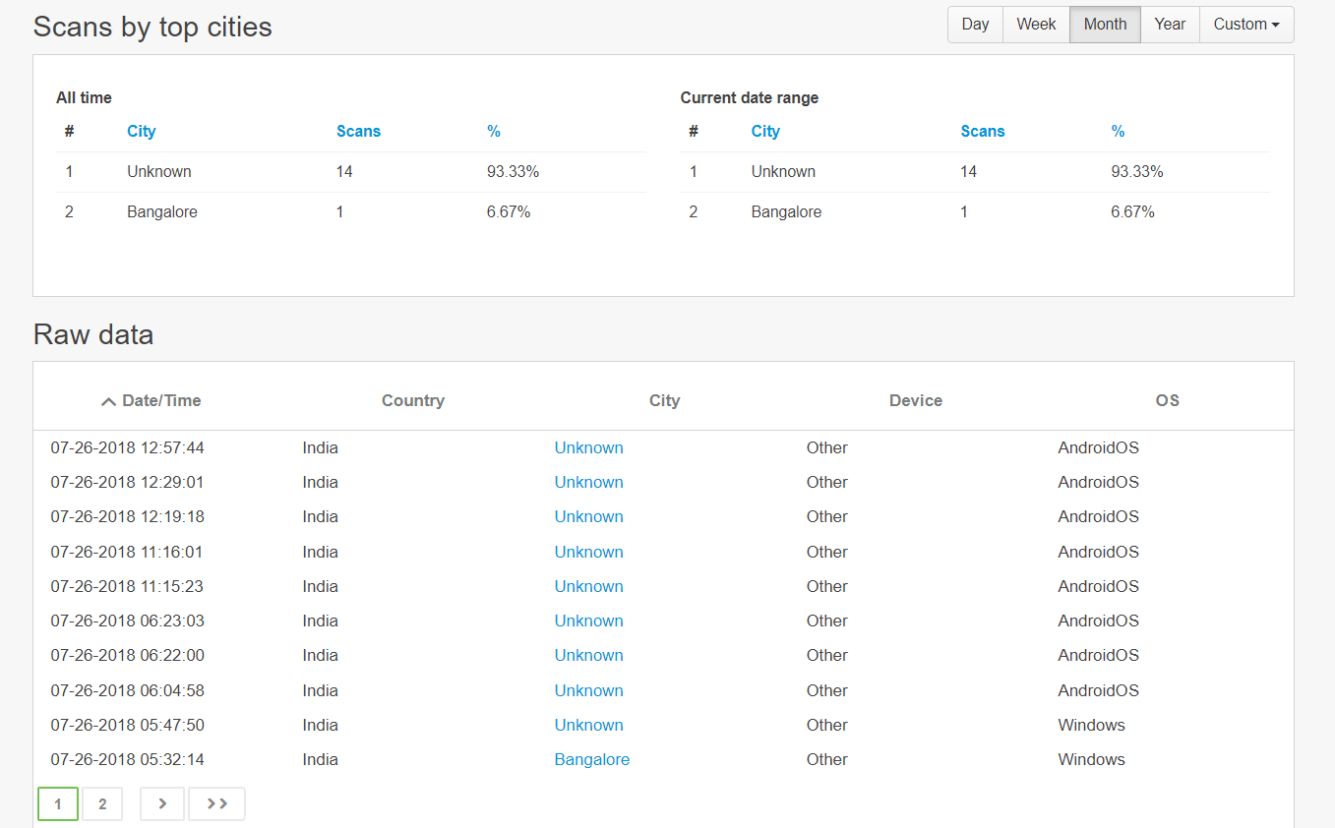

**Extension of Proposed Solution :**It can also be used for many transportation system all over the country.

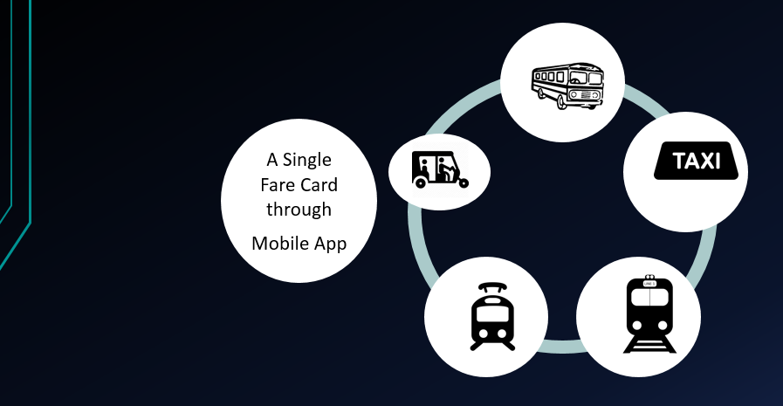

**Our Solutions Extensions:** These are the extended features that can be provided to our app.

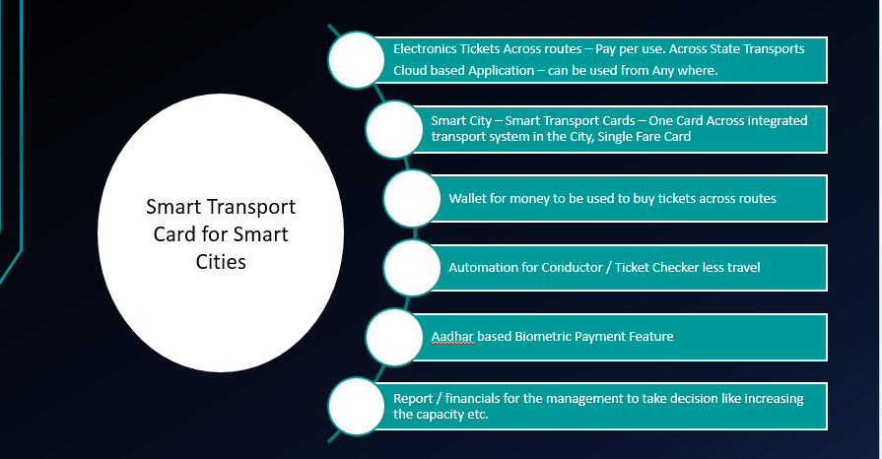

**Links:**

1. **Pricing:** SandBox Cluster 15$ Monthly

Heroku Platform 7$ Monthly(120 GB)

Instamojo Payment API 2083Rs Monthly

QR code Premium 37.50$ Monthly

Cisco Firewall(Security) 1283$ Unlimited

1. **For apk:** https://drive.google.com/drive/folders/1wkyEGbc53Mw5lfnl9WlZB9h3CMu4vw8_

