RT–DOR binding-energy calculations using free-energy perturbation (FEP)

Summary
HIV acquires resistance to doravirine through mutations in reverse transcriptase (RT). Resistance can arise in several ways — the mutation may weaken drug binding, alter the enzyme’s catalytic activity or fitness, or change the kinetics by which the inhibitor binds and the non-nucleoside pocket forms. We compute one of these contributions from physical first principles: how much a mutation changes the binding free energy of doravirine. Across the genotype panel we then ask where that change accounts for the measured resistance and where it does not.
The binding free energy sets how strongly doravirine binds into its pocket rather than staying in solution. A mutation shifts it; we compute that shift, ΔΔG_{bind}, for each mutation. It is not the whole of resistance, but it is the component binding physics can, in principle, settle rigorously, and for mutations where binding dominates it is directly comparable to the clinical fold-change.
Absolute binding free energies are hard to compute reliably; the difference between wild-type and mutant is not. We morph the wild-type residue into the mutant one atom by atom inside the simulation and measure the energetic cost — once with doravirine in the pocket, once in the empty enzyme. The difference between the two costs is the change in binding; everything common to both cancels (Figure 1; the Free Energy Perturbation (FEP) cycle is derived in Methods Section).
Both morphs run in a complete simulation of the enzyme in explicit water at physiological salt, so the buried, electrostatically sensitive pocket is modeled directly rather than approximated. We run each morph with the drug bound and drug-free, in triplicate; ΔΔG_{bind} is the bound-minus-free difference, and the three replicates give the reported mean ± standard error.
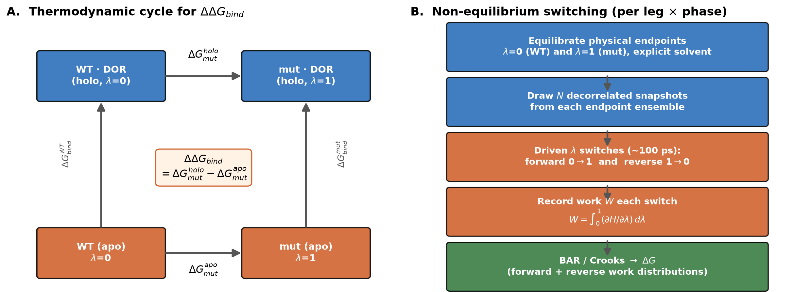
Figure 1. (A) The Free Energy Perturbation (FEP) cycle that defines ΔΔG_{bind}. (B) The non-equilibrium switching workflow, run per mutation × phase (drug-bound / drug-free) × replicate.

Results
Till now, we have computed ΔΔG_{bind} for seven of the single-residue mutations of the genotype panel; each value is the mean of three independent replicates (Table 1). Two canonical resistance mutations, V106A and Y188L, both weaken binding, with Y188L showing greater impact than V106A. However, across the seven single mutations, the rank correlation between computed ΔΔG_{bind} and fold-change in susceptibility is modest (Spearman ρ = 0.32).
Genotype | ΔΔG_{bind} (kcal/mol) | Fold-change
Y188L | +4.52 ± 0.49 | 149×
Y318F | +1.41 ± 0.45 | 11×
V106A | +1.76 ± 0.51 | 9.6×
V106M | +6.10 ± 0.16 | 3.4×
G190A | +0.27 ± 0.17 | 2.7×
Y181C | −0.66 ± 1.06 | 1.4×
V106I | +2.27 ± 0.74 | 1.1×
Table 1. Single-mutation ΔΔG_{bind} (mean ± SEM over 3 replicates), ordered by fold-change. Positive ΔΔG_{bind} = weaker binding.
Two charge-changing mutations (K103N, G190E) and all the double-mutation genotypes are still running. The correlation above is therefore preliminary and will change as the remaining genotypes are added. What the present data establish is that the calculation is reproducible — the replicate standard error is at or below ~1 kcal/mol. How far the binding contribution accounts for resistance across the complete panel is the question the finished panel will answer.

Main Limitation
The drug-free pocket is dynamic. The doravirine pocket does not exist in the empty enzyme — the drug creates it on binding — so once the drug is absent the pocket begins to collapse. Our drug-free legs start from a bound-like, open-pocket conformation and are equilibrated for ~5 ns, so they sample the pocket part-way through that collapse rather than at equilibrium; this is the largest source of uncertainty in the cycle. Every drug-free leg starts from the same wild-type apo ensemble, so error in that shared baseline is common to all mutations and cancels when we rank them, while the mutation-specific reshaping of the collapsing pocket does not. One lever to overcome this limitation is sampling: seeding the drug-free endpoint from long unliganded trajectories (100 ns and beyond) so its ensemble reaches the true collapsed state, rather than the short equilibration used so far (see Next Steps).

Next steps
- Charge-changing mutations (K103N, G190E). These change the net charge, which distorts electrostatics in a periodic box if handled naively. We have implemented a scheme in which, as the mutation removes a unit of charge, one distant counter-ion is simultaneously discharged, so the box stays neutral throughout the morph and its identical contribution cancels between the drug-bound and drug-free legs. Both charge legs are running under this protocol; validation — confirming the result is independent of which distant ion is chosen — is in progress.
- Timescale test. For a representative mutation we will seed the morph from longer trajectories (the 100 ns runs already available, and longer if warranted) instead of the short endpoint equilibration, and check whether ΔΔG_{bind} moves — the same logic as the switch-length test in Methods section, applied to the sampling timescale.
- Panel completion. Finish the single mutations, then the double mutation genotypes (a test of whether individual mutation effects add), then the full comparison against experiment.

Methods
Free-energy calculations have guided NNRTI inhibitor design and RT–inhibitor modeling for two decades (Rizzo et al., 2000; Zeevaart et al., 2008); the non-equilibrium mutation protocol used here has been benchmarked on large protein-mutation and protein–ligand datasets (Aldeghi et al., 2018; Gapsys et al., 2020) and applied to inhibitor resistance (Aldeghi et al., 2019).

The Free Energy Perturbation (FEP) cycle
The change in binding free energy on mutation is the difference of two binding free energies — wild-type and mutant. Computing either absolute binding free energy would mean reversibly removing the drug from the pocket, which is slow and poorly converged. The FEP cycle avoids it: because free energy is a state function, going around the closed cycle sums to zero, which lets us replace the two physical binding steps with two computational mutation steps — one in the drug-bound enzyme, one in the drug-free enzyme:
The intractable absolute binding terms cancel exactly, leaving two transformations we can compute (drug vs no drug and mut vs WT).

Why we drive the transition instead of equilibrating it
To morph wild-type into mutant we introduce a coupling coordinate λ that runs from 0 (wild-type) to 1 (mutant); intermediate λ is a hybrid, part one residue and part the other. The free-energy difference we want is a property of the two equilibrium endpoints.
The textbook equilibrium route holds the system at a ladder of fixed λ values, equilibrates each, and adds the increments. Its weakness is that it must converge the intermediate, unphysical states — the partly-morphed residues — and for a buried, tightly packed pocket these are exactly the states that equilibrate slowly. Our own fixed-λ attempt on this system failed to converge for that reason.
The non-equilibrium route avoids this. We equilibrate only the two physical endpoints, then drive λ from 0 to 1 rapidly and repeatedly, recording the work W done on the system in each switch; no intermediate state is ever asked to equilibrate. The price is that a fast switch is irreversible and does more work than the free-energy difference, ⟨W⟩ ≥ ΔG (the second law of thermodynamics), with equality only for an infinitely slow switch — the surplus is dissipated energy. Two results turn those irreversible switches back into an exact free energy.

Jarzynski’s equality — an exact free energy from irreversible work
Jarzynski (1997) showed that the equilibrium free-energy difference is recovered exactly from the exponential average of the non-equilibrium work, at any switching speed. This is a strong statement: although every individual switch dissipates energy and ⟨W⟩ > ΔG, the ensemble of switches encodes the exact reversible free energy. The intuition is in the exponential weight. The factor e^{-W/kT} up-weights the rare switches in which the system happened to do unusually little work — trajectories where thermal fluctuations transiently assisted the morph, so that W dipped below its average and even below ΔG. Those rare favorable events carry the free-energy information; the typical, dissipative switches contribute little. In effect, fluctuations do occasionally, and reversibly, what an infinitely slow pull would do every time.
That same feature is the practical catch: because the average is dominated by rare low-work trajectories, a one-directional estimate has high variance and a finite-sample bias. Jarzynski’s equality tells us the information is present in fast switches, but using it in one direction alone is inefficient. The fix is to use both directions.

Crooks fluctuation theorem and Bennett Acceptance Ratio (BAR) — reading the free energy where the Work distributions meet
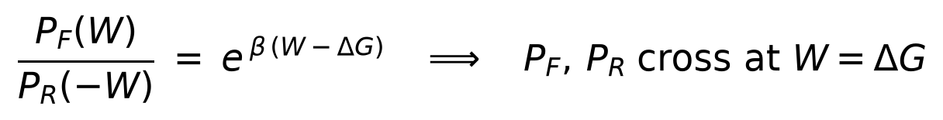
Running the morph forward (wild-type → mutant) and in reverse (mutant → wild-type), Crooks (1999) related the two work distributions. Setting W = ΔG makes the right-hand side one, so the forward and reverse work distributions cross exactly at the free energy. Instead of chasing the rare tail of a single distribution, we locate ΔG at the crossing point of two distributions, which sits near their well-sampled bulk — a far more robust, low-bias handle. It also provides a direct visual measure of convergence, the overlap of the two distributions: wide overlap means the driving is gentle relative to thermal energy and ΔG is well determined; poor overlap signals large dissipation and the need for more or longer switches.
The Bennett acceptance ratio (BAR; Bennett, 1976) is the statistically optimal way to combine the forward and reverse work consistent with the Crooks relation — the minimum-variance estimator of ΔG, obtained as the self-consistent solution of
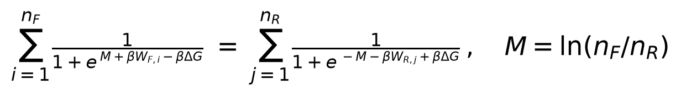
which weights each switch by how much free-energy information it carries. Because BAR uses both directions and weights optimally, it converges with far fewer switches, and far less bias, than the one-directional average — this is what makes the non-equilibrium approach accurate at a practical number of switches. As an internal check, BAR, the Crooks-Gaussian intersection, and the Jarzynski average agree to within ~0.4 kcal/mol on our data.
Why this is more reliable here than equilibrium approaches. End-point rescoring of a single trajectory (e.g. our previous MM/GBSA approach; Zhang et al., 2010) omits configurational entropy and treats solvent implicitly, and its errors are systematic and uncalibrated, precisely in the small-difference regime where ranking lives. Equilibrium λ-window FEP (e.g. FEP+; Wang et al., 2015) is a genuine free energy, but it stakes the whole answer on converging unphysical intermediate states, which can introduce artifacts for a buried pocket. The non-equilibrium route asks only the two physical endpoints to equilibrate, recovers the exact free energy through the theorems above, and — through the forward/reverse overlap — carries its own convergence diagnostic and honest error bars.

Protocol and convergence
- System: the complete RT enzyme, explicit water, physiological salt, periodic boundaries with particle-mesh-Ewald electrostatics; a modern fixed-charge protein force field and an open small-molecule force field for doravirine.
- Morph: a dual-state (wild-type↔mutant) hybrid residue (Gapsys et al., 2015) seeds both endpoints. Endpoint equilibration is a soft-core minimization, a short constant-pressure warm-up (Bernetti & Bussi, 2020), and a production run that supplies the switching snapshots; protein and solvent are thermostatted separately.
- Switching: ~100 decorrelated snapshots per endpoint per replicate, switched forward and reverse; ΔG per leg by BAR; ΔΔG_{bind} = ΔG(drug-bound) − ΔG(drug-free); three replicates give mean ± SEM.
- Convergence is checked four independent ways: (1) the running BAR estimate plateaus well before the full switch count; (2) BAR, Crooks-Gaussian, and Jarzynski agree to ~0.4 kcal/mol; (3) three replicates give a standard error below 1 kcal/mol; (4) increasing the switch time fivefold leaves ΔΔG statistically unchanged (V106A +1.69 ± 0.70 → +1.76 ± 0.51), confirming independence from driving speed — so the panel runs at the cheaper setting with no loss of accuracy.
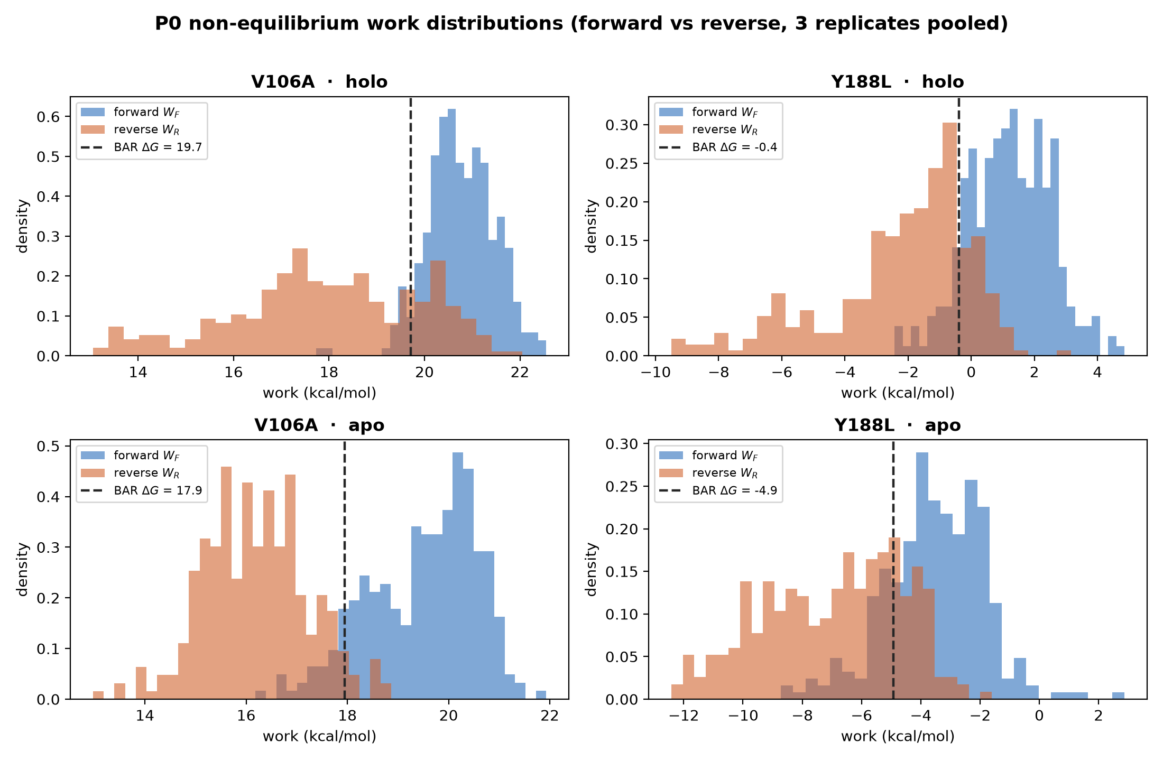
Figure 2. Forward and reverse work distributions for V106A and Y188L mutations (3 replicates pooled). As required by the Crooks theorem, the two distributions cross at the BAR ΔG (dashed line).
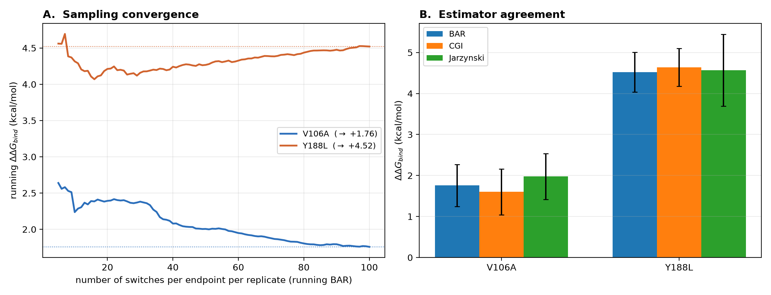
Figure 3. (A) The running BAR estimate of ΔΔG_{bind} plateaus as switches accumulate. (B) The three estimators agree for both pilot mutations.

References
1. Jarzynski, C. Nonequilibrium equality for free energy differences. Phys. Rev. Lett. 1997, 78, 2690–2693.
2. Crooks, G. E. Entropy production fluctuation theorem and the nonequilibrium work relation for free energy differences. Phys. Rev. E 1999, 60, 2721–2726.
3. Bennett, C. H. Efficient estimation of free energy differences from Monte Carlo data. J. Comput. Phys. 1976, 22, 245–268.
4. Gapsys, V.; Michielssens, S.; Seeliger, D.; de Groot, B. L. pmx: Automated protein structure and topology generation for alchemical perturbations. J. Comput. Chem. 2015, 36, 348–354.
5. Aldeghi, M.; Gapsys, V.; de Groot, B. L. Accurate estimation of ligand binding affinity changes upon protein mutation. ACS Cent. Sci. 2018, 4, 1708–1718.
6. Aldeghi, M.; Gapsys, V.; de Groot, B. L. Predicting kinase inhibitor resistance: physics-based and data-driven approaches. ACS Cent. Sci. 2019, 5, 1468–1474.
7. Gapsys, V.; et al. Large scale relative protein–ligand binding affinities using non-equilibrium alchemy. Chem. Sci. 2020, 11, 1140–1152.
8. Bernetti, M.; Bussi, G. Pressure control using stochastic cell rescaling. J. Chem. Phys. 2020, 153, 114107.
9. Zhang, J.; Hou, T.; Wang, W.; Liu, J. S. Detecting and understanding combinatorial mutation patterns responsible for HIV drug resistance. Proc. Natl. Acad. Sci. U.S.A. 2010, 107, 1321–1326.
10. Rizzo, R. C.; Wang, D.-P.; Tirado-Rives, J.; Jorgensen, W. L. Validation of a Model for the Complex of HIV-1 Reverse Transcriptase with Nonnucleoside Inhibitor TMC125. J. Am. Chem. Soc. 2000, 122, 12898–12900.
11. Zeevaart, J. G.; Wang, L.; Thakur, V. V.; Leung, C. S.; Tirado-Rives, J.; Bailey, C. M.; Domaoal, R. A.; Anderson, K. S.; Jorgensen, W. L. Optimization of azoles as anti-HIV agents guided by free-energy calculations. J. Am. Chem. Soc. 2008, 130, 9492–9499.
12. Wang, L.; et al. Accurate and reliable prediction of relative ligand binding potency in prospective drug discovery by way of a modern free-energy calculation protocol and force field (FEP+). J. Am. Chem. Soc. 2015, 137, 2695–2703.

