S1. Finite-size corrections for the charge-changing legs. The leading periodicity (net-charge self-energy) term of the Rocklin scheme is +0.0407 kcal/mol per phase and cancels to below 0.0001 kcal/mol in ΔΔGbind for both WT→K103N and WT→G190E. The higher-order terms — net-charge undersolvation, discrete-solvent and residual integrated potential — were not applied, since computing them exactly requires a Poisson-Boltzmann treatment of each environment. They are bounded instead by cancellation: each depends on the net charge, the box, the solvent density and the solute excluded volume; the charge change is identical in the holo and apo phases by construction; and the cells are matched to within 0.13% (K103N) and 0.31% (G190E) in volume, with DOR occupying 0.019% of the cell. Taking a per-phase correction of 1 kcal/mol, about 25 times the leading term, the residual on ΔΔGbind is at most 0.003 kcal/mol — two to three orders of magnitude below the 0.2–1.2 kcal/mol per-leg statistical uncertainties in Table 2.
S2. Effect of the ligand charge model. DOR parameters were generated with Gasteiger partial charges. To test how much that choice matters, the same trajectories and snapshots were re-scored with AM1-BCC charges under an otherwise identical protocol, so the charge set is the only difference. The two charge sets are both neutral and correlate at 0.890, but AM1-BCC is more polarised (mean |q| 0.228 e against 0.138 e; RMS difference 0.165 e, maximum 0.390 e), with the largest differences on the triazolinone and pyridinone carbonyl and amide atoms. Supplementary Table 6 reports the comparison. [PENDING: extended to all genotypes; correlation of each charge model with phenotype to follow]
S3. Snapshot relaxation protocol. Each snapshot is energy-minimized before its energy is evaluated. We compared hydrogen-only relaxation, with heavy atoms restrained, against the unrestrained full minimization used in the main text, for all 19 mutant genotypes (Supplementary Table 5). The two protocols agree on the terms that do not depend on close atomic contacts: the Spearman correlation between them is 0.69 for ΔΔEelec and 0.81 for ΔΔEGB. They do not agree on ΔΔEvdW (0.26), nor on ΔΔETotal (0.09), which ΔΔEvdW dominates. The disagreement is not only noise. Under hydrogen-only relaxation F227C gives ΔΔETotal = -8.89 ± 0.19 kcal/mol, against +1.15 ± 0.31 under full minimization, and four other genotypes behave the same way. Hydrogen-only relaxation leaves heavy-atom contacts in place, and those contacts enter the van der Waals term. The two protocols also differ in direction against phenotype. Over the 13 genotypes with an established phenotype, ΔΔETotal from full minimization correlates with log10 fold reduction at Spearman +0.45 (p = 0.13), while hydrogen-only relaxation gives -0.32 (p = 0.29). Neither reaches significance. The only correlation that does is ΔΔEelec under full minimization, at +0.63 (p = 0.02); eight correlations were examined, so this would not survive a correction for multiple comparisons. Full minimization is therefore not one workable option among several: ΔΔETotal is not interpretable until the contacts are relieved. Single-point evaluation, with no relaxation at all, was also tested on six genotypes. It is dominated by a small number of snapshots carrying steric contacts, reaching 7 × 10⁸ kcal/mol in the worst case, and the effect depends on the genotype: in wild type none of the 100 scored snapshots exceeds +100 kcal/mol, while in G190E half of them do.
S4. The unliganded (apo) pocket. The NNIBP is not an open cavity in RT on its own. DOR has to open it, and that costs free energy. The thermodynamic cycle introduces each mutation twice, once in the DOR-bound state and once in the unliganded state. A mutation that changes the cost of opening the pocket therefore changes both legs in the same direction, and the two changes largely cancel in ΔΔGbind. We ran apo simulations for wild type and seven genotypes. Wild-type apo is 10 ns, so every apo trajectory was cut to a matched 10 ns window for comparison. Supplementary Table 7 gives the unliganded pocket volume on that window beside the bound-state volume from Table 3. Every apo pocket is smaller than its bound counterpart. The difference between the two states is larger than wild type (137 Å³) for the three genotypes whose ΔΔGbind misses the phenotype: G190E (242 Å³), V106I+F227C (178 Å³) and A98G+F227C (176 Å³).
Supplementary Figures
A) B)
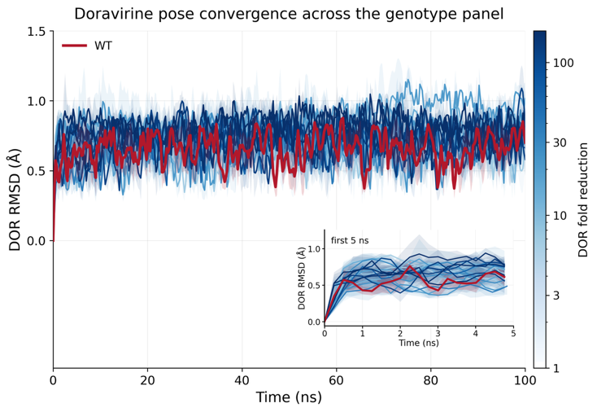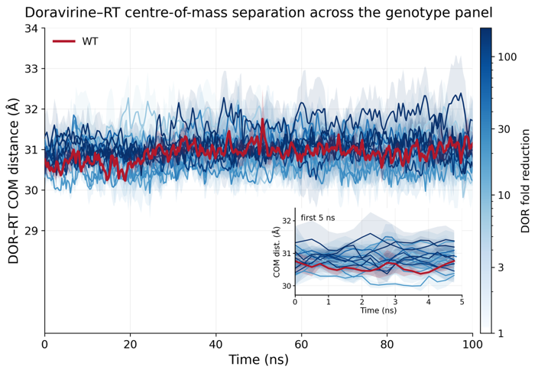
Supplementary Figure 1. DOR Root Mean Squared Deviation (RMSD) and distance between centers of mass (COM) of DOR and RT indicate 100ns runtime is sufficient for DOR-RT interactions to stabilize.
(A) Each solid line provides the average RMSD of the DOR heavy atoms vs the minimized structure within the NNIBP (at t = 0) computed at each time point across triplicate simulations. Shaded regions represent the standard error this mean (SEM). The red curve represents WT and the remaining trajectories are color-coded based on the respective genotype’s fold-change in susceptibility (Table 1 in main text). Inset shows the same data highlighting the rapid changes in the first 5ns of the simulations. (B) Similar plot for the average distance between the centers of mass (COM) of DOR and RT atoms.

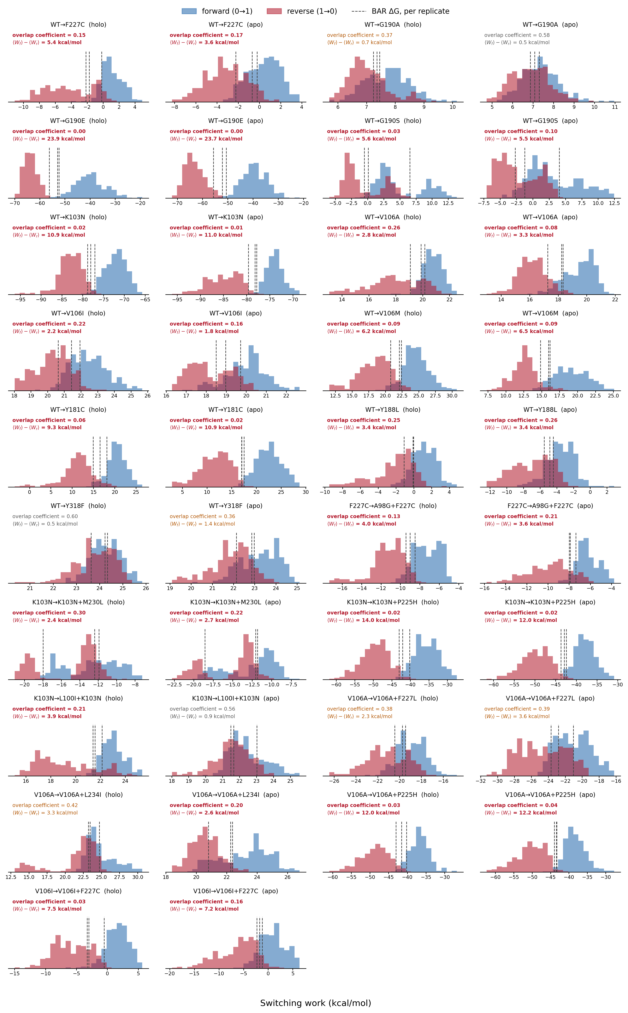
Supplementary Figure 2. Non-equilibrium switching work distributions for all alchemical transformations.
Forward (0→1, blue) and reverse (1→0, red) switching work for each of the 19 alchemical legs, shown separately for the holo and apo phases and pooled across three independent replicates (100 switches per direction per replicate). Dashed lines mark the BAR free energy, ∆G, of each replicate. Each panel reports the forward/reverse overlap coefficient — the shared area under the two normalized work densities, where 0 is disjoint and 1 identical — and the hysteresis ⟨W_{f}⟩ − ⟨W_{r}⟩, which measures the work dissipated by switching at finite speed. Annotations are colored red below an overlap of 0.3 and amber below 0.5. Compound genotypes are reached by two sequential legs, both shown.

Supplementary Figure 3. Convergence diagnostics. Block averages over the production trajectories, together with integrated autocorrelation times estimated by Geyer's initial positive sequence and the resulting effective sample sizes, for six structural observables across all 60 holo replicates. Median autocorrelation times are 1.0–3.7 ns, giving a median effective sample size of 14–50 per 100 ns replicate; per-genotype median values range from 8 (V106M) to 73 (F227C). These bound the precision of the reported replicate means. They do not establish that the sampled basin is the only relevant one: an autocorrelation time measures motion within the basin a replicate occupies, so a trajectory that never leaves its starting basin can show a short correlation time and a healthy effective sample size regardless.
Supplementary Figure 4. Protein-level conformational analysis. Per-residue Cα RMSF after superposition on the NNIBP-lining residues, and three-state secondary structure by DSSP, both referenced to wild type across the panel. Regional RMSF changes reach at most 0.25 Å, in the primer grip (225–235) and the β9–β10 sheet for Y181C and G190S, and secondary structure is essentially unchanged throughout, the largest shift being G190E losing 0.08 of strand character at the NNIBP lining. No genotype remodels the fold in the bound state, which indicates that the differences in Table 3 are local to the DOR interface rather than consequences of broader conformational change.
Supplementary Figure 5. Apo and holo NNIBP volume distributions. Per-frame pocket volume for the bound state over full production, and for the unliganded state over a matched 10 ns window. The wild-type apo trajectories are 10 ns and set that window. The unliganded pocket is much smaller than the bound pocket in every genotype; per-genotype values are given in Supplementary Table 7. In all three G190E apo simulations RT became extended, after 18.5, 23 and 71 ns, with the chain spanning more than the box edge while every covalent bond stayed intact at 1.2 Å. Those frames are excluded. The matched 10 ns window comes before the change in every replicate, and no holo trajectory behaves this way.

