Supporting Information
Molecular Simulation of Doravirine Resistance in HIV-1 Reverse Transcriptase
Rohit Satija, Kaiming Tao, Robert W. Shafer
Division of Infectious Diseases, School of Medicine, Stanford University, Stanford, CA, USA
Corresponding author: rsatija@stanford.edu

Contents
1 Is the RT-DOR crystal structure representative of the true RT-DOR structural ensemble?
2 Sensitivity of the MM/GBSA energies to the ligand charge model
3 The crystallographic pose is recovered from perturbed starting poses
4 Convergence of the molecular dynamics ensemble
5 Sensitivity of the MM/GBSA energies to the snapshot relaxation protocol
6 Non-equilibrium switching work distributions
7 Finite-size corrections for the charge-changing alchemical legs
8 Protein-level conformational analysis
9 Conformation of the unliganded binding pocket

1. Is the RT-DOR crystal structure representative of the true RT-DOR structural ensemble?
We address this question in two steps: first by comparing the DOR pose in the crystal structure (PDB ID: 4NCG) with a second, independent WT RT–DOR–DNA ternary structure determined by cryo-EM (PDB ID: 7Z2G), and then by comparing key NNIBP residues across published RT–NNRTI structures. The 3.65 Å cryo-EM structure 7Z2G contains RT bound to a 38-mer DNA aptamer and DOR and was determined independently of the 2.58 Å X-ray structure 4NCG. We superposed the structures using 16 corresponding NNIBP-lining Cα atoms: fifteen in p66 and Glu138 in p51. Following this alignment, the DOR heavy-atom RMSD was 0.62 Å across its 29 heavy atoms, and its centroid differed by 0.30 Å between structures (Supplementary Figure 1A). The pocket-lining Cα RMSD was 0.49 Å, and the median per-residue side-chain heavy-atom RMSD was 0.80 Å. The calculated NNIBP volumes were 198 Å³ in 4NCG and 194 Å³ in 7Z2G. Finally, we compared the minimum heavy-atom distance from each of the sixteen NNIBP residues to DOR. The median absolute difference between structures was 0.16 Å, the largest absolute difference was 0.41 Å at Lys103, and the distances were strongly correlated across residues (r = 0.974; Supplementary Table 7).
To place the agreement between the two DOR-bound structures in context, we compared them with three WT RT–NNRTI structures using the same pocket alignment: RPV (PDB ID: 2ZD1, 1.80 Å), EFV (PDB ID: 1FK9, 2.50 Å) and NVP (PDB ID: 1VRT, 2.20 Å). Tyr181 adopts a similar rotamer in the two DOR-bound structures but a different rotamer in the other three complexes. Relative to 4NCG, its χ1 angle differs by 93°, 95° and 90° in the RPV-, EFV- and NVP-bound structures, respectively, with corresponding ring-centroid displacements of 4.9, 4.2 and 4.2 Å (Supplementary Figure 1B). Tyr188 shows smaller differences: relative to 4NCG, its χ1 angle differs by 13–20° and its ring centroid by 1.3–2.6 Å in the other four structures (Supplementary Figure 1C). The calculated NNIBP volumes range from 181 to 258 Å³ across the five structures (Supplementary Table 7). Thus, the two independently determined DOR-bound structures share a similar local binding geometry, including a Tyr181 rotamer distinct from those observed with the other NNRTIs. The starting geometry of this work is therefore a property of the DOR–RT complex rather than an artifact of one crystal form.

Supplementary Figure 1. The DOR-NNIBP pose is reproducible across independently determined RT-DOR structures. (A) Doravirine in the two independent experimental structures, 4NCG (X-ray, 2.58 Å, grey) and 7Z2G (cryo-EM, 3.65 Å, blue), with the 4NCG pocket side chains in faint grey; heavy-atom RMSD 0.62 Å over 29 atoms. (B) Tyr181 in five NNRTI complexes: 4NCG (grey) and 7Z2G (blue) against rilpivirine 2ZD1 (red), efavirenz 1FK9 (orange) and nevirapine 1VRT (purple). The two DOR structures agree with each other and differ from the other three by 90–95° in χ1. (C) Tyr188 in the same five structures, which share one rotamer and differ by only 13–20°. Doravirine from 4NCG is drawn faintly in (B) and (C) for orientation.

2. Sensitivity of the MM/GBSA energies to the ligand charge model
DOR parameters for the equilibrium MD simulations were generated with Gasteiger partial charges, as opposed to AM1-BCC for the FEP simulations. To test how much that choice matters, the same trajectories and snapshots were re-scored with AM1-BCC charges for wild type and four genotypes, chosen to span the panel's sensitivity to the charge assignment: G190E and K103N+M230L, where the electrostatic and generalised-Born terms contribute most to ΔΔETotal, together with V106A and Y188L, where they contribute least. The two charge sets are both neutral and correlate at 0.890, but AM1-BCC is more polarised (mean |q| 0.228 e against 0.138 e; RMS difference 0.165 e, maximum 0.390 e), with the largest differences on the triazolinone and pyridinone carbonyl and amide atoms. The WT-referenced ΔΔETotal changed by at most 1.33 kcal/mol and kept its sign for every genotype tested (Supplementary Table 5). The individual components move further than the total and in opposing directions: for K103N+M230L the electrostatic term shifts by −2.13 kcal/mol and the generalised-Born term by +2.01 kcal/mol, which largely cancel.

3. The crystallographic pose is recovered from perturbed starting poses
To test whether representative systems from independent starting poses can recover the same DOR-bound state used in the simulations, we ran energy minimization followed by 2 ns MD equilibrations for a ladder of sixteen starting poses at increasing distance from the crystallographic pose. In the WT production ensemble, the DOR pose RMSD lies between 0.33 and 1.78 Å, the centroid displacement is at most 1.75 Å and the long-axis tilt at most 15.1°; we take that envelope as the sampled WT basin. All ten poses starting between 1.3 and 2.9 Å converged into the WT basin, ending at a median pose RMSD of 0.74 to 1.01 Å with 78 to 100% of their frames inside the envelope. However, extreme perturbations, corresponding to the six poses starting at 3.3 Å or beyond, failed to converge to the WT basin in the 2 ns simulations, ending between 5.0 and 9.4 Å (Supplementary Figure 2). The crystallographic pose is therefore an attractor with a basin of, at least, roughly 3 Å DOR pose RMSD from the crystal structure used in this study.

Supplementary Figure 2: Perturbed doravirine poses against the wild-type sampled basin. Axes are the pocket-frame coordinates after superposition on the NNIBP Cα atoms: centroid displacement separates translation, long-axis tilt separates rotation. Blue shading and contours give the density of the wild-type production ensemble (3 × 100 ns) enclosing 50, 90 and 99% of frames; the star is the crystallographic pose. Each run is drawn as an arrow from its starting pose, labelled with its heavy-atom RMSD as generated, to the median of its second half (last 1ns of the equilibration simulation). Green ends inside the basin, red outside. (A) All sixteen poses. (B) The same data over the convergent region.

4. Convergence of the molecular dynamics ensemble
Three 100 ns replicates are long relative to local relaxation of the DOR pose but short relative to RT domain rearrangements and the conformational equilibrium of the unliganded pocket. Production replicates were seeded from the same crystallographic pose with small coordinate perturbations. Stable RMSD values, overlapping work distributions and small replicate-to-replicate errors therefore establish convergence within the sampled basin, not that it is the only relevant basin. Across the panel, the DOR heavy-atom RMSD from the crystallographic pose settles between 0.64 and 0.93 Å, with WT at 0.66 Å. The separate perturbed-pose tests are reported in Supplementary Section 3 and Supplementary Figure 2.



Supplementary Figure 3. DOR Root Mean Squared Deviation (RMSD) and distance between centers of mass (COM) of DOR and RT indicate 100ns runtime is sufficient for DOR-RT interactions to stabilize. (A) Each solid line provides the average RMSD of the DOR heavy atoms vs the minimized structure within the NNIBP (at t = 0) computed at each time point across triplicate simulations. Shaded regions represent the standard error of this mean (SEM). The red curve represents WT and the remaining trajectories are color-coded based on the respective genotype's fold-change in susceptibility (Table 1 in main text). Inset shows the same data highlighting the rapid changes in the first 5ns of the simulations. (B) Similar plot for the average distance between COMs of DOR and RT atoms. (C, D) Normalised autocorrelation functions of these two chosen convergence metrics, computed for each replicate and averaged within each genotype, with the shaded region showing the SEM across replicates. From these plots, DOR RMSD and the DOR-RT COM distance in our simulations decorrelate within about 5 ns and roughly 20 ns, respectively. (E, F) Blocked standard error of the convergence metrics against block length. The shaded band, drawn for wild type alone to keep the panel legible, is the 95% chi-square interval on a standard error estimated from that number of blocks. From these plots, the blocked error is nearly flat beyond 10 ns for DOR RMSD, but DOR-RT COM distance takes about 40-50 ns, up to the statistical limit of the trajectories simulated here.

5. Sensitivity of the MM/GBSA energies to the snapshot relaxation protocol
Each snapshot is energy-minimized before its energy is evaluated. We compared hydrogen-only relaxation, with heavy atoms restrained, against the unrestrained full minimization used in the main text, for all 19 mutant genotypes (Supplementary Table 6). The two protocols agree on the terms that do not depend on close atomic contacts: the Spearman correlation between them is 0.69 for ΔΔE_{elec} and 0.81 for ΔΔE_{GB}. This is not the case for ΔΔE_{vdW} (0.26) or ΔΔE_{Total} (0.09). We find that hydrogen-only relaxation leaves heavy-atom contacts in place, and those contacts enter the van der Waals term, which dominates total MM/GBSA computed interaction energy shifts. Furthermore, over the 13 genotypes with an established phenotype, ΔΔE_{Total} from full minimization correlates with log₁₀ fold reduction in DOR susceptibility at Spearman +0.45 (p = 0.13), while hydrogen-only relaxation gives -0.32 (p = 0.29), though neither reaches statistical significance. For completeness, we also tested single-point evaluation, with no relaxation at all, on six genotypes. In these cases, we found that ΔΔE_{Total} is dominated by a small number of snapshots carrying steric contacts, reaching 7 × 10⁸ kcal/mol in the worst case. Our view is ΔΔE_{Total} is not interpretable until close heavy atom contacts are relieved.

6. Non-equilibrium switching work distributions
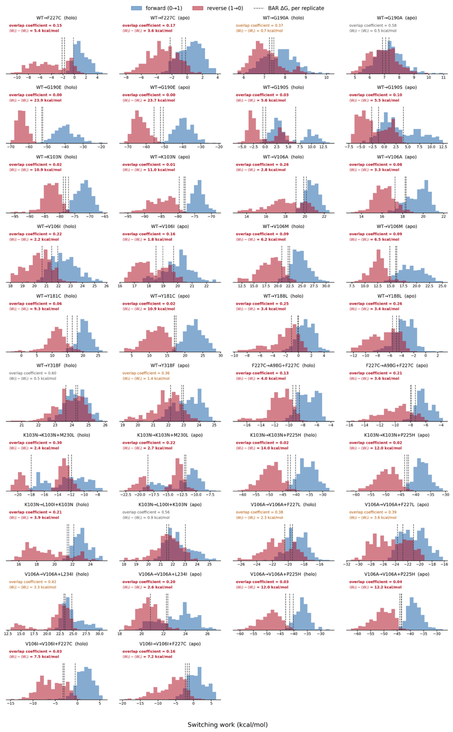
Supplementary Figure 4. Non-equilibrium switching work distributions for all alchemical transformations. Forward
(0→1, blue) and reverse (1→0, red) switching work for each of the 19 alchemical legs, shown separately for the holo and apo phases and pooled across three independent replicates (100 switches per direction per replicate). Dashed lines mark the BAR free energy, ∆G, of each replicate. Each panel reports the forward/reverse overlap coefficient — the shared area under the two normalized work densities, where 0 is disjoint and 1 identical — and the hysteresis ⟨W_{f}⟩ − ⟨W_{r}⟩, which measures the work dissipated by switching at finite speed. Annotations are colored red below an overlap of 0.3 and amber below 0.5. Compound genotypes are reached by two sequential legs, both shown.

7. Finite-size corrections for the charge-changing alchemical legs
The leading periodicity (net-charge self-energy) term of the Rocklin scheme is +0.0407 kcal/mol per phase and cancels to below 0.0001 kcal/mol in ΔΔG_{bind} for both WT→K103N and WT→G190E. The higher-order terms — net-charge undersolvation, discrete-solvent and residual integrated potential — were not applied, since computing them exactly requires a Poisson-Boltzmann treatment of each environment. However, the charge change is identical in the holo and apo phases by construction; and the cells are matched to within 0.13% (K103N) and 0.31% (G190E) in volume, with DOR occupying 0.019% of the cell. Taking a per-phase correction of 1 kcal/mol, about 25 times the leading term, the residual on ΔΔGbind is below 0.004 kcal/mol, at least 40-fold smaller than the 0.16–1.06 kcal/mol per-leg standard errors derived from Supplementary Table 3.

8. Protein-level conformational analysis
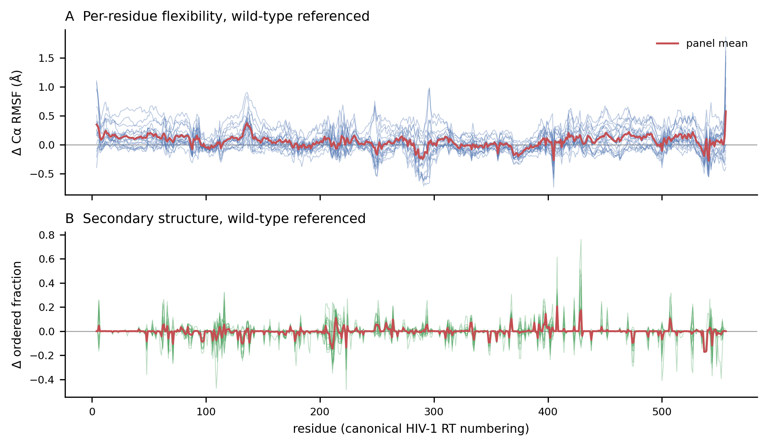
Supplementary Figure 5. Protein-level conformational analysis. Per-residue Cα RMSF after superposition on the NNIBP-lining residues, and three-state secondary structure by DSSP, both referenced to wild type across the panel. Of the 171 genotype-by-region fluctuation comparisons, 22 have a 95% confidence interval excluding zero, and they are not scattered at random. The primer grip (225–235) becomes more mobile in eleven of the nineteen genotypes, by 0.07 to 0.17 Å and always in the same direction, and G190E is more mobile than wild type in five regions at once: the pocket lining, the primer grip, β6, the p66 palm, and the p66 fingers, the last by 0.56 Å [0.12, 0.99]. Secondary structure moves by at most 0.11 of strand character, in the YMDD motif of K103N, and only 9 of 342 such comparisons are resolved at three replicates. No genotype remodels the fold in the bound state, so the differences in Table 3 are local to the DOR interface rather than consequences of broader conformational change. The one systematic signal outside the pocket is the loosening of the primer grip, which a binary complex containing no template/primer cannot connect to a mechanism.

9. Conformation of the unliganded binding pocket
Three 100 ns apo replicates were run for WT and all nineteen simulated mutant genotypes, including the F227C alchemical intermediate. Supplementary Table 4 reports the per-replicate structural observables in both states and the WT-referenced bound–unliganded differences. Supplementary Figure 6 shows the replicate estimates for all ten RT conformational metrics used in Figure 5: NNIBP volume, Tyr181 and Tyr188 χ1, Cα RMSF in six regions, and β9–β10 strand content. WT and all eighteen mutant genotypes other than the standalone F227C alchemical intermediate are shown. These measurements describe the sampled RT conformations; they do not quantify the free energy required to form the pocket.

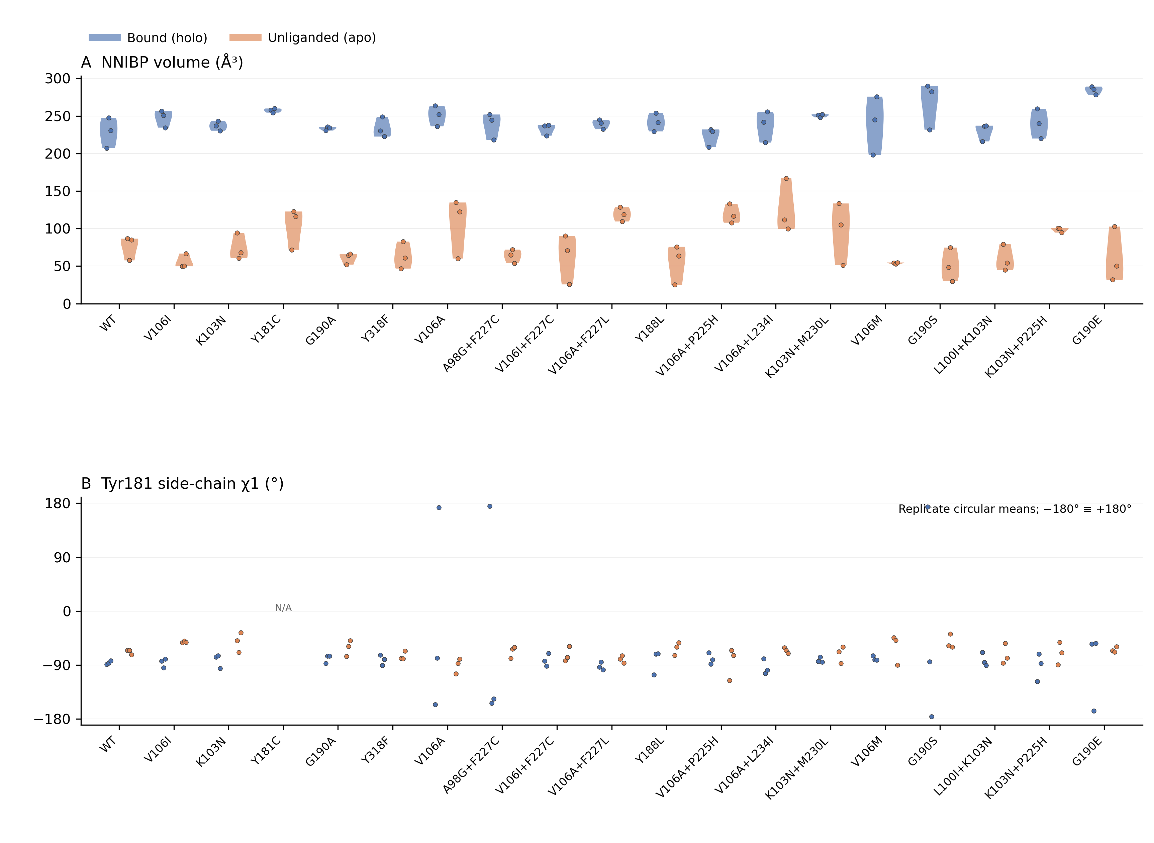
Supplementary Figure 6. RT conformational metrics in bound and unliganded ensembles. A–B: NNIBP volume and Tyr181 χ1. For nonangular metrics, violin plots summarize the three independent replicate estimates per genotype and state from Supplementary Table 4; dots show each replicate estimate (n = 3). Blue denotes bound RT and orange unliganded RT. These are distributions across replicate estimates, not per-frame distributions. RMSF is calculated over each trajectory, and strand content is a trajectory-averaged fraction. Tyr181 and Tyr188 χ1 are shown as individual replicate circular means without density smoothing; −180° and +180° represent the same angle. Tyr181 χ1 is undefined for Y181C and Tyr188 χ1 for Y188L (N/A). The standalone F227C alchemical intermediate is omitted. The same table values and frame inclusion are retained. With only three replicates, violin shape is descriptive and does not establish multimodality.

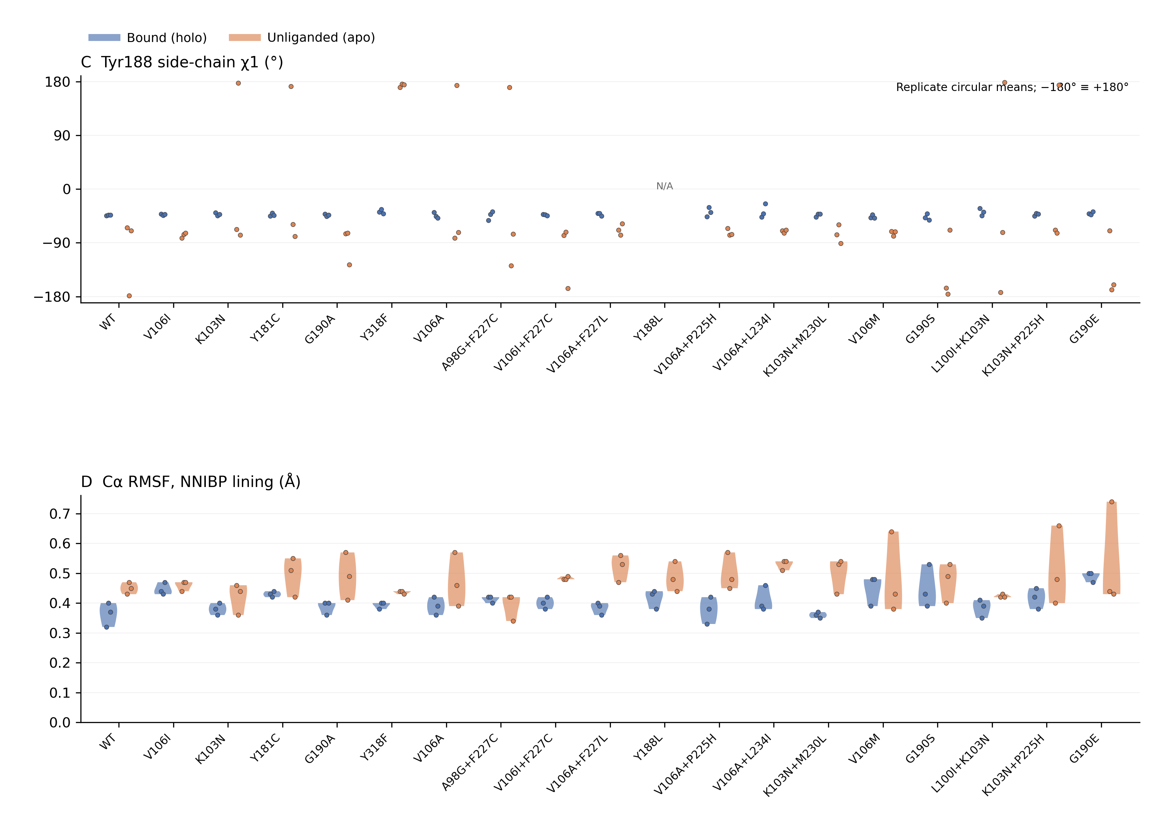
Supplementary Figure 6, continued. RT conformational metrics in bound and unliganded ensembles. C–D: Tyr188 χ1 and NNIBP-lining RMSF. Dots show the three replicate estimates per state; violin densities summarize these estimates. Genotype order, colors and frame inclusion are as in panels A–B.

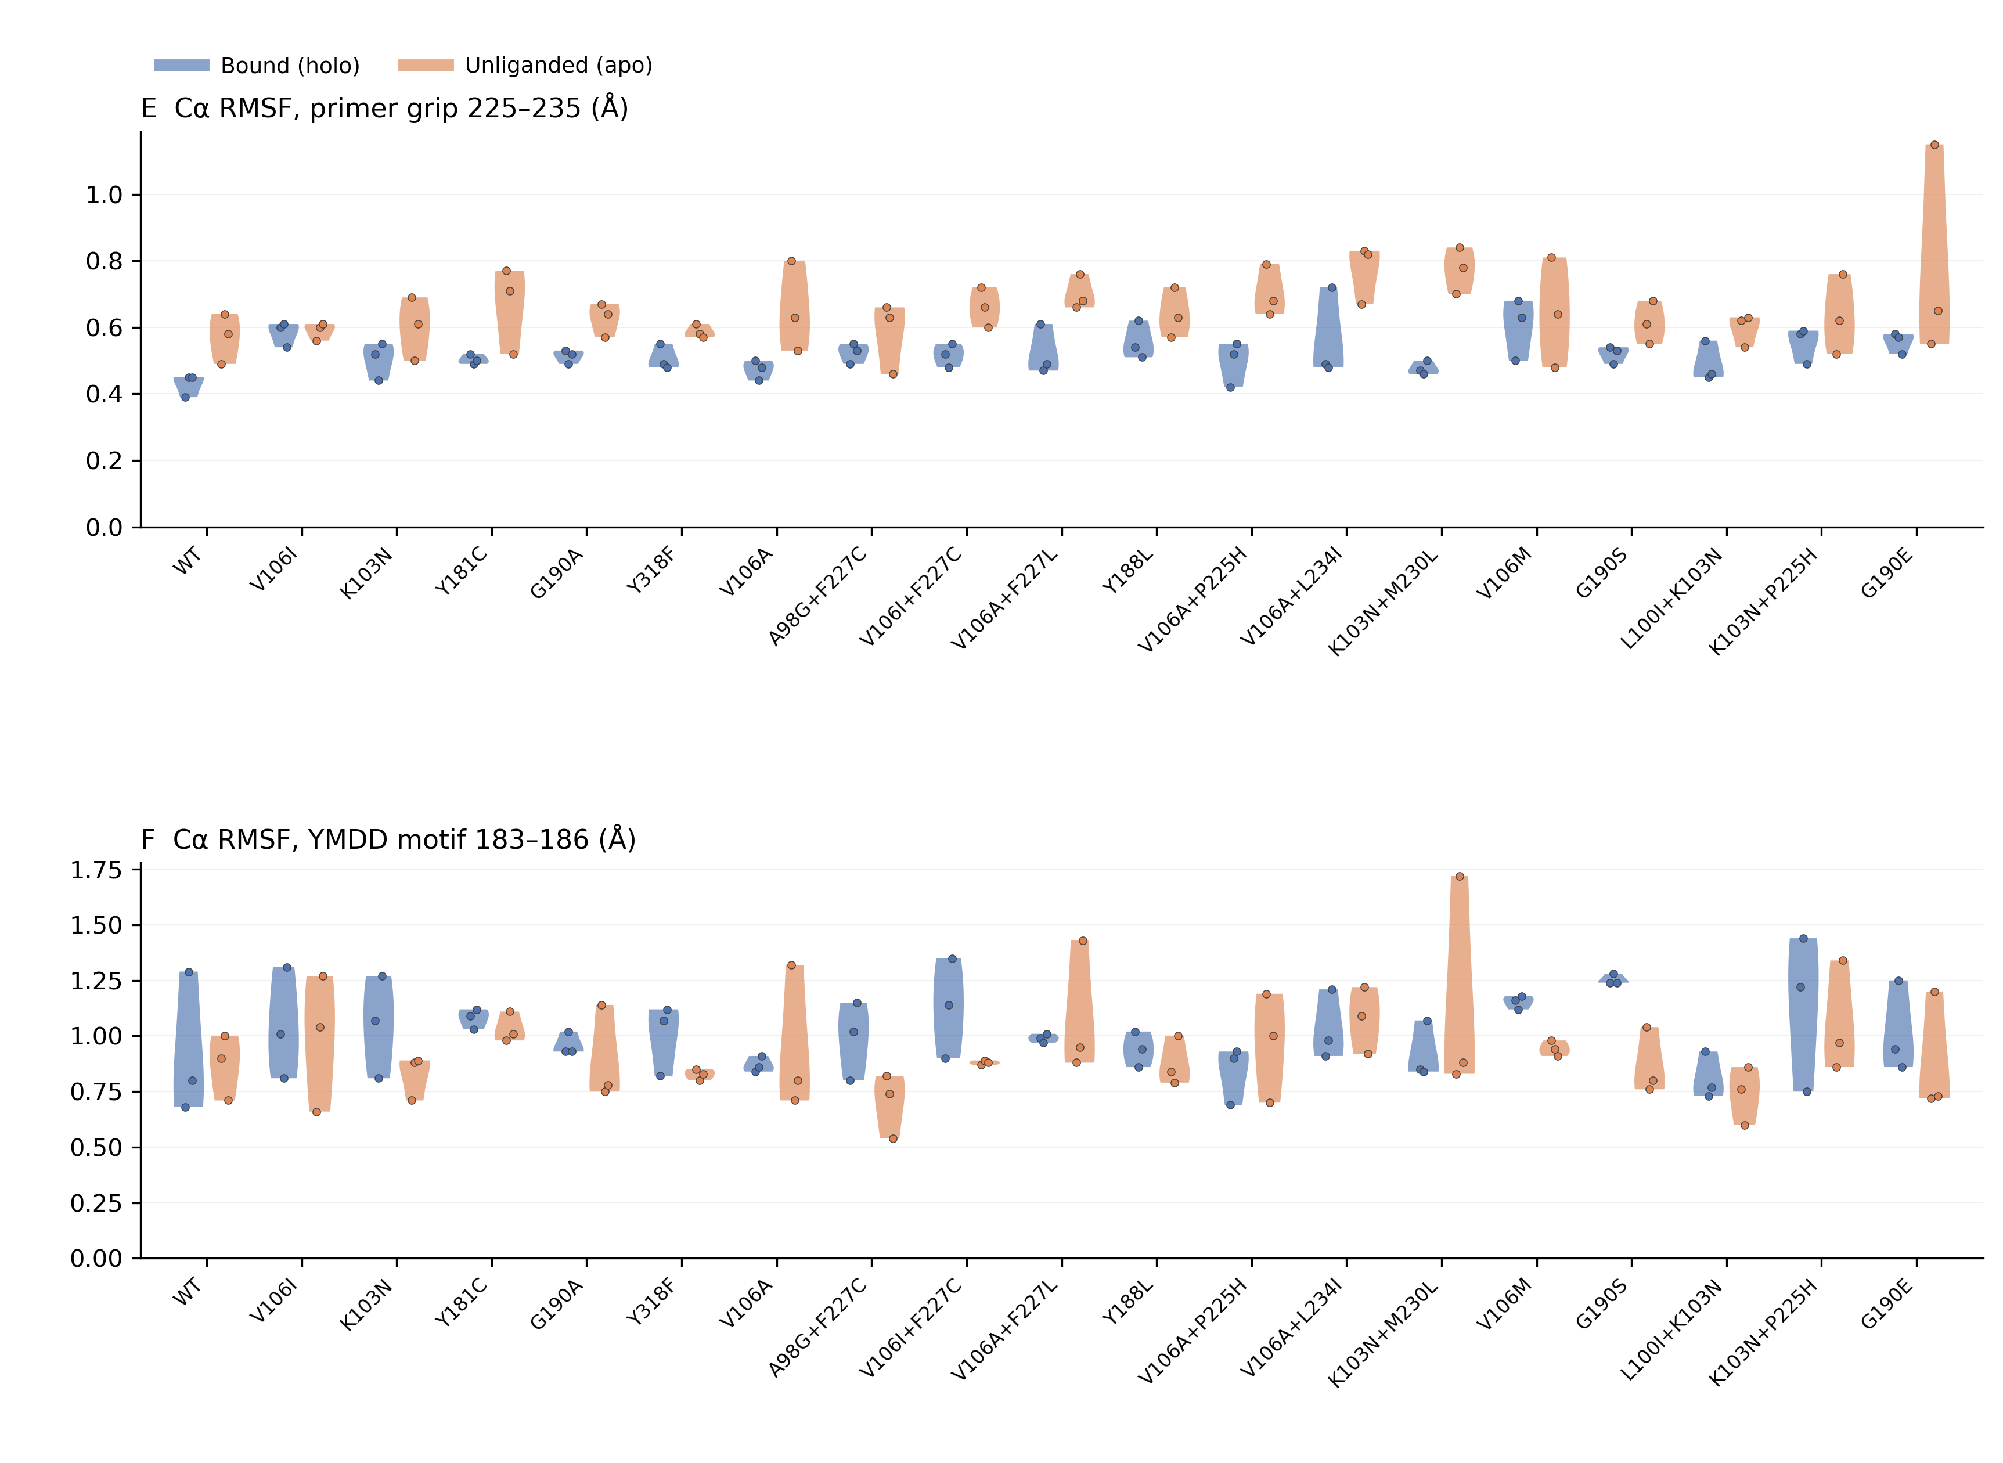
Supplementary Figure 6, continued. RT conformational metrics in bound and unliganded ensembles. E–F: Primer-grip and YMDD-motif RMSF. Dots show the three replicate estimates per state; violin densities summarize these estimates. Genotype order, colors and frame inclusion are as in panels A–B.

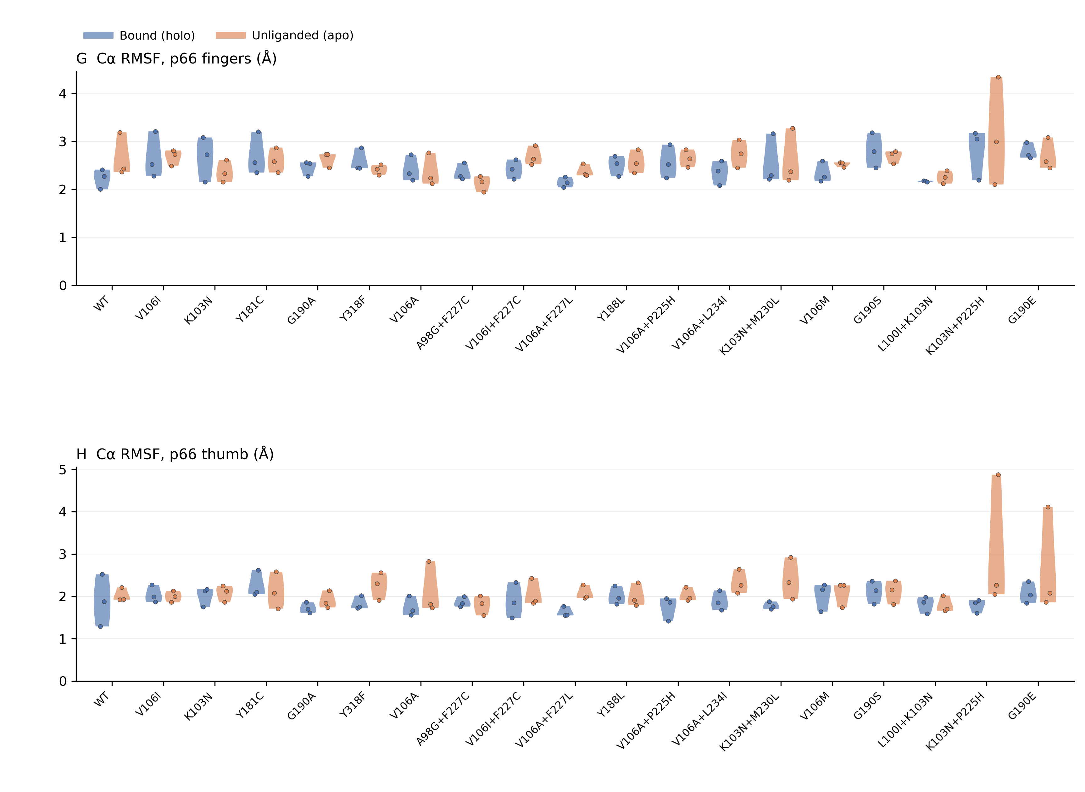
Supplementary Figure 6, continued. RT conformational metrics in bound and unliganded ensembles. G–H: p66 fingers and thumb RMSF. Dots show the three replicate estimates per state; violin densities summarize these estimates. Genotype order, colors and frame inclusion are as in panels A–B.

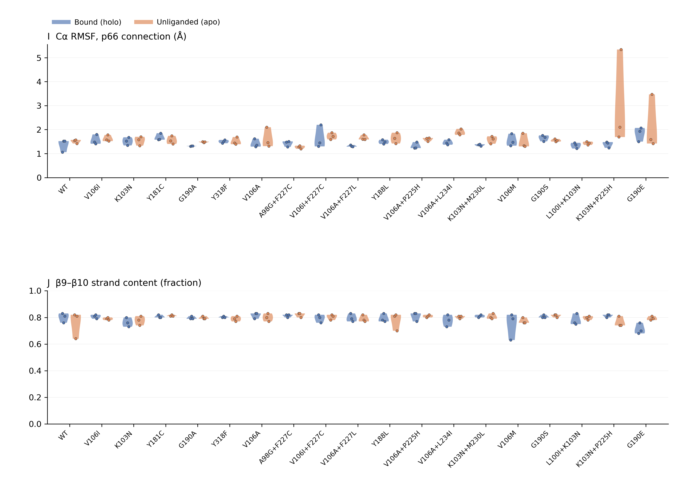
Supplementary Figure 6, continued. RT conformational metrics in bound and unliganded ensembles. I–J: p66 connection RMSF and β9–β10 strand content. Dots show the three replicate estimates per state; violin densities summarize these estimates. Genotype order, colors and frame inclusion are as in panels A–B.

