Response to Reviewers
Manuscript ci-2026-030865 — “Molecular Simulation of Doravirine Resistance in HIV-1 Reverse Transcriptase”
Rohit Satija, Kaiming Tao, Robert W. Shafer
Response: We thank the editor and the three reviewers for a careful and constructive set of critiques. We believe the updates made due to these reviews have significantly strengthened the manuscript. Reviewer comments are reproduced below in blue and our responses are in red/black. All changes to the manuscript and the supplementary text are marked in red in accompanying revised files.

Reviewer 1
Comments:
This is a methodologically solid study that asks a genuinely useful question: whether relative RT–DOR binding free energies, computed from molecular simulation, track phenotypic resistance across a clinically representative genotype panel. Several individual cases, particularly Y188L and V106A, give a convincing structural account of altered DOR recognition, consistent with prior crystallography.
The deeper limitation is conceptual rather than computational: the manuscript treats the sampled DOR-bound pose (inherited unmodified from the crystal structure) as representative of the relevant binding ensemble, without testing that assumption. Because the NNRTI pocket only forms upon ligand binding, and RT itself rearranges on timescales far longer than the 100 ns simulated here, that assumption is precisely what the manuscript's own inconsistent results (Section 3, below) call into question.
Response: We thank the reviewer for this framing. The concern is that one crystal structure fixes the starting pose that every simulation then inherits, with the underlying assumption that this starting pose is representative of the true RT-DOR binding ensemble. We have tested this assumption directly against a second, independent experimental structure of the same complex, and separately against alternative starting poses.
To address this comment, we have added a new section to the Supporting Information:
“ 1. Is the RT-DOR crystal structure representative of the true RT-DOR structural ensemble?
We address this question in two steps: first by comparing the DOR pose in the crystal structure (PDB ID: 4NCG) with a second, independent RT-DOR-DNA ternary structure determined by cryo-EM (PDB ID: 7Z2G), and then by quantifying changes in key residues of the NNIBP, using other published structures of NNRTI complexes as a reference set. For all comparisons, we align 16 NNIBP-lining Cα atoms of 4NCG, fifteen in p66 and Glu138 in p51. 7Z2G is a 3.65 Å single-particle cryo-EM structure of HIV-1 RT bound to a 38-mer DNA aptamer and DOR, determined by a different group, by a different method, and in a different functional state from the 2.58 Å X-ray structure 4NCG. Superposed on the pocket Cα atoms alone, DOR agrees between them to 0.62 Å heavy-atom RMSD over its 29 atoms, with a centroid displacement of 0.30 Å (Supplementary Figure 1A). Fitted ligand on ligand, its internal conformation agrees to 0.44 Å, no ring system is placed differently from the rest, and the four rotatable dihedrals agree to within 15°. The pocket agrees to 0.49 Å over the same Cα atoms and to a median side-chain RMSD of 0.80 Å, and the NNIBP volume is 198 Å³ in 4NCG against 194 Å³ in 7Z2G. Per-residue values are in Supplementary Table 7. Furthermore, even without any superposition, the minimum heavy-atom distance from each NNIBP residue to DOR agrees between the two structures to a median of 0.16 Å, with the largest discrepancy of 0.41 Å at Lys103 and a correlation of r = 0.974 across the sixteen residues.
To calibrate these alignment results, we applied the identical superposition to three further complexes of wild-type RT with an NNRTI: RPV (2ZD1, 1.80 Å), EFV (1FK9, 2.50 Å) and NVP (1VRT, 2.20 Å). Tyr181 occupies a different rotamer in the DOR structures than in all three others: its χ1 angle differs from 4NCG by 93°, 95° and 90° respectively, displacing the ring centroid by 4.9, 4.2 and 4.2 Å (Supplementary Figure 1B). The NNIBP volume across the five structures ranges from 181 to 258 Å³. Furthermore, Tyr188 χ1 differs by only 13–20° and its ring centroid by 1.3–2.6 Å across all five structures (Supplementary Figure 1C). Per-structure values for both tyrosines are in Supplementary Table 8. Taken together these results support the claim that the DOR-containing NNIBP conformations are the same in two experimental structures determined independently, while the same pocket demonstrably adopts a different conformation when it holds other drugs in the same class. The starting geometry of this work is therefore a property of the DOR–RT complex rather than an artifact of one crystal form.”

Reviewer 1, comment 1
Major comments:
1. Weak correlation with phenotype. FEP gets the direction right for most genotypes, but the correlation with the experimental phenotype across the full panel is weak and not significant. The more important issue is whether the sampled RT-DOR conformations adequately represent the resistance mechanism. The weak correlation may therefore reflect not only limitations of the free-energy calculation, but also resistance mechanisms involving mutation-induced changes in RT conformation and NNIBP formation.
Response: We agree that the weak correlation between ∆∆G_{bind} and phenotypic susceptibility data requires a cautious interpretation. We now discuss the limitations of our approach at length, including sampling limitations, model limitations, and forcefield limitations.
The Discussion now states:
“There are three important limitations of this work. First, each system was simulated in triplicate from a single seeded pose, so the replicates explore one basin of the bound ensemble and their agreement measures convergence within that basin. It is possible that there are several plausible RT-DOR conformations amongst the genotype panel that are not sampled here. Moreover, this limitation extends to the unliganded RT conformational ensembles, where the NNIBP without DOR may not equilibrate in 100ns. Of the 715 genotype-by-observable comparisons, 68 had 95% confidence intervals excluding zero, against approximately 36 expected at a nominal 5% threshold without correction for multiple comparisons (Supplementary Table 4). Most structural features in this panel are therefore unresolved at three replicates, and we distinguish the well-resolved local shifts from the more tentative conformational interpretations.
Second, we simulate a binary RT–DOR complex with no template/primer and no incoming dNTP, so a resistance mechanism acting through the nucleic-acid interface is structurally absent from our calculations. Specifically for this panel, Met230 and Pro225 both lie in the p66 primer grip, and a change in how the template is held, or in how often RT adopts a catalytically productive conformation, may not change ∆∆G_{bind} or ∆∆E_{Total} as we measure them, yet could still lower susceptibility in host cells. Agreement of the DOR pose and local pocket between the independent binary and DNA-bound experimental structures supports using this starting geometry for local drug-site comparisons (Supplementary Section 1, Supplementary Figure 1, and Supplementary Tables 7 and 8). It does not establish that a simple RT-DOR model captures the conformational ensemble or catalytic coupling of substrate-bound RT.
The third limitation is in the simulation forcefields. The two energy calculation methods in this study use different ligand charge models: the equilibrium simulations, and the MM/GBSA energies taken from them, use Gasteiger charges, whereas the alchemical legs use the AM1-BCC charges OpenFF assigns by default. This charge sensitivity can materially impact ∆∆E_{Total} ranking (Supplementary Table 5) because, even though the sign of an interface penalty is largely robust to the charge model; the rank of an individual genotype is not. Moreover, the shift falls almost entirely on the polar terms, and is largest where a substitution changes the formal charge. Note that MM/GBSA estimates are known to depend on the force field and the simulation protocol as much as on the structure being scored.^{34,51} We have therefore drawn conclusions where a sign or a rank order carries them, and have avoided resting an argument on a difference of about one kcal/mol. Nevertheless, this issue partly explains why several genotypes show inconsistencies between ∆∆E_{Total} and ∆∆G_{bind} (Table 2).
More generally, resistance can act through large-scale allosteric change, through the conformational equilibrium of the unliganded pocket on timescales far longer than we sample, or through effects on enzyme processivity and viral fitness, none of which are captured in these calculations. Such mechanisms are in principle accessible to hybrid QM/MM approaches,^{84,85} enhanced sampling techniques,^{86–88} and machine learning.^{89–91}”

Reviewer 1, comment 2
2. Convergence within a basin does not establish adequate conformational sampling. Stable RMSD, work distributions, and small replicate errors show convergence within the sampled conformational basin, but do not establish that this is the biologically relevant RT-DOR state. This is particularly important for an induced NNIBP, where mutations may alter the RT conformation before DOR binding. The authors should address this in two ways:
- First, test representative systems from independent starting poses to determine whether the same DOR-bound state is recovered.
- The authors should perform longer-timescale apo simulations for a selected set of mutants, particularly P225- and M230-containing genotypes, and compare the resulting RT and pocket conformational ensembles with WT. These mutations are located in loop-rich regions and could affect pocket formation through slower conformational remodeling that is not captured in the current simulations.
Response: We agree that perturbed starting poses provide a stronger test. We added sixteen starting-pose simulations, described in Methods:
“ Convergence tests
To test whether the sampled DOR-bound state is recovered starting from gradually extreme perturbations to the starting configuration, alternative DOR poses were generated by random rigid-body placement within the NNIBP, screened to keep every ligand–protein heavy-atom contact above 2.2 Å, and accepted in 0.5 Å wide bands of heavy-atom RMSD from the crystallographic pose. Sixteen poses spanning 1.3 to 6.8 Å were prepared, minimized and simulated exactly as the production systems, one replicate each, but for 2 ns and without the 0.1 Å coordinate jitter used to decorrelate the production replicates. Endpoint pose coordinates are reported after superposition on the NNIBP Cα atoms as the DOR heavy-atom RMSD from the crystallographic pose, the displacement of the DOR centroid and the tilt of its long axis.”
The corresponding results are summarized in the Supplementary Information:
“ 3. The crystallographic pose is recovered from perturbed starting poses
To test whether representative systems from independent starting poses can recover the same DOR-bound state used in the simulations, we ran energy minimization followed by 2 ns MD equilibrations for a ladder of sixteen starting poses at increasing distance from the crystallographic pose. In the wild-type (WT) production ensemble, the DOR pose RMSD lies between 0.33 and 1.78 Å, the centroid displacement is at most 1.75 Å and the long-axis tilt at most 15.1°; we take that envelope as the sampled WT basin. All ten poses starting between 1.3 and 2.9 Å converged into the WT basin, ending at a median pose RMSD of 0.74 to 1.01 Å with 78 to 100% of their frames inside the envelope. However, extreme perturbations, corresponding to the six poses starting at 3.3 Å or beyond, failed to converge to the WT basin in the 2 ns simulations, ending between 5.0 and 9.4 Å (Supplementary Figure 2). The crystallographic pose is therefore an attractor with a basin of, at least, roughly 3 Å DOR pose RMSD from the crystal structure used in this study.”
For the second request, we added three 100 ns apo simulations for every genotype, including the P225- and M230-containing combinations. Methods now describes apo preparation and the matched production protocol:
“Apo systems were built by removing DOR from the corresponding prepared holo structure and were solvated, minimized, heated and run under the same protocol.”
“Three unliganded replicates of 100 ns were run for each genotype, matching the bound-state protocol.”
The new apo/holo comparisons are reported in Figure 5 and Supplementary Table 4, with pocket-volume distributions in Supplementary Figure 6:

“ 9. Conformation of the unliganded binding pocket
Three 100 ns apo replicates were run for WT and all nineteen simulated mutant genotypes, including the F227C alchemical intermediate. Supplementary Table 4 reports pocket volumes in both states, the per-replicate values and the WT-referenced bound–unliganded differences alongside the other structural observables. Supplementary Figure 6 shows the volume distributions. These measurements describe pocket geometry; they do not quantify the free energy required to form the pocket.”
Results now states:
“We further tracked RT conformational remodeling in both holo and apo configurations, including pocket volume, side-chain rotamers and regional fluctuations (Figure 5; Supplementary Table 4). Unliganded pockets were smaller than their bound counterparts across the panel (Supplementary Section 9 and Supplementary Figure 6); the following comparisons examine how DOR binding changes these structural observables relative to WT.
In WT RT simulated here, binding DOR rotates Tyr181 by −18° and Tyr188 by +53°, from unliganded values of −68° and −97° (Supplementary Table 4). A98G+F227C and G190S depart sharply from that pattern: their unliganded Tyr181 sits close to WT, at −68° and −52°, but binding drives it to −162° and −153°, a rotamer the WT complex does not adopt, giving induced-fit shifts of −76 ± 11° ([−101, −51]°, p < 0.001) and −83 ± 28° ([−148, −18]°, p = 0.02). The A98G+F227C value is the largest effect in Figure 5 relative to its error, at 6.9 standard errors. Y318F does the converse at Tyr188: its unliganded Tyr188 starts at +174°, a rotamer no other genotype visits, and DOR returns it to the common bound value of −38°, an induced-fit shift of +95 ± 32° ([22, 169]°, p = 0.02).
Protein-level fluctuations and secondary structure are summarized in Supplementary Section 8 and Supplementary Figure 5. In WT, binding DOR damps both regions we track: the pocket lining falls from 0.452 ± 0.011 Å unliganded to 0.361 ± 0.023 Å bound, and the primer grip from 0.570 ± 0.043 Å to 0.429 ± 0.021 Å (Supplementary Table 4). In A98G+F227C, the pocket lining is not damped at all, moving from 0.394 ± 0.027 Å to 0.415 ± 0.009 Å, an induced-fit shift of +0.11 ± 0.04 Å from WT ([0.02, 0.20] Å, p = 0.02) and the second largest effect in Figure 5. Its bound interface is otherwise close to WT, the only resolved contact metric being a −0.24 ± 0.06 Å change in the Val179 distance ([−0.40, −0.07] Å, p = 0.02).
In K103N+M230L, the unliganded primer grip is markedly more mobile than WT, 0.772 ± 0.041 Å against 0.570 ± 0.043 Å, and binding DOR suppresses that excess, to 0.474 ± 0.012 Å (Supplementary Table 4). The induced fit is therefore twice that of WT, −0.30 Å against −0.14 Å, an induced-fit shift of −0.16 ± 0.06 Å ([−0.31, −0.01] Å, p = 0.04; Figure 5). K103N+M230L showed the largest DOR-associated reduction in primer-grip RMSF in the panel. V106I shows the same metric in the opposite direction, +0.14 ± 0.06 Å ([0.01, 0.27] Å, p = 0.04), its primer grip being equally mobile with and without the drug.”

Reviewer 1, comment 3
3. The mismatches suggest different resistance mechanisms. The mismatches between calculated ΔΔG_{bind} and the experimental phenotype are not simply random errors and should be discussed mechanistically. For example:
- K103N+M230L shows only a small calculated binding penalty despite 36-fold resistance.
- A98G+F227C and G190E show substantial resistance despite favorable calculated ΔΔG_{bind}. G190E is particularly notable because it produces the largest pocket expansion, yet no binding penalty. The authors should examine whether mutation-induced changes occur in both apo and holo RT and whether such remodeling could therefore be poorly reflected in ΔΔG_{bind}.
Response: We agree that these discrepancies warrant mechanistic examination. We added apo/holo structural comparisons in Results (Figure 5; Supplementary Table 4) and qualified their interpretation in Discussion. See Response to the above comment for the text added in Results section. The Discussion further illustrates these findings:
“Similarly, for K103N+M230L, our calculations suggest negligible binding penalty (∆∆G_{bind} = 0.59 ± 0.41 kcal/mol) despite a 36-fold reduction in susceptibility (Table 1). Structural metrics suggest DOR interface is unperturbed — chlorocyanophenyl burial is the second highest in the panel, 22.8 ± 2.4 against 19.5 ± 0.5 in WT, and the Lys103 anchor is intact at 3.05 ± 0.04 Å (Table 3). Interestingly, Met230 lies in the p66 primer grip, where its side chain contacts the primer terminus,⁸¹ and M230L impairs RT enzymatic function and viral replicative capacity in addition to reducing NNRTI susceptibility.⁸² The larger binding-associated reduction in primer-grip fluctuations in K103N+M230L is consistent with altered coupling between the drug site and the primer grip (Figure 5). Unfortunately, the binary RT-DOR complex simulated here cannot establish whether this affects template/primer utilization or explains resistance (see below).
The apo comparisons suggest that a mutation can alter the conformational response of RT to DOR binding even when contacts in the bound complex remain largely intact. In WT, DOR binding reduces fluctuations of the pocket-lining residues. In A98G+F227C, this reduction is smaller and is accompanied by a different binding-associated rotation of Tyr181, suggesting that DOR stabilizes a different local pocket arrangement. Y318F illustrates a complementary pattern: Tyr188 adopts a distinct rotamer in the unliganded enzyme but returns to a conformation close to WT in the DOR-bound complex. Examining the bound structures alone would therefore miss this difference in the starting conformational ensemble and the rearrangement associated with binding (Figure 5). These observations identify possible contributions from mutation-dependent changes in RT conformation and flexibility, although the simulations do not establish their energetic cost or whether they explain the observed resistance.”
For G190E, the Results report the expanded bound pocket. However, these observations do not establish a common pre-binding mechanism for all three mismatches.

Reviewer 1, comment 4
4. The structural analysis needs a clearer summary. The structural information is currently spread across several dense tables, making it difficult to see how the different mutations alter the RT-DOR system. A figure mapping all mutations onto the RT-DOR structure would be important, particularly to show their positions relative to DOR and the NNIBP. A WT-referenced heatmap summarizing the structural metrics in Table 3 would also help identify patterns in DOR contacts, pocket size, and mutation-induced remodeling across genotypes.
The structural analysis would be further strengthened by including protein-level changes that are currently not shown, particularly RMSF, secondary-structure changes, and pocket conformational distributions. These would help distinguish direct changes in DOR contacts from broader conformational effects on the RT pocket.
Response: To address this comment, Figure 1 now includes a new panel showing the zoomed-in DOR binding pocket with key residues highlighted:
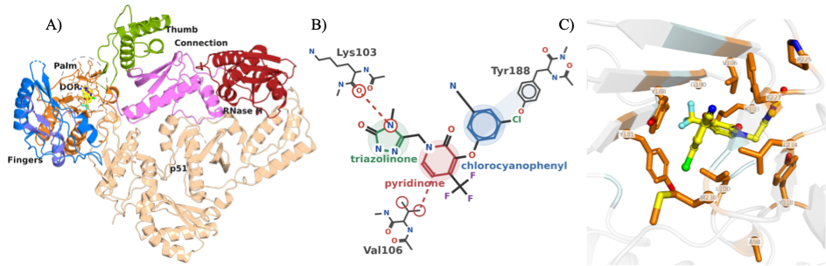
“
Figure 1: Crystal structure of Doravirine (DOR) bound to wild-type (WT) Reverse Transcriptase (RT). (A) 3D structure of WT RT in complex with DOR (PDB ID: 4NCG) used as the starting point of all simulations in this work. The Non-Nucleoside Inhibitor Binding Pocket (NNIBP) including DOR is highlighted in a light gray oval. (B) 2D schematic structure of DOR illustrating 3 key interactions with RT p66 residues: (i) Lys103 mainchain carbonyl hydrogen bond with the triazolinone moiety, (ii) Hydrophobic interaction between Val106 C_{γ} and central pyridinone core, (iii) Aromatic stacking between the Tyr188 sidechain and the chlorocyanophenyl ring. (C) DOR-binding pocket zoomed in with 12 highlighted residues corresponding to genotypes studied here.”
Table 3 is now supplemented by the new Figures 3 and 5:
“
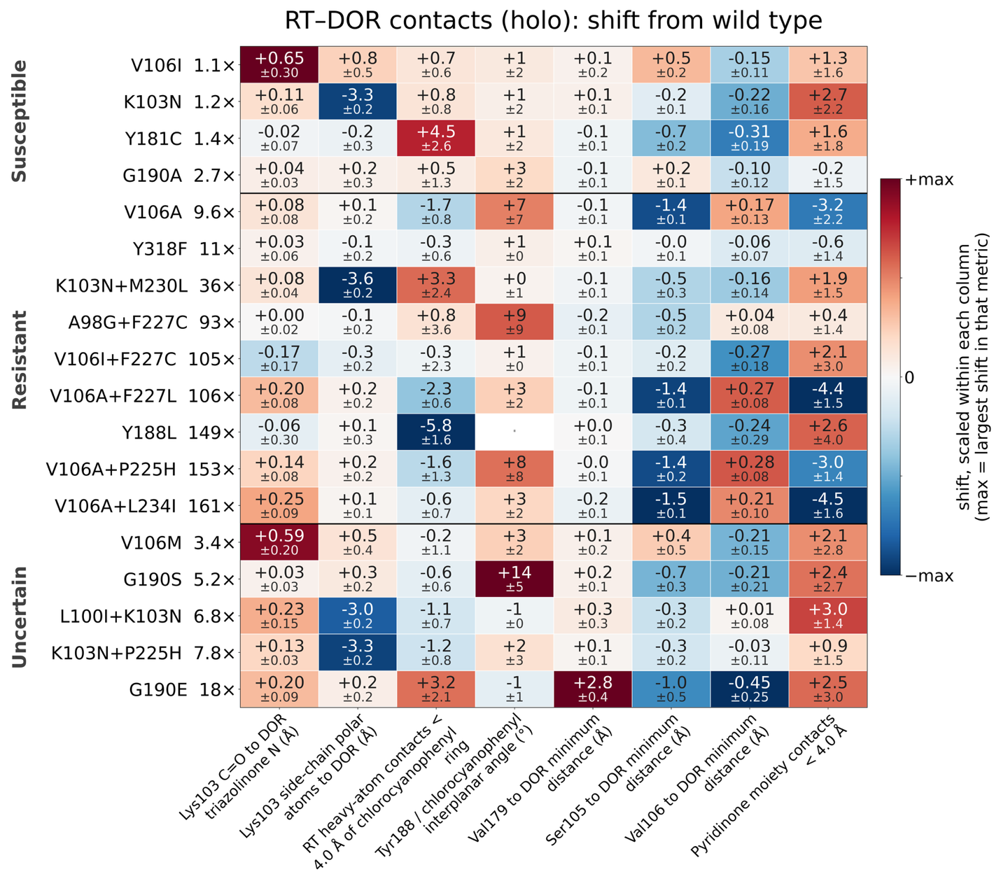
Figure 3: Changes in RT–DOR contacts across the genotype panel, referenced to WT. Each cell gives the shift of a structural metric from its WT value, in that metric's own units, along with the standard error of the shift. Errors combine the genotype's and WT's standard errors over three independent 100 ns replicates in quadrature, since wild type is itself a three-replicate mean. Color is scaled within each column, so the darkest cell in a column is the largest shift for that metric; it carries no meaning across columns, which are in ångström, degrees and counts. Genotypes are grouped by the resistance category of Table 1 and ordered by fold reduction in DOR susceptibility within each group. Per-comparison effect sizes, confidence intervals and p values for every metric, are in Supplementary Table 4.
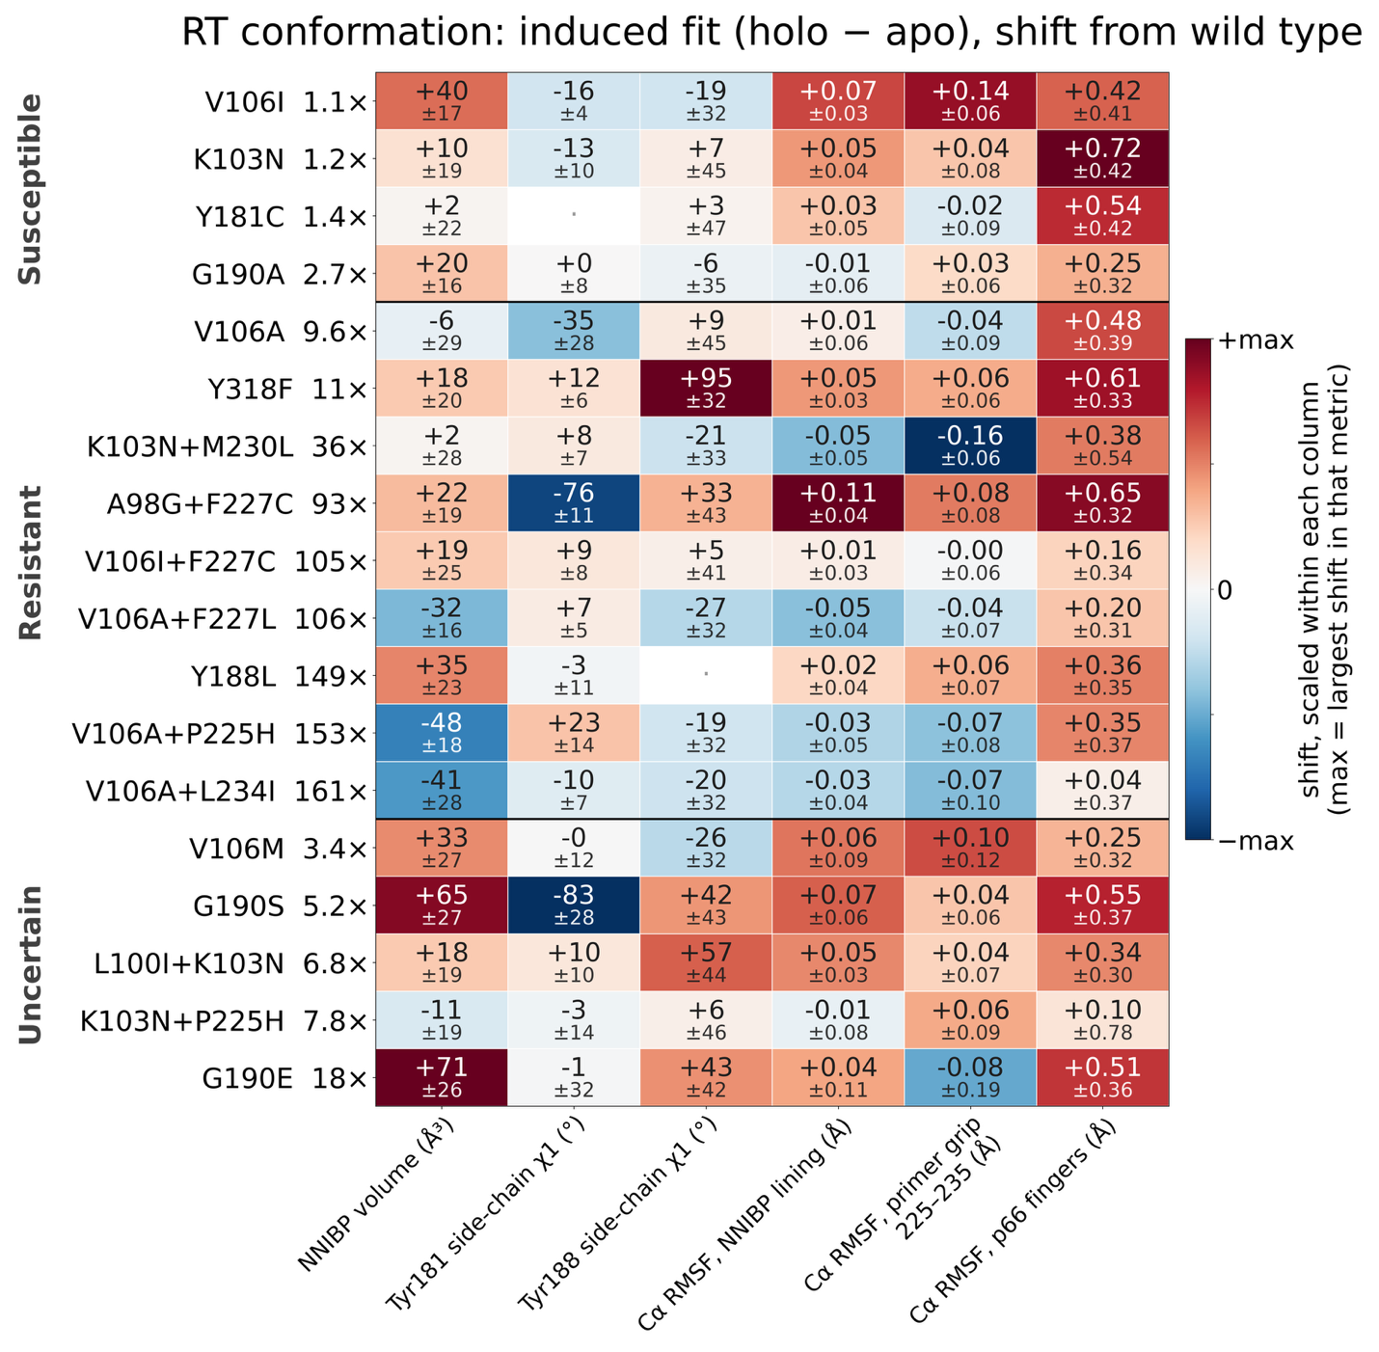
Figure 5: Mutation-induced changes in RT's own conformation, as the difference between the bound and unliganded states, referenced to WT. Each cell gives (holo − apo) for a genotype minus (holo − apo) for WT: the extent to which binding DOR reshapes the enzyme, and how far that reshaping differs from WT. A value near zero means the mutation shifts the bound and unliganded states by the same amount, concordant remodeling. Errors propagate the standard errors of all four three-replicate means in quadrature. Color, grouping and ordering are as in Figure 3.”
We also added regional RMSF, secondary-structure and apo/holo analyses to Methods; Supplementary Table 4 now contains both states and their uncertainty estimates. Supplementary Figure 5 summarizes protein-level changes, and Supplementary Figure 6 shows apo and holo pocket-volume distributions.

Reviewer 2
Comments:
In this manuscript, the authors use all-atom MD simulations with alchemical FEP and MM/GBSA to retrospectively assess doravirine resistance across 18 clinically observed HIV-1 RT genotypes. FEP correctly predicts little effect for 3 of 4 susceptible mutations and reduced binding for 7 of 9 resistant genotypes, though correlations with experimental fold-change are weak (R² = 0.26, p = 0.07). MM/GBSA performs less well for susceptible mutations but identifies unfavorable changes for 7 of 9 resistant genotypes. Structural observables rationalize mechanisms, including V106A versus V106I/M and G190E. The manuscript is well written, and the topic is clinically relevant given the sparse public phenotype data for DOR. However, several methodological and interpretive issues need to be addressed before the manuscript can be considered for publication. Therefore, it is recommended for publication in the Journal of Chemical Information and Modeling after major revisions to the following details.
More comments:
Response: We thank the reviewer for their very thoughtful and constructive comments.

Reviewer 2, comment 1
1. The three independent 100 ns replicates are short relative to the timescales of RT domain rearrangements and unliganded pocket conformational equilibria. The authors should provide more rigorous convergence diagnostics (e.g., block averaging, autocorrelation analysis) for both the structural observables and the FEP/MM-GBSA estimates, and discuss how limited sampling may bias the results.
Response: We agree that local stability alone is insufficient. We added autocorrelation and blocked-error diagnostics for DOR pose RMSD and DOR–RT separation, report FEP work-distribution checks, and explicitly mention longer-timescale sampling as a limitation in the Discussion.
To address this comment, we have performed the convergence diagnostics suggested by the reviewer. The details of the protocol are added to the Methods section:
“For a series of N successive frames of a structural observable, with values x_{t} and mean x̄, sampled at interval Δt, the normalized autocorrelation function (ACF) was computed as $C(τ)={\sum_{t=1}^{t=N-τ}{(x_{t}-\overline{x})(x_{t+τ}-\overline{x})}}/{\sum_{t=1}^{t=N}{{(x_{t}-\overline{x})}^{2}}}$, so that C(0) = 1; lags are reported as τΔt in nanoseconds. For block averaging, each series was partitioned into M = ⌊N/n⌋ non-overlapping blocks of length n with block means ${\overline{x}}_{b}=\frac{1}{n}\sum_{t=(b-1)n+1}^{t=bn}{x_{t}}$ where $b=1,2,...,M$. The standard error of the mean implied by that block length, also called the blocked standard error, is $SEM(n) = \sqrt{{\sum_{b}{{({\overline{x}}_{b}-\overline{x})}^{2}}}/{M(M-1)}}$. It rises with n and levels off once a block is longer than the correlation time of the observable, and that plateau is the standard error of the mean with correlation between frames accounted for. Block means were pooled across the three replicates of a genotype, so that even a 50 ns block yields six blocks from three 100 ns trajectories. Since g is the square of a ratio of estimated standard deviations, the interval shown on it is the chi-square interval on M − 1 degrees of freedom.”
The corresponding results are summarized in Supplementary Figure 3:
The time-series diagnostics concern the two structural observables; they do not establish convergence of all energetic or apo conformational degrees of freedom. FEP work overlap and estimator checks are described in Methods and Supplementary Figure 4. The MM/GBSA protocol-sensitivity analyses are reported in Supplementary Tables 5–6.
“ 4. Convergence of the molecular dynamics ensemble



Supplementary Figure 3. DOR Root Mean Squared Deviation (RMSD) and distance between centers of mass (COM) of DOR and RT indicate 100ns runtime is sufficient for DOR-RT interactions to stabilize. (A) Each solid line provides the average RMSD of the DOR heavy atoms vs the minimized structure within the NNIBP (at t = 0) computed at each time point across triplicate simulations. Shaded regions represent the standard error of this mean (SEM). The red curve represents WT and the remaining trajectories are color-coded based on the respective genotype's fold-change in susceptibility (Table 1 in main text). Inset shows the same data highlighting the rapid changes in the first 5ns of the simulations. (B) Similar plot for the average distance between COMs of DOR and RT atoms. (C, D) Normalised autocorrelation functions of these two chosen convergence metrics, computed for each replicate and averaged within each genotype, with the shaded region showing the SEM across replicates. From these plots, DOR RMSD and the DOR-RT COM distance in our simulations decorrelate within about 5 ns and roughly 20 ns, respectively. (E, F) Blocked standard error of the convergence metrics against block length. The shaded band, drawn for wild type alone to keep the panel legible, is the 95% chi-square interval on a standard error estimated from that number of blocks. From these plots, the blocked error is nearly flat beyond 10 ns for DOR RMSD, but DOR-RT COM distance takes about 40-50 ns, up to the statistical limit of the trajectories simulated here.”

Reviewer 2, comment 2
2. The binary RT–DOR system omits the nucleic acid substrate and incoming dNTP, which are essential for resistance mechanisms involving the primer grip (e.g., M230L) and allosteric coupling (e.g., K103N). The authors should explicitly discuss which mechanisms are inaccessible in this setup and how this may affect the correlation with phenotypic data.
Response: We agree that substrate-dependent mechanisms cannot be tested in a binary complex. We expanded the Discussion to identify primer-grip and catalytic-coupling mechanisms that our setup cannot capture. See response to Reviewer 1, Comment 1.

Reviewer 2, comment 3
3. Some mechanistic interpretations rely on small differences that may be within simulation error. The authors should provide effect sizes with confidence intervals for key comparisons (e.g., V106A vs. V106I/M, G190A vs. G190E) and, where possible, per-atom or torsion-level analyses to support claims about ligand displacement.
Response: We agree that small shifts must be assessed against replicate uncertainty. We added effect sizes in the observable’s own units, 95% confidence intervals and per-comparison statistics in Supplementary Table 4, with key comparisons in Results and atom-level displacement summaries in Figures 3–4. Methods now specifies:
“Differences between genotypes in a structural observable were quantified with the replicate trajectory as the unit of comparison. For each genotype and observable we report the difference of replicate means — the effect size, in the observable's own units — its standard error, and a two-sided pooled-variance t-test on that difference, with the corresponding 95% confidence interval.”
Results explicitly reports both resolved and unresolved V106 comparisons:
“The displacement toward Ser105 is well resolved: −1.35 ± 0.09 Å for V106A against WT (95% interval [−1.61, −1.09] Å) and +1.85 ± 0.14 Å for V106I against V106A ([1.45, 2.24] Å). The accompanying change in pyridinone contact count, however, is not resolved (−3.2 ± 2.2 contacts for V106A against WT, [−9.2, +2.8]), and V106A against V106M is within error (Supplementary Table 4).”
The G190A/G190E contrast is reported with WT-referenced uncertainty, rather than inferred from mean values alone:
“G190A leaves the DOR pose essentially unperturbed, with chlorocyanophenyl ring burial (20.0 ± 1.2), stacking angle with Tyr188 sidechain (16.0 ± 1.8°), the distances to Ser105, Val179 and Val106, and the NNIBP volume (233 ± 2 Å³) all within replicate error of the corresponding WT values (every comparison p ≥ 0.22). G190E is distinct from every other genotype in two respects: (i) the minimum distance from Val179 to DOR increases from 3.62 ± 0.06 Å in WT to 6.47 ± 0.44 Å, more than 2.5 Å beyond the next largest value in the panel (3.89 ± 0.29 Å, in L100I+K103N), and (ii) the NNIBP volume expands from 228 ± 12 Å³ in WT to 284 ± 3 Å³, the largest of any genotype. Both are resolved against WT (+2.84 ± 0.44 Å, [1.62, 4.07] Å, p = 0.003 and +55.9 ± 12.1 Å³, [22.3, 89.4] Å³, p = 0.01).”

Reviewer 2, comment 4
4. The FEP calculations involve two charge-changing legs (WT → K103N, WT → G190E). The authors should verify that protonation states of titratable residues in the NNIBP are consistent across WT and mutants, and provide more detail on the hybrid residue topologies, soft-core parameters, and finite-size correction.
Response: To address this comment, we have added this text in the Methods section:
“Titratable residues were assigned in the prepared wild-type structure and carried unchanged through mutation modeling, so no titratable residue differs between the end states of any leg. All thirteen histidines are neutral with the proton on Nδ1, in the wild type and in all 18 genotypes. The glutamate introduced by G190E is deprotonated and singly charged, which is what makes that leg charge-changing. In the hybrid topologies, bonded parameters are interpolated linearly in λ and dummy atoms are relaxed during the end-state minimization. Soft-core parameters were α = 0.3, σ = 0.25 nm and a soft-core power of 1, applied to both Lennard-Jones and Coulomb interactions.”
As well as the following section in the Supplementary Text:
“ 7. Finite-size corrections for the charge-changing alchemical legs
The leading periodicity (net-charge self-energy) term of the Rocklin scheme is +0.0407 kcal/mol per phase and cancels to below 0.0001 kcal/mol in ΔΔG_{bind} for both WT→K103N and WT→G190E. The higher-order terms — net-charge undersolvation, discrete-solvent and residual integrated potential — were not applied, since computing them exactly requires a Poisson-Boltzmann treatment of each environment. However, the charge change is identical in the holo and apo phases by construction; and the cells are matched to within 0.13% (K103N) and 0.31% (G190E) in volume, with DOR occupying 0.019% of the cell. Taking a per-phase correction of 1 kcal/mol, about 25 times the leading term, the residual on ΔΔGbind is below 0.004 kcal/mol, at least 40-fold smaller than the 0.16–1.06 kcal/mol per-leg standard errors derived from Supplementary Table 3.”

Reviewer 2, comment 5
5. Gasteiger charges are less accurate than AM1-BCC or RESP for drug-like molecules. The authors should either compare with a more accurate charge model for a subset of systems or explicitly discuss how this choice may affect the computed energies and the resulting correlations.
Response: We thank the reviewer for pointing this out. This comment helped reveal a documentation error in the Methods section that is now corrected:
“DOR was parameterized for the alchemical legs with the OpenFF 2.0.0 force field and its default AM1-BCC partial charges, then exported to GROMACS format through OpenFF Interchange 0.5.0.”
To address this comment, we have added a new section in the Supplementary Text:
“ 2. Sensitivity of the MM/GBSA energies to the ligand charge model
DOR parameters for the equilibrium MD simulations were generated with Gasteiger partial charges, as opposed to AM1-BCC for the FEP simulations. To test how much that choice matters, the same trajectories and snapshots were re-scored with AM1-BCC charges for wild type and four genotypes, chosen to span the panel's sensitivity to the charge assignment: G190E and K103N+M230L, where the electrostatic and generalised-Born terms contribute most to ΔΔETotal, together with V106A and Y188L, where they contribute least. The two charge sets are both neutral and correlate at 0.890, but AM1-BCC is more polarised (mean |q| 0.228 e against 0.138 e; RMS difference 0.165 e, maximum 0.390 e), with the largest differences on the triazolinone and pyridinone carbonyl and amide atoms. The WT-referenced ΔΔETotal changed by at most 1.33 kcal/mol and kept its sign for every genotype tested (Supplementary Table 5). The individual components move further than the total and in opposing directions: for K103N+M230L the electrostatic term shifts by −2.13 kcal/mol and the generalised-Born term by +2.01 kcal/mol, which largely cancel.”
Reviewer 3
Comments:
The topic of this manuscript is timely and clinically relevant, the genotype panel is thoughtfully curated with transparent provenance (Stanford HIVDB, PhenoSense/Merck assays), and the use of open-source tooling (OpenMM, GROMACS, pmx, OpenFF) is commendable for reproducibility. The manuscript is generally well written and the structural analysis is a genuine strength. However, the central quantitative claim — that FEP "partially tracks" phenotype — rests on weak statistics derived from a small panel, and several methodological choices and interpretive statements require clarification, additional support, or tempering before the work can be considered suitable for publication. My specific concerns follow:
Response: We thank the reviewer for their comments. We have transparently justified our methodological choices and clarified our interpretations in the updated manuscript.

Reviewer 3, comment 1
1. The Abstract states "FEP correctly predicted little effect on DOR binding for 3 of 4 susceptible mutations and reduced binding for 7 of 9 resistant genotypes." Please define "correctly predicted" quantitatively — what threshold on ΔΔG_{bind} constitutes "little effect" versus "reduced binding"? A stated cutoff (e.g., | ΔΔG_{bind}| > 1 kcal/mol) would make this claim reproducible.
Response: To clarify the origin of our chosen threshold for “little effect” vs “reduced binding”, we have updated the Abstract:
“…Results: Using a cutoff of ΔΔG_{bind} = +0.5 kcal/mol, approximately the thermal energy (k_{B}T) at 300 K, FEP correctly predicted little effect on DOR binding for 3 of 4 susceptible mutations and reduced binding for 7 of 9 resistant genotypes….”
And added a statement in the Methods section:
“Agreement with phenotype was additionally summarized as a binary classification. A genotype was scored as predicted-resistant when the computed quantity (binding free energy or DOR-RT interaction energy), minus its standard error over replicates, exceeded +0.5 kcal/mol, approximately kBT at 300 K, and as predicted-susceptible otherwise. These classifications are referred to as strong and weak energetic effects, respectively. This cutoff was fixed a priori rather than fitted to the panel.”

Reviewer 3, comment 2
2. There are several minor typographical issues: "NRNTI-resistance mutations" (Page 16) should be "NNRTI-resistance mutations"; "hinges on" (Page 30) should be "hinges on" or "depends on"; "APPROVAL" section header (Page 35) is redundant with "Author Contributions." Please proofread carefully.
Response: We have proofread the manuscript in full and corrected the errors found.
On the three specific items, we were unable to locate the strings “NRNTI-resistance mutations” or an “APPROVAL” section header in our submitted manuscript file or Supporting Information, and we suspect these arose in the typeset proof rather than in our source. We would be glad to correct them if the editor can point us to the page in the version the reviewer read. The third item, “hinges on”, appears in the Discussion and has been rewritten.

Reviewer 3, comment 3
3. The MM/GBSA protocol minimizes each snapshot with all atoms free before energy evaluation (Page 11). This is unusual: standard MM/GBSA evaluates single-point energies on snapshots (or after minimizing only hydrogens) to avoid artificially distorting the ensemble. Full minimization of 100 snapshots per trajectory can substantially reduce energetic noise and may bias ΔΔE components, particularly ΔE_{elec} and ΔE_{GB}. The authors should:
(a) Justify full minimization versus the more standard single-point or hydrogen-only relaxation protocol.
(b) Report how sensitive ΔΔE_{Total} and its components are to this choice (e.g., by recomputing without minimization for a subset of genotypes).
Response: We agree that this choice needs justification and a sensitivity check. (a) Methods now states the scoring and comparison protocols:
“Each snapshot was energy-minimized with all atoms free before energy evaluation in double precision, to relieve artificial steric clashes; minimization was run to convergence over 2,000 iterations.”
“Minimization relieves steric strain that single-point evaluation of frames sampled under explicit solvent, periodic boundary conditions and constrained bond lengths would otherwise carry into the cutoff-free, unconstrained implicit-solvent Hamiltonian used for scoring, where it contributes Lennard-Jones energies far larger than the binding signal. Snapshot-relaxation sensitivity was assessed by comparing full minimization with hydrogen-only relaxation with heavy atoms restrained for all nineteen mutant genotypes, and with single-point evaluation for six genotypes (Supplementary Section 5 and Supplementary Table 6). Note that this choice only affects the MM/GBSA calculations; ΔΔGbind is an alchemical free energy and involves no snapshot minimization.”
Methods places the choice in the context of earlier minimization-based end-point methods:
“Minimizing each snapshot before the energy evaluation follows established practice for end-point methods. Minimization-based MM-PBSA has been validated for drug discovery,⁴⁹ minimization-based MM-PBSA and MM-GBSA have been shown to reproduce the accuracy of ensemble averaging at a fraction of the cost,⁵⁰ and minimizing from a series of MD snapshots, as done here, has been shown to give results similar to single-point ensemble averages.^{34,51} ”
(b) To address this comment, we have added a new Supplementary Table 6 and this new section in the Supplementary Text:
“5. Sensitivity of the MM/GBSA energies to the snapshot relaxation protocol
Each snapshot is energy-minimized before its energy is evaluated. We compared hydrogen-only relaxation, with heavy atoms restrained, against the unrestrained full minimization used in the main text, for all 19 mutant genotypes (Supplementary Table 6). The two protocols agree on the terms that do not depend on close atomic contacts: the Spearman correlation between them is 0.69 for ΔΔE_{elec} and 0.81 for ΔΔE_{GB}. This is not the case for ΔΔE_{vdW} (0.26) or ΔΔE_{Total} (0.09). We find that hydrogen-only relaxation leaves heavy-atom contacts in place, and those contacts enter the van der Waals term, which dominates total MM/GBSA computed interaction energy shifts. Furthermore, over the 13 genotypes with an established phenotype, ΔΔE_{Total} from full minimization correlates with log₁₀ fold reduction in DOR susceptibility at Spearman +0.45 (p = 0.13), while hydrogen-only relaxation gives -0.32 (p = 0.29), though neither reaches statistical significance. For completeness, we also tested single-point evaluation, with no relaxation at all, on six genotypes. In these cases, we found that ΔΔE_{Total} is dominated by a small number of snapshots carrying steric contacts, reaching 7 × 10⁸ kcal/mol in the worst case. Our view is ΔΔE_{Total} is not interpretable until close heavy atom contacts are relieved. ”

