Response to Reviewers
Manuscript ci-2026-030865 — “Molecular Simulation of Doravirine Resistance in HIV-1 Reverse Transcriptase”
Rohit Satija, Kaiming Tao, Robert W. Shafer
We thank the editor and the three reviewers for their careful and constructive comments. We believe the updates made due to these reviews have significantly strengthened the manuscript. Reviewer comments are reproduced in bold; our responses are in plain text. Quoted text from the revised manuscript and Supplementary Text is italicized.

Reviewer 1
Comments:
This is a methodologically solid study that asks a genuinely useful question: whether relative RT–DOR binding free energies, computed from molecular simulation, track phenotypic resistance across a clinically representative genotype panel. Several individual cases, particularly Y188L and V106A, give a convincing structural account of altered DOR recognition, consistent with prior crystallography.
The deeper limitation is conceptual rather than computational: the manuscript treats the sampled DOR-bound pose (inherited unmodified from the crystal structure) as representative of the relevant binding ensemble, without testing that assumption. Because the NNRTI pocket only forms upon ligand binding, and RT itself rearranges on timescales far longer than the 100 ns simulated here, that assumption is precisely what the manuscript's own inconsistent results (Section 3, below) call into question.
Response: To test this assumption, we compared the starting snapshot in our simulations with an independent experimentally determined RT/DOR/DNA structure as well as other published structures of NNRTI complexes. Additionally, we tested perturbed starting poses using new simulations. The experimental comparisons are described below, while the perturbed pose tests are addressed under Reviewer 1, Comment 2.
To address this comment, we have added new sections to the Methods, Results, and the Supporting Information:
(Methods, Trajectory Processing and structural features)
“For experimental structure comparisons, the sixteen NNIBP-lining C_{α} atoms were superposed between the DOR-bound structures (Protein Data Bank [PDB] IDs: 4NCG¹⁴ and 7Z2G⁴⁴) and the RPV- (PDB ID: 2ZD1¹³), EFV- (PDB ID: 1FK9⁴⁵) and NVP-bound (PDB ID: 1VRT⁴⁶) structures. DOR heavy-atom RMSD and DOR centroid displacement were computed as defined above. The internal DOR conformation between the two DOR-bound structures was compared by superposing the ligand atoms on each other, followed by heavy-atom RMSD calculation. Residue–DOR distances and pocket volumes were computed as defined above. Tyr181 and Tyr188 side-chain conformations were compared by their χ₁ dihedral angles and by the displacement of their ring centroid in the common pocket frame.”
(Results, RT-DOR binding free energy analyses)
“To interrogate molecular mechanisms of DOR resistance, we started with the published X-ray crystal structure of WT RT bound to DOR (Figure 1A). This structure represents a minimal atomic scale 3D model of the local interactions within the NNIBP. It aligns well with an independent ternary structure of WT RT/DOR/DNA determined via cryo-EM,⁴⁴ while demonstrating key differences, such as rotation of the Tyr181 sidechain, compared to experimentally determined structures of other NNRTI complexes with WT RT (Supplementary Text, Section 1). To test robustness of the initial starting pose, we performed increasingly disruptive perturbations to the DOR pose within this structure and short 2ns equilibration simulations (Supplementary Text, Section 3). We find that perturbations up to 3 Å in DOR RMSD from the starting pose return to the sampled WT RT–DOR binding-pose basin (Supplementary Figure 2).”
(Supplementary Text, Section 1)
“1. Is the RT-DOR crystal structure representative of the true RT-DOR structural ensemble?”
“We address this question in two steps: first by comparing the DOR pose in the crystal structure (PDB ID: 4NCG) with a second, independent WT RT–DOR–DNA ternary structure determined by cryo-EM (PDB ID: 7Z2G), and then by comparing key NNIBP residues across published RT–NNRTI structures. The 3.65 Å cryo-EM structure 7Z2G contains RT bound to a 38-mer DNA aptamer and DOR and was determined independently of the 2.58 Å X-ray structure 4NCG. We superposed the structures using 16 corresponding NNIBP-lining C_{α} atoms: fifteen in p66 and Glu138 in p51. Following this alignment, the DOR heavy-atom RMSD was 0.62 Å across its 29 heavy atoms, and its centroid differed by 0.30 Å between structures (Supplementary Figure 1A). The pocket-lining C_{α} RMSD was 0.49 Å, and the median per-residue side-chain heavy-atom RMSD was 0.80 Å. The calculated NNIBP volumes were 198 Å³ in 4NCG and 194 Å³ in 7Z2G. Finally, we compared the minimum heavy-atom distance from each of the sixteen NNIBP residues to DOR. The median absolute difference between structures was 0.16 Å, the largest absolute difference was 0.41 Å at Lys103, and the distances were strongly correlated across residues (r = 0.974; Supplementary Table 7).”
“To place the agreement between the two DOR-bound structures in context, we compared them with three WT RT–NNRTI structures using the same pocket alignment: RPV (PDB ID: 2ZD1, 1.80 Å), EFV (PDB ID: 1FK9, 2.50 Å) and NVP (PDB ID: 1VRT, 2.20 Å). Tyr181 adopts a similar rotamer in the two DOR-bound structures but a different rotamer in the other three complexes. Relative to 4NCG, its χ₁ angle differs by 93°, 95° and 90° in the RPV-, EFV- and NVP-bound structures, respectively, with corresponding ring-centroid displacements of 4.9, 4.2 and 4.2 Å (Supplementary Figure 1B). Tyr188 shows smaller differences: relative to 4NCG, its χ₁ angle differs by 13–20° and its ring centroid by 1.3–2.6 Å in the other four structures (Supplementary Figure 1C). The calculated NNIBP volumes range from 181 to 258 Å³ across the five structures (Supplementary Table 7). Thus, the two independently determined DOR-bound structures share a similar local binding geometry, including a Tyr181 rotamer distinct from those observed with the other NNRTIs. The starting geometry of this work is therefore a property of the DOR–RT complex rather than an artifact of one crystal form.”

Reviewer 1, comment 1
Major comments:
1. Weak correlation with phenotype. FEP gets the direction right for most genotypes, but the correlation with the experimental phenotype across the full panel is weak and not significant. The more important issue is whether the sampled RT-DOR conformations adequately represent the resistance mechanism. The weak correlation may therefore reflect not only limitations of the free-energy calculation, but also resistance mechanisms involving mutation-induced changes in RT conformation and NNIBP formation.
Response: We agree that the weak correlation between ∆∆G_{bind} and the phenotypic susceptibility data requires a cautious interpretation. To address this comment, we have expanded the Discussion to distinguish sampling limitations and resistance mechanisms excluded by the binary complex employed in this work.
(Discussion)
“Although these structural observations suggest mechanisms by which mutations alter the RT response to DOR, their ability to explain phenotypic resistance is constrained by the conformational states sampled. Limited sampling may therefore partly explain the weak correspondence between calculated DOR binding free energies and phenotypic susceptibility. Each alchemical endpoint was sampled for only 5 ns, potentially undersampling alternative pocket conformations, hydration states, and ligand poses, particularly in unliganded RT.⁸⁵ The 100 switches initiated from each endpoint trajectory need not represent independent starting configurations, and limited sampling of overlapping forward and reverse work distributions can introduce uncertainty or bias.⁸⁶ Independent replicates, extended switching, and convergence diagnostics helped assess consistency within the sampled states, but cannot exclude systematic errors arising from unvisited conformations.^{85,87}”
“The three 100 ns equilibrium trajectories similarly limit interpretation of MM/GBSA energies and structural observables. Picosecond fluctuations within the NNRTI pocket⁸⁸ do not establish equilibration of slower, functionally relevant RT motions: substrate-induced fingers closure occurs at approximately 2,500 s⁻¹ (0.4 ms), and correct nucleotide incorporation at approximately 34 s⁻¹ (30 ms).⁸⁹ EFV binding to RT–substrate complexes involves an association rate constant of approximately 10⁴ M⁻¹ s⁻¹ and a dissociation rate constant of approximately 10⁻⁴ s⁻¹.⁹⁰ Our simulations therefore characterize local interactions and flexibility within the sampled ensembles, without establishing the populations or kinetics of all states relevant to DOR inhibition.”
“Furthermore, our binary RT–DOR model lacks template/primer and an incoming dNTP, limiting its ability to connect inhibitor binding with inhibition of reverse transcription. This distinction is particularly relevant to substitutions near the primer grip, including M230L and P225H, which may affect substrate positioning, processivity, or inhibitor kinetics without corresponding changes in binary-complex binding energies.^{30,82,83,91,92} Experimental precedents illustrate how these effects can influence resistance: K103N RT can form a productive substrate complex despite retained EFV binding,⁸ while reduced RNase H activity can preserve stalled complexes long enough for NNRTI dissociation and resumption of DNA synthesis.⁹³ These mechanisms provide plausible explanations for discrepancies between calculated binding penalties and phenotypic resistance, although their contributions to DOR resistance in the simulated genotypes remain untested.”
“G190 substitutions further illustrate how viral phenotype can depend on processes beyond local inhibitor binding. G190E alters template/primer positioning and processivity, while G190E and G190S reduce virion-associated RT activity and viral replication.^{79,94} Such effects, together with RT maturation and proteolytic stability,⁹⁵ are outside the scope of our binding calculations. Equilibrium binding energies also do not resolve inhibitor association and dissociation kinetics⁹⁶ or the distinct requirements of initiation and elongation.^{97,98} Thus, even fully converged simulations of the binary complex would leave important determinants of cellular DOR susceptibility unresolved.”
“Addressing these limitations will require both broader conformational sampling and models that explicitly represent the relevant biological states. Enhanced sampling could help characterize alternative pocket conformations and large-scale allosteric rearrangements,^{85,99–101} whereas simulations of substrate-bound initiation and elongation complexes would be needed to investigate coupling between DOR binding, primer positioning, and catalytic-state populations. QM/MM approaches could examine selected catalytic steps, including nucleotide incorporation by HIV RT,^{102,103} and machine-learning methods could complement these calculations.^{104–106} Effects on RT maturation, virion incorporation, and viral fitness would additionally require experimental evaluation.”
“On the experimental side, more extensive publicly available phenotypic susceptibility data are needed to evaluate these computational approaches.¹⁸ Replicated DOR susceptibility measurements for individual substitutions and clinically relevant combinations, accompanied by complete RT sequences, assay conditions, and measurement uncertainty, would help distinguish mutation-specific effects from variation attributable to genetic background or assay methodology. Moreover, broader coverage of uncommon genotypes would strengthen estimates of their phenotypic effects and provide a more reliable benchmark for assessing whether increasingly detailed simulations improve prediction of cellular susceptibility.”

Reviewer 1, comment 2
2. Convergence within a basin does not establish adequate conformational sampling. Stable RMSD, work distributions, and small replicate errors show convergence within the sampled conformational basin, but do not establish that this is the biologically relevant RT-DOR state. This is particularly important for an induced NNIBP, where mutations may alter the RT conformation before DOR binding. The authors should address this in two ways:
- First, test representative systems from independent starting poses to determine whether the same DOR-bound state is recovered.
- The authors should perform longer-timescale apo simulations for a selected set of mutants, particularly P225- and M230-containing genotypes, and compare the resulting RT and pocket conformational ensembles with WT. These mutations are located in loop-rich regions and could affect pocket formation through slower conformational remodeling that is not captured in the current simulations.
Response: To address the first ask, we have added sixteen perturbation-relaxation MD simulations, with the simulation protocol in Methods and the results in Supplementary Text, Section 3.
(Methods, Convergence tests)
“Convergence tests ”
“To test whether the sampled DOR-bound state is recovered starting from gradually extreme perturbations to the starting configuration, alternative DOR poses were generated by random rigid-body placement within the NNIBP, screened to keep every ligand–protein heavy-atom contact above 2.2 Å, and accepted in 0.5 Å wide bands of heavy-atom RMSD from the crystallographic pose. Sixteen poses spanning 1.3 to 6.8 Å were prepared, minimized and simulated exactly as the production systems, one replicate each, but for 2 ns and without the 0.1 Å coordinate jitter used to decorrelate the production replicates. Endpoint pose coordinates are reported after superposition on the NNIBP C_{α} atoms as the DOR heavy-atom RMSD from the crystallographic pose, the displacement of the DOR centroid and the tilt of its long axis. Results are reported in Supplementary Section 3 and Supplementary Figure 2.”
(Supplementary Text, Section 3)
“3. The crystallographic pose is recovered from perturbed starting poses”
“To test whether representative systems from independent starting poses can recover the same DOR-bound state used in the simulations, we ran energy minimization followed by 2 ns MD equilibrations for a ladder of sixteen starting poses at increasing distance from the crystallographic pose. In the WT production ensemble, the DOR pose RMSD lies between 0.33 and 1.78 Å, the centroid displacement is at most 1.75 Å and the long-axis tilt at most 15.1°; we take that envelope as the sampled WT basin. All ten poses starting between 1.3 and 2.9 Å converged into the WT basin, ending at a median pose RMSD of 0.74 to 1.01 Å with 78 to 100% of their frames inside the envelope. However, extreme perturbations, corresponding to the six poses starting at 3.3 Å or beyond, failed to converge to the WT basin in the 2 ns simulations, ending between 5.0 and 9.4 Å (Supplementary Figure 2). The crystallographic pose is therefore an attractor with a basin of, at least, roughly 3 Å DOR pose RMSD from the crystal structure used in this study.”
For the second request, we have added three 100 ns equilibrium MD simulations for every genotype, including the P225- and M230-containing combinations, in the apo configuration. Simulation details are appended in the Methods sections, while the results are captured in Results section and Supplementary Text.
(Methods, 3D Structure Preparation and mutation modeling)
“Unliganded (Apo) systems were built by removing DOR from the corresponding prepared DOR-bound (holo) structures and were solvated, minimized, heated and run under the same protocol.”
(Methods, Molecular dynamics simulations)
“Three unliganded replicates of 100 ns were run for each genotype, matching the bound-state protocol.”
(Results, Structural consequences of DOR-associated substitutions)
“We next compared RT-specific conformational features in the DOR-bound, holo, and in the unliganded, apo, simulations (Figure 5 and Supplementary Figures 6-7). Supplementary Table 4 summarizes statistics of several observables that we considered. In the following, we summarize a few stark observations pertaining to shifts in local and global features of the NNIBP or broader RT conformational dynamics.
First, in all the RT genotypes simulated here, Tyr188 never reaches the trans rotamer state while DOR is bound (genotype-mean Tyr188 sidechain χ1 angles lie between −37° and −47°; Figure 5). Yet, Tyr188 often samples the trans rotamer state in unliganded RT (Supplementary Figure 6). Notably, unliganded Y318F RT has Tyr188 sidechain firmly in trans configuration (χ₁ = +174°; Figure 5) and DOR returns it to the common bound value of −38° (binding-associated change relative to WT: +95 ± 32°, p = 0.02; Supplementary Table 4). Conversely, both unliganded and liganded simulations of WT RT largely sample the gauche-minus form of the Tyr181 sidechain rotamer, χ₁ = −68° to −86° (Figure 5 and Supplementary Figure 6). While A98G+F227C and G190S simulations begin close to WT in unliganded RT, with Tyr181 sidechain χ₁ at −68° and −53°, DOR binding drives this angle to −162° and −153°, with binding-associated changes resolved against WT (−76 ± 11°, p < 0.001, and −82 ± 28°, p = 0.02, vs WT; Supplementary Table 4). ”
“Second, an effect of DOR binding to WT RT is dampening of fluctuations in most regions, e.g. the NNIBP lining C_{α} RMSF falls from 0.452 ± 0.011 Å unliganded to 0.361 ± 0.023 Å bound, and the primer grip from 0.570 ± 0.043 Å to 0.429 ± 0.021 Å (Figure 5). This effect is not observed in A98G+F227C, where the pocket lining is not damped at all, changing from 0.394 ± 0.027 Å to 0.415 ± 0.009 Å, a binding-associated shift of +0.11 ± 0.04 Å from WT ([0.02, 0.20] Å, p = 0.02; Supplementary Table 4). In K103N+M230L, the unliganded primer grip is markedly more mobile than WT, 0.772 ± 0.041 Å against 0.570 ± 0.043 Å, a difference of +0.20 ± 0.06 Å ([0.04, 0.37] Å, p = 0.03; Supplementary Table 4) and binding DOR suppresses that excess, to 0.474 ± 0.012 Å (Figure 5). We describe the bound-minus-unliganded difference in an observable as its binding-associated change (termed “induced fit” in Supplementary Table 4); this comparison does not distinguish induced fit from conformational selection. For the primer grip, the binding-associated change in K103N+M230L is twice that of WT, −0.30 Å against −0.14 Å, a binding-associated shift of −0.16 ± 0.06 Å ([−0.31, −0.01] Å, p = 0.04; Supplementary Figure 7). V106I shows the same metric in the opposite direction, +0.14 ± 0.06 Å ([0.01, 0.27] Å, p = 0.04; Supplementary Table 4), with no resolved difference in its primer-grip mobility between the bound and unliganded states (Supplementary Figure 7).”
“Finally, we computed the C_{α} RMSF along the whole p66 chain (Figure 6). We find that 16 of the 18 mutant genotypes have higher mean mobility than WT and G190E is amongst the most mobile genotypes in the panel at 2.40 Å against 1.92 Å in WT averaged over the full p66 chain. It is resolved above WT in three regions at once: the p66 fingers (G190E C_{α} RMSF 2.782 ± 0.139 Å vs WT 2.226 ± 0.072 Å, shift +0.56 ± 0.16 Å, [0.12, 0.99] Å, p = 0.02; Supplementary Table 4), the pocket lining (+0.13 ± 0.03 Å, [0.06, 0.20], p = 0.007; Supplementary Table 4), and the primer grip (+0.13 ± 0.03 Å, [0.05, 0.21], p = 0.01; Supplementary Table 4).”
(Supplementary Text, Section 9)

“9. RT-specific conformational rearrangements”
“Three 100 ns apo replicates were run for WT and all eighteen simulated mutant genotypes, matching the holo simulations in length, force field and protocol. Supplementary Table 4 reports every structural observable in both states, with the per-replicate values and the WT-referenced bound–unliganded differences. Supplementary Figure 6 shows the distributions behind those means: all ten RT-specific metrics, including those not shown in Figure 5, for WT and all eighteen mutant genotypes in both states.”
“Figure 5 and Supplementary Figure 6 compare each genotype with WT within one state at a time. Supplementary Figure 7 compares the binding-associated change, (bound − unliganded), for each genotype with the corresponding change in WT. This identifies mutation-dependent differences in the conformational response to DOR binding. These geometric comparisons complement the thermodynamic cycle, but equal geometric shifts in the two states do not establish cancellation of energetic contributions to ΔΔG_{bind}.”

Reviewer 1, comment 3
3. The mismatches suggest different resistance mechanisms. The mismatches between calculated ΔΔG_{bind} and the experimental phenotype are not simply random errors and should be discussed mechanistically. For example:
- K103N+M230L shows only a small calculated binding penalty despite 36-fold resistance.
- A98G+F227C and G190E show substantial resistance despite favorable calculated ΔΔG_{bind}. G190E is particularly notable because it produces the largest pocket expansion, yet no binding penalty. The authors should examine whether mutation-induced changes occur in both apo and holo RT and whether such remodeling could therefore be poorly reflected in ΔΔG_{bind}.
Response: To address this comment, we have added the apo/holo comparisons quoted under Reviewer 1, Comment 2. We interpret these findings in the following Discussion paragraphs:
(Discussion)
“For K103N+M230L, our calculations suggest negligible binding penalty (∆∆G_{bind} = 0.59 ± 0.41 kcal/mol) despite a 36-fold reduction in susceptibility (Table 1). Structural metrics suggest DOR interface is unperturbed — chlorocyanophenyl burial is the second highest in the panel, 22.8 ± 2.4 against 19.5 ± 0.5 in WT, and the Lys103 anchor is intact at 3.05 ± 0.04 Å (Figure 3). Interestingly, Met230 lies in the p66 primer grip, where its sidechain contacts the primer terminus,⁸² and M230L is known to impair RT enzymatic function and viral replicative capacity in addition to reducing NNRTI susceptibility.⁸³ The larger binding-associated reduction in primer-grip fluctuations in K103N+M230L is consistent with altered coupling between the drug site and the primer grip (Supplementary Figure 7).”
“In WT RT, DOR binding dampens fluctuations of the pocket-lining and primer-grip residues, coupling ligand occupancy to local conformational stabilization. A98G+F227C attenuates this response and alters the binding-associated rotation of Tyr181, indicating that the mutation changes how the pocket reorganizes around DOR. Y318F shows a different pattern: Tyr188 occupies a distinct rotamer in the unliganded enzyme but adopts a WT-like conformation in the DOR-bound complex. Thus, similar bound structures can conceal differences in the conformational reorganization that accompanies binding. Experimental evidence that F227C can affect RT structure beyond the NNRTI pocket comes from cryo-EM structures showing remodeling of a palm-domain loop near nucleotide access, associated with increased ISL susceptibility.⁸⁴ Together, these findings support a role for mutation-dependent pocket reorganization and flexibility in shaping the RT response to DOR.”

Reviewer 1, comment 4
4. The structural analysis needs a clearer summary. The structural information is currently spread across several dense tables, making it difficult to see how the different mutations alter the RT-DOR system. A figure mapping all mutations onto the RT-DOR structure would be important, particularly to show their positions relative to DOR and the NNIBP. A WT-referenced heatmap summarizing the structural metrics in Table 3 would also help identify patterns in DOR contacts, pocket size, and mutation-induced remodeling across genotypes.
The structural analysis would be further strengthened by including protein-level changes that are currently not shown, particularly RMSF, secondary-structure changes, and pocket conformational distributions. These would help distinguish direct changes in DOR contacts from broader conformational effects on the RT pocket.
Response: We have added Figure 1B to map the substituted positions, Figure 3 to show a heatmap of important WT-referenced RT-DOR structural metrics, Figures 5 and 6 for RT-specific structural metrics, including C_{α} RMSF and dihedral angles in key NNIBP residues. The original Figure 3 is now Figure 4. Because Figure 3 now carries the same values that Table 3 held, with the same standard errors, Table 3 has been removed from the main text; its full contents, with per-comparison effect sizes and intervals, remain in Supplementary Table 4.
(Methods, Trajectory processing and structural features)
“Per-residue C_{α} root-mean-square fluctuation (RMSF) was computed after superposing every frame on the C_{α} atoms of the sixteen NNIBP-lining residues, and was then averaged over the residues of a region. Regions were the pocket lining defined above; the primer grip (residues 225–235); the YMDD motif (residues 183–186); and the p66 fingers (1–85, 118–155), thumb (237–318) and connection (319–426) subdomains.”

(Figure 1)
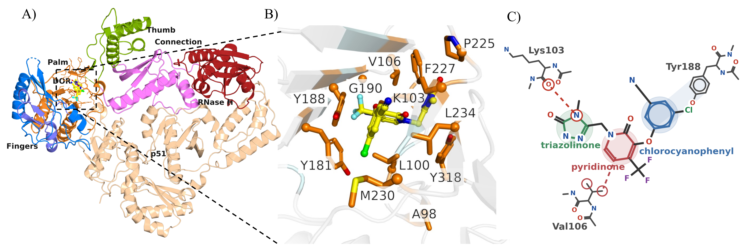
“Figure 1: Crystal structure of Doravirine (DOR) bound to wild-type (WT) Reverse Transcriptase (RT). (A) 3D structure of WT RT in complex with DOR (PDB ID: 4NCG) used as the starting point of all simulations in this work. The Non-Nucleoside Inhibitor Binding Pocket (NNIBP) including DOR is highlighted in a dashed black box. (B) DOR-binding pocket zoomed in with 12 highlighted residues corresponding to genotypes studied here. (C) 2D schematic structure of DOR illustrating 3 key interactions with RT p66 residues: (i) Lys103 mainchain carbonyl hydrogen bond with the triazolinone moiety, (ii) Hydrophobic interaction between Val106 C_{γ} and central pyridinone core, (iii) Aromatic stacking between the Tyr188 sidechain and the chlorocyanophenyl ring. ”

(Figure 3)
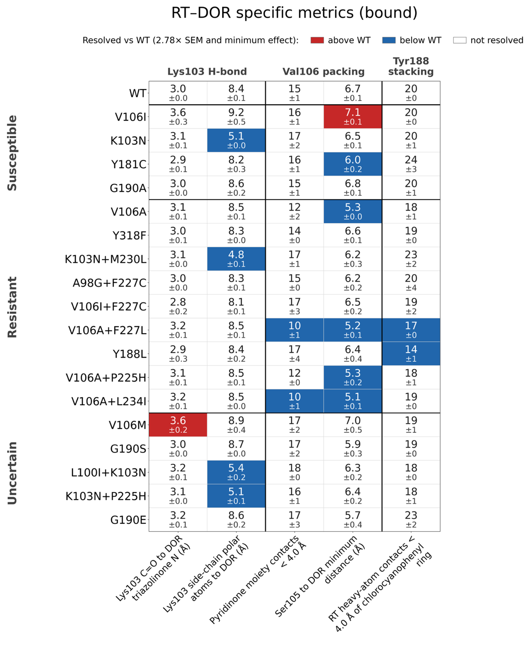

“Figure 3: Changes in RT–DOR specific metrics across the genotype panel, with at least one genotype resolved vs WT. Each cell gives that genotype's mean over the three 100 ns replicates, with the standard error of the mean (SEM) across those three replicates beneath it. Cells are colored only when the difference from WT has a 95% confidence interval excluding zero and exceeds the observable-specific minimum interpretable difference defined in Methods. Because resolution depends on both replicate variability and effect magnitude, genotypes with similar mean differences from WT need not both be colored. Genotypes are grouped by the resistance category of Table 1 and ordered by fold reduction in DOR susceptibility within each group. Per-comparison effect sizes, confidence intervals and p-values for every metric, are in Supplementary Table 4, and the per-frame distributions behind these means are in Supplementary Figure 5.”

(Figure 5)
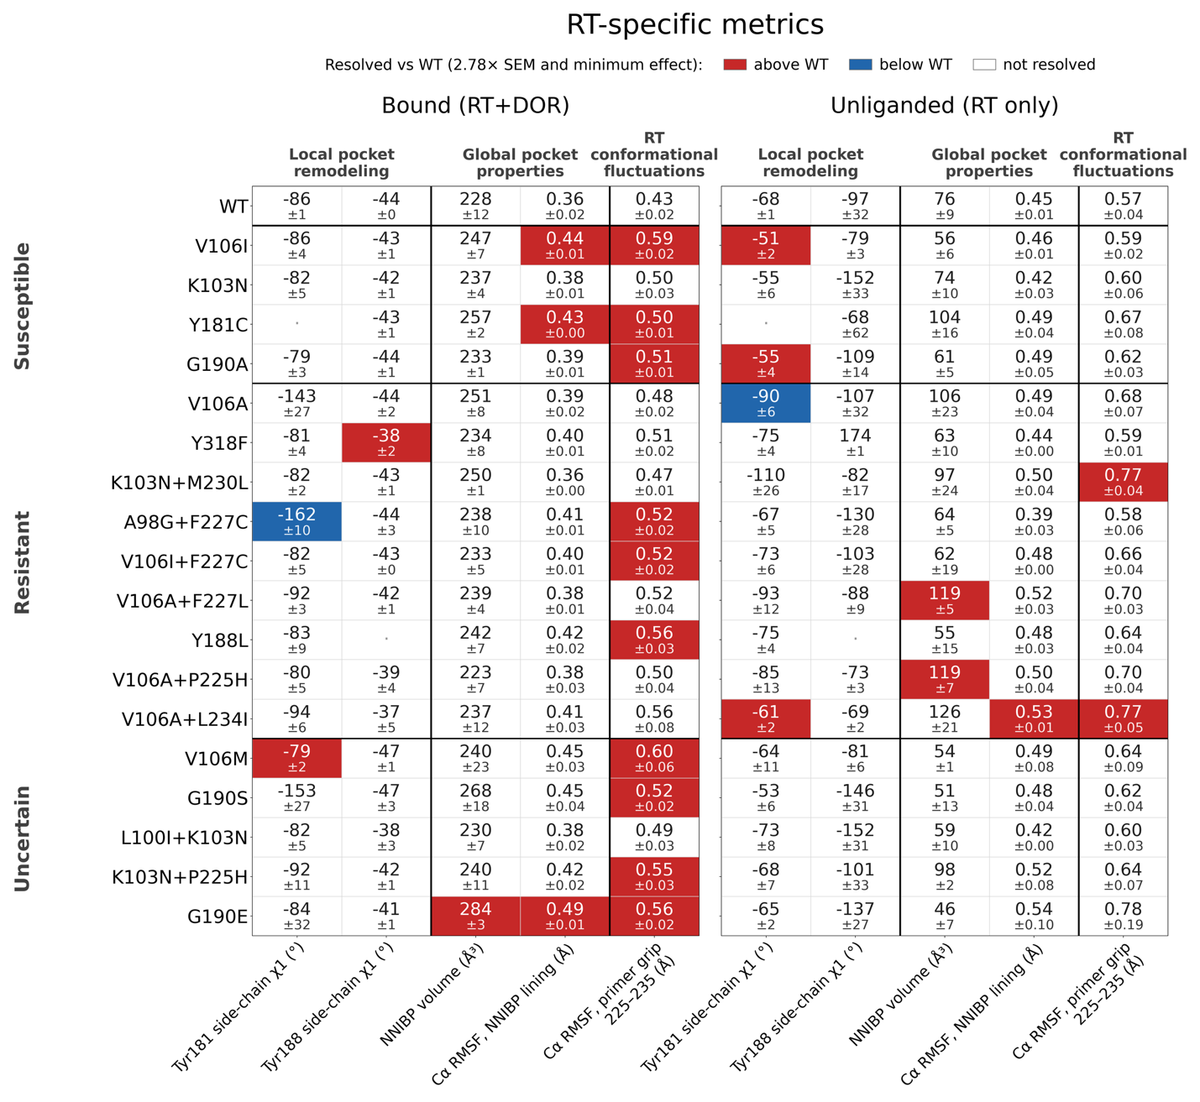
“Figure 5: RT-specific metrics computed from equilibrium MD simulations in the holo (DOR-bound) and the apo (unliganded) state. Left, DOR-bound simulations; right, unliganded RT simulations, for the same genotypes. Each cell gives that genotype's mean in that state, in the metric's own units, with the standard error of the mean (SEM) across its three replicates beneath it; WT heads each panel as the reference row. Fill, unit grouping and the ordering of rows are as in Figure 3. Cells are colored only when the difference from WT has a 95% confidence interval excluding zero and exceeds the observable-specific minimum interpretable difference defined in Methods. Genotypes with similar mean differences from WT need not both be highlighted.”

(Figure 6)
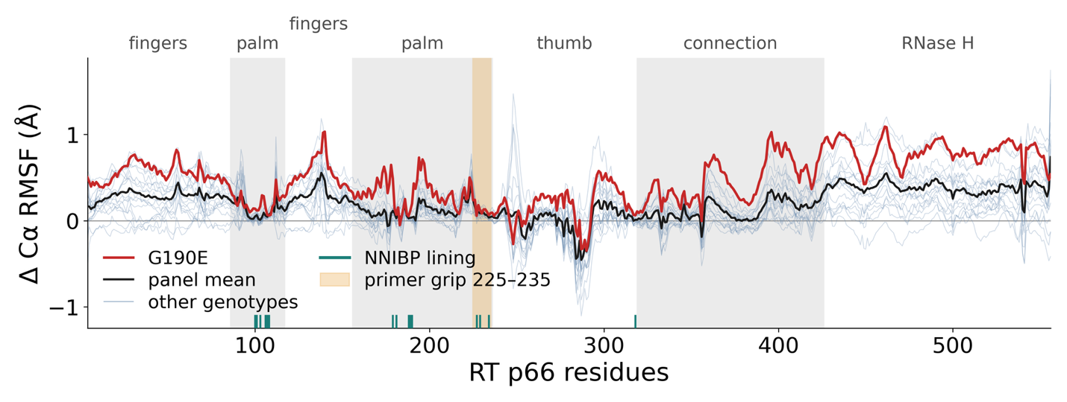
“Figure 6: Flexibility along p66, referenced to WT. Change in per-residue Cα RMSF relative to WT in the DOR-bound state, after superposition on the NNIBP-lining residues, so that what is plotted is motion about each residue's own mean position. G190E is shown in red, the mean over all 18 mutant genotypes in black, and the individual genotypes in pale blue. Shading and the labels along the top mark the p66 subdomains. Primer grip is shown in amber and the residues lining the NNIBP are indicated along the x-axis. Each curve is the mean over that genotype's three 100 ns replicates.”
Also see Supplementary Text, Sections 8 and 9.

Reviewer 2
Comments:
In this manuscript, the authors use all-atom MD simulations with alchemical FEP and MM/GBSA to retrospectively assess doravirine resistance across 18 clinically observed HIV-1 RT genotypes. FEP correctly predicts little effect for 3 of 4 susceptible mutations and reduced binding for 7 of 9 resistant genotypes, though correlations with experimental fold-change are weak (R² = 0.26, p = 0.07). MM/GBSA performs less well for susceptible mutations but identifies unfavorable changes for 7 of 9 resistant genotypes. Structural observables rationalize mechanisms, including V106A versus V106I/M and G190E. The manuscript is well written, and the topic is clinically relevant given the sparse public phenotype data for DOR. However, several methodological and interpretive issues need to be addressed before the manuscript can be considered for publication. Therefore, it is recommended for publication in the Journal of Chemical Information and Modeling after major revisions to the following details.
More comments:

Reviewer 2, comment 1
1. The three independent 100 ns replicates are short relative to the timescales of RT domain rearrangements and unliganded pocket conformational equilibria. The authors should provide more rigorous convergence diagnostics (e.g., block averaging, autocorrelation analysis) for both the structural observables and the FEP/MM-GBSA estimates, and discuss how limited sampling may bias the results.
Response: To address this comment, we have added autocorrelation and blocked-error diagnostics for DOR pose RMSD and DOR–RT separation and explicitly discuss effects of limited sampling in the Discussion.
(Methods, Convergence tests)
“For a series of N successive frames of a structural observable, with values x_{t} and mean x̄, sampled at interval Δt, the normalized autocorrelation function (ACF) was computed as $C(τ)={\sum_{t=1}^{t=N-τ}{(x_{t}-\overline{x})(x_{t+τ}-\overline{x})}}/{\sum_{t=1}^{t=N}{{(x_{t}-\overline{x})}^{2}}}$, so that C(0) = 1; lags are reported as τΔt in nanoseconds. For block averaging, each series was partitioned into M = ⌊N/n⌋ non-overlapping blocks of length n with block means ${\overline{x}}_{b}=\frac{1}{n}\sum_{t=(b-1)n+1}^{t=bn}{x_{t}}$ where $b=1,2,...,M$. The standard error of the mean implied by that block length, also called the blocked standard error, is $SEM(n) = \sqrt{{\sum_{b}{{({\overline{x}}_{b}-\overline{x})}^{2}}}/{M(M-1)}}$. Block means were pooled across the three replicates of a genotype. The diagnostics are shown in Supplementary Section 4 and Supplementary Figure 3.”
(Supplementary Figure 3)
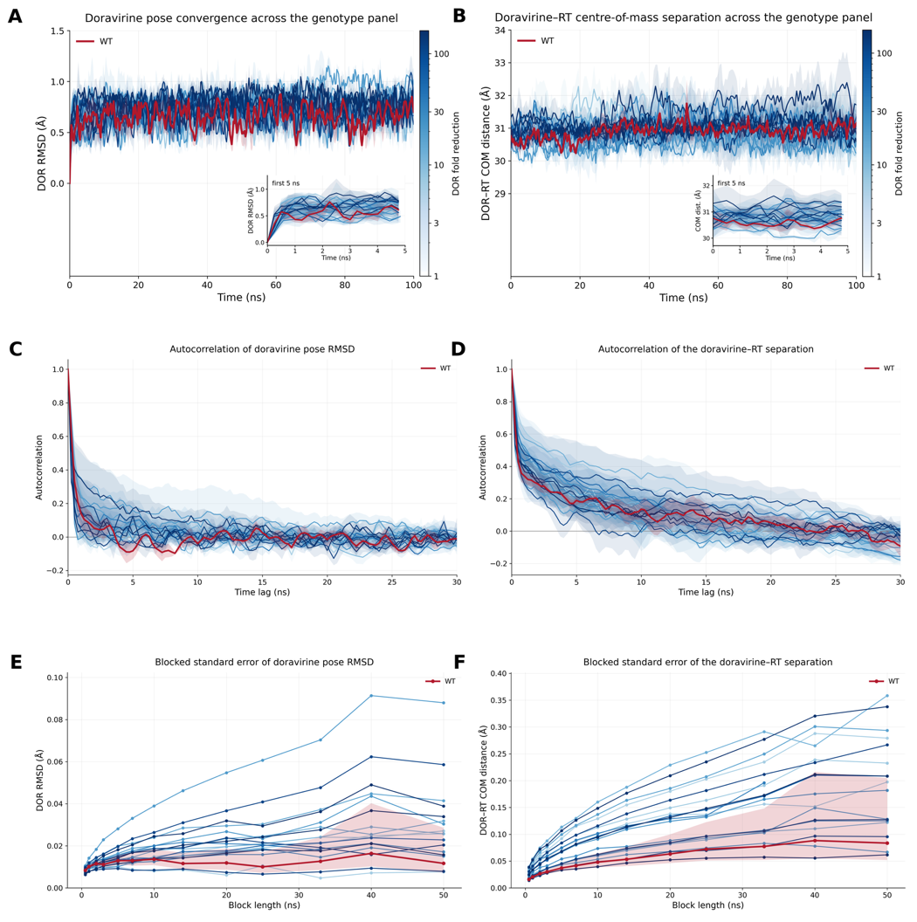
Supplementary Figure 3. DOR Root Mean Squared Deviation (RMSD) and distance between centers of mass (COM) of DOR and RT characterize the stability of the sampled local DOR pose over 100 ns. (A) Each solid line provides the average RMSD of the DOR heavy atoms vs the minimized structure within the NNIBP (at t = 0) computed at each time point across triplicate simulations. Shaded regions represent the standard error of this mean (SEM). The red curve represents WT and the remaining trajectories are color-coded based on the respective genotype's fold-change in susceptibility (Table 1 in main text). Inset shows the same data highlighting the rapid changes in the first 5ns of the simulations. (B) Similar plot for the average distance between COMs of DOR and RT atoms. (C, D) Normalized autocorrelation functions (ACF) of these two convergence metrics, computed for each replicate and averaged within each genotype, with the shaded region showing the SEM across replicates. From these plots, DOR RMSD and the DOR-RT COM distance in our simulations decorrelate within about 5 ns and roughly 20 ns, respectively. (E, F) Blocked standard error of the convergence metrics against block length. The shaded band, drawn for wild type alone to keep the panel legible, is the 95% χ² interval on a standard error estimated from that number of blocks. From these plots, the blocked error is nearly flat beyond 10 ns for DOR RMSD, but DOR-RT COM distance takes about 40-50 ns, up to the statistical limit of the trajectories simulated here.
FEP work overlap and estimator checks are described in Methods and Supplementary Figure 4. The MM/GBSA protocol-sensitivity analyses are reported in Supplementary Tables 5–6. Sampling limitations are discussed at length in the Discussion section (see response to Reviewer 1 Comment 1)

Reviewer 2, comment 2
2. The binary RT–DOR system omits the nucleic acid substrate and incoming dNTP, which are essential for resistance mechanisms involving the primer grip (e.g., M230L) and allosteric coupling (e.g., K103N). The authors should explicitly discuss which mechanisms are inaccessible in this setup and how this may affect the correlation with phenotypic data.
Response: The Discussion paragraph beginning “Furthermore, our binary RT–DOR model” identifies the primer-grip and catalytic-coupling mechanisms that cannot be tested. The exact paragraph is quoted under Reviewer 1, Comment 1; the complementary K103N+M230L interpretation is quoted under Reviewer 1, Comment 3.

Reviewer 2, comment 3
3. Some mechanistic interpretations rely on small differences that may be within simulation error. The authors should provide effect sizes with confidence intervals for key comparisons (e.g., V106A vs. V106I/M, G190A vs. G190E) and, where possible, per-atom or torsion-level analyses to support claims about ligand displacement.
Response: To address this comment, we have added effect sizes, standard errors, 95% confidence intervals and p-values in Supplementary Table 4, and distinguish resolved from unresolved changes throughout the “Structural consequences of DOR-associated substitutions” section in the Results. Figures 3 and 5 summarize the WT-referenced shifts, while Figure 4 retains the trajectory-level contact and displacement plots. The statistical definition and representative Results excerpts follow.
(Methods, Statistical analysis)
“Differences between genotypes in a structural observable were quantified with the replicate trajectory as the unit of comparison. For each genotype and observable, we report the difference of replicate means, i.e. the “effect size” (in the observable's own units), its standard error, and a two-sided pooled-variance t-test on that difference, with the corresponding 95% confidence interval. A difference was considered resolved only when its 95% confidence interval excluded zero and its magnitude exceeded the observable-specific minimum interpretable difference. Confidence intervals used Student t critical values of 2.78 for genotype-versus-WT comparisons (4 degrees of freedom) and 2.31 for genotype × ligand-state interactions (8 degrees of freedom). The minimum interpretable differences were: 0.30 Å for interatomic distances, one contact for contact counts, 5° for the interplanar angle and side-chain χ1 dihedrals, 10 Å³ for NNIBP volume, 0.05 Å for Cα RMSF, and 0.05 for secondary-structure fractions.”
(Results, Structural consequences of DOR-associated substitutions)
“To identify potential structural mechanisms underlying these energetic shifts, we measured a set of geometric observables in every equilibrium MD trajectory (Figures 3-4, Supplementary Figure 5, and per-comparison statistics in Supplementary Table 4). In case of DOR-bound simulations, these observables follow from the three key DOR:NNIBP interactions in the crystal structure (Figure 1C): the DOR-Lys103 hydrogen bond, measured using the distance from the Lys103 main-chain carbonyl oxygen to the triazolinone nitrogen and the distance from the Lys103 side chain to DOR; the hydrophobic packing of the pyridinone core against Val106, measured as the number of RT contacts with the pyridinone moiety and the distance from Ser105 to DOR; and the aromatic stacking on Tyr188, as the number of RT contacts burying the chlorocyanophenyl ring. Several additional observables found during exploratory analysis of the MD trajectories are summarized in Supplementary Table 4. In what follows, we summarize the most striking observations.
First, we find that the hydrogen bond between the residue 103 main-chain carbonyl oxygen and the DOR triazolinone nitrogen is conserved in most trajectories (Figure 3): this distance is 2.97 ± 0.01 Å in WT simulations and between 2.80 and 3.22 Å in 16 of the 18 mutant genotypes, including all four K103N-containing genotypes (3.05–3.20 Å). Mean distances were larger in V106I and V106M, but only V106M met both criteria for a resolved difference from WT (+0.59 ± 0.20 Å, 95% CI [0.04, 1.14] Å, p = 0.04; Supplementary Table 4). Moreover, substituting Lys by Asn at position 103 shortens the side chain and brings its polar atoms closer to DOR, decreasing the Lys103 sidechain distance to DOR from 8.38 ± 0.15 Å in WT to 4.80–5.43 Å in every K103N-containing genotype (all p ≤ 0.0003; Supplementary Table 4). In contrast, this distance is 8.07–9.20 Å in every genotype that retains Lys103 (Figure 3).”
“Second, burial of the chlorocyanophenyl ring, counted as RT heavy-atom contacts within 4.0 Å, is 19.5 ± 0.5 in WT (Figure 3). The largest reduction in the panel occurs in Y188L (13.7 ± 1.5; Figure 3 and Figure 4A) and is statistically resolved against WT (−5.84 ± 1.56, [−10.2, −1.5], p = 0.02; Supplementary Table 4). Notably, Y181C shows no resolved reduction in these contacts (24.0 ± 2.6).”
“Notably, G190A leaves the DOR pose essentially unperturbed (Supplementary Table 4), with chlorocyanophenyl ring burial (20.0 ± 1.2), stacking angle with Tyr188 sidechain (16.0 ± 1.8°), the distances to Ser105, Val179 and Val106, and the NNIBP volume (233 ± 2 Å³; Figure 4C) all within replicate error of the corresponding WT values (every comparison p ≥ 0.22). On the other hand, G190E leads to several disruptive perturbations observed in our simulations: (i) the minimum distance from Val179 to DOR increases from 3.62 ± 0.06 Å in WT to 6.47 ± 0.44 Å in G190E (Supplementary Figure 5), more than 2.5 Å beyond the next largest value in the panel (3.89 ± 0.29 Å, in L100I+K103N), and (ii) the NNIBP volume expands from 228 ± 12 Å³ in WT to 284 ± 3 Å³, the largest of any genotype (Figure 4C). Both are resolved against WT (+2.84 ± 0.44 Å, [1.62, 4.07] Å, p = 0.003 and +55.9 ± 12.1 Å³, [22.3, 89.4] Å³, p = 0.01). At the same time, these disruptions are not accompanied by any loss of aromatic packing: neither the Tyr188 ring stacking angle (12.0 ± 0.9°) nor chlorocyanophenyl burial (22.7 ± 2.0) differs from WT by a resolved amount (Supplementary Table 4).”
“Third, V106A-containing genotypes show a resolved displacement of DOR toward Ser105. In all four V106A-containing genotypes, DOR (i) moves toward Ser105, from 6.65 ± 0.09 Å in WT to between 5.13 and 5.30 Å (Figure 3 and Figure 4B), (ii) has a larger mean distance from residue 106 (3.36 ± 0.07 Å in WT to 3.54–3.64 Å; Supplementary Table 4), and (iii) has fewer mean pyridinone contacts, from 14.8 ± 1.4 in WT to between 10.3 and 11.8 (Figure 3). V106I and V106M have higher mean distances from Ser105 (Figure 3) (7.15 ± 0.14 and 7.04 ± 0.46 Å) and lower mean distances from residue 106 (3.22 ± 0.09 and 3.16 ± 0.14 Å), while mean pyridinone contact counts are similar or slightly higher (16.0 ± 0.8 and 16.8 ± 2.4). The displacement toward Ser105 is well resolved (Supplementary Table 4): −1.35 ± 0.09 Å for V106A against WT (95% interval [−1.61, −1.09] Å) and +1.85 ± 0.14 Å for V106I against V106A ([1.45, 2.24] Å). Of V106I and V106M, only V106I shows a resolved increase in Ser105 distance against WT (+0.50 ± 0.17 Å, 95% CI [0.03, 0.96] Å, p = 0.04). Pyridinone contact reductions are resolved for V106A+F227L and V106A+L234I, but not for V106A (−3.2 ± 2.2 contacts for V106A against WT, [−9.2, +2.8]), and V106A against V106M is within error (Supplementary Table 4).”

Reviewer 2, comment 4
4. The FEP calculations involve two charge-changing legs (WT → K103N, WT → G190E). The authors should verify that protonation states of titratable residues in the NNIBP are consistent across WT and mutants, and provide more detail on the hybrid residue topologies, soft-core parameters, and finite-size correction.
Response: To address this comment, we have added the protonation assignments, hybrid-topology treatment and soft-core parameters in Methods, “Free Energy Perturbation Calculations”, and quantified the finite-size correction in Supplementary Text, Section 7.
(Methods, Free Energy Perturbation Calculations)
“Titratable residues were assigned in the prepared WT RT-DOR structure and carried unchanged through mutation modeling. All thirteen histidines in the system were neutral with the proton on Nδ1, in the WT and in all 18 genotypes. Specifically for G190E, the glutamate introduced was deprotonated and singly charged. In the hybrid topologies, bonded parameters were interpolated linearly in λ and dummy atoms were relaxed during the end-state minimization. Soft-core parameters were α = 0.3, σ = 0.25 nm and a soft-core power of 1, applied to both Lennard-Jones and Coulomb interactions.”
(Supplementary Text, Section 7)
“7. Finite-size corrections for the charge-changing alchemical legs”
“The leading periodicity (net-charge self-energy) term of the Rocklin scheme is +0.0407 kcal/mol per phase and cancels to below 0.0001 kcal/mol in ΔΔG_{bind} for both WT→K103N and WT→G190E. The higher-order terms — net-charge undersolvation, discrete-solvent and residual integrated potential — were not applied, since computing them exactly requires a Poisson-Boltzmann treatment of each environment. However, the charge change is identical in the holo and apo phases by construction; and the cells are matched to within 0.13% (K103N) and 0.31% (G190E) in volume, with DOR occupying 0.019% of the cell. Taking a per-phase correction of 1 kcal/mol, about 25 times the leading term, the residual on ΔΔG_{bind} is below 0.004 kcal/mol, at least 40-fold smaller than the 0.16–1.06 kcal/mol per-leg standard errors derived from Supplementary Table 3.”

Reviewer 2, comment 5
5. Gasteiger charges are less accurate than AM1-BCC or RESP for drug-like molecules. The authors should either compare with a more accurate charge model for a subset of systems or explicitly discuss how this choice may affect the computed energies and the resulting correlations.
Response: We have corrected the FEP charge-model description, added the same-snapshot AM1-BCC sensitivity analysis in Supplementary Text, Section 2 and Supplementary Table 5, and identify the measured sensitivity of the MM/GBSA energies to the charge model in the new supplementary analysis.
(Methods, Free Energy Perturbation Calculations)
“DOR was parameterized for the alchemical legs with the OpenFF 2.0.0 force field and its default AM1-BCC partial charges, then exported to GROMACS format through OpenFF Interchange 0.5.0. The hybrid Hamiltonian interpolates between the two physical end states,”
(Methods, Molecular dynamics simulations)
“Charge-model sensitivity was assessed by re-scoring the same trajectories and snapshots with AM1-BCC charges for a subset of genotypes (Supplementary Section 2 and Supplementary Table 5).”
(Supplementary Text, Section 2)
“2. Sensitivity of the MM/GBSA energies to the ligand charge model”
“DOR parameters for the equilibrium MD simulations were generated with Gasteiger partial charges, as opposed to AM1-BCC for the FEP simulations. To test how much that choice matters, the same trajectories and snapshots were re-scored with AM1-BCC charges for wild type and four genotypes, chosen to span the panel's sensitivity to the charge assignment: G190E and K103N+M230L, where the electrostatic and generalized-Born terms contribute most to ΔΔE_{Total}, together with V106A and Y188L, where they contribute least. The two charge sets are both neutral and correlate at 0.890, but AM1-BCC is more polarized (mean |q| 0.228 e against 0.138 e; RMS difference 0.165 e, maximum 0.390 e), with the largest differences on the triazolinone and pyridinone carbonyl and amide atoms. The WT-referenced ΔΔE_{Total} changed by at most 1.33 kcal/mol and kept its sign for every genotype tested (Supplementary Table 5). The individual components move further than the total and in opposing directions: for K103N+M230L the electrostatic term shifts by −2.13 kcal/mol and the generalised-Born term by +2.01 kcal/mol, which largely cancel.”
Reviewer 3
Comments:
The topic of this manuscript is timely and clinically relevant, the genotype panel is thoughtfully curated with transparent provenance (Stanford HIVDB, PhenoSense/Merck assays), and the use of open-source tooling (OpenMM, GROMACS, pmx, OpenFF) is commendable for reproducibility. The manuscript is generally well written and the structural analysis is a genuine strength. However, the central quantitative claim — that FEP "partially tracks" phenotype — rests on weak statistics derived from a small panel, and several methodological choices and interpretive statements require clarification, additional support, or tempering before the work can be considered suitable for publication. My specific concerns follow:

Reviewer 3, comment 1
1. The Abstract states "FEP correctly predicted little effect on DOR binding for 3 of 4 susceptible mutations and reduced binding for 7 of 9 resistant genotypes." Please define "correctly predicted" quantitatively — what threshold on ΔΔG_{bind} constitutes "little effect" versus "reduced binding"? A stated cutoff (e.g., | ΔΔG_{bind}| > 1 kcal/mol) would make this claim reproducible.
Response: We have now updated the Abstract to clarify terminology and defined the ∆∆G_{bind} threshold in multiple places, including the Methods section.
(Abstract, Results)
“Results: A genotype was classified as having a high energetic impact when its estimated ΔΔG_{bind} minus one standard error exceeded +0.5 kcal/mol. Under this rule, FEP classified 3 of 4 susceptible genotypes as low-impact and 7 of 9 resistant genotypes as high-impact. ΔΔG_{bind} showed limited correlation with log₁₀-transformed susceptibility fold-change across all 18 genotypes (R² = 0.08, p = 0.26), with a stronger association among the 13 genotypes with established susceptible or resistant phenotypes (R² = 0.26, p = 0.07). MM/GBSA classified 7 of 9 resistant genotypes as high-impact but only 1 of 4 susceptible genotypes as low-impact. ΔΔG_{bind} and ΔΔE_{Total} were modestly correlated (R² = 0.18, p = 0.08), with van der Waals contributions frequently dominating MM/GBSA shifts. Structural analyses identified changes in aromatic packing, ligand positioning, and the conformational response to DOR binding.”
(Abstract, Conclusion)
“Conclusion: Relative binding free-energy classifications agreed with established susceptibility categories for 10 of 13 genotypes, but limited quantitative correspondence with susceptibility fold-changes restricts their use as a proxy for in vitro testing. The simulations identify mutation-dependent changes in DOR contacts and pocket reorganization, providing mechanistic hypotheses that complement experimental susceptibility data.”
(Methods, Statistical analysis)
“Agreement with phenotype was additionally summarized as a binary classification. A genotype was scored as predicted-resistant when the computed quantity (binding free energy or DOR-RT interaction energy), minus its standard error over replicates, exceeded +0.5 kcal/mol, approximately k_{B}T at 300 K, and as predicted-susceptible otherwise. These classifications are sometimes referred to as “strong” and “weak” energetic effects, respectively. This cutoff was fixed a priori rather than fitted to the panel. ”
The same threshold is defined in the Results section:
(Results, RT-DOR binding free energy analyses)
“Throughout this work, we classify a genotype as having a strong impact on ∆∆G_{bind} or ∆∆E_{Total} when its estimate lies more than one standard error above (approximately) the thermal energy at room temperature, k_{B}T = 0.5 kcal/mol, and as having a weak impact otherwise; genotypes with free energy below this threshold or whose replicate error spans this threshold are therefore counted as weak.”

Reviewer 3, comment 2
2. There are several minor typographical issues: "NRNTI-resistance mutations" (Page 16) should be "NNRTI-resistance mutations"; "hinges on" (Page 30) should be "hinges on" or "depends on"; "APPROVAL" section header (Page 35) is redundant with "Author Contributions." Please proofread carefully.
Response: We have proofread the manuscript and corrected the typographical and spacing errors we found.

Reviewer 3, comment 3
3. The MM/GBSA protocol minimizes each snapshot with all atoms free before energy evaluation (Page 11). This is unusual: standard MM/GBSA evaluates single-point energies on snapshots (or after minimizing only hydrogens) to avoid artificially distorting the ensemble. Full minimization of 100 snapshots per trajectory can substantially reduce energetic noise and may bias ΔΔE components, particularly ΔE_{elec} and ΔE_{GB}. The authors should:
(a) Justify full minimization versus the more standard single-point or hydrogen-only relaxation protocol.
(b) Report how sensitive ΔΔE_{Total} and its components are to this choice (e.g., by recomputing without minimization for a subset of genotypes).
Response: We have added the rationale and supporting literature in Methods, “MM/GBSA Calculations”, and compared full minimization with hydrogen-only relaxation for the eighteen panel genotypes and the F227C alchemical intermediate, each referenced to WT and single-point evaluation for six genotypes (Supplementary Text, Section 5; Supplementary Table 6).
( Methods, MM/GBSA Calculations)
“Each snapshot was energy-minimized with all atoms free before energy evaluation in double precision, to relieve artificial steric clashes; minimization was run to convergence over 2,000 iterations.”
( Methods, MM/GBSA Calculations):
“Minimizing each snapshot before the energy evaluation follows established practice for end-point methods. Minimization-based MM-PBSA has been validated for drug discovery,⁴⁹ minimization-based MM-PBSA and MM-GBSA have been shown to reproduce the accuracy of ensemble averaging at a fraction of the cost,⁵⁰ and minimizing from a series of MD snapshots, as done here, has been shown to give results similar to single-point ensemble averages.^{34,51} Minimization relieves steric strain that single-point evaluation of frames sampled under explicit solvent, periodic boundary conditions and constrained bond lengths would otherwise carry into the cutoff-free, unconstrained implicit-solvent Hamiltonian used for scoring, where it contributes Lennard-Jones energies far larger than the binding signal. Snapshot-relaxation sensitivity was assessed by comparing full minimization with hydrogen-only relaxation with heavy atoms restrained for all eighteen panel genotypes and the F227C alchemical intermediate, each referenced to WT, and with single-point evaluation for six genotypes (Supplementary Section 5 and Supplementary Table 6). Note that this choice only affects the MM/GBSA calculations; ΔΔG_{bind} is an alchemical free energy and involves no snapshot minimization.”
(Supplementary Text, Section 5)
“5. Sensitivity of the MM/GBSA energies to the snapshot relaxation protocol”
“Each snapshot is energy-minimized before its energy is evaluated. We compared hydrogen-only relaxation, with heavy atoms restrained, against the unrestrained full minimization used in the main text, for all 18 panel genotypes and the F227C alchemical intermediate, each referenced to WT (Supplementary Table 6). The two protocols agree on the terms that do not depend on close atomic contacts: the Spearman correlation between them is 0.69 for ΔΔE_{elec} and 0.81 for ΔΔE_{GB}. This is not the case for ΔΔE_{vdW} (0.26) or ΔΔE_{Total} (0.09). We find that hydrogen-only relaxation leaves heavy-atom contacts in place, and those contacts enter the van der Waals term, which dominates total MM/GBSA computed interaction energy shifts. Furthermore, over the 13 genotypes with an established phenotype, ΔΔE_{Total} from full minimization correlates with log₁₀ fold reduction in DOR susceptibility at Spearman +0.45 (p = 0.13), while hydrogen-only relaxation gives -0.32 (p = 0.29), though neither reaches statistical significance. For completeness, we also tested single-point evaluation, with no relaxation at all, on six genotypes. In these cases, we found that ΔΔE_{Total} is dominated by a small number of snapshots carrying steric contacts, reaching 7 × 10⁸ kcal/mol in the worst case. Our view is ΔΔE_{Total} is not interpretable until close heavy atom contacts are relieved. ”

