Supporting Information
Molecular Simulation of Doravirine Resistance in HIV-1 Reverse Transcriptase
Rohit Satija, Kaiming Tao, Robert W. Shafer
Division of Infectious Diseases, School of Medicine, Stanford University, Stanford, CA, USA
Corresponding author: rsatija@stanford.edu

Contents
1 Is the RT-DOR crystal structure representative of the true RT-DOR structural ensemble?
2 Sensitivity of the MM/GBSA energies to the ligand charge model
3 The crystallographic pose is recovered from perturbed starting poses
4 Convergence of the molecular dynamics ensemble
5 Sensitivity of the MM/GBSA energies to the snapshot relaxation protocol
6 Non-equilibrium switching work distributions
7 Finite-size corrections for the charge-changing alchemical legs
8 Distributions behind the RT–DOR specific metrics
9 RT-specific conformational rearrangements

1. Is the RT-DOR crystal structure representative of the true RT-DOR structural ensemble?
We address this question in two steps: first by comparing the DOR pose in the crystal structure (PDB ID: 4NCG) with a second, independent WT RT–DOR–DNA ternary structure determined by cryo-EM (PDB ID: 7Z2G), and then by comparing key NNIBP residues across published RT–NNRTI structures. The 3.65 Å cryo-EM structure 7Z2G contains RT bound to a 38-mer DNA aptamer and DOR and was determined independently of the 2.58 Å X-ray structure 4NCG. We superposed the structures using 16 corresponding NNIBP-lining C_{α} atoms: fifteen in p66 and Glu138 in p51. Following this alignment, the DOR heavy-atom RMSD was 0.62 Å across its 29 heavy atoms, and its centroid differed by 0.30 Å between structures (Supplementary Figure 1A). The pocket-lining C_{α} RMSD was 0.49 Å, and the median per-residue side-chain heavy-atom RMSD was 0.80 Å. The calculated NNIBP volumes were 198 Å³ in 4NCG and 194 Å³ in 7Z2G. Finally, we compared the minimum heavy-atom distance from each of the sixteen NNIBP residues to DOR. The median absolute difference between structures was 0.16 Å, the largest absolute difference was 0.41 Å at Lys103, and the distances were strongly correlated across residues (r = 0.974; Supplementary Table 7).
To place the agreement between the two DOR-bound structures in context, we compared them with three WT RT–NNRTI structures using the same pocket alignment: RPV (PDB ID: 2ZD1, 1.80 Å), EFV (PDB ID: 1FK9, 2.50 Å) and NVP (PDB ID: 1VRT, 2.20 Å). Tyr181 adopts a similar rotamer in the two DOR-bound structures but a different rotamer in the other three complexes. Relative to 4NCG, its χ₁ angle differs by 93°, 95° and 90° in the RPV-, EFV- and NVP-bound structures, respectively, with corresponding ring-centroid displacements of 4.9, 4.2 and 4.2 Å (Supplementary Figure 1B). Tyr188 shows smaller differences: relative to 4NCG, its χ₁ angle differs by 13–20° and its ring centroid by 1.3–2.6 Å in the other four structures (Supplementary Figure 1C). The calculated NNIBP volumes range from 181 to 258 Å³ across the five structures (Supplementary Table 7). Thus, the two independently determined DOR-bound structures share a similar local binding geometry, including a Tyr181 rotamer distinct from those observed with the other NNRTIs. The starting geometry of this work is therefore a property of the DOR–RT complex rather than an artifact of one crystal form.

Supplementary Figure 1. The DOR-NNIBP pose is reproducible across independently determined RT-DOR structures. (A) Doravirine in the two independent experimental structures, 4NCG (X-ray, 2.58 Å, grey) and 7Z2G (cryo-EM, 3.65 Å, blue), with the 4NCG pocket side chains in faint grey; heavy-atom RMSD 0.62 Å over 29 atoms. (B) Tyr181 in five NNRTI complexes: 4NCG (grey) and 7Z2G (blue) against RPV 2ZD1 (red), EFV 1FK9 (orange) and NVP 1VRT (purple). The two DOR structures agree with each other and differ from the other three by 90–95° in χ₁. (C) Tyr188 in the same five structures, which share one rotamer and differ by only 13–20°. DOR from 4NCG is drawn faintly in (B) and (C) for orientation.

2. Sensitivity of the MM/GBSA energies to the ligand charge model
DOR parameters for the equilibrium MD simulations were generated with Gasteiger partial charges, as opposed to AM1-BCC for the FEP simulations. To test how much that choice matters, the same trajectories and snapshots were re-scored with AM1-BCC charges for wild type and four genotypes, chosen to span the panel's sensitivity to the charge assignment: G190E and K103N+M230L, where the electrostatic and generalized-Born terms contribute most to ΔΔE_{Total}, together with V106A and Y188L, where they contribute least. The two charge sets are both neutral and correlate at 0.890, but AM1-BCC is more polarized (mean |q| 0.228 e against 0.138 e; RMS difference 0.165 e, maximum 0.390 e), with the largest differences on the triazolinone and pyridinone carbonyl and amide atoms. The WT-referenced ΔΔE_{Total} changed by at most 1.33 kcal/mol and kept its sign for every genotype tested (Supplementary Table 5). The individual components move further than the total and in opposing directions: for K103N+M230L the electrostatic term shifts by −2.13 kcal/mol and the generalised-Born term by +2.01 kcal/mol, which largely cancel.

3. The crystallographic pose is recovered from perturbed starting poses
To test whether representative systems from independent starting poses can recover the same DOR-bound state used in the simulations, we ran energy minimization followed by 2 ns MD equilibrations for a ladder of sixteen starting poses at increasing distance from the crystallographic pose. In the WT production ensemble, the DOR pose RMSD lies between 0.33 and 1.78 Å, the centroid displacement is at most 1.75 Å and the long-axis tilt at most 15.1°; we take that envelope as the sampled WT basin. All ten poses starting between 1.3 and 2.9 Å converged into the WT basin, ending at a median pose RMSD of 0.74 to 1.01 Å with 78 to 100% of their frames inside the envelope. However, extreme perturbations, corresponding to the six poses starting at 3.3 Å or beyond, failed to converge to the WT basin in the 2 ns simulations, ending between 5.0 and 9.4 Å (Supplementary Figure 2). The crystallographic pose is therefore an attractor with a basin of, at least, roughly 3 Å DOR pose RMSD from the crystal structure used in this study.

Supplementary Figure 2: Perturbed doravirine poses against the wild-type sampled basin. Axes are the pocket-frame coordinates after superposition on the NNIBP C_{α} atoms: centroid displacement separates translation, long-axis tilt separates rotation. Blue shading and contours give the density of the wild-type production ensemble (3 × 100 ns) enclosing 50, 90 and 99% of frames; the star is the crystallographic pose. Each run is drawn as an arrow from its starting pose, labelled with its heavy-atom RMSD as generated, to the median of its second half (last 1ns of the equilibration simulation). Green ends inside the basin, red outside. (A) All sixteen poses. (B) The same data over the convergent region.

4. Convergence of the molecular dynamics ensemble


Supplementary Figure 3. DOR Root Mean Squared Deviation (RMSD) and distance between centers of mass (COM) of DOR and RT characterize the stability of the sampled local DOR pose over 100 ns. (A) Each solid line provides the average RMSD of the DOR heavy atoms vs the minimized structure within the NNIBP (at t = 0) computed at each time point across triplicate simulations. Shaded regions represent the standard error of this mean (SEM). The red curve represents WT and the remaining trajectories are color-coded based on the respective genotype's fold-change in susceptibility (Table 1 in main text). Inset shows the same data highlighting the rapid changes in the first 5ns of the simulations. (B) Similar plot for the average distance between COMs of DOR and RT atoms. (C, D) Normalized autocorrelation functions (ACF) of these two convergence metrics, computed for each replicate and averaged within each genotype, with the shaded region showing the SEM across replicates. From these plots, DOR RMSD and the DOR-RT COM distance in our simulations decorrelate within about 5 ns and roughly 20 ns, respectively. (E, F) Blocked standard error of the convergence metrics against block length. The shaded band, drawn for wild type alone to keep the panel legible, is the 95% χ² interval on a standard error estimated from that number of blocks. From these plots, the blocked error is nearly flat beyond 10 ns for DOR RMSD, but DOR-RT COM distance takes about 40-50 ns, up to the statistical limit of the trajectories simulated here.

5. Sensitivity of the MM/GBSA energies to the snapshot relaxation protocol
Each snapshot is energy-minimized before its energy is evaluated. We compared hydrogen-only relaxation, with heavy atoms restrained, against the unrestrained full minimization used in the main text, for all 18 panel genotypes and the F227C alchemical intermediate, each referenced to WT (Supplementary Table 6). The two protocols agree on the terms that do not depend on close atomic contacts: the Spearman correlation between them is 0.69 for ΔΔE_{elec} and 0.81 for ΔΔE_{GB}. This is not the case for ΔΔE_{vdW} (0.26) or ΔΔE_{Total} (0.09). We find that hydrogen-only relaxation leaves heavy-atom contacts in place, and those contacts enter the van der Waals term, which dominates total MM/GBSA computed interaction energy shifts. Furthermore, over the 13 genotypes with an established phenotype, ΔΔE_{Total} from full minimization correlates with log₁₀ fold reduction in DOR susceptibility at Spearman +0.45 (p = 0.13), while hydrogen-only relaxation gives -0.32 (p = 0.29), though neither reaches statistical significance. For completeness, we also tested single-point evaluation, with no relaxation at all, on six genotypes. In these cases, we found that ΔΔE_{Total} is dominated by a small number of snapshots carrying steric contacts, reaching 7 × 10⁸ kcal/mol in the worst case. Our view is ΔΔE_{Total} is not interpretable until close heavy atom contacts are relieved.

6. Non-equilibrium switching work distributions
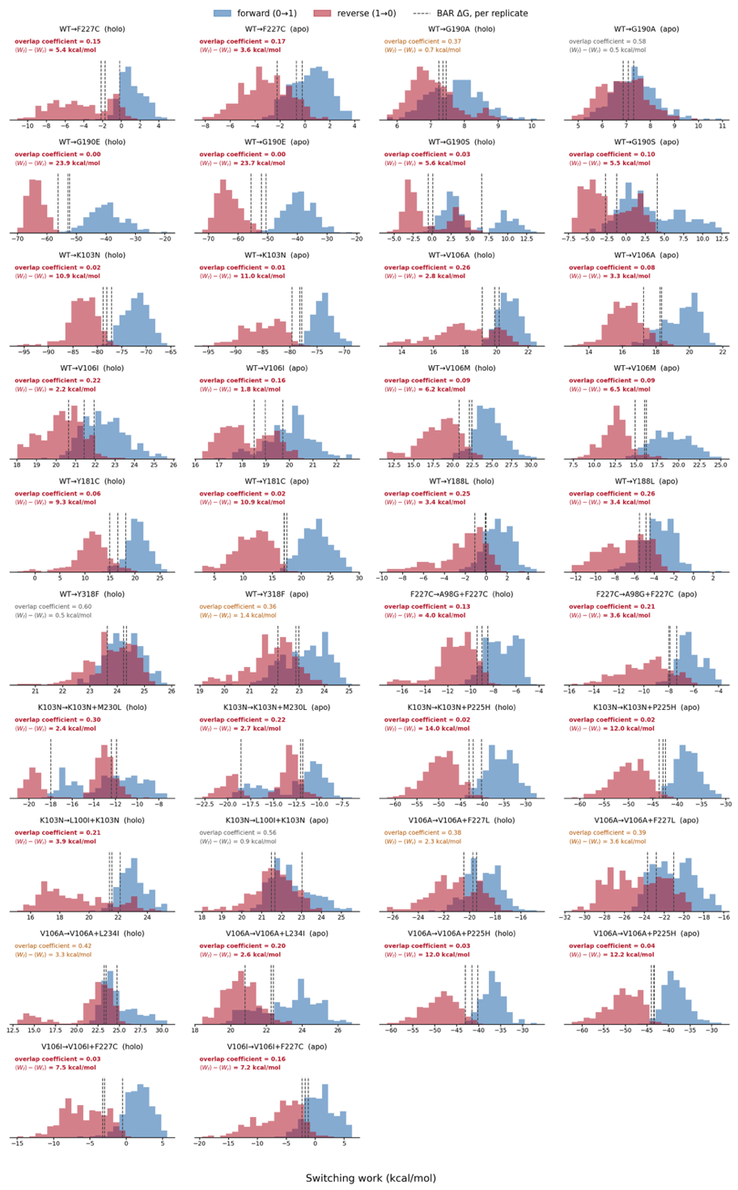
Supplementary Figure 4. Non-equilibrium switching work distributions for all alchemical transformations. Forward (0→1, blue) and reverse (1→0, red) switching work for each of the 19 alchemical legs, shown separately for the holo and apo phases and pooled across three independent replicates (100 switches per direction per replicate). Dashed lines mark the BAR free energy, ∆G, of each replicate. Each panel reports the forward/reverse overlap coefficient — the shared area under the two normalized work densities, where 0 is disjoint and 1 identical — and the hysteresis ⟨W_{f}⟩ − ⟨W_{r}⟩, which measures the work dissipated by switching at finite speed. Annotations are colored red below an overlap of 0.3 and amber below 0.5. Compound genotypes are reached by two sequential legs, both shown.

7. Finite-size corrections for the charge-changing alchemical legs
The leading periodicity (net-charge self-energy) term of the Rocklin scheme is +0.0407 kcal/mol per phase and cancels to below 0.0001 kcal/mol in ΔΔG_{bind} for both WT→K103N and WT→G190E. The higher-order terms — net-charge undersolvation, discrete-solvent and residual integrated potential — were not applied, since computing them exactly requires a Poisson-Boltzmann treatment of each environment. However, the charge change is identical in the holo and apo phases by construction; and the cells are matched to within 0.13% (K103N) and 0.31% (G190E) in volume, with DOR occupying 0.019% of the cell. Taking a per-phase correction of 1 kcal/mol, about 25 times the leading term, the residual on ΔΔG_{bind} is below 0.004 kcal/mol, at least 40-fold smaller than the 0.16–1.06 kcal/mol per-leg standard errors derived from Supplementary Table 3.

8. Distributions behind the RT–DOR specific metrics
Supplementary Figure 5 shows the per-frame distributions for eight RT–DOR specific metrics: the five shown in Figure 3, plus the minimum distances from Val179 and Val106 to DOR and the Tyr188 interplanar angle reported in Supplementary Table 4. Each of them requires DOR, so none has an unliganded counterpart.
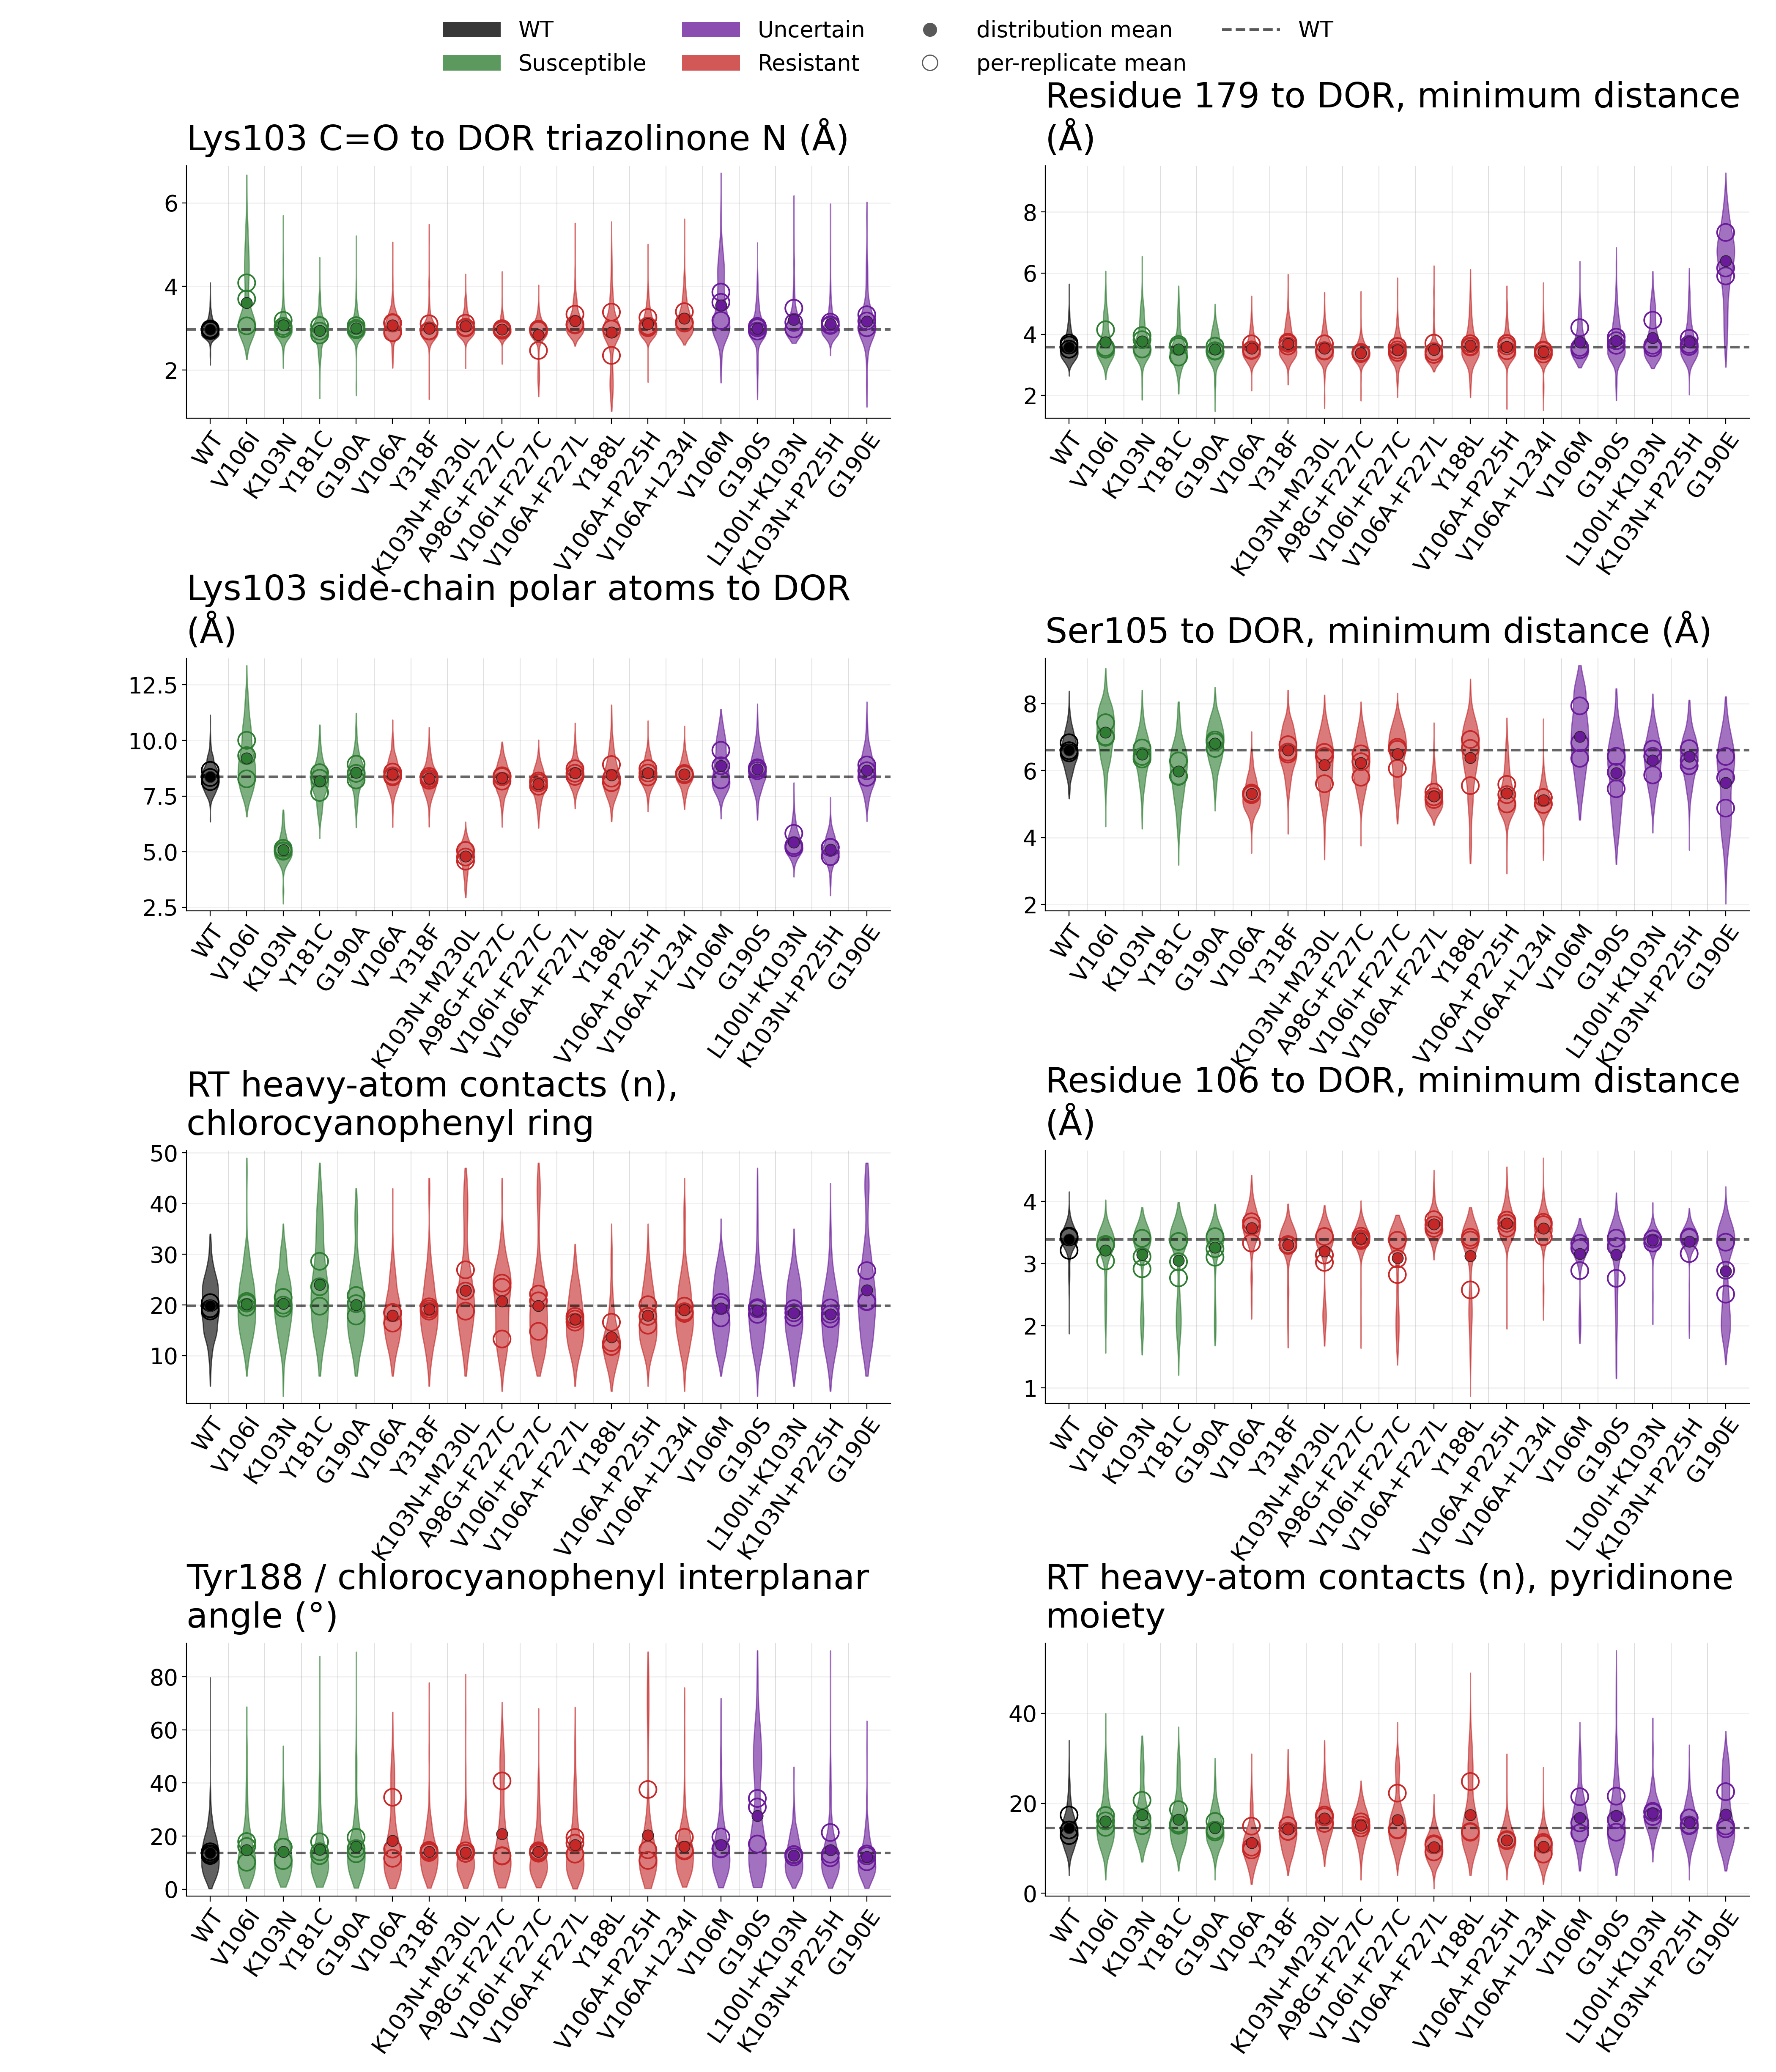
Supplementary Figure 5. Distributions of the eight RT–DOR specific metrics computed from equilibrium MD simulations in the holo configuration. Genotypes along the x-axis are in the order of Figure 3 rows and are coloured by the resistance category of Table 1. The filled marker is the mean of the plotted distribution, the open markers are its three per-replicate means, and the dashed line is the WT mean. Values are per frame over full production, pooled across the three replicates.

9. RT-specific conformational rearrangements
Three 100 ns apo replicates were run for WT and all eighteen simulated mutant genotypes, matching the holo simulations in length, force field and protocol. Supplementary Table 4 reports every structural observable in both states, with the per-replicate values and the WT-referenced bound–unliganded differences. Supplementary Figure 6 shows the distributions behind those means: all ten RT-specific metrics, including those not shown in Figure 5, for WT and all eighteen mutant genotypes in both states.
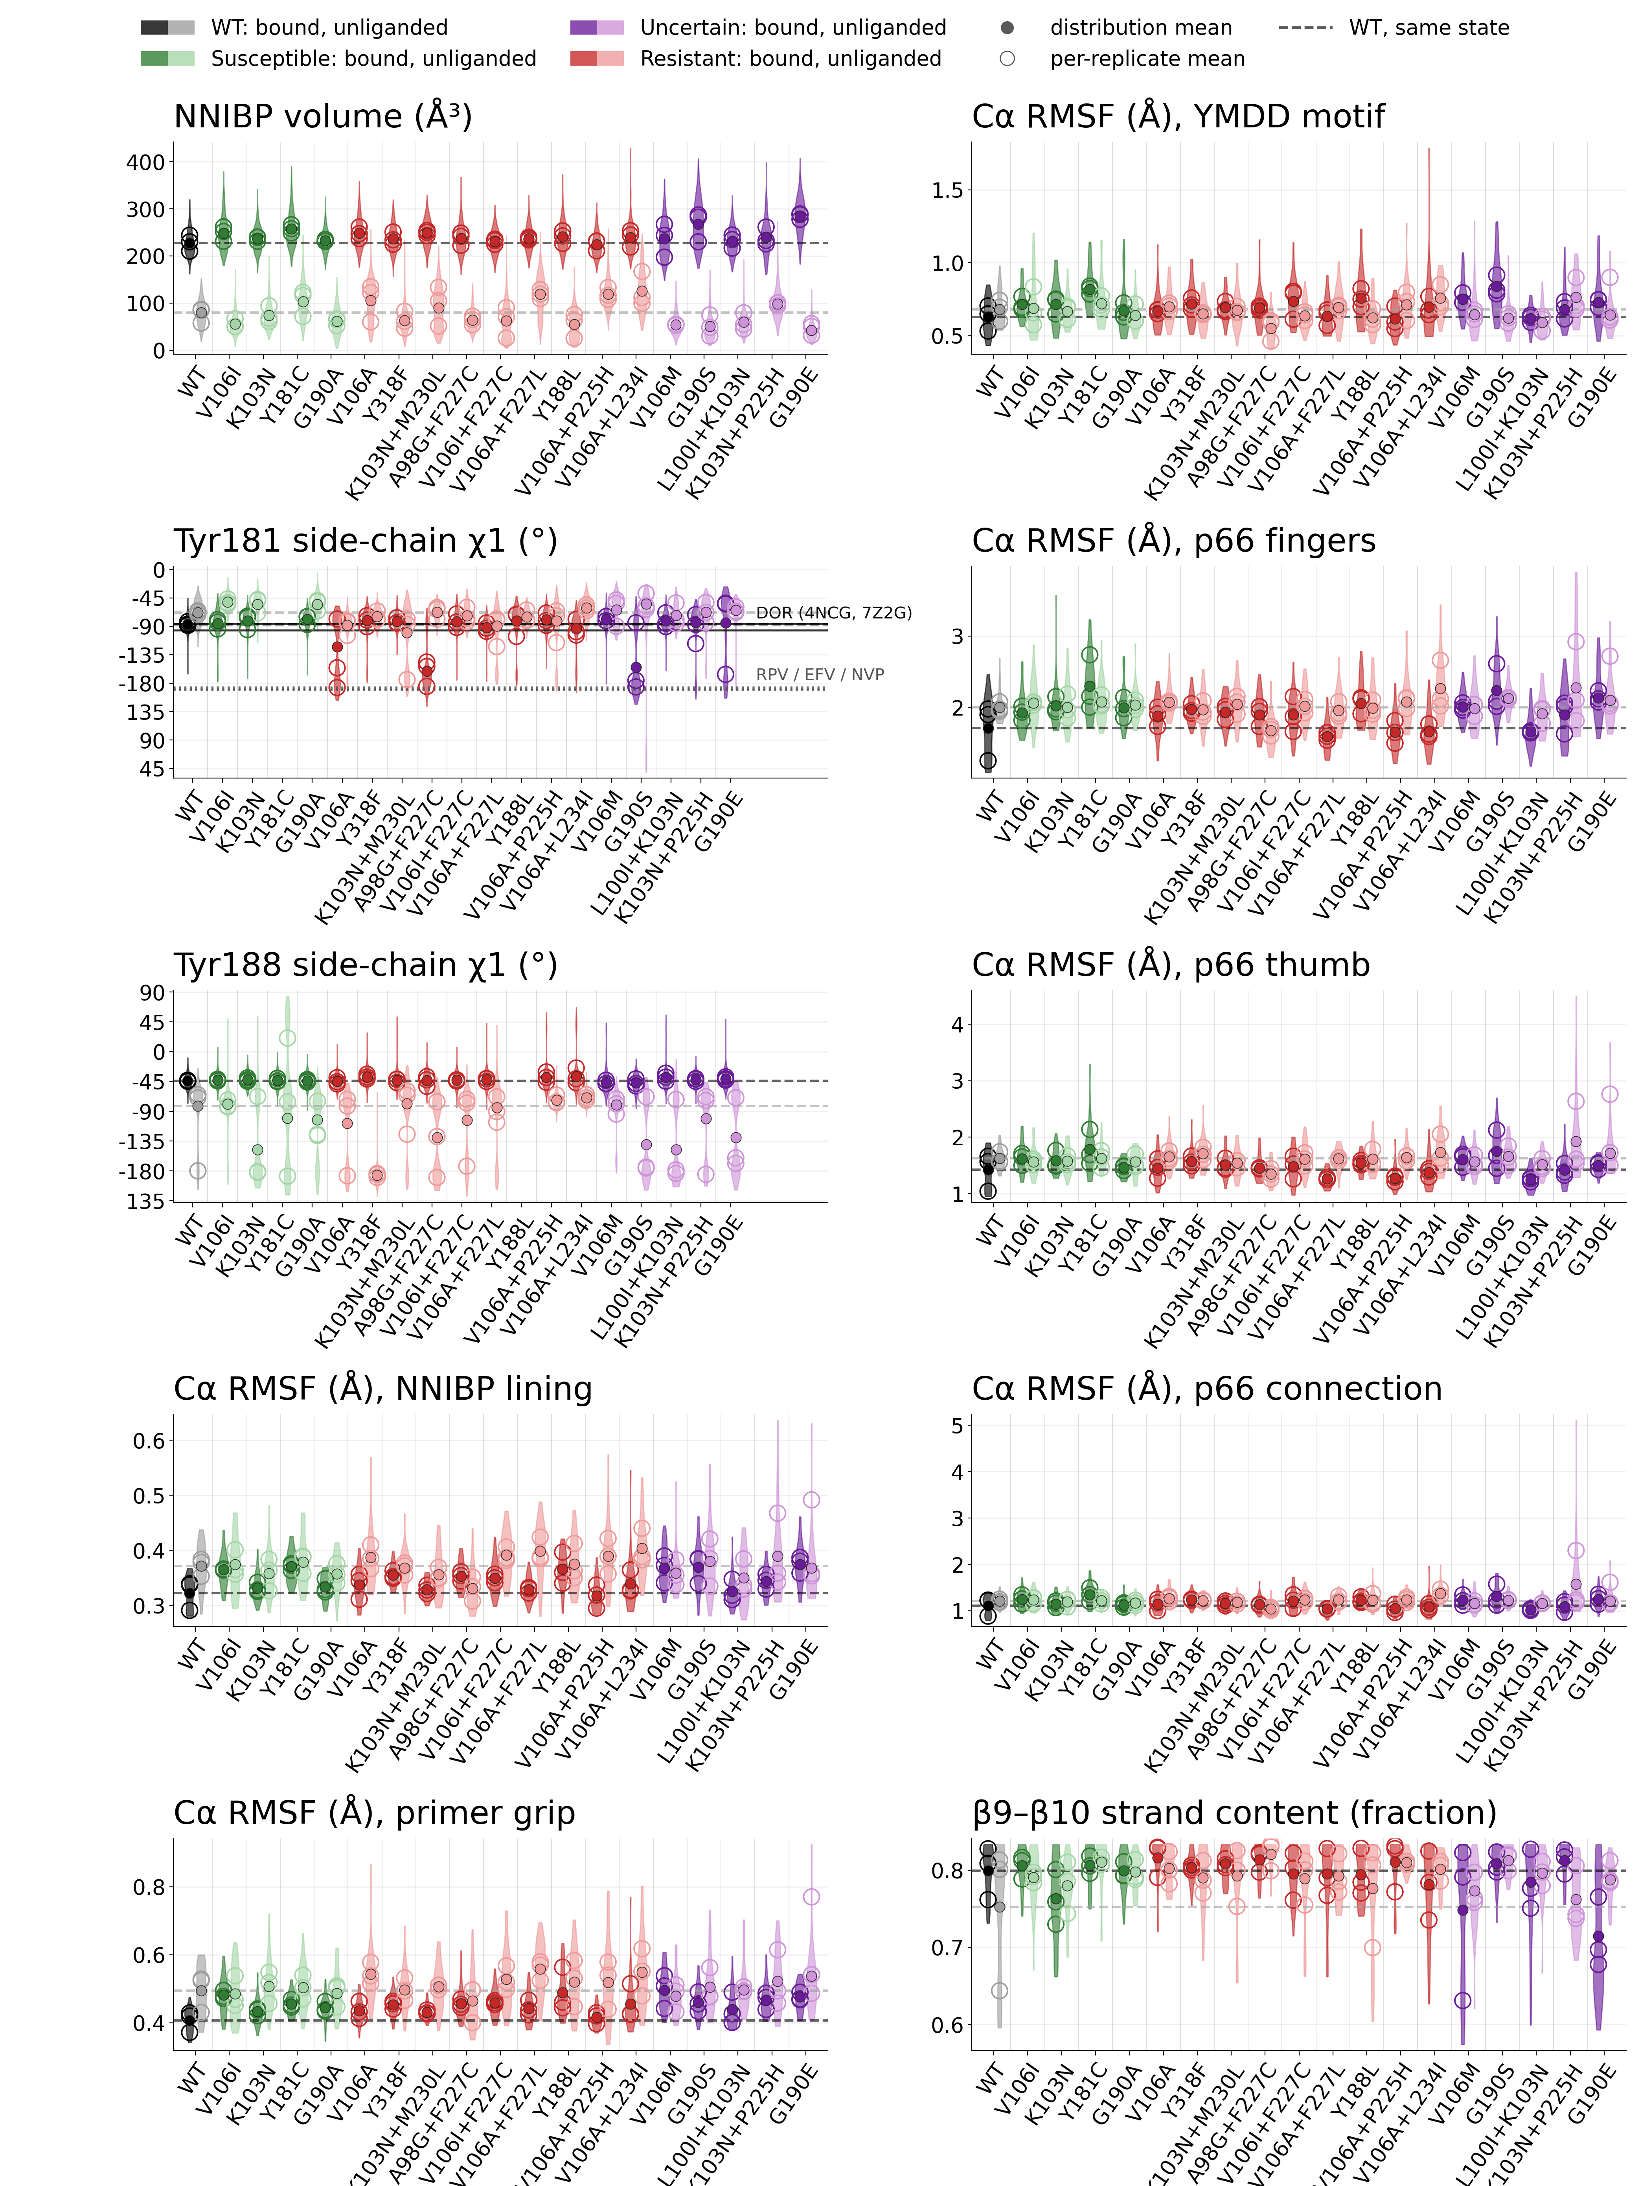

Supplementary Figure 6. Distributions of ten RT-specific metrics computed from equilibrium MD simulations in holo and apo configurations. Genotypes run along the x-axis in the order of Figure 5 rows. At each genotype the darker violin is the bound state and the paler one the unliganded state, coloured by the resistance category of Table 1. The filled marker is the mean of the plotted distribution, the open markers are its three per-replicate means, and the dashed lines are WT mean in each state. Pocket volume and the two χ₁ dihedral angles exist frame by frame and are plotted per frame. A C_{α} RMSF is a fluctuation about a mean structure and so has no per-frame value; those panels, and β9–β10 strand content, are plotted per 10 ns block, ten blocks per replicate. χ₁ is signed, on the (−180, +180] convention of Supplementary Table 4, but each χ₁ panel's axis is rotated to wrap at its least populated angle so that a rotamer is drawn as one distribution rather than split across both edges. The Tyr181 panel also carries the experimental χ₁ values from the five crystal structures of Supplementary Section 1. The unliganded pocket is smaller than the bound pocket in every genotype. In one G190E apo replicate RT became extended, from 21.5 ns onward, with the chain spanning more than the box edge while every covalent bond stayed intact; those 158 of 200 frames are excluded from analyses requiring an intact pocket; the pocket-volume calculation also excludes the three preceding frames (20.0–21.0 ns) because their cavity volumes exceed the largest bound-state replicate mean, and the other two G190E replicates and every other apo replicate in the panel keep an intact pocket throughout.
Figure 5 and Supplementary Figure 6 compare each genotype with WT within one state at a time. Supplementary Figure 7 compares the binding-associated change, (bound − unliganded), for each genotype with the corresponding change in WT. This identifies mutation-dependent differences in the conformational response to DOR binding. These geometric comparisons complement the thermodynamic cycle, but equal geometric shifts in the two states do not establish cancellation of energetic contributions to ΔΔG_{bind}.

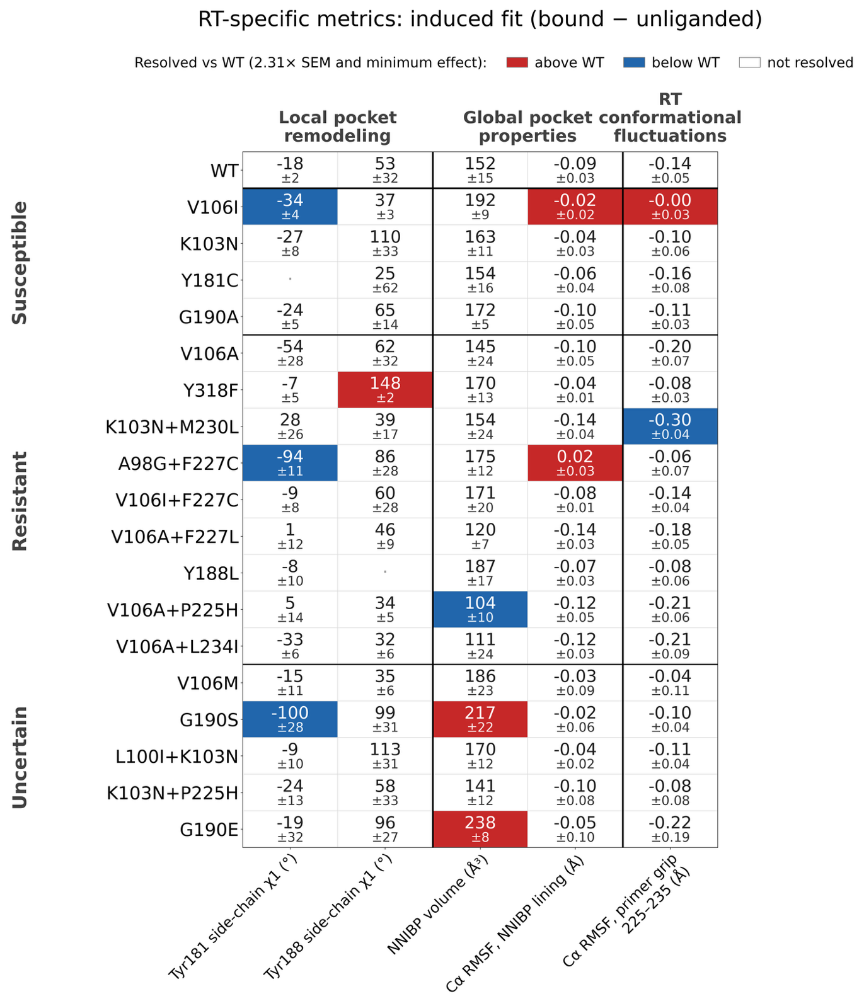Supplementary Figure 7. Binding-associated changes in the RT-specific metrics. Each cell gives that genotype's binding-associated change, the bound minus the unliganded mean, in the metric's own units, with its standard error beneath; the WT change heads the panel as the reference row. Fill marks whether the genotype-specific binding-associated change is resolved against WT: its 95% confidence interval must exclude zero and its magnitude must exceed the observable-specific minimum interpretable difference defined in Methods. White cells indicate that these criteria are not both met. The interval propagates the standard errors of all four three-replicate means in quadrature and uses a Student t critical value of 2.31 (8 degrees of freedom) for four groups of three replicates. Columns, fill, grouping and ordering are otherwise as in Figure 5.

