Abstract
Doravirine (DOR) is a next-generation Non-Nucleotide Reverse Transcriptase Inhibitor (NNRTI) with durable clinical activity and a unique resistance profile, but publicly available phenotypic susceptibility data for DOR-associated resistance mutations remains limited. Here, we performed all-atom explicit-solvent molecular dynamics (MD) simulations of wild-type (WT) HIV-1 reverse transcriptase (RT) and 18 mutant genotypes as a structure-based approach to fill this gap. We observed that the electrostatic component of the relative RT-DOR binding energy, computed from short (100ns) MD simulations, demonstrates weak but statistically significant correlation with the available phenotypic DOR susceptibility changes in vitro. Furthermore, local trajectory-level analyses identified mutation-specific structural effects: Y188L disrupts aromatic packing with Tyr188 inside the hydrophobic tunnel and remodels the DOR binding pocket near Pro225; V106A-containing genotypes shift DOR toward the pocket entrance, leading to compensatory interactions with Lys104 and Ser105; V106I+F227C samples distinct DOR poses from V106A+F227L despite similar phenotypic resistance; and G190E perturbs the β9-β10 hairpin, weakening contact with Val179. A custom logistic regression model trained on local MD-derived structural features is able to segregate low- and high-resistance genotypes, producing probabilities that correlate well with available in vitro DOR susceptibility data. Together, these results support a structurally grounded framework for interpreting DOR resistance, estimating risk in viruses with pre-existing NNRTI mutations, and informing the design of future NNRTIs.

Introduction
Doravirine (DOR) is an established oral NNRTI whose phase 3 trials and extension studies showed virologic efficacy, low treatment-emergent resistance, and favorable tolerability through 192 weeks of follow-up (Orkin et al., 2019; Orkin et al., 2021; Molina et al., 2020; Orkin et al., 2024). It was rationally designed to address efavirenz (EFV)-associated neuropsychiatric toxicity and common NNRTI resistance pathways, while also derisking the dose-limited QTc liability observed with rilpivirine (RPV) through potency and pharmacokinetic optimization that supported low clinical exposure at the approved dose (Hwang et al., 2020). Clinical pharmacology studies further showed that DOR has a comparatively favorable drug-drug interaction profile (Boyle et al., 2019; Yee et al., 2018). In DRIVE-AHEAD, DOR/lamivudine (3TC)/tenofovir disoproxil fumarate (TDF) remained noninferior to EFV/emtricitabine (FTC)/TDF while producing fewer neuropsychiatric adverse events and more favorable lipid changes through 48 and 96 weeks (Orkin et al., 2019; Orkin et al., 2021). In DRIVE-FORWARD, DOR also remained noninferior to ritonavir-boosted darunavir (DRV/r) with favorable lipid outcomes through 96 weeks (Molina et al., 2020). Real-world cohort data have since supported effectiveness and tolerability of DOR-containing regimens in treatment-experienced populations (Mejias-Trueba et al., 2024).

Current knowledge of DOR resistance comes primarily from recombinant phenotypic susceptibility assays and from in vitro selection experiments (Asante-Appiah et al., 2021; Rhee et al., 2023; Feng et al., 2015). Much of the informative phenotypic evidence comes from the Monogram PhenoSense platform, which reports fold-change in IC₅₀ relative to a WT reference strain and underlies the largest published susceptibility datasets for DOR (Asante-Appiah et al., 2021; Rhee et al., 2023). In the Monogram-based analysis of 4,070 clinical isolates, DOR retained activity against more isolates than EFV, nevirapine (NVP), rilpivirine (RPV), or etravirine (ETR), depending on the biological cutoff applied (Asante-Appiah et al., 2021). In that dataset, Y188L and Y318F stood out even as single substitutions, and patterns containing V106A, F227C/L, and M230L showed larger losses of susceptibility (Asante-Appiah et al., 2021; Rhee et al., 2023). A broader synthesis of published phenotypic data similarly identified V106A, Y188L, F227C/L, M230L, and Y318F as the mutations most consistently associated with large reductions in DOR susceptibility (Rhee et al., 2023). That same synthesis also flagged G190E, some G190S-containing isolates, L100I+K103N, and K103N+P225H as potentially important but less well resolved resistance patterns (Rhee et al., 2023).

The resistance profile of DOR differs from both first-generation NNRTIs and the more flexible diarylpyrimidine (DAPY) inhibitors (Hwang et al., 2020; Das et al., 2004; Das et al., 2008). First-generation NNRTIs were commonly compromised by K103N, Y181C, and G190A (Hwang et al., 2020; Boyle et al., 2019). ETR and RPV broadened coverage by exploiting conformational adaptability within the NNRTI binding pocket (NNIBP), the classic “wiggling” and “jiggling” paradigm (Das et al., 2004; Das et al., 2008). DOR instead emerged from a more conformationally constrained scaffold optimized for potency, pharmacokinetics, and a distinct resistance profile (Cote et al., 2014; Hwang et al., 2020). Structural studies indicate that DOR forms hydrogen bonds to Lys103 backbone, not sidechain, atoms and adopts a binding mode less dependent on Tyr181 than many earlier NNRTIs (Hwang et al., 2020; Singh et al., 2022). This binding mode is consistent with the relatively weak impact of K103N and Y181C on DOR, and with the stronger effects of substitutions around Val106 and the F227/P225/L234 region (Hwang et al., 2020; Asante-Appiah et al., 2021; Rhee et al., 2023).

Selection experiments sharpen this contrast but also expose the limits of the current literature (Feng et al., 2015; Brenner et al., 2021). Under DOR pressure, recurrent pathways include V106A/I/M, V108I, F227L/C/I, M230L, L234I, H221Y, and Y318F (Feng et al., 2015; Brenner et al., 2021; Rhee et al., 2023). By contrast, K103N, Y181C, and G190A were not the dominant outcomes in DOR selection studies or in the resistance patterns summarized from DOR clinical trials (Feng et al., 2015; Hwang et al., 2020; Orkin et al., 2026). Clinical failures in DOR trials were also enriched for multi-mutation backgrounds containing V106- and F227-region changes (Orkin et al., 2026). Important mechanistic questions therefore remain unresolved, including why V106A and V106I behave differently and why combinations such as V106A+F227L or V106A+L234I produce much larger fold changes than nearby single mutants (Rhee et al., 2023).

These unresolved genotype-phenotype relationships are biophysical questions because NNRTI resistance arises through allosteric effects on NNIBP formation, local packing, polar anchoring, ligand pose, and longer-range coupling within RT (Spence et al., 1995; Esnouf et al., 1995; Schauer et al., 2014; Vijayan et al., 2014). Here, we use all-atom explicit-solvent MD simulations of WT RT and 18 DOR-relevant genotypes to define structural mechanisms that could account for the observed phenotypic landscape. By comparing global energetic readouts with local contact and pose features, we aim to identify mutation-specific routes to reduced susceptibility and to generate mechanistic hypotheses for genotypes whose phenotypes are established, suspected, or still only partially resolved. More broadly, we ask whether simulation-derived structural features can support an in silico susceptibility framework for estimating the risk of DOR resistance in persons living with HIV (PLWH) who carry pre-existing NNRTI mutations and for informing the design of future NNRTIs without relying exclusively on expensive in vitro resistance experiments.

Results

DOR susceptibility data
We queried the Stanford HIVDB to obtain phenotypic susceptibility data for 18 DOR-associated RT mutations. Figure 1 shows the median fold-change in DOR susceptibility for each of the mutant viruses vs WT.
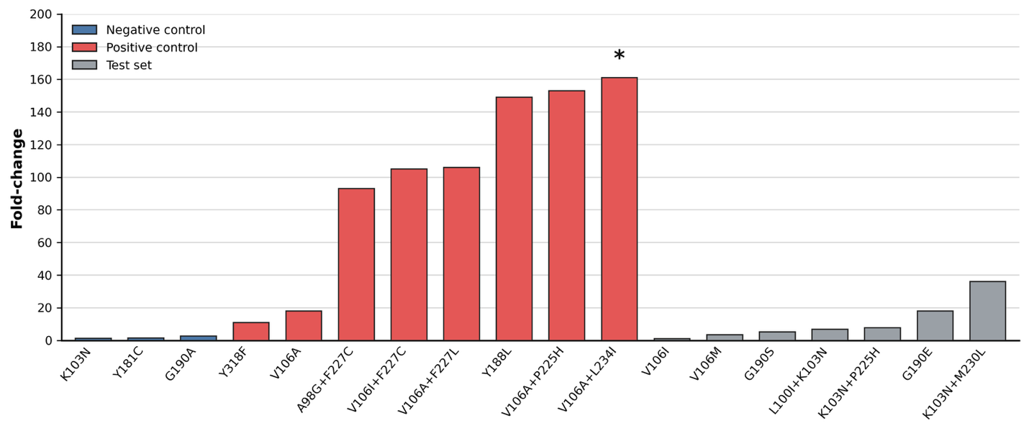
Figure 1: Fold-change in DOR susceptibility associated with selected genotypes. Values represent median fold reductions in susceptibility relative to wild-type control viruses. Asterisk (*) denotes susceptibility results generated using non-PhenoSense assays.

Our rationale for choosing these mutations was as follows:
- We picked K103N, Y181C, and G190A as “negative control mutations” in our simulations, since these are well known to have little to no impact on DOR susceptibility (Lai et al., 2014; Feng et al., 2016; Asante-Appiah et al., 2021).
- We picked V106A, Y188L, and Y318F as “positive control” or canonical DOR-associated mutations (Feng et al., 2015; Asante-Appiah et al., 2021; Martin et al., 2020). Similarly, A98G+F227C, V106A+F227L, V106A+L234I, V106A+P225H, and V106I+F227C have shown large reductions in published phenotypic susceptibility datasets or were identified in participants during DOR clinical development (Asante-Appiah et al., 2021; Martin et al., 2020).
- Finally, we included 7 genotypes with limited, sparse, or mechanistically ambiguous DOR susceptibility data as our “test set”: K103N+L100I, K103N+P225H, K103N+M230L, V106I, V106M, G190E, and G190S (Asante-Appiah et al., 2021; Smith et al., 2016; Saladini et al., 2021; Rhee et al., 2023).

RT-DOR binding energy calculations
We performed all-atom explicit solvent MD simulations on WT and all 18 mutant RT molecules in complex with DOR (see Methods). From these simulations, we extracted snapshots of RT alone, DOR alone, and RT bound to DOR, then computed the binding energy of each pose using MM/GBSA calculations:
∆G_{i} = G_{RT-DOR}(i) - G_{DOR}(i) - G_{RT}(i)
Where i = van der Waals energy (vdW), Electrostatics (elec), Generalized Born polar solvation energy (GB), and Surface Area nonpolar solvation energy (SA). Total binding energy is computed by summing up each component:
∆G_{Total} = ∆G_{vdW} + ∆G_{elec} + ∆G_{GB} + ∆G_{SA}
Finally, these binding energies for mutant systems can only be interpreted with respect to WT as reference:
∆∆G^{Mut} = ∆G^{Mut} - ∆G^{WT}
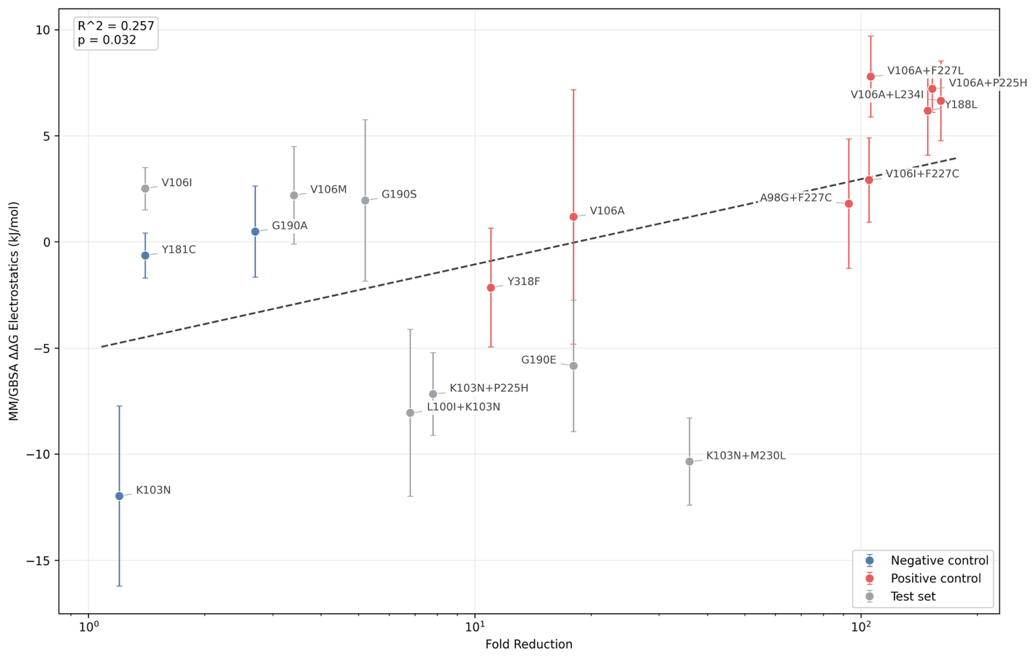
Figure 2: Changes in Electrostatic Binding Energy vs WT weakly correlates with phenotypic DOR susceptibility data. Data show the average electrostatic energy values over 100 frames sampled uniformly from 100ns all-atom MD simulations of each system, after discarding the first 25% of production runs to allow equilibration. Error bars represent the standard error of the mean over N = 3 replicates.

Supplementary Figure 1 shows these changes in binding energy relative to WT and their individual components for all 18 mutant systems. If the mechanism of resistance could be fully explained by global destabilization of the mutant RT-DOR conformations from our MD simulations, we would have observed all canonical DRMs to exhibit large positive ∆∆G and all “negative control” genotypes to have ∆∆G ≈ 0.

However, we find that ∆∆G_{Total} does not correlate with the phenotypic susceptibility data (R²=0.018, p=0.586). Moreover, most components of the binding energy computed here do not correlate with the phenotypic susceptibility data either (Supplementary Figure 1), except the electrostatics component, which demonstrates weak but statistically significant correlation (Figure 2). Since our simulation timescale (100ns) is much smaller than domain rearrangement timescales in RT (~1ms) (Sharaf et al., 2016) or typical drug binding kinetics (~1s) (Schuckmann et al., 2010) and an accurate estimate of binding energy would require sampling equilibrium populations of bound and unbound complexes, lack of correlation between the binding energy and observed phenotypic susceptibility is not surprising (see Discussion). However, the potential impact of resistance associated mutations on the electrostatic component of the binding energy in our simulations motivated us to probe structural mechanisms that could explain this trend.

Structural mechanisms of DOR resistance
We anticipated that the small size of the NNIBP, roughly 18 x 16 x 11 Å in span, should allow direct observation of any physically meaningful impact on DOR-RT contacts due to RT mutations even in our relatively short MD simulations. To elucidate these local DOR-RT dynamics in the context of resistance associated mutations, we analyzed trajectories of contacts with key NNIBP residues from our simulations. We defined a “contact” between an RT residue and DOR as the moment when the minimum distance between the heavy atoms of DOR and the residue (mainchain or sidechain) is below 4.0Å. Consequently, due to fluctuations in their positions, NNIBP residues can go in and out of contact with DOR in the course of our simulations (Figure 3).
A) B)
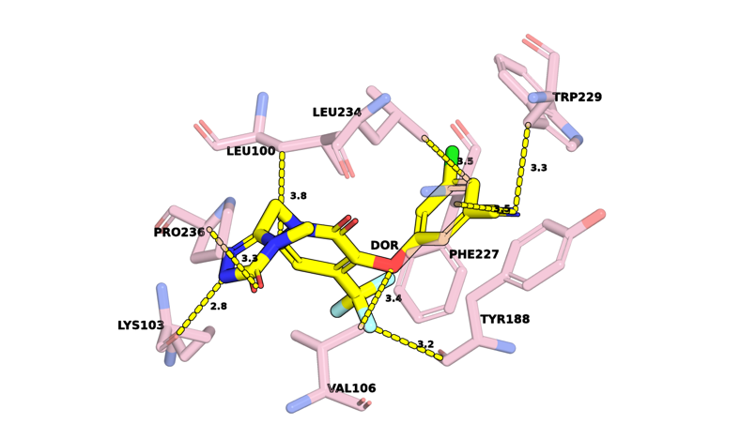
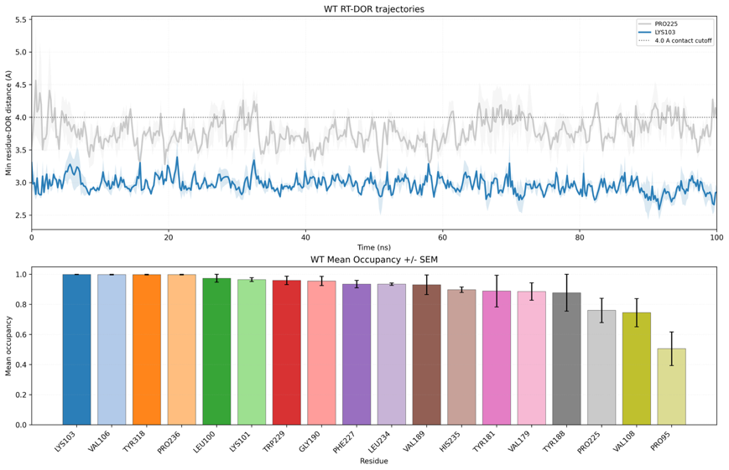
Figure 3: DOR dynamics in the NNRTI Binding Pocket. (A) Snapshot of DOR (yellow) within the NNRTI binding pocket surrounded by 8 key NNIBP residues, as observed in the crystal structure (PDB ID: 4NCG; Cote et al., 2014). (B) (Top) Minimum heavy-atom distance between DOR and two exemplary RT residues as a function of time, observed in 100ns MD simulations of the WT DOR-RT complex performed in triplicates (N=3). Solid lines indicate the mean trajectory and lighter color bands show the standard error of the mean across N = 3 replicates in this as well as other trajectory visualizations in this work. The dotted line represents the 4.0 Å cutoff used to define each contact. (Bottom) Mean Occupancy, defined as the fraction of total number of frames in the simulation where the residue is in contact with DOR, for all 18 residues found to be in contact with DOR in the crystal structure. Error bars represent standard error of the mean over N = 3 simulations.

We further defined a “Mean Occupancy” metric as the fraction of total number of frames in the simulation where the residue is in contact with DOR. Supplementary Figure 2 shows this metric calculated for all residues which were in contact with DOR at least 50% of the time, i.e. Mean Occupancy ≥ 0.5, in any simulation. Through this occupancy heatmap, we identified contacts that were preferentially disrupted in DOR associated genotypes and, consequently, structural mechanisms that may contribute to DOR resistance.

Y188L vs Y181C and WT
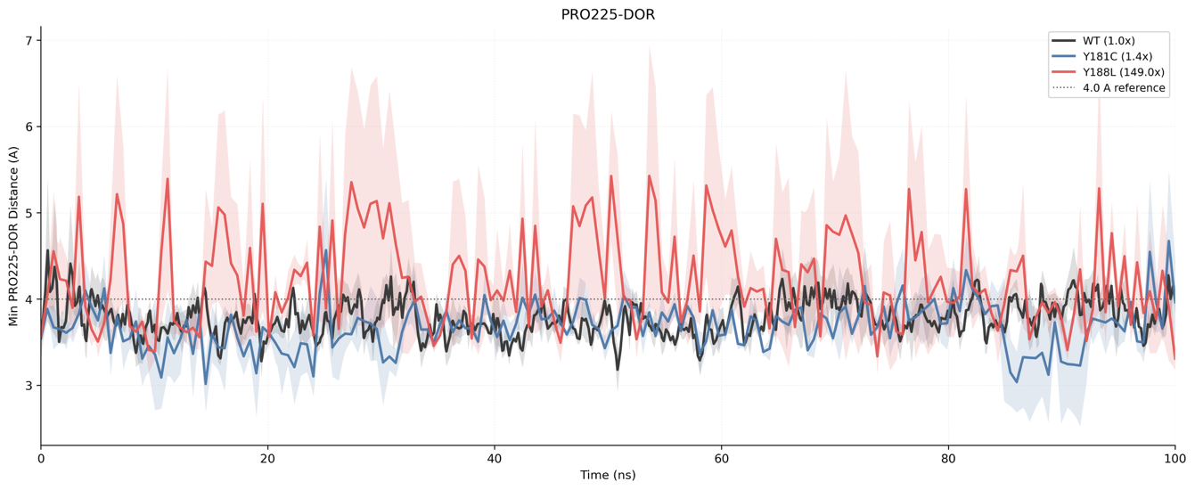
WT Y181C Y188L
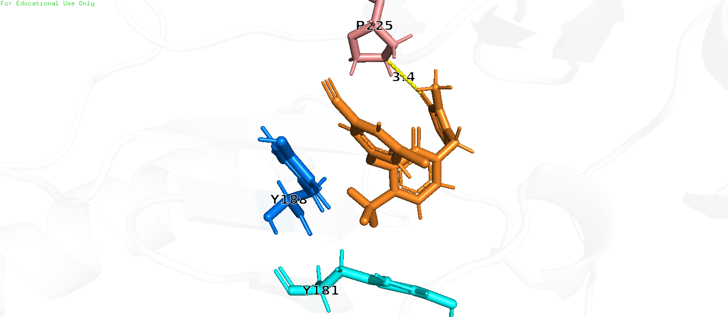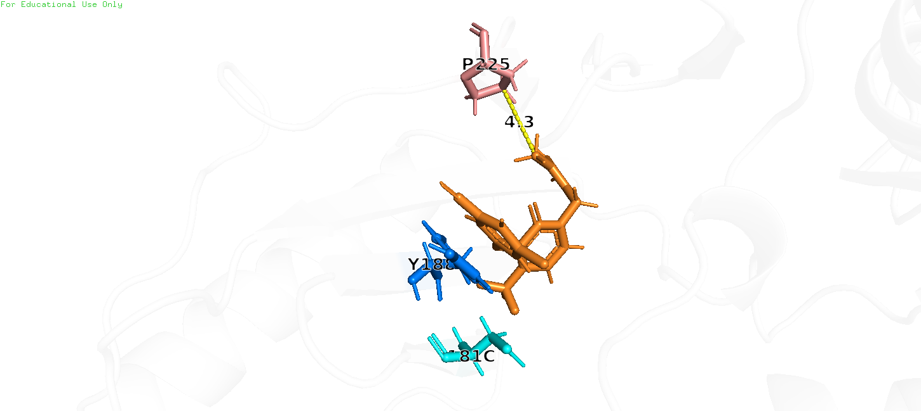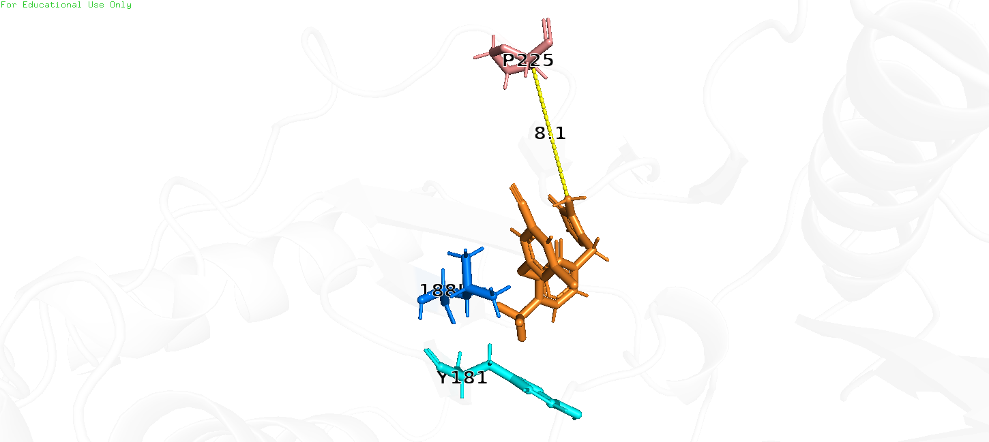
Figure 4: Y188L preferentially alters binding pocket geometry, causing Pro225 to shift away from DOR. (Top) Minimum distance between heavy atoms of Pro225 and DOR observed in MD simulations of WT, Y181C, and Y188L. (Bottom) Snapshots of a single frame across WT, Y181C, and Y188L trajectories, showing Pro225 almost twice the distance away from DOR in case of Y188L as compared to WT and Y181C.

In the crystal structure of WT RT in complex with DOR (Cote et al., 2014), the chlorophenol ring stacks with Tyr188. This aromatic interaction is critical for efficient packing of DOR in the hydrophobic tunnel and is consistently observed to hold throughout our simulations. On the contrary, loss of this interaction in case of Y188L leads to not only a significant reduction in binding energy (Supplementary Figure 1) but also alteration in pocket geometry that transiently shifts Pro225 away from DOR (Supplementary Figure 2, Figure 4). This shift is not observed in case of Y181C simulations, suggesting DOR-Pro225 distance may be a valuable coordinate that tracks structural changes in the NNIBP arising from Y188L, but not Y181C. One of the reasons why this shift is not observed in Y181C could be that DOR does not form a strong interaction with Tyr181, and in the crystal structure of WT RT in complex with DOR, the Tyr181 residue is tilted toward the rim of the pocket, rather than DOR. Pro225 appears to also exhibit an altered sidechain rotation geometry in case of Y188L, as opposed to WT and Y181C. Together, these observations suggest that Y188L reduces susceptibility to DOR by reducing interaction strength between RT and DOR, as well as pocket remodeling effects that may allow DOR to more easily escape the binding pocket.

V106A vs V106I and WT
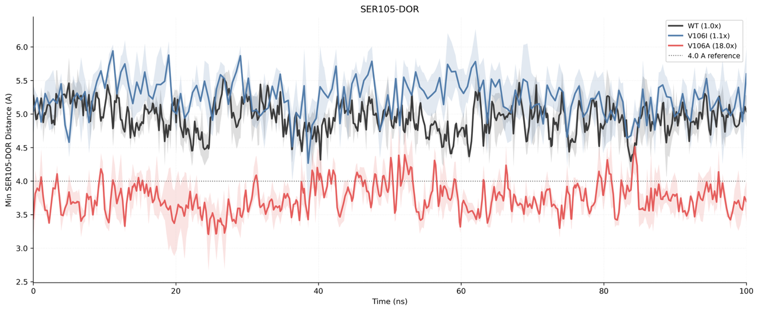
WT V106I V106A
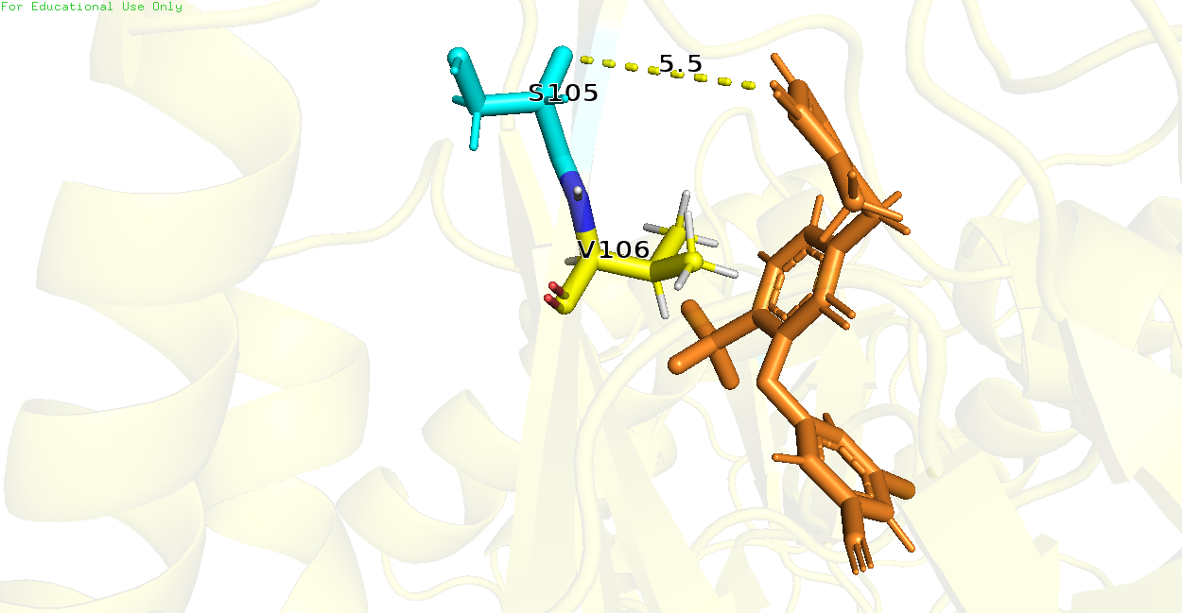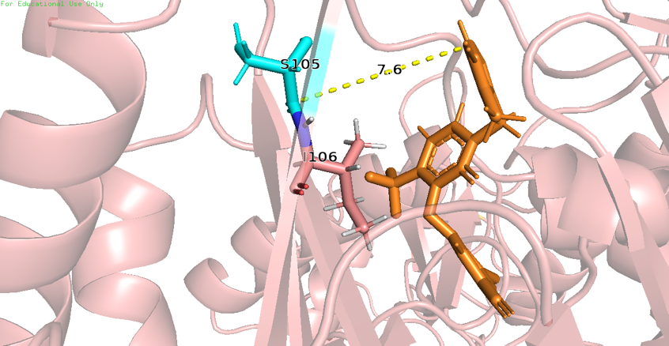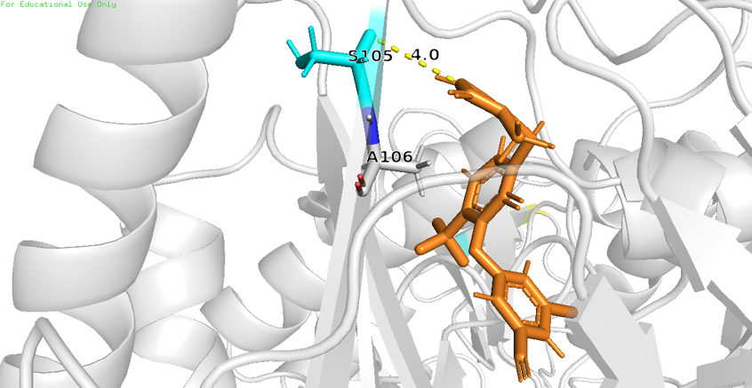
Figure 5: V106A preferentially alters DOR pose, causing Ser105 to shift closer to DOR. (Top) Minimum distance between heavy atoms of Ser105 and DOR observed in MD simulations of WT, V106I, and V106A. (Bottom) Snapshots of a single frame across WT, V106I, and V106A trajectories, showing Ser105 shifted closer to DOR in case of V106A as compared to WT and V106I.

V106A has a significant impact on the interaction with the central pyridone core in DOR due to the loss of the hydrophobic sidechain in Val106. On the other hand, substitution of Val106 to Ile106 is not as disruptive. It is possible that RT-DOR binding is sensitive to this hydrophobic interaction, such that a minor alteration in case of V106I is uncommon but not disruptive, while a complete loss in case of V106A causes resistance. Nonetheless, Supplementary Figure 1 suggests that this observation cannot be rationalized using binding energy changes alone. In our simulations, we find that V106A preferentially causes a shift in DOR pose in the binding pocket such that Ser105 moves closer (Supplementary Figure 2, Figure 5). One potential reason why Ser105 is observed to shift toward DOR could be a compensatory mechanism of retaining interaction with the β6 strand lining the pocket entrance, in the absence of the hydrophobic bond with Val106. This reasoning is reinforced by the observations that (a) the emergent DOR contact is with the backbone atoms of Ser105, so the precise identity of the residue 105 is not relevant for this interaction, and (b) neighboring residues, e.g. Lys104, exhibit a similar shift toward DOR (Supplementary Figure 2).

V106A+L234I and V106A vs WT
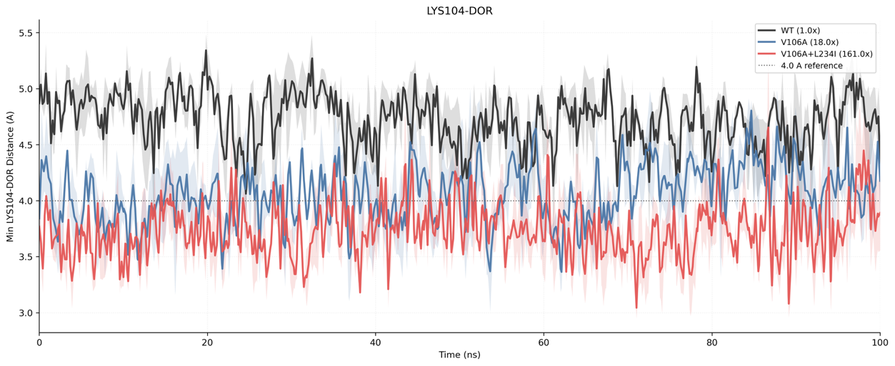
WT V106A V106A+L234I
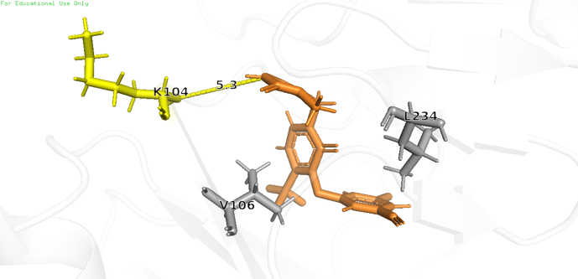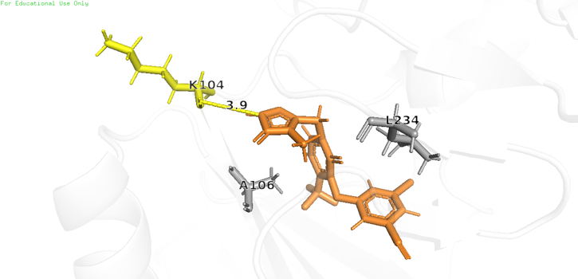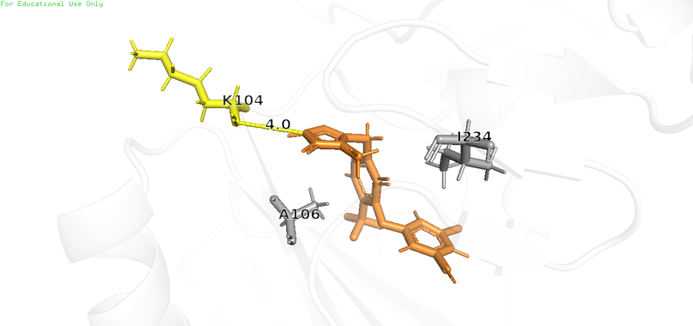
Figure 6: L234I exacerbates DOR pose alteration associated with V106A, causing Lys104 to remain in contact with DOR longer. (Top) Minimum distance between heavy atoms of Lys104 and DOR observed in MD simulations of WT, V106A, and V106A+L234I. (Bottom) Snapshots of a single frame across WT, V106A, and V106A+L234I trajectories, showing Lys104 shifted closer to DOR in case of V106A and V106A+L234I as compared to WT.

Similar structural shift toward the pocket entrance, as observed in V106A simulations, is also seen in V106A+L234I, suggesting that the mechanism of resistance in both these genotypes may be similar (Figure 6). DOR contact with Lys104 is rare in WT, observed often in V106A, and remains most consistent in case of V106A+L234I. This observation suggests that there may be a transient hydrophobic interaction between DOR and Leu234 (cf. Figure 3) that gets disrupted due to the switch from Leu234 to Ile234 in case of L234I and further exacerbates the pocket entrance shift of DOR associated with V106A. However, why such a subtle shift may have an outstanding impact on DOR susceptibility is not clear here. Note that, as in case of V106A, V106A+L234I also leads to a mean occupancy shift toward Ser105 (Supplementary Figure 2).

V106A+F227L and V106I+F227C vs WT
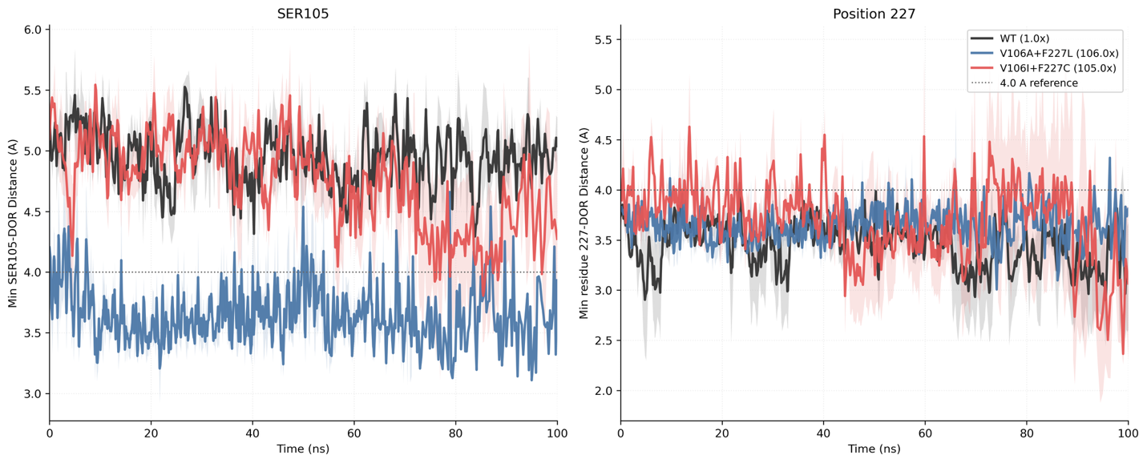
WT V106A+F227L V106I+F227C
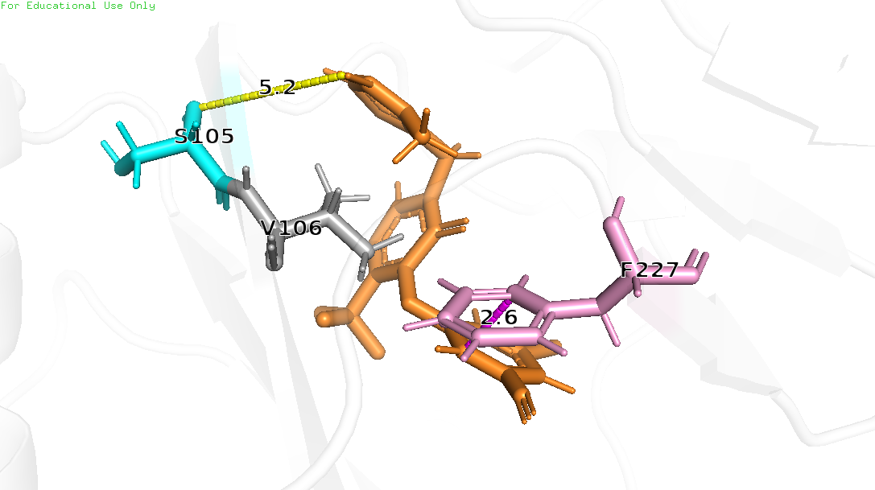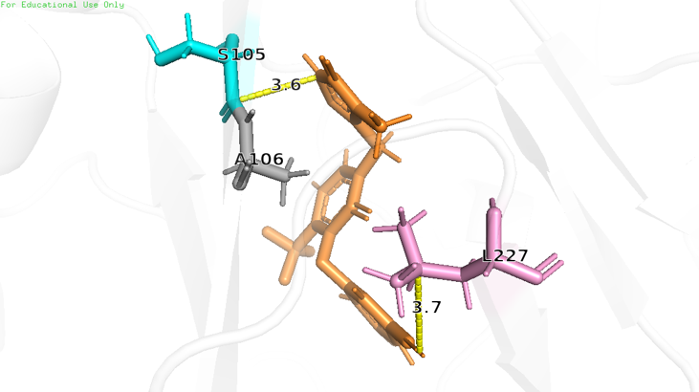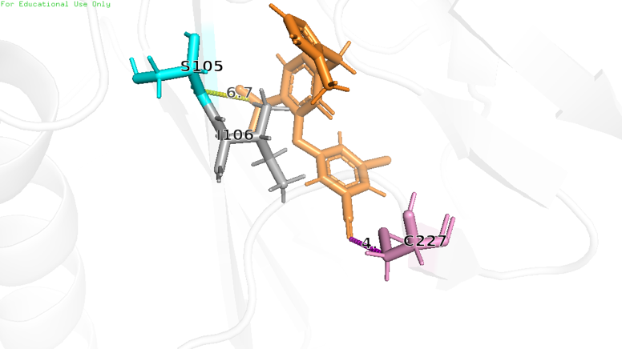
Figure 7: V106I+F227C exhibits alternative dynamics than V106A+F227L. (Top) Minimum distances between heavy atoms of Ser105 and DOR as well as Position 227 and DOR observed in MD simulations of WT, V106A+F227L, and V106I+F227C. (Bottom) Snapshots of a single frame across WT, V106A+F227L, and V106I+F227C trajectories, showing Ser105 shifted closer to DOR in case of V106A+F227L (but not in case of V106I+F227C or WT); and an alternate DOR pose in case of V106I+F227C that is further away from residue 227 than in WT or V106A+F227L.

Despite nearly identical drop in DOR susceptibility (106x vs 105x median fold-change), V106A+F227L and V106I+F227C exhibit different structural dynamics in the NNIBP binding pocket (Figure 7). Similar to V106A, V106A+L234I, and V106A+P225H, V106A+F227L exhibits a shift toward the pocket entrance p66 β6 region (Figures 5-7, Supplementary Figure 2). However, unlike V106A+F227L, V106I+F227C does not show this shift (Supplementary Figure 2). Instead, V106I+F227C appears to show alternate DOR poses that are transiently further away from residue 227 than in WT or V106A+F227L (Figure 7). Despite these apparent differences, however, it is not yet clear how these alternate DOR poses in V106I+F227C could lead to >100x fold-reduction in DOR susceptibility vs WT.

G190E vs G190A and WT
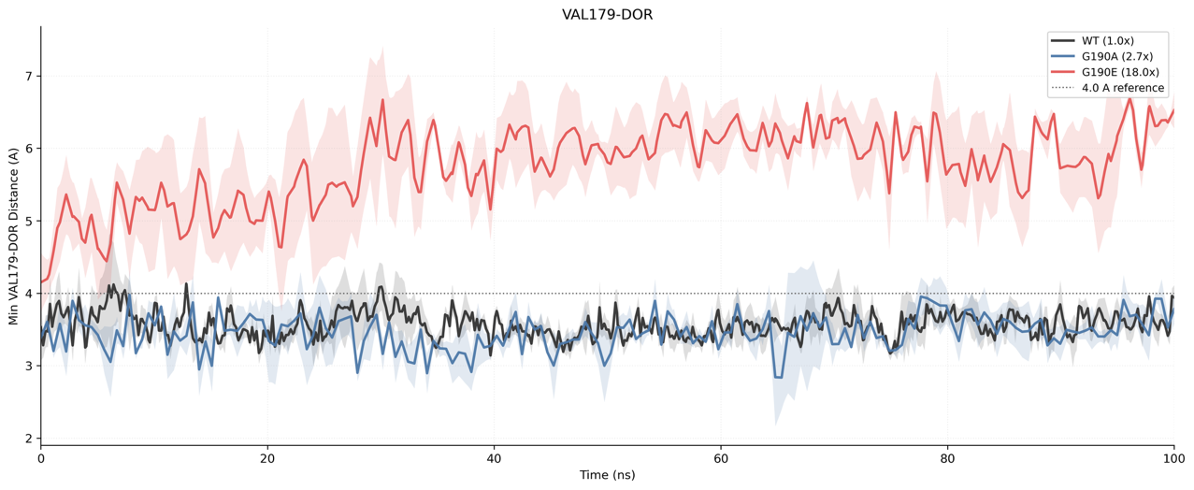
WT G190A G190E
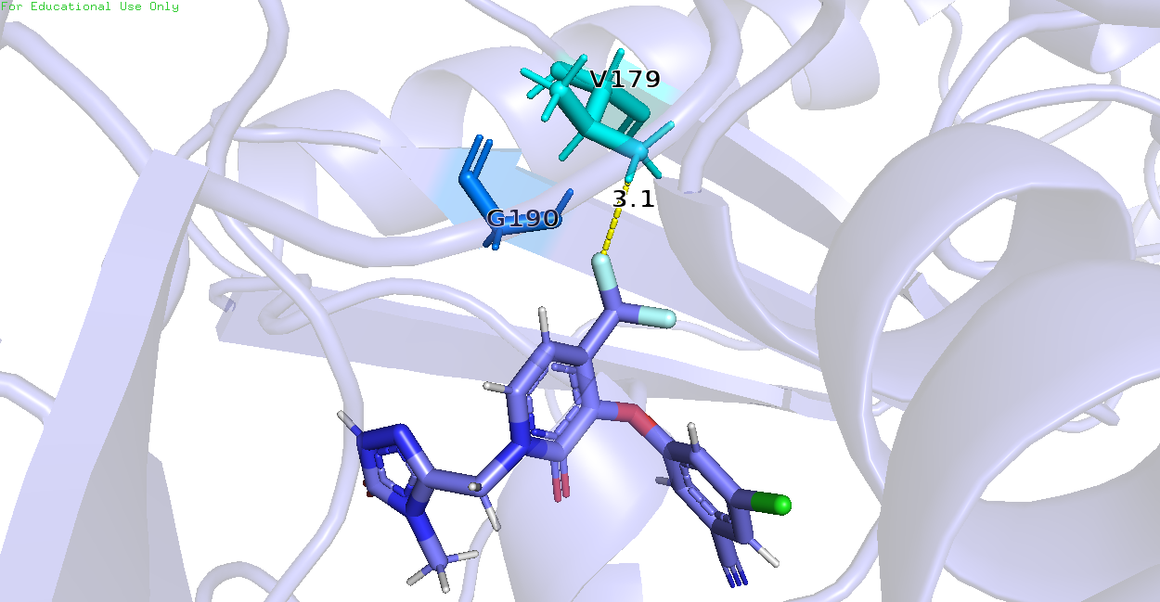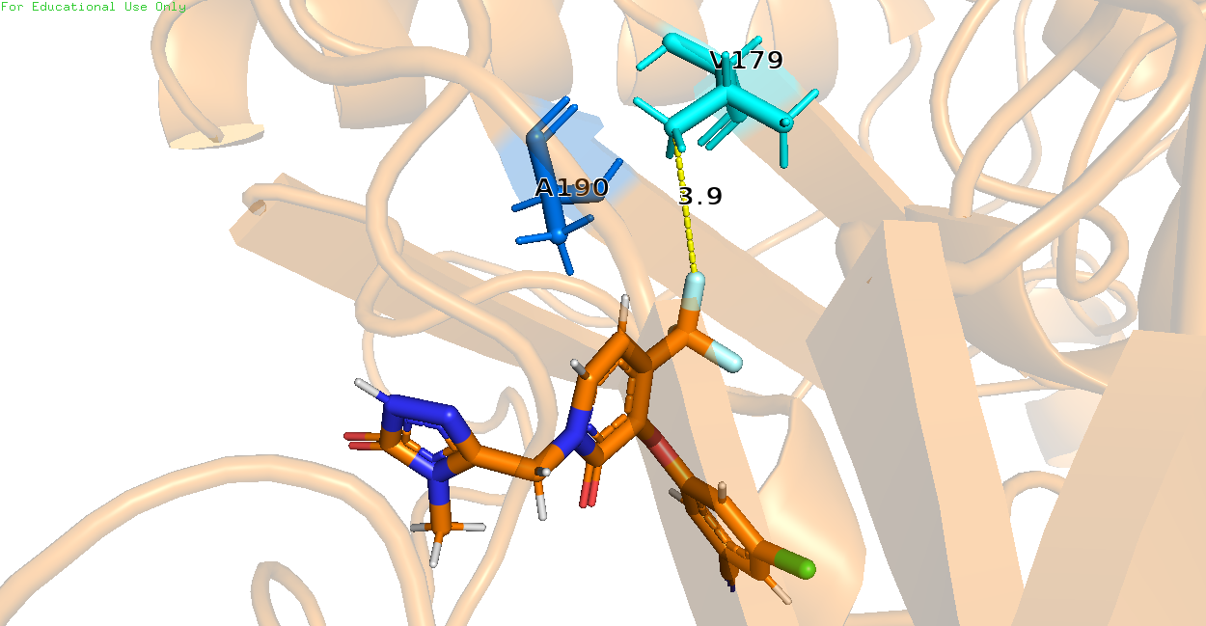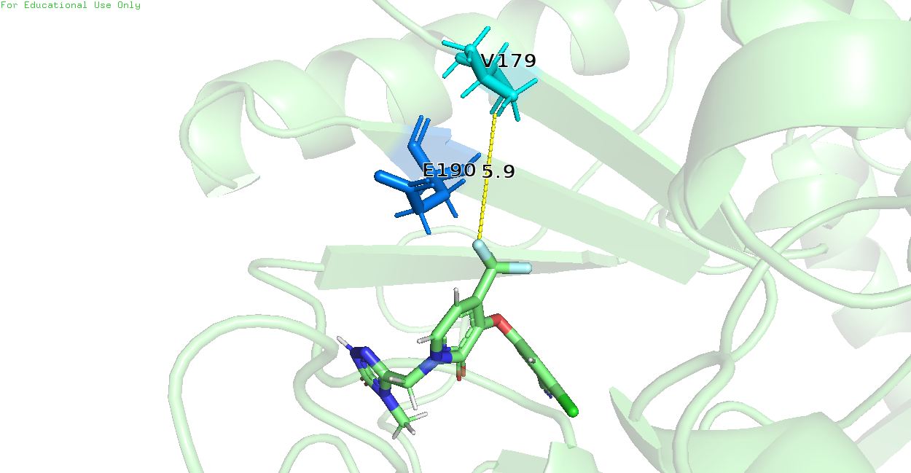
Figure 8: G190E preferentially disrupts β9-β10 hairpin, causing Val179 to lose contact with DOR. (Top) Minimum distance between heavy atoms of Val179 and DOR observed in MD simulations of WT, G190A, and G190E. (Bottom) Snapshots of a single frame across WT, G190A, and G190E trajectories, showing Val179 further away from DOR in case of G190E but not in WT and G190A.

G190E is not considered a canonical DOR DRM. Indeed, even Figure 2 suggests minimal impact on the overall electrostatic binding energy of the RT-DOR complex due to this mutation. However, the mean occupancy analysis suggests that G190E causes serious disruption to the p66 β9-β10 hairpin, leading to a complete loss of DOR contact with Val179 that is not observed in WT or G190A simulations (Supplementary Figure 2, Figure 8). This loss of contact with Val179 is likely to disrupt DOR packing and lead to a drop in susceptibility. Consequently, we anticipate that further laboratory studies of G190E viruses will likely surface strong evidence of resistance to DOR. Unlike the addition of a charged sidechain like Glu, substitution from Gly to Ala does not incur such a dramatic change, thus DOR retains contact with Val179 akin to WT. In this respect, DOR is more flexible than first-generation NNRTIs like EFV/NPV.

Together, this analysis of local DOR dynamics in the NNIBP revealed specific structural features corresponding to DOR contacts with key RT residues that may contribute to genotype-dependent HIV resistance. To assess if these disparate structural features could be used for predicting phenotypic susceptibility changes from genotype, we turned to machine learning.

Logistic Regression model for predicting mutation resistance
Using structural features derived from our simulations, we trained a logistic regression model on the negative and positive control mutations (see Methods). The training objective was to classify negative control mutations into “low” resistance and positive control mutations into “high” resistance bucket using a minimal set of structural features derived from the MD simulations.

We selected 3 structural features that represented orthogonal signals toward DOR binding – DOR-Ser105 Distance, DOR-Tyr188 Distance, and the Root Mean Square Deviation (RMSD) of the heavy atoms in DOR from the baseline conformation in the crystal structure (Cote et al., 2014). Their individual correlation with DOR susceptibility data is shown in Supplementary Figure 3.

The results of the trained model are shown in Figure 9. The model shows an overall accuracy of 89.5% (100% on train and 75% on test set) and ROC AUC of 83.3% (100% on train and 41.7% on test set). Importantly, the 3 input features appear to contribute approximately equally and the predicted probabilities of the model correlate well with the observed DOR susceptibility data (R²=0.444 and p-value=0.002).
A)
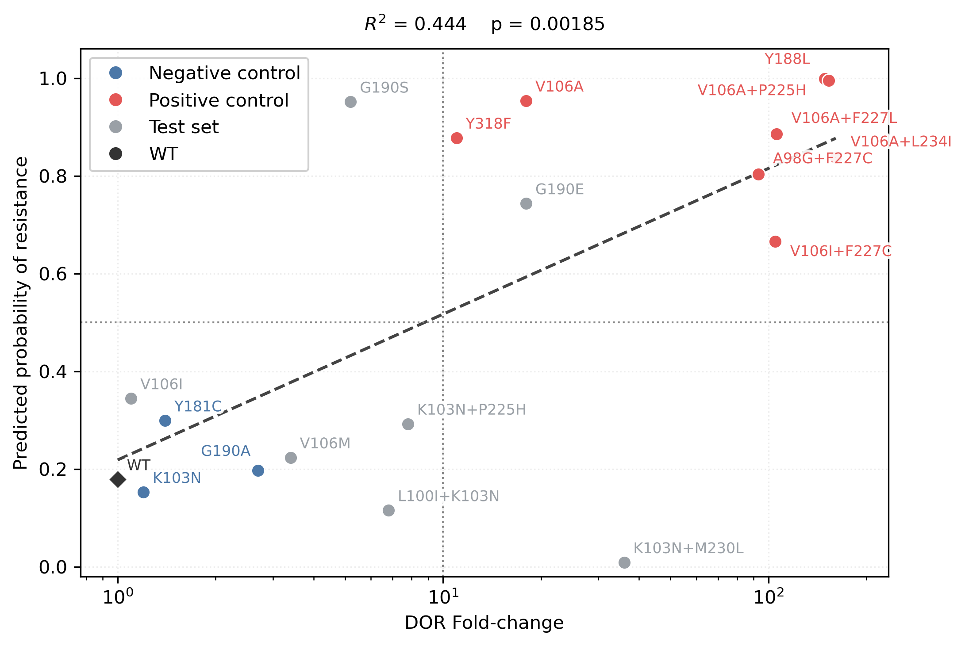
B) C) D)
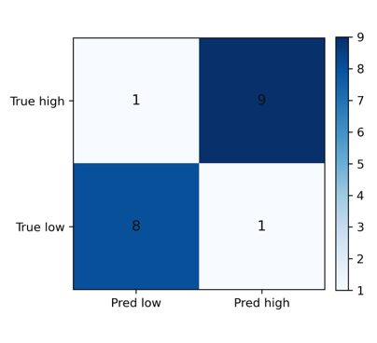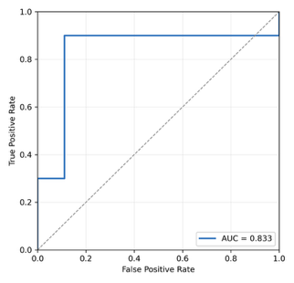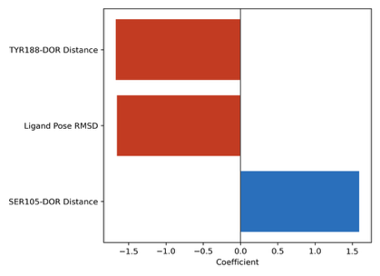
Figure 9: Performance of Logistic Regression model to predict DOR susceptibility from MD simulation features. Each circle represents P(high), the trained model’s probability of a mutation having “high” resistance based on values of structural features derived from MD simulations, compared with actual fold-change in susceptibility. The model was fit on data from negative and control mutations only. B) Confusion matrix showing predicted labels compared with true labels across train and test set. C) Receiver Operating Characteristic (ROC) curve of the trained model. D) Trained model coefficients for the standardized features showing roughly equal contribution of all 3 features to the model’s output.

A major limitation of this model is that it appears to overfit the training data due to lack of negative control sample data points. This limitation will be overcome in the future as more reliable and robust DOR susceptibility data are published.

Discussion
DOR poses an unusual resistance problem among second-generation NNRTIs. Like ETR and RPV, DOR retains activity against common NNRTI-associated backgrounds such as K103N, Y181C, and G190A, yet the pathways that reduce DOR susceptibility are distinct and increasingly relevant in clinical use (Hwang et al., 2020; Asante-Appiah et al., 2021; Rhee et al., 2023). Specific substitutions such as Y188L, V106A, and Y318F, and combinations including V106I+F227C, V106A+F227L, and V106A+L234I, now recur across phenotypic studies, in vitro selection experiments, and clinical trial datasets (Feng et al., 2015; Asante-Appiah et al., 2021; Brenner et al., 2021; Rhee et al., 2023; Orkin et al., 2026). Despite these observations, publicly indexed isolate-level susceptibility data for DOR remain sparse. As of April 2026, Stanford HIVDB indexes only 134 DOR-associated isolates tested by PhenoSense, compared with 330 for RPV and 1,193 for ETR. This mismatch between growing clinical relevance and limited public phenotype data for DOR resistance motivated the present study.

In this work, we used all-atom molecular dynamic simulations and in silico mutagenesis to uncover structural mechanisms of DOR resistance and predict risk of DOR resistance in genotypes with uncertain or limited data. Few mechanistic findings of this study are:
- Y188L leads to a drop in DOR susceptibility via a direct loss in aromatic sidechain interaction of the DOR chlorophenol ring with Tyr188 and pocket remodeling that transiently shifts and rotates Pro225 away from DOR. Pro225 is located near the entrance of the NNIBP in the primer grip (β12–β13 hairpin) region, which means that this remodeling likely increases the risk of DOR escaping the NNIBP in the Y188L genotype.
- V106A and associated combinations, i.e. V106A+L234I, V106A+P225H, V106A+F227L, involve loss of a critical hydrophobic interaction between Val106 and the central pyridone core in DOR that invariably shifts DOR closer to the p66 β6 strand lining the NNIBP entrance. This shift may allow compensatory interactions with Lys104 and Ser105 backbone atoms but these are likely suboptimal interactions and make DOR susceptible to frequent escape from the binding pocket.
- V106I+F227C simulations do not exhibit this shift toward β6 residues and, thus, even though V106I+F227C has similar fold-change in DOR susceptibility in experiments, we hypothesize that its mechanism of resistance is different from V106A+F227L.
- G190E introduces a negative charge in the palm region of p66 that is observed to be disruptive to the β9-β10 hairpin in our simulations, leading to a complete loss in DOR contact with Val179. This impact is not observed in WT or G190A simulations, suggesting that G190E is likely to be an important DOR-associated genotype as more phenotypic susceptibility data is collected.

In general, these dynamics in the NNIBP did not translate to a correlation of RT-DOR relative binding energy changes with phenotypic susceptibility changes to DOR resistance in vitro. There may be several reasons for this discrepancy. First, MM/GBSA calculations are based on solute-only trajectories and omit potentially important and interesting contributions from water molecules. Second, our equilibrium MD simulations are much shorter (100ns) compared to typical timescales of domain rearrangements in RT (~1ms) (Sharaf et al., 2016) and DOR-binding kinetics (~1s) (Schuckmann et al., 2010). Thus, even with multiple replicates, it is infeasible to sufficiently sample the RT-DOR conformational space to accurately compute binding energy components from these simulations. Third, even if we computed accurate binding energy with longer MD simulations on specialized hardware or clever enhanced sampling techniques, the observed phenotypic susceptibility data come from in vitro experiments where the relevant timescale of activity is a viral replication cycle (~24h) (Mohammadi et al., 2013). Thus, there may fundamentally be a weak correlation between the experimentally observed phenotypic susceptibility changes and RT-DOR binding energy changes that can be calculated computationally.

On the other hand, through a systematic protocol of feature selection, we found a set of 3 structural features derived from our MD simulations that successfully classify all the “high” and “low” resistance-associated genotypes in the training set, defined by a threshold of 10x median fold-change in phenotypic susceptibility. When applied to the “test set” mutations, it correctly classifies 5 out of 7 mutations (75% accuracy) with the default parameters. However, this sample size is quite small and the test ROC AUC metric of 41.7% strongly suggests this model does not yet generalize well to unseen data. Nevertheless, we hope that this model can set the stage for both drug discovery and clinical applications. Specifically, the predicted probability of resistance resulting from this model correlates well with phenotypic susceptibility data, motivating its use to predict risk of DOR resistance in patients with pre-existing NNRTI mutations. Similarly, this method of training machine learning models on MD simulation-derived features may be used to predict resistance to next-generation NNRTIs, mitigating the need to design phenotypic susceptibility assays for each new NNRTI and perform expensive in vitro experiments to assess resistance to each genotype.

There are several limitations in our work that future studies could build upon. First, our equilibrium MD simulations were short (100ns), so the agreement between relative binding energy and phenotypic susceptibility data may improve by extending the simulations to longer durations or using enhanced sampling approaches. Second, our logistic regression model exhibits limited generalizability to unseen data, which may be overcome by including more genotypes in the sample set or potentially using alternative ML models. Third, it remains unclear why V106A combinations with P225H, F227L, and L234I have ~10x larger drop in DOR susceptibility compared to V106A. Fourth, detailed structural mechanisms of resistance to two canonical DOR DRMs, Y318F and A98G+F227C, were not elucidated from our work. These two latter limitations may require deeper structural investigation or novel experiments to elucidate the underlying biochemical mechanism.

Methods

System Preparation

All simulations used a DOR-bound HIV-1 RT complex derived from PDB ID 4NCG (Cote et al., 2014). Mutant structures were generated by applying amino-acid substitutions (single or double) to the template structure, producing one prepared complex per genotype. Each structure was simulated in triplicates with a small deterministic coordinate jitter (0.1Å) for replicate diversity.

Before simulation, a number of structure clean up steps were taken, namely non-standard residues were replaced, missing atoms were added, hydrogen atoms were rebuilt, and residues missing from the crystal structure were not modeled. DOR ligand was rebuilt from PubChem structure (CID: 58460047) template and rigidly aligned back into the crystallographic binding pose (Cote et al., 2014).

Protein parameters used AMBER14 ff14SB (Maier et al., 2015); solvent model was explicit TIP3P (Jorgensen et al., 1983); and the ligand was parameterized via an OpenFF SMIRNOFF template generator (Mobley et al., 2018) with Gasteiger partial charges (Gasteiger and Marsili, 1980). Systems were solvated with 1.0nm padding and 0.15M ionic strength, then exported as OpenMM-ready assets.

Simulation Protocol

Prepared systems were simulated with OpenMM (Eastman et al., 2017) using H-bond constraints and a 2 fs integration timestep, with particle mesh Ewald electrostatics (Darden et al., 1993) and a 1.0 nm real-space cutoff. Each system underwent a three-stage minimization with C⍺ restraints that reduced then released, followed by NVT heating from 10 K to 300 K over 25 ps. Production simulations were then run in the NPT ensemble at 300 K and 1 bar using a Langevin middle integrator and Monte Carlo barostat for 100 ns per replicate.

For downstream analysis, a stripped solute-only trajectory was subsampled at the rate of 1 frame per 500 ps and a matching solute-only topology was saved. Periodic-boundary artifacts were removed by applying no-jump and centering transforms before trajectory analysis.

Binding Energy Analysis

To extract global binding energies from MD trajectories of solute-only RT-DOR complex, we first discarded the first 25% of each production run. We then uniformly sampled 100 snapshots of the full complex, RT alone, or DOR alone. Binding Energy, ∆G, is computed using MM/GBSA (Massova and Kollman, 2000) along 4 components – van der Waals, electrostatics, GB polar solvation, and SA nonpolar solvation – as the remaining energy of the RT-DOR complex upon subtracting the energy of the constituents RT and DOR alone. Before each snapshot is analyzed, hydrogen atoms are briefly relaxed while heavy atoms are restrained, to remove small finite-timestep hydrogen-overlap artifacts from the MD frames.

MM/GBSA calculation is performed using OpenMM with NoCutoff nonbonded settings. We construct separate systems for vdW-only and electrostatics-only interactions by zeroing either charges or Lennard-Jones epsilons in the NonbondedForce. Similarly, we construct GBSA systems with GBSAOBCForce (Onufriev et al., 2004) using solvent dielectric=80 and solute dielectric=2 to separate polar and nonpolar solvation. Once all snapshots in each replicate are computed, we convert these values into WT-referenced ∆∆G values reported as mean over N = 3 replicates. Error bars represent standard error over this mean.

Contact and Occupancy Analysis

Residue-level DOR contacts were computed from the stripped solute-only trajectories using protein and ligand heavy atoms only (Michaud-Agrawal et al., 2011; Gowers et al., 2016). For each frame, a protein residue was classified as in contact with DOR if any heavy atom from that residue lay within 4.0 Å of any DOR heavy atom. Contact occupancy for a given residue was defined as the fraction of analyzed frames satisfying this criterion. Occupancies were either first computed separately for each replicate and then summarized across triplicates as a mean occupancy and standard error of the mean, or reported as a pooled mean across all replicates in the form of Mean Occupancy.

Machine Learning Feature Selection and Model Training

For each training run, we assigned class labels based on DOR fold-change in susceptibility as:
“High” if fold-change > 10.0 and “Low” if fold-change ≤ 10.0

We used a uniform decision_threshold = 0.5, solver = liblinear, max_iter=5000 and random_state=0. Before fitting, the train set feature matrix was transformed by median imputation and z-scoring with StandardScaler.

We first trained an L1-regularized logistic regression model (Cox, 1958; Tibshirani, 1996) with 5-fold stratified cross-validation (CV) (Stone, 1974; Geisser, 1975) on the following set of custom features from all the negative and positive control mutations (including F227C and V106I genotypes as negative control): Ser105-DOR distance, V106-F227 sidechain distance, Val106-DOR distance, Val179-DOR distance, Tyr188-DOR distance, P225-DOR distance, F227-DOR distance, DOR pose RMSD, DOR-palm centroid distance, DOR-entrance centroid distance.

The best model had hyperparameter C=3.0 and Leave One Out (LOO) CV accuracy = 0.692 and ROC AUC = 0.725. Features selected by this model were Ser105-DOR distance, Tyr188-DOR distance, F227-DOR distance, DOR pose RMSD, DOR-palm centroid distance. This model was plugged into a series of successive ablation iterations where we dropped one feature at a time and retrained the model with the same hyperparameter, selecting the best performing model in each iteration, until accuracy and ROC AUC peaked.

This procedure yielded an L1-regularized logistic regression model comprising with only 3 features, namely Ser105-DOR distance, Tyr188-DOR distance, and ligand pose RMSD, and C = 3.0. This final model was retrained on the 11 control mutations (cf. Figure 1) and applied onto the held out set of WT and all genotypes in the test set. In the raw feature form, the equation corresponding to this final model can be written numerically as:

$${}_{low}=53.53748 + 3.01631*SER105 - 12.94269*TYR188 - 18.20537*RMSD$$
$$P\left(high\right)=1-\frac{1}{1+e^{-{}_{low}}}$$

Supplementary Information
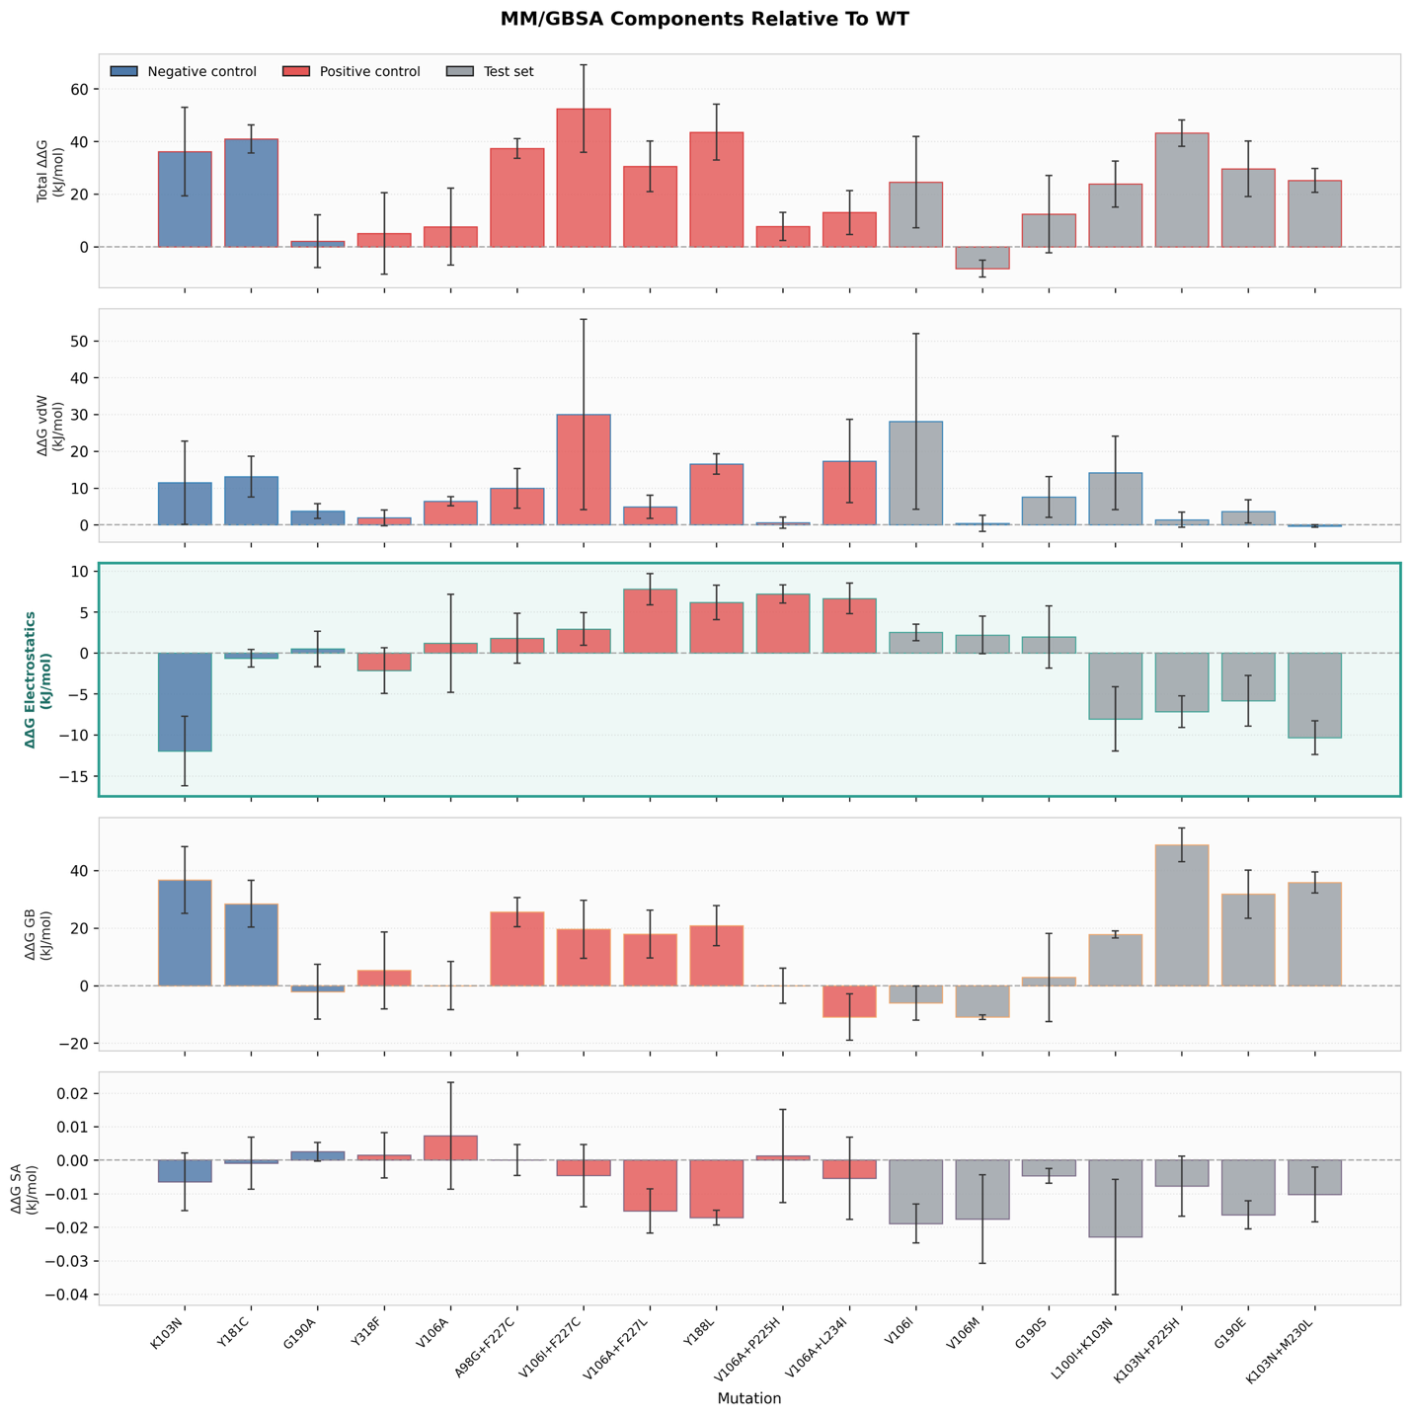
Supplementary Figure 1: Changes in binding energy vs WT observed in MD simulations of mutant RT-DOR systems. Data show the average energy values over 100 frames sampled uniformly from 100ns all-atom MD simulations of each system, after discarding the first 25% of production runs to allow equilibration. Error bars represent the standard error of the mean over N = 3 replicates. The electrostatics component is highlighted because it correlates with phenotypic DOR susceptibility data.

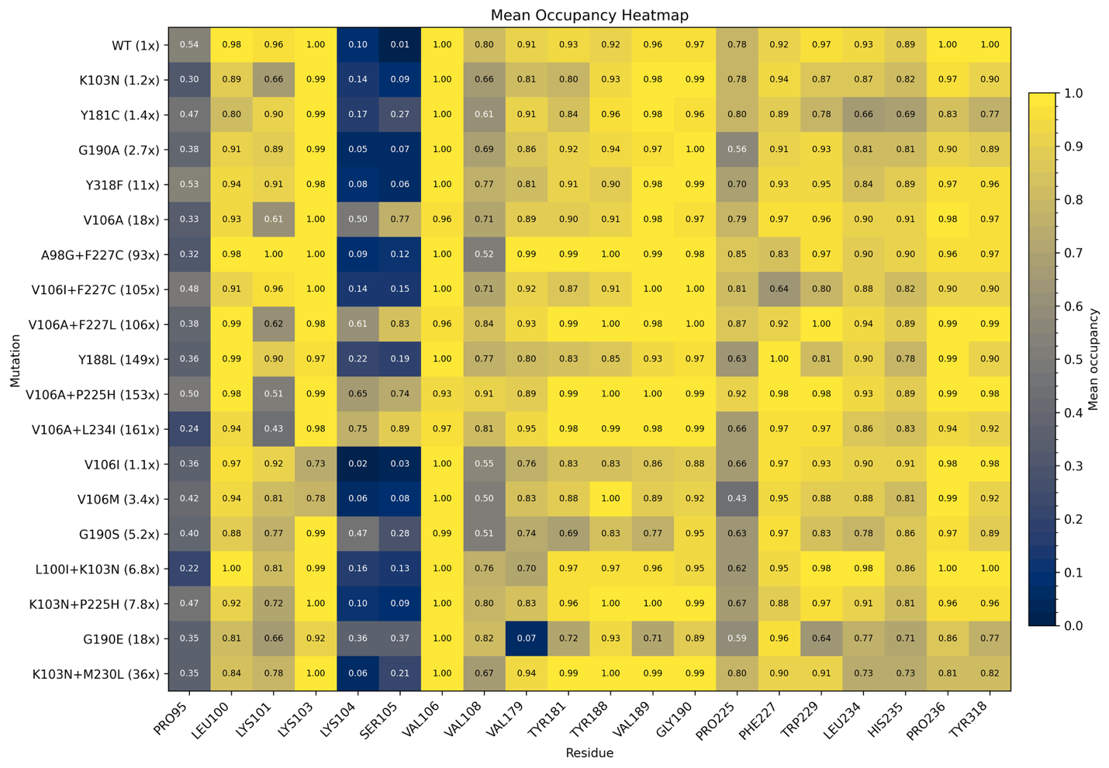
Supplementary Figure 2: Mean Occupancy of NNIBP residues from MD simulations. Pooled mean occupancy across all frames and replicate simulations for each genotype computed across all residues that exhibit mean occupancy ≥ 0.5 for at least one genotype.

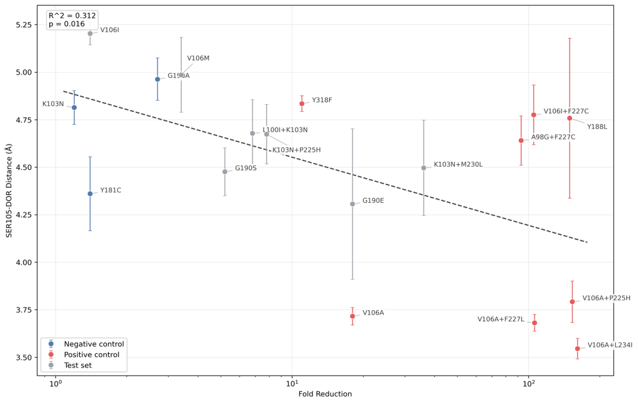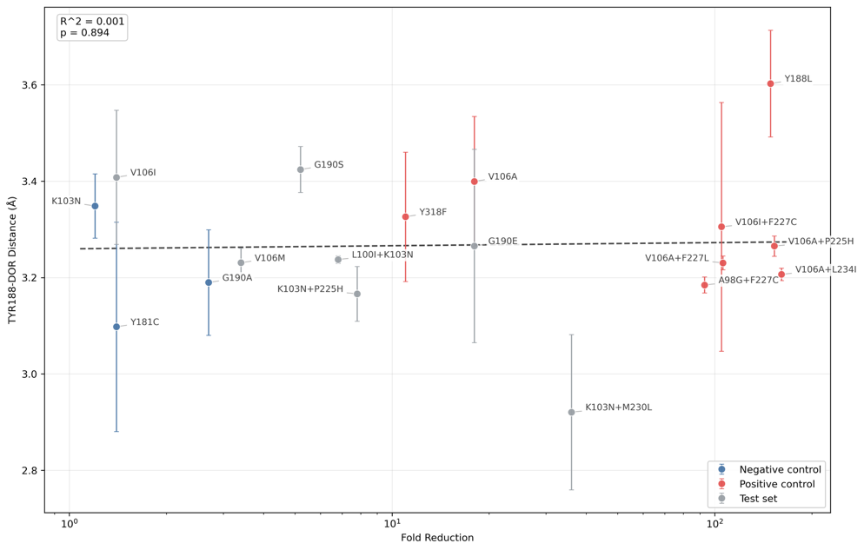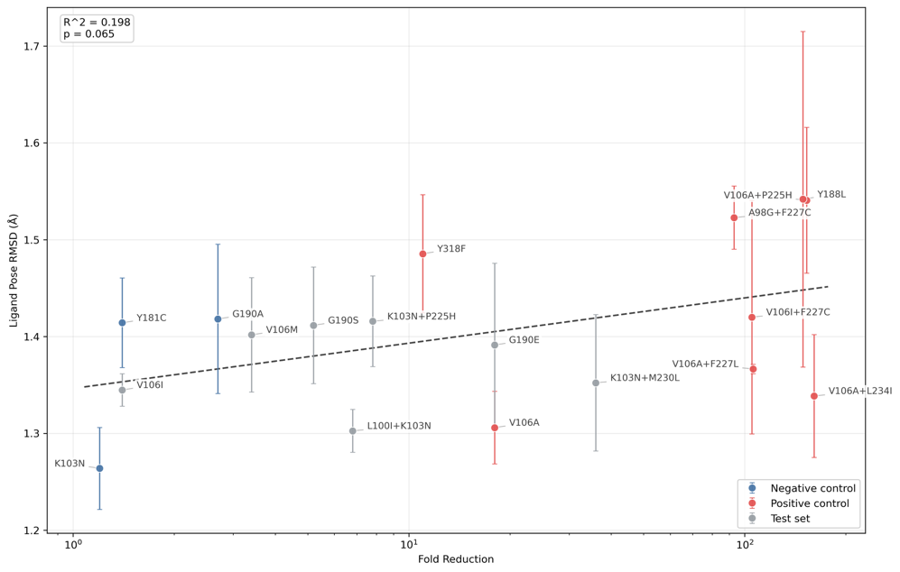
Supplementary Figure 3: Correlation between MD-simulations-derived structural features used for training with the target variable. These features emerged out of a series of successive ablation experiments, starting from a set of 10 (see Methods), with the objective of improving model accuracy.

References

Asante-Appiah E, Lai J, Wan H, et al. Impact of HIV-1 resistance-associated mutations on susceptibility to doravirine: analysis of real-world clinical isolates. Antimicrob Agents Chemother. 2021;65(12):e01216-21. doi:10.1128/AAC.01216-21.

Bec G, Meyer B, Gerard MA, et al. Thermodynamics of HIV-1 reverse transcriptase in action elucidates the mechanism of action of non-nucleoside inhibitors. J Am Chem Soc. 2013;135(26):9743-9752. doi:10.1021/ja4018418.

Boyle A, Hodge D, Marzolini C, Khoo S. Clinical Pharmacodynamics, Pharmacokinetics, and Drug Interaction Profile of Doravirine. Clin Pharmacokinet. 2019;58(12):1553-1565. doi:10.1007/s40262-019-00806-9.

Braz VA, Holladay LA, Barkley MD. Efavirenz binding to HIV-1 reverse transcriptase monomers and dimers. Biochemistry. 2010;49(3):601-610. doi:10.1021/bi901579y.

Brenner BG, Oliveira M, Ibanescu RI, Routy JP, Thomas R. Cell culture selections reveal favourable drug resistance profiles for doravirine and islatravir. J Antimicrob Chemother. 2021;76(8):2137-2142. doi:10.1093/jac/dkab126.

Cote B, Burch JD, Asante-Appiah E, et al. Discovery of MK-1439, an orally bioavailable non-nucleoside reverse transcriptase inhibitor potent against a wide range of resistant mutant HIV viruses. Bioorg Med Chem Lett. 2014;24(3):917-922. doi:10.1016/j.bmcl.2013.12.070.

Cox DR. The regression analysis of binary sequences. J R Stat Soc Series B Stat Methodol. 1958;20(2):215-232. doi:10.1111/j.2517-6161.1958.tb00292.x.

Darden T, York D, Pedersen L. Particle mesh Ewald: an N·log(N) method for Ewald sums in large systems. J Chem Phys. 1993;98(12):10089-10092. doi:10.1063/1.464397.

Das K, Bauman JD, Clark AD Jr, et al. High-resolution structures of HIV-1 reverse transcriptase/TMC278 complexes: strategic flexibility explains potency against resistance mutations. Proc Natl Acad Sci U S A. 2008;105(5):1466-1471. doi:10.1073/pnas.0711209105.

Das K, Clark AD Jr, Lewi PJ, et al. Roles of conformational and positional adaptability in structure-based design of TMC125-R165335 (etravirine) and related non-nucleoside reverse transcriptase inhibitors that are highly potent and effective against wild-type and drug-resistant HIV-1 variants. J Med Chem. 2004;47(10):2550-2560. doi:10.1021/jm030558s.

Eastman P, Swails J, Chodera JD, et al. OpenMM 7: rapid development of high performance algorithms for molecular dynamics. PLoS Comput Biol. 2017;13(7):e1005659. doi:10.1371/journal.pcbi.1005659.

Esnouf RM, Ren J, Ross C, et al. Mechanism of inhibition of HIV-1 reverse transcriptase by non-nucleoside inhibitors. Nat Struct Biol. 1995;2(4):303-308. doi:10.1038/nsb0495-303.

Feng M, Sachs NA, Xu M, Grobler JA, Blair W, Hazuda DJ, et al. Doravirine suppresses common nonnucleoside reverse transcriptase inhibitor-associated mutants at clinically relevant concentrations. Antimicrob Agents Chemother. 2016;60(4):2241-2247. doi:10.1128/AAC.02650-15.

Feng M, Wang D, Grobler JA, et al. In vitro resistance selection with doravirine (MK-1439), a novel nonnucleoside reverse transcriptase inhibitor with distinct mutation development pathways. Antimicrob Agents Chemother. 2015;59(1):590-598. doi:10.1128/AAC.04201-14.

Gasteiger J, Marsili M. Iterative partial equalization of orbital electronegativity-a rapid access to atomic charges. Tetrahedron. 1980;36(22):3219-3228. doi:10.1016/0040-4020(80)80168-2.

Geisser S. The predictive sample reuse method with applications. J Am Stat Assoc. 1975;70(350):320-328. doi:10.1080/01621459.1975.10479865.

Gowers RJ, Linke M, Barnoud J, Reddy TJE, Melo MN, Seyler SL, et al. MDAnalysis: A Python package for the rapid analysis of molecular dynamics simulations. In: Benthall S, Rostrup S, editors. Proceedings of the 15th Python in Science Conference. 2016. p. 98-105. doi:10.25080/Majora-629e541a-00e.

Hwang C, Lai MT, Hazuda D. Rational design of doravirine: from bench to patients. ACS Infect Dis. 2020;6(1):64-73. doi:10.1021/acsinfecdis.9b00178.
Jorgensen WL, Chandrasekhar J, Madura JD, Impey RW, Klein ML. Comparison of simple potential functions for simulating liquid water. J Chem Phys. 1983;79(2):926-935. doi:10.1063/1.445869.

Lai M-T, Feng M, Falgueyret J-P, Tawa P, Witmer M, DiStefano D, et al. In vitro characterization of MK-1439, a novel HIV-1 nonnucleoside reverse transcriptase inhibitor. Antimicrob Agents Chemother. 2014;58(3):1652-1663. doi:10.1128/AAC.02403-13.

Maier JA, Martinez C, Kasavajhala K, Wickstrom L, Hauser KE, Simmerling C. ff14SB: improving the accuracy of protein side chain and backbone parameters from ff99SB. J Chem Theory Comput. 2015;11(8):3696-3713. doi:10.1021/acs.jctc.5b00255.

Martin EA, Lai M-T, Ngo W, Feng M, Graham D, Hazuda DJ, et al. Review of doravirine resistance patterns identified in participants during clinical development. J Acquir Immune Defic Syndr. 2020;85(5):635-642. doi:10.1097/QAI.0000000000002481.

Massova I, Kollman PA. Combined molecular mechanical and continuum solvent approach (MM-PBSA/GBSA) to predict ligand binding. Perspect Drug Discov Des. 2000;18:113-135. doi:10.1023/A:1008763014207.

Michaud-Agrawal N, Denning EJ, Woolf TB, Beckstein O. MDAnalysis: a toolkit for the analysis of molecular dynamics simulations. J Comput Chem. 2011;32(10):2319-2327. doi:10.1002/jcc.21787.

Mejias-Trueba M, Gutierrez-Valencia A, Llaves-Flores S, et al. Long-term effectiveness, safety, and tolerability of doravirine in antiretroviral-experienced people with HIV in real life. Microbiol Spectr. 2024;12(8):e00654-24. doi:10.1128/spectrum.00654-24.

Mobley DL, Bannan CC, Rizzi A, et al. Escaping atom types in force fields using direct chemical perception. J Chem Theory Comput. 2018;14(11):6076-6092. doi:10.1021/acs.jctc.8b00640.

Mohammadi P, Desfarges S, Bartha I, et al. 24 hours in the life of HIV-1 in a T cell line. PLoS Pathog. 2013;9(1):e1003161. doi:10.1371/journal.ppat.1003161.

Molina JM, Squires K, Sax PE, et al. Doravirine versus ritonavir-boosted darunavir in antiretroviral-naive adults with HIV-1 (DRIVE-FORWARD): 96-week results of a randomised, double-blind, non-inferiority, phase 3 trial. Lancet HIV. 2020;7(1):e16-e26. doi:10.1016/S2352-3018(19)30336-4.

Onufriev A, Bashford D, Case DA. Exploring protein native states and large-scale conformational changes with a modified generalized Born model. Proteins. 2004;55(2):383-394. doi:10.1002/prot.20033.

Orkin C, Kuritzkes DR, Katlama C, et al. Doravirine Resistance Patterns Identified Through Week 192 in the DRIVE-FORWARD and DRIVE-AHEAD Phase 3 Clinical Trials. J Acquir Immune Defic Syndr. 2026;101(3):308-315. doi:10.1097/QAI.0000000000003787.

Orkin C, Molina JM, Cahn P, et al. Safety and efficacy of doravirine as first-line therapy in adults with HIV-1: week 192 results from the open-label extensions of the DRIVE-FORWARD and DRIVE-AHEAD phase 3 trials. Lancet HIV. 2024;11(2):e75-e85. doi:10.1016/S2352-3018(23)00258-8.

Orkin C, Squires KE, Molina JM, et al. Doravirine/Lamivudine/Tenofovir Disoproxil Fumarate (TDF) Versus Efavirenz/Emtricitabine/TDF in Treatment-naive Adults With Human Immunodeficiency Virus Type 1 Infection: Week 96 Results of the Randomized, Double-blind, Phase 3 DRIVE-AHEAD Noninferiority Trial. Clin Infect Dis. 2021;73(1):33-42. doi:10.1093/cid/ciaa822.

Orkin C, Squires KE, Molina JM, et al. Doravirine/Lamivudine/Tenofovir Disoproxil Fumarate is Non-inferior to Efavirenz/Emtricitabine/Tenofovir Disoproxil Fumarate in Treatment-naive Adults With Human Immunodeficiency Virus-1 Infection: Week 48 Results of the DRIVE-AHEAD Trial. Clin Infect Dis. 2019;68(4):535-544. doi:10.1093/cid/ciy540.

Rhee SY, Schapiro JM, Saladini F, Zazzi M, Khoo S, Shafer RW. Potential role of doravirine for the treatment of HIV-1-infected persons with transmitted drug resistance. AIDS Res Ther. 2023;20(1):8. doi:10.1186/s12981-023-00503-5.

Saladini F, Giammarino F, Hosseini BA, Giannini A, Boccuto A, Dragoni F, et al. In vitro cross-resistance to doravirine in a panel of HIV-1 clones harbouring multiple NNRTI resistance mutations. J Antimicrob Chemother. 2021;76(1):130-134. doi:10.1093/jac/dkaa412.

Schauer GD, Huber KD, Leuba SH, Sluis-Cremer N. Mechanism of allosteric inhibition of HIV-1 reverse transcriptase revealed by single-molecule and ensemble fluorescence. Nucleic Acids Res. 2014;42(18):11687-11696. doi:10.1093/nar/gku819.

Schuckmann MM, Marchand B, Hachiya A, et al. The N348I mutation at the connection subdomain of HIV-1 reverse transcriptase decreases binding to nevirapine. J Biol Chem. 2010;285(49):38700-38709. doi:10.1074/jbc.M110.153783.

Sharaf NG, Ishima R, Gronenborn AM. Conformational plasticity of the NNRTI-binding pocket in HIV-1 reverse transcriptase: a fluorine nuclear magnetic resonance study. Biochemistry. 2016;55(27):3864-3873. doi:10.1021/acs.biochem.6b00113.

Singh AK, De Wijngaert B, Bijnens M, et al. Cryo-EM structures of wild-type and E138K/M184I mutant HIV-1 RT/DNA complexed with inhibitors doravirine and rilpivirine. Proc Natl Acad Sci U S A. 2022;119(30):e2203660119. doi:10.1073/pnas.2203660119.

Smith SJ, Pauly GT, Akram A, Melody K, Ambrose Z, Schneider JP, et al. Rilpivirine and doravirine have complementary efficacies against NNRTI-resistant HIV-1 mutants. J Acquir Immune Defic Syndr. 2016;72(5):485-491. doi:10.1097/QAI.0000000000000990.

Spence RA, Kati WM, Anderson KS, Johnson KA. Mechanism of inhibition of HIV-1 reverse transcriptase by nonnucleoside inhibitors. Science. 1995;267(5200):988-993. doi:10.1126/science.7532321.

Stone M. Cross-validation and multinomial prediction. Biometrika. 1974;61(3):509-515. doi:10.1093/biomet/61.3.509.

Tibshirani R. Regression shrinkage and selection via the lasso. J R Stat Soc Series B Stat Methodol. 1996;58(1):267-288. doi:10.1111/j.2517-6161.1996.tb02080.x.

Vijayan RSK, Arnold E, Das K. Molecular dynamics study of HIV-1 RT-DNA-nevirapine complexes explains NNRTI inhibition and resistance by connection mutations. Proteins. 2014;82(5):815-829. doi:10.1002/prot.24460.

Yee KL, Khalilieh S, Sanchez RI, et al. Clinical Pharmacokinetics and Drug Interactions of Doravirine. Eur J Drug Metab Pharmacokinet. 2018;43(6):651-663. doi:10.1007/s13318-018-0497-3.

