Doravirine Resistance Mechanisms in HIV-1 Reverse Transcriptase Revealed by Molecular Dynamics Simulations

Abstract
Doravirine (DOR) is a next-generation Non-Nucleotide Reverse Transcriptase Inhibitor (NNRTI) with durable clinical activity and a unique resistance profile, but publicly available phenotypic susceptibility data for DOR-associated resistance mutations remains limited. Here, we performed all-atom explicit-solvent molecular dynamics (MD) simulations of wild-type (WT) HIV-1 reverse transcriptase (RT) and 18 mutant genotypes as a structure-based approach to fill this gap. We observed that the electrostatic component of the relative RT-DOR binding energy, computed from short (100ns) MD simulations, demonstrates weak but statistically significant correlation with the available phenotypic DOR susceptibility changes in vitro. Furthermore, local trajectory-level analyses identified mutation-specific structural effects: Y188L disrupts aromatic packing with Tyr188 inside the hydrophobic tunnel and remodels the DOR binding pocket near Pro225; V106A-containing genotypes shift DOR toward the pocket entrance, leading to compensatory interactions with Lys104 and Ser105; V106I+F227C samples distinct DOR poses from V106A+F227L despite similar phenotypic resistance; and G190E perturbs the β9-β10 hairpin, weakening contact with Val179. A custom logistic regression model trained on local MD-derived structural features is able to segregate low- and high-resistance genotypes, producing probabilities that correlate well with the available in vitro DOR susceptibility data. Together, these results support a structurally grounded framework for interpreting DOR resistance, estimating the risk of DOR use in people living with HIV who carry pre-existing NNRTI mutations, and informing the design of future NNRTIs.

Introduction

Results

DOR Phenotypic susceptibility landscape
We assembled a panel of 18 DOR-associated genotypes for simulation together with WT RT. These genotypes were selected to cover three distinct categories: (i) Negative controls: well-established low-impact control mutations, (ii) Positive controls: canonical DOR-associated resistance genotypes, and (iii) Limited data: genotypes with limited, sparse, or mechanistically ambiguous DOR susceptibility data. Figure 1 summarizes the median fold-change in DOR susceptibility used to define the panel, and Supplementary Table 1 traces each genotype-level value to its original published source and assay context.

We chose K103N, Y181C, and G190A as negative controls because multiple studies indicate that DOR generally retains activity against these classical NNRTI mutations (Feng et al., 2016; Asante-Appiah et al., 2021). We chose V106A, Y188L, Y318F, A98G+F227C, V106A+F227L, V106A+L234I, V106A+P225H, and V106I+F227C as canonical DOR-associated high-resistance positive controls because they recur across in vitro selection studies, clinical development datasets, and phenotypic susceptibility analyses (Feng et al., 2015; Martin et al., 2020; Asante-Appiah et al., 2021; Lai et al., 2022). Finally, we included K103N+L100I, K103N+P225H, K103N+M230L, V106I, V106M, G190E, and G190S as a limited-data set comprising genotypes with sparse primary susceptibility measurements, subtype-dependent uncertainty, or incomplete mechanistic resolution in the published literature (Martin et al., 2020; Soulie et al., 2019; Giammarino et al., 2024; Reddy et al., 2024; Orkin et al., 2026).

Note that not all fold-change values derive from the same assay platform or experimental design. Some come from large-scale Monogram PhenoSense datasets, some from Merck reporter-gene or site-directed mutant studies, and some from clinical-development isolates or more limited targeted phenotyping studies. Because the DOR phenotype literature remains small and heterogeneous, the panel assembled here should not currently be viewed as a standardized benchmark dataset.

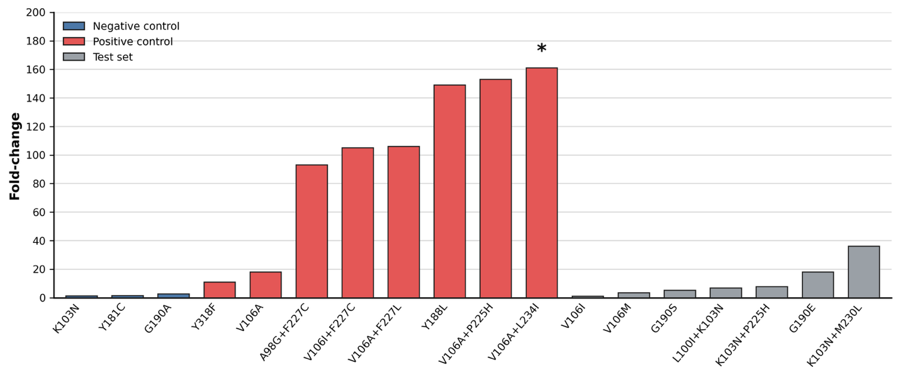
Figure 1: Fold-change in DOR susceptibility associated with selected genotypes. Values represent median fold reductions in susceptibility relative to wild-type control viruses. Asterisk (*) denotes susceptibility results generated using non-PhenoSense assays.

