Probing Doravirine Resistance Mechanisms in HIV-1 Reverse Transcriptase Using Molecular Dynamics Simulations

Rohit Satija¹, Kaiming Tao¹, Robert W. Shafer^{1*}
¹Division of Infectious Diseases, School of Medicine, Stanford University, Stanford, CA, USA
*Corresponding author (rshafer@stanford.edu)

Abstract
Doravirine (DOR) is a next-generation Non-Nucleotide Reverse Transcriptase Inhibitor (NNRTI) with durable clinical activity and a unique resistance profile, but publicly available phenotypic susceptibility data for DOR-associated resistance mutations remains limited. Here, we performed all-atom explicit-solvent molecular dynamics (MD) simulations of DOR-bound wild-type HIV-1 reverse transcriptase (RT) and 18 mutant genotypes in an attempt to fill this gap. We observed that local trajectory-level analyses identified mutation-specific structural changes associated with DOR resistance – simulations with V106A-containing genotypes consistently shift DOR toward the 103-108 loop, leading to compensatory interactions with Lys104 and Ser105; V106I+F227C simulations sample DOR poses distinct from V106A+F227L despite mutations at the same positions and similar phenotypic resistance; and G190E perturbs the pocket entrance, disrupting DOR contact with Val179. However, the relative RT-DOR binding energy or its individual components, computed from these simulations, demonstrated only weak correlation with available data for HIV-1 DOR susceptibility; while a custom linear regression model trained on select MD-derived structural features performed better. Together, these results demonstrate a structure-based framework for interpreting DOR resistance and possibly informing the design of future NNRTIs.

Introduction
NNRTIs noncompetitively inhibit the HIV-1 Reverse Transcriptase (RT) enzyme by binding to the allosteric NNRTI binding pocket (NNIBP),^{1,2}. The NNIBP is ~10Å from the RT DNA polymerase active site and forms only upon NNRTI binding, via an induced conformational change in the RT p66 subunit.^{3,4} Since the NNIBP can more readily accommodate mutations than the polymerase active site without a significant cost to enzyme fitness, emergence of NNRTI resistance occurs commonly if virological suppression is not complete in patients receiving an NNRTI.^{5,6}
NNRTI resistance mutations generally decrease HIV-1 susceptibility by affecting interactions between the inhibitor and the NNIBP.⁷ K103N alters allosteric RT dynamics and permit a productive RT-template/primer-dNTP complex despite NNRTI binding⁸ or stabilize the closed pocket form of RT, thus decreasing NNRTI binding affinity.⁹ Y181C removes critical aromatic ring stacking interactions between NNRTIs and the NNIBP.^{10,11} G190A adds a bulge in a compact binding region, causing steric conflict with the NNRTI.⁶ The second generation NNRTIs Etravirine (ETR) and Rilpivirine (RPV) counteract such common NNRTI resistance mutations by introducing positional and conformational flexibility.^{12,13} The flexible structures of ETR and RPV allow them to rotate within the NNIBP, permitting multiple interactions with NNIBP residues even in the presence of NNRTI mutations and thereby allowing them to retain activity against certain mutant viruses.⁶
DOR was designed by introducing cyclic constraints in a novel class of diaryl ether NNRTIs.¹⁴ DOR makes a unique H-bond with the backbone of Lys103, and the Tyr181 side chain is rotated by 90° away from Tyr188 when compared to apo, ETR, EFV, and RPV X-ray structures.¹⁵ As a result, binding of DOR is likely less dependent on Lys103 and Tyr181 and consequently has a superior profile against common resistance mutations at these sites. On the other hand, the central phenyl ring in DOR makes a hydrophobic bond with Val106, which is often mutated to alanine in viruses from patients with virological failure receiving DOR and which results in reduced DOR susceptibility^{16,17}. Similarly, combinations of V106A/I with F227C/L, L234I, and P225H cause >100-fold reductions in susceptibility to DOR¹⁸.
This unique resistance profile has allowed DOR to become an integral component of the standard of care in antiretroviral therapy (ART).^{19–22} Yet limited availability of DOR-resistance data has complicated its use in persons with pre-existing NNRTI resistance. To investigate mechanisms of DOR resistance and explore computational approaches to fill gaps in DOR susceptibility data, we performed all-atom explicit solvent molecular dynamics (MD) simulations on 19 RT-DOR complexes, corresponding to wild-type (WT) RT and 18 DOR-associated genotypes. Our results demonstrate that computational approaches relying on a combination of physics-based molecular dynamics simulations and machine learning models correlate with, and provide structural interpretations for, mutation-induced changes in susceptibility.
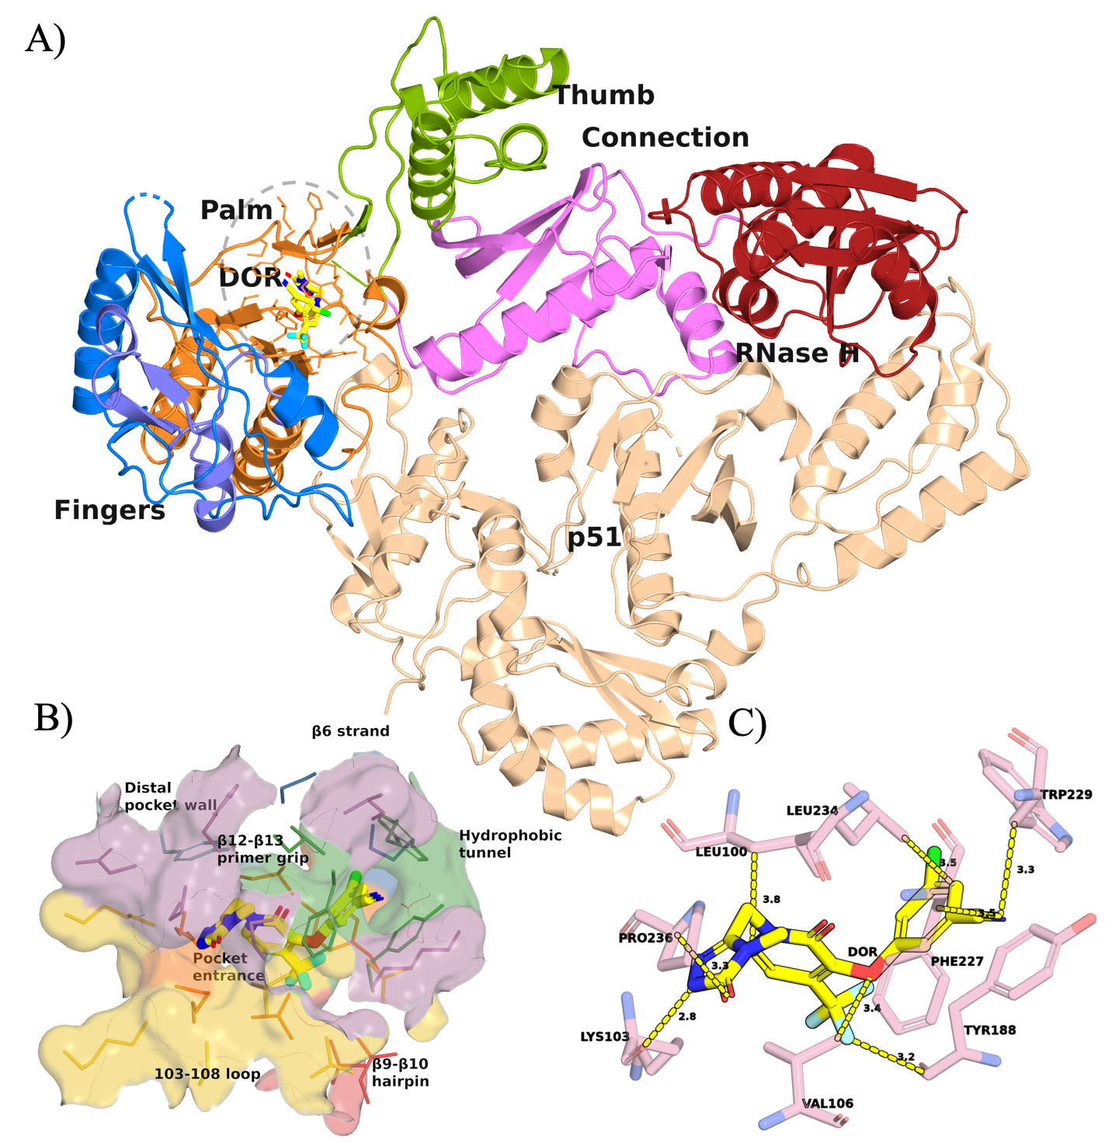
Figure 1: Crystal structure of DOR bound to WT RT (PDB ID: 4NCG). (A) Annotated structure of WT RT in complex with DOR simulated in this work. The NNIBP including DOR is highlighted in a light gray oval. (B) Visualization of DOR within the NNIBP, segmented into seven regions: β6 strand (blue), Pocket entrance (orange), 103-108 loop (yellow), Hydrophobic tunnel (green), β9-β10 hairpin (red), β12-β13 primer grip (purple), Distal pocket wall (teal). (C) Minimum heavy atom distances between DOR (yellow) and eight key NNIBP residues (pink).
Results
DOR Phenotypic susceptibility landscape
We assembled a panel of 18 DOR-associated genotypes for simulation together with WT RT. These genotypes were selected to cover three distinct categories:
- Susceptible phenotype: well-established low-impact control mutations associated with little, if any, reduction in DOR susceptibility. These include K103N, V106I, Y181C, and G190A.
- Resistant phenotype: canonical DOR-associated resistance mutations and mutation patterns, consistently associated with reduced susceptibility. These were chosen to be K103N+M230L, V106A, Y188L, Y318F, A98G+F227C, V106A+F227L, V106A+L234I, V106A+P225H, and V106I+F227C.
- Uncertain phenotype: mutations and mutation patterns associated with limited or inconsistent reductions in susceptibility. These were K103N+L100I, K103N+P225H, V106M, G190E, and G190S.
Table 1 summarizes the median fold-change in DOR susceptibility used to define the panel and Supplementary Table 1 traces the isolate-level data indexed in the Stanford HIVDB (https://hivdb.stanford.edu/). These susceptibility data were derived from assays performed using the Monogram PhenoSense assay and the relatively similar Merck reporter-gene assay. Isolates undergoing testing were either site-directed mutants or clinical isolates for which known NNRTI-resistance mutations were specified.
Table 1. Fold-change in DOR susceptibility associated with selected genotypes
Mutation category | Mutation | Median fold-change in susceptibility vs WT | Number of isolates | Raw fold-change values | Primary source studies
Susceptible | V106I | 1.1 | 2 | [0.8, 1.4] | Lai et al (2014)¹⁶; Orkin et al (2026)²²
 | K103N | 1.2 | 6 | [0.6, 1.2, 1.2, 1.3, 2.8, 3.0] | Lai et al (2014)¹⁶
 | Y181C | 1.4 | 4 | [1.2, 1.3, 1.5, 6.0] | Lai et al (2014)¹⁶
 | G190A | 2.7 | 2 | [1.8, 3.6] | Lai et al (2014)¹⁶
Resistant | Y318F | 11 | 3 | Unavailable (see Table 2 in source study) | Asante-Appiah et al (2021)²³
 | V106A | 9.6 | 2 | [7.1, 9.6, 28] | Lai et al (2014)¹⁶; Feng et al (2014)¹⁷
 | A98G+F227C | 93 | 1 | [93] | Lai et al (2018)²⁴
 | V106I+F227C | 105 | 1 | [105] | Lai et al (2018)²⁴
 | V106A+F227L | 106 | 1 | [106] | Orkin et al (2026)²²
 | Y188L | 149 | 6 | [95, 116, 116, 181, 181, 182] | Lai et al (2014)¹⁶; Hazuda et al (2018)²⁵; Lai et al (2018)²⁴; Orkin et al (2026)²²
 | V106A+P225H | 153 | 2 | [95, 210] | Lai et al (2018)²⁴; Orkin et al (2026)²²
 | V106A+L234I | 161 | 2 | [150, 173] | Feng et al (2014)²⁶; Smith et al (2016)²⁶
 | K103N+M230L | 36 | 1 | [36] | Lai et al (2018)²⁴
Uncertain | V106M | 3.4 | 1 | [3.4] | Lai et al (2014)¹⁶
 | G190S | 5.2 | 4 | [1.5, 4.5, 5.9, 11] | Lai et al (2014)¹⁶
 | K103N+L100I | 6.8 | 8 | [2.7, 4.5, 4.6, 5.1, 8.4, 10, 11, 19] | Lai et al (2014)¹⁶
 | K103N+P225H | 7.8 | 2 | [5.7, 10] | Lai et al (2014)¹⁶
 | G190E | 18 | 1 | [18] | Lai et al (2018)²⁴

RT-DOR binding energy changes weakly correlate with the DOR phenotypic susceptibility landscape
We first asked whether short MD simulations could recapitulate the phenotypic DOR susceptibility landscape using a global destabilization metric derived from binding energy calculations. Starting from the published X-ray crystal structure of WT RT bound to DOR (Figure 1), we introduced each resistance-associated mutation in silico and applied restrained followed by unrestrained energy minimization to generate 18 mutant RT-DOR complex structures corresponding to the curated genotype panel described above. The RT variant sequences simulated in this study are provided in Supplementary Table 2.
For each system, we ran three independent 100ns all-atom, explicit-solvent production simulations and calculated the average MM/GBSA energy over the final 20 frames of each trajectory, corresponding to approximately the final 10ns. For each mutant genotype, we then computed WT-referenced energetic changes, ΔΔG, for the total MM/GBSA energy (∆∆G_{Total}) and for four individual energy components: van der Waals (∆∆G_{vdW}), electrostatic (∆∆G_{elec}), generalized Born polar solvation (∆∆G_{GB}), and nonpolar surface area (∆∆G_{SA}) contributions. In this framework, a positive WT-referenced energy shift, ∆∆G, represents a global destabilization of the bound RT-DOR complex. The results are summarized in Table 2 and Supplementary Table 3.
Table 2. WT-referenced MM/GBSA energy shifts for DOR-bound RT variants*
Mutation category | Mutation | ∆∆G_{Total} (kJ/mol) | ∆∆G_{vdW} (kJ/mol) | ∆∆G_{elec} (kJ/mol) | ∆∆G_{GB} (kJ/mol) | ∆∆G_{SA} (kJ/mol)
Susceptible | V106I | -78 ± 93 | -68 ± 84 | 2.1 ± 3.9 | -11.8 ± 11.5 | -0.04 ± 0.01
 | K103N | 40 ± 102 | 25 ± 105 | -7.9 ± 3.3 | 22.5 ± 11.4 | -0.00 ± 0.01
 | Y181C | -5 ± 79 | -19 ± 67 | -2.5 ± 4.3 | 16.4 ± 9.8 | -0.03 ± 0.01
 | G190A | -22 ± 122 | -32 ± 110 | 1.9 ± 3.9 | 7.5 ± 12.2 | -0.03 ± 0.01
Resistant | Y318F | 37 ± 157 | 30 ± 138 | 0.8 ± 8.1 | 5.6 ± 14.7 | 0.02 ± 0.02
 | V106A | -62 ± 98 | -73 ± 83 | -1.6 ± 3.1 | 12.5 ± 13.7 | -0.02 ± 0.00
 | A98G+F227C | -44 ± 99 | -67 ± 92 | -1.6 ± 4.7 | 25.0 ± 5.3 | -0.00 ± 0.01
 | V106I+F227C | 183 ± 116 | 155 ± 126 | 9.6 ± 2.4 | 19.3 ± 15.0 | -0.01 ± 0.01
 | V106A+F227L | -59 ± 85 | -76 ± 77 | 4.9 ± 1.7 | 12.0 ± 6.8 | -0.03 ± 0.01
 | Y188L | 82 ± 213 | 64 ± 189 | 10.5 ± 6.1 | 8.0 ± 18.7 | 0.02 ± 0.07
 | V106A+P225H | -89 ± 87 | -82 ± 83 | 4.7 ± 3.7 | -11.6 ± 3.6 | -0.04 ± 0.03
 | V106A+L234I | -79 ± 95 | -77 ± 85 | -0.9 ± 2.0 | -1.2 ± 12.2 | -0.03 ± 0.01
 | K103N+M230L | 83 ± 40 | 72 ± 41 | -8.7 ± 6.4 | 19.5 ± 2.9 | -0.01 ± 0.00
Uncertain | V106M | 15 ± 160 | 23 ± 153 | 1.3 ± 6.0 | -9.0 ± 7.1 | -0.02 ± 0.03
 | G190S | 38 ± 130 | 22 ± 116 | 12.8 ± 5.2 | 2.6 ± 12.9 | 0.00 ± 0.03
 | K103N+L100I | -75 ± 94 | -83 ± 83 | -10.6 ± 7.0 | 17.9 ± 8.4 | -0.04 ± 0.01
 | K103N+P225H | -24 ± 103 | -61 ± 95 | -2.4 ± 7.8 | 39.9 ± 5.5 | -0.02 ± 0.00
 | G190E | 141 ± 86 | 90 ± 69 | 4.6 ± 2.2 | 45.7 ± 17.1 | 0.00 ± 0.02
*Values are averages over the last 20 frames (~10ns) of 3 independent 100ns production MD simulations. Errors are computed as standard errors of the mean (SEM) over the 3 replicates.
First, we observed huge trajectory to trajectory variability in the ∆∆G values. For reference, the average of the non-negative ∆∆G_{Total} values across the panel was 77 kJ/mol, while the average of their standard error was 126 kJ/mol. The only three genotypes that exhibited global destabilization of RT-DOR complex relative to WT were V106I+F227C (∆∆G_{Total} = 183 ± 116 kJ/mol), G190E (∆∆G_{Total} = 141 ± 86 kJ/mol), and K103N+M230L (∆∆G_{Total} = 83 ± 40 kJ/mol). For all other genotypes, the WT-referenced total energy shift was zero or near zero within error.
We found that the van der Waals component generally dominated over the other components, both in terms of absolute contribution to and the overall variation across replicates of the total binding energy changes with respect to WT. For example, for the well-known DOR associated mutation Y188L, WT-referenced total energy shift was ∆∆G_{Total} = 82 ± 213 kJ/mol with the van der Waals component ∆∆G_{vdW} = 64 ± 189 kJ/mol. Thus, on average, Y188L was found to destabilize the RT-DOR complex by 82 kJ/mol with 64 kJ/mol (78%) being contributed by the van der Waals component. However, independent simulations suggested a huge variation in these numbers, with the standard deviation for total WT-referenced energy shift being 369 kJ/mol and for the van der Waals component being 327 kJ/mol. Visual inspection of the structures indicated that this variation may have arisen from alternate conformations of Leu188, which produced distinct DOR packing arrangements across replicates, some resembling Tyr188 in WT and others deviating substantially from it.
From the perspective of WT-referenced electrostatic energy shifts, all susceptible mutations showed little to no destabilization, with K103N appearing slightly more stable than WT (∆∆G_{elec} ~ -7.9 ± 3.3 kJ/mol). In contrast, four of the nine resistant mutations—V106I+F227C, V106A+F227L, Y188L, and V106A+P225H—had positive ∆∆G_{elec} values within error, consistent with reduced electrostatic stability relative to WT. Among the five mutations with uncertain phenotype, G190S and G190E were electrostatically less stable than WT, whereas V106M, K103N+L100I, and K103N+P225H were equally stable or more stable than WT.
Overall, neither the total WT-referenced energetic shifts nor most individual energy components correlated with the available phenotypic fold-change data (Table 2 and Supplementary Table 3). The main exception was the electrostatic component, which showed a weak but statistically insignificant correlation with fold-change values among the susceptible and resistant mutations (Figure 2). Together, these results suggest that a simple global destabilization model is insufficient to explain the DOR susceptibility landscape over the simulation timescales sampled here. However, the weak electrostatic association with phenotype, together with mutation-specific van der Waals signatures and heterogeneous local packing behavior, raised the possibility that DOR resistance may be better captured by localized structural rearrangements than by aggregate binding energy shifts with respect to the WT complex.
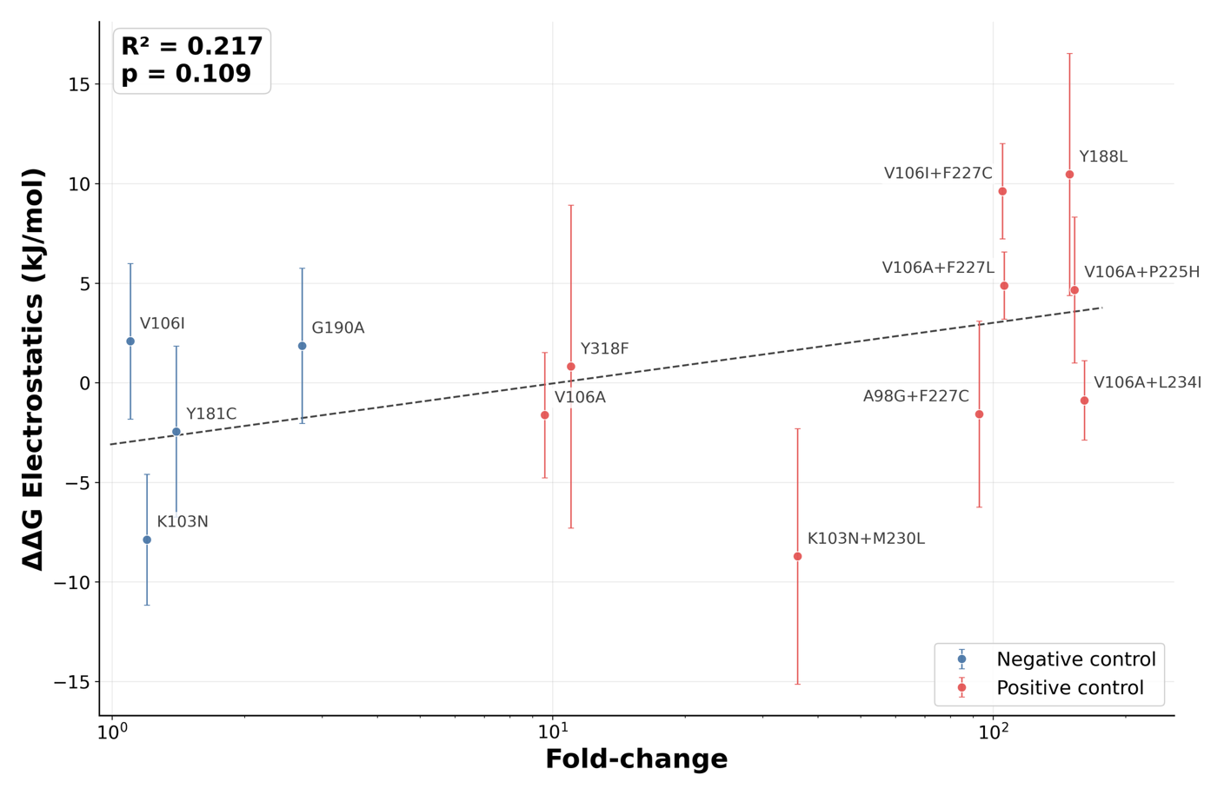
Figure 2: Changes in electrostatic component of the RT-DOR binding energy vs WT weakly correlates with phenotypic DOR susceptibility data of the susceptible and resistant mutations. Data correspond to the average MM/GBSA electrostatic components over the last 20 frames (~10ns) sampled from 100ns all-atom MD simulations of each system. Error bars represent the standard error of the mean over N = 3 replicates. Dashed trend line shows an ordinary least-squares linear regression between electrostatic energy shift and resistance fold-change on a log scale. R² is the coefficient of determination for this fit and the p-value tests whether the regression slope differs from zero using the standard two-tailed t-test.
Local trajectory-level analysis reveals WT RT-DOR contact occupancy profile
We next asked whether DOR resistance might instead be encoded in mutation-specific redistribution of local binding-pocket interactions. This hypothesis was motivated by two considerations. First, the NNIBP is sufficiently compact that short MD simulations may resolve local contact rearrangements even if they do not accurately recover full binding thermodynamics. Second, prior structural studies of NNRTI resistance suggest that reduced susceptibility can arise from altered pocket geometry, shifted anchoring interactions, and increased ligand pose heterogeneity, without necessarily producing a simple global affinity signal.^{9,27,28} We therefore shifted to systematic residue-level characterization of DOR contacts within the NNIBP.
To define the WT local interaction landscape, we quantified residue-level DOR contacts across WT RT-DOR simulations. A residue was classified as contacting DOR in a given frame if the minimum heavy-atom distance between that residue and DOR was less than 4.0 Å (Figure 1). For each residue, we then calculated mean contact occupancy as the fraction of analyzed simulation frames in which this contact criterion was satisfied. This analysis was performed for all residues that contacted DOR at any point in any WT RT-DOR trajectory, yielding a residue-level mean contact occupancy profile for the WT complex (Figure 3).
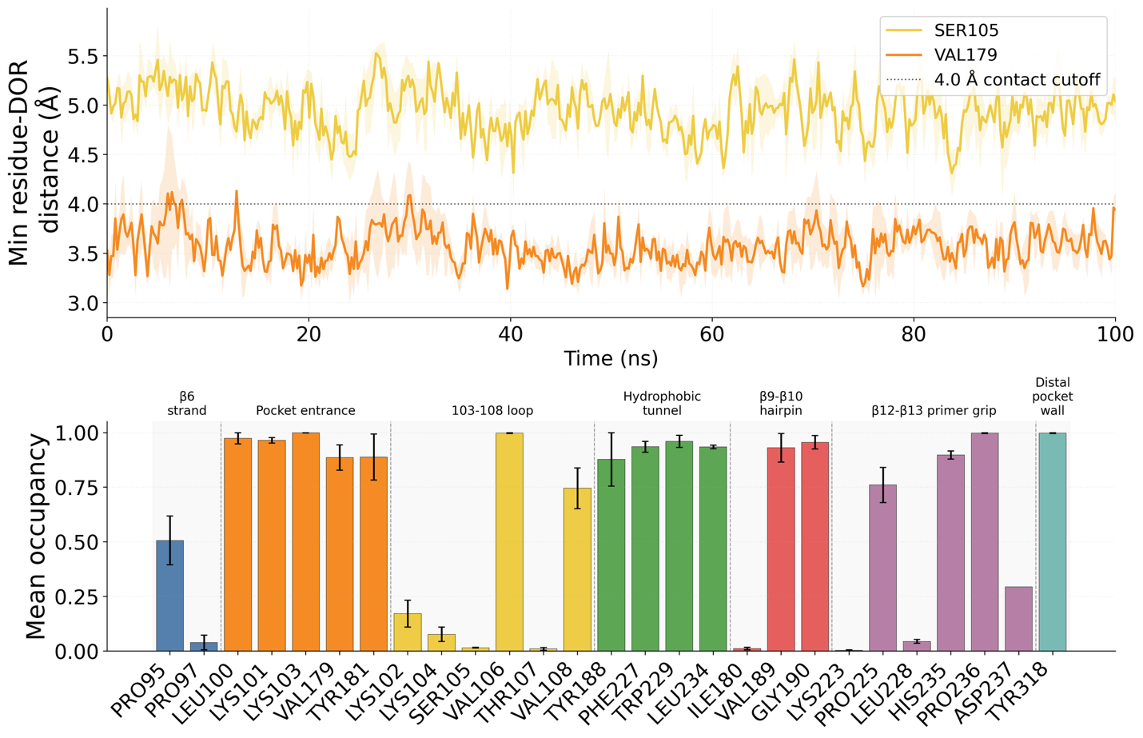
Figure 3: Local trajectory-level contact analysis between DOR and NNIBP residues in WT RT-DOR simulations. Top panel: Trajectories of minimum heavy atom distances between DOR and two exemplary NNIBP residues, Ser105 and Val179, observed in 100ns MD simulations of the WT DOR-RT complex performed in triplicates. Solid lines indicate the mean trajectory and lighter color bands show the standard error of the mean across N = 3 replicates in this as well as other trajectory visualizations in this study. The dotted line represents the 4.0 Å cutoff used to define each contact. Bottom panel: Mean contact occupancy computed for all RT residues that came in contact with DOR at any point during the simulations, segregated by NNIBP regions (cf. Figure 1).
The WT contact occupancy profile revealed three notable features. First, DOR maintained persistent contacts with many NNIBP residues: of the 27 residues that contacted DOR at least once during the WT simulations, 18 had mean occupancy > 0.5, indicating contact for more than half of the simulation time. Second, several NNIBP regions showed consistently high occupancy, including the pocket entrance (5 residues), hydrophobic tunnel (4 residues), and distal pocket wall (1 residue), each with an average mean occupancy across residues within the region exceeding 0.9. Third, contact behavior was highly residue-specific, as neighboring positions could display markedly different mean occupancies, exemplified by positions 105 versus 106 and 180 versus 181. Together, these results establish a WT reference map of stable and heterogeneous DOR-pocket interactions against which mutation-associated local rearrangements can be evaluated.
Contact occupancy profiles encode mutation-sensitive structural signals of DOR resistance
We then extended the contact analysis across all trajectories in the genotype panel to identify residues whose DOR-contact behavior changed in specific mutation backgrounds. For each mutant genotype, we compared residue-level mean occupancy against the WT reference profile, thereby generating a mutation-associated occupancy shift map across the NNIBP (Figure 4).
This systematic screen revealed two broad patterns. First, residues at the mutated positions themselves generally showed only modest changes in DOR contact occupancy, with few shifts exceeding 0.1, relative to WT. The main exceptions were V106I+F227C, which reduced occupancy at the mutated position Phe227 by 0.28, and K103N+P225H, which reduced occupancy at the mutated position Pro225 by 0.12 relative to WT. Second, the largest mutation-associated occupancy shifts typically occurred at residues that were not themselves mutated. For example, G190E reduced DOR contact occupancy at the unmutated residue Val179 by 0.85 relative to WT, whereas V106A+L234I increased occupancy at the unmutated residue Ser105 by 0.87. These observations suggest that resistance-associated mutations can remodel the local DOR interaction network indirectly, rather than simply disrupting contacts at the mutated residue.
Comparing occupancy-shift patterns between DOR resistant and susceptible mutations further suggested that specific residue-level contacts may function as reporter coordinates for resistance-associated structural rearrangements. Such reporter residues or reporter groups as local readouts of protein conformational dynamics are commonly used in the biophysics literature to describe complex high-dimensional conformational changes through low-dimensional structural descriptors, otherwise called order parameters, collective variables, or reaction coordinates.^{29–31} In our case, reporter coordinates are residue-level DOR-contact features whose occupancy changes reflect mutation-associated remodeling in the NNIBP or DOR pose fluctuations.
For example, Y188L, a canonical DOR resistance-associated mutation, increased DOR contact occupancy at Lys102 by 0.23 and decreased occupancy at Pro225 by 0.16 relative to WT. In contrast, Y181C, a known DOR susceptible mutation, produced minimal occupancy changes at the same positions, with shifts of approximately ±0.01 relative to WT for Lys102 and Pro225, respectively. These divergent patterns suggest that DOR interactions with Lys102 and Pro225 may serve as local structural readouts of resistance-associated pocket remodeling, even when these residues themselves are not necessarily the primary sites of mutational perturbation.
Because many residue-level contacts were evaluated, we treated candidate reporter coordinates as hypothesis-generating features rather than as definitive biomarkers of resistance based solely on effect size. To reduce the likelihood that these signals reflect chance observations from multiple comparisons, we compared observed occupancy shifts against an empirical null distribution generated by trajectory-level resampling. Specifically, mutation labels were permuted 10,000 times across replicate trajectories, and the largest absolute occupancy shift observed across all 27 WT-contacted residues was recorded for each permutation. This global maximum statistic estimates the magnitude of occupancy shift expected by chance when applying the same residue-screening procedure to the same trajectory set. Only two reporter coordinates were observed to have absolute WT-referenced occupancy shifts exceeding the 90th percentile of this null distribution (Supplementary Figure 1) – Ser105 for V106A containing genotypes (V106A, V106A+P225H, V106A+F227L, V106A+L234I) and Val179 for G190E.

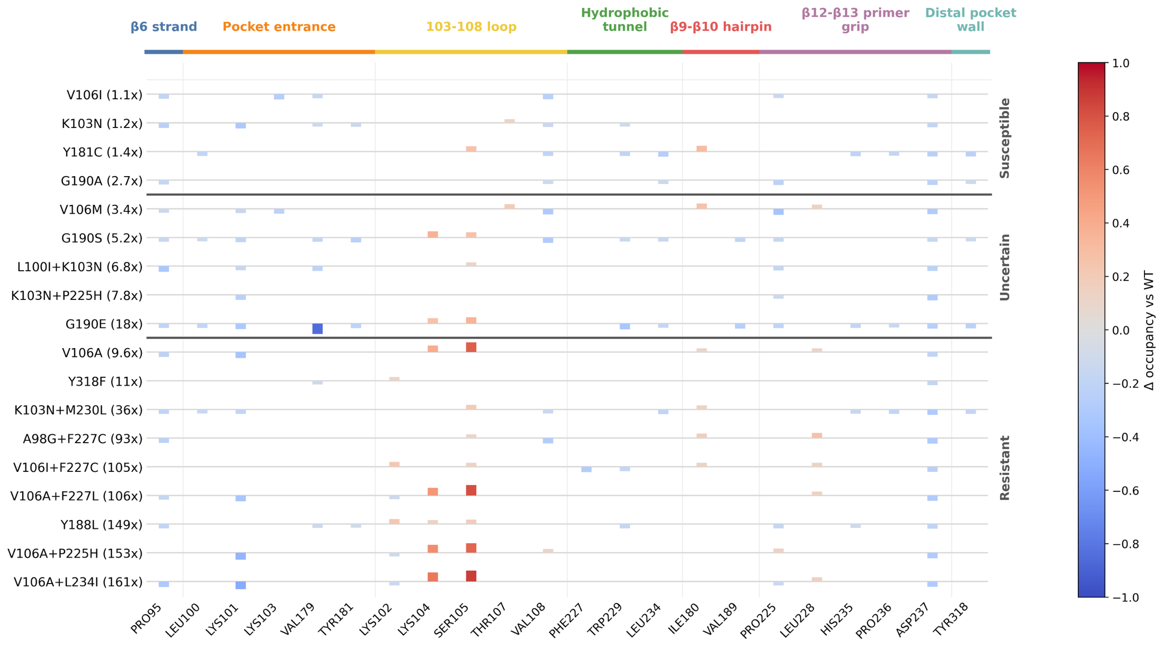
Figure 4: Mutation-associated changes in mean contact occupancy. X-axis lists all residues that were ever in contact with DOR in WT RT-DOR simulations and had mean contact occupancy ≥ |0.1| for at least one genotype. Y-axis lists the 18 genotypes including DOR susceptible, DOR resistant, and the uncertain phenotype set defined in this work. Ticks show shifts with |∆occupancy vs WT| ≥ 0.1; smaller values are shown as 0.

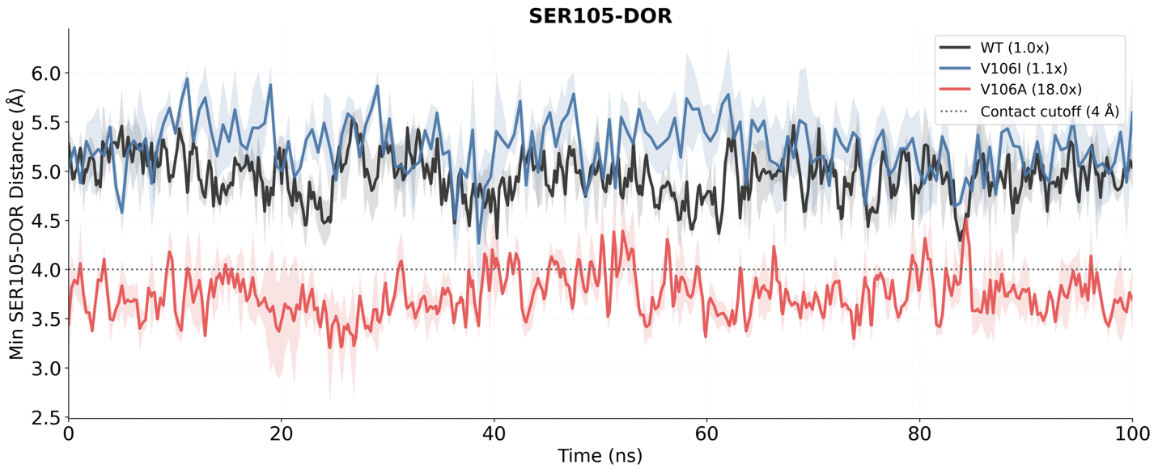
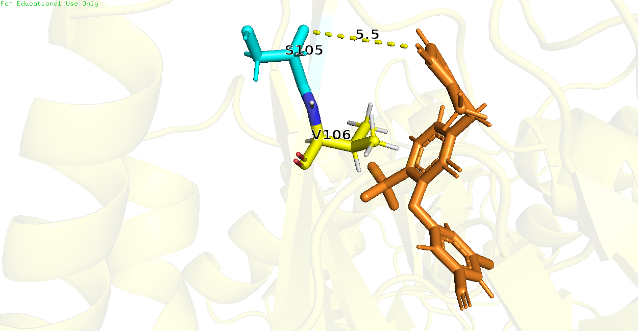
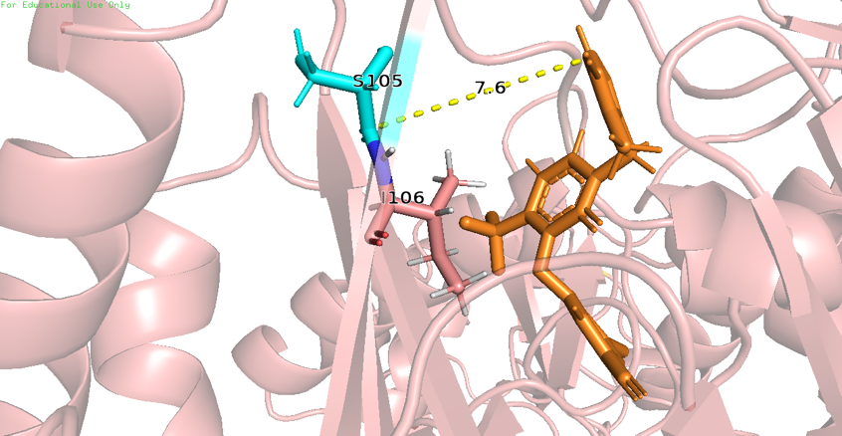
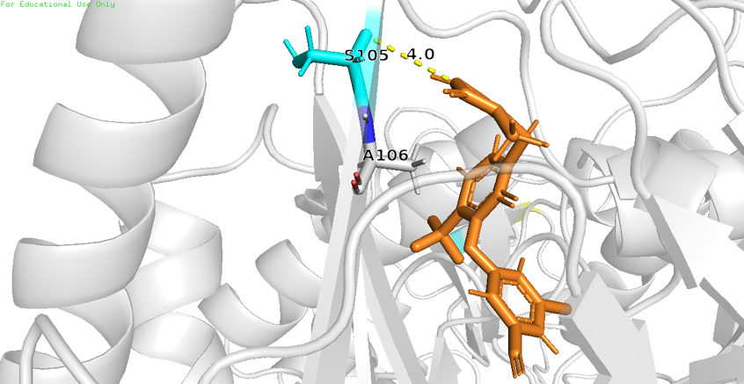
V106A-containing genotypes shift DOR toward the 103-108 loop
WT
V106I
V106A
Figure 5: V106A preferentially alters DOR pose, causing Ser105 to shift closer to DOR. (Top) Minimum distance between heavy atoms of Ser105 and DOR observed in MD simulations of WT, V106I, and V106A. (Bottom) Snapshots of a single frame across WT, V106I, and V106A trajectories, showing Ser105 shifted closer to DOR in case of V106A as compared to WT and V106I.
The V106 region is a major determinant of DOR susceptibility because V106 directly contacts the central pyridone core of DOR. However, in vitro susceptibility assays and clinical prevalence data indicate that not all V106 mutations behave equivalently. V106I, a polymorphic substitution observed to some extent in the general population, does not reduce susceptibility when present alone, whereas V106A is a canonical DOR resistance mutation and serves as the first step in several high-resistance combination pathways. While V106M is not a canonical DOR mutation, limited data suggest it could cause low-level resistance to DOR.
The contact occupancy analysis (Figure 4) highlighted Lys104 and Ser105 as informative reporter residues for this distinction. Both residues sit near the pocket entrance within the 103-108 loop region, and both showed shifts in DOR proximity in V106A-containing trajectories. In direct comparisons among WT, V106I, and V106A, the V106A simulations showed a reproducible shift of DOR toward the 103-108 loop, bringing DOR closer to Ser105 and often also to Lys104 (Figure 5).
The most plausible interpretation is that replacement of valine with alanine removes hydrophobic bulk from a direct DOR-contact site and allows the bound ligand to redistribute toward a slightly more 103-108 loop-shifted local pose ensemble. In that ensemble, contacts with Lys104 and Ser105 can arise as compensatory interactions, but these appear to be secondary to the loss of optimal packing at position 106. The contrast with V106I is informative: isoleucine preserves a branched hydrophobic side chain at position 106, which mitigates local geometry perturbation.
According to this analysis, the mutation V106M, despite exhibiting ~3x-fold reduction in DOR susceptibility, is predicted to be closer to V106I than V106A in terms of the DOR interaction network within the NNIBP (Figure 4). Specifically, V106M does not display a shift toward Lys104 and Ser105 (mean contact occupancy < |0.1| vs WT). On the other hand, if V106A first redistributes the DOR pose toward the 103-108 loop, then additional substitutions around P225, F227, or L234 can further destabilize an already altered local contact network. Accordingly, all three combinations display mean contact occupancy > 0.5 compared with WT toward both Lys104 and Ser105. This model is consistent with the observation that V106A leads to high-level DOR resistance in combination with secondary hydrophobic tunnel and primer grip mutations.
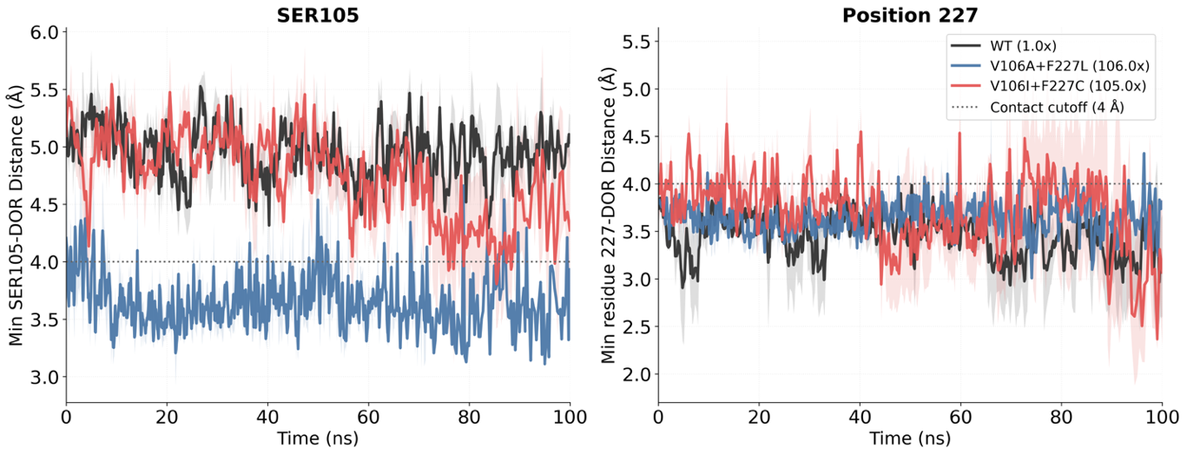
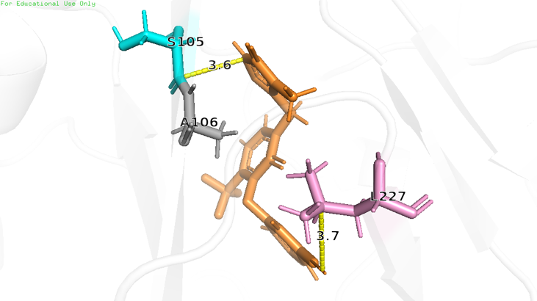
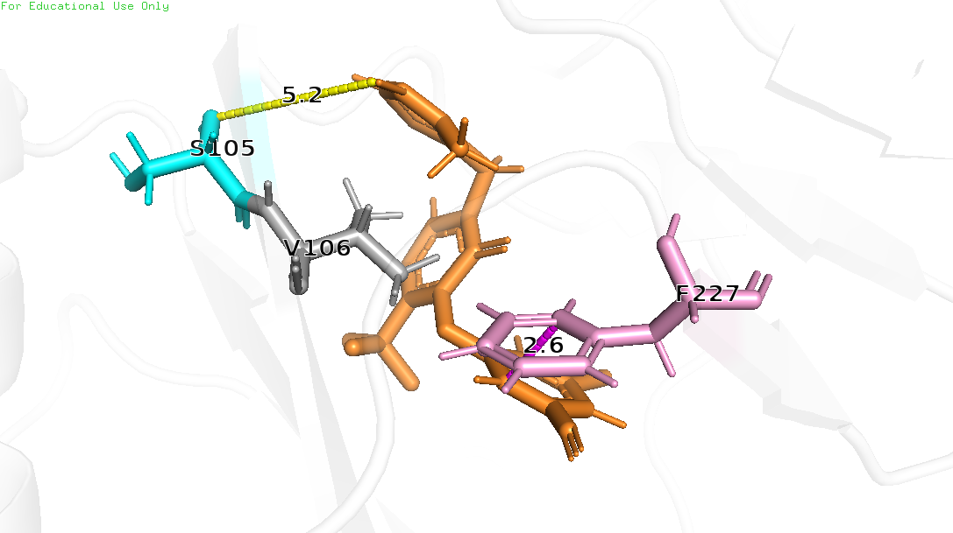
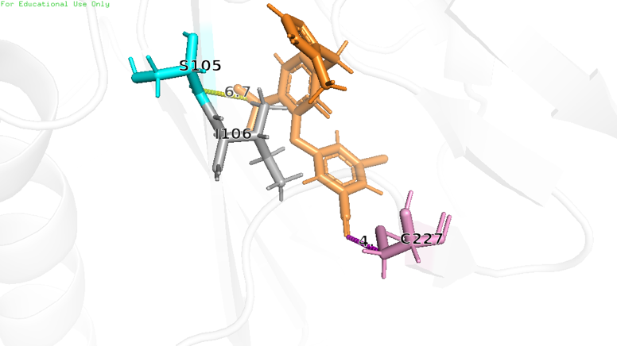
V106I+F227C reaches high resistance through a different local route than V106A+F227L
WT
V106A+F227L
V106I+F227C
Figure 6: V106I+F227C exhibits alternative dynamics than V106A+F227L. (Top) Minimum distances between heavy atoms of Ser105 and DOR as well as Position 227 and DOR observed in MD simulations of WT, V106A+F227L, and V106I+F227C. (Bottom) Snapshots of a single frame across WT, V106A+F227L, and V106I+F227C trajectories, showing Ser105 shifted closer to DOR in case of V106A+F227L (but not in case of V106I+F227C or WT); and an alternate DOR pose in case of V106I+F227C that is further away from residue 227 than in WT or V106A+F227L.
V106I+F227C and V106A+F227L are both highly DOR-resistant genotypes, but the contact occupancy analysis suggests that they achieve resistance through distinct structural mechanisms (Figure 4). V106A+F227L falls within the broader V106A genotype family and, accordingly, retains the characteristic 103–108 loop-shifted signature observed in other V106A-containing backgrounds. Specifically, it shows a local shift toward Ser105 and Lys104.
By contrast, V106I+F227C does not display this pattern. Instead, it combines a relatively modest V106 substitution with a hydrophobic tunnel substitution at position 227, producing alternative local conformations centered around the 227 region. In these simulations, DOR becomes transiently more separated from residue 227 than in either WT or V106A+F227L (Figure 6).
This comparison is important because the two genotypes have similar median DOR fold-change values in the available phenotype data, yet our simulations indicate that they reach the shared resistance phenotype through different structural routes. These results suggest that structurally distinct genotype classes can converge on comparable susceptibility outcomes through different local reorganizations of the binding pocket.
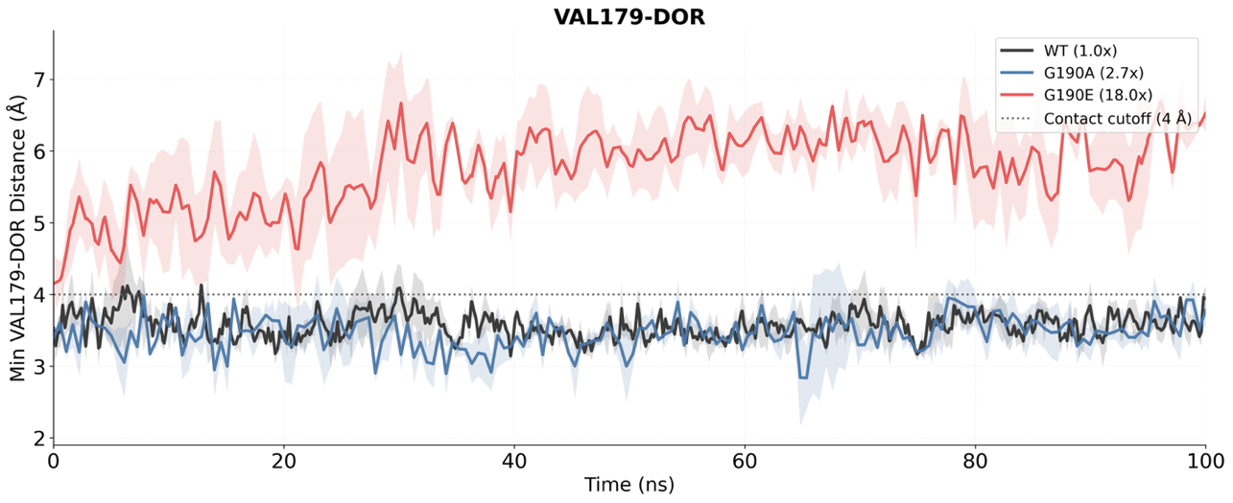
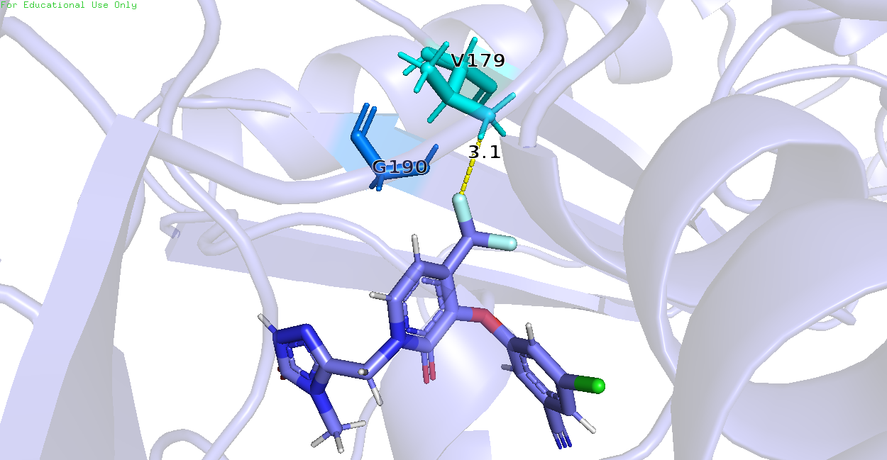
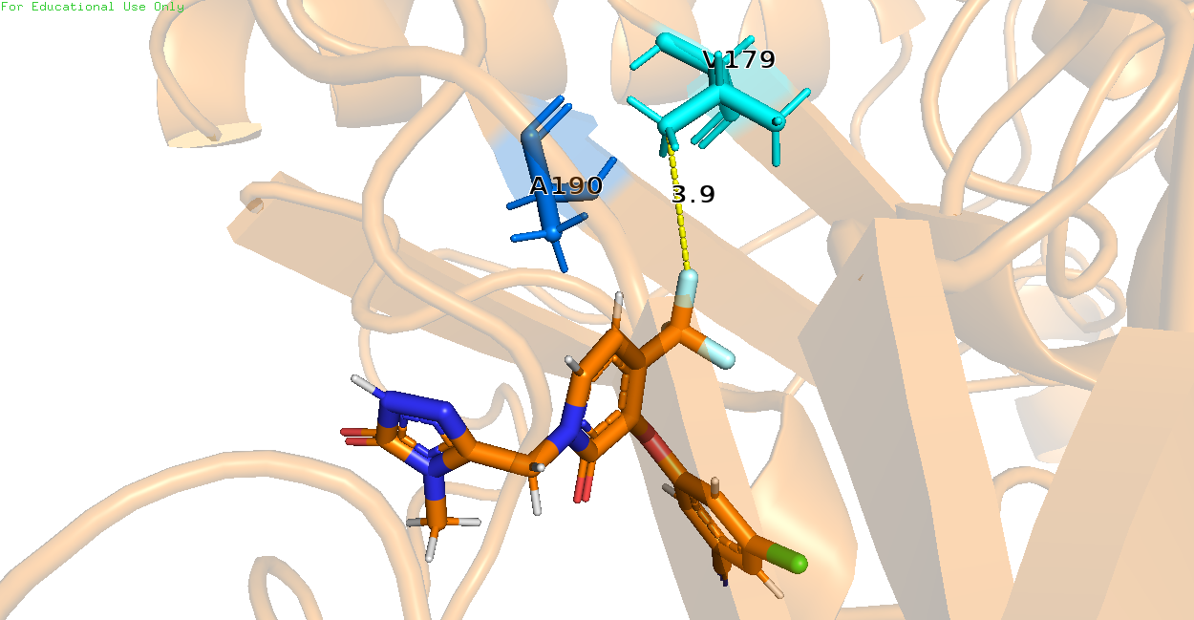
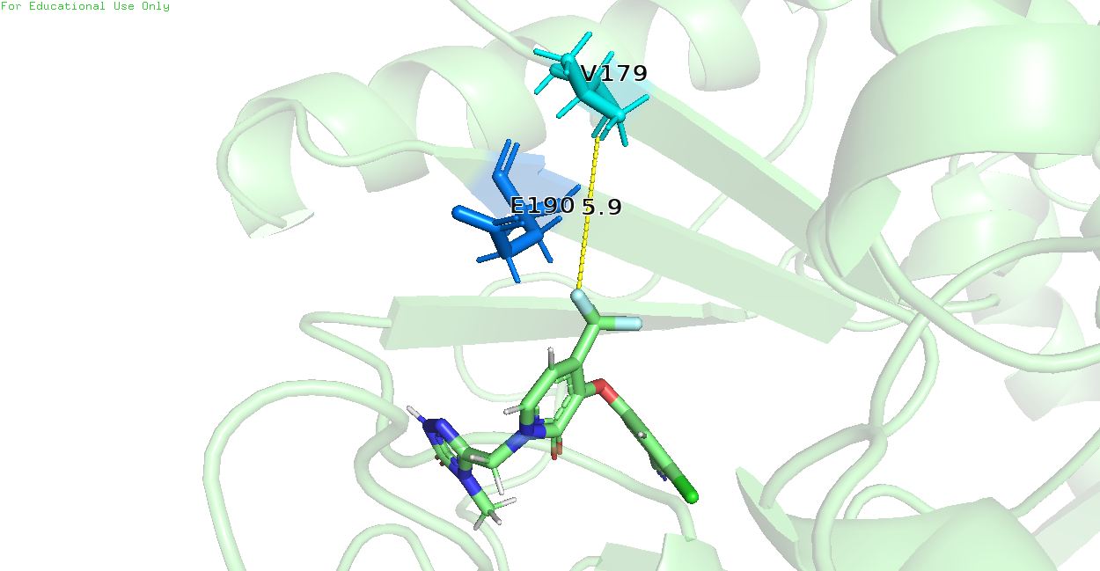
Figure 7: G190E preferentially disrupts β9-β10 hairpin, causing Val179 to lose contact with DOR. (Top) Minimum distance between heavy atoms of Val179 and DOR observed in MD simulations of WT, G190A, and G190E. (Bottom) Snapshots of a single frame across WT, G190A, and G190E trajectories, showing Val179 further away from DOR in case of G190E but not in WT and G190A.
WT
G190A
G190E
G190E perturbs the pocket entrance and weakens Val179 contact
Publicly available phenotype data suggest that G190E may reduce DOR susceptibility. We therefore compared WT, G190A, and G190E to ask whether introduction of a negatively charged glutamate at position 190 produces local structural effects distinct from the more common G190A substitution that is known to have little to no impact on DOR susceptibility.
The panel-wide contact occupancy analysis identified Val179 as the clearest reporter residue for this comparison (Figure 4). Val179 lines the pocket entrance and showed strong genotype-specific contact loss in G190E. In direct trajectory comparisons, G190E caused marked separation of Val179 from DOR that was not observed in WT or G190A (Figure 7). This effect was accompanied by broader local perturbation of the pocket environment.
The simplest interpretation is that the G190E side chain introduces a local electrostatic and steric perturbation in the β9-β10 hairpin that propagates into the Val179 side of the pocket, thereby weakening DOR packing on that face of the binding site. G190A, which lacks this charge switch and imposes a much smaller structural perturbation, did not produce the same effect. These results therefore support G190E as a plausible DOR-relevant genotype deserving further targeted phenotypic study.
Interestingly, G190S appears to have a less pronounced impact on the DOR interaction network than G190E, but more so than G190A (Figure 4). Specifically, G190S displays a mean occupancy shift of -0.17 vs WT, while G190A displays a mean occupancy shift of only -0.05 vs WT for Val179. Furthermore, G190S and G190E might share a structural mechanism with the V106A family mutations as they both exhibit a mean occupancy shift > 0.25 vs WT for Lys104 and Ser105 (Figure 4). This observation suggests that multiple structural mechanisms may overlap to contribute to DOR resistance.
A simple linear regression model trained on MD-derived structural features correlates well with DOR phenotypic landscape
After identifying local structural signatures across the genotype panel, we asked whether a small number of MD-derived variables could summarize the available data for genotype-phenotype relationships. We thus fit a linear regression model using two mechanistically motivated features (Figure 8):
- Ser105-DOR minimum distance that captures the 103-108 loop-proximal shift observed in V106A-containing genotypes.
- Root mean squared deviation (RMSD) of DOR backbone atoms from the crystal structure that summarizes general atomic rearrangement of the drug.
These two features were determined using a multi-step feature ablation approach: starting with a large set of MD-derived features, we recursively trained regularized logistic regression models on the DOR susceptible and resistant mutations (including WT) using one less feature and picked the model with the best accuracy in each step. Selected features were standardized and used to train an ordinary least squares (OLS) model on WT, DOR susceptible and resistant genotypes from scratch. The final model had the equation:
$$y=β_{0}+w_{1}*z\left(x_{1}\right)+w_{2}*z(x_{2})$$
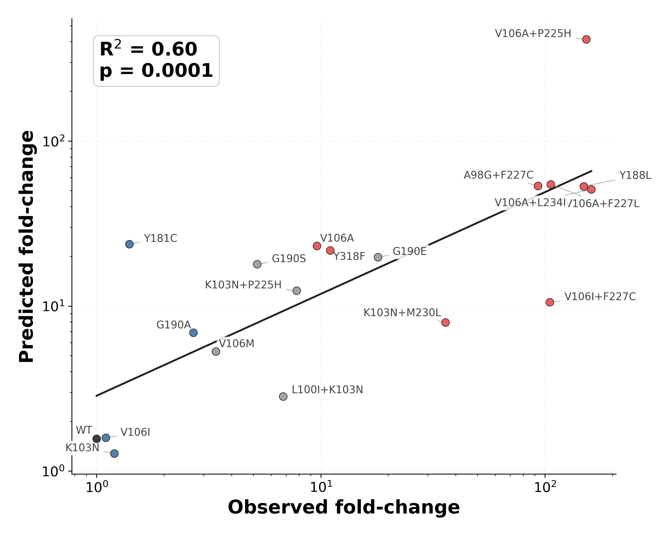
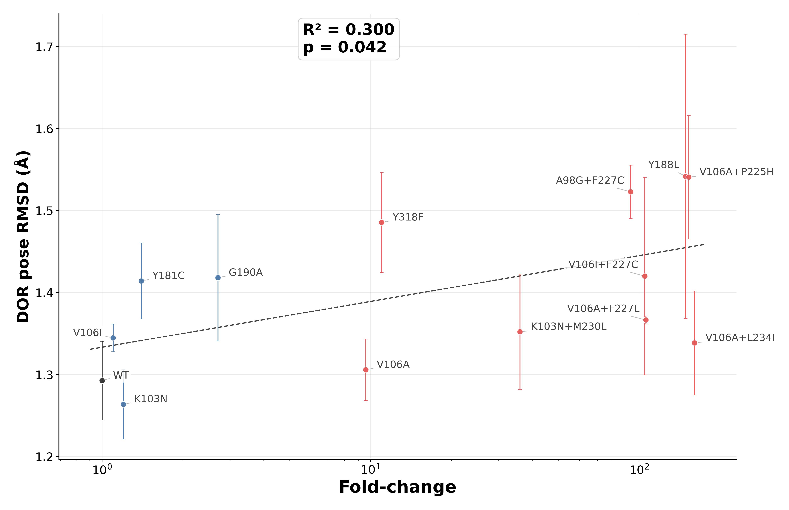
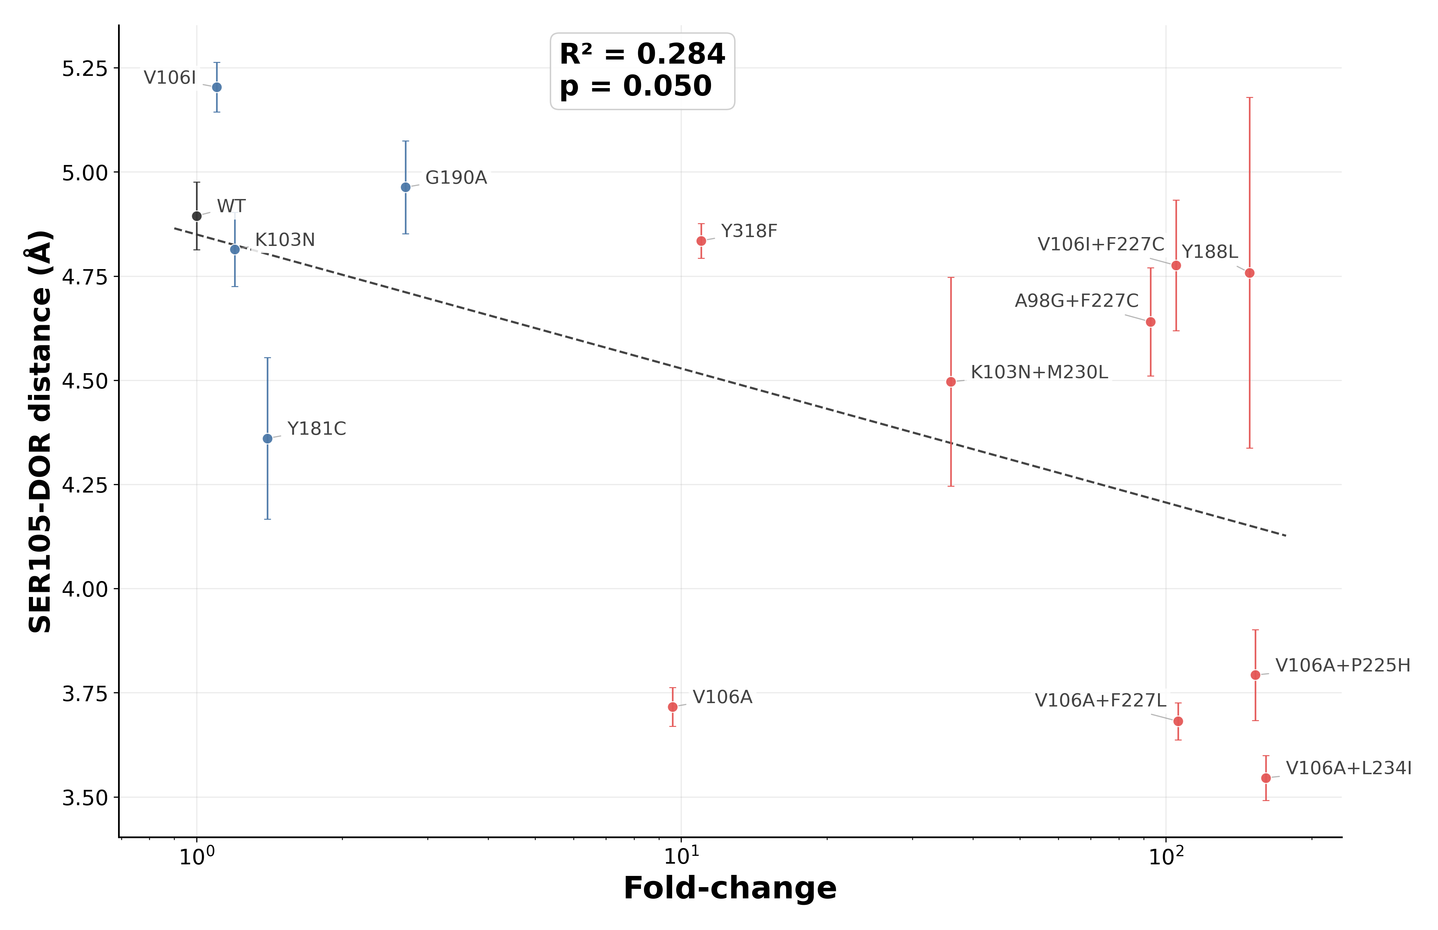
Where $z\left(x\right)=\frac{x-〈x〉}{\sqrt{〈x^{2}〉-{〈x〉}^{2}}}$ represents the standardized version of each feature $x$ ($x_{1}$: DOR pose RMSD; $x_{2}$: Ser105-DOR distance); $y$ is the log₁₀(predicted fold-change) and the coefficients of the model are approximately $β_{0}=1.204$, $w_{1}=0.505$, and $w_{2}=-0.492$.
A)
B)
C)
Figure 8: Performance of a Linear Regression model correlating MD simulation features to DOR susceptibility. (A) Output of the linear regression model, i.e. the predicted DOR fold-change, plotted against median DOR fold-change in susceptibility on the log scale. The solid black line is a fitted trend line. R² is the coefficient of determination for this fit and the p-value tests the null hypothesis that the true linear correlation between the two variables is zero. (B) Correlation of the raw Ser105-DOR distance with fold-change data of the DOR susceptible and resistant mutations. (C) Correlation of the raw DOR pose RMSD metric with fold-change data of the DOR susceptible and resistant mutations.
This minimal model, when applied across the full panel, resulted in predicted fold-change values that correlated with the observed phenotypic fold-change values (R² = 0.60, p = 0.0001). The only DOR susceptible mutation that was incorrectly predicted to have a high (>10x) DOR fold-change was Y181C. Among genotypes with limited or uncertain phenotype, K103N+P225H, G190E, and G190S were predicted to have high fold-change, while V106M and L100I+K103N were predicted to have low fold-change in susceptibility.
To estimate uncertainty in model predictions, we performed bootstrap resampling of replicate-level feature values within each genotype. Briefly, replicate rows were sampled with replacement within each genotype, averaged to genotype-level features, and used to refit the two-feature linear regression model. This process was repeated 1,000 times. 95% confidence intervals were then calculated from the bootstrapped predicted fold-change values (Supplementary Table 4). Nevertheless, the ability of two local MD-derived features to summarize much of the observed phenotypic susceptibility landscape supports the broader hypothesis that much of the mutation-induced fold-changes in DOR susceptibility could be explained by coordinated local rearrangements in the NNIBP.
Discussion
DOR poses an unusual resistance problem among second-generation NNRTIs. Like ETR and RPV, DOR retains activity against common NNRTI-associated backgrounds such as K103N, Y181C, and G190A, yet the pathways that reduce DOR susceptibility are distinct and increasingly relevant in clinical use. Specific substitutions such as Y188L, V106A, and Y318F, and combinations including V106I+F227C, V106A+F227L, and V106A+L234I, now recur across phenotypic studies, in vitro selection experiments, and clinical trial datasets. Despite these observations, publicly available isolate-level susceptibility data for DOR remain sparse. As of April 2026, Stanford HIVDB indexes only 134 DOR-associated isolates tested by the PhenoSense assay, compared with 330 for RPV and 1,193 for ETR. This mismatch between growing clinical relevance and limited public phenotype data for DOR resistance motivated the present study.
We asked whether short explicit-solvent MD simulations could provide a coherent structural framework for understanding known and limited-data DOR resistance genotypes. This choice was motivated by prior studies that successfully used such energy calculations from MD simulations to interrogate HIV resistance mutations in RT,³² Integrase,³³ and Protease.³⁴ However, we observed that the average ∆∆G values of total MM/GBSA energy across independent replicates had no statistically significant association with the DOR phenotypic susceptibility values in our panel. There may be several reasons for this observation. First, the computed MM/GBSA energy values do not represent equilibrium binding free energies because the simulations do not sample the full bound and unbound state populations needed for an accurate free energy estimate. Second, although the simulations were performed in explicit solvent, the MM/GBSA calculations omit any explicit solvent contributions that could have contributed to errors in the entropic components. Third, the simulations sample dynamics on a timescale that is much shorter than the conformational rearrangements and kinetic processes governing RT-DOR binding in vitro.
We also observed large trajectory to trajectory variability in ∆∆G values that precluded any significant correlation with the phenotype panel, even for the individual MM/GBSA components. Interestingly, the largest variability was achieved by the Y188L simulations, where WT-referenced total energy standard deviation between replicates of ~369kJ/mol was mainly driven by the van der Waals component. Upon closer inspection, Leu188 sidechain was found to exhibit more diverse orientations vs Tyr188 sidechain in WT in different replicates with respect to DOR, which likely altered NNIBP packing efficiency and contributed to high variance of the van der Waals energy shift. This observation, along with the weak association observed between the electrostatic component and DOR fold-change values in the susceptible and resistant mutations set, suggested that local DOR contact network reorganization in the NNIBP could be more informative.
The mean contact occupancy analysis revealed the baseline contact network in WT simulations and how it shifts in case of mutations. Our data suggest at least two robust mechanistic findings:
- V106A containing genotypes consistently involve DOR shifting to the 103-108 loop region of the NNIBP. The loss of the hydrophobic interaction between Val106 sidechain and the central pyridone core of DOR in case of V106A likely causes this shift. The resulting DOR contacts with mainchain atoms of Lys104 and Ser105 are suboptimal compensatory interactions and could, therefore, explain resistance to V106A containing genotypes in terms of loose DOR packing within the NNIBP. This mechanism is further supported by the observation that simulations containing V106I, a DOR susceptible polymorphic mutation, do not demonstrate this DOR shift toward the 103-108 loop.
- G190E adds a large negatively charged glutamate in the β9-β10 hairpin that makes DOR lose contact with Val179, a residue that otherwise remains in proximity to DOR in WT simulations. This perturbation likely affects DOR packing and further suggests that future studies may reveal G190E as DOR-associated resistance mutation in in vitro assays.
Finally, starting from a large set of MD-derived features and following a systematic feature selection approach, we arrived at a minimal linear regression model that adequately captures the available DOR phenotypic landscape in terms of two mechanistically interpretable features: minimum heavy atom distance between DOR-Ser105 and root mean square deviation (RMSD) of DOR backbone atoms from the crystallographic pose. However, the model incorrectly predicts Y181C to have >10x fold-change and shows large confidence intervals for each prediction in bootstrap experiments (Supplementary Table 4). These limitations are, at least in part, due to limited sample size of the training data and caveats of our MD simulations noted above. Nevertheless, machine learning models of this kind could be used to estimate DOR fold-change using MD simulations when the relevant experimental data is unavailable.
Methods
Structure Preparation and mutation modeling
The starting holo structure was the crystal structure of HIV-1 RT bound to doravirine (DOR; PDB ligand residue 2KW) from PDB 4NCG (https://www.rcsb.org/structure/4NCG).¹⁴ Mutant complexes were generated from the WT RT-DOR structure by introducing the selected p66 substitutions in silico while preserving the crystallographic DOR pose. Missing heavy atoms were added, nonstandard residues were standardized, and hydrogens were rebuilt consistently across WT and mutant systems. DOR was rebuilt from an SDF template (https://pubchem.ncbi.nlm.nih.gov/compound/Doravirine) and rigidly aligned to the crystallographic ligand heavy atoms by least-squares superposition using the Kabsch algorithm.³⁵ Replicate starting structures were generated by applying small coordinate jitter (0.1 Å) before local minimization. During the initial restrained minimization, heavy atoms more than 8 Å from DOR were harmonically restrained, allowing the binding-pocket region to relax while limiting global structural drift.
Molecular dynamics simulations
All MD simulations were performed with OpenMM.³⁶ Protein and nucleic-acid parameters were assigned from the Amber14 OpenMM force-field files, using ff14SB for protein,³⁷ bsc1 for DNA,³⁸ and TIP3P water.³⁹ DOR parameters were generated through the OpenFF/SMIRNOFF template generator using direct chemical perception,⁴⁰ with Gasteiger partial charges.⁴¹ Each complex was solvated in a TIP3P periodic box with 1.0 nm padding and neutralized at 0.15 M ionic strength. Nonbonded interactions used particle-mesh Ewald electrostatics⁴² with a 1.0 nm cutoff, and bonds to hydrogen atoms were constrained.
Each WT or mutant complex was simulated in three independent 100 ns production replicates. Systems underwent a short pre-production minimization of the solvated system, followed by staged Cα-restrained minimization (1,000 iterations at 50 kcal mol⁻¹ Å⁻², 1,000 iterations at 10 kcal mol⁻¹ Å⁻², and 5,000 unrestrained iterations). Systems were then heated from 10 K to 300 K over 25 ps under NVT conditions. Production simulations were run at 300 K and 1 bar using the Langevin middle integrator, a 2 fs timestep, 1 ps⁻¹ friction coefficient, and a Monte Carlo barostat. State information was written every 2,000 integration steps. For downstream analysis, stripped protein-plus-ligand DCD trajectories were saved at approximately 200 evenly spaced frames per 100 ns production simulation.
Trajectory processing and structural features
Trajectory analyses were performed with MDAnalysis⁴³ and MDTraj.⁴⁴ Periodic-boundary artifacts were corrected by making protein chains whole and wrapping DOR to the nearest periodic image of the protein center of mass. For structural comparisons, trajectories were aligned to the 4NCG reference using Cα atoms. DOR pose RMSD was computed after protein-pocket alignment from DOR heavy atoms relative to the crystallographic pose. Residue-DOR proximity features were computed as the minimum heavy-atom distance between DOR and each specified RT residue in each analyzed frame.
MM/GBSA binding-energy analysis
For each replicate trajectory, MM/GBSA-style binding-energy components were computed from solute-only snapshots of the explicit-solvent simulations.⁴⁵ The analysis used the same molecular-mechanics parameters as the production simulations. We evaluated complex, receptor, and ligand energies separately, and computed binding components as ∆G = G_{complex} − G_{receptor} − G_{ligand}. Van der Waals and electrostatic molecular-mechanics terms were evaluated separately by selectively zeroing the complementary nonbonded parameters. Polar solvation was computed with the Onufriev-Bashford-Case generalized Born model,⁴⁶ and the nonpolar surface-area term was computed from the GBSA surface-area contribution. Hydrogen atoms were locally relaxed before energy evaluation while non-hydrogen atoms were restrained to their MD coordinates. The main manuscript reports replicate means from the final 20 saved frames of each trajectory, corresponding to approximately the final 10 ns. WT-referenced shifts were calculated replicate-wise as ∆∆G = ∆G_{Mut} - ∆G_{WT} for total MM/GBSA energy and for van der Waals, electrostatic, GB polar-solvation, and nonpolar surface-area components. Positive ΔΔG values were interpreted as relative destabilization of the bound RT-DOR complex.
Contact occupancy analysis
Residue-level DOR contact occupancy was quantified from the 100 ns production trajectories using a 4.0 Å heavy-atom distance cutoff. A residue was considered to contact DOR in a frame if any non-hydrogen atom in that residue was within 4.0 Å of any DOR non-hydrogen atom. Occupancy was defined as the fraction of analyzed frames satisfying this criterion. Contact occupancy was computed per replicate and then averaged by genotype. The WT reference contact set comprised all residues that contacted DOR at least once in any WT trajectory, grouped by the NNRTI-binding-pocket regions shown in Figure 1. For WT-referenced contact maps, each mutant genotype occupancy was subtracted from the WT mean occupancy for the same residue.
Permutation null analysis of occupancy shifts
To estimate the magnitude of occupancy shifts expected by chance under the same screening procedure, an empirical null distribution was generated by trajectory-level label permutation. Mutation labels were permuted across replicate trajectories 10,000 times using a fixed random seed. For each permutation, replicate-level occupancies were aggregated by the permuted genotype labels, WT-referenced shifts were recalculated across the 27 screened residues, and the maximum absolute occupancy shift across the residue-genotype matrix was recorded. Observed reporter-coordinate shifts were compared with the 90th percentile of this global maximum null distribution.
Regression analysis of MD-derived features
To test whether a compact set of trajectory-derived structural descriptors summarized the phenotypic DOR landscape, regression models were fit to log₁₀-transformed DOR fold-change values. Candidate features were derived from replicate-level residue-DOR distances, DOR pose RMSD, and MM/GBSA energy components. Feature-screening analyses used regularized logistic models and greedy feature ablation on WT, susceptible control, and resistant control genotypes to identify mechanistically interpretable variables. The final model used two features: mean Ser105-DOR minimum heavy-atom distance and mean DOR heavy-atom pose RMSD. Genotype-level features were averaged across the three replicates, standardized within the training set, and fit with ordinary least-squares linear regression to log₁₀ fold-change. Model performance was summarized with R², root-mean-square error (RMSE), mean absolute error (MAE), and grouped cross-validation by genotype. scikit-learn and scipy were used for model fitting, statistics, and resampling workflows.
Uncertainty in model predictions was estimated by within-genotype bootstrap resampling of replicate-level feature rows. For each of 1,000 bootstrap iterations, replicate rows were sampled with replacement within each genotype, averaged to genotype-level features, standardized, and used to refit the two-feature linear model. The resulting bootstrap distribution of predicted log₁₀ fold-change values was used to calculate 95% prediction intervals reported in Supplementary Table 4.
References
1. Kohlstaedt, L. A., Wang, J., Friedman, J. M., Rice, P. A. & Steitz, T. A. Crystal Structure at 3.5 Å Resolution of HIV-1 Reverse Transcriptase Complexed with an Inhibitor. Science 256, 1783–1790 (1992).
2. Spence, R. A., Kati, W. M., Anderson, K. S. & Johnson, K. A. Mechanism of Inhibition of HIV-1 Reverse Transcriptase by Nonnucleoside Inhibitors. Science 267, 988–993 (1995).
3. Rodgers, D. W. et al. The structure of unliganded reverse transcriptase from the human immunodeficiency virus type 1. Proceedings of the National Academy of Sciences 92, 1222–1226 (1995).
4. Hsiou, Y. et al. Structure of unliganded HIV-1 reverse transcriptase at 2.7 å resolution: implications of conformational changes for polymerization and inhibition mechanisms. Structure 4, 853–860 (1996).
5. Arts, E. J. & Hazuda, D. J. HIV-1 Antiretroviral Drug Therapy. Cold Spring Harb Perspect Med 2, a007161 (2012).
6. Cilento, M. E., Kirby, K. A. & Sarafianos, S. G. Avoiding Drug Resistance in HIV Reverse Transcriptase. Chem. Rev. 121, 3271–3296 (2021).
7. Tantillo, C. et al. Locations of Anti-AIDS Drug Binding Sites and Resistance Mutations in the Three-dimensional Structure of HIV-1 Reverse Transcriptase: Implications for Mechanisms of Drug Inhibition and Resistance. Journal of Molecular Biology 243, 369–387 (1994).
8. Schauer, G. D., Huber, K. D., Leuba, S. H. & Sluis-Cremer, N. Mechanism of allosteric inhibition of HIV-1 reverse transcriptase revealed by single-molecule and ensemble fluorescence. Nucleic Acids Res 42, 11687–11696 (2014).
9. Hsiou, Y. et al. The Lys103Asn mutation of HIV-1 RT: a novel mechanism of drug resistance. Journal of Molecular Biology 309, 437–445 (2001).
10. Lai, M.-T. et al. Mechanistic Study of Common Non-Nucleoside Reverse Transcriptase Inhibitor-Resistant Mutations with K103N and Y181C Substitutions. Viruses 8, 263 (2016).
11. Ren, J. et al. Structural mechanisms of drug resistance for mutations at codons 181 and 188 in HIV-1 reverse transcriptase and the improved resilience of second generation non-nucleoside inhibitors1. Journal of Molecular Biology 312, 795–805 (2001).
12. Das, K. et al. Roles of Conformational and Positional Adaptability in Structure-Based Design of TMC125-R165335 (Etravirine) and Related Non-nucleoside Reverse Transcriptase Inhibitors That Are Highly Potent and Effective against Wild-Type and Drug-Resistant HIV-1 Variants. J. Med. Chem. 47, 2550–2560 (2004).
13. Das, K. et al. High-resolution structures of HIV-1 reverse transcriptase/TMC278 complexes: Strategic flexibility explains potency against resistance mutations. Proceedings of the National Academy of Sciences 105, 1466–1471 (2008).
14. Côté, B. et al. Discovery of MK-1439, an orally bioavailable non-nucleoside reverse transcriptase inhibitor potent against a wide range of resistant mutant HIV viruses. Bioorganic & Medicinal Chemistry Letters 24, 917–922 (2014).
15. Hwang, C., Lai, M.-T. & Hazuda, D. Rational Design of Doravirine: From Bench to Patients. ACS Infect. Dis. 6, 64–73 (2020).
16. Lai, M.-T. et al. In Vitro Characterization of MK-1439, a Novel HIV-1 Nonnucleoside Reverse Transcriptase Inhibitor. Antimicrobial Agents and Chemotherapy 58, 1652–1663 (2014).
17. Feng, M. et al. In Vitro Resistance Selection with Doravirine (MK-1439), a Novel Nonnucleoside Reverse Transcriptase Inhibitor with Distinct Mutation Development Pathways. Antimicrobial Agents and Chemotherapy 59, 590–598 (2014).
18. Rhee, S.-Y. et al. Potential role of doravirine for the treatment of HIV-1-infected persons with transmitted drug resistance. AIDS Res Ther 20, 8 (2023).
19. Calza, L. et al. Doravirine/lamivudine/tenofovir disoproxil fumarate in virologically suppressed people living with HIV: A real-life experience. Int J STD AIDS 34, 1018–1023 (2023).
20. Mejías-Trueba, M. et al. Long-term effectiveness, safety, and tolerability of doravirine in antiretroviral-experienced people with HIV in real life. Microbiology Spectrum 12, e00654-24 (2024).
21. Yang, H., Li, M., Liu, Q., Zeng, Q. & Yuan, J. The efficacy and safety of doravirine/lamivudine/tenofovir disoproxil fumarate in treatment-naïve and treatment-experienced patients with HIV. Annals of Medicine 57, 2564286 (2025).
22. Orkin, C. et al. Switch to fixed-dose doravirine (100 mg) and islatravir (0·25 mg) once daily in virologically suppressed adults with HIV-1 on oral antiretroviral therapy: 48-week results of a phase 3, multicentre, randomised, open-label, non-inferiority trial. The Lancet 407, 599–610 (2026).
23. Asante-Appiah, E. et al. Impact of HIV-1 Resistance-Associated Mutations on Susceptibility to Doravirine: Analysis of Real-World Clinical Isolates. Antimicrobial Agents and Chemotherapy 65, 10.1128/aac.01216-21 (2021).
24. Lai, M.-T. et al. Characterization of Doravirine-Selected Resistance Patterns From Participants in Treatment-Naïve Phase 3 Clinical Trials. https://www.natap.org/2018/IAC/IAC_54.htm (2018).
25. Hazuda, D. J. et al. Understanding the Resistance Profile of the HIV-1 NNRTI Doravirine in Combination With the Novel NRTTI MK-8591. https://www.natap.org/2018/IAC/IAC_48.htm (2018).
26. Smith, S. J. et al. Rilpivirine and Doravirine Have Complementary Efficacies Against NNRTI-Resistant HIV-1 Mutants. JAIDS Journal of Acquired Immune Deficiency Syndromes 72, 485 (2016).
27. Geitmann, M., Unge, T. & Danielson, U. H. Interaction Kinetic Characterization of HIV-1 Reverse Transcriptase Non-nucleoside Inhibitor Resistance. J. Med. Chem. 49, 2375–2387 (2006).
28. Srivastava, A., Birari, V. & Sinha, S. Small Conformational Changes Underlie Evolution of Resistance to NNRTI in HIV Reverse Transcriptase. Biophysical Journal 118, 2489–2501 (2020).
29. Shakhnovich, E., Abkevich, V. & Ptitsyn, O. Conserved residues and the mechanism of protein folding. Nature 379, 96–98 (1996).
30. Portman, J. J., Takada, S. & Wolynes, P. G. Microscopic theory of protein folding rates. II. Local reaction coordinates and chain dynamics. J. Chem. Phys. 114, 5082–5096 (2001).
31. Best, R. B., Hummer, G. & Eaton, W. A. Native contacts determine protein folding mechanisms in atomistic simulations. Proceedings of the National Academy of Sciences 110, 17874–17879 (2013).
32. Zhang, J., Hou, T., Wang, W. & Liu, J. S. Detecting and understanding combinatorial mutation patterns responsible for HIV drug resistance. Proceedings of the National Academy of Sciences 107, 1321–1326 (2010).
33. da Silva, H. H. S. A., Pereira, N., Brandão, L., Crovella, S. & Moura, R. Prediction of HIV integrase resistance mutation using in silico approaches. Infection, Genetics and Evolution 68, 10–15 (2019).
34. Hosseini, A. et al. Computational Prediction of HIV-1 Resistance to Protease Inhibitors. J. Chem. Inf. Model. 56, 915–923 (2016).
35. Kabsch, W. A solution for the best rotation to relate two sets of vectors. Acta Crystallographica Section A 32, 922–923 (1976).
36. Eastman, P. et al. OpenMM 7: Rapid development of high performance algorithms for molecular dynamics. PLOS Computational Biology 13, e1005659 (2017).
37. Maier, J. A. et al. ff14SB: Improving the Accuracy of Protein Side Chain and Backbone Parameters from ff99SB. J. Chem. Theory Comput. 11, 3696–3713 (2015).
38. Ivani, I. et al. Parmbsc1: a refined force field for DNA simulations. Nat Methods 13, 55–58 (2016).
39. Jorgensen, W. L., Chandrasekhar, J., Madura, J. D., Impey, R. W. & Klein, M. L. Comparison of simple potential functions for simulating liquid water. J. Chem. Phys. 79, 926–935 (1983).
40. Mobley, D. L. et al. Escaping Atom Types in Force Fields Using Direct Chemical Perception. J. Chem. Theory Comput. 14, 6076–6092 (2018).
41. Gasteiger, J. & Marsili, M. Iterative partial equalization of orbital electronegativity—a rapid access to atomic charges. Tetrahedron 36, 3219–3228 (1980).
42. Darden, T., York, D. & Pedersen, L. Particle mesh Ewald: An N⋅log(N) method for Ewald sums in large systems. J. Chem. Phys. 98, 10089–10092 (1993).
43. Michaud-Agrawal, N., Denning, E. J., Woolf, T. B. & Beckstein, O. MDAnalysis: A toolkit for the analysis of molecular dynamics simulations. Journal of Computational Chemistry 32, 2319–2327 (2011).
44. McGibbon, R. T. et al. MDTraj: A Modern Open Library for the Analysis of Molecular Dynamics Trajectories. Biophysical Journal 109, 1528–1532 (2015).
45. Massova, I. & Kollman, P. A. Combined molecular mechanical and continuum solvent approach (MM-PBSA/GBSA) to predict ligand binding. Perspectives in Drug Discovery and Design 18, 113–135 (2000).
46. Onufriev, A., Bashford, D. & Case, D. A. Exploring protein native states and large-scale conformational changes with a modified generalized born model. Proteins: Structure, Function, and Bioinformatics 55, 383–394 (2004).

