Doravirine Resistance Mechanisms in HIV-1 Reverse Transcriptase Revealed by Molecular Dynamics Simulations

Abstract
Doravirine (DOR) is a next-generation Non-Nucleotide Reverse Transcriptase Inhibitor (NNRTI) with durable clinical activity and a unique resistance profile, but publicly available phenotypic susceptibility data for DOR-associated resistance mutations remains limited. Here, we performed all-atom explicit-solvent molecular dynamics (MD) simulations of wild-type (WT) HIV-1 reverse transcriptase (RT) and 18 mutant genotypes as a structure-based approach in an attempt to fill this gap. We observed that the relative RT-DOR binding energy or its individual components, computed from these simulations, do not correlate with the available phenotypic DOR susceptibility changes in vitro. However, local trajectory-level analyses identified mutation-specific structural effects. For example, V106A-containing genotypes shift DOR toward the 103-108 loop, leading to compensatory interactions with Lys104 and Ser105; V106I+F227C samples distinct DOR poses from V106A+F227L despite similar phenotypic resistance; and G190E perturbs the pocket entrance, disrupting DOR contact with Val179. A custom logistic regression model trained on MD-derived structural features is able to segregate low- and high-resistance genotypes, producing probabilities that correlate well with the available in vitro DOR susceptibility data. Together, these results support a structurally grounded framework for interpreting DOR resistance, estimating the risk of DOR use in people living with HIV who carry pre-existing NNRTI mutations, and possibly informing the design of future NNRTIs.

Introduction
Work in Progress

Results

DOR Phenotypic susceptibility landscape
We assembled a panel of 18 DOR-associated genotypes for simulation together with WT RT. These genotypes were selected to cover three distinct categories:
- Negative controls: well-established low-impact control mutations associated with little, if any, reduction in DOR susceptibility. These include K103N, V106I, Y181C, and G190A.
- Positive controls: canonical DOR-associated resistance mutations and mutation patterns, consistently associated with reduced susceptibility. These were chosen to be V106A, Y188L, Y318F, A98G+F227C, V106A+F227L, V106A+L234I, V106A+P225H, and V106I+F227C.
- Uncertain phenotype: mutations and mutation patterns associated with limited or inconsistent reductions in susceptibility. These were K103N+L100I, K103N+P225H, K103N+M230L, V106I, V106M, G190E, and G190S.

Figure 1 summarizes the median fold-change in DOR susceptibility used to define the panel, and Supplementary Table 1 traces each data point to its original published sources. The susceptibility data were derived from assays performed using the Monogram PhenoSense assay and the relatively similar Merck reporter-gene assay. Isolates undergoing testing were either site-directed mutants or clinical isolates for which known NNRTI-resistance mutations were specified.
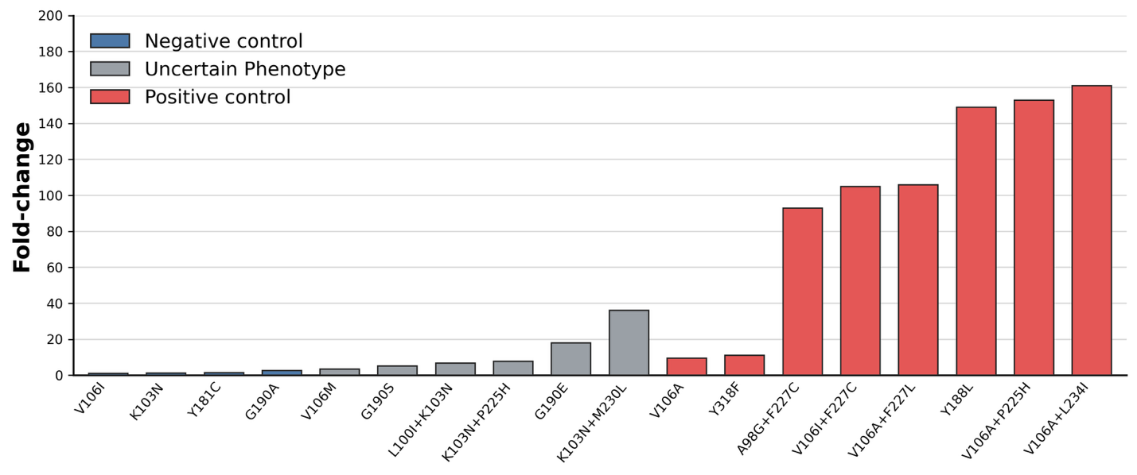
Figure 1: Fold-change in DOR susceptibility associated with selected genotypes. Values represent median fold reductions in susceptibility relative to wild-type control viruses.

Global RT-DOR energetic analysis fails to capture the DOR phenotypic susceptibility landscape
We first tested whether short MD simulations could recover the phenotypic DOR susceptibility landscape through global structure destabilization captured by a binding energy-like calculation. Starting with the published X-ray crystal structure of WT RT bound to DOR, we performed in silico mutagenesis followed by restrained and unrestrained energy minimization to generate a total of 18 mutant RT-DOR complex structures corresponding to the curated genotype panel described above (see Supplementary Table 2 for the sequences of the RT variants simulated in this study).

For each system, we performed three 100 ns all-atom explicit-solvent production simulations and computed MM/GBSA energies from uniformly sampled bound-state snapshots after discarding the first 25% of each trajectory. For each mutant genotype, we then calculated WT-referenced changes, ∆∆G, in total energy and in four energy components: van der Waals, electrostatics, generalized Born polar solvation, and nonpolar surface area.

Overall, we observed that total WT-referenced energetic shifts did not correlate with the available phenotypic fold-change data (Supplementary Table 3). Most energy components behaved similarly. The main exception was the electrostatic component, which showed a weak but statistically significant association with fold-change (Figure 2). This result suggested that a simple global destabilization model is insufficient to explain the DOR phenotype susceptibility landscape on the timescales sampled here, yet mutation-dependent changes in local electrostatic organization might contribute to DOR resistance.

Despite a generally inconclusive relationship observed between RT-DOR binding energy shifts with respect to WT and phenotypic susceptibility, there were certain connections with structural mechanisms that are of note. Specifically, we found that two of the negative control mutations K103N and Y181C showed significant total energy shift ~40kJ/mol vs WT, driven primarily by the GB polar solvation energy penalty.

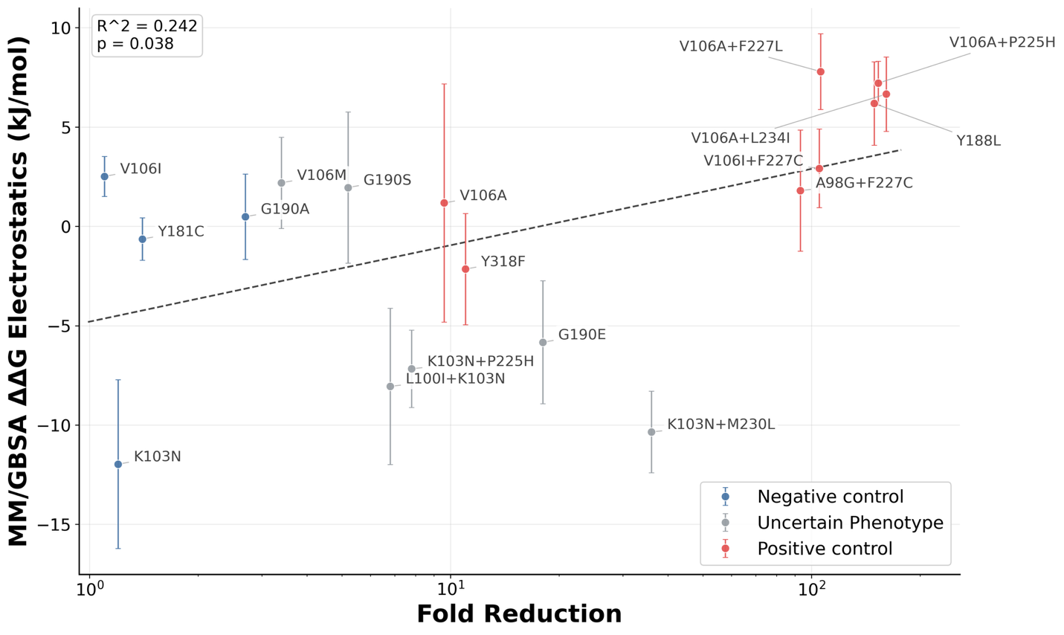
Figure 2: Changes in electrostatic component of the RT-DOR binding energy vs WT weakly correlates with phenotypic DOR susceptibility data. Data show the average electrostatic energy values over 100 frames sampled uniformly from 100ns all-atom MD simulations of each system, after discarding the first 25% of production runs to allow equilibration. Error bars represent the standard error of the mean over N = 3 replicates. Dashed trend line shows an ordinary least-squares linear regression between electrostatic MM/GBSA change and resistance fold-change on a log scale. R² is the coefficient of determination for this fit and the p-value tests whether the regression slope differs from zero using the standard two-tailed t-test.

Local trajectory-level analysis reveals WT RT-DOR contact occupancy profile
We next asked whether DOR resistance might instead be encoded in mutation-specific redistribution of local binding pocket interactions. This was plausible for two reasons. First, the NNIBP is small enough that short MD simulations could still resolve local contact rearrangements even when they do not recover full binding thermodynamics. Second, prior structural studies of NNRTI resistance indicate that altered pocket geometry, shifted anchoring interactions, and increased pose heterogeneity can all reduce susceptibility without producing a simple global affinity signal. We therefore shifted our focus to systematic local analyses of DOR-RT contacts within the NNIBP.
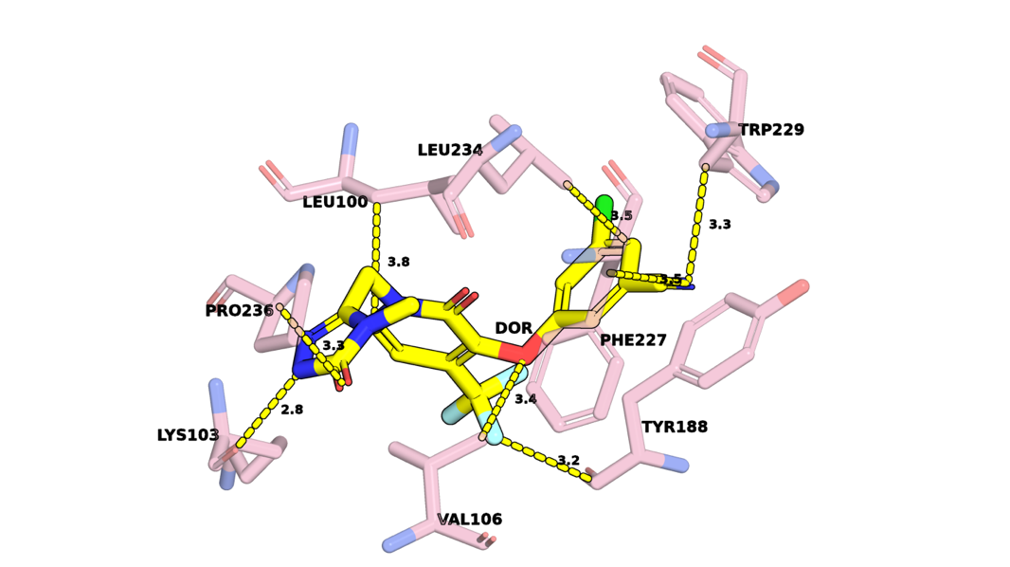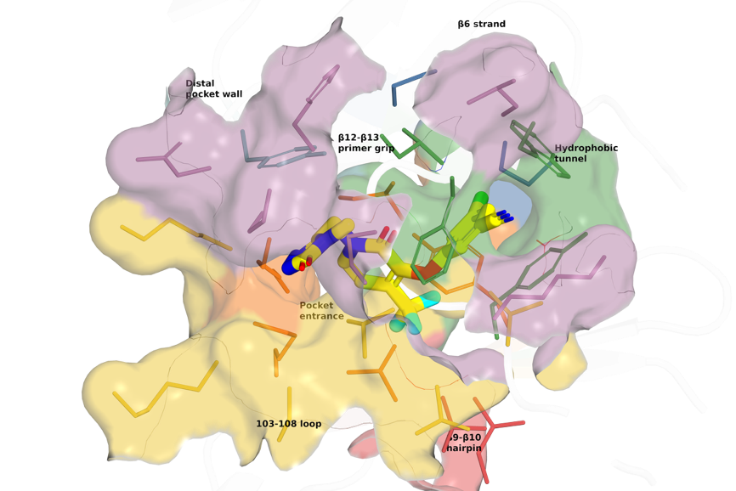
Figure 3: Crystal structure of DOR bound to WT RT (PDB ID: 4NCG). Left panel: Minimum heavy atom distances between DOR (yellow) and eight key NNIBP residues (pink). Right panel: Visualization of DOR within the NNIBP, segmented into seven regions: β6 strand (blue), Pocket entrance (orange), 103-108 loop (yellow), Hydrophobic tunnel (green), β9-β10 hairpin (red), β12-β13 primer grip (purple), Distal pocket wall (teal).

To discover local structural signatures of DOR resistance, we first quantified residue-level DOR contacts across WT RT-DOR simulations. A residue was classified as being in contact with DOR in a given frame if the minimum heavy-atom distance between that residue and DOR was less than 4.0 Å (Figure 3).
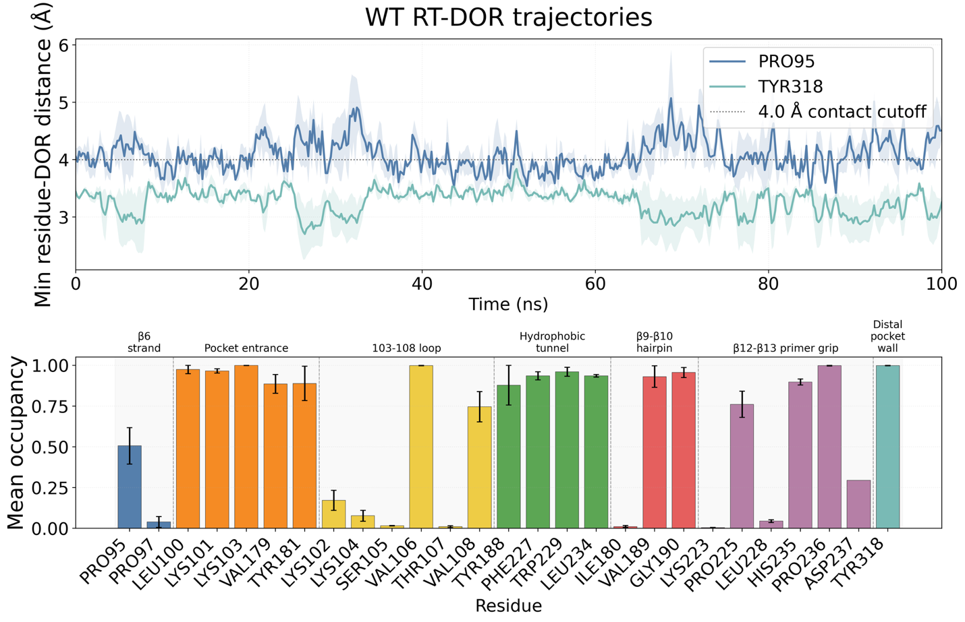 Figure 4: Local trajectory-level contact analysis between DOR and NNIBP residues in WT RT-DOR simulations. Top panel: Trajectories of minimum heavy atom distances between DOR and two exemplary NNIBP residues, Pro95 and Tyr318, observed in 100ns MD simulations of the WT DOR-RT complex performed in triplicates. Solid lines indicate the mean trajectory and lighter color bands show the standard error of the mean across N = 3 replicates in this as well as other trajectory visualizations in this study. The dotted line represents the 4.0 Å cutoff used to define each contact. Bottom panel: Mean occupancy computed for all RT residues that came in contact with DOR at any point during the simulations, segregated by NNIBP regions (cf. Figure 3).

Mean contact occupancy, or concisely Mean occupancy, was then defined as the fraction of analyzed frames in the simulation in which the contact criterion was satisfied. We computed this quantity for all residues that contacted DOR at any point in any WT RT-DOR simulation trajectory and found several observations in the resulting mean occupancy profile (Figure 4).

First, out of 27 residues that were at any point in contact with DOR, 18 of them had mean occupancy > 0.5, i.e. they were in contact with DOR for more than half the duration of the simulations. Second, some NNIBP regions, namely the pocket entrance (5 residues), the hydrophobic tunnel, (4 residues) and the distal pocket wall (1 residue), demonstrate consistently high mean occupancy (average mean occupancy > 0.9). Third, nearby residues can exhibit remarkably different mean occupancies (e.g. positions 100-109 and 179-181).

Contact occupancy profiles encode mutation-sensitive structural signals of DOR resistance
We then summarized the mean occupancy landscape across all trajectories in the genotype panel and used it to identify residues whose DOR-contact behavior changed preferentially in specific mutation backgrounds (Figure 5).
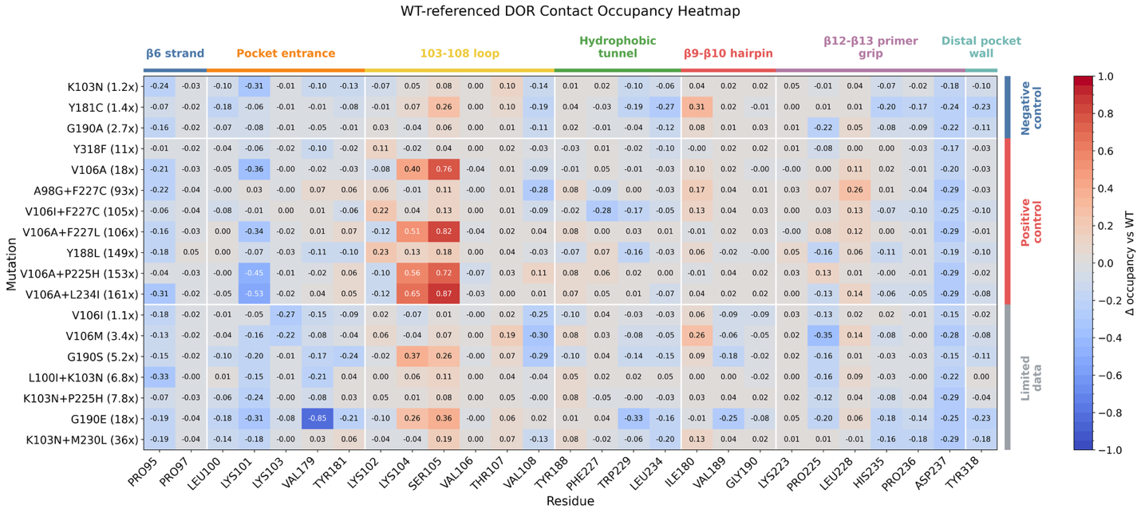 Figure 5: Mutation-associated changes in mean occupancy. X-axis lists all the 27 residues that were ever in contact with DOR in WT RT-DOR simulations. Y-axis lists the 18 DOR-associated genotypes including negative controls, positive controls, and the limited data set. Values inside each cell in the heatmap represent the change in mean occupancy vs WT for each residue as observed in MD simulations for each genotype.

This systematic screen yielded two broad insights. First, amino acid positions at which the mutation occurs are rarely displaced more than 10% in terms of contact occupancy vs WT, except for V106I+F227C that leads to ∆occupancy = -0.28 vs WT for Phe227 and for K103N+P225H that leads to ∆occupancy = -0.12 vs WT for Pro225. Conversely, most dramatic mutation-associated occupancy changes occur in unmutated residues, e.g. G190E leads to ∆occupancy = -0.85 vs WT at Val179 and V106A+L234I is associated with ∆occupancy = +0.87 vs WT for Ser105.

Second, comparing patterns of mutation-associated occupancy changes in positive vs negative control mutations provides rationale for interpreting the phenotypic susceptibility landscape in terms of specific reporter coordinates. For example, Y188L (a canonical DOR DRM) is associated with ∆occupancy = +0.23 vs WT for Lys102 and ∆occupancy = -0.16 vs WT for Pro225, while Y181C (a negative control mutation) is only associated with ∆occupancy = ∓0.01 vs WT for Lys102 and Pro225 respectively. Thus, DOR distance to Lys102 and Pro225 may be useful reporters of resistance associated structural shifts in the DOR-RT complex.

Y188L disrupts the Tyr188 aromatic wall and remodels the pocket near Pro225
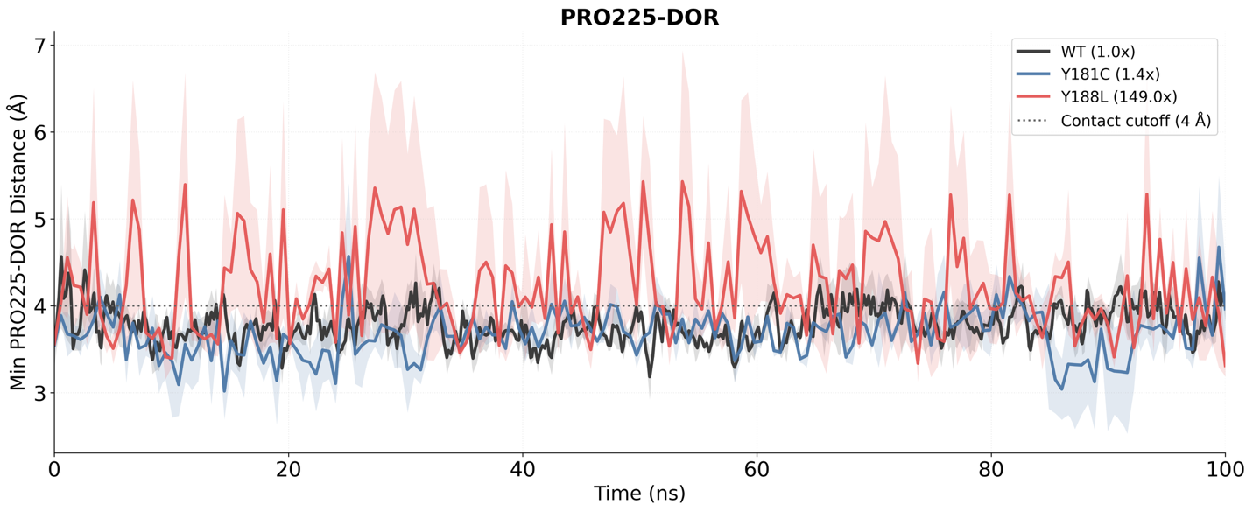 WT Y181C Y188L
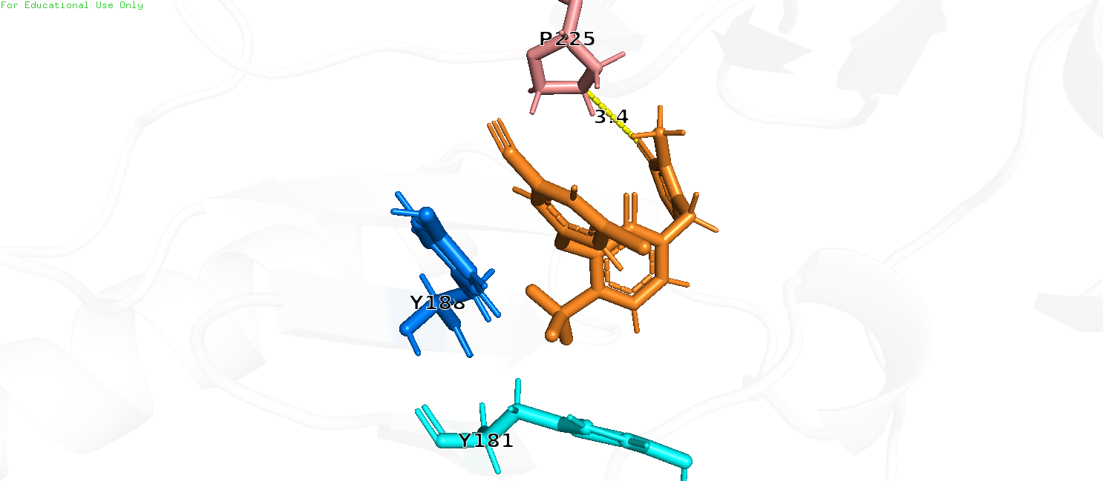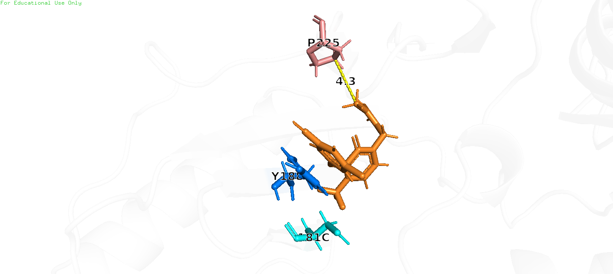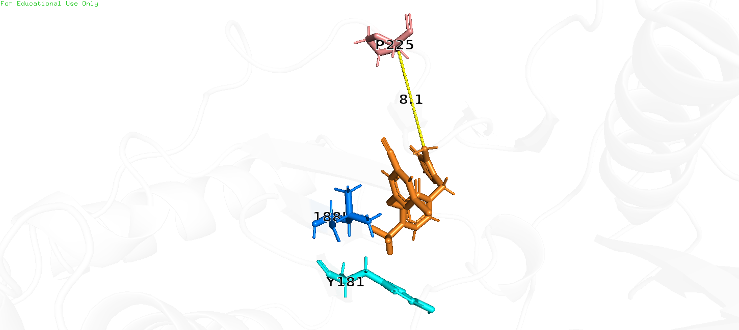
Figure 6: Y188L preferentially alters binding pocket geometry, causing Pro225 to shift away from DOR. (Top) Minimum distance between heavy atoms of Pro225 and DOR observed in MD simulations of WT, Y181C, and Y188L. (Bottom) Snapshots of a single frame across WT, Y181C, and Y188L trajectories, showing Pro225 almost twice the distance away from DOR in case of Y188L as compared to WT and Y181C.

Y188L is one of the clearest single-mutation DOR resistance genotypes in the literature, whereas Y181C is a classical NNRTI mutation that usually has little effect on DOR susceptibility. We therefore compared WT, Y181C, and Y188L to determine whether the local trajectory features of these two tyrosine-site mutations differ in a way that matches their distinct phenotypes.

In the WT DOR-bound structure, the chlorophenol ring of DOR packs against Tyr188 within the aromatic wall of the NNIBP. Loss of this aromatic surface in Y188L was expected to weaken local packing directly, but the residue-level contact screen suggested a second structural effect: a preferential shift in the DOR-Pro225 relationship. Pro225 is not mutated in this genotype; rather, it serves here as a reporter of local pocket remodeling propagated from the Tyr188 side of the pocket.

The Y188L simulations indeed differed from both WT and Y181C in this respect (Figure 6). Relative to WT and Y181C, Y188L showed increased Tyr188-DOR separation together with more frequent excursions of Pro225 away from DOR. By contrast, Y181C retained a largely WT-like local geometry. This distinction is consistent with the known DOR binding mode, in which Tyr188 contributes directly to packing while Tyr181 is positioned closer to the rim of the pocket and is less central to the DOR interaction network.

Taken together, these results support a two-part interpretation of Y188L resistance: direct loss of aromatic packing on the Tyr188 side of the pocket, coupled with local remodeling near Pro225 that may broaden the set of accessible DOR poses and weaken pocket confinement.

V106A-containing genotypes shift DOR toward the 103-108 loop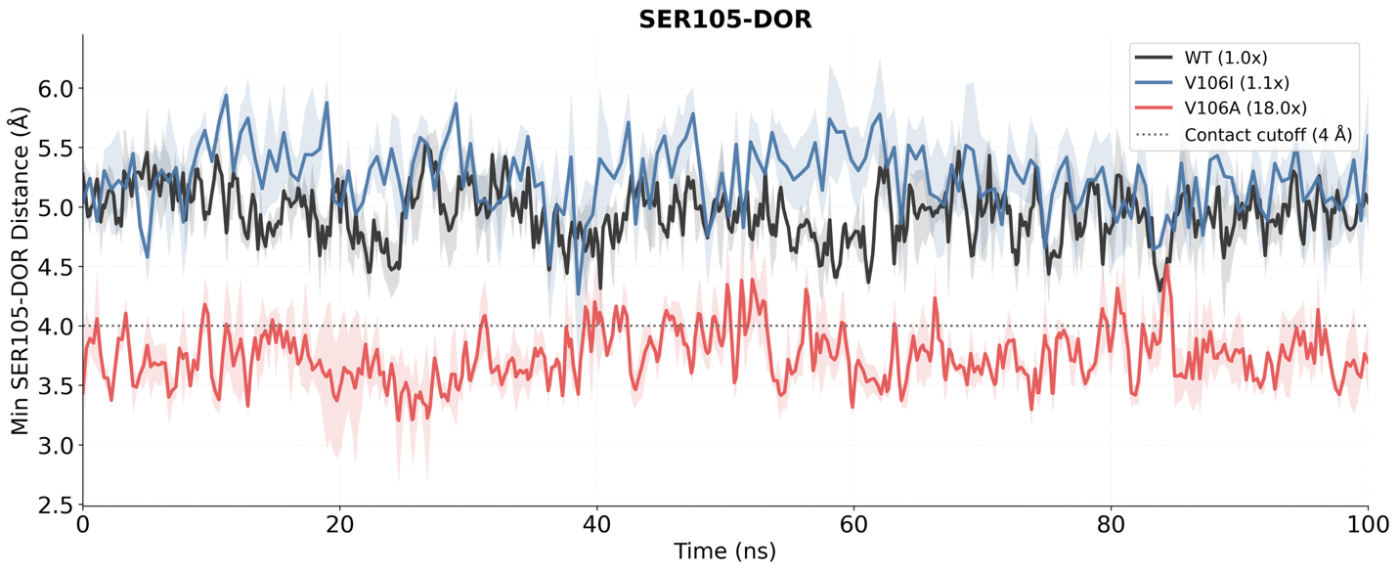 WT V106I V106A
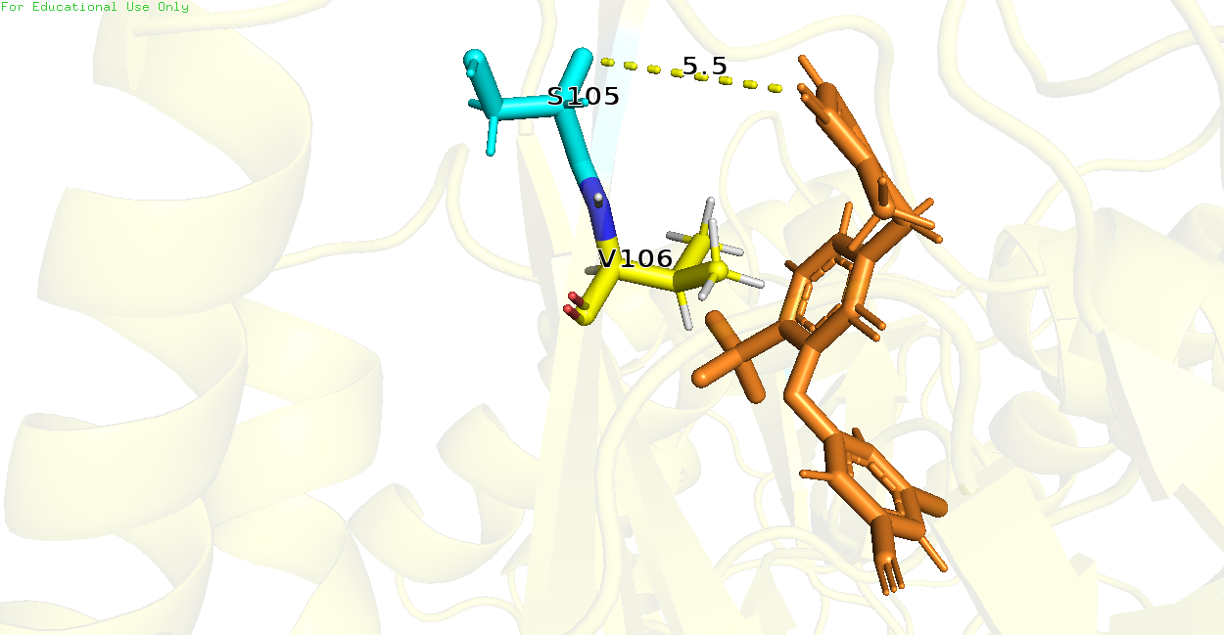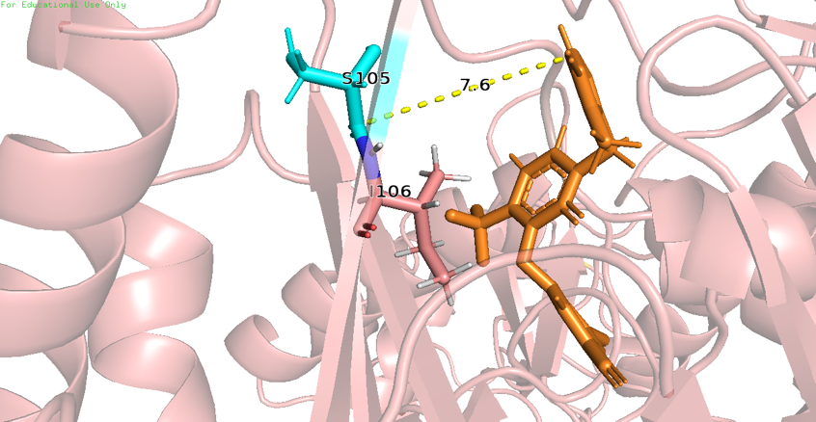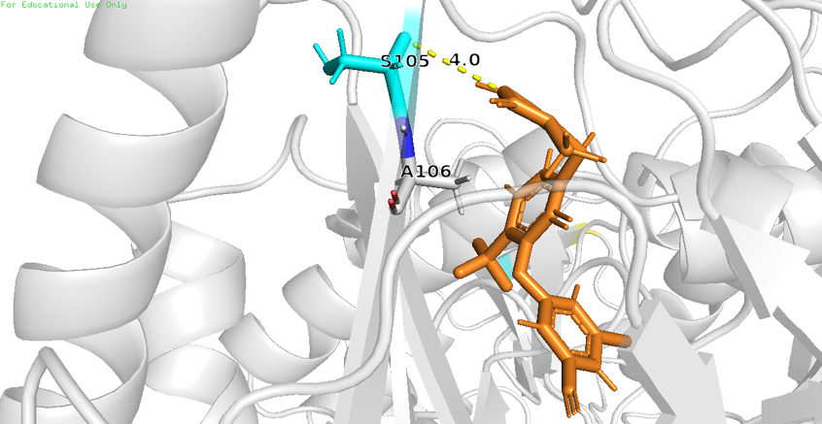
Figure 7: V106A preferentially alters DOR pose, causing Ser105 to shift closer to DOR. (Top) Minimum distance between heavy atoms of Ser105 and DOR observed in MD simulations of WT, V106I, and V106A. (Bottom) Snapshots of a single frame across WT, V106I, and V106A trajectories, showing Ser105 shifted closer to DOR in case of V106A as compared to WT and V106I.

The V106 region is a major determinant of DOR susceptibility because V106 directly contacts the central pyridone core of DOR. However, the literature and our own genotype panel indicate that not all V106 mutations behave equivalently. V106I, a polymorphic substitution observed to some extent in the general population, generally has little effect on DOR susceptibility when present alone, whereas V106A is a canonical DOR resistance mutation and serves as the first step in several high-resistance combination pathways.

The systematic contact analysis highlighted Lys104 and Ser105 as informative reporter residues for this distinction. Both residues sit near the pocket entrance within the 103-108 loop region, and both showed preferential shifts in DOR proximity in V106A-containing trajectories. In direct comparisons among WT, V106I, and V106A, the V106A simulations showed a reproducible shift of DOR toward the 103-108 loop, bringing DOR closer to Ser105 and often also to Lys104 (Figure 7).

The most plausible interpretation is that replacement of valine with alanine removes hydrophobic bulk from a direct DOR-contact site and allows the bound ligand to redistribute toward a slightly more 103-108 loop-shifted local pose ensemble. In that ensemble, contacts with Lys104 and Ser105 can arise as compensatory interactions, but these appear to be secondary to the loss of optimal packing at position 106. The contrast with V106I is informative: isoleucine preserves a branched hydrophobic side chain at position 106, which mitigates local geometry perturbation.

This model also helps explain why V106A becomes especially problematic in combination with secondary hydrophobic tunnel or primer grip mutations. If V106A first redistributes the DOR pose toward the 103-108 loop, then additional substitutions around P225, F227, or L234 can further destabilize an already altered local contact network.

V106I+F227C reaches high resistance through a different local route than V106A+F227L
V106I+F227C and V106A+F227L are both highly resistant DOR-associated genotypes, yet the pathway-specific logic above predicts that they should not be structurally identical. V106A+F227L belongs to the V106A family and therefore might be expected to retain the 103-108 loop-shifted signature. V106I+F227C, by contrast, combines a relatively low-impact V106 substitution with a hydrophobic tunnel substitution at position 227.

In line with this expectation, V106A+F227L showed the same local shift toward Ser105 and Lys104 seen in other V106A-containing backgrounds. V106I+F227C did not show that same 103-108 loop-focused pattern. Instead, it sampled alternative local conformations involving the residue 227 region, with DOR becoming transiently more separated from position 227 than in WT or V106A+F227L (Figure 8).

The importance of this comparison is conceptual as well as mechanistic. These two genotypes have nearly identical median DOR fold-change values in the available phenotype data, yet the simulations suggest that they arrive at that shared phenotype through different structural routes. Similar resistance magnitude therefore need not imply a shared mechanism. For DOR resistance interpretation, this means that structurally distinct genotype classes may converge on a similar susceptibility outcome through different local reorganizations of the same pocket.
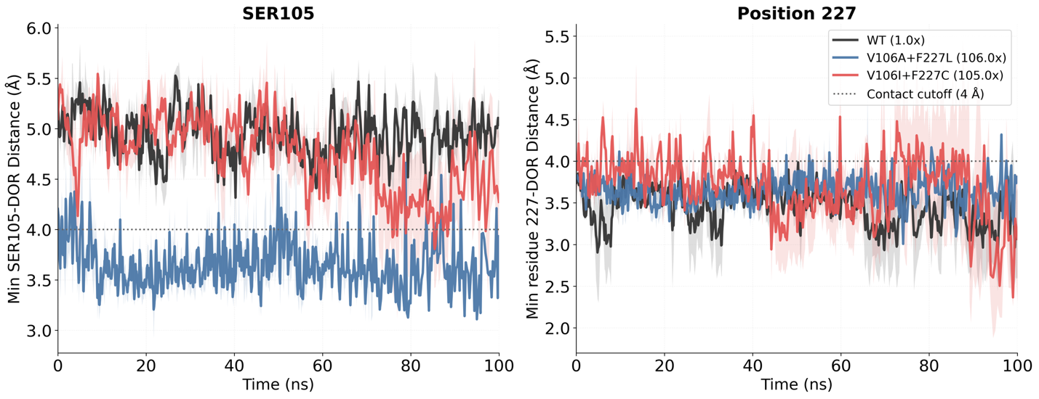 WT V106A+F227L V106I+F227C
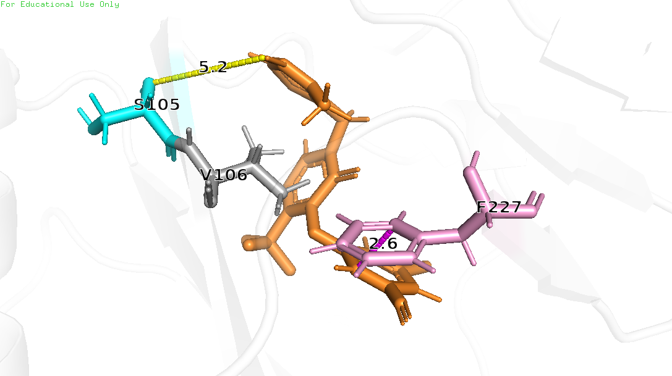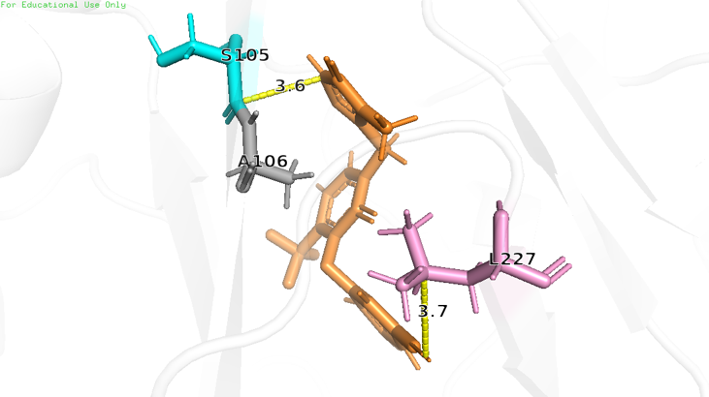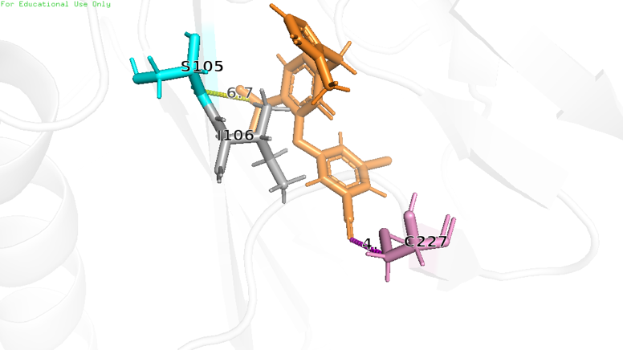
Figure 8: V106I+F227C exhibits alternative dynamics than V106A+F227L. (Top) Minimum distances between heavy atoms of Ser105 and DOR as well as Position 227 and DOR observed in MD simulations of WT, V106A+F227L, and V106I+F227C. (Bottom) Snapshots of a single frame across WT, V106A+F227L, and V106I+F227C trajectories, showing Ser105 shifted closer to DOR in case of V106A+F227L (but not in case of V106I+F227C or WT); and an alternate DOR pose in case of V106I+F227C that is further away from residue 227 than in WT or V106A+F227L.

G190E perturbs the pocket entrance and weakens Val179 contact
Publicly available phenotype data suggest that G190E may reduce DOR susceptibility. We therefore compared WT, G190A, and G190E to ask whether introduction of a negatively charged glutamate at position 190 produces local structural effects distinct from the more common G190A substitution that is known to have little to no impact on DOR susceptibility.

The panel-wide contact analysis identified Val179 as the clearest reporter residue for this comparison (Figure 5). Val179 lines the pocket entrance and showed strong genotype-specific contact loss in G190E. In direct trajectory comparisons, G190E caused marked separation of Val179 from DOR that was not observed in WT or G190A (Figure 9). This effect was accompanied by broader local perturbation of the pocket environment.

The simplest interpretation is that the G190E side chain introduces a local electrostatic and steric perturbation in the β9-β10 hairpin that propagates into the Val179 side of the pocket, thereby weakening DOR packing on that face of the binding site. G190A, which lacks this charge switch and imposes a much smaller structural perturbation, did not produce the same effect. These results therefore support G190E as a plausible DOR-relevant genotype deserving further targeted phenotypic study.
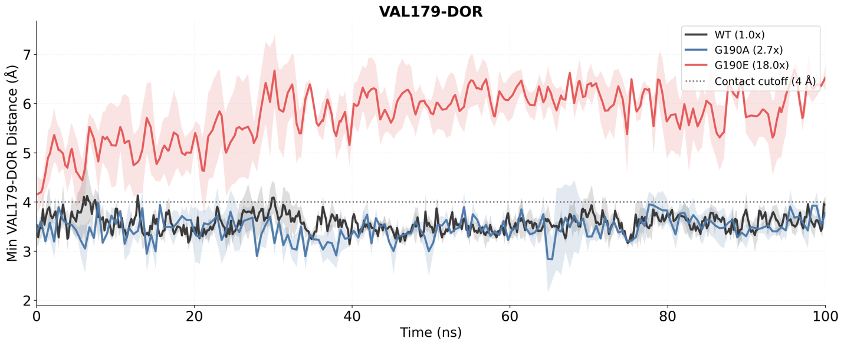
WT G190A G190E
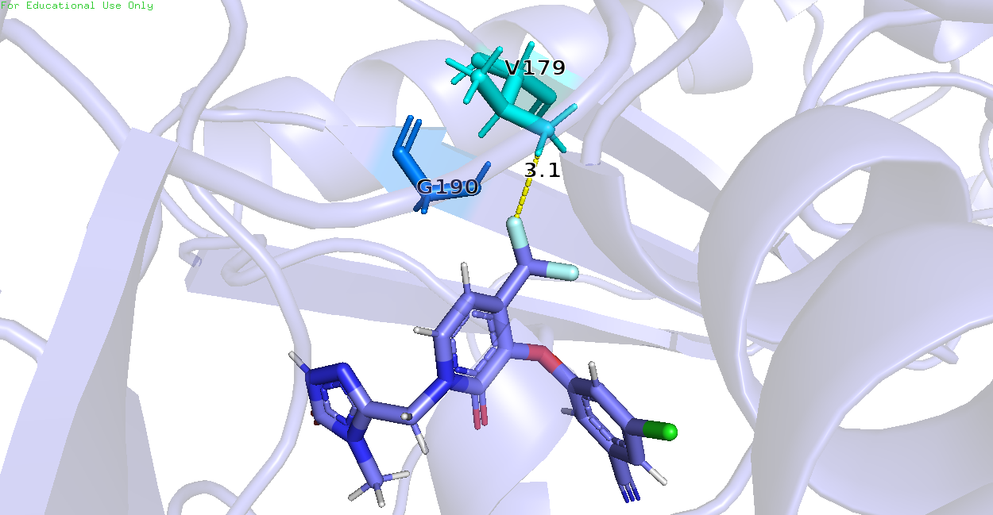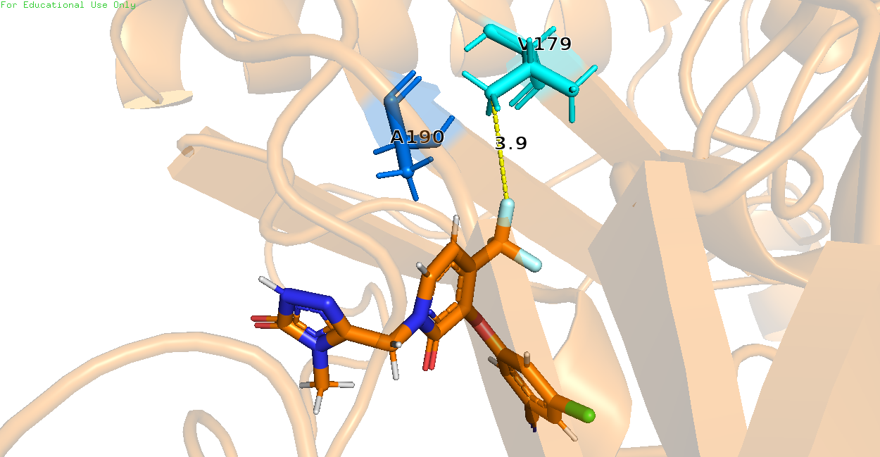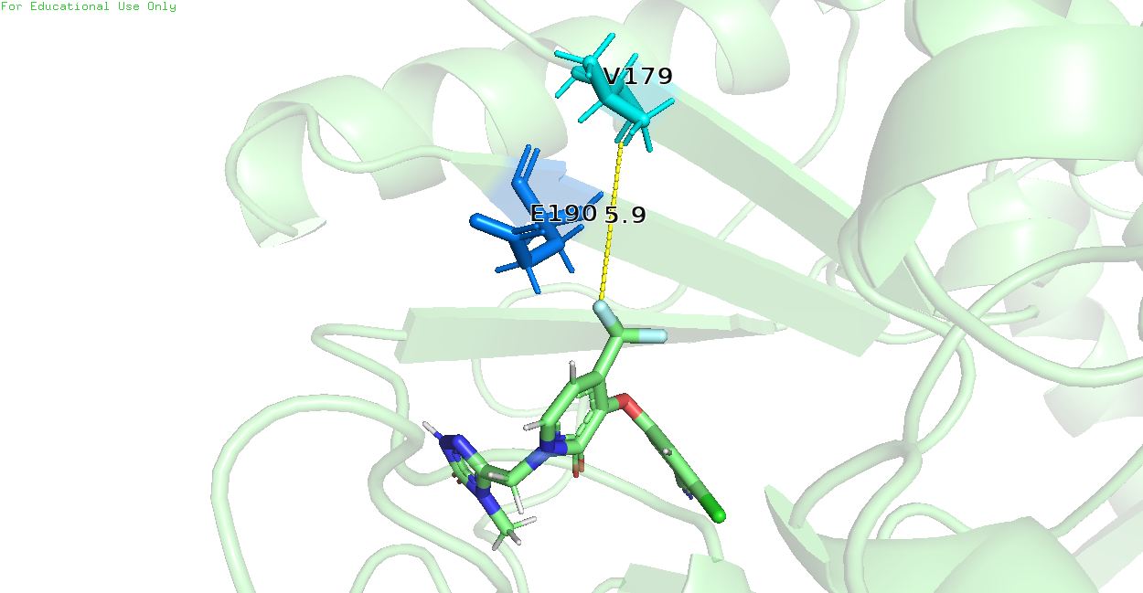
Figure 9: G190E preferentially disrupts β9-β10 hairpin, causing Val179 to lose contact with DOR. (Top) Minimum distance between heavy atoms of Val179 and DOR observed in MD simulations of WT, G190A, and G190E. (Bottom) Snapshots of a single frame across WT, G190A, and G190E trajectories, showing Val179 further away from DOR in case of G190E but not in WT and G190A.

A parsimonious 3-feature logistic regression model summarizes the separation between low- and high-resistance controls
After identifying local structural signatures across the genotype panel, we asked whether a small set of MD-derived features could summarize the distinction between low- and high-resistance genotypes. We therefore trained an L1-regularized logistic regression model using only the negative and positive control genotypes (Figure 10).

Feature selection converged on a parsimonious three-feature model comprising the Ser105-DOR distance, the Tyr188-DOR distance, and ligand pose RMSD. The selected features capture, respectively, the 103-108 loop-shift signature of V106A-containing genotypes, the Tyr188-side perturbation characteristic of Y188L-related effects, and the broader redistribution of ligand pose within the pocket. The equation of the logistic regression model in the raw feature form may be written numerically as:

$${}_{low}=53.53748 + 3.01631*SER105 - 12.94269*TYR188 - 18.20537*RMSD$$
$$P_{high}=1-\frac{1}{1+e^{-{}_{low}}}$$

A)
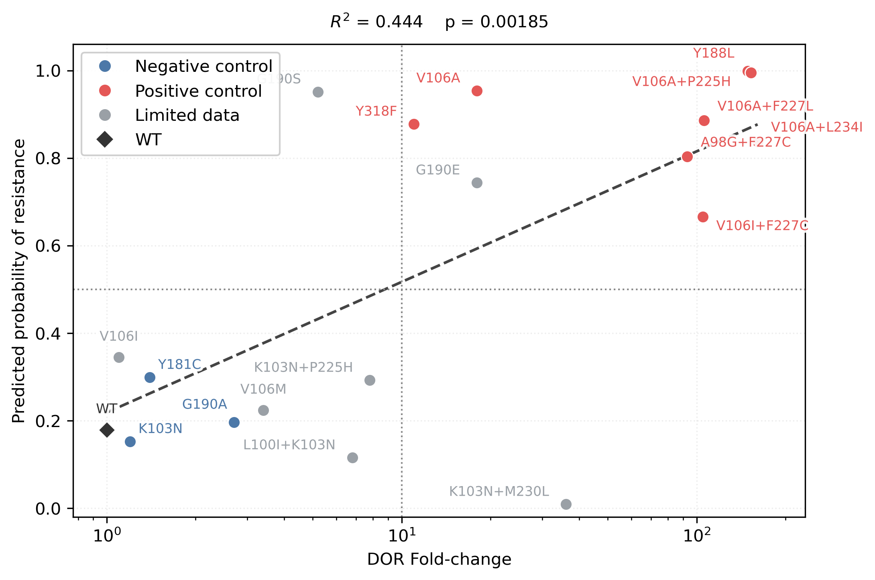
B) C)
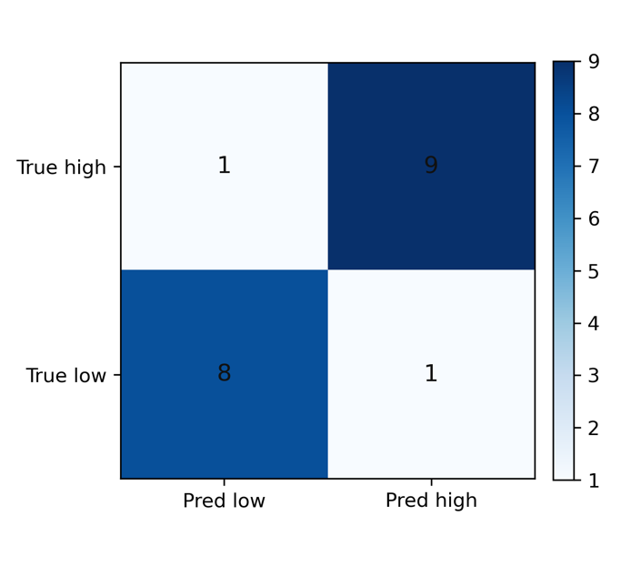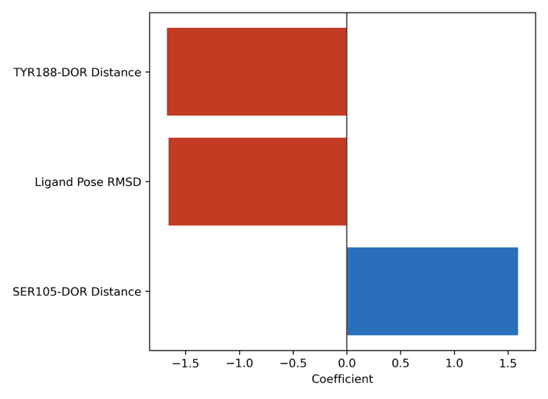
Figure 10: Performance of Logistic Regression model to predict DOR susceptibility from MD simulation features. (A) Output of the logistic regression model, P_{high}, i.e. the probability of a mutation being labeled as high resistance, plotted against median DOR fold-change in susceptibility on the log scale. The dotted lines represent the thresholds for the labels: Genotypes were labeled as high resistance if their median DOR fold-change exceeded 10 and low resistance otherwise. We used a decision threshold of P_{high} = 0.5 for class assignment. The dashed trend line is a linear regression fit of the data. R² is the coefficient of determination for this fit and the p-value test the null hypothesis that the true linear correlation between the two variables is zero. (B) Confusion matrix showing predicted labels compared with true labels across train and test set. (C) Trained model coefficients for the standardized features showing roughly equal contribution of all 3 features to the model’s output.

When fit on the control set, the model separated low- and high-resistance controls with good within-panel performance, and the resulting resistance probabilities correlated with the available fold-change data. This is the main value of the model: it compresses the dominant structural signals identified above into a compact, interpretable summary of resistance-associated risk across the panel.

Furthermore, WT, which was not used as a training control, was assigned a low resistance probability when evaluated as an unseen reference case. In the limited-data set, the model assigned high resistance probability to G190E and low resistance probability to V106I, V106M, L100I+K103N, and K103N+P225H, while remaining discordant for some genotypes such as G190S and K103N+M230L.

Note that this model is trained on a small, hand-selected control panel and is not a validated susceptibility predictor. Its value lies in interpretability rather than in standalone predictive performance. Nonetheless, the fact that only three structural features can summarize much of the control-genotype separation supports the broader conclusion that short MD simulations capture mechanistically interpretable signals that could be informative for comparisons with phenotypic data.

Discussion
DOR poses an unusual resistance problem among second-generation NNRTIs. Like ETR and RPV, DOR retains activity against common NNRTI-associated backgrounds such as K103N, Y181C, and G190A, yet the pathways that reduce DOR susceptibility are distinct and increasingly relevant in clinical use. Specific substitutions such as Y188L, V106A, and Y318F, and combinations including V106I+F227C, V106A+F227L, and V106A+L234I, now recur across phenotypic studies, in vitro selection experiments, and clinical trial datasets. Despite these observations, publicly available isolate-level susceptibility data for DOR remain sparse. As of April 2026, Stanford HIVDB indexes only 134 DOR-associated isolates tested by PhenoSense, compared with 330 for RPV and 1,193 for ETR. This mismatch between growing clinical relevance and limited public phenotype data for DOR resistance motivated the present study. We therefore asked whether short explicit-solvent MD simulations could provide a coherent structural framework for understanding known and limited-data DOR resistance genotypes.

We observed that total WT-referenced energetic shifts derived from bound-state MD snapshots did not correlate well with the available phenotypic DOR landscape. There may be several reasons for this observation. First, the computed MM/GBSA energy values fundamentally do not represent equilibrium binding free energies because the simulations do not sample the full bound and unbound state populations needed for a true free energy estimate. Second, though the simulations are performed in explicit solvent, the MM/GBSA calculations omit explicit solvent contributions that could have contributed to errors in the entropic components. Third, the simulations reveal dynamics on a timescale that is much shorter than the conformational rearrangements and kinetic processes governing RT-DOR binding in vitro. We therefore recommend viewing the energetic analysis as a directional binding energy score rather than as a precise estimate for RT-DOR binding affinity.

Most of the energetic components behaved similarly. However, significant loss of RT-DOR interaction, such as loss of the aromatic pi-stacking interaction between the DOR chlorophenol ring and the RT Tyr188 sidechain in Y188L simulations led to a cumulative energetic penalty of ~40kJ/mol vs WT, mainly driven by the van der Waals and polar solvation energy components. Furthermore, the weak but statistically significant association observed for the electrostatic component suggested that local electrostatic reorganization in the NNIBP may be more informative.

Consequently, systematic residue-level contact analysis revealed that different DOR-associated genotypes preferentially perturb different local regions of the pocket. Y188L destabilized the Tyr188 aromatic wall and was associated with remodeling near Pro225. V106A-containing genotypes redistributed DOR toward the 103-108 loop and favored compensatory proximity to Lys104 and Ser105. V106I+F227C achieved similarly high resistance through a different local route centered more strongly on the residue 227 region. G190E uniquely perturbed the β9-β10 hairpin and weakened the Val179 side of the pocket. These observations support a model in which DOR resistance emerges through multiple mechanistic classes rather than through a single generic reduction in binding strength.

This mechanistic diversity is especially important for interpreting epistasis. The V106A-containing double mutants retained the same local signature already seen in V106A alone, consistent with the idea that V106A acts as a priming mutation that redistributes the DOR pose, after which upper-pocket substitutions exacerbate the resulting vulnerability. By contrast, V106I+F227C shows that a high-resistance phenotype can also emerge without that same structural route. Similar fold-change values can therefore conceal distinct local mechanisms.

The logistic regression analysis supports this interpretation. The fact that a three-feature model built from Ser105-DOR distance, Tyr188-DOR distance, and ligand pose RMSD could summarize the low-versus-high resistance control separation suggests that the dominant structural signals in this system are both local and low-dimensional. At the same time, the mixed performance in the limited-data set emphasizes that such a model is currently best understood as an interpretable structural summary rather than as a deployable prediction tool.

Several limitations should frame the interpretation of this work. First, the simulations were short relative to the conformational and kinetic timescales relevant to RT-DOR binding, so there are likely mechanistically important events that remain unsampled. Second, the limited-data classifier is constrained by small sample size and by the difficulty of drawing hard class boundaries in a sparse phenotype landscape.

Despite these limitations, we think the central contribution of this study is clear. Short explicit-solvent MD simulations do not replace phenotypic susceptibility experiments, but they do provide a practical and mechanistically interpretable framework for understanding how pre-existing NNRTI mutations might alter DOR binding in RT. That framework is useful in two ways. First, it can help estimate the risk associated with DOR use in people living with HIV whose viruses harbor pre-existing NNRTI mutations but lack extensive direct DOR phenotype data. Second, it identifies concrete structural features that medicinal chemists can target when designing future NNRTIs with improved resilience against Tyr188-side, V106-side, upper-pocket, or β9-β10 hairpin-mediated resistance pathways.

