Probing Doravirine Resistance Mechanisms in HIV-1 Reverse Transcriptase Using Molecular Dynamics Simulations

Abstract
Doravirine (DOR) is a next-generation Non-Nucleotide Reverse Transcriptase Inhibitor (NNRTI) with durable clinical activity and a unique resistance profile, but publicly available phenotypic susceptibility data for DOR-associated resistance mutations remains limited. Here, we performed all-atom explicit-solvent molecular dynamics (MD) simulations of DOR-bound wild-type (WT) HIV-1 reverse transcriptase (RT) and 18 mutant genotypes in an attempt to fill this gap. We observed that the relative RT-DOR binding energy or its individual components, computed from these simulations, generally do not correlate with the available phenotypic DOR susceptibility changes in vitro. However, local trajectory-level analyses identified mutation-specific structural changes associated with DOR resistance. For example, simulations with V106A-containing genotypes consistently shift DOR toward the 103-108 loop, leading to compensatory interactions with Lys104 and Ser105; V106I+F227C simulations sample distinct DOR poses from V106A+F227L despite mutations at the same positions and similar phenotypic resistance; and G190E perturbs the pocket entrance, disrupting DOR contact with Val179. A custom logistic regression model trained on select MD-derived structural features is able to segregate low- and high-resistance genotypes, producing probabilities that correlate well with the available in vitro DOR susceptibility data. Together, these results support a structurally grounded framework for interpreting DOR resistance, estimating the risk of DOR use in people living with HIV who carry pre-existing NNRTI mutations, and possibly informing the design of future NNRTIs.

Introduction
Work in Progress

Results

DOR Phenotypic susceptibility landscape
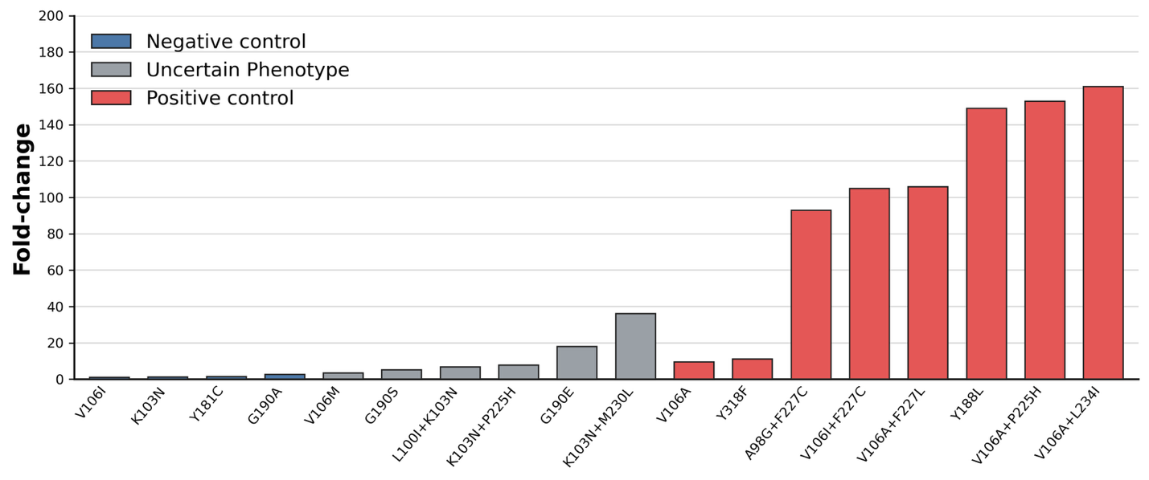
Figure 1: Fold-change in DOR susceptibility associated with selected genotypes. Values represent median fold reductions in susceptibility relative to wild-type control viruses.

We assembled a panel of 18 DOR-associated genotypes for simulation together with WT RT. These genotypes were selected to cover three distinct categories:
- Negative controls: well-established low-impact control mutations associated with little, if any, reduction in DOR susceptibility. These include K103N, V106I, Y181C, and G190A.
- Positive controls: canonical DOR-associated resistance mutations and mutation patterns, consistently associated with reduced susceptibility. These were chosen to be V106A, Y188L, Y318F, A98G+F227C, V106A+F227L, V106A+L234I, V106A+P225H, and V106I+F227C.
- Uncertain phenotype: mutations and mutation patterns associated with limited or inconsistent reductions in susceptibility. These were K103N+L100I, K103N+P225H, K103N+M230L, V106I, V106M, G190E, and G190S.

Figure 1 summarizes the median fold-change in DOR susceptibility used to define the panel, and Supplementary Table 1 traces each data point to its original published sources. The susceptibility data were derived from assays performed using the Monogram PhenoSense assay and the relatively similar Merck reporter-gene assay. Isolates undergoing testing were either site-directed mutants or clinical isolates for which known NNRTI-resistance mutations were specified.

Global RT-DOR energetic analysis fails to capture the DOR phenotypic susceptibility landscape
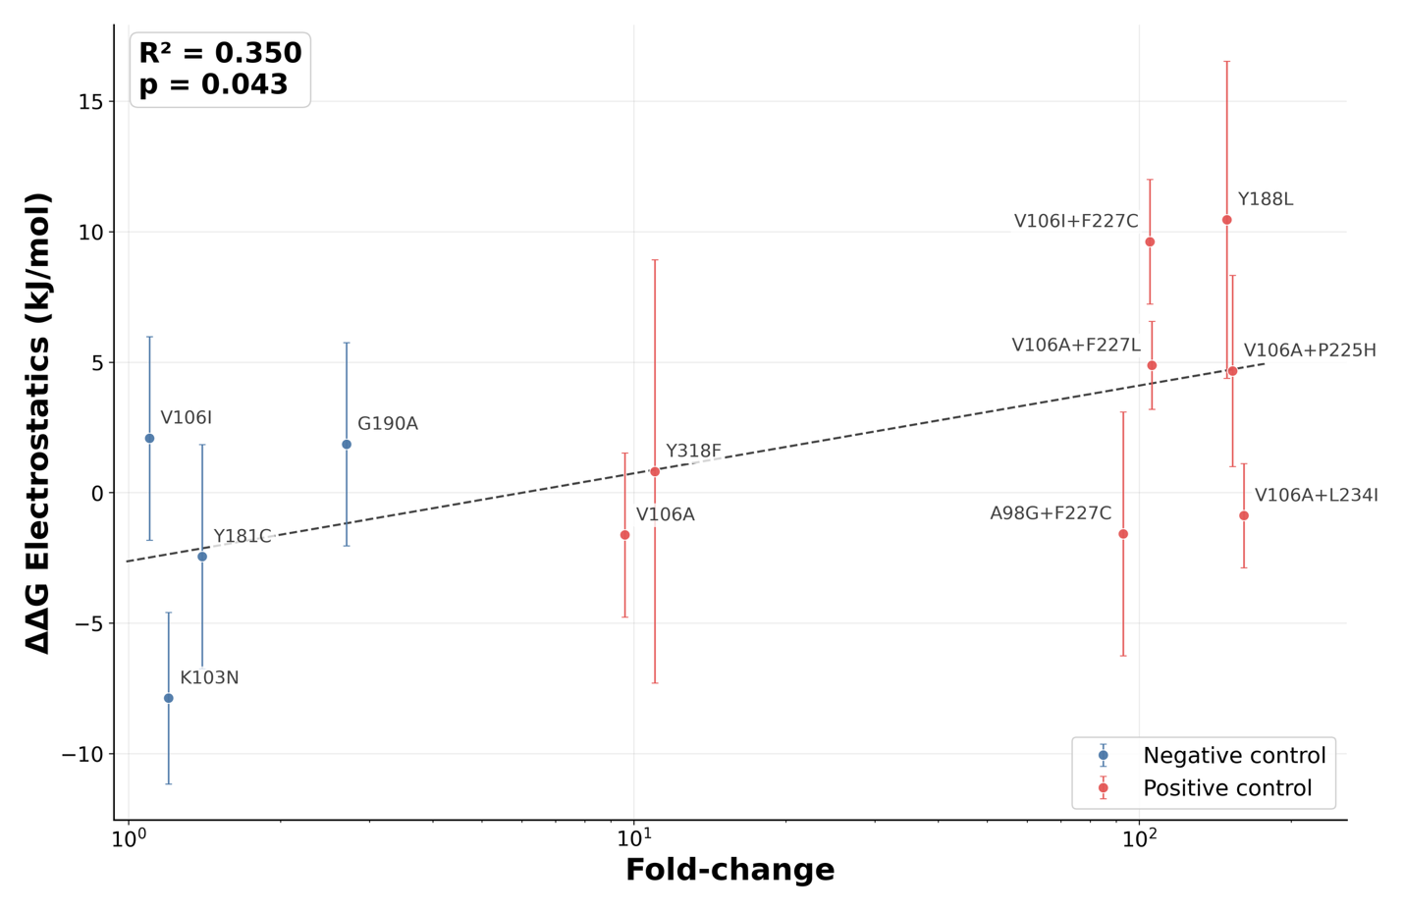
Figure 2: Changes in electrostatic component of the RT-DOR binding energy vs WT weakly correlates with phenotypic DOR susceptibility data of the control mutations. Data correspond to the average MM/GBSA electrostatic components over the last 20 frames (~10ns) sampled from 100ns all-atom MD simulations of each system. Error bars represent the standard error of the mean over N = 3 replicates. Dashed trend line shows an ordinary least-squares linear regression between electrostatic energy shift and resistance fold-change on a log scale. R² is the coefficient of determination for this fit and the p-value tests whether the regression slope differs from zero using the standard two-tailed t-test.

We first asked whether short MD simulations could recapitulate the phenotypic DOR susceptibility landscape using a global destabilization metric derived from binding energy-like calculations. Starting from the published X-ray crystal structure of WT RT bound to DOR, we introduced each resistance-associated genotype in silico and applied restrained followed by unrestrained energy minimization to generate 18 mutant RT-DOR complex structures corresponding to the curated genotype panel described above. The RT variant sequences simulated in this study are provided in Supplementary Table 2. For each system, we ran three independent 100 ns all-atom, explicit-solvent production simulations and calculated the average MM/GBSA energy over the final 20 frames of each trajectory, corresponding to approximately the final 10 ns. For each mutant genotype, we then computed WT-referenced energetic changes, ΔΔG, for the total MM/GBSA energy and for four individual energy components: van der Waals, electrostatic, generalized Born polar solvation, and nonpolar surface area contributions.

Overall, neither the total WT-referenced energetic shifts nor most individual energy components correlated with the available phenotypic fold-change data (Supplementary Table 3). The main exception was the electrostatic component, which showed a weak but statistically significant correlation with fold-change values among the negative and positive control mutations (Figure 2). From the perspective of WT-referenced electrostatic shifts, all negative control mutations showed little to no destabilization, with K103N appearing slightly more stable than WT (∆∆G_{elec} ~ -7.9 kJ/mol). In contrast, four of the eight positive control mutations—V106I+F227C, V106A+F227L, Y188L, and V106A+P225H—had positive ∆∆G_{elec} values within error, consistent with reduced electrostatic stability relative to WT. Among the six mutations with uncertain phenotype, G190S and G190E were also electrostatically less stable than WT, whereas K103N+L100I and K103N+M230L were more stable than WT.

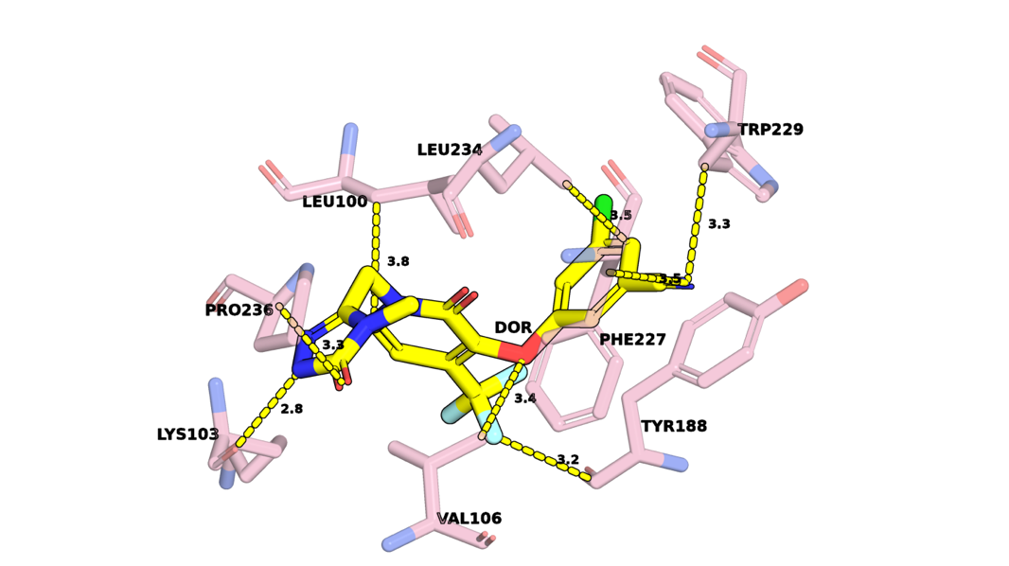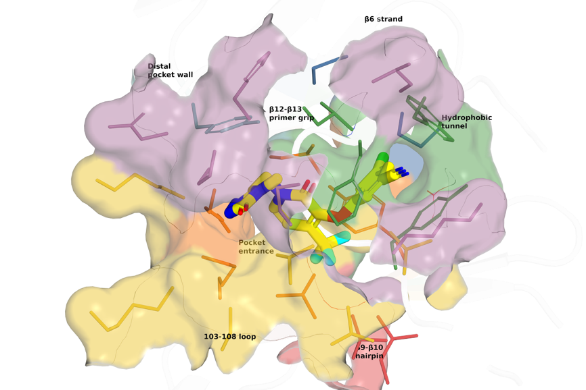
Figure 3: Crystal structure of DOR bound to WT RT (PDB ID: 4NCG). Left panel: Minimum heavy atom distances between DOR (yellow) and eight key NNIBP residues (pink). Right panel: Visualization of DOR within the NNIBP, segmented into seven regions: β6 strand (blue), Pocket entrance (orange), 103-108 loop (yellow), Hydrophobic tunnel (green), β9-β10 hairpin (red), β12-β13 primer grip (purple), Distal pocket wall (teal).
Although these global energetic metrics did not fully explain the DOR susceptibility landscape, several mutation-specific patterns suggested possible links to local structural mechanisms of resistance. For example, Y188L showed large trajectory-to-trajectory variation in the van der Waals component, with a (∆∆G_{vdW} standard deviation of approximately 231 kJ/mol. Visual inspection indicated that this variation arose from alternate conformations of Leu188, which produced distinct DOR packing arrangements across simulations, some resembling WT and others deviating substantially from it. Similarly, V106A+F227L and V106I+F227C showed qualitatively different van der Waals shifts relative to WT, with ∆∆G_{vdW} values of −75.7 kJ/mol and +154.5 kJ/mol, respectively. Thus, mutations affecting the same positions and producing similar phenotypic resistance profiles may nevertheless perturb the RT-DOR complex through distinct local structural mechanisms.
Together, these results suggest that a simple global destabilization model is insufficient to explain the DOR susceptibility landscape over the simulation timescales sampled here. However, the weak electrostatic association with phenotype, together with mutation-specific van der Waals signatures and heterogeneous local packing behavior, raised the possibility that DOR resistance is better captured by localized structural rearrangements than by aggregate binding energy shifts alone.
Local trajectory-level analysis reveals WT RT-DOR contact occupancy profile
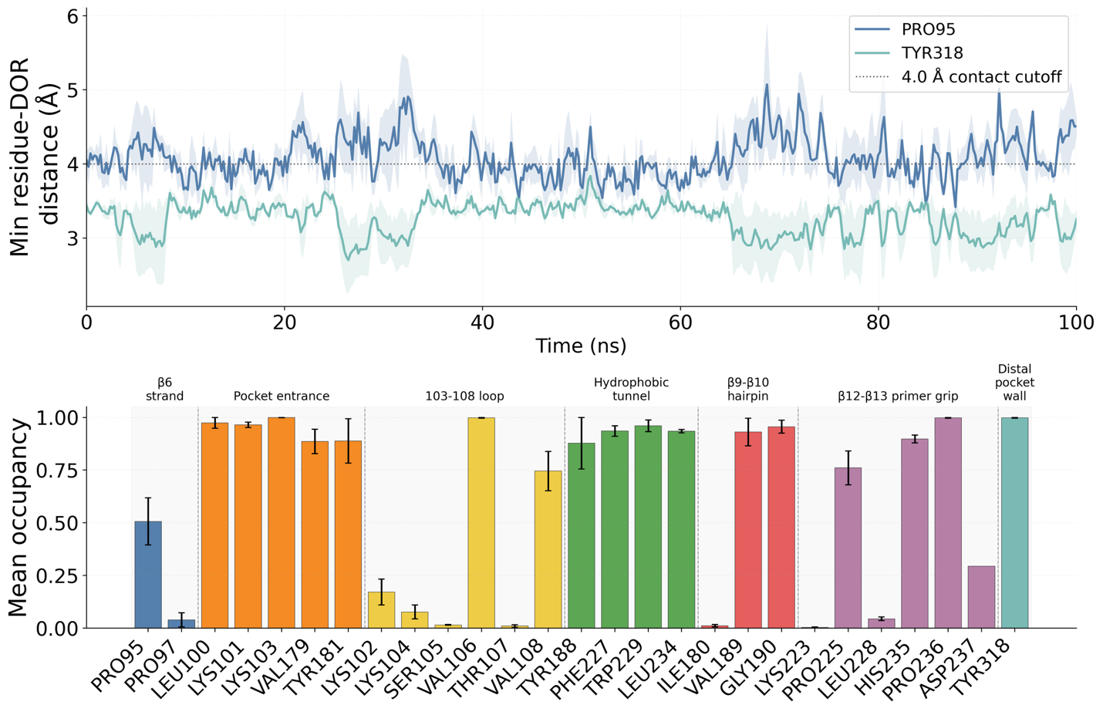
Figure 4: Local trajectory-level contact analysis between DOR and NNIBP residues in WT RT-DOR simulations. Top panel: Trajectories of minimum heavy atom distances between DOR and two exemplary NNIBP residues, Pro95 and Tyr318, observed in 100ns MD simulations of the WT DOR-RT complex performed in triplicates. Solid lines indicate the mean trajectory and lighter color bands show the standard error of the mean across N = 3 replicates in this as well as other trajectory visualizations in this study. The dotted line represents the 4.0 Å cutoff used to define each contact. Bottom panel: Mean occupancy computed for all RT residues that came in contact with DOR at any point during the simulations, segregated by NNIBP regions (cf. Figure 3).

We next asked whether DOR resistance might instead be reflected in mutation-specific redistribution of local binding-pocket interactions. This hypothesis was motivated by two considerations. First, the NNIBP is sufficiently compact that short MD simulations may resolve local contact rearrangements even if they do not accurately recover full binding thermodynamics. Second, prior structural studies of NNRTI resistance suggest that reduced susceptibility can arise from altered pocket geometry, shifted anchoring interactions, and increased ligand pose heterogeneity, without necessarily producing a simple global affinity signal.^{1–3} We therefore shifted our analysis from aggregate energetic metrics to systematic residue-level characterization of DOR contacts within the NNIBP.
To define the WT local interaction landscape, we quantified residue-level DOR contacts across WT RT-DOR simulations. A residue was classified as contacting DOR in a given frame if the minimum heavy-atom distance between that residue and DOR was less than 4.0 Å (Figure 3). For each residue, we then calculated mean contact occupancy, hereafter referred to as mean occupancy, as the fraction of analyzed simulation frames in which this contact criterion was satisfied. This analysis was performed for all residues that contacted DOR at any point in any WT RT-DOR trajectory, yielding a residue-level mean occupancy profile for the WT complex (Figure 4).
The WT occupancy profile revealed three notable features. First, DOR maintained persistent contacts with many NNIBP residues: of the 27 residues that contacted DOR at least once during the WT simulations, 18 had mean occupancy > 0.5, indicating contact for more than half of the simulation time. Second, several NNIBP regions showed consistently high occupancy, including the pocket entrance (5 residues), hydrophobic tunnel (4 residues), and distal pocket wall (1 residue), each with an average mean occupancy across residues within the region exceeding 0.9. Third, contact behavior was highly residue-specific, as neighboring positions could display markedly different mean occupancies, exemplified by positions 105 versus 106 and 180 versus 181. Together, these results establish a WT reference map of stable and heterogeneous DOR-pocket interactions against which mutation-associated local rearrangements can be evaluated.
Contact occupancy profiles encode mutation-sensitive structural signals of DOR resistance
We then extended the contact analysis across all trajectories in the genotype panel to identify residues whose DOR-contact behavior changed preferentially in specific mutation backgrounds (Figure 5). For each mutant genotype, we compared residue-level mean occupancy against the WT reference profile, thereby generating a mutation-associated occupancy shift map across the NNIBP.

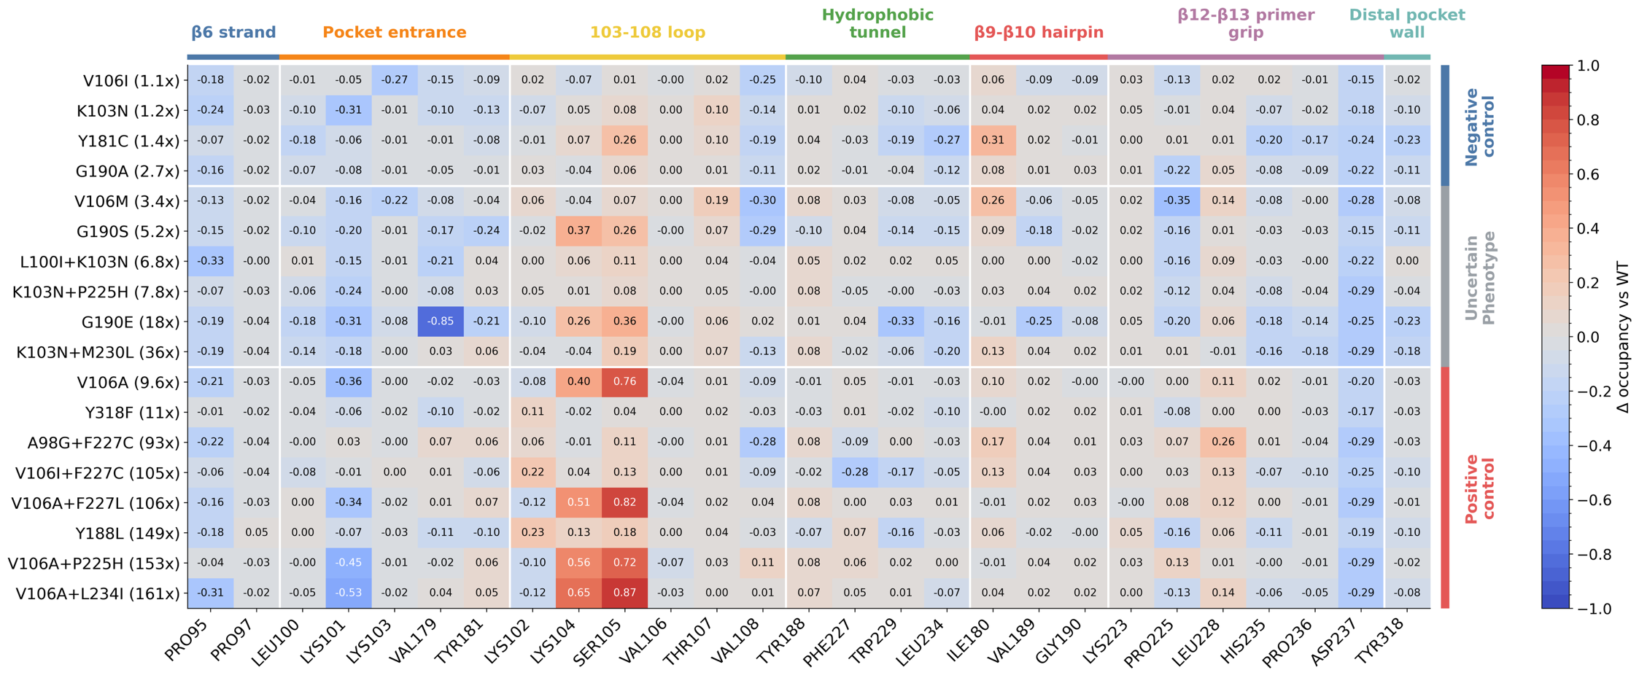

Figure 5: Mutation-associated changes in mean occupancy. X-axis lists all the 27 residues that were ever in contact with DOR in WT RT-DOR simulations. Y-axis lists the 18 DOR-associated genotypes including negative controls, positive controls, and the uncertain phenotype set. Values inside each cell in the heatmap represent the change in mean occupancy vs WT for each residue as observed in MD simulations for each genotype.

This systematic screen revealed two broad patterns. First, residues at the mutated positions themselves generally showed only modest changes in DOR contact occupancy relative to WT, with few shifts exceeding 10 percentage points. The main exceptions were V106I+F227C, which reduced occupancy at the mutated position Phe227 by 0.28 relative to WT, and K103N+P225H, which reduced occupancy at the mutated position Pro225 by 0.12. Second, the largest mutation-associated occupancy shifts typically occurred at residues that were not themselves mutated. For example, G190E reduced DOR contact occupancy at the unmutated residue Val179 by 0.85 relative to WT, whereas V106A+L234I increased occupancy at the unmutated residue Ser105 by 0.87. These observations suggest that resistance-associated mutations can remodel the local DOR interaction network indirectly, rather than simply disrupting contacts at the mutated residue.

Comparing occupancy-shift patterns between positive and negative control mutations further suggested that specific residue-level contacts may function as reporter coordinates for resistance-associated structural rearrangements. Such reporter residues or reporter groups as local readouts of protein conformational dynamics are commonly used to describe complex conformational changes through reduced structural descriptors, otherwise called order parameters, collective variables, or reaction coordinates. In this context, reporter coordinates are residue-level DOR-contact features whose occupancy changes reflect mutation-associated remodeling elsewhere in the NNIBP.

For example, Y188L, a canonical DOR resistance-associated mutation, increased DOR contact occupancy at Lys102 by 0.23 and decreased occupancy at Pro225 by 0.16 relative to WT. In contrast, Y181C, a negative control mutation in this analysis, produced minimal occupancy changes at the same positions, with shifts of approximately ±0.01 relative to WT for Lys102 and Pro225, respectively. These divergent patterns suggest that DOR interactions with Lys102 and Pro225 may serve as local structural readouts of resistance-associated pocket remodeling, even when the residues themselves are not necessarily the primary sites of mutational perturbation.

Because many residue-level contacts were evaluated, we treated candidate reporter coordinates as hypothesis-generating features rather than as definitive biomarkers of resistance based solely on effect size. To reduce the likelihood that these signals reflect chance observations from multiple comparisons, we prioritized residues that satisfied several criteria: reproducible occupancy shifts across independent trajectories, large WT-referenced effect sizes, consistency within structurally interpretable NNIBP regions, and differential behavior between positive and negative control mutations. Thus, reporter coordinates were not selected solely because they showed an extreme value in a high-dimensional screen, but because they captured recurrent, mutation-associated changes in DOR-pocket organization that were also interpretable in the structural context of the RT-DOR complex.

We further addressed this concern by comparing observed occupancy shifts against an empirical null distribution generated by trajectory-level resampling. Specifically, mutation labels were permuted across replicate trajectories, and the largest absolute occupancy shift observed across all 27 WT-contacted residues was recorded for each permutation. This global maximum statistic estimates the magnitude of occupancy shift expected by chance when applying the same residue-screening procedure to the same trajectory set. Only two reporter coordinates were observed to have absolute WT-referenced occupancy shifts exceeding the 90th percentile of this null distribution (Supplementary Figure 1) – Val179 for G190E and Ser105 for V106A containing genotypes (V106A, V106A+P225H, V106A+F227L, V106A+L234I).

V106A-containing genotypes shift DOR toward the 103-108 loop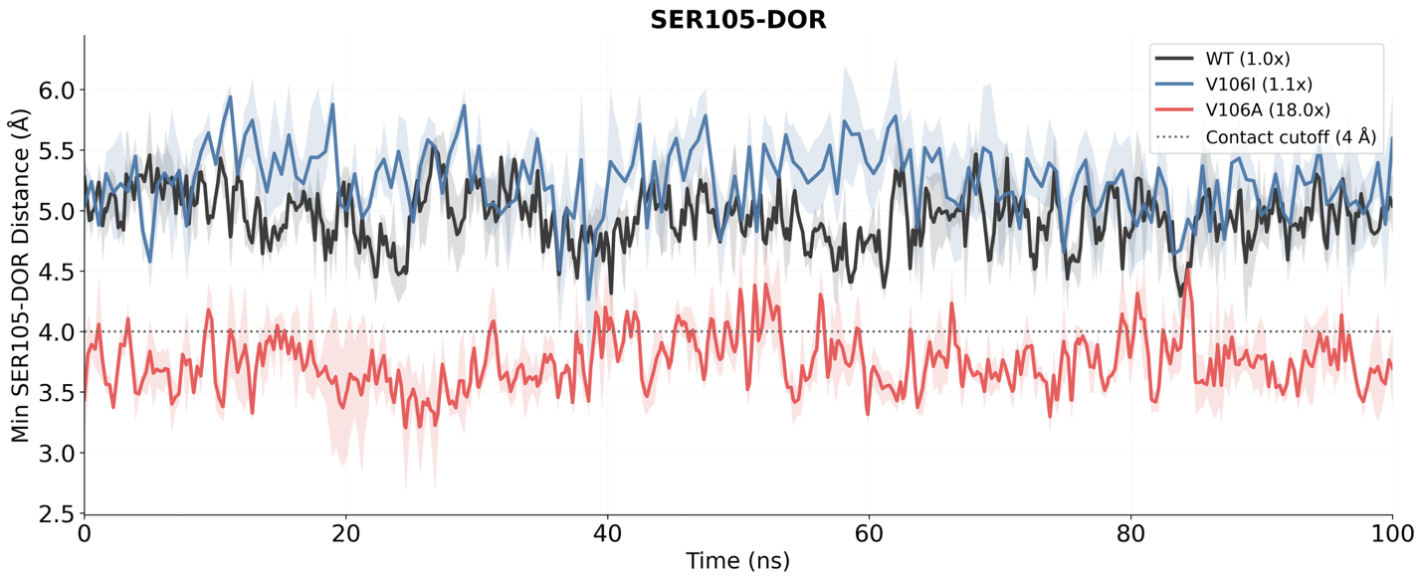 WT V106I V106A
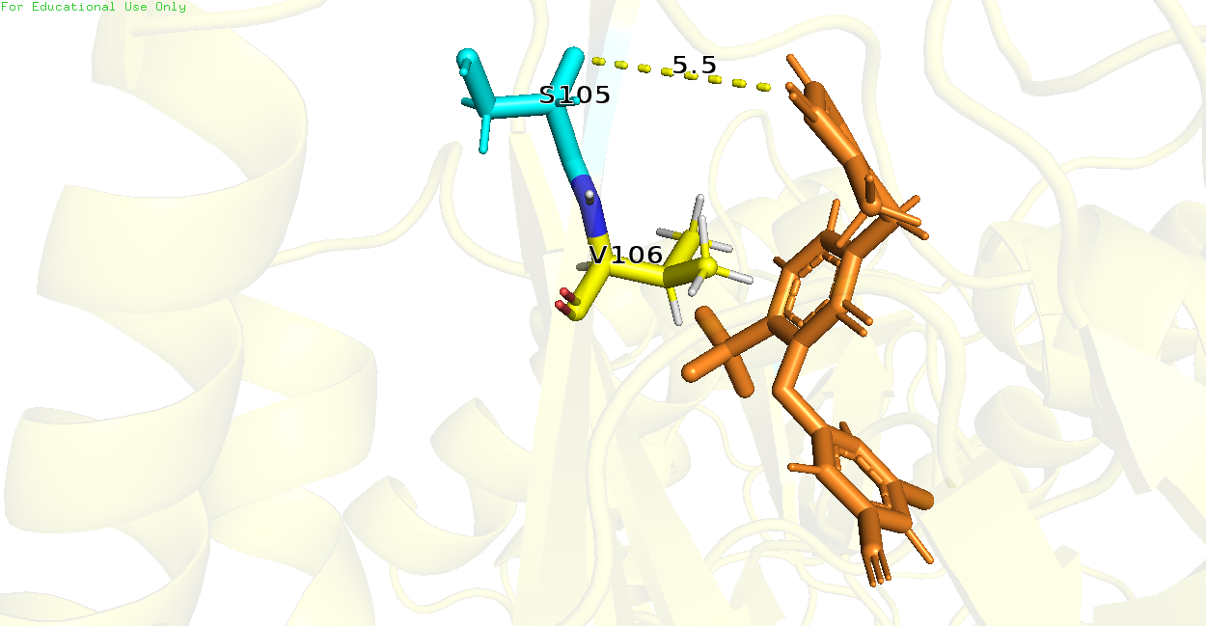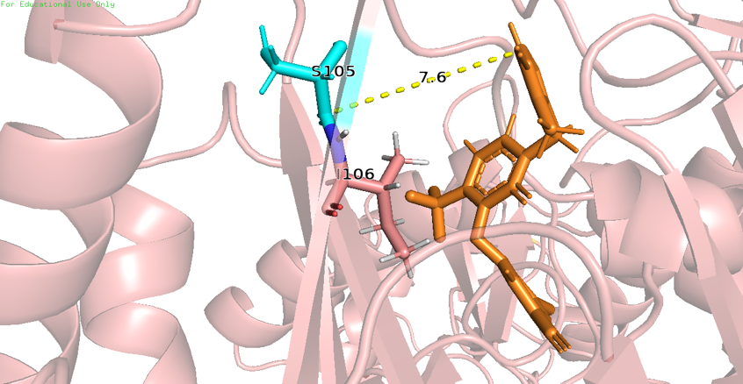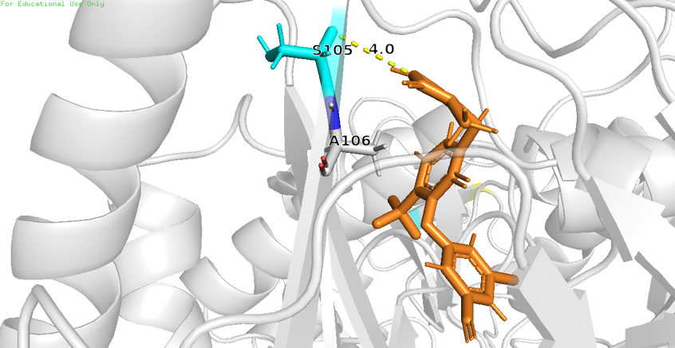
Figure 7: V106A preferentially alters DOR pose, causing Ser105 to shift closer to DOR. (Top) Minimum distance between heavy atoms of Ser105 and DOR observed in MD simulations of WT, V106I, and V106A. (Bottom) Snapshots of a single frame across WT, V106I, and V106A trajectories, showing Ser105 shifted closer to DOR in case of V106A as compared to WT and V106I.

The V106 region is a major determinant of DOR susceptibility because V106 directly contacts the central pyridone core of DOR. However, the literature and our own genotype panel indicate that not all V106 mutations behave equivalently. V106I, a polymorphic substitution observed to some extent in the general population, generally has little effect on DOR susceptibility when present alone, whereas V106A is a canonical DOR resistance mutation and serves as the first step in several high-resistance combination pathways.

The systematic contact analysis highlighted Lys104 and Ser105 as informative reporter residues for this distinction. Both residues sit near the pocket entrance within the 103-108 loop region, and both showed preferential shifts in DOR proximity in V106A-containing trajectories. In direct comparisons among WT, V106I, and V106A, the V106A simulations showed a reproducible shift of DOR toward the 103-108 loop, bringing DOR closer to Ser105 and often also to Lys104 (Figure 7).

The most plausible interpretation is that replacement of valine with alanine removes hydrophobic bulk from a direct DOR-contact site and allows the bound ligand to redistribute toward a slightly more 103-108 loop-shifted local pose ensemble. In that ensemble, contacts with Lys104 and Ser105 can arise as compensatory interactions, but these appear to be secondary to the loss of optimal packing at position 106. The contrast with V106I is informative: isoleucine preserves a branched hydrophobic side chain at position 106, which mitigates local geometry perturbation.

This model also helps explain why V106A becomes especially problematic in combination with secondary hydrophobic tunnel or primer grip mutations. If V106A first redistributes the DOR pose toward the 103-108 loop, then additional substitutions around P225, F227, or L234 can further destabilize an already altered local contact network.

V106I+F227C reaches high resistance through a different local route than V106A+F227L
V106I+F227C and V106A+F227L are both highly resistant DOR-associated genotypes, yet the pathway-specific logic above predicts that they should not be structurally identical. V106A+F227L belongs to the V106A family and therefore might be expected to retain the 103-108 loop-shifted signature. V106I+F227C, by contrast, combines a relatively low-impact V106 substitution with a hydrophobic tunnel substitution at position 227.

In line with this expectation, V106A+F227L showed the same local shift toward Ser105 and Lys104 seen in other V106A-containing backgrounds. V106I+F227C did not show that same 103-108 loop-focused pattern. Instead, it sampled alternative local conformations involving the residue 227 region, with DOR becoming transiently more separated from position 227 than in WT or V106A+F227L (Figure 8).

The importance of this comparison is conceptual as well as mechanistic. These two genotypes have nearly identical median DOR fold-change values in the available phenotype data, yet the simulations suggest that they arrive at that shared phenotype through different structural routes. Similar resistance magnitude therefore need not imply a shared mechanism. For DOR resistance interpretation, this means that structurally distinct genotype classes may converge on a similar susceptibility outcome through different local reorganizations of the same pocket.
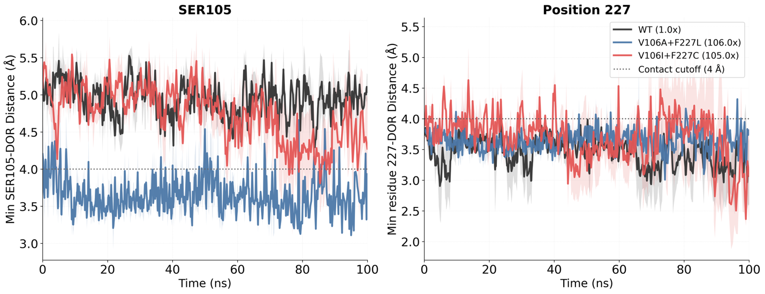 WT V106A+F227L V106I+F227C
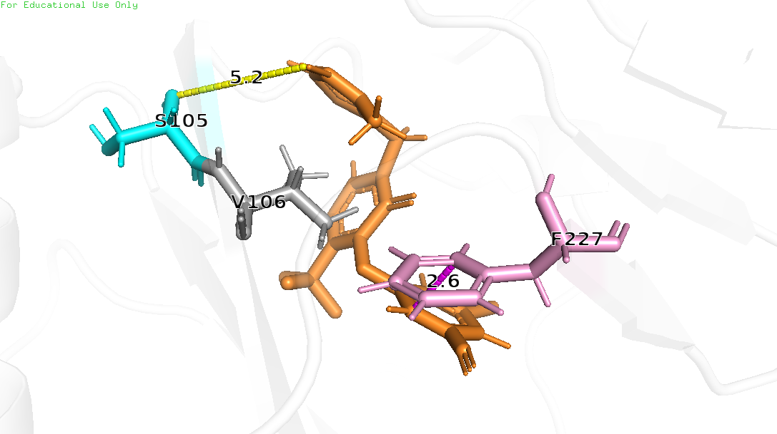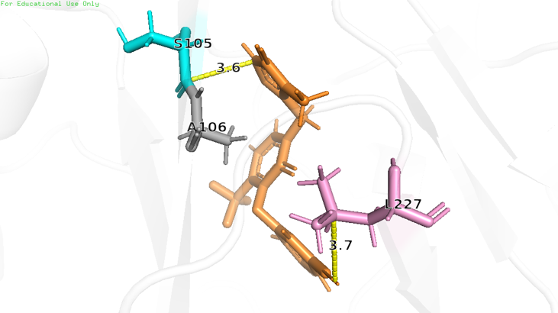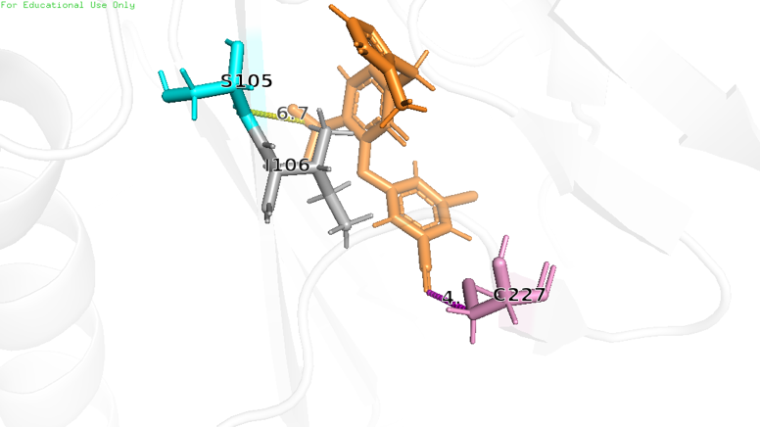
Figure 8: V106I+F227C exhibits alternative dynamics than V106A+F227L. (Top) Minimum distances between heavy atoms of Ser105 and DOR as well as Position 227 and DOR observed in MD simulations of WT, V106A+F227L, and V106I+F227C. (Bottom) Snapshots of a single frame across WT, V106A+F227L, and V106I+F227C trajectories, showing Ser105 shifted closer to DOR in case of V106A+F227L (but not in case of V106I+F227C or WT); and an alternate DOR pose in case of V106I+F227C that is further away from residue 227 than in WT or V106A+F227L.

G190E perturbs the pocket entrance and weakens Val179 contact
Publicly available phenotype data suggest that G190E may reduce DOR susceptibility. We therefore compared WT, G190A, and G190E to ask whether introduction of a negatively charged glutamate at position 190 produces local structural effects distinct from the more common G190A substitution that is known to have little to no impact on DOR susceptibility.

The panel-wide contact analysis identified Val179 as the clearest reporter residue for this comparison (Figure 5). Val179 lines the pocket entrance and showed strong genotype-specific contact loss in G190E. In direct trajectory comparisons, G190E caused marked separation of Val179 from DOR that was not observed in WT or G190A (Figure 9). This effect was accompanied by broader local perturbation of the pocket environment.

The simplest interpretation is that the G190E side chain introduces a local electrostatic and steric perturbation in the β9-β10 hairpin that propagates into the Val179 side of the pocket, thereby weakening DOR packing on that face of the binding site. G190A, which lacks this charge switch and imposes a much smaller structural perturbation, did not produce the same effect. These results therefore support G190E as a plausible DOR-relevant genotype deserving further targeted phenotypic study.
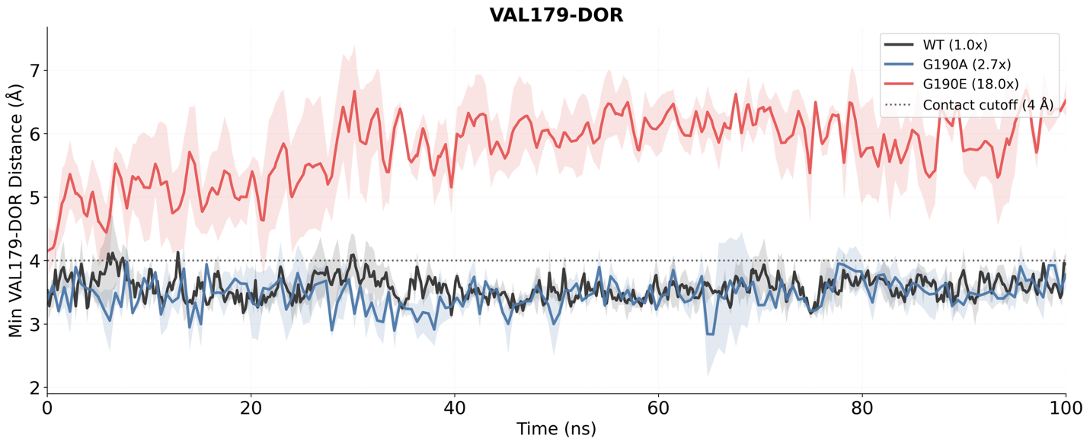
WT G190A G190E
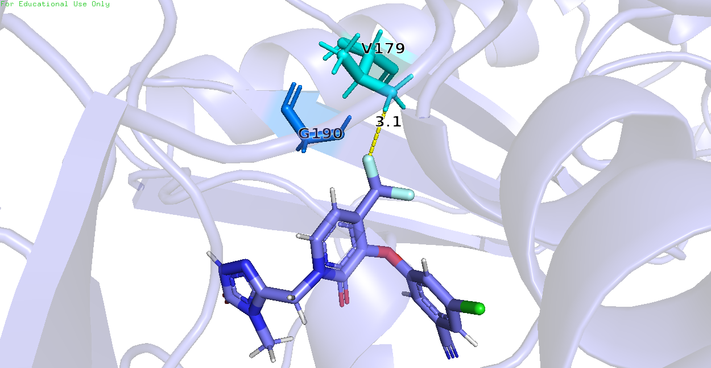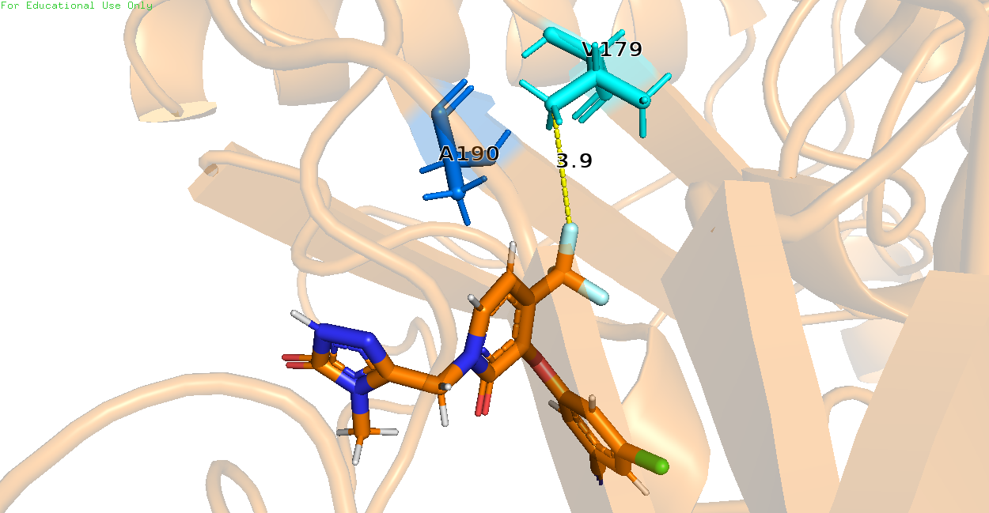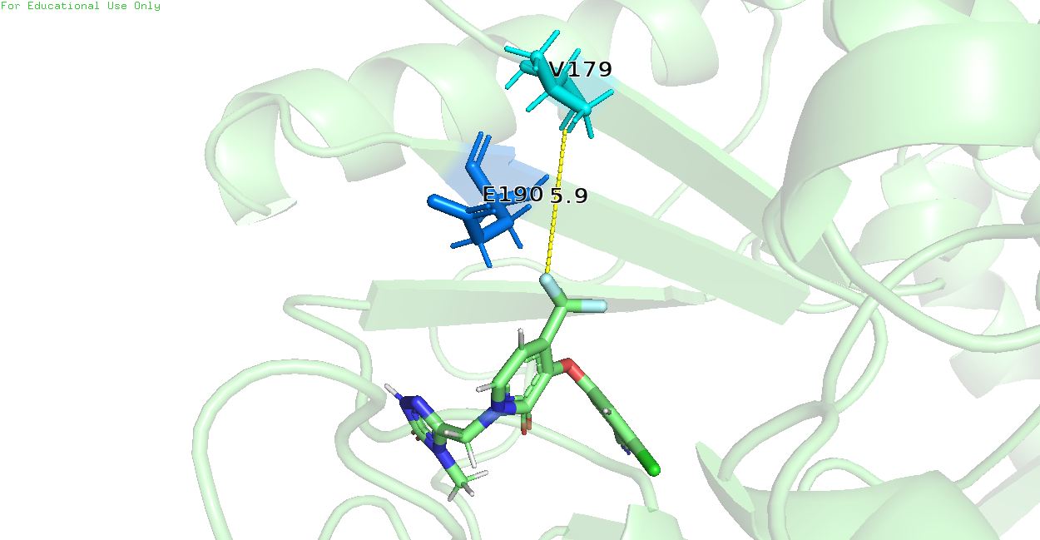
Figure 9: G190E preferentially disrupts β9-β10 hairpin, causing Val179 to lose contact with DOR. (Top) Minimum distance between heavy atoms of Val179 and DOR observed in MD simulations of WT, G190A, and G190E. (Bottom) Snapshots of a single frame across WT, G190A, and G190E trajectories, showing Val179 further away from DOR in case of G190E but not in WT and G190A.

A parsimonious 3-feature logistic regression model summarizes the separation between low- and high-resistance controls
A)
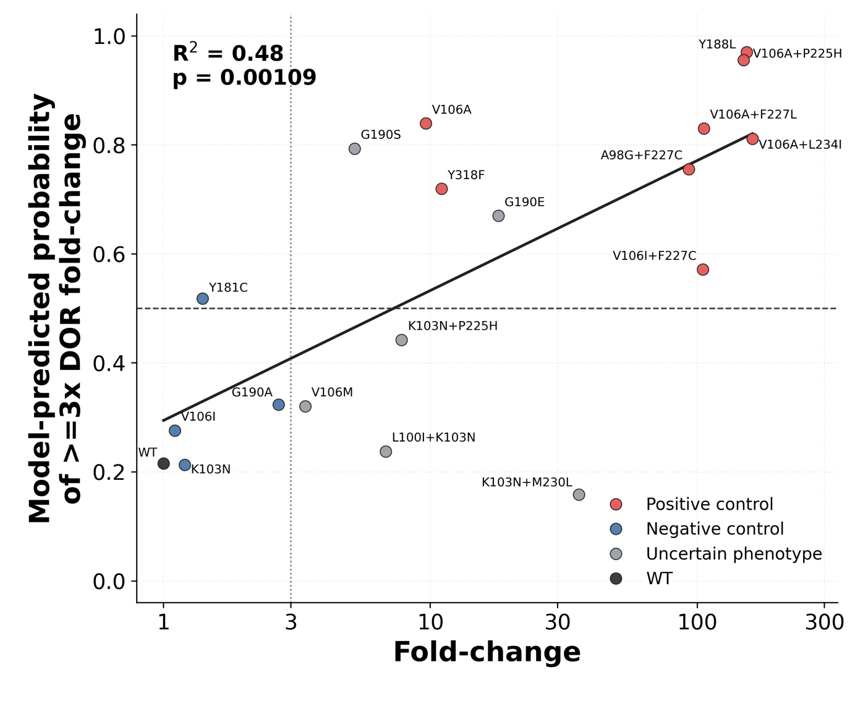
B) C)
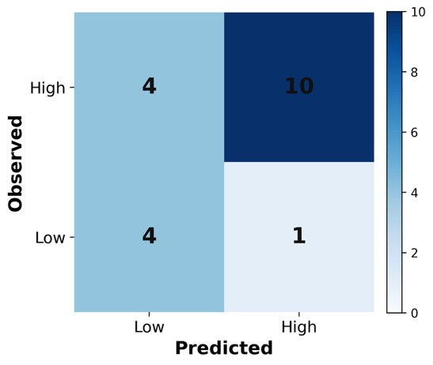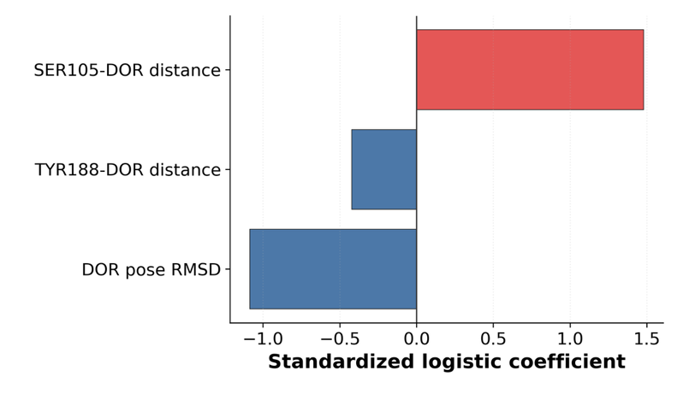
Figure 10: Performance of Logistic Regression model relating MD simulation features to DOR susceptibility. (A) Output of the logistic regression model, P_{high}, i.e. the probability of a mutation being labeled as high resistance, plotted against median DOR fold-change in susceptibility on the log scale. The dotted lines represent the thresholds for the labels: Genotypes were labeled as high resistance if their median DOR fold-change exceeded 3x and low resistance otherwise. We used a decision threshold of P_{high} = 0.5 for class assignment. The dashed trend line is a linear regression fit of the data. R² is the coefficient of determination for this fit and the p-value test the null hypothesis that the true linear correlation between the two variables is zero. (B) Confusion matrix showing predicted labels compared with true labels across train and test set. (C) Trained model coefficients for the standardized features showing roughly equal contribution of all 3 features to the model’s output.

After identifying local structural signatures across the genotype panel, we asked whether a small number of MD-derived variables could summarize the distinction between low- and high-resistance genotypes. Genotypes were labeled as high resistance if the median DOR fold-change was ≥3 and low resistance otherwise; WT was included as a low-resistance reference. We then fit a regularized logistic regression model using three mechanistically motivated features: the Ser105-DOR minimum distance, the Tyr188-DOR minimum distance, and DOR pose RMSD (Figure 10).

This compact model separated the low- and high-resistance control mutations with strong performance in replicate-level grouped cross-validation, achieving 12/13 correct classifications. When fit across the full panel, the resulting model probabilities also tracked the continuous phenotypic fold-change values, despite being trained on a binary resistance threshold (R² = 0.50, p = 6.6 × 10⁻⁴). Thus, the classifier produced a graded score that increased with the magnitude of observed DOR susceptibility loss.

The selected features are also mechanistically interpretable. Ser105-DOR distance captures the 103-108 loop-proximal shift observed in V106A-containing genotypes, Tyr188-DOR distance captures disruption of the aromatic wall of the NNRTI-binding pocket, and DOR pose RMSD summarizes broader ligand rearrangement. WT was assigned a low probability of high resistance, whereas most positive-control genotypes were assigned high probabilities. Among genotypes with limited or uncertain phenotype, G190E and G190S received high model probabilities, while V106M, L100I+K103N, K103N+P225H, and K103N+M230L were assigned low probabilities.

Note that this model should be interpreted as a compact structural summary rather than as a validated clinical susceptibility predictor. The training set is small, the phenotype labels depend on a pragmatic 3-fold threshold, and bootstrap intervals remain wide for several genotypes (Supplementary Table 4: @Rohit to add). Nevertheless, the ability of four local MD-derived features to summarize much of the low-versus-high resistance separation supports the broader conclusion that DOR resistance is better explained by coordinated local rearrangements in the binding pocket than by a single global binding-energy metric.

Discussion
DOR poses an unusual resistance problem among second-generation NNRTIs. Like ETR and RPV, DOR retains activity against common NNRTI-associated backgrounds such as K103N, Y181C, and G190A, yet the pathways that reduce DOR susceptibility are distinct and increasingly relevant in clinical use. Specific substitutions such as Y188L, V106A, and Y318F, and combinations including V106I+F227C, V106A+F227L, and V106A+L234I, now recur across phenotypic studies, in vitro selection experiments, and clinical trial datasets. Despite these observations, publicly available isolate-level susceptibility data for DOR remain sparse. As of April 2026, Stanford HIVDB indexes only 134 DOR-associated isolates tested by PhenoSense, compared with 330 for RPV and 1,193 for ETR. This mismatch between growing clinical relevance and limited public phenotype data for DOR resistance motivated the present study. We therefore asked whether short explicit-solvent MD simulations could provide a coherent structural framework for understanding known and limited-data DOR resistance genotypes.

We observed that total WT-referenced energetic shifts derived from bound-state MD snapshots did not correlate well with the available phenotypic DOR landscape. There may be several reasons for this observation. First, the computed MM/GBSA energy values fundamentally do not represent equilibrium binding free energies because the simulations do not sample the full bound and unbound state populations needed for a true free energy estimate. Second, though the simulations are performed in explicit solvent, the MM/GBSA calculations omit explicit solvent contributions that could have contributed to errors in the entropic components. Third, the simulations reveal dynamics on a timescale that is much shorter than the conformational rearrangements and kinetic processes governing RT-DOR binding in vitro. We therefore recommend viewing the energetic analysis as a directional binding energy score rather than as a precise estimate for RT-DOR binding affinity.

Most of the energetic components behaved similarly. However, significant loss of RT-DOR interaction, such as loss of the aromatic pi-stacking interaction between the DOR chlorophenol ring and the RT Tyr188 sidechain in Y188L simulations led to a cumulative energetic penalty of ~40kJ/mol vs WT, mainly driven by the van der Waals and polar solvation energy components. Furthermore, the weak but statistically significant association observed for the electrostatic component suggested that local electrostatic reorganization in the NNIBP may be more informative.

Consequently, systematic residue-level contact analysis revealed that different DOR-associated genotypes preferentially perturb different local regions of the pocket. V106A-containing genotypes redistributed DOR toward the 103-108 loop and favored compensatory proximity to Lys104 and Ser105. V106I+F227C achieved similarly high resistance through a different local route centered more strongly on the residue 227 region. G190E uniquely perturbed the β9-β10 hairpin and weakened the Val179 side of the pocket. These observations support a model in which DOR resistance emerges through multiple mechanistic classes rather than through a single generic reduction in binding strength.

This mechanistic diversity is especially important for interpreting epistasis. The V106A-containing double mutants retained the same local signature already seen in V106A alone, consistent with the idea that V106A acts as a priming mutation that redistributes the DOR pose, after which upper-pocket substitutions exacerbate the resulting vulnerability. By contrast, V106I+F227C shows that a high-resistance phenotype can also emerge without that same structural route. Similar fold-change values can therefore conceal distinct local mechanisms.

The logistic regression analysis supports this interpretation. The fact that a four-feature model built from Ser105-DOR distance, Tyr188-DOR distance, and ligand pose RMSD could summarize the low-versus-high resistance control separation suggests that the dominant structural signals in this system are both local and low-dimensional. At the same time, the mixed performance in the uncertain phenotype data set emphasizes that such a model is currently best understood as an interpretable structural summary rather than as a deployable prediction tool.

Several limitations should frame the interpretation of this work. First, the simulations were short relative to the conformational and kinetic timescales relevant to RT-DOR binding, so there are likely mechanistically important events that remain unsampled. Second, the logistic regression classifier is constrained by small sample size and by the difficulty of drawing hard class boundaries in a sparse phenotype landscape.

Despite these limitations, we think the central contribution of this study is clear. Short explicit-solvent MD simulations do not replace phenotypic susceptibility experiments, but they do provide a practical and mechanistically interpretable framework for understanding how pre-existing NNRTI mutations might alter DOR binding in RT. That framework is useful in two ways. First, it can help estimate the risk associated with DOR use in people living with HIV whose viruses harbor pre-existing NNRTI mutations but lack extensive direct DOR phenotype data. Second, it identifies concrete structural features that medicinal chemists can target when designing future NNRTIs with improved resilience against Tyr188-side, V106-side, upper-pocket, or β9-β10 hairpin-mediated resistance pathways.

