HIV-1 Reverse Transcriptase — Doravirine Resistance
Pivot to Alchemical Free-Energy Calculations (pmx + GROMACS Non-Equilibrium Switching)
Project update for collaborators · Rohit Satija · July 30, 2026

1. Summary
We have moved the doravirine (DOR) resistance free-energy estimation from MM/GBSA rescoring of molecular-dynamics trajectories to rigorous alchemical free-energy perturbation (FEP) using pmx hybrid topologies and GROMACS non-equilibrium (NEQ) switching, analysed with the Bennett acceptance-ratio (BAR) estimator. For each mutation we compute the change in DOR binding free energy, ΔΔG_bind, through a holo/apo thermodynamic cycle. Positive ΔΔG_bind = weaker binding = resistance.
A two-mutation pilot (P0: V106A, Y188L) reproduces the experimental resistance direction and ranking; the ΔΔG values are converged by four independent criteria (Section 6). An 8-mutation single-residue panel (P1) is now running to test rank correlation against clinical fold-change.
Genotype | ΔΔG_bind (kcal/mol) | Exp. fold | Sign | Ranking
V106A | +1.76 ± 0.51 | 9.6× | positive ✓ | correct
Y188L | +4.52 ± 0.49 | 149× | positive ✓ | correct
Table 1. P0 pilot results (500 ps switches, 3 replicates). Both mutations give the correct sign and order versus experiment; SEM < 1 kcal/mol.

2. Why we pivoted: from MM/GBSA to alchemical FEP

2.1 What MM/GBSA gave us, and its limits
MM/GBSA is an end-point method: it rescores snapshots from a single MD trajectory with a molecular-mechanics energy plus an implicit (generalized-Born) solvation term. It is fast and useful for triage, but for quantitative, defensible ranking of resistance it has well-known weaknesses:
- Semi-empirical, not a true free energy — results depend strongly on the assumed interior dielectric constant.
- Configurational entropy is neglected or only crudely approximated.
- Implicit solvent misses discrete water and specific electrostatics in the buried NNRTI pocket.
- Errors are systematic and poorly calibrated, so small ΔΔG differences between mutations — the ranking regime we need — are not reliably resolved.

2.2 What alchemical FEP provides, and why non-equilibrium
FEP computes a rigorous free-energy difference from the full Boltzmann ensemble in explicit solvent; a closed thermodynamic cycle (Section 4) cancels the intractable absolute binding free energies and leaves two well-defined alchemical transformations. The pmx/NEQ realisation has an established accuracy of ≈1.2 kcal/mol RMSE across 134 protein mutations (Aldeghi et al., 2018) and has been applied to kinase-inhibitor resistance (Aldeghi et al., 2019). We chose the non-equilibrium variant because equilibrium fixed-λ FEP must sample and converge unphysical intermediate states — and our open-source fixed-λ attempt (below) failed to do so. NEQ equilibrates only the two physical endpoints, is embarrassingly parallel, and yields a rigorous BAR estimate with error bars (Gapsys et al., 2020).

3. Comparison with other FEP methods, and why we chose this one

3.1 The established approach in the NNRTI field
Free-energy calculations have a long history in NNRTI optimisation. The Jorgensen group pioneered Monte-Carlo-based FEP (MCPRO) and used it to guide HIV-1 RT inhibitor design and to rationalise resistance at residues including L100, V106 and Y181 (Zeevaart et al., 2008). The modern, MD-based commercial descendant of this lineage is Schrödinger's FEP+ (Wang et al., 2015), which pairs the OPLS force field with replica-exchange solute tempering and is widely used for relative binding free energies.

3.2 Why we chose an open-source non-equilibrium protocol
- Software access & reproducibility. MCPRO/BOSS and FEP+ are licensed, closed-source packages. Our pipeline is fully open source (pmx, GROMACS, OpenFF), so the protocol is transparent, auditable, and freely reproducible by collaborators and reviewers.
- Practical robustness. We first attempted an open-source equilibrium (fixed-λ) FEP replication (Perses / OpenMM); it did not converge at the alchemical endpoints for this system. Non-equilibrium switching removes that failure mode by equilibrating only the two physical endpoints and driving the change with many short, independent switches.
- Physical completeness (vs. the classical protocol). The classical MCPRO NNRTI calculations used truncated binding-site environments and a distance-dependent dielectric to approximate solvation. Ours use full periodic boundary conditions with particle-mesh-Ewald electrostatics, explicit TIP3P water, and a modern force field — a more complete physical treatment of the buried, electrostatically sensitive NNRTI pocket.
We are careful about scope here: the physical-completeness advantage is stated against the classical truncated MC/FEP protocol specifically. Modern full-PBC FEP+ shares comparable underlying physics; there our advantage is openness and reproducibility, not a claim of superior accuracy. A systematic comparison against the full protein–ligand free-energy literature is beyond the scope of this update — the references cited are representative primary sources for the methods used, not an exhaustive review.

4. Theory: why non-equilibrium FEP with BAR is accurate

4.1 Thermodynamic cycle
The mutational change in binding free energy equals the difference of two alchemical (WT→mutant) transformations — one in the DOR-bound (holo) enzyme, one in the apo enzyme. The binding legs of the cycle cancel exactly:

4.2 Non-equilibrium work and Jarzynski's identity
Driving the coupling coordinate λ from 0 (WT) to 1 (mutant) in finite time performs non-equilibrium work W. By the second law ⟨W⟩ ≥ ΔG, with equality only in the reversible limit. Jarzynski's identity nonetheless recovers the exact equilibrium free energy from the exponential average of the work, at any switching speed:
Used one-directionally, however, this average is dominated by rare low-work trajectories, so it has high variance and finite-sample bias — which is why we do not rely on it alone.

4.3 Crooks fluctuation theorem
The Crooks theorem sharpens the picture by relating the forward and reverse work distributions; they cross exactly at W = ΔG:
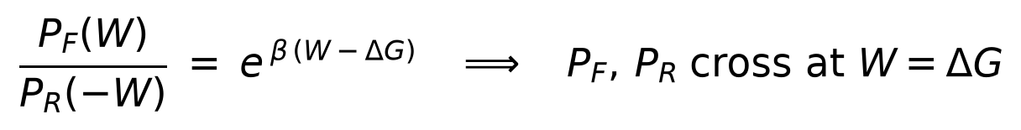
This gives an independent, low-bias handle on ΔG (the crossing point) and the formal basis for combining both switching directions. The overlap of P_{F} and P_{R} is also our primary convergence diagnostic (Section 6).

4.4 Bennett acceptance ratio (BAR) — the optimal combination
BAR is the minimum-variance estimator that combines the forward and reverse work sets consistent with the Crooks relation; ΔG is the self-consistent solution of
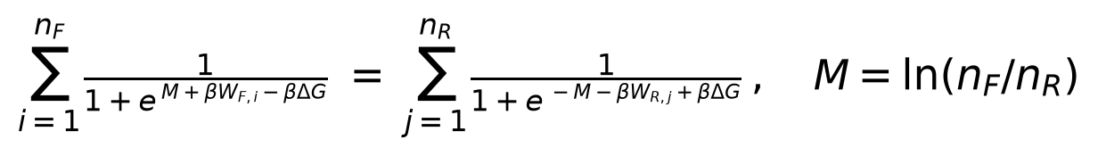
Because BAR uses both directions and weights each trajectory optimally, it converges far faster and with much lower bias than the one-directional Jarzynski average — the reason the NEQ protocol is accurate at an affordable number of switches. As a direct check, BAR, the Crooks-Gaussian intersection, and the Jarzynski average agree to within ~0.4 kcal/mol on our data (Section 6).

5. Procedure overview
Each mutation is transformed in both the holo and apo enzyme, in triplicate; ΔΔG_bind is the holo−apo difference and the three replicates give the reported mean ± SEM.
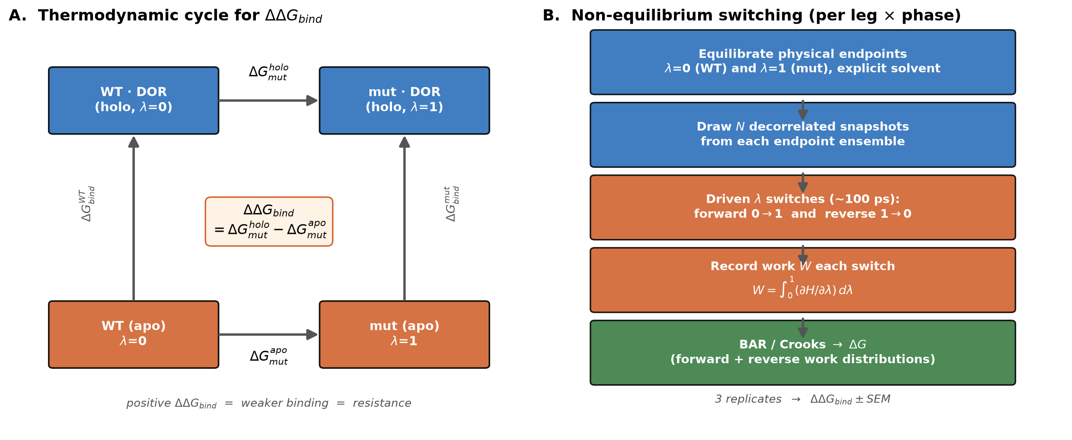
Figure 1. (A) Thermodynamic cycle defining ΔΔG_bind. (B) Non-equilibrium switching workflow, per leg (mutation) × phase (holo/apo) × replicate.

6. Results to date

6.1 P0 pilot
- Both ΔΔG_bind are positive (resistance) and correctly ordered: Y188L ≫ V106A, matching clinical fold 149× ≫ 9.6× (Table 1).

6.2 Work distributions
Figure 2 shows the forward and reverse work distributions for each P0 leg. As required by the Crooks theorem, the two distributions cross at the BAR ΔG. The overlap is modest — a signature of intrinsic dissipation in the buried pocket — but, as the convergence analysis shows next, this does not bias ΔΔG.
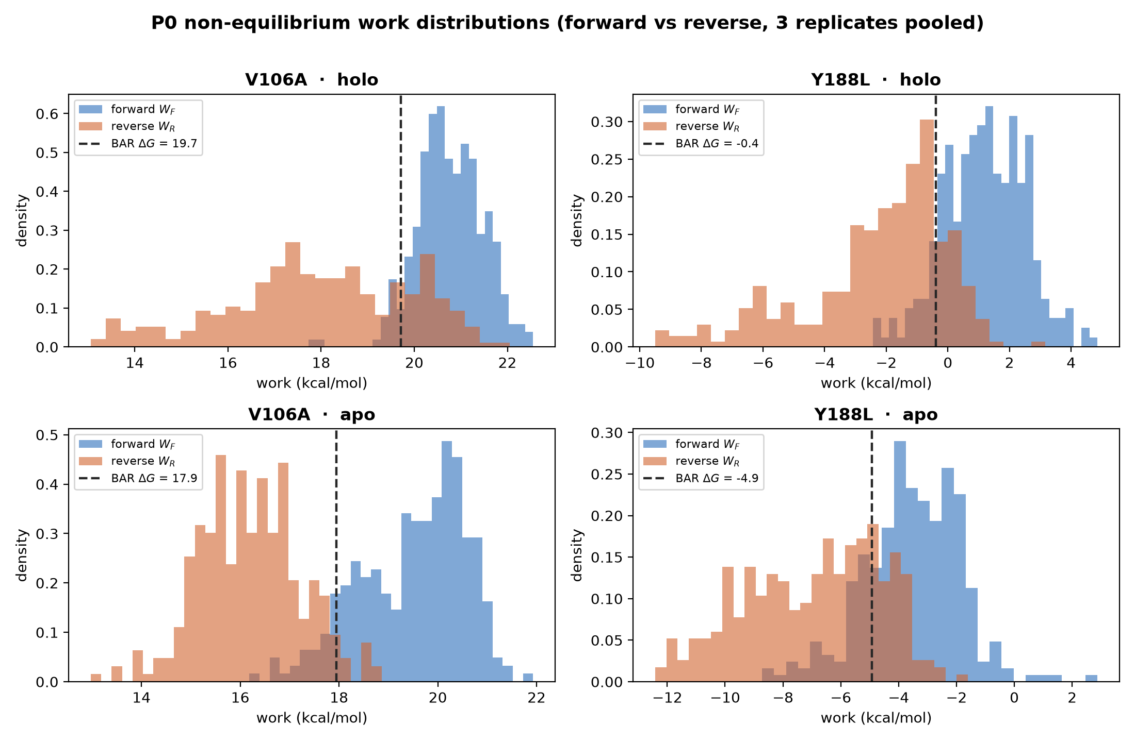
Figure 2. P0 non-equilibrium work distributions (forward vs. reverse, 3 replicates pooled). Dashed line = BAR ΔG, at which the distributions cross.

6.3 Convergence — how we know the result is converged
Our collaborators asked how we know these values are converged. We assess it four independent ways:
1. Sampling plateau (Fig. 3A): the running BAR estimate stabilises well before the full 100 switches per endpoint per replicate.
2. Estimator agreement (Fig. 3B): BAR, Crooks-Gaussian and Jarzynski agree to within ~0.4 kcal/mol — they would diverge if the work distributions were poorly sampled.
3. Replicate agreement: three independent replicates give SEM < 1 kcal/mol.
4. Switch-length invariance: increasing the switch time 5× (100 → 500 ps) leaves ΔΔG statistically unchanged (V106A +1.69 ± 0.70 → +1.76 ± 0.51), confirming independence from driving speed. Because the answer is invariant, the larger P1 panel runs at the cheaper 100 ps — a ~5× compute saving with no loss of accuracy.
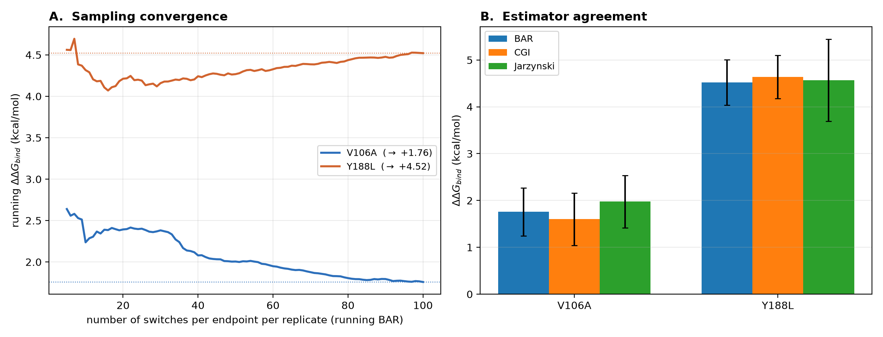
Figure 3. (A) Running BAR ΔΔG_bind vs. number of switches — the estimate plateaus. (B) Three independent estimators agree for both P0 mutations.

6.4 P1 (ranking test — in progress)
- Eight single-residue mutations (V106A, Y188L, F227C, G190A, V106I, V106M, Y181C, Y318F), including negative controls V106I (1.1×) and Y181C (1.4×), are running to compute a Spearman rank correlation against clinical fold-change.
- The two net-charge-changing mutations (K103N, G190E) are deferred to a dedicated co-alchemical-ion protocol.

7. Limitations
- Apo-state uncertainty (largest source of error). The NNRTI pocket does not exist in the unliganded enzyme — it is created by inhibitor binding — so the apo endpoint can partially collapse on accessible MD timescales, and its free energy is the least well-defined part of the cycle. We mitigate by treating every mutation identically (a systematic apo error then largely cancels in the ranking) and by reporting rank over absolute ΔΔG. Ways to strengthen it: identical weak harmonic restraints on the pocket-lining residues across all apo legs; seeding the apo endpoint from the holo (bound-like) pocket while monitoring pocket volume; or the alternative double-decoupling / absolute-binding-FEP route, which avoids an explicit apo protein state altogether.
- Modest forward/reverse work overlap. The buried pocket dissipates non-trivial work during switching, limiting overlap. We have shown this does not bias ΔΔG (switch-length invariance and three-estimator agreement), but it does inflate the per-leg statistical error, so absolute ΔΔG carries ~1 kcal/mol-scale uncertainty. Remedies: more switches (tightens the BAR error without shifting the mean); optimised or bidirectional switching schedules (Gapsys et al.); or, if the endpoints can be converged, equilibrium λ-window FEP with MBAR — which trades the dissipation problem for an intermediate-state sampling problem.
- Classical, fixed-protonation model. An additive force field (ff14SB / OpenFF 2.0.0), fixed protonation states, and TIP3P water are standard but approximate — no electronic polarization, no response to pH. For protonation-sensitive residues (pocket histidines, or K103N) constant-pH MD or explicit pKa-aware setup removes the fixed-state assumption; polarizable force fields (AMOEBA, Drude) or alternative water models (OPC, TIP4P/2005) are available if a specific interaction warrants them.
- Conformational sampling and timescale (see §8.2). RT has genuinely slow domain motions on µs timescales, while our 5 ns endpoint equilibration samples only fast, local relaxation. Our convergence checks establish that ΔΔG is converged with respect to switching and replicates, but not that the 5 ns endpoint ensemble is the true equilibrium. Because the alchemical change is local and slow global motions common to WT and mutant cancel in the ΔΔG difference, FEP is expected to be far less sensitive to µs dynamics than absolute end-point scoring — but this is testable, and we address it explicitly in Next Steps.
- Scope of validation. Results so far are a two-mutation pilot; broader accuracy and ranking claims await the full panel and a systematic comparison against the literature.

8. Next steps
Several items below are natural extensions the method already supports — capabilities we have not yet run — rather than fundamental limitations.

8.1 Charge-changing mutations (K103N, G190E)
K103N and G190E change the net charge, which introduces well-known finite-size artifacts if treated naively — but this is a solved problem, not a barrier. We will adopt one established scheme and apply it consistently to both charge legs: a co-alchemical ion (a compensating counter-ion decoupled in step with the mutation; King et al.) or the double-system/single-box approach (Gapsys et al., 2020). These run after the neutral panel completes.

8.2 Conformational sampling: do we need 1 µs?
Our collaborators noted that MM/GBSA on plain MD may need ~1 µs to capture RT's slow dynamics, and asked whether our results could be a short-timescale artifact. Three points:
- The concern is legitimate for any leg whose mutation shifts a slow conformational equilibrium — most plausibly the apo pocket — which a 5 ns endpoint equilibration would miss.
- But ΔΔG is a difference of ensembles: slow motions shared by WT and mutant cancel, so FEP is structurally far less exposed to this than absolute end-point scoring of a single trajectory. This is a key reason we expect the ranking to be robust even at modest equilibration.
- NEQ decouples endpoint sampling from switching. We can seed the endpoint ensembles from arbitrarily long trajectories — including the existing 100 ns (and, if warranted, 1 µs) plain-MD runs the collaborators already generated — at no extra switching cost. The method fully supports µs-scale endpoint sampling.
Planned test — for a representative leg (e.g. the apo side of V106A and Y188L), draw the switch snapshots from the long MD trajectory instead of the 5 ns equilibration and check whether ΔΔG moves — the same sensitivity logic as our switch-length test, applied to the endpoint-sampling timescale. If it moves, we escalate to enhanced sampling of the endpoints: replica-exchange solute tempering (REST2, as used by FEP+), Hamiltonian replica exchange, or metadynamics on the slow pocket coordinate, optionally guided by a Markov state model of the long trajectories.

8.3 Panel completion
Complete P1 (8 single mutations → Spearman ranking gate), then P2 (compound genotypes → additivity check) and P3 (full manuscript table with experimental correlation).

9. Detailed protocol

9.1 System preparation & force field
- Protein AMBER ff14SB; ligand (DOR) OpenFF 2.0.0; water TIP3P; His protonation from the input MD structures.
- Rhombic-dodecahedron box, ~1.0 nm buffer; neutralised to 0.15 M NaCl.

9.2 Hybrid topology
- pmx builds a dual-state (WT↔mutant) hybrid residue with dummy atoms; the same physical structure seeds both endpoints.

9.3 Endpoint equilibration (per λ = 0 and λ = 1)
- Soft-core energy minimisation at the endpoint λ; 0.5 ns C-rescale NPT warm-up; 5 ns Parrinello–Rahman NPT production (the snapshot source).
- Separate protein / non-protein thermostat groups (avoids the hot-solvent / cold-solute artefact).

9.4 Switching & analysis
- 100 decorrelated snapshots per endpoint per replicate; forward and reverse switches (100 ps panel / 500 ps validation); gapsys soft-core.
- Per-leg ΔG by BAR; ΔΔG_bind = ΔG_holo − ΔG_apo; 3 replicates → mean ± SEM. QC: Crooks overlap, work-outlier fraction, BAR-vs-Jarzynski agreement.
- GROMACS 2023.1 (CUDA), Stanford Sherlock GPU partition; ~450 GPU-hours for the P1 panel at 100 ps.

10. References
1. Jarzynski, C. Nonequilibrium equality for free energy differences. Phys. Rev. Lett. 1997, 78, 2690–2693. doi:10.1103/PhysRevLett.78.2690
2. Crooks, G. E. Entropy production fluctuation theorem and the nonequilibrium work relation for free energy differences. Phys. Rev. E 1999, 60, 2721–2726. doi:10.1103/PhysRevE.60.2721
3. Bennett, C. H. Efficient estimation of free energy differences from Monte Carlo data. J. Comput. Phys. 1976, 22, 245–268. doi:10.1016/0021-9991(76)90078-4
4. Gapsys, V.; Michielssens, S.; Seeliger, D.; de Groot, B. L. pmx: Automated protein structure and topology generation for alchemical perturbations. J. Comput. Chem. 2015, 36, 348–354. doi:10.1002/jcc.23804
5. Aldeghi, M.; Gapsys, V.; de Groot, B. L. Accurate estimation of ligand binding affinity changes upon protein mutation. ACS Cent. Sci. 2018, 4, 1708–1718. doi:10.1021/acscentsci.8b00717
6. Aldeghi, M.; Gapsys, V.; de Groot, B. L. Predicting kinase inhibitor resistance: physics-based and data-driven approaches. ACS Cent. Sci. 2019, 5, 1468–1474. doi:10.1021/acscentsci.9b00590
7. Gapsys, V.; et al. Large scale relative protein–ligand binding affinities using non-equilibrium alchemy. Chem. Sci. 2020, 11, 1140–1152. doi:10.1039/C9SC03754C
8. Bernetti, M.; Bussi, G. Pressure control using stochastic cell rescaling. J. Chem. Phys. 2020, 153, 114107. doi:10.1063/5.0020514
9. Zeevaart, J. G.; Wang, L.; Thakur, V. V.; Leung, C. S.; Tirado-Rives, J.; Bailey, C. M.; Domaoal, R. A.; Anderson, K. S.; Jorgensen, W. L. Optimization of azoles as anti-HIV agents guided by free-energy calculations. J. Am. Chem. Soc. 2008, 130, 9492–9499. doi:10.1021/ja8019214
10. Wang, L.; et al. Accurate and reliable prediction of relative ligand binding potency in prospective drug discovery by way of a modern free-energy calculation protocol and force field (FEP+). J. Am. Chem. Soc. 2015, 137, 2695–2703. doi:10.1021/ja512751q

