Probing Doravirine Resistance Mechanisms in HIV-1 Reverse Transcriptase Using Molecular Dynamics Simulations

Rohit Satija¹, Kaiming Tao¹, Robert W. Shafer^{1*}
¹Division of Infectious Diseases, School of Medicine, Stanford University, Stanford, CA, USA
*Corresponding author (rshafer@stanford.edu)

Abstract
Doravirine (DOR) is a next-generation Non-Nucleotide Reverse Transcriptase Inhibitor (NNRTI) with durable clinical activity and a unique resistance profile, but publicly available phenotypic susceptibility data for DOR-associated resistance mutations remains limited. Here, we performed all-atom explicit-solvent molecular dynamics (MD) simulations of DOR-bound wild-type (WT) HIV-1 reverse transcriptase (RT) and 18 mutant genotypes in an attempt to fill this gap. We observed that the relative RT-DOR binding energy or its individual components, computed from these simulations, demonstrate weak correlation with the available phenotypic data for DOR susceptibility to HIV. However, local trajectory-level analyses identified mutation-specific structural changes associated with DOR resistance. For example, simulations with V106A-containing genotypes consistently shift DOR toward the 103-108 loop, leading to compensatory interactions with Lys104 and Ser105; V106I+F227C simulations sample DOR poses distinct from V106A+F227L despite mutations at the same positions and similar phenotypic resistance; and G190E perturbs the pocket entrance, disrupting DOR contact with Val179. A custom logistic regression model trained on select MD-derived structural features is able to segregate low- and high-resistance genotypes, producing probabilities that correlate well with the available in vitro DOR susceptibility data. Together, these results demonstrate a structure-based framework for interpreting DOR resistance, estimating the risk of DOR use in people living with HIV who carry pre-existing NNRTI mutations, and possibly informing the design of future NNRTIs.

Introduction
Doravirine (DOR) was first approved in 2018 as a once-daily pill, in combination with other antiretroviral therapy (ART) agents, for the treatment of HIV-1 infection in treatment-naïve individuals.¹ Its durable efficacy and safety profile was established in long-running clinical trials^{2–6} and, more recently, in real-world studies.⁷ DOR belongs to the class of Non-Nucleoside Reverse Transcriptase Inhibitors (NNRTIs) and is commonly prescribed in combination with two Nucleoside Reverse Transcriptase Inhibitors (NRTIs) – lamivudine (3TC) and tenofovir disoproxil fumarate (TDF).^{8,9} Recently, it has also been proven effective in combination with a novel Nucleoside Reverse Transcriptase Translocation Inhibitor (NRTTI), Islatravir.¹⁰
NNRTIs are generally considered to have favorable tolerability, fewer drug-drug interactions, and fewer side effects than other ART classes, such as Protease Inhibitors (PIs).¹¹ However, early NNRTIs, such as efavirenz (EFV) and nevirapine (NVP), were notorious for rapid selection of resistance mutations in viral samples isolated from treated individuals.^{12,13} A subsequent flurry of drug development effort led to the discovery of next-generation NNRTIs, such as etravirine (ETR) and rilpivirine (RPV), which offered a relatively higher genetic barrier to resistance.^{14,15} Even amongst these second generation NNRTIs, DOR exhibits a unique drug resistance profile,¹⁶ making it an attractive target for mechanistic studies.
NNRTIs operate by noncompetitively binding the HIV-1 Reverse Transcriptase (RT) enzyme at an allosteric pocket,^{17,18} often called the NNRTI binding pocket (NNIBP). This NNIBP is ~10Å from the RT DNA polymerase active site and forms only upon NNRTI binding, via an induced conformational change in the RT p66 subunit.^{19,20} NNRTI binding has been shown to slow down the polymerase activity, thus preventing HIV-1 infection, through a dynamic allosteric mechanism.²¹ Since the NNIBP can more readily accommodate mutations than the polymerase active site without a significant cost to enzyme fitness, emergence of NNRTI resistance is unsurprising.^{22,23}
NNRTI resistance mutations generally decrease HIV-1 susceptibility by affecting interactions between the inhibitor and the NNIBP.²⁴ K103N may alter allosteric RT dynamics and permit a productive RT-template/primer-dNTP complex despite NNRTI binding²¹ or stabilize the closed pocket form of RT, thus decreasing NNRTI binding affinity.²⁵ Y181C may remove critical aromatic ring stacking interactions between NNRTIs and the NNIBP.^{26,27} G190A may add a bulge in a compact binding region, causing steric conflict with the NNRTI.²³ Second generation NNRTIs like ETR and RPV were specifically designed to counteract such common NNRTI resistance mutations by introducing positional and conformational flexibility, also called “wiggling” and “jiggling”.^{28,29} The flexible structures of ETR/RPV allow them to rotate within the NNIBP, permitting multiple interactions with NNIBP residues even in the presence of NNRTI mutations and thereby allowing them to retain activity against certain mutant viruses.²³
Unlike ETR/RPV, DOR was designed by introducing cyclic constraints in a novel class of diaryl ether NNRTIs.³⁰ DOR makes a unique H-bond with the backbone of Lys103, and the Tyr181 side chain is rotated by 90° away from Tyr188 when compared to apo, ETR, EFV, and RPV X-ray structures.¹⁶ As a result, binding of DOR is likely less dependent on Lys103 and Tyr181 and consequently has a superior profile against common resistance mutations at these sites. On the other hand, the central phenyl ring in DOR makes a hydrophobic bond with Val106 that is often observed in in vitro susceptibility assays to be mutated to V106A,^{31,32} causing significant reduction in activity for DOR. Similarly, combinations of V106A/I with F227C/L, L234I, and P225H could cause >100-fold reduction in susceptibility to DOR³³ but not EFV, ETR, or RPV.
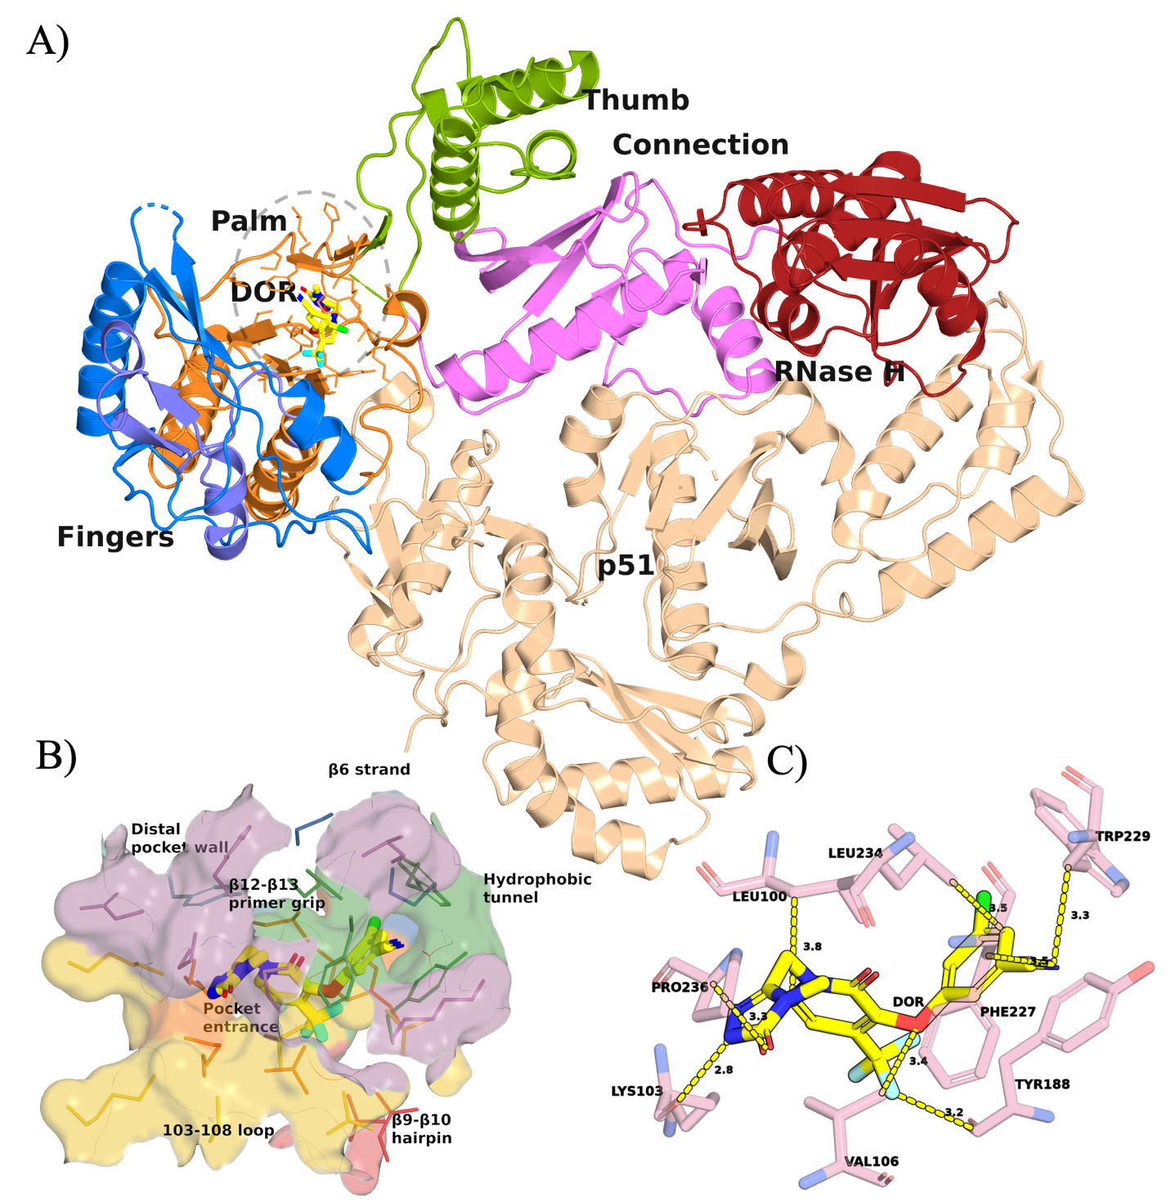
Figure 1: Crystal structure of DOR bound to WT RT (PDB ID: 4NCG). (A) Annotated structure of WT RT in complex with DOR simulated in this work. The NNIBP including DOR is highlighted in a light gray oval. (B) Visualization of DOR within the NNIBP, segmented into seven regions: β6 strand (blue), Pocket entrance (orange), 103-108 loop (yellow), Hydrophobic tunnel (green), β9-β10 hairpin (red), β12-β13 primer grip (purple), Distal pocket wall (teal). (C) Minimum heavy atom distances between DOR (yellow) and eight key NNIBP residues (pink).
This unique resistance profile has allowed DOR to become an integral component of the standard of care in ART. Yet the limited availability of DOR-resistance data has precluded its use in persons with pre-existing NNRTI resistance. To investigate mechanisms of DOR resistance and explore computational approaches to fill gaps in DOR susceptibility data, we performed all-atom explicit solvent molecular dynamics (MD) simulations on 19 RT-DOR complexes, corresponding to wild-type (WT) RT and 18 DOR-associated genotypes. Our results demonstrate that computational approaches relying on a combination of physics-based molecular dynamics simulations and machine learning models can correlate with, and provide structural interpretations for, mutation-induced changes in DOR susceptibility to HIV. Such computational approaches could potentially be used to predict the risk of prescribing DOR in people with pre-existing NNRTI resistance mutations in the clinic as well as for rational design of novel NNRTIs with higher genetic barriers to drug resistance in the laboratory.
Results
DOR Phenotypic susceptibility landscape
We assembled a panel of 18 DOR-associated genotypes for simulation together with WT RT. These genotypes were selected to cover three distinct categories:
- Negative controls: well-established low-impact control mutations associated with little, if any, reduction in DOR susceptibility. These include K103N, V106I, Y181C, and G190A.
- Positive controls: canonical DOR-associated resistance mutations and mutation patterns, consistently associated with reduced susceptibility. These were chosen to be K103N+M230L, V106A, Y188L, Y318F, A98G+F227C, V106A+F227L, V106A+L234I, V106A+P225H, and V106I+F227C.
- Uncertain phenotype: mutations and mutation patterns associated with limited or inconsistent reductions in susceptibility. These were K103N+L100I, K103N+P225H, V106I, V106M, G190E, and G190S.
Table 1 summarizes the median fold-change in DOR susceptibility used to define the panel and Supplementary Table 1 traces the isolate-level data indexed in the Stanford HIVDB (https://hivdb.stanford.edu/). The susceptibility data were derived from assays performed using the Monogram PhenoSense assay and the relatively similar Merck reporter-gene assay. Isolates undergoing testing were either site-directed mutants or clinical isolates for which known NNRTI-resistance mutations were specified.
Table 1. Fold-change in DOR susceptibility associated with selected genotypes
Mutation category | Mutation | Median fold-change in susceptibility vs WT | Number of isolates | Raw fold-change values | Primary source studies
Negative Control | V106I | 1.1 | 2 | [0.8, 1.4] | Lai et al (2014)³¹; Orkin et al (2026)¹⁰
 | K103N | 1.2 | 6 | [0.6, 1.2, 1.2, 1.3, 2.8, 3.0] | Lai et al (2014)³¹
 | Y181C | 1.4 | 4 | [1.2, 1.3, 1.5, 6.0] | Lai et al (2014)³¹
 | G190A | 2.7 | 2 | [1.8, 3.6] | Lai et al (2014)³¹
Positive Control | Y318F | 11 | 3 | Unavailable (see Table 2 in source study) | Asante-Appiah et al (2021)³⁴
 | V106A | 9.6 | 2 | [7.1, 9.6, 28] | Lai et al (2014)³¹; Feng et al (2014)³²
 | A98G+F227C | 93 | 1 | [93] | Lai et al (2018)³⁵
 | V106I+F227C | 105 | 1 | [105] | Lai et al (2018)³⁵
 | V106A+F227L | 106 | 1 | [106] | Orkin et al (2026)¹⁰
 | Y188L | 149 | 6 | [95, 116, 116, 181, 181, 182] | Lai et al (2014)³¹; Hazuda et al (2018)³⁶; Lai et al (2018)³⁵; Orkin et al (2026)¹⁰
 | V106A+P225H | 153 | 2 | [95, 210] | Lai et al (2018)³⁵; Orkin et al (2026)¹⁰
 | V106A+L234I | 161 | 2 | [150, 173] | Feng et al (2014)³⁷; Smith et al (2016)³⁷
 | K103N+M230L | 36 | 1 | [36] | Lai et al (2018)³⁵
Uncertain Phenotype | V106M | 3.4 | 1 | [3.4] | Lai et al (2014)³¹
 | G190S | 5.2 | 4 | [1.5, 4.5, 5.9, 11] | Lai et al (2014)³¹
 | K103N+L100I | 6.8 | 8 | [2.7, 4.5, 4.6, 5.1, 8.4, 10, 11, 19] | Lai et al (2014)³¹
 | K103N+P225H | 7.8 | 2 | [5.7, 10] | Lai et al (2014)³¹
 | G190E | 18 | 1 | [18] | Lai et al (2018)³⁵

Global RT-DOR energetic analysis weakly correlates with the DOR phenotypic susceptibility landscape
We first asked whether short MD simulations could recapitulate the phenotypic DOR susceptibility landscape using a global destabilization metric derived from binding energy calculations. Starting from the published X-ray crystal structure of WT RT bound to DOR (Figure 1), we introduced each resistance-associated mutation in silico and applied restrained followed by unrestrained energy minimization to generate 18 mutant RT-DOR complex structures corresponding to the curated genotype panel described above. The RT variant sequences simulated in this study are provided in Supplementary Table 2.
For each system, we ran three independent 100ns all-atom, explicit-solvent production simulations and calculated the average MM/GBSA energy over the final 20 frames of each trajectory, corresponding to approximately the final 10ns. For each mutant genotype, we then computed WT-referenced energetic changes, ΔΔG, for the total MM/GBSA energy and for four individual energy components: van der Waals, electrostatic, generalized Born polar solvation, and nonpolar surface area contributions. In this framework, a positive WT-referenced energy shift, ∆∆G, represents a global destabilization of the bound RT-DOR complex.
Overall, neither the total WT-referenced energetic shifts nor most individual energy components correlated with the available phenotypic fold-change data (Table 2 and Supplementary Table 3). The main exception was the electrostatic component, which showed a weak but statistically insignificant correlation with fold-change values among the negative and positive control mutations (Figure 2).
Table 2. WT-referenced MM/GBSA energy shifts for DOR-bound RT variants*
Mutation category | Mutation | ∆∆G_{Total} (kJ/mol) | ∆∆G_{vdW} (kJ/mol) | ∆∆G_{elec} (kJ/mol)
Negative Control | V106I | -78 ± 93 | -68 ± 84 | 2.1 ± 3.9
 | K103N | 40 ± 102 | 25 ± 105 | -7.9 ± 3.3
 | Y181C | 5 ± 79 | -19 ± 67 | -2.5 ± 4.3
 | G190A | -22 ± 122 | -32 ± 110 | 1.9 ± 3.9
Positive Control | Y318F | 37 ± 157 | 30 ± 138 | 0.8 ± 8.1
 | V106A | -62 ± 98 | -73 ± 83 | -1.6 ± 3.1
 | A98G+F227C | -44 ± 99 | -67 ± 92 | -1.6 ± 4.7
 | V106I+F227C | 183 ± 116 | 155 ± 126 | 9.6 ± 2.4
 | V106A+F227L | -59 ± 85 | -76 ± 77 | 4.9 ± 1.7
 | Y188L | 82 ± 213 | 64 ± 189 | 10.5 ± 6.1
 | V106A+P225H | -89 ± 87 | -82 ± 83 | 4.7 ± 3.7
 | V106A+L234I | -79 ± 95 | -77 ± 85 | -0.9 ± 2.0
 | K103N+M230L | 83 ± 40 | 72 ± 41 | -8.7 ± 6.4
Uncertain Phenotype | V106M | 15 ± 160 | 23 ± 153 | 1.3 ± 6.0
 | G190S | 38 ± 130 | 22 ± 116 | 12.8 ± 5.2
 | K103N+L100I | -75 ± 94 | -83 ± 83 | -10.6 ± 7.0
 | K103N+P225H | -24 ± 103 | -61 ± 95 | -2.4 ± 7.8
 | G190E | 141 ± 86 | 90 ± 69 | 4.6 ± 2.2
*Values are averages over the last 20 frames (~10ns) of 3 independent 100ns production MD simulations

From the perspective of WT-referenced electrostatic shifts, all negative control mutations showed little to no destabilization, with K103N appearing slightly more stable than WT (∆∆G_{elec} ~ -7.9 kJ/mol). In contrast, four of the eight positive control mutations—V106I+F227C, V106A+F227L, Y188L, and V106A+P225H—had positive ∆∆G_{elec} values within error, consistent with reduced electrostatic stability relative to WT. Among the six mutations with uncertain phenotype, G190S and G190E were electrostatically less stable than WT, whereas K103N+L100I and K103N+M230L were more stable than WT.
Although these global energetic metrics did not fully explain the DOR susceptibility landscape, several mutation-specific patterns suggested possible links to local structural mechanisms of resistance (Table 2 and Supplementary Table 3). For example, Y188L showed large trajectory-to-trajectory variation in the van der Waals component, with a ∆∆G_{vdW} standard deviation of approximately 327 kJ/mol. Visual inspection indicated that this variation arose from alternate conformations of Leu188, which produced distinct DOR packing arrangements across replicates, some resembling WT and others deviating substantially from it. Similarly, V106A+F227L and V106I+F227C showed qualitatively different van der Waals shifts relative to WT, with ∆∆G_{vdW} mean values of −76 kJ/mol and +154 kJ/mol, respectively. Thus, mutations affecting the same positions and producing similar phenotypic resistance profiles may nevertheless perturb the RT-DOR complex through distinct local structural mechanisms.
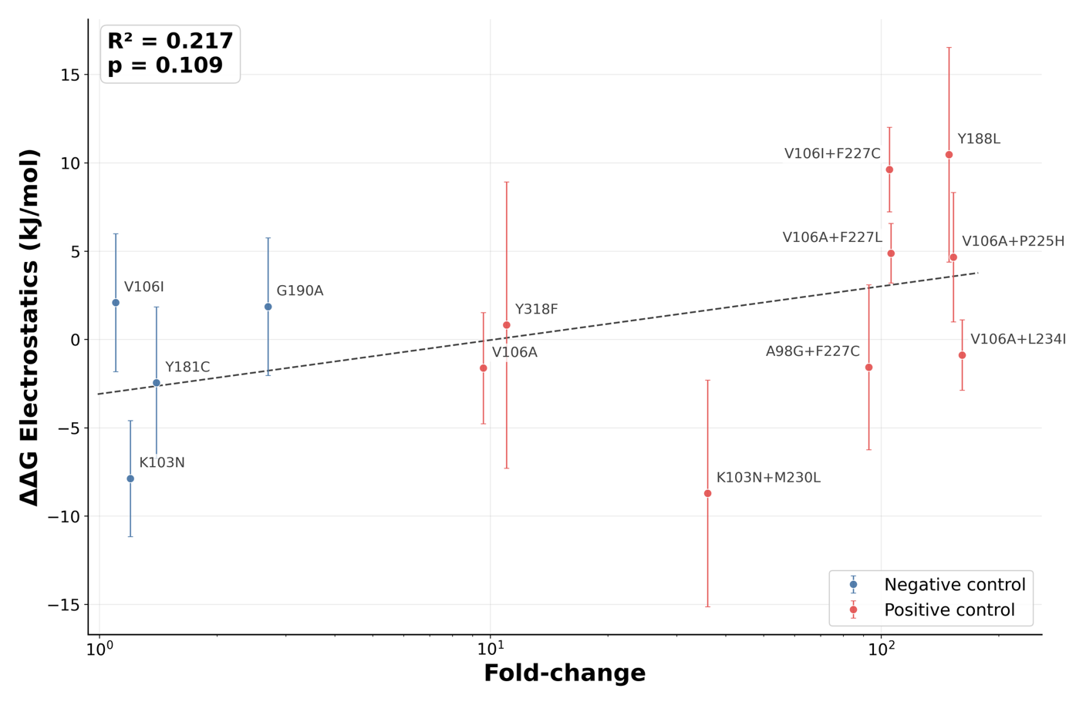
Figure 2: Changes in electrostatic component of the RT-DOR binding energy vs WT weakly correlates with phenotypic DOR susceptibility data of the negative and positive control mutations. Data correspond to the average MM/GBSA electrostatic components over the last 20 frames (~10ns) sampled from 100ns all-atom MD simulations of each system. Error bars represent the standard error of the mean over N = 3 replicates. Dashed trend line shows an ordinary least-squares linear regression between electrostatic energy shift and resistance fold-change on a log scale. R² is the coefficient of determination for this fit and the p-value tests whether the regression slope differs from zero using the standard two-tailed t-test.
Together, these results suggest that a simple global destabilization model is insufficient to explain the DOR susceptibility landscape over the simulation timescales sampled here. However, the weak electrostatic association with phenotype, together with mutation-specific van der Waals signatures and heterogeneous local packing behavior, raised the possibility that DOR resistance is better captured by localized structural rearrangements than by aggregate binding energy shifts alone.
Local trajectory-level analysis reveals WT RT-DOR contact occupancy profile
We next asked whether DOR resistance might instead be encoded in mutation-specific redistribution of local binding-pocket interactions. This hypothesis was motivated by two considerations. First, the NNIBP is sufficiently compact that short MD simulations may resolve local contact rearrangements even if they do not accurately recover full binding thermodynamics. Second, prior structural studies of NNRTI resistance suggest that reduced susceptibility can arise from altered pocket geometry, shifted anchoring interactions, and increased ligand pose heterogeneity, without necessarily producing a simple global affinity signal.^{25,38,39} We therefore shifted to systematic residue-level characterization of DOR contacts within the NNIBP.
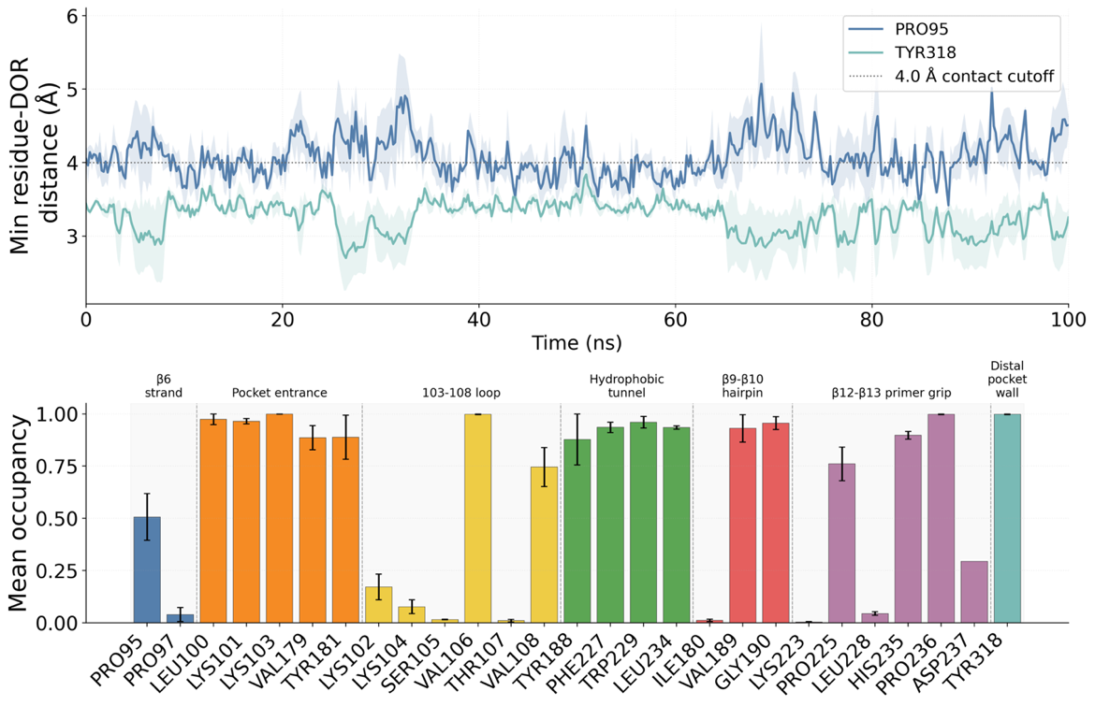
Figure 3: Local trajectory-level contact analysis between DOR and NNIBP residues in WT RT-DOR simulations. Top panel: Trajectories of minimum heavy atom distances between DOR and two exemplary NNIBP residues, Pro95 and Tyr318, observed in 100ns MD simulations of the WT DOR-RT complex performed in triplicates. Solid lines indicate the mean trajectory and lighter color bands show the standard error of the mean across N = 3 replicates in this as well as other trajectory visualizations in this study. The dotted line represents the 4.0 Å cutoff used to define each contact. Bottom panel: Mean contact occupancy computed for all RT residues that came in contact with DOR at any point during the simulations, segregated by NNIBP regions (cf. Figure 1).
To define the WT local interaction landscape, we quantified residue-level DOR contacts across WT RT-DOR simulations. A residue was classified as contacting DOR in a given frame if the minimum heavy-atom distance between that residue and DOR was less than 4.0 Å (Figure 1). For each residue, we then calculated mean contact occupancy as the fraction of analyzed simulation frames in which this contact criterion was satisfied. This analysis was performed for all residues that contacted DOR at any point in any WT RT-DOR trajectory, yielding a residue-level mean contact occupancy profile for the WT complex (Figure 3).
The WT contact occupancy profile revealed three notable features. First, DOR maintained persistent contacts with many NNIBP residues: of the 27 residues that contacted DOR at least once during the WT simulations, 18 had mean occupancy > 0.5, indicating contact for more than half of the simulation time. Second, several NNIBP regions showed consistently high occupancy, including the pocket entrance (5 residues), hydrophobic tunnel (4 residues), and distal pocket wall (1 residue), each with an average mean occupancy across residues within the region exceeding 0.9. Third, contact behavior was highly residue-specific, as neighboring positions could display markedly different mean occupancies, exemplified by positions 105 versus 106 and 180 versus 181. Together, these results establish a WT reference map of stable and heterogeneous DOR-pocket interactions against which mutation-associated local rearrangements can be evaluated.
Contact occupancy profiles encode mutation-sensitive structural signals of DOR resistance
We then extended the contact analysis across all trajectories in the genotype panel to identify residues whose DOR-contact behavior changed preferentially in specific mutation backgrounds (Figure 4). For each mutant genotype, we compared residue-level mean occupancy against the WT reference profile, thereby generating a mutation-associated occupancy shift map across the NNIBP.
This systematic screen revealed two broad patterns. First, residues at the mutated positions themselves generally showed only modest changes in DOR contact occupancy, with few shifts exceeding 0.1, relative to WT. The main exceptions were V106I+F227C, which reduced occupancy at the mutated position Phe227 by 0.28, and K103N+P225H, which reduced occupancy at the mutated position Pro225 by 0.12 relative to WT. Second, the largest mutation-associated occupancy shifts typically occurred at residues that were not themselves mutated. For example, G190E reduced DOR contact occupancy at the unmutated residue Val179 by 0.85 relative to WT, whereas V106A+L234I increased occupancy at the unmutated residue Ser105 by 0.87. These observations suggest that resistance-associated mutations can remodel the local DOR interaction network indirectly, rather than simply disrupting contacts at the mutated residue.
Comparing occupancy-shift patterns between positive and negative control mutations further suggested that specific residue-level contacts may function as reporter coordinates for resistance-associated structural rearrangements. Such reporter residues or reporter groups as local readouts of protein conformational dynamics are commonly used to describe complex high-dimensional conformational changes through low-dimensional structural descriptors, otherwise called order parameters, collective variables, or reaction coordinates.^{40–42} In our context, reporter coordinates are residue-level DOR-contact features whose occupancy changes reflect mutation-associated remodeling in the NNIBP or DOR pose fluctuations.
For example, Y188L, a canonical DOR resistance-associated mutation, increased DOR contact occupancy at Lys102 by 0.23 and decreased occupancy at Pro225 by 0.16 relative to WT. In contrast, Y181C, a negative control mutation in this analysis, produced minimal occupancy changes at the same positions, with shifts of approximately ±0.01 relative to WT for Lys102 and Pro225, respectively. These divergent patterns suggest that DOR interactions with Lys102 and Pro225 may serve as local structural readouts of resistance-associated pocket remodeling, even when these residues themselves are not necessarily the primary sites of mutational perturbation.

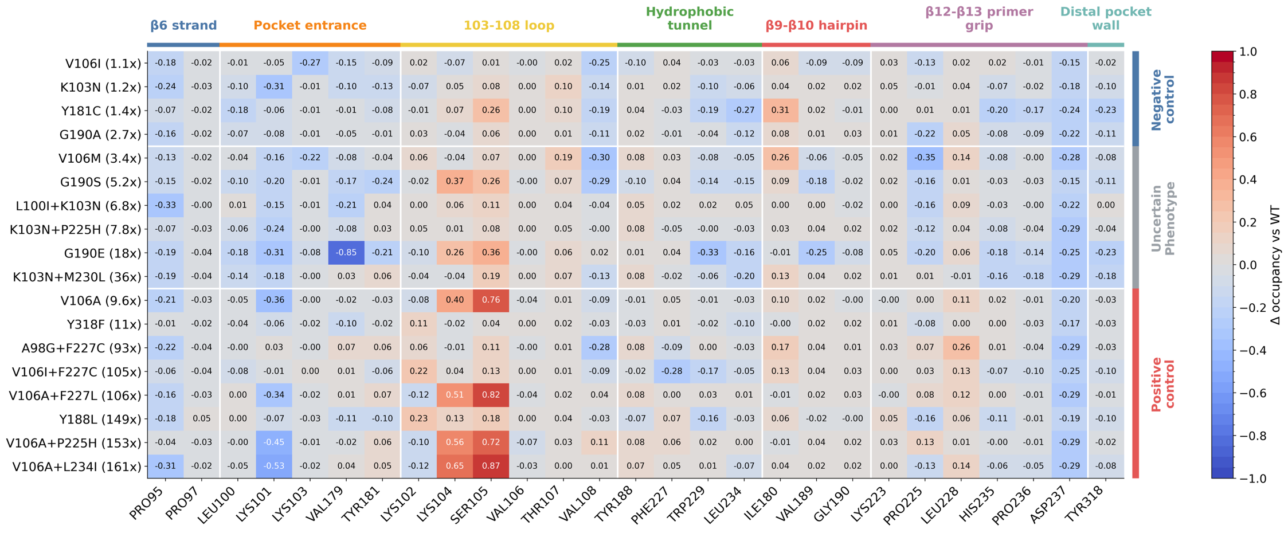
Figure 4: Mutation-associated changes in mean occupancy. X-axis lists all the 27 residues that were ever in contact with DOR in WT RT-DOR simulations. Y-axis lists the 18 DOR-associated genotypes including negative controls, positive controls, and the uncertain phenotype set. Values inside each cell in the heatmap represent the change in mean contact occupancy vs WT for each residue as observed in MD simulations for each genotype.

Because many residue-level contacts were evaluated, we treated candidate reporter coordinates as hypothesis-generating features rather than as definitive biomarkers of resistance based solely on effect size. To reduce the likelihood that these signals reflect chance observations from multiple comparisons, we prioritized residues that satisfied several criteria: reproducible occupancy shifts across independent trajectories, large WT-referenced effect sizes, consistency within structurally interpretable NNIBP regions, and differential behavior between positive and negative control mutations. Thus, reporter coordinates were not selected because they showed an anomalous value in a high-dimensional screen, but because they captured consistent, mutation-associated changes in DOR-pocket organization that were also interpretable in the structural context of the RT-DOR complex.
We further addressed this concern by comparing observed occupancy shifts against an empirical null distribution generated by trajectory-level resampling. Specifically, mutation labels were permuted across replicate trajectories, and the largest absolute occupancy shift observed across all 27 WT-contacted residues was recorded for each permutation. This global maximum statistic estimates the magnitude of occupancy shift expected by chance when applying the same residue-screening procedure to the same trajectory set. Only two reporter coordinates were observed to have absolute WT-referenced occupancy shifts exceeding the 90th percentile of this null distribution (Supplementary Figure 1) – Ser105 for V106A containing genotypes (V106A, V106A+P225H, V106A+F227L, V106A+L234I) and Val179 for G190E.
V106A-containing genotypes shift DOR toward the 103-108 loop
The V106 region is a major determinant of DOR susceptibility because V106 directly contacts the central pyridone core of DOR. However, in vitro susceptibility assays and clinical prevalence data indicate that not all V106 mutations behave equivalently. V106I, a polymorphic substitution observed to some extent in the general population, generally has little effect on DOR susceptibility when present alone, whereas V106A is a canonical DOR resistance mutation and serves as the first step in several high-resistance combination pathways. While V106M is not a canonical DOR mutation, limited data suggest it could cause low-level resistance to DOR.
The contact occupancy analysis (Figure 4) highlighted Lys104 and Ser105 as informative reporter residues for this distinction. Both residues sit near the pocket entrance within the 103-108 loop region, and both showed preferential shifts in DOR proximity in V106A-containing trajectories. In direct comparisons among WT, V106I, and V106A, the V106A simulations showed a reproducible shift of DOR toward the 103-108 loop, bringing DOR closer to Ser105 and often also to Lys104 (Figure 5).
The most plausible interpretation is that replacement of valine with alanine removes hydrophobic bulk from a direct DOR-contact site and allows the bound ligand to redistribute toward a slightly more 103-108 loop-shifted local pose ensemble. In that ensemble, contacts with Lys104 and Ser105 can arise as compensatory interactions, but these appear to be secondary to the loss of optimal packing at position 106. The contrast with V106I is informative: isoleucine preserves a branched hydrophobic side chain at position 106, which mitigates local geometry perturbation.
According to this analysis, the mutation V106M, despite exhibiting ~3x-fold reduction in DOR susceptibility, is predicted to be closer to V106I than V106A in terms of the DOR interaction network within the NNIBP (Figure 4). Specifically, V106M does not display a shift toward Lys104 and Ser105 (mean occupancy -0.04 and 0.07 vs WT). On the other hand, if V106A first redistributes the DOR pose toward the 103-108 loop, then additional substitutions around P225, F227, or L234 can further destabilize an already altered local contact network. Accordingly, all three combinations display mean contact occupancy > 0.5 vs WT toward both Lys104 and Ser105. This model is consistent with the observation that V106A leads to high-level DOR resistance in combination with secondary hydrophobic tunnel and primer grip mutations.
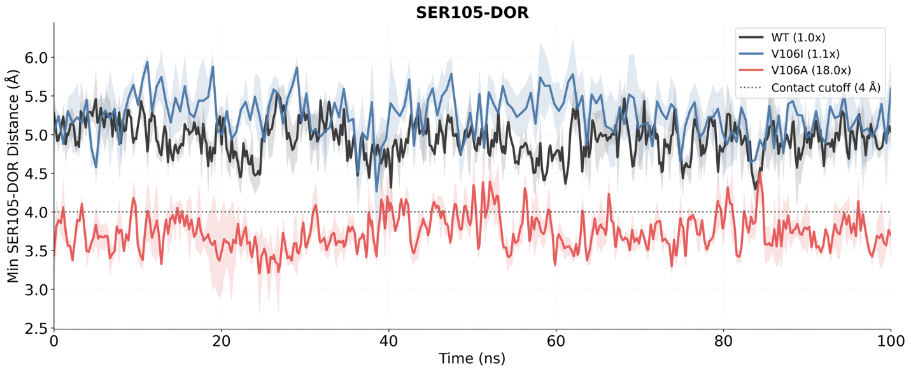
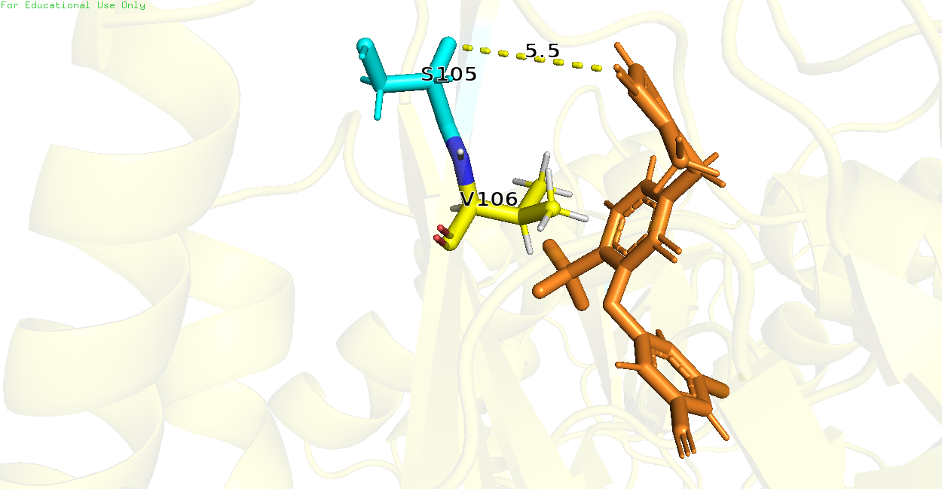
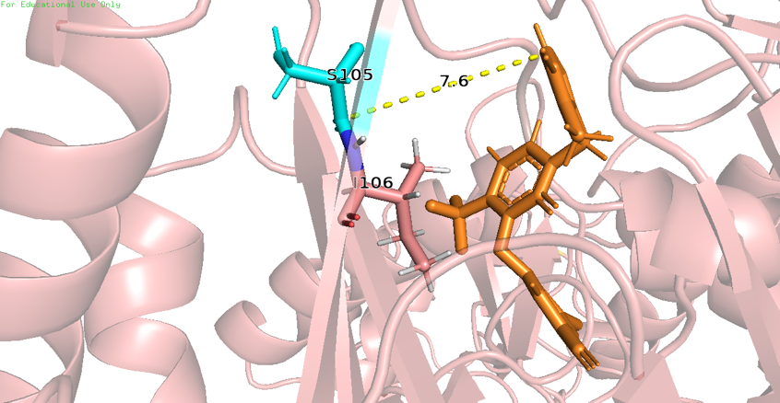
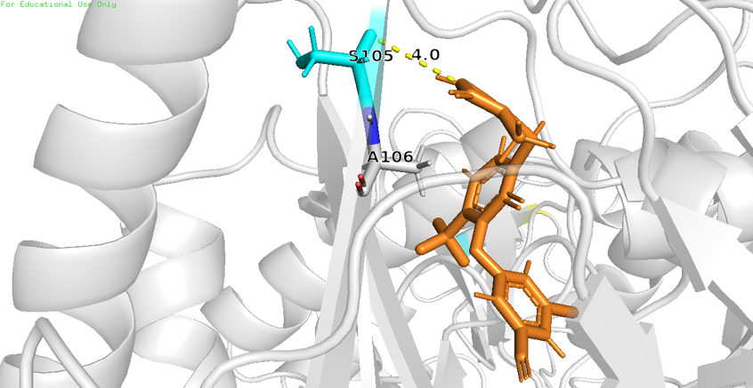
WT
V106I
V106A
Figure 5: V106A preferentially alters DOR pose, causing Ser105 to shift closer to DOR. (Top) Minimum distance between heavy atoms of Ser105 and DOR observed in MD simulations of WT, V106I, and V106A. (Bottom) Snapshots of a single frame across WT, V106I, and V106A trajectories, showing Ser105 shifted closer to DOR in case of V106A as compared to WT and V106I.
V106I+F227C reaches high resistance through a different local route than V106A+F227L
V106I+F227C and V106A+F227L are both highly DOR-resistant genotypes, but the contact occupancy analysis suggests that they achieve resistance through distinct structural mechanisms (Figure 4). V106A+F227L falls within the broader V106A genotype family and, accordingly, retains the characteristic 103–108 loop-shifted signature observed in other V106A-containing backgrounds. Specifically, it shows a local shift toward Ser105 and Lys104.
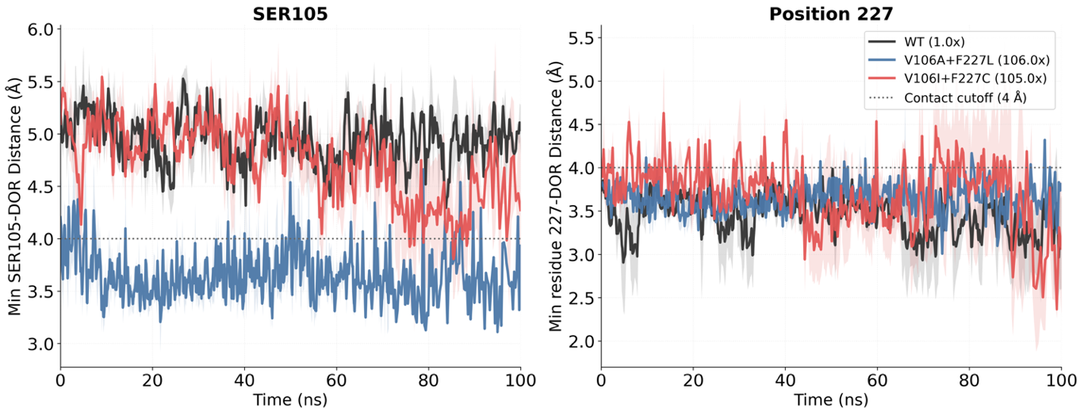
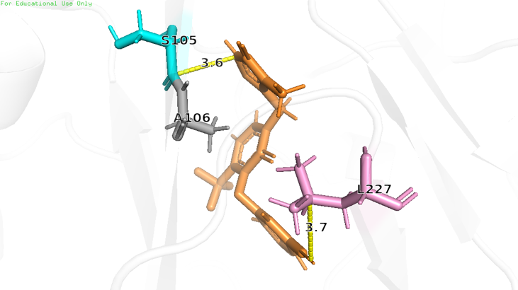
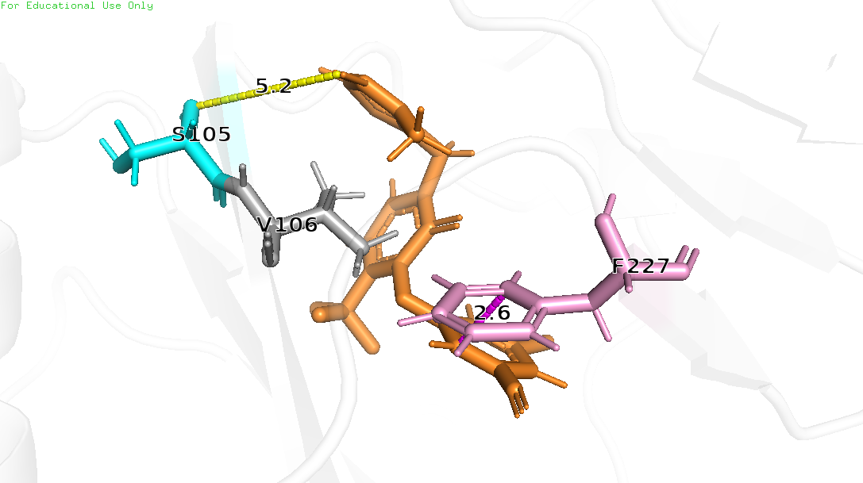
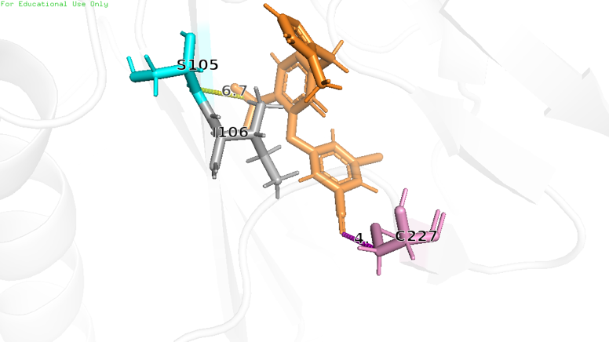
WT
V106A+F227L
V106I+F227C
Figure 6: V106I+F227C exhibits alternative dynamics than V106A+F227L. (Top) Minimum distances between heavy atoms of Ser105 and DOR as well as Position 227 and DOR observed in MD simulations of WT, V106A+F227L, and V106I+F227C. (Bottom) Snapshots of a single frame across WT, V106A+F227L, and V106I+F227C trajectories, showing Ser105 shifted closer to DOR in case of V106A+F227L (but not in case of V106I+F227C or WT); and an alternate DOR pose in case of V106I+F227C that is further away from residue 227 than in WT or V106A+F227L.
By contrast, V106I+F227C does not display this pattern. Instead, it combines a relatively modest V106 substitution with a hydrophobic tunnel substitution at position 227, producing alternative local conformations centered around the 227 region. In these simulations, DOR becomes transiently more separated from residue 227 than in either WT or V106A+F227L (Figure 6).
This comparison is important because the two genotypes have similar median DOR fold-change values in the available phenotype data, yet appear to reach that shared resistance phenotype through different structural routes. For DOR resistance interpretation, these results suggest that structurally distinct genotype classes can converge on comparable susceptibility outcomes through different local reorganizations of the binding pocket.
G190E perturbs the pocket entrance and weakens Val179 contact
Publicly available phenotype data suggest that G190E may reduce DOR susceptibility. We therefore compared WT, G190A, and G190E to ask whether introduction of a negatively charged glutamate at position 190 produces local structural effects distinct from the more common G190A substitution that is known to have little to no impact on DOR susceptibility.
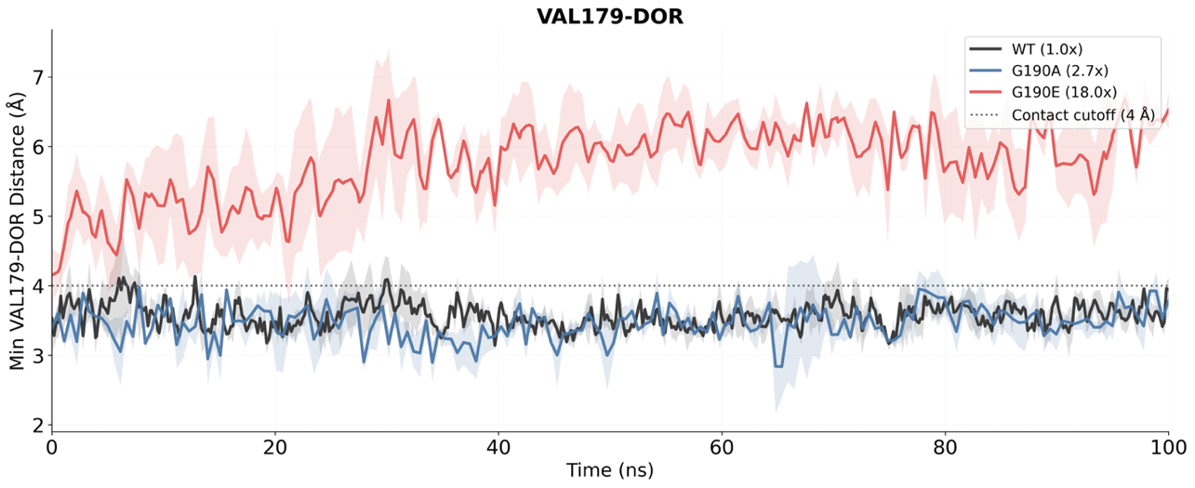
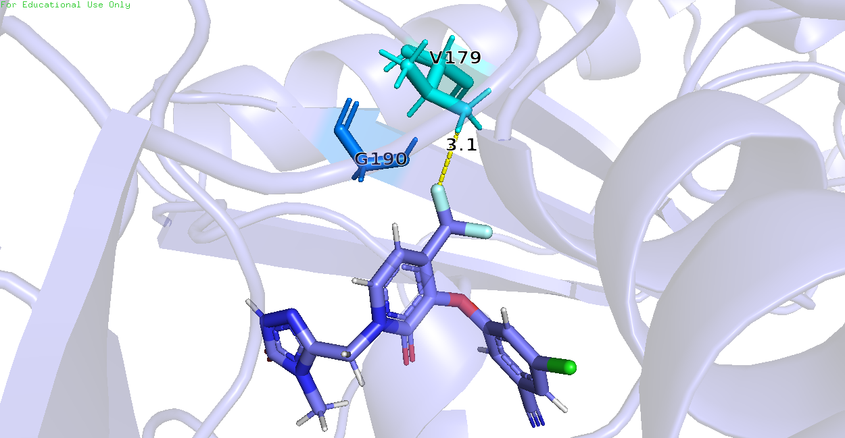
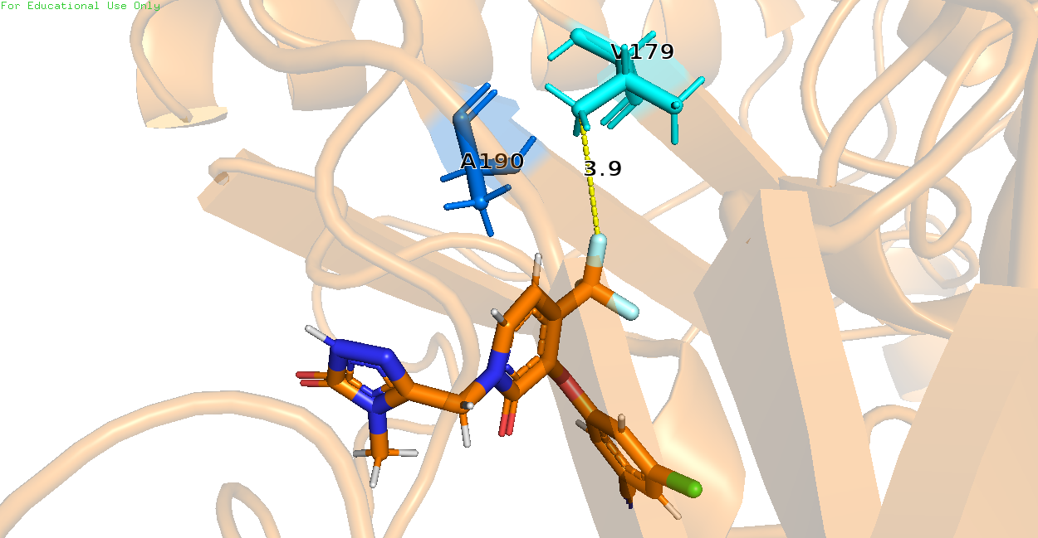
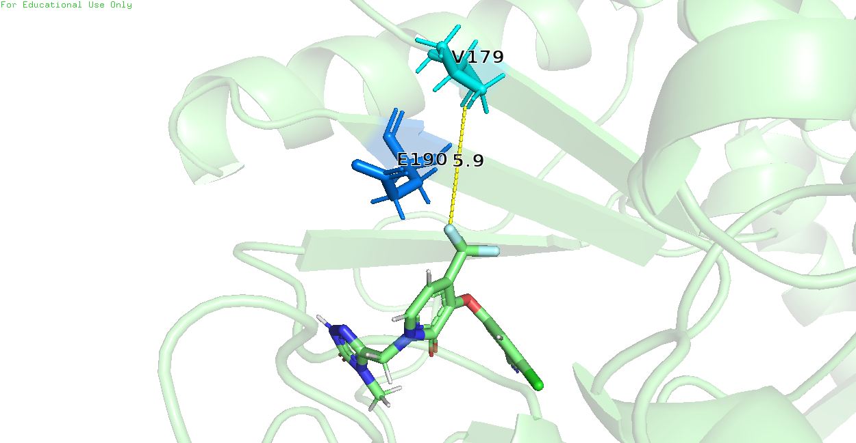
Figure 7: G190E preferentially disrupts β9-β10 hairpin, causing Val179 to lose contact with DOR. (Top) Minimum distance between heavy atoms of Val179 and DOR observed in MD simulations of WT, G190A, and G190E. (Bottom) Snapshots of a single frame across WT, G190A, and G190E trajectories, showing Val179 further away from DOR in case of G190E but not in WT and G190A.
WT
G190A
G190E

The panel-wide contact occupancy analysis identified Val179 as the clearest reporter residue for this comparison (Figure 4). Val179 lines the pocket entrance and showed strong genotype-specific contact loss in G190E. In direct trajectory comparisons, G190E caused marked separation of Val179 from DOR that was not observed in WT or G190A (Figure 7). This effect was accompanied by broader local perturbation of the pocket environment.
The simplest interpretation is that the G190E side chain introduces a local electrostatic and steric perturbation in the β9-β10 hairpin that propagates into the Val179 side of the pocket, thereby weakening DOR packing on that face of the binding site. G190A, which lacks this charge switch and imposes a much smaller structural perturbation, did not produce the same effect. These results therefore support G190E as a plausible DOR-relevant genotype deserving further targeted phenotypic study.
Interestingly, G190S appears to have a less pronounced impact on the DOR interaction network than G190E, but more so than G190A (Figure 4). Specifically, G190S displays a mean occupancy shift of -0.17 vs WT, while G190A displays a mean occupancy shift of only -0.05 vs WT for Val179. Furthermore, G190S and G190E might share a structural mechanism with the V106A family mutations as they both exhibit a mean occupancy shift > 0.25 vs WT for Lys104 and Ser105 (Figure 4). This observation suggests that multiple structural mechanisms may overlap to contribute to DOR resistance.
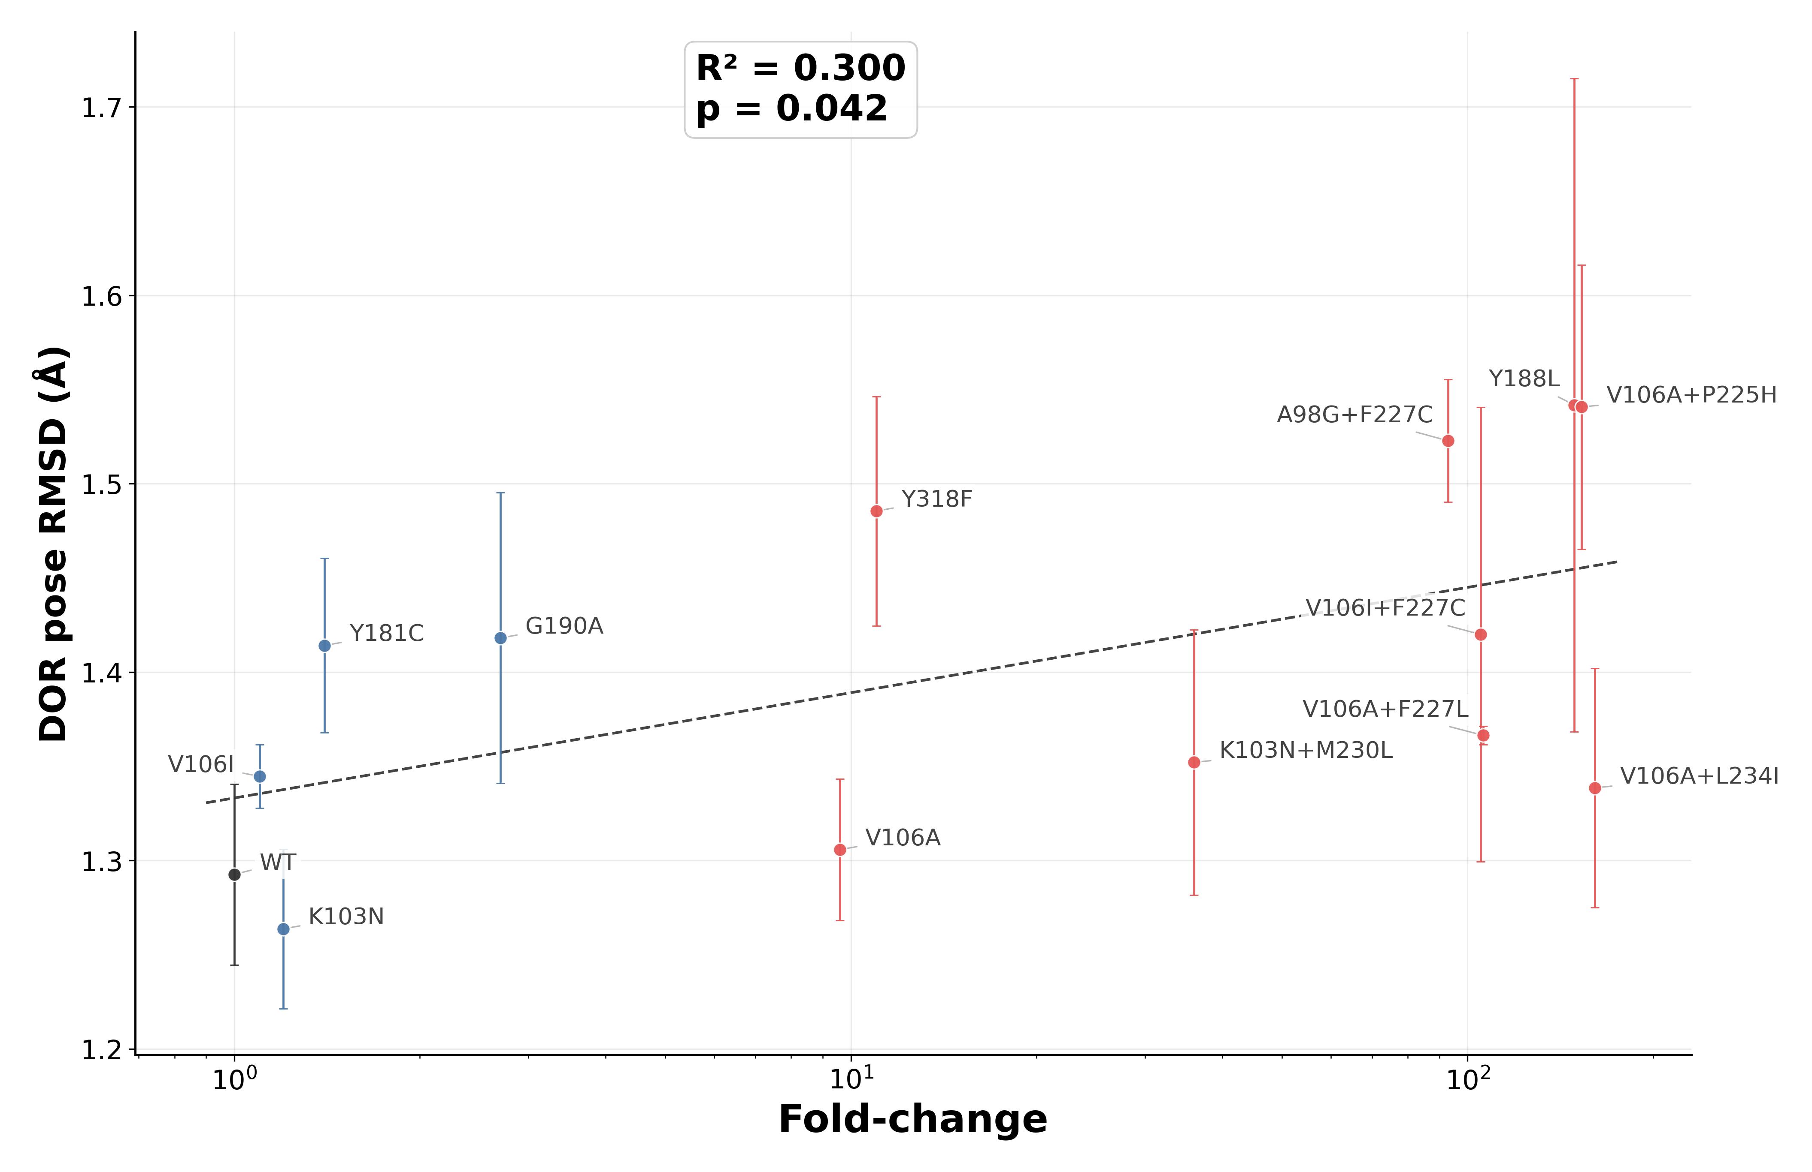
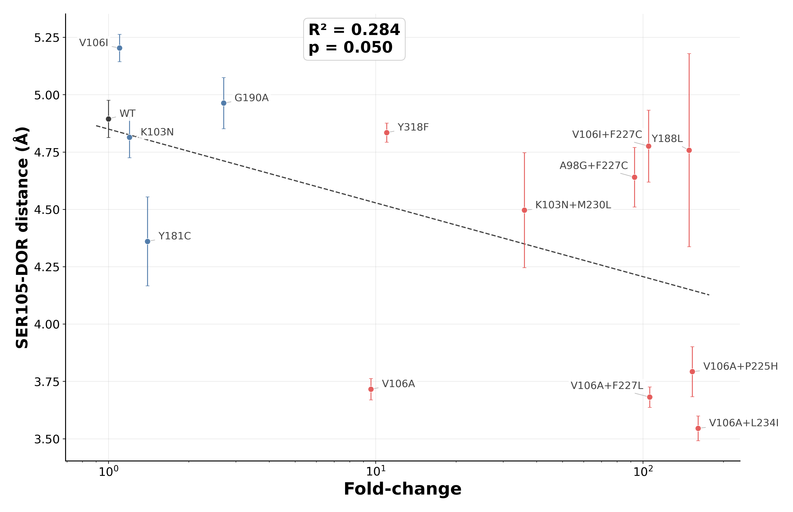
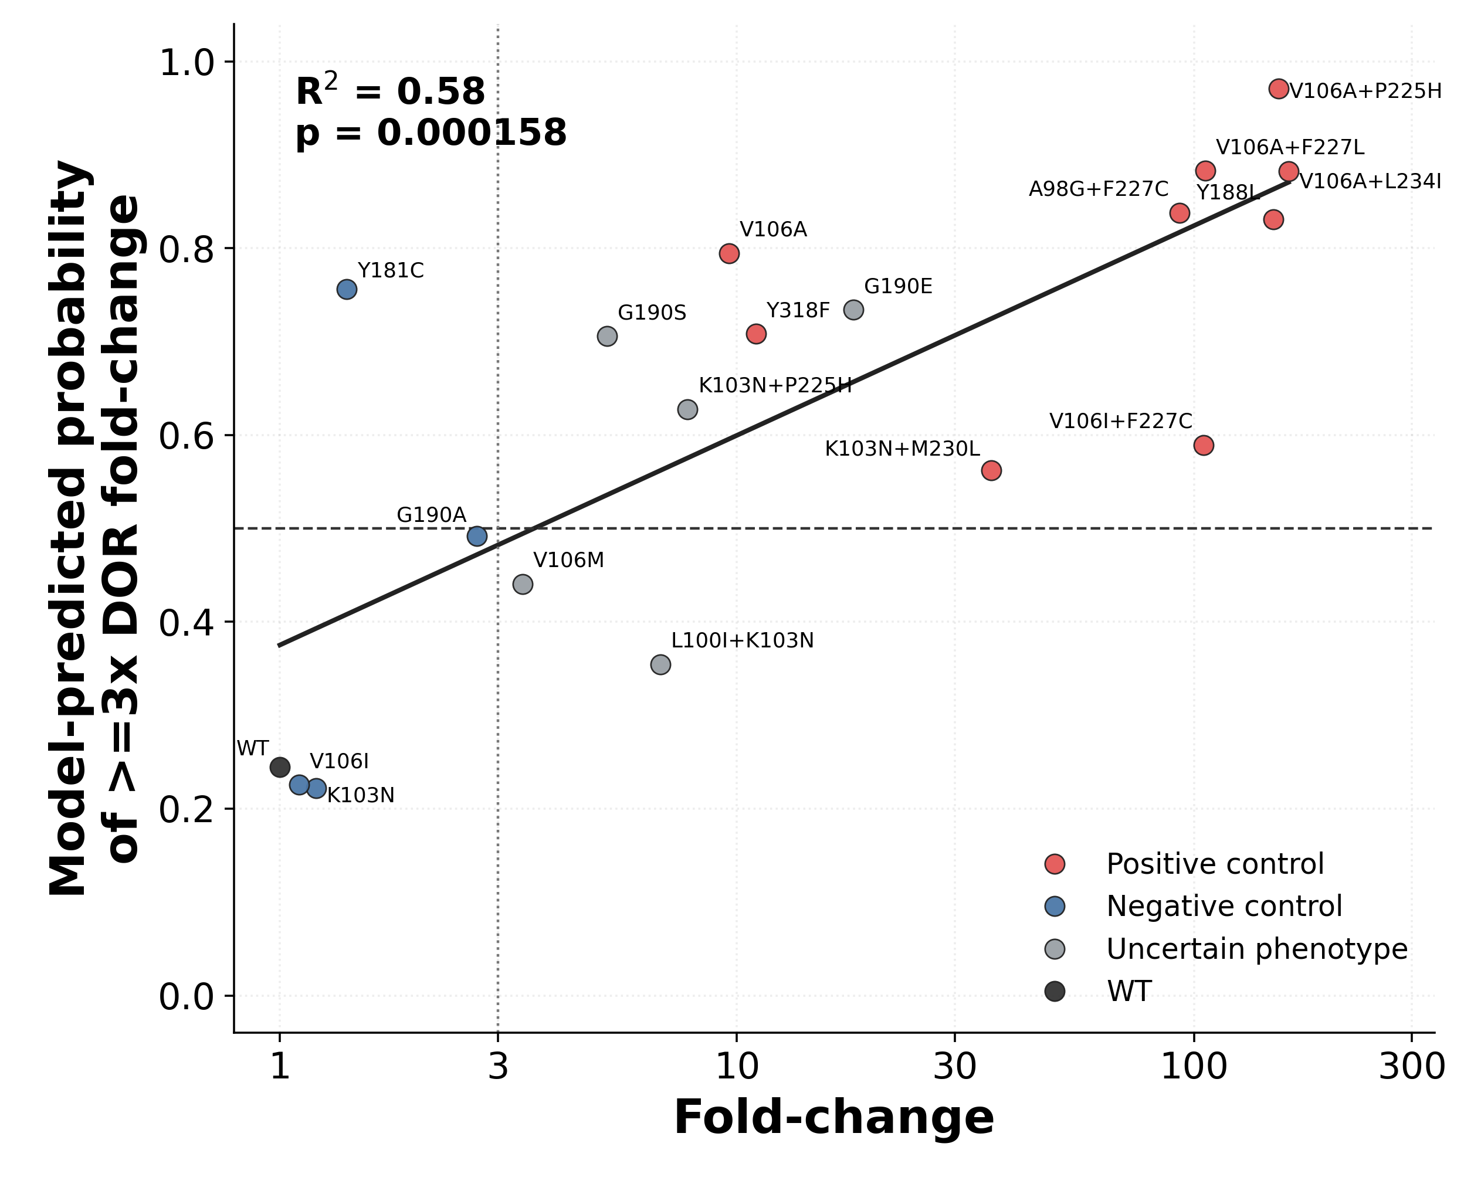
A parsimonious 2-feature logistic regression model summarizes the separation between low- and high-resistance controls
A)
B)
C)
Figure 8: Performance of Logistic Regression model relating MD simulation features to DOR susceptibility. (A) Output of the logistic regression model, i.e. the probability of a mutation exceeding 3x DOR fold-change, plotted against median DOR fold-change in susceptibility on the log scale. The dotted lines represent the thresholds for the labels. The dashed trend line is a linear regression fit of the data. R² is the coefficient of determination for this fit and the p-value tests the null hypothesis that the true linear correlation between the two variables is zero. (B) Correlation of the raw Ser105-DOR distance with fold-change data of the positive and negative control mutations. (C) Correlation of the raw DOR pose RMSD metric with fold-change data of the positive and negative control mutations.

After identifying local structural signatures across the genotype panel, we asked whether a small number of MD-derived variables could summarize the distinction between low- and high-resistance genotypes. Genotypes were labeled as high resistance if the median DOR fold-change was ≥3 and low resistance otherwise; WT was included as a low-resistance reference. We then fit a regularized logistic regression model using two mechanistically motivated features (Figure 8):
- Ser105-DOR minimum distance that captures the 103-108 loop-proximal shift observed in V106A-containing genotypes.
- Root mean squared deviation (RMSD) of DOR backbone atoms from the crystal structure that summarizes general atomic rearrangement of the drug.
These two features were determined using a multi-step feature ablation approach: starting with a large set of MD-derived features, we trained regularized logistic regression models on the control mutations (including WT) using one less feature and recursively picked the model with the best accuracy in each step. The final model was fit on only the data from negative and positive control mutations. The output of the trained model was the probability that a genotype, parameterized by MD-derived values of the 2 final structural features, would exhibit ≥3-fold change in DOR susceptibility. The probability threshold distinguishing class labels was fixed at 0.5.
This parsimonious model separated the low- and high-resistance control mutations with strong performance in replicate-level grouped cross-validation, achieving 13/14 correct classifications. When applied across the full panel, the resulting model probabilities correlated with the continuous phenotypic fold-change values (R² = 0.58, p = 1.6 × 10⁻⁴). WT was assigned a low probability value, whereas all positive-control genotypes were assigned high probabilities. The only negative control mutation that was incorrectly predicted to have high DOR fold-change was Y181C. Among genotypes with limited or uncertain phenotype, K103N+P225H, G190E, and G190S received high model probabilities, while V106M and L100I+K103N were assigned low probabilities.

As a caveat, this model should be interpreted as a compact structural summary rather than as a validated clinical susceptibility predictor – the training set is small, the phenotype labels depend on a pragmatic 3-fold threshold, and bootstrap intervals remain wide for several genotypes (Supplementary Table 4). Nevertheless, the ability of three local MD-derived features to summarize much of the low-versus-high resistance separation supports the broader conclusion that DOR susceptibility landscape can be better explained by coordinated local rearrangements in the binding pocket than by a single global binding-energy metric.

Discussion
DOR poses an unusual resistance problem among second-generation NNRTIs. Like ETR and RPV, DOR retains activity against common NNRTI-associated backgrounds such as K103N, Y181C, and G190A, yet the pathways that reduce DOR susceptibility are distinct and increasingly relevant in clinical use. Specific substitutions such as Y188L, V106A, and Y318F, and combinations including V106I+F227C, V106A+F227L, and V106A+L234I, now recur across phenotypic studies, in vitro selection experiments, and clinical trial datasets. Despite these observations, publicly available isolate-level susceptibility data for DOR remain sparse. As of April 2026, Stanford HIVDB indexes only 134 DOR-associated isolates tested by the PhenoSense assay, compared with 330 for RPV and 1,193 for ETR. This mismatch between growing clinical relevance and limited public phenotype data for DOR resistance motivated the present study.

We asked whether short explicit-solvent MD simulations could provide a coherent structural framework for understanding known and limited-data DOR resistance genotypes. This choice was motivated by prior studies that successfully used such energy calculations from MD simulations to interrogate HIV resistance mutations in RT and Protease. However, we observed that WT-referenced energetic shifts, ∆∆G, derived from bound-state MD snapshots did not correlate well with the available phenotypic DOR landscape. Specifically, the average ∆∆G values of total MM/GBSA energy across independent replicates had no statistically significant association with the DOR phenotypic susceptibility values in our assembled panel. There may be several reasons for this observation. First, the computed MM/GBSA energy values fundamentally do not represent equilibrium binding free energies because the simulations do not sample the full bound and unbound state populations needed for a true free energy estimate. Second, though the simulations are performed in explicit solvent, the MM/GBSA calculations omit explicit solvent contributions that could have contributed to errors in the entropic components. Third, the simulations sample dynamics on a timescale that is much shorter than the conformational rearrangements and kinetic processes governing RT-DOR binding in vitro. We therefore recommend viewing the energetic analysis as a directional binding energy score rather than as a precise estimate for RT-DOR binding affinity.

Most of the energetic components behaved similarly. However, significant loss of RT-DOR interaction, such as loss of the aromatic pi-stacking interaction between the DOR chlorophenol ring and the RT Tyr188 sidechain in Y188L simulations led to a large WT-referenced total energy standard deviation between replicates of ~369kJ/mol, mainly driven by the van der Waals component. Moreover, V106A+F227L and V106I+F227C showed qualitatively different van der Waals shifts relative to WT (negative vs positive). Since van der Waals interactions capture residue packing efficiency, these observations, along with the weak but statistically significant association observed between the electrostatic component and DOR fold-change values in the control set, suggested that local DOR contact network reorganization in the NNIBP could be more informative.

Consequently, systematic residue-level contact analysis revealed that different DOR-associated genotypes preferentially perturb different local regions of the pocket. V106A-containing genotypes redistributed DOR toward the 103-108 loop and favored compensatory proximity to Lys104 and Ser105. V106I+F227C achieved similarly high resistance through a different local route centered more strongly on the residue 227 region. G190E uniquely perturbed the β9-β10 hairpin and weakened the Val179 side of the pocket. These observations support a model in which DOR resistance emerges through multiple mechanistic classes rather than through a single generic reduction in binding strength.

This mechanistic diversity is especially important for interpreting epistasis. The V106A-containing double mutants retained the same local signature already seen in V106A alone, consistent with the idea that V106A acts as a priming mutation that redistributes the DOR pose, after which upper-pocket substitutions exacerbate the resulting vulnerability. By contrast, V106I+F227C shows that a high-resistance phenotype can also emerge without that same structural route. Similar fold-change values can therefore conceal distinct local mechanisms.

The logistic regression analysis supports this interpretation. The fact that a 2-feature model built from Ser105-DOR distance and DOR pose RMSD could summarize the low-versus-high resistance control separation suggests that the dominant structural signals in this system are both local and low-dimensional. At the same time, the mixed performance in the uncertain phenotype data set emphasizes that such a model is currently best understood as an interpretable structural summary rather than as a deployable prediction tool.

Several limitations should frame the interpretation of this work. First, the simulations were short relative to the conformational and kinetic timescales relevant to RT-DOR binding, so there are likely mechanistically important events that remain unsampled. Second, the logistic regression classifier is constrained by small sample size and by the difficulty of drawing hard class boundaries in a sparse phenotype landscape.

Despite these limitations, we think the central contribution of this study is clear. Short explicit-solvent MD simulations do not replace phenotypic susceptibility experiments, but they do provide a practical and mechanistically interpretable framework for understanding how pre-existing NNRTI mutations might alter DOR binding in RT. That framework is useful in two ways. First, it can help estimate the risk associated with DOR use in people living with HIV whose viruses harbor pre-existing NNRTI mutations but lack extensive direct DOR phenotype data. Second, it identifies concrete structural features that medicinal chemists can target when designing future NNRTIs with improved resilience against Tyr188-side, V106-side, upper-pocket, or β9-β10 hairpin-mediated resistance pathways.

References

1. Gandhi, R. T. Doravirine Approved for Treatment of HIV Infection. NEJM Clinician https://clinician.nejm.org/doravirine-approved-treatment-hiv-infection-nejm-jw.NA47512 (2018).
2. Molina, J.-M. et al. Doravirine versus ritonavir-boosted darunavir in antiretroviral-naive adults with HIV-1 (DRIVE-FORWARD): 48-week results of a randomised, double-blind, phase 3, non-inferiority trial. The Lancet HIV 5, e211–e220 (2018).
3. Orkin, C. et al. Doravirine/Lamivudine/Tenofovir Disoproxil Fumarate is Non-inferior to Efavirenz/Emtricitabine/Tenofovir Disoproxil Fumarate in Treatment-naive Adults With Human Immunodeficiency Virus–1 Infection: Week 48 Results of the DRIVE-AHEAD Trial. Clin Infect Dis 68, 535–544 (2019).
4. Molina, J.-M. et al. Doravirine versus ritonavir-boosted darunavir in antiretroviral-naive adults with HIV-1 (DRIVE-FORWARD): 96-week results of a randomised, double-blind, non-inferiority, phase 3 trial. The Lancet HIV 7, e16–e26 (2020).
5. Orkin, C. et al. Doravirine/Lamivudine/Tenofovir Disoproxil Fumarate (TDF) Versus Efavirenz/Emtricitabine/TDF in Treatment-naive Adults With Human Immunodeficiency Virus Type 1 Infection: Week 96 Results of the Randomized, Double-blind, Phase 3 DRIVE-AHEAD Noninferiority Trial. Clin Infect Dis 73, 33–42 (2021).
6. Orkin, C. et al. Safety and efficacy of doravirine as first-line therapy in adults with HIV-1: week 192 results from the open-label extensions of the DRIVE-FORWARD and DRIVE-AHEAD phase 3 trials. The Lancet HIV 11, e75–e85 (2024).
7. Mejías-Trueba, M. et al. Long-term effectiveness, safety, and tolerability of doravirine in antiretroviral-experienced people with HIV in real life. Microbiology Spectrum 12, e00654-24 (2024).
8. Calza, L. et al. Doravirine/lamivudine/tenofovir disoproxil fumarate in virologically suppressed people living with HIV: A real-life experience. Int J STD AIDS 34, 1018–1023 (2023).
9. Yang, H., Li, M., Liu, Q., Zeng, Q. & Yuan, J. The efficacy and safety of doravirine/lamivudine/tenofovir disoproxil fumarate in treatment-naïve and treatment-experienced patients with HIV. Annals of Medicine 57, 2564286 (2025).
10. Orkin, C. et al. Switch to fixed-dose doravirine (100 mg) and islatravir (0·25 mg) once daily in virologically suppressed adults with HIV-1 on oral antiretroviral therapy: 48-week results of a phase 3, multicentre, randomised, open-label, non-inferiority trial. The Lancet 407, 599–610 (2026).
11. Moyle, G. The Emerging Roles of Non-Nucleoside Reverse Transcriptase Inhibitors in Antiretroviral Therapy. Drugs 61, 19–26 (2001).
12. Maggiolo, F. Efavirenz: a decade of clinical experience in the treatment of HIV. J Antimicrob Chemother 64, 910–928 (2009).
13. Wang, Y. et al. The development of drug resistance mutations K103N Y181C and G190A in long term Nevirapine-containing antiviral therapy. AIDS Res Ther 11, 36 (2014).
14. Schöller-Gyüre, M., Kakuda, T. N., Raoof, A., De Smedt, G. & Hoetelmans, R. M. W. Clinical Pharmacokinetics and Pharmacodynamics of Etravirine. Clin Pharmacokinet 48, 561–574 (2009).
15. Schafer, J. J. & Short, W. R. Rilpivirine, a Novel Non-Nucleoside Reverse Transcriptase Inhibitor for the Management of HIV-1 Infection: A Systematic Review. Antiviral Therapy 17, 1495–1502 (2012).
16. Hwang, C., Lai, M.-T. & Hazuda, D. Rational Design of Doravirine: From Bench to Patients. ACS Infect. Dis. 6, 64–73 (2020).
17. Kohlstaedt, L. A., Wang, J., Friedman, J. M., Rice, P. A. & Steitz, T. A. Crystal Structure at 3.5 Å Resolution of HIV-1 Reverse Transcriptase Complexed with an Inhibitor. Science 256, 1783–1790 (1992).
18. Spence, R. A., Kati, W. M., Anderson, K. S. & Johnson, K. A. Mechanism of Inhibition of HIV-1 Reverse Transcriptase by Nonnucleoside Inhibitors. Science 267, 988–993 (1995).
19. Rodgers, D. W. et al. The structure of unliganded reverse transcriptase from the human immunodeficiency virus type 1. Proceedings of the National Academy of Sciences 92, 1222–1226 (1995).
20. Hsiou, Y. et al. Structure of unliganded HIV-1 reverse transcriptase at 2.7 å resolution: implications of conformational changes for polymerization and inhibition mechanisms. Structure 4, 853–860 (1996).
21. Schauer, G. D., Huber, K. D., Leuba, S. H. & Sluis-Cremer, N. Mechanism of allosteric inhibition of HIV-1 reverse transcriptase revealed by single-molecule and ensemble fluorescence. Nucleic Acids Res 42, 11687–11696 (2014).
22. Arts, E. J. & Hazuda, D. J. HIV-1 Antiretroviral Drug Therapy. Cold Spring Harb Perspect Med 2, a007161 (2012).
23. Cilento, M. E., Kirby, K. A. & Sarafianos, S. G. Avoiding Drug Resistance in HIV Reverse Transcriptase. Chem. Rev. 121, 3271–3296 (2021).
24. Tantillo, C. et al. Locations of Anti-AIDS Drug Binding Sites and Resistance Mutations in the Three-dimensional Structure of HIV-1 Reverse Transcriptase: Implications for Mechanisms of Drug Inhibition and Resistance. Journal of Molecular Biology 243, 369–387 (1994).
25. Hsiou, Y. et al. The Lys103Asn mutation of HIV-1 RT: a novel mechanism of drug resistance. Journal of Molecular Biology 309, 437–445 (2001).
26. Lai, M.-T. et al. Mechanistic Study of Common Non-Nucleoside Reverse Transcriptase Inhibitor-Resistant Mutations with K103N and Y181C Substitutions. Viruses 8, 263 (2016).
27. Ren, J. et al. Structural mechanisms of drug resistance for mutations at codons 181 and 188 in HIV-1 reverse transcriptase and the improved resilience of second generation non-nucleoside inhibitors1. Journal of Molecular Biology 312, 795–805 (2001).
28. Das, K. et al. Roles of Conformational and Positional Adaptability in Structure-Based Design of TMC125-R165335 (Etravirine) and Related Non-nucleoside Reverse Transcriptase Inhibitors That Are Highly Potent and Effective against Wild-Type and Drug-Resistant HIV-1 Variants. J. Med. Chem. 47, 2550–2560 (2004).
29. Das, K. et al. High-resolution structures of HIV-1 reverse transcriptase/TMC278 complexes: Strategic flexibility explains potency against resistance mutations. Proceedings of the National Academy of Sciences 105, 1466–1471 (2008).
30. Côté, B. et al. Discovery of MK-1439, an orally bioavailable non-nucleoside reverse transcriptase inhibitor potent against a wide range of resistant mutant HIV viruses. Bioorganic & Medicinal Chemistry Letters 24, 917–922 (2014).
31. Lai, M.-T. et al. In Vitro Characterization of MK-1439, a Novel HIV-1 Nonnucleoside Reverse Transcriptase Inhibitor. Antimicrobial Agents and Chemotherapy 58, 1652–1663 (2014).
32. Feng, M. et al. In Vitro Resistance Selection with Doravirine (MK-1439), a Novel Nonnucleoside Reverse Transcriptase Inhibitor with Distinct Mutation Development Pathways. Antimicrobial Agents and Chemotherapy 59, 590–598 (2014).
33. Rhee, S.-Y. et al. Potential role of doravirine for the treatment of HIV-1-infected persons with transmitted drug resistance. AIDS Res Ther 20, 8 (2023).
34. Asante-Appiah, E. et al. Impact of HIV-1 Resistance-Associated Mutations on Susceptibility to Doravirine: Analysis of Real-World Clinical Isolates. Antimicrobial Agents and Chemotherapy 65, 10.1128/aac.01216-21 (2021).
35. Lai, M.-T. et al. Characterization of Doravirine-Selected Resistance Patterns From Participants in Treatment-Naïve Phase 3 Clinical Trials. https://www.natap.org/2018/IAC/IAC_54.htm (2018).
36. Hazuda, D. J. et al. Understanding the Resistance Profile of the HIV-1 NNRTI Doravirine in Combination With the Novel NRTTI MK-8591. https://www.natap.org/2018/IAC/IAC_48.htm (2018).
37. Smith, S. J. et al. Rilpivirine and Doravirine Have Complementary Efficacies Against NNRTI-Resistant HIV-1 Mutants. JAIDS Journal of Acquired Immune Deficiency Syndromes 72, 485 (2016).
38. Geitmann, M., Unge, T. & Danielson, U. H. Interaction Kinetic Characterization of HIV-1 Reverse Transcriptase Non-nucleoside Inhibitor Resistance. J. Med. Chem. 49, 2375–2387 (2006).
39. Srivastava, A., Birari, V. & Sinha, S. Small Conformational Changes Underlie Evolution of Resistance to NNRTI in HIV Reverse Transcriptase. Biophysical Journal 118, 2489–2501 (2020).
40. Shakhnovich, E., Abkevich, V. & Ptitsyn, O. Conserved residues and the mechanism of protein folding. Nature 379, 96–98 (1996).
41. Portman, J. J., Takada, S. & Wolynes, P. G. Microscopic theory of protein folding rates. II. Local reaction coordinates and chain dynamics. J. Chem. Phys. 114, 5082–5096 (2001).
42. Best, R. B., Hummer, G. & Eaton, W. A. Native contacts determine protein folding mechanisms in atomistic simulations. Proceedings of the National Academy of Sciences 110, 17874–17879 (2013).

