***zomato***

Zomato- A giant in the making?

In this case study, we discuss how Zomato turned profitable.

**QoQ Performance:** This is the first time, Zomato is profitable

**Adjusted Revenue Breakdown:** Major revenue drivers include Food Delivery, Hyperpure (B2B supplies), Quick Commerce (Blinkit) and Going-out

**Power customers:** In the food delivery segment, though Average Monthly Transacting Customers (AMTC) and Average Order Value (AOV) shows an average modest growth of 3% QoQ, Gross Order Value (GOV) shows an average growth of 70% QoQ owing to what Zomato calls its **Power Customers** (>50 orders/year) grew 50% YoY to 2.7 million in CY22. These power customers (5% of Average Annual Customers) could account for more than 45% of GOV because their AOV is higher compared to infrequent customers.

|  |  |  |  |
| --- | --- | --- | --- |
| 25% | **2.7 M Power Customers** | **Avg. orders** |  |
|  | 1.62 | 65 | 105.3 |
| 15% | 0.405 | 90 | 36.45 |
|  | 0.675 | 110 | 74.25 |
|  |  |  | 216 |
|  |  |  | 473 |
| 60% | 4.66% |  |  |
|  |  | **Order Value** | **45.67%** |
|  |  |  |  |



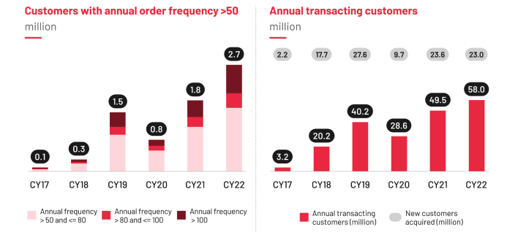

Source: Zomato

A similar trend is observed in the Quick Commerce vertical, which caters to even more power customers.

|  |  |  |  |  |
| --- | --- | --- | --- | --- |
|  | **Q4FY23** | **Q1FY24** | **Q2FY24** | **Q3FY24** |
| **GOV** | 2046 | 2140 | 2760 | 3542 |
| **Orders** | 3.92 | 3.68 | 4.55 | 5.58 |
| **AOV** | 522 | 582 | 607 | 635 |

This pattern of power customers accounting for chunk of the orders is seen even in the E-commerce sector. (Top 5 million customers drive 60% of all online sales.)

**Other factors favouring Zomato:**

* In-house proprietary geo-location technology has led to >30% decrease in drop location errors.
* Use of AI customer support platform has led to a 35% drop in query resolution time.
* Further investments in ‘**Shiprocket**’ and ‘**MagicPin**’ has led to growth
* Monthly active restaurants onboarded grown by 20% YoY in Q3FY23 (still underserved from the supply side)
* Zomato Gold customers account for 40% of food delivery GOV and drive loyalty and frequency.

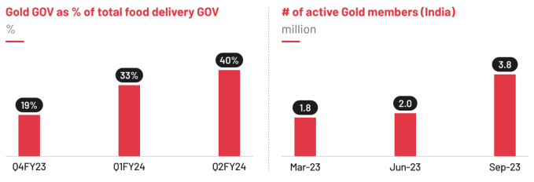

Source: Zomato