**TABLE OF CONTENTS**

|  |  |
| --- | --- |
| List of Figures | 02 |
| Nomenclature used | 02 |
| **Chapter 1** | 03 |
| 1. **Introduction** | 03 |
| 1.1 Description on the topic | 03 |
| 1.2 Problem Definition | 05 |
| 1.3 Objectives | 06 |
| 1.4 Hardware and Software tools used | 06 |
|  |  |
| **Chapter 2** | 07 |
| 1. **Design** | 07 |
| 2.1 Architecture Description |  |
|  |  |
| **Chapter 3** | 09 |
| 1. **Implementation** | 09 |
| 3.1 Description on Implementation | 10 |
| 3.1.1 Description on each module implemented | 11 |
|  |  |
| **Chapter 4** | 12 |
| 1. **Results And Discussion** |  |
|  |  |
| **Conclusions And Future Scope** | 16 |
|  |  |
| **References** | 17 |

**LIST OF FIGURES**

|  |  |  |
| --- | --- | --- |
| Fig. No. | Description of the figure | Page No. |
| 2.1 | Architecture Outline | 07 |
| 3.1 | Relational Schema Diagram | 09 |
| 3.2 | E-R Diagram | 10 |
| 3.3 | Pycode-1 | 11 |
| 3.4 | Pycode-2 | 11 |
| 4.1 | Result Screens - 1 | 12 |
| 4.2 | Result Screens – 2 | 14 |

NOMENCLATURE USED

|  |  |
| --- | --- |
| WC | World Cup |
| E-R | Entity – Relationship |
| DBMS | Database Management System |
| GUI | Graphical User Interface |
| PPI | Player Performance Index |
| SQLite | Structured Query LanguageLite |

**CHAPTER 1**

**1. Introduction**

**1.1 Description on the topic**

It can be said that football is one of the most popular sports in the world. Many teenagers around the world dream to be a football player since they can earn lots of money and also have a potential step to other careers such as presenter, or even superstar. Now, one can see that football becomes a business with enormous investment. Therefore unsurprisingly some technologies and athletic science now focus on this sport and many researches are widely contributed in this field. By this reason the intelligent systems have been designed for helping coaches, staffs and football players to evaluate the tactics during a football match and even after the game finished. These systems are also used to help the football players improving their skills. For example, the tracking football system is the system that employs the video cameras located in specific places in the football field for recording the movement of players. It can then generate some graphical viewing of the players’ movement in a monitor. The coach can watch the game in many views and hence can design and plan the tactic during each match. This kind of system has been commonly used in many countries that have worldwide and well-known football leagues such as England, Spain, Italy, some countries in South America and some countries in Asia such as Japan, South Korea and Middle East countries . All of these countries have their particular systems for their football leagues for collect particular data and information which are necessary for developing their football league in order to improve the overall performance. Although the conceptual framework and the purpose of the system used by these football leagues are the same, the necessary and sufficiency information of each league is significantly different due to many constraints such as financial supports, the managing characteristics, the acceptance and reputation of the league, etc.

**1.2 Problem Definition**

Football is played worldwide by hundreds of millions of people, as a hobby, as well as professionally. It is also followed by billions across the world, and the WC Final 2014 was watched by almost 3 billion people.

There are various clubs, National Leagues, International Championships played every weekend, such as La Liga, Bundesliga, Premier League, Ligue 1 etc. The world of football is vast and has many interconnected links. There are millions of professional players, thousands of clubs and agents, looking to make their mark on the international stage.

So, how is the common man supposed to remember all these players, clubs and agents?

Football Database contains the latest information on all player transfers, agents and clubs. It details the agents linked to players, the position they play in, their nationality, years played at a club, their player rating and so much more.

The FIFA WC is in 2018 and Football Database contains all the information needed to stay up to date with all the teams, managers, FIFA ratings of each National side.

**1.3 Objectives**

The objective of Football Database is to create a unique platform through which football fans can access data about their favorite clubs and players in a simple manner.From the findings been made, most organization used filing method to store information during the tournament, which has caused typical problems. Information that store using paper might get decay if it is being used severally. It takes a lot of time searching for a document. There are also some organizations stored their data in Excel file which is an improper data management method. It may look systemic but not a proper way to store large amount of data using Excel files. So, this database could be interesting and useful in order to check information systems support and benefit in such a complex organization as a football club, which is a good area to test information systems abilities in different departments, such as sports, finance and so on. It would give a way to football club managers how to operate and improve their work in pursuance to solve or avoid some problems in various areas.

**1.4 Hardware and Software tools used**

* Hardware tools (Minimum)

1. Microprocessor: 1.0 GHz and above CPU basedon either AMD orINTEL Microprocessor Architecture
2. Main memory: 512 MB RAM
3. Hard Disk: 50 GB
4. Hard Disk speed in RPM: 5400
5. Keyboard: QWERTY
6. Mouse: 2 or 3 Button
7. Monitor: 1024x768 resolution

* Software tools(Minimum)

1. Operating system: Windows 10
2. Database Tool: SQLite
3. GUI Tool: tkinter Library– Python 3.6

**CHAPTER 2**

**2.1 Architecture Description**

This DBMS uses a three-tier architecture.

A 3-tier architecture separates its tiers from each other based on the complexity of the users and how they use the data present in the database. It is the most widely used architecture to design a DBMS.

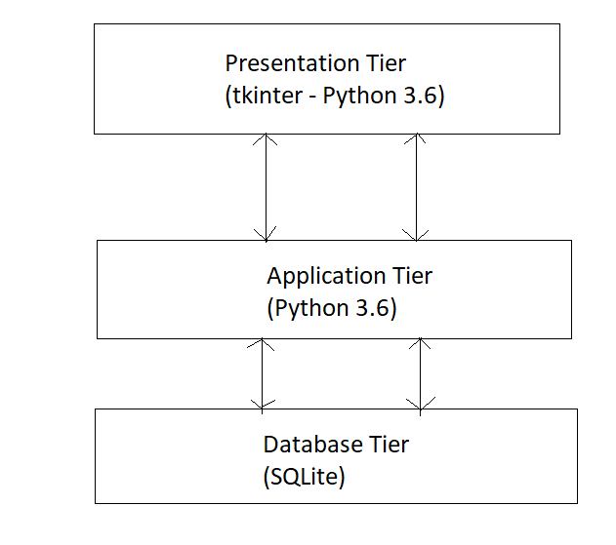

*Fig 2.1*

* **Database (Data) Tier** − At this tier, the database resides along with its query processing languages. We also have the relations that define the data and their constraints at this level. (**Done using SQLite**)
* **Application (Middle) Tier** − At this tier reside the application server and the programs that access the database. For a user, this application tier presents an abstracted view of the database. End-users are unaware of any existence of the database beyond the application. At the other end, the database tier is not aware of any other user beyond the application tier. Hence, the application layer sits in the middle and acts as a mediator between the end-user and the database.(**Done using Python**)
* **User (Presentation) Tier** − End-users operate on this tier and they know nothing about any existence of the database beyond this layer. At this layer, multiple views of the database can be provided by the application. All views are generated by applications that reside in the application tier.(**Done using tkinter library – Python 3.6**)

**CHAPTER 3**

**3.1 Implementation**

* Relational Schema Diagram

**CLUBS**

|  |  |  |  |  |  |  |  |
| --- | --- | --- | --- | --- | --- | --- | --- |
| ID | NAME | RATING | MANAGER | CHAIRMAN | LEAGUE | TITLES | YEAR FOUNDED |

**AGENTS**

|  |  |  |
| --- | --- | --- |
| NAME | NATIONALITY | RATING |

**NATIONALS**

|  |  |  |  |
| --- | --- | --- | --- |
| NATION | MANAGER | WC WON | RATING |

**PLAYERS**

|  |  |  |  |  |  |  |  |  |
| --- | --- | --- | --- | --- | --- | --- | --- | --- |
| FNAME | LNAME | NATIONALITY | CLUB NAME | AGE | YEARS AT CLUB | AGENTNAME | RATING | POSITION |

***Fig 3.1***

The database comprises of four interrelated tables.

The four tables are related by relations, as given in the following E-R Diagram, *Fig 3.2*

* E-R Diagram

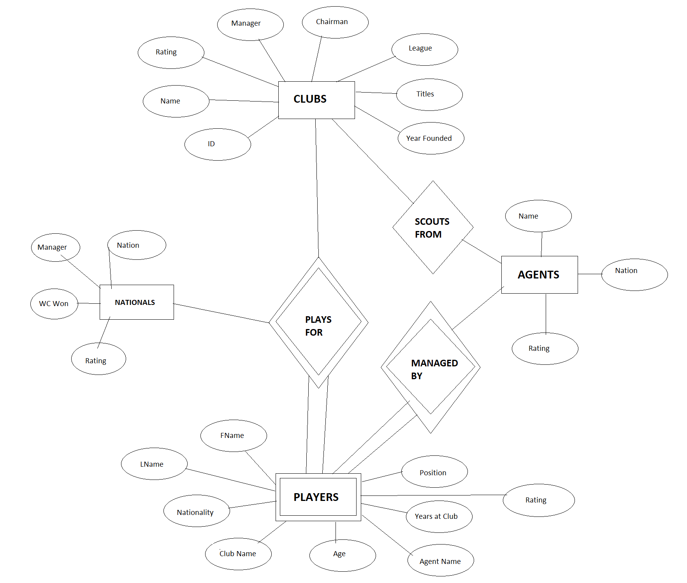

***Fig 3.2***

The above models are implemented using SQLite, and the graphical as well as query side of things is done using Python 3.6.

The Database has been normalized, i.e. it follows the relevant Normal Forms.

Given below in Fig 3.3 is an excerpt from the pycode to display some relevant player data.

*Fig 3.3*

Given below in Fig 3.4 is an excerpt from the pycode to insert agent data.



**CHAPTER 4**

* 1. **Results And Discussion**

The queries given in Fig 3.3 and Fig 3.4 have been executed, to give the following results.

*Fig 3.3 Query:-*

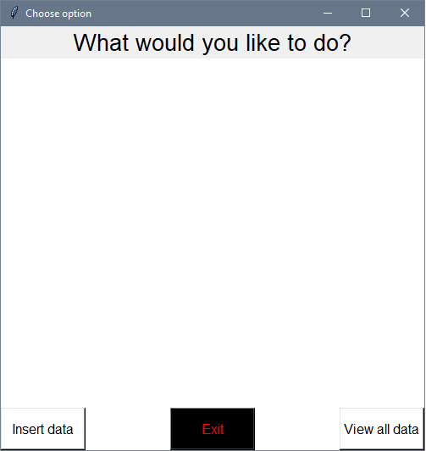

The user clicks the Insert data Button, because he wants to add data to the database.

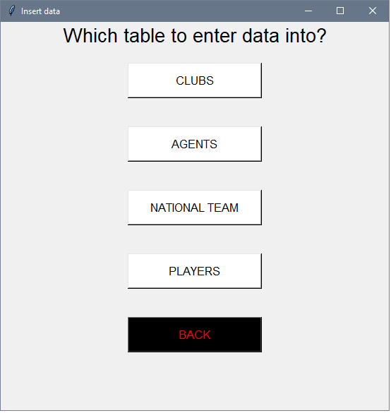

Here, the user gets an option to choose which table to enter data into (in this case, Agents table).

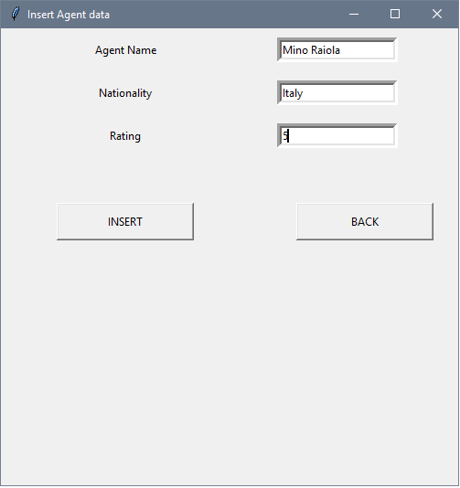

The user enters relevant Agent information.

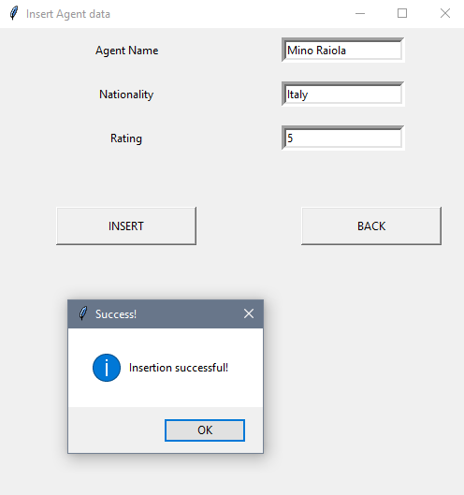

Appropriate message is displayed.

*Fig4.1*

*Fig 3.4 Query:-*



The user clicks the View data Button, because he wants to view the data from the database.

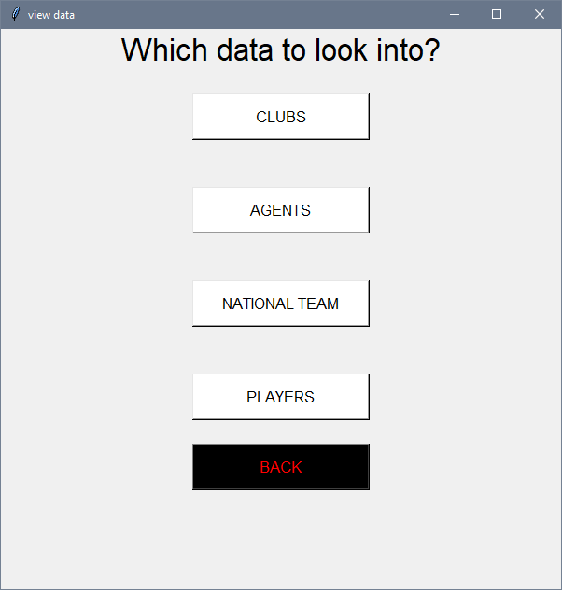

Here, the user gets an option to choose which table to view data from (in this case, Players table).

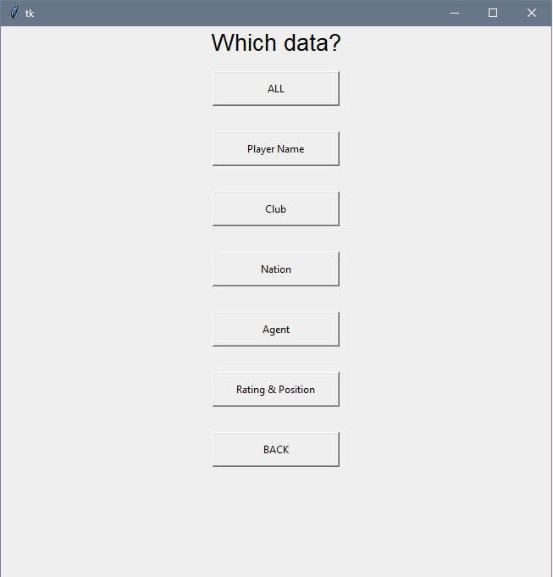

The user is asked to provide the details of the query he wants to submit.

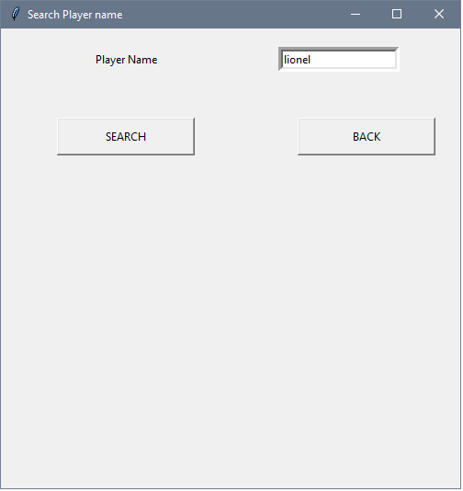

The user is asked for the query input (in this case, Name of the player).

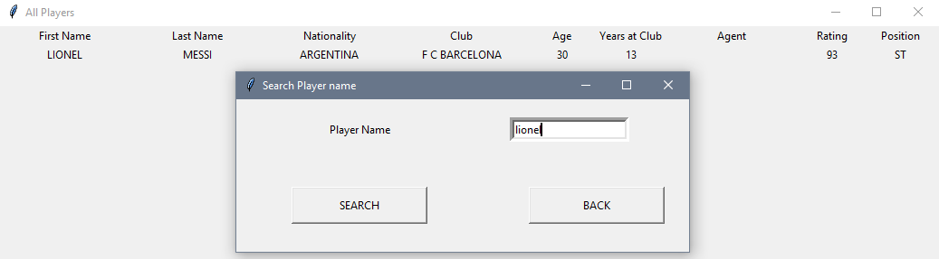

Details of the query result are displayed.

*Fig 4.2*

**4.2Conclusions and Future Scope**

As seen in the above results, user is able to enter as well as display queries of his choice. This helps out millions of people worldwide immensely to keep track of their favorite sport.

The data of the database currently is approximately 500 tuples, and so the plan for the future is to incorporate most of the major leagues and clubs, and to include more statistics such as Minutes Played, PPI etc.

Every few months a new talent emerges, or a player transfers to a different club. Every season is different, the WC is every 4 years, so players hop between clubs to improve themselves, and to get a better chance to play for their national team.

The software has been developed in such a way that it can accept modifications and further changes. The software is very user friendly and future any changes can be done easily. Every system should allow scope for further development or enhancement. The system can be adopted for any further development.Since the objectives may be broad in the future, the system can be easily modified accordingly, as the system has been modularized. The future expansion can be done in a concise manner in order to improve the efficiency of the system.

**REFERENCES**

**Elmasri and Navathe :**Fundamentals of Database Systems,5th Edition, Pearson Education, 2007.

**Raghu Ramakrishnan and Johannes Gehrke :**Database Management Systems, 3rd Edition, McGraw-Hill, 2003.

**Mark Lutz**: Programming Python, 3rd Edition.

<https://www.tutorialspoint.com/dbms/index.htm>

<https://stackoverflow.com>

<https://www.blog.pythonlibrary.org/2012/07/18/python-a-simple-step-by-step-sqlite-tutorial/>