***RegEx***

**Regex(Regular Expression)**:- The regular expression in java defines a pattern for a String. Regular Expression can be used to search, edit or manipulate text. A regular expression is not language specific but they differ slightly for each language.

Java Regex classes are present in ***java.util.regex*** package that contains three classes:

**Pattern**: Pattern object is the compiled version of the regular expression. Pattern class doesn’t have any public constructor and *we use it’s public static method compile() to create the pattern object* by passing regular expression argument.

**Matcher**: Matcher is the java regex engine object that matches the input String pattern with the pattern object created. Matcher class doesn’t have any public constructor and *we get a Matcher object using pattern object matcher() method* that takes the input String as argument. *We then use matches() method that returns boolean result* based on input String matches the regex pattern or not.

**PatternSyntaxException**: PatternSyntaxException is an *unchecked exception* thrown if the regular expression syntax is not correct.

**Regular Expression Syntax**

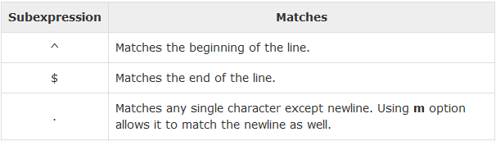

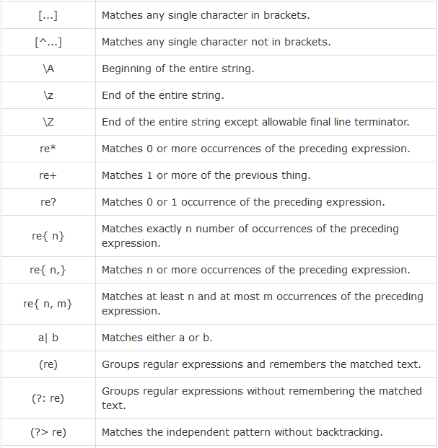

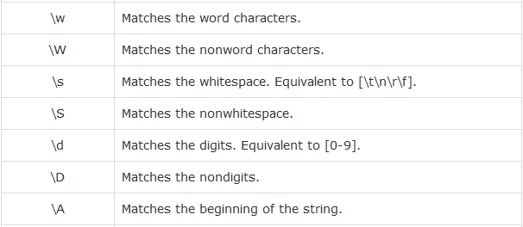

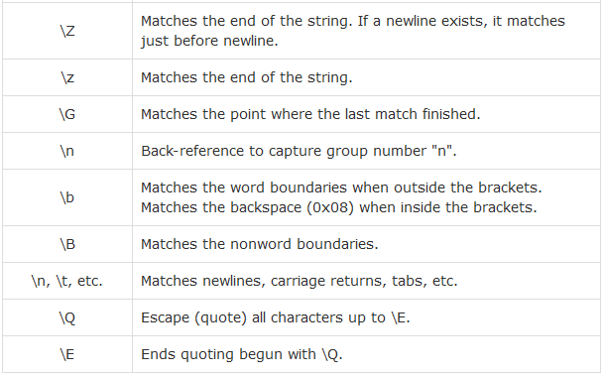

## Methods of the Matcher Class

## 

## 

## 

## 