1. create all given tables

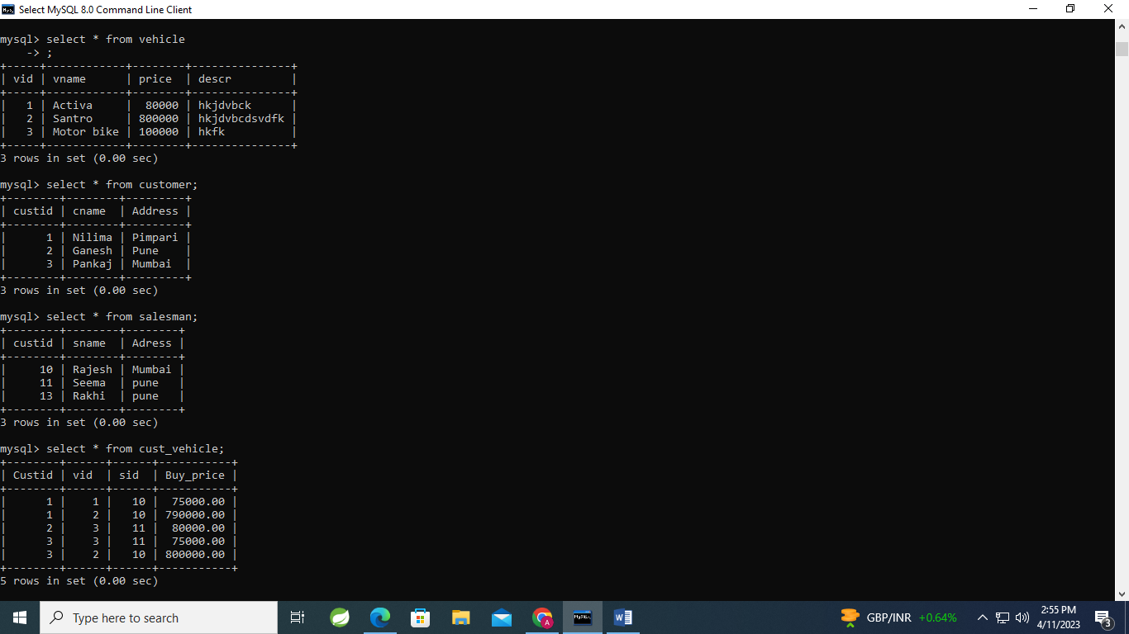

2. create index on vehicle table based on price

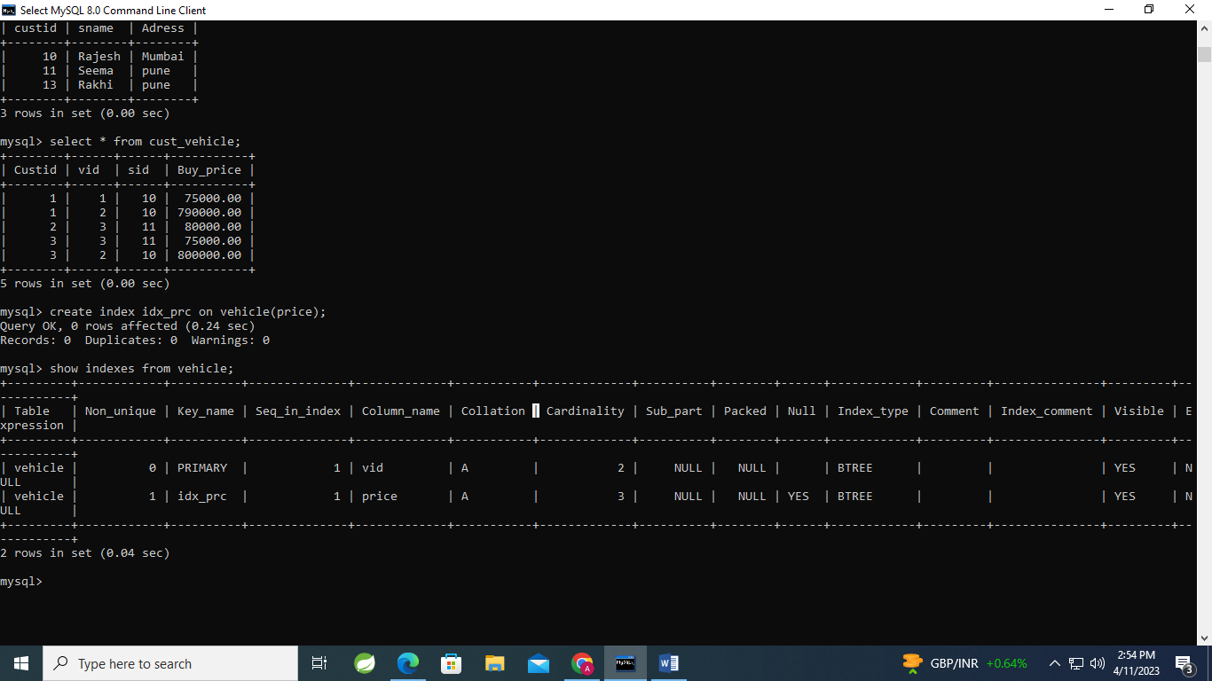3. find all customer name,vehicle name, salesman name, discount earn by all customer

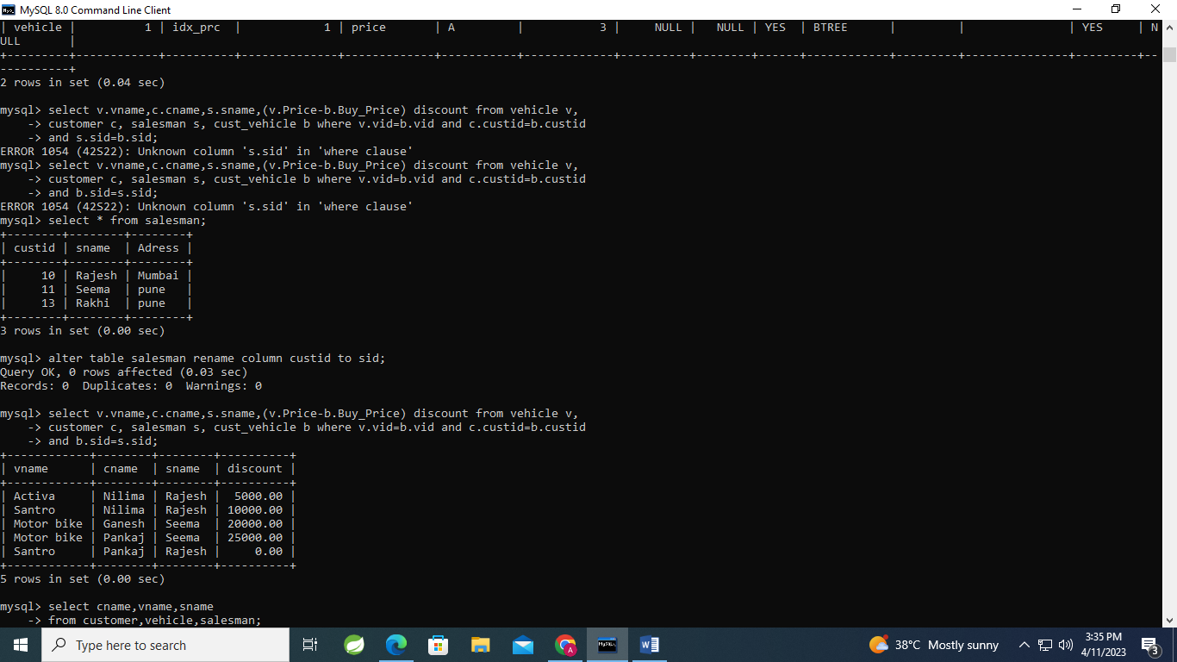

4

. find all customer name,vehicle name,salesman name for all salesman who stays in pune

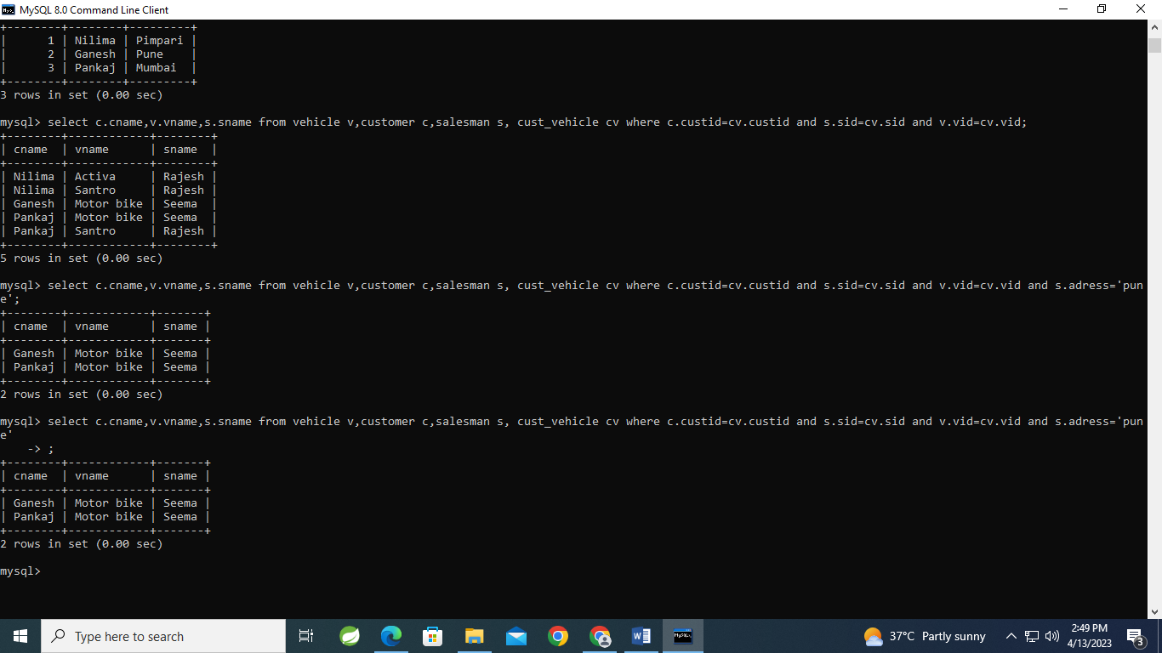

5. find how many customers bought motor bike

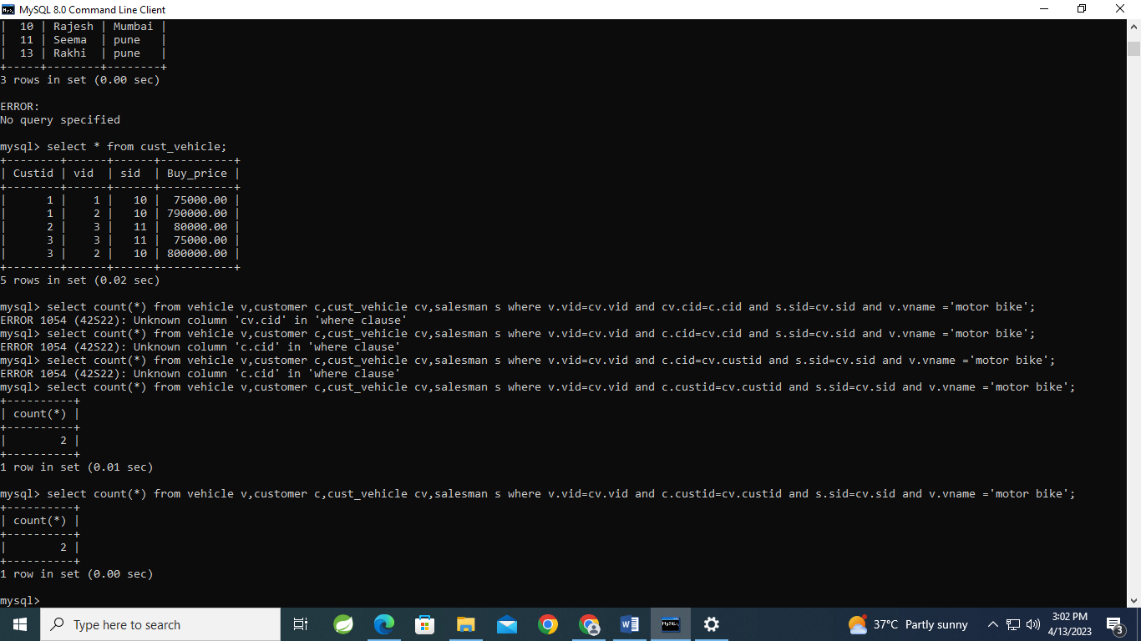

6. create a view find_discount which displays output -------to create view create view find_discount as select cname,vname,price,buying_price,price-buying_price “discount”

from customer c inner join cust_vehicle cv on c.custid=cv.cid inner join vehicle v on v.vid=cv.vid --------to display discount select * from find_discount;

