Project Report

Group members:

Name- Shubham Saoji
Ufid- 26364957

Name: Rohit Karumuri
UFID: 90971158

How to run project:

make test.out to compile test.out
./test.out to run the compiled binary
make gtest to compile google test cases
./gtest to run test cases

Method description:

q1:
(r_name = 'EUROPE')
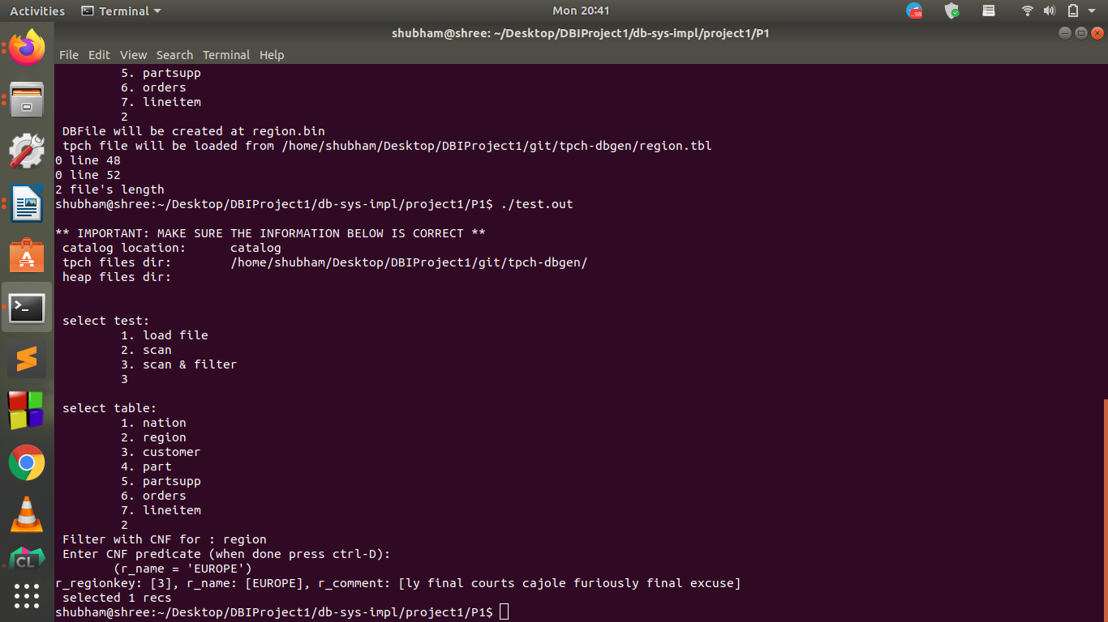

q2:
(r_name < 'MIDDLE EAST') AND(r_regionkey > 1)

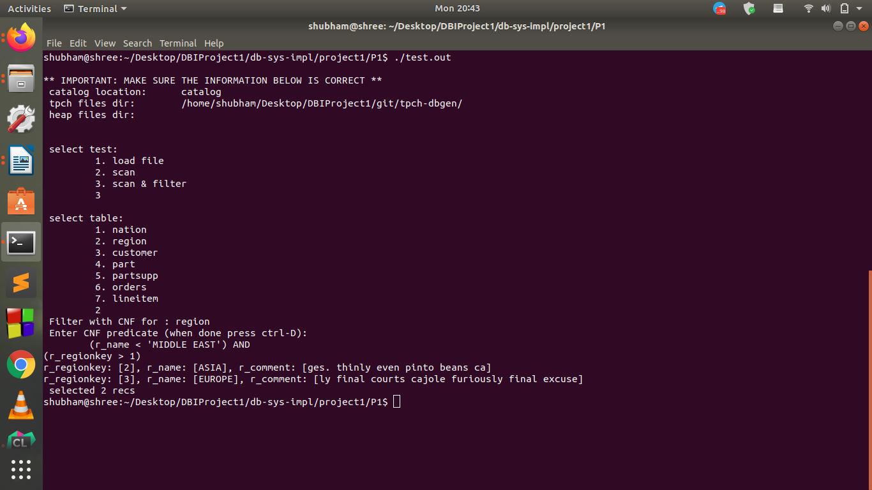

q3:
(n_regionkey = 3) AND(n_nationkey > 10) AND(n_name > 'JAPAN')
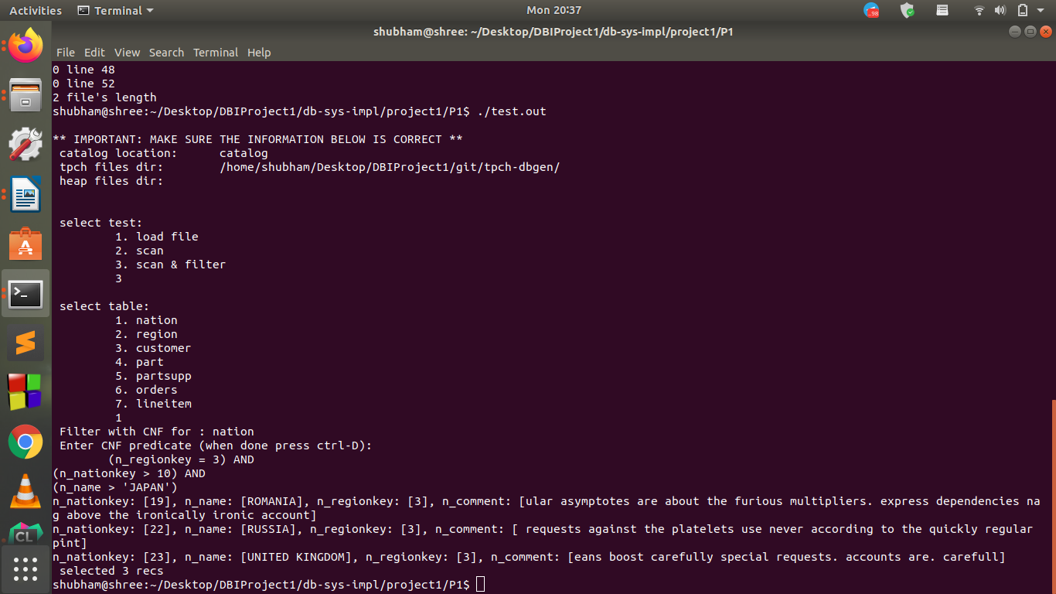
q11:
(l_shipdate > '1994-01-01') AND(l_shipdate < '1994-01-07') AND(l_discount > 0.04) AND(l_discount < 0.07) AND(l_quantity = 4.00)
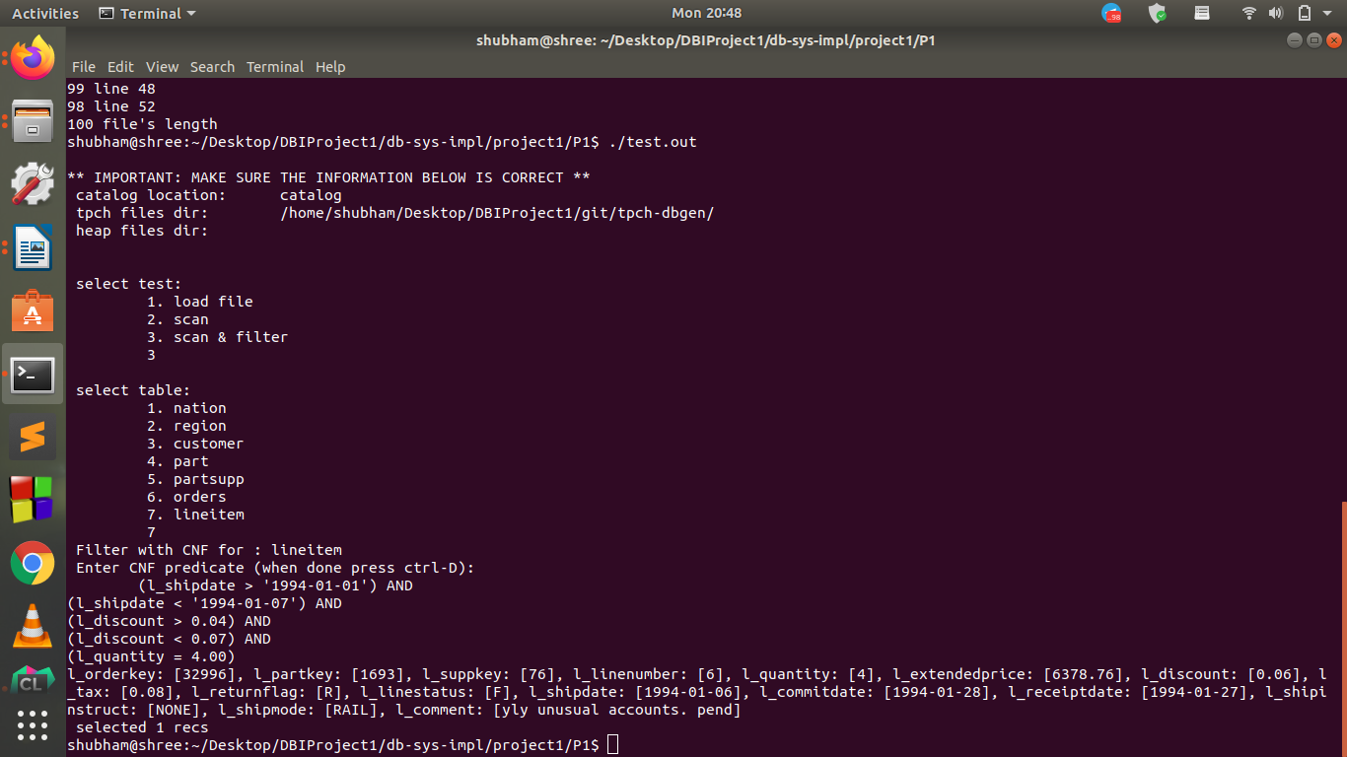

q12:
(l_orderkey > 100) AND(l_orderkey < 1000) AND(l_partkey > 100) AND(l_partkey < 5000) AND(l_shipmode = 'AIR') AND(l_linestatus = 'F') AND(l_tax < 0.07)

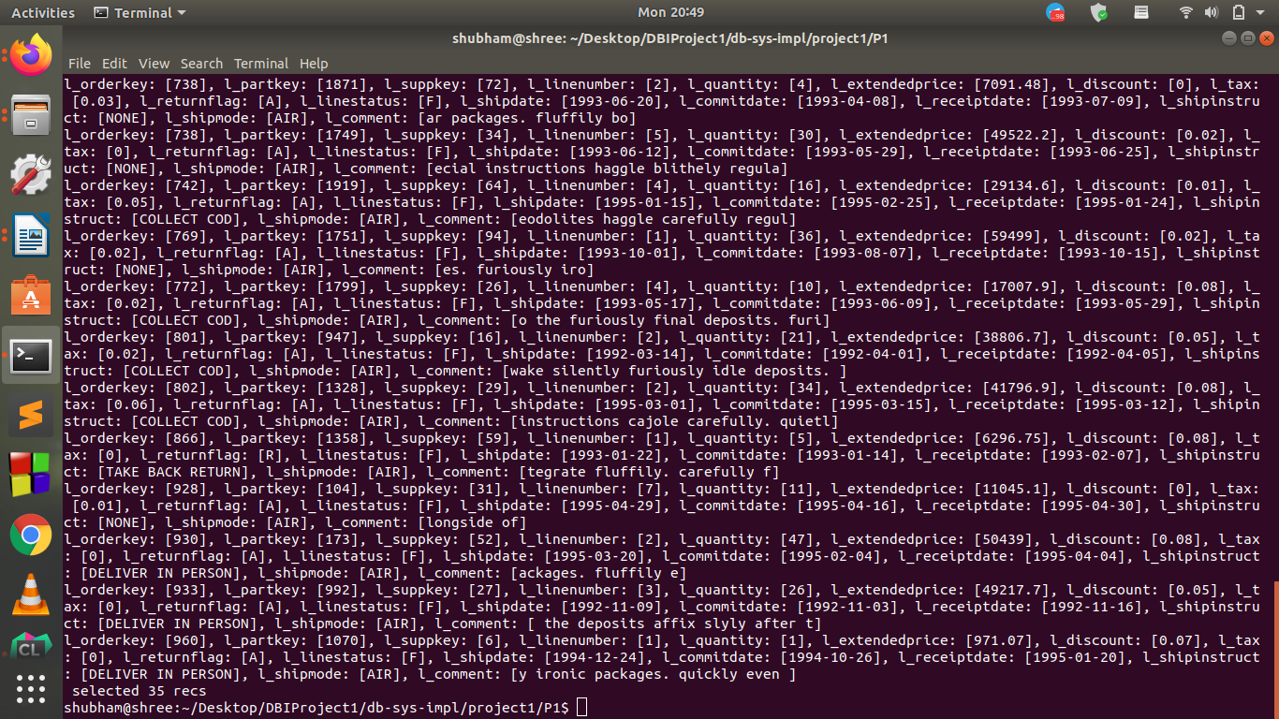

gTest result:

