**Project Report**

Group members:

Name: Rohit Karumuri

UFID: 90971158

How to run project:

make clean//to remove compiled files

make //to compile all files

./a4-1.out//to run the compiled binary

make gtest //to compile google test cases

./gtest to run test cases

Statistics Class:

* It is made of map with key as table name and value as table information.
* Table information is made of class TableInfo. TableInfo consists of relation name, number of tuples, relation size ( to make sure only one relation exists ) and map which include list of attributes added.

TableInfo Class Methods:

* Constructor, Copy constructor and destructor
* Getter and setter methods for each attribute of TableInfo class (not confused with attributes of map)

Statistics Class Methods:

* Constructor, copy constructor and destructor
* Getter method for map of TableInfo.
* AddRel – Adds relations in stats object
* AddAtt – Adds attributes to given relation in stats object
* CopyRel – Updates relation name and its data
* Read – Reads the file for statistics information and adds to stats object
* Write – Process stats object and prints output about number of tuples and number of distinct values
* Apply – Calls Estimate method which rounds the results of estimate method
* Estimate – finds estimation of number of tuples
* Evaluate – computes the estimate value step by step
* Validate - Checks whether the arguments passed to evaluate method are valid or not
* ContainsAtt - Checks whether attribute is present or not

Output is written in “output41.txt”. This is a snapshot of Q1 method.

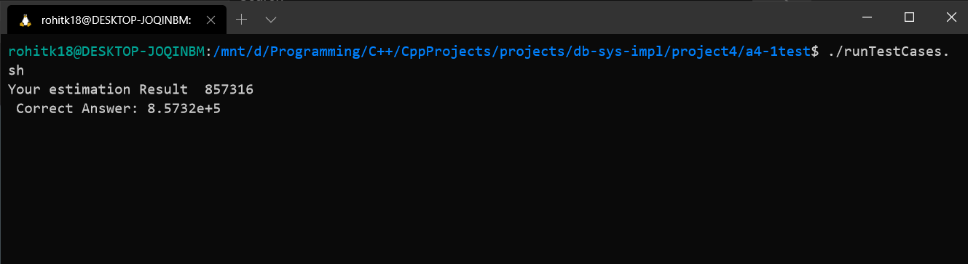

GTests:

* TableInfoCreate – tests whether table info object is created with correct attribute values
* TableInfoCopy – tests whether all the table info object data is copied properly to new object.
* StatisticsCopy – Tests whether all the statistics object data is copies to new statistics object
* StatisticsAddAttneg1input – Tests if the number of distinct value equals to number of tuples when given input is -1.

