**Project Report**

Group members:

Name: Rohit Karumuri

UFID: 90971158

How to run project:

make clean//to remove compiled files

make //to compile all files

./a4-1.out//to run the compiled binary for project 4.1

./a42.out//to run the compiled binary for project 4.2

runTestCases42.sh // to run all sql queries

make gtest //to compile google test cases

./gtest < tc6.sql to run test cases

QueryNode Class:

* This node class uses each part of the query string as single component which is used for parsing.
* Based on the operation, it has various child class node.
  + LeafNode – Node which is used to consist object names like table name, table attribute names etc.
  + UnaryNode – Node which consists of single table operation.
    - ProjectNode – For project based operation
    - RemdupliNode – For remove duplicate operation
    - SumNode – For sum operation
    - GroupByNode – For group by operation
    - WriteNode – For printing output operation
  + BinaryNode – Node which consists of two tables operation.
    - JoinNode – For join operation
* Query node has general functions which include constructor, print output methods. Also each child class has its own specialized member methods.

QueryPlanner Class:

* It consists of parsing, optimizing and compiling all nodes.
* It provides log of operations to output file.
* The planner object starts from root node. Then each component of query is converted to node and is linked to root node.

QueryPlanner Class Methods:

* Constructor, Destructor
* createLeafs – makes new leafnodes from query
* createJoins – makes joinnodes if join operations exist
* createSums – makes sumnodes, or remove duplicate nodes or group nodes based on the given query.
* createProjects – makes project nodes
* createDistinct – makes remove duplicate nodes
* createWrite – makes write output nodes
* orderJoins – orders elements of join operation
* evaluateOrder – gathers elements from two pipes of join and analyse the operation
* concateLists – connects two AndLists

Output

The output of all sql queries is stored in output42.txt.

The following screenshot of outputs of each sql query.

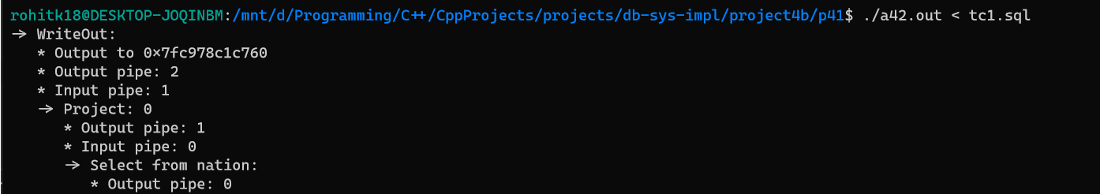

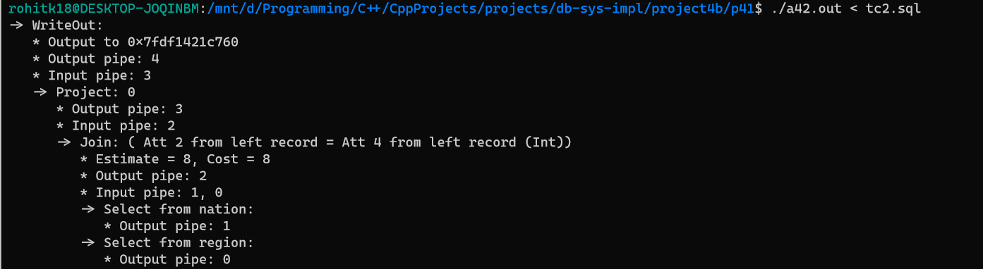

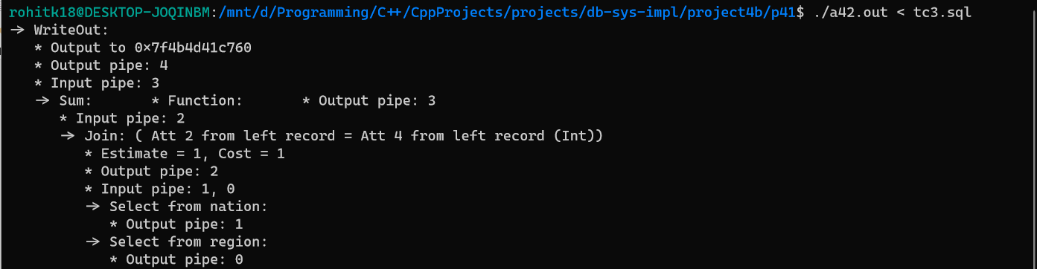

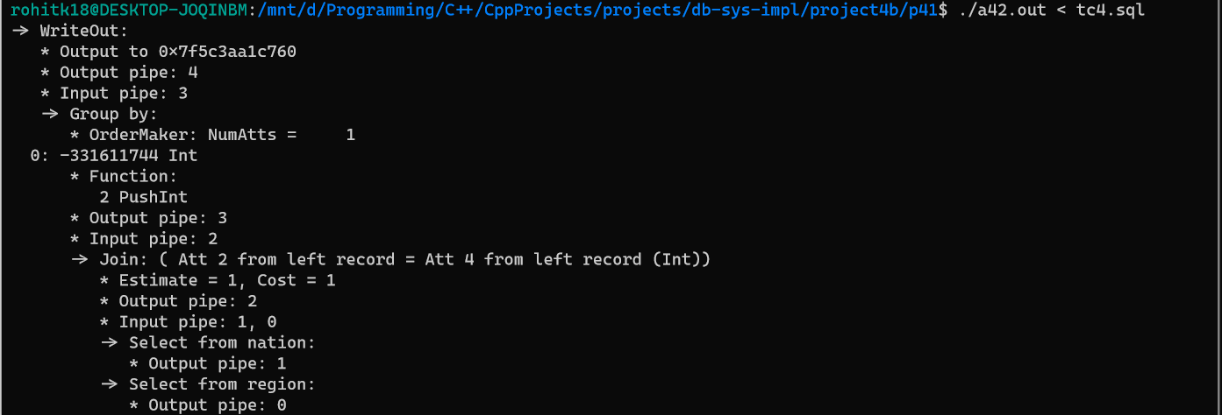

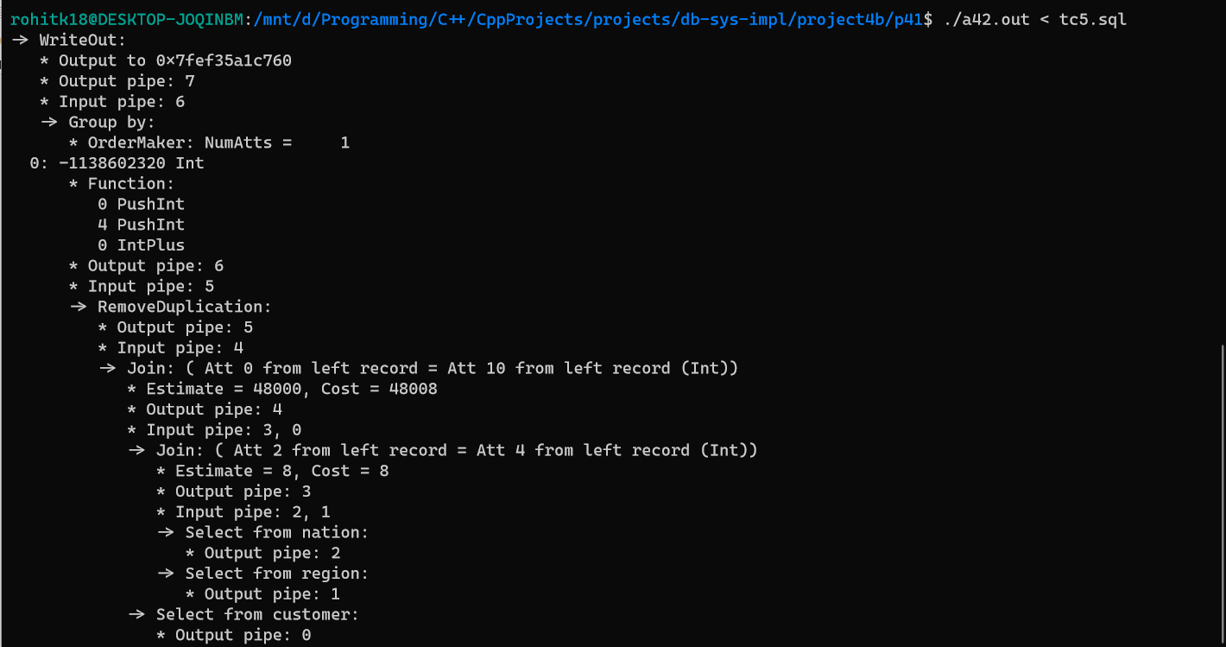

Tests:

The test was based on tc6.sql file. Run command is ./gtest < tc6.sql

* Tables – Verifies the tables collected are correct
* GroupBy – Verifies the inputted group by clause is correct
* WhereClause – Verifies all andlists and checks all the left and right values are correct

