Predicting Obesity Level from Eating Habits and Daily Life
Machine Learning Capstone Project Report

Name: ROHAIT KUMAR

1. Problem Definition
Being overweight is a health problem in many countries. Doctors find a person's weight level from height and weight. In this project I ask a different question: how well can eating habits and daily life alone tell a person's weight level? A model that does this could be a quick first check, but it is not a medical tool.
The task is multi-class classification with 7 classes: Insufficient Weight, Normal Weight, Overweight Level I, Overweight Level II, and Obesity Types I, II and III. The target column is NObesity. I use the macro F1-score as the main metric, with accuracy as a second number. There are 7 classes and each one matters equally. Macro F1 gives every class the same weight and counts both missed people and wrong labels, while accuracy alone can hide a class where the model is weak.

2. Dataset Understanding
The data comes from the UCI Machine Learning Repository (dataset id 544), "Estimation of Obesity Levels Based on Eating Habits and Physical Condition". It describes people from Mexico, Peru and Colombia. The file has 2,111 rows and 17 columns: 16 inputs and 1 target. The inputs include gender, age, family history of overweight, high-calorie food (FAVC), vegetables in meals (FCVC), main meals per day (NCP), eating between meals (CAEC), smoking, water per day (CH2O), calorie monitoring (SCC), physical activity (FAF), screen time (TUE), alcohol (CALC) and transport (MTRANS).
What the exploration showed (training data, 1,688 rows):
- There are no missing values. There are 20 repeated rows.
- The classes are fairly balanced, from 12.9% (Insufficient Weight) to 16.6% (Obesity Type I).
- Age has an average of 24.3 years, a middle value of 22.7, and runs from 15 to 61.
- Many answers that should be whole numbers have decimals: 61.3% of rows in CH2O, 57.6% in FAF, 56.0% in TUE, 39.8% in FCVC and 30.5% in NCP.
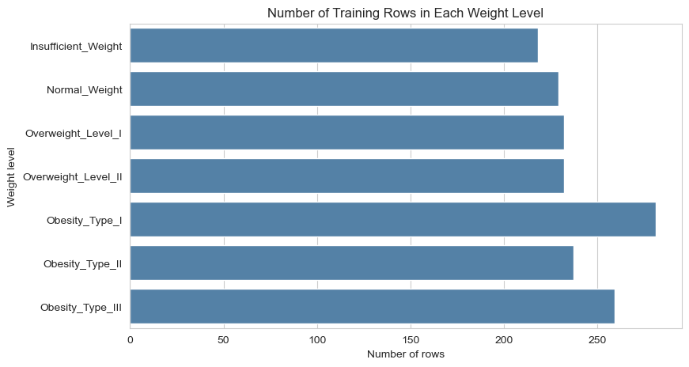
Two important data problems. First, the decimals above are a sign that many rows were made by a computer. The dataset notes that about 77% of the rows were created with SMOTE from real survey answers, and only about 23% are real answers. Near copies of a row can land in both the training and the test set, so scores can look better than they would on new real people. Second, the weight level is worked out from height and weight (BMI). If these two columns were kept, the model would copy the formula and not learn from habits. This is called target leakage, so I removed Height and Weight and used only eating habits and daily life.

Figure 1: Number of training rows in each weight level.

3. Methodology
- Test set first. I put 20% of the rows aside (423 rows) with a stratified split and random_state=42. The test set was not used until the final step. The training set has 1,688 rows.
- Pipeline with no leakage. A Pipeline and ColumnTransformer fill missing values (median for numbers, most common answer for text), scale the number columns with StandardScaler, and one-hot encode the text columns. Inside cross-validation, each fold learns these steps from its own training part only.
- Baseline and models. A baseline that always guesses the most common class, then Logistic Regression, Decision Tree, Random Forest and KNN, all compared with 5-fold stratified cross-validation on macro F1.
- Tuning. The best model was tuned with GridSearchCV (5 folds, macro F1).
- Final test. The tuned model was tested one time on the locked test set.

4. Results
Cross-validation results on the training set:
Model | Mean macro F1 | Std
Random Forest | 0.837 | 0.013
KNN | 0.721 | 0.021
Decision Tree | 0.717 | 0.014
Logistic Regression | 0.574 | 0.013
Baseline (most frequent) | 0.041 | 0.000

Random Forest was clearly the best, about 0.12 above the next model, and the spread between folds was small, so I tuned it. The best settings were max_depth=20, min_samples_split=2 and n_estimators=100. The cross-validation macro F1 went from 0.837 to 0.841 after tuning, a small gain.
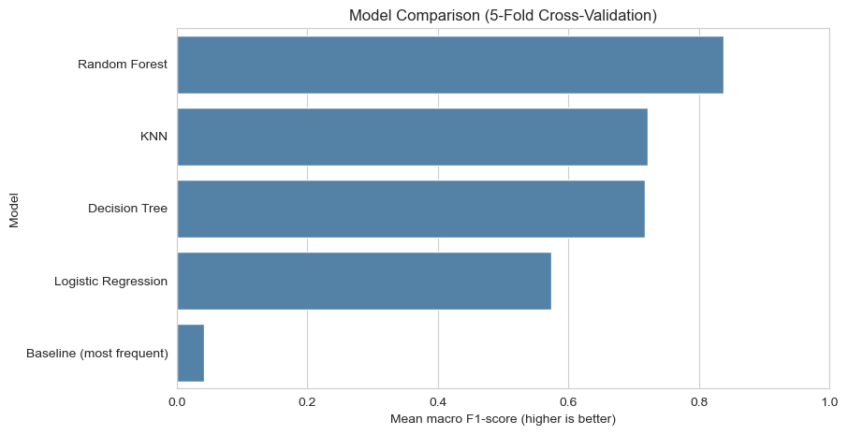
Figure 2: Model comparison with 5-fold cross-validation.

On the locked test set (423 rows), the tuned Random Forest reached a macro F1 of 0.856 and an accuracy of 0.856. The test score is a little higher than the cross-validation score (0.841), which is within normal variation for a test set of this size. Results for each class:
Weight level | Precision | Recall | F1
Insufficient Weight | 0.891 | 0.907 | 0.899
Normal Weight | 0.676 | 0.828 | 0.744
Overweight Level I | 0.833 | 0.776 | 0.804
Overweight Level II | 0.915 | 0.741 | 0.819
Obesity Type I | 0.806 | 0.829 | 0.817
Obesity Type II | 0.917 | 0.917 | 0.917
Obesity Type III | 1.000 | 0.985 | 0.992

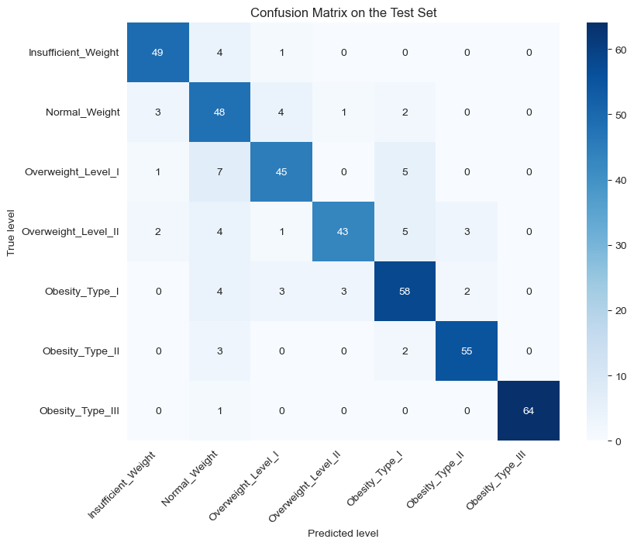
Figure 3: Confusion matrix on the test set.

5. Error Analysis
The model made 61 wrong predictions out of 423 (14.4%). Half of them (50.8%, or 31 cases) were only one level away from the true level, 18 were two levels away, and 12 were three or more levels away. The most mixed-up pairs were Overweight Level I predicted as Normal Weight (7 cases), Overweight Level II predicted as Obesity Type I (5 cases) and Overweight Level I predicted as Obesity Type I (5 cases).
Why does the model fail? Weight levels sit on one scale, and the border between two neighbouring levels is not sharp, so two people with similar habits can sit on different sides of a border. Because I removed Height and Weight, two people with the same habits can also have different body sizes. Obesity Type III is almost perfect (F1 0.992), while Normal Weight is the weakest (precision 0.676), because it is often confused with the levels next to it. Answers are also self-reported, which adds noise.

6. Limitations
- About 77% of the rows are computer-made, so the test score may be higher than the score on new real people.
- The data covers only three countries, so the model may not work for other ages, places or food cultures.
- Answers come from an online form and may not be exact.
- The dataset is small (2,111 rows), so scores can change with a different random split.

7. Fairness and Ethical Considerations
The data has gender and age columns, and I did not check whether the model works equally well for men and women or for different age groups. This should be done before any real use. Weight is linked to many things outside a person's control, such as health problems, medicine, income and family history, so a model based on habits can wrongly blame a person.
Weight and health data are private. A real tool needs consent, safe storage, and no sharing with employers or insurers. The model must not be used as a medical diagnosis, to shame people, or to refuse a job or an insurance plan. A wrong guess can scare a healthy person or make an unwell person feel safe.

8. Conclusion and Next Steps
Without Height and Weight, a tuned Random Forest reached a test macro F1 of 0.856, far above the baseline of 0.041, and half of its mistakes were only one level away. The locked test set and the pipeline make this score honest for this dataset, but the computer-made rows mean it should be read with care. Next steps: train and test on real survey rows only, check scores for each group, study which habits matter most, and collect more real data.

Project Record Table
Item | Details
Project Title | Predicting obesity level from eating habits and daily life
Problem and ML Task Type | Guess the weight level of a person (7 classes): multi-class classification
Dataset | UCI Machine Learning Repository (id 544), 2,111 rows, 17 columns (before removing Height and Weight)
Metric and Justification | Macro F1-score: 7 classes that all matter equally; it counts both missed people and wrong labels
Algorithms Compared | Logistic Regression, Decision Tree, Random Forest, KNN (plus a baseline)
Final Model and Test Score | Tuned Random Forest: test macro F1 = 0.856, accuracy = 0.856
Main Limitation | About 77% of the rows are computer-made, so the score may be higher than on new real people

