Multi-Agent Enterprise RAG Architecture
Kafka + Spark + Docling/OCR + Vector DB + LangGraph/ADK + Gemini/Vertex AI
Architecture Design Document
2026-07-06
Table of Contents

Multi-Agent Enterprise RAG Architecture

Kafka + Spark + Docling/OCR + Vector DB + LangGraph/ADK + Gemini/Vertex AI
This architecture is designed for enterprise-scale document analysis over huge document volumes: PDFs, scanned PDFs, DOCX, PPTX, TXT, images, contracts, RFPs, finance documents, HR policies, technical manuals, and mixed-layout documents.
The design is multi-agent, but not “LLM agent for everything.” The correct approach is:
Deterministic distributed systems for heavy processing
+
Specialized agents for orchestration and decisions
+
LLMs only for reasoning, hard enrichment, verification, and final answers
ADK is suitable for production-grade agent systems because it is designed for building, debugging, and deploying enterprise agents with graph workflows, multi-agent workflows, model routing, Gemini support, observability, evaluation, and cloud deployment options. LangChain gives the model/tool harness, LangGraph gives advanced orchestration with durable execution and human-in-the-loop support, and LangSmith provides tracing, debugging, and evaluation.

1. Whole Project Architecture

Image 1: Complete Multi-Agent RAG System
Complete Multi-Agent RAG System

2. Main Design Layers
Layer | Purpose | Recommended Tools
Event backbone | Move document events between services | Kafka
Distributed compute | High-speed batch/stream processing | Spark, Spark Structured Streaming
Document intelligence | Parse PDFs, DOCX, PPTX, OCR, tables, layout | Docling, Unstructured, pdfplumber, Tesseract, PaddleOCR
Agent orchestration | Multi-agent workflows and state transitions | LangGraph, Google ADK
Model/tool abstraction | LLM, tool, retriever interfaces | LangChain
Observability | Trace every agent/tool/model call | LangSmith, OpenTelemetry, Prometheus, Grafana
Storage | Raw files, markdown, JSON, metadata | Object storage, PostgreSQL, Iceberg/Delta
Search | Semantic + keyword retrieval | Milvus, Qdrant, Weaviate, OpenSearch
LLM reasoning | Query planning, enrichment, verification, answer | Gemini/Vertex AI, vLLM-hosted open models
Spark is useful here because Spark’s Kafka integration supports parallel event processing and streaming ingestion patterns. Docling is a strong parser base because it supports multiple document formats and exports structured representations such as Markdown and JSON. Unstructured is useful as a complementary parser for element extraction and document partitioning.

3. Agent Catalog
Agent Group | Main Responsibility
Ingestion Agent Group | Detect files, validate, checksum, version, store raw file, publish event
Classification Agent Group | Identify file type, OCR need, layout complexity, document category, risk
Parser Router Agent | Decide single parser, ensemble parser, OCR path, layout path, or manual review
Parser Agent Group | Run Docling, OCR, pdfplumber, Unstructured, layout-aware extraction
Parser Quality Judge Agent | Score parser outputs and decide best/merged result
Markdown Builder Agent | Create canonical LLM-ready markdown
JSON Builder Agent | Store machine-readable page/layout/table/image structure
Chunking Agent Group | Create structure-aware parent/child chunks
Embedding Agent Group | Choose embedding model and generate vectors at scale
Vector Writer Agent | Idempotently write vectors, metadata, ACLs, versions
Query Planner Agent | Convert user question into retrieval plan
Domain Retrieval Agents | Search contracts, RFP, finance, policies, technical docs, etc.
Fusion + Dedup Agent | Merge keyword/vector/domain results
Reranker Agent | Select best evidence chunks
Evidence Verifier Agent | Check claims, citations, ACLs, latest versions
Answer Synthesis Agent | Generate final answer from verified evidence
Audit/Observability Agent | Track lineage, traces, latency, cost, quality

4. Ingestion Agent Group

Purpose
This agent group receives file discovery events and prepares reliable raw-document records.
It should not parse the file yet. It only answers:
Is this file valid?
Is it new or duplicate?
Where is it stored?
Who can access it?
What event should happen next?

Image 2: Ingestion Agent Architecture
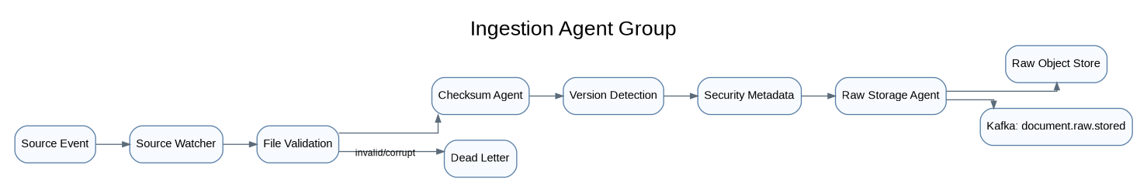
Ingestion Agent Architecture

Workflow
1. Receive document.discovered event.
2. Validate extension, MIME type, file size, checksum.
3. Detect duplicate or new version.
4. Extract source metadata and ACL.
5. Store original file in raw object storage.
6. Publish document.raw.stored.
7. Send corrupted/encrypted/unsupported files to dead-letter/manual-review queue.

Output Event
{
"event_type": "document.raw.stored",
"document_id": "doc_789",
"tenant_id": "company_a",
"version": 4,
"raw_file_uri": "s3://rag/raw/company_a/doc_789/v4/original.pdf",
"checksum": "sha256:abc123",
"security_acl": ["legal_team", "finance_team"]
}
Kafka should carry metadata and object-storage pointers, not large file bytes.

5. Document Classification Agent Group

Purpose
This is the first intelligence layer. It decides the document complexity before parsing.
It generates a Document Intelligence Profile.

Image 3: Classification Agent Architecture
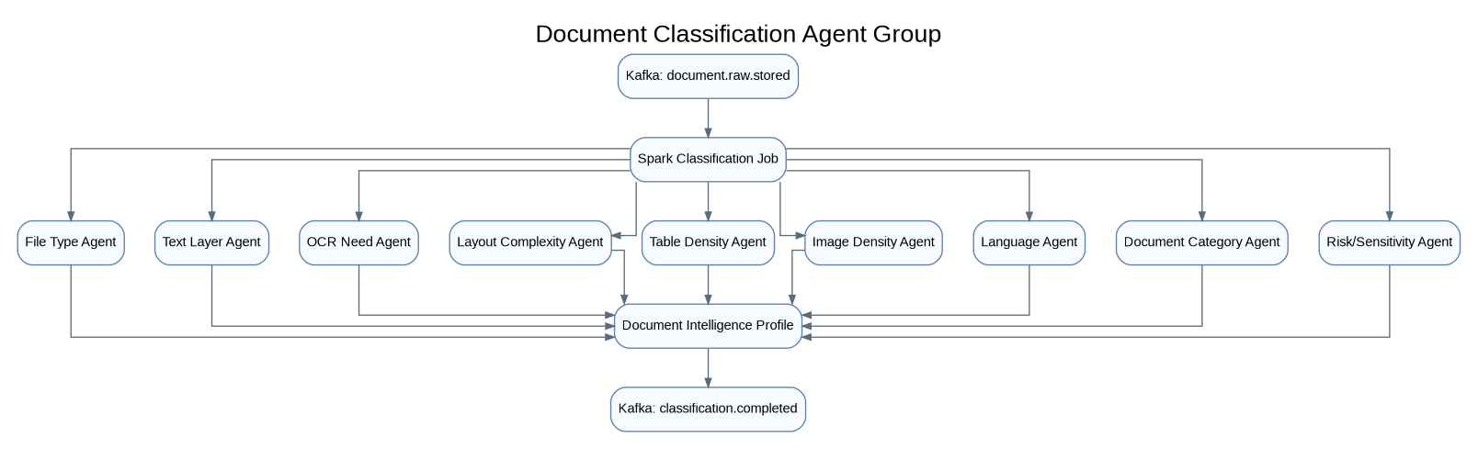
Classification Agent Architecture

Workflow
1. Spark consumes document.raw.stored events.
2. Read file metadata and lightweight document signals.
3. Detect file type: PDF, DOCX, PPTX, TXT, image, email.
4. Detect digital text layer vs scanned content.
5. Estimate OCR need.
6. Estimate layout/table/image complexity.
7. Classify domain: contract, RFP, finance, HR, policy, technical.
8. Detect sensitivity: PII, PHI, PCI, confidential, legal hold.
9. Generate Document Intelligence Profile.

Document Intelligence Profile
{
"document_id": "doc_789",
"file_type": "pdf",
"document_category": "contract",
"text_density_score": 0.91,
"ocr_required_score": 0.05,
"table_density_score": 0.72,
"image_density_score": 0.34,
"layout_complexity_score": 0.68,
"classification_confidence": 0.86,
"recommended_path": "docling_plus_pdfplumber"
}

6. Parser Router Agent

Purpose
The Parser Router Agent chooses the right extraction path. This is where the system becomes smarter than normal RAG.

Image 4: Parser Router Agent Architecture
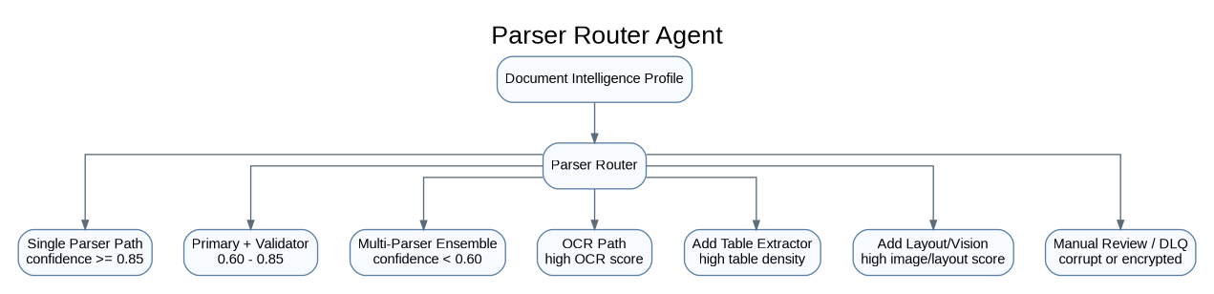
Parser Router Agent Architecture

Routing Rules
classification_confidence >= 0.85
-> single parser
0.60 <= classification_confidence < 0.85
-> primary parser + validator parser
classification_confidence < 0.60
-> multi-parser ensemble
ocr_required_score >= 0.70
-> OCR-first path
table_density_score >= 0.60
-> add table extraction agent
image_density_score >= 0.60 or layout_complexity_score >= 0.70
-> add layout/image caption agent
corrupt/encrypted/password-protected
-> manual review or dead letter

7. Parser Agent Group

Purpose
This group extracts text, tables, images, layout, page numbers, bounding boxes, and metadata.

Image 5: Parser Agent Group Architecture
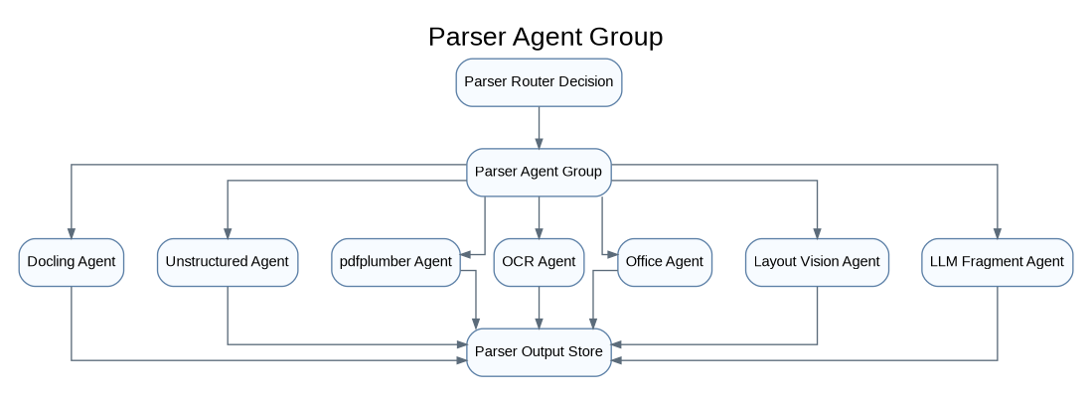
Parser Agent Group Architecture

Tool Responsibility
Agent | Best For
Docling Agent | Main document parser, layout, reading order, tables, Markdown/JSON
Unstructured Agent | Element extraction, quick parsing, alternate validation
pdfplumber Agent | PDF tables and exact text-region extraction
OCR Agent | Scanned pages, image text
Office Agent | DOCX/PPTX structure, slides, comments, notes
Layout Vision Agent | Images, diagrams, chart-text alignment
LLM Fragment Agent | Only hard fragments, not entire documents

8. Multi-Parser Ensemble Agent

Purpose
For difficult documents, do not trust one parser. Run multiple parsers, compare results, and merge the best pieces.

Image 6: Multi-Parser Ensemble Architecture
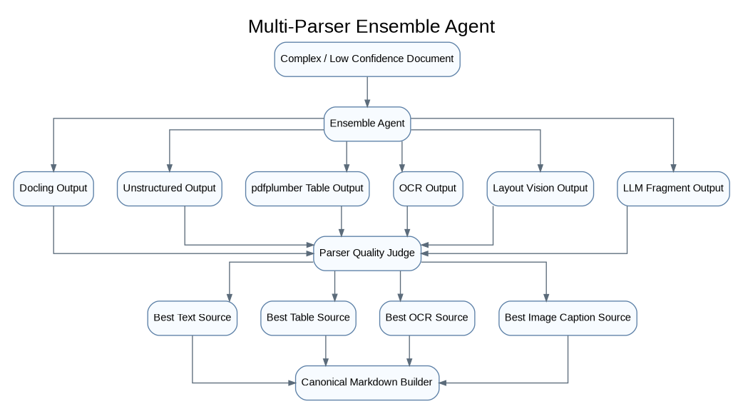
Multi-Parser Ensemble Architecture

Quality Score
final_parse_score =
0.20 * text_coverage_score
+ 0.15 * reading_order_score
+ 0.15 * table_quality_score
+ 0.15 * layout_preservation_score
+ 0.10 * OCR_confidence_score
+ 0.10 * image_caption_coverage_score
+ 0.10 * metadata_completeness_score
- 0.05 * duplicate_noise_score

Important Rule
Do not run this expensive path for every document.
Simple document -> one parser
Medium document -> primary parser + validator
Complex document -> parser ensemble
Critical document -> parser ensemble + human review if confidence is low

9. Parser Quality Judge Agent

Purpose
The quality judge decides whether the parser output is trustworthy.

Image 7: Parser Quality Judge Workflow
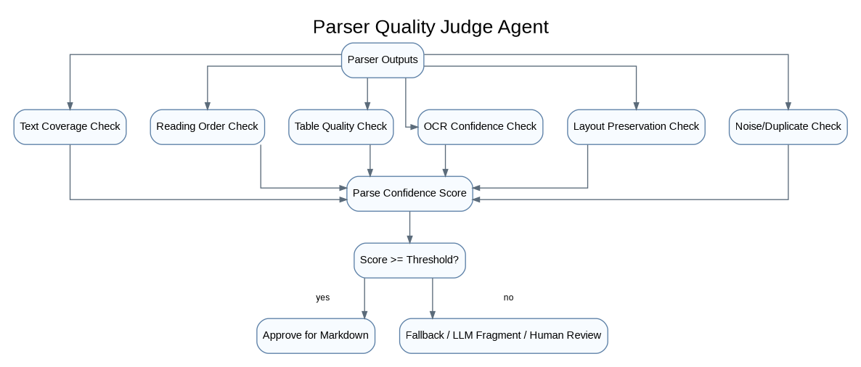
Parser Quality Judge Workflow

Output
{
"document_id": "doc_789",
"best_text_source": "docling",
"best_table_source": "pdfplumber",
"best_ocr_source": "paddleocr",
"parse_confidence": 0.92,
"manual_review_required": false
}

10. Canonical Markdown Builder Agent

Purpose
This agent creates the final LLM-friendly document. The markdown file becomes the trusted clean document used for chunking, audit, and citations.

Image 8: Markdown Builder Architecture
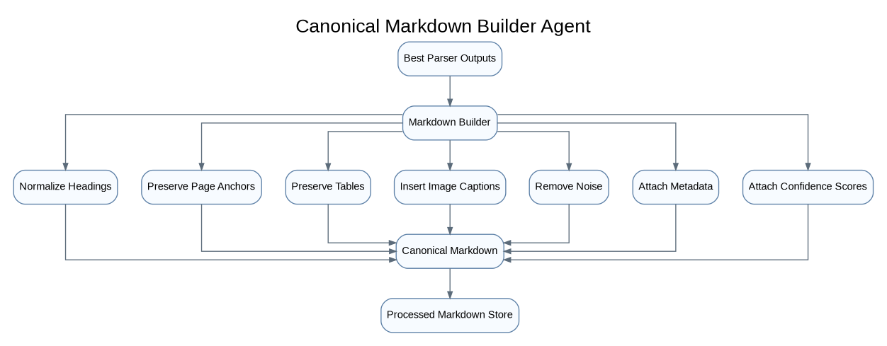
Markdown Builder Architecture

Example Output
# Vendor ABC Master Services Agreement
metadata:
document_id: doc_789
version: 4
document_type: contract
parser_path: docling_plus_pdfplumber
parse_confidence: 0.92
security_acl:
- legal_team
- finance_team
---
## Page 2: Payment Terms
Invoices shall be paid within thirty calendar days after approval.
### Table: Pricing Schedule
| Service | Unit Cost | Billing Frequency |
|---|---:|---|
| Data Processing | 1200 | Monthly |
## Page 5: Approval Workflow Diagram
Image description:
The diagram shows vendor invoice submission, legal approval, finance approval,
and payment execution.

11. Structured JSON Builder Agent

Purpose
Markdown is good for humans and LLMs. JSON is good for systems. The JSON stores page coordinates, tables, image locations, confidence, and lineage.

Image 9: Structured JSON Builder Architecture
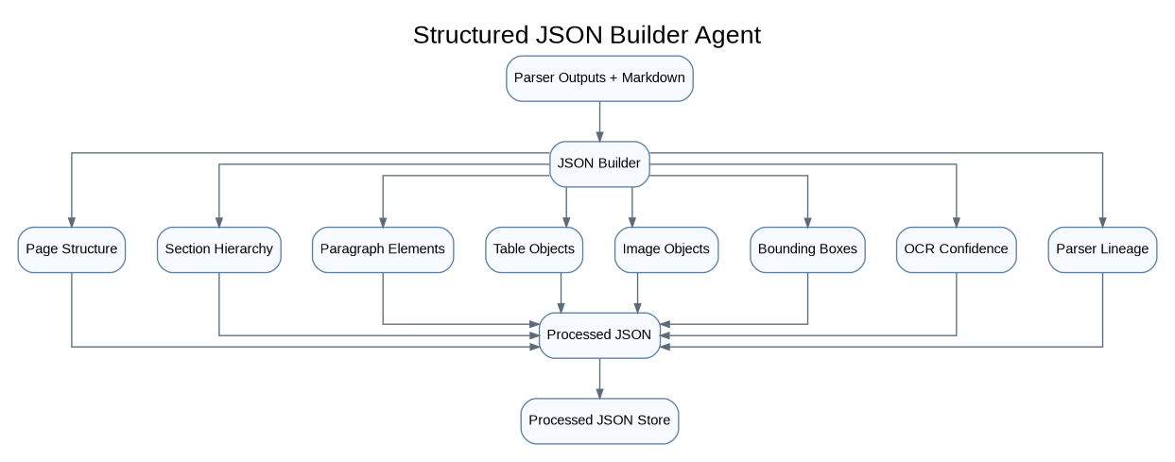
Structured JSON Builder Architecture

JSON Example
{
"document_id": "doc_789",
"version": 4,
"sections": [
{
"title": "Payment Terms",
"page_start": 2,
"page_end": 2,
"elements": [
{
"type": "paragraph",
"text": "Invoices shall be paid within thirty calendar days after approval.",
"bbox": [100, 250, 500, 290],
"confidence": 0.96
}
]
}
]
}

12. Chunking Agent Group

Purpose
Chunking should depend on document type. A contract should not be chunked the same way as a PPTX or finance spreadsheet.

Image 10: Chunking Agent Group Architecture
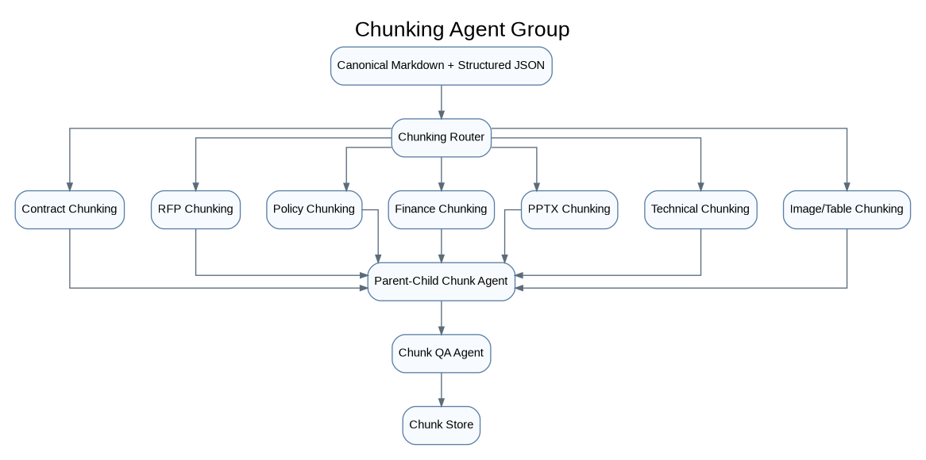
Chunking Agent Group Architecture

Chunking Rules
Document Type | Chunking Strategy
Contract | Clause + section parent chunks
RFP | Requirement/question/answer chunks
Policy | Heading/subheading chunks
PPTX | Slide parent + bullet/image child chunks
Finance | Table chunks + approval notes
Technical docs | Procedure/API/step chunks
Scanned PDF | Page/section chunks with OCR confidence
Image-heavy document | Image caption + nearby text chunk

Chunk Object
{
"chunk_id": "doc_789_v4_chunk_021",
"document_id": "doc_789",
"version": 4,
"chunk_type": "contract_clause",
"section_path": "Payment Terms > Invoice Approval",
"page_start": 2,
"page_end": 2,
"text": "Invoices shall be paid within thirty calendar days after approval.",
"parent_chunk_id": "doc_789_v4_section_payment_terms",
"security_acl": ["legal_team", "finance_team"],
"source_markdown_uri": "s3://processed_markdown/company_a/doc_789/v4/document.md"
}

13. Embedding Agent Group

Purpose
This group generates embeddings at scale using Spark. It should not embed bad chunks, empty chunks, unauthorized chunks, or old versions incorrectly.

Image 11: Embedding Agent Architecture
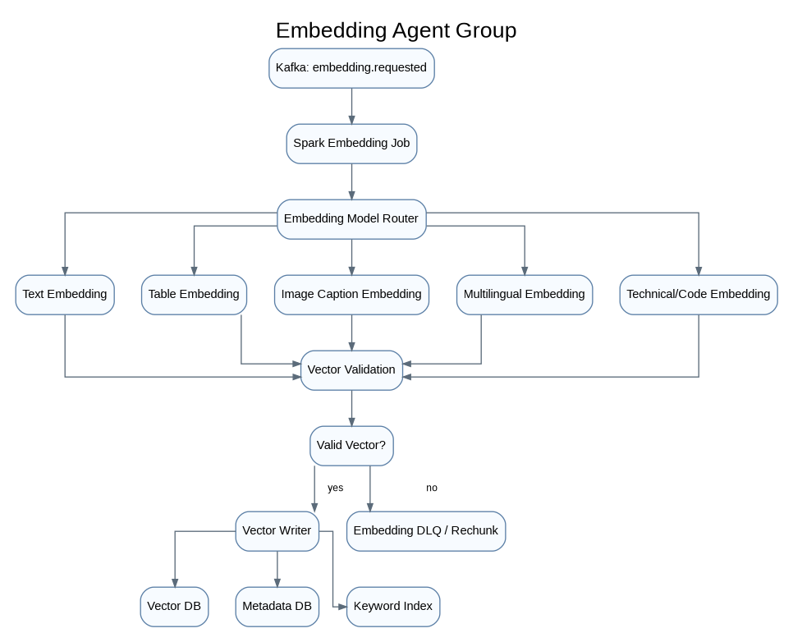
Embedding Agent Architecture

Embedding Model Choices
Chunk Type | Model Choice
Normal text | ModernBERT, BGE, E5, GTE
Long technical text | ModernBERT / long-context embedding
Multilingual text | BGE-M3, multilingual-E5, Gemini embeddings
Tables | table-to-text + table metadata embedding
Images | caption embedding, not raw image by default
Code | code-aware embedding
Low-confidence OCR | skip, review, or embed with confidence penalty

14. Vector Writer Agent

Purpose
The Vector Writer Agent writes vectors safely.

Image 12: Vector Writer Architecture
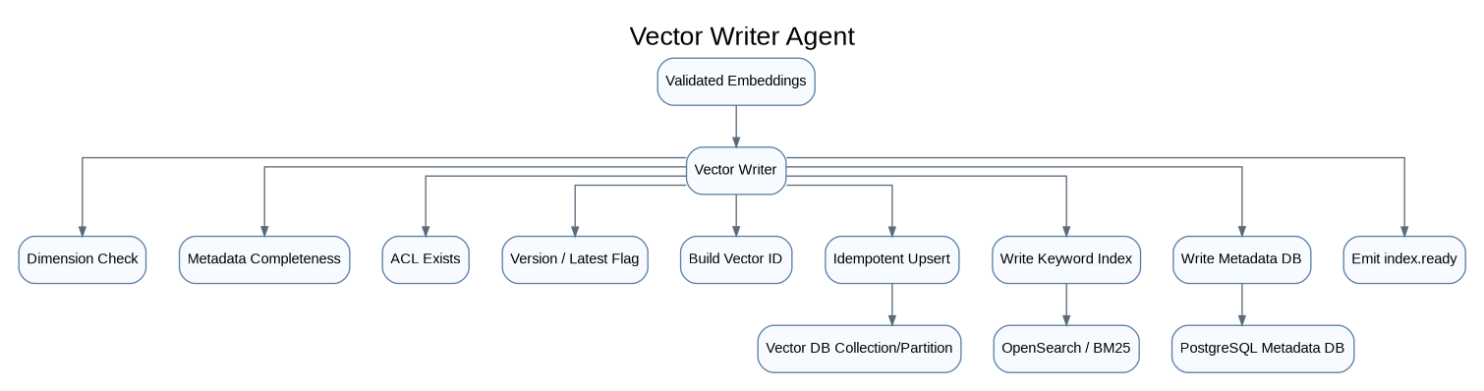
Vector Writer Architecture
The Vector Writer Agent must do:
idempotent upsert
dimension validation
metadata validation
ACL validation
version validation
delete old vectors if needed
mark latest version
write to correct collection/partition
emit index-ready event

15. Query-Time Multi-Agent Orchestration

Purpose
This is the live user-question flow. Use LangGraph or ADK here, not Spark. Spark is for heavy background processing. Query-time retrieval needs low-latency orchestration.

Image 13: Query-Time Multi-Agent Architecture
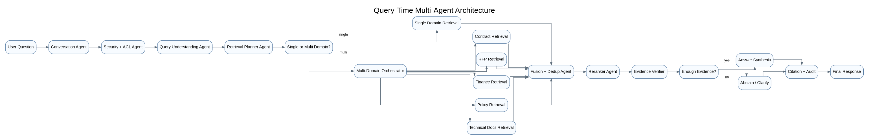
Query-Time Multi-Agent Architecture

16. Query Planner Agent

Purpose
The Query Planner Agent converts the user’s question into a retrieval plan. This is like Spark Catalyst, but for RAG retrieval.

Image 14: Query Planner Workflow
Query Planner Workflow

Example Question
Compare Vendor ABC's RFP pricing requirement, signed contract payment terms,
and finance approval notes.

Logical Plan
{
"intent": "compare_documents",
"domains": ["rfp", "contract", "finance"],
"entities": {
"vendor": "Vendor ABC"
},
"required_evidence": [
"pricing requirement",
"payment terms",
"approval notes"
]
}

Physical Plan
{
"collections": [
"rfp_vectors",
"contracts_vectors",
"finance_vectors"
],
"filters": {
"tenant_id": "company_a",
"vendor": "Vendor ABC",
"latest_version": true,
"security_acl": "resolved_user_acl"
},
"retrieval_strategy": "hybrid",
"top_k_per_collection": 50,
"reranker": "cross_encoder_or_gemini_judge"
}

17. Domain Retrieval Agents

Purpose
Each domain retrieval agent understands one business domain.

Image 15: Domain Retrieval Agent Pattern
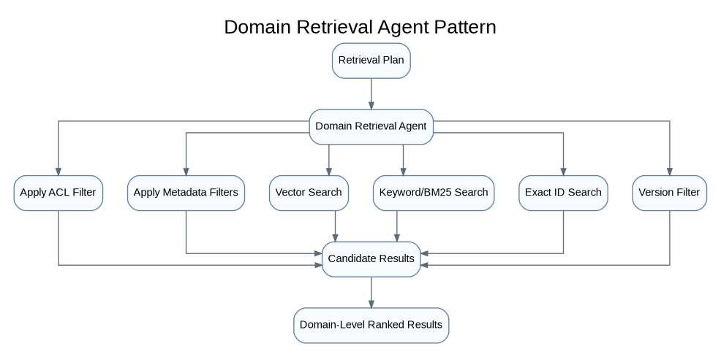
Domain Retrieval Agent Pattern

Domain Agents
Agent | Search Focus
Contract Retrieval Agent | Clauses, obligations, payment terms, signed version
RFP Retrieval Agent | Requirements, proposals, scoring, pricing
Finance Retrieval Agent | Approval notes, invoices, budgets, tables
HR Policy Retrieval Agent | HR rules, benefits, PTO, compliance
Legal Retrieval Agent | Legal memos, case references, contracts
Technical Docs Agent | APIs, architecture, SOPs, manuals
Security/Compliance Agent | Controls, policies, audit evidence

18. Fusion + Dedup Agent

Purpose
When multiple agents return results, this agent merges them.

Image 16: Fusion Agent Architecture
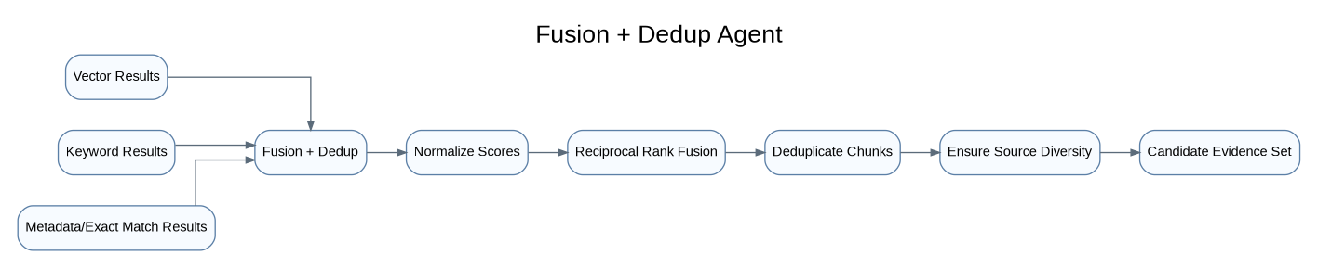
Fusion Agent Architecture

Fusion Rules
1. Prefer chunks that match both semantic and keyword search.
2. Prefer exact entity matches.
3. Prefer latest version unless user asks historical.
4. Remove duplicate chunks from same page/section.
5. Keep source diversity across contracts, RFPs, finance docs.
6. Never include unauthorized chunks.

19. Reranker Agent

Purpose
The Reranker Agent reduces many candidates to the best evidence.

Image 17: Reranker Agent Workflow
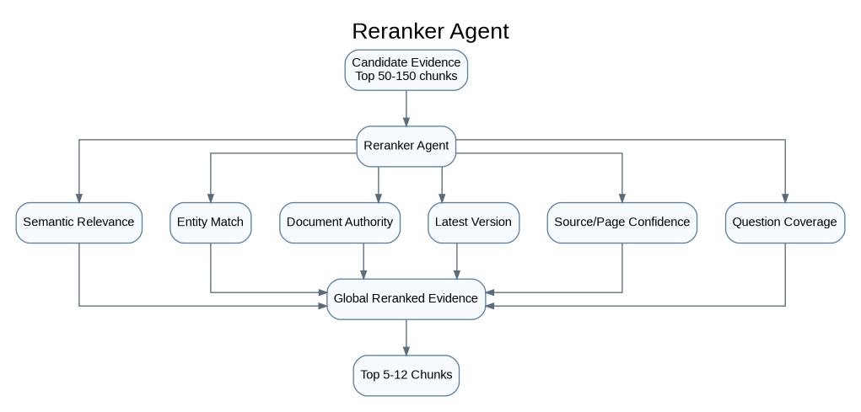
Reranker Agent Workflow

Reranking Criteria
semantic relevance
exact vendor/document/entity match
latest version
document authority
page/section confidence
parse confidence
OCR confidence
question coverage
source diversity

20. Evidence Verifier Agent

Purpose
This is the trust layer. The verifier checks whether the answer can be safely generated.

Image 18: Evidence Verifier Architecture
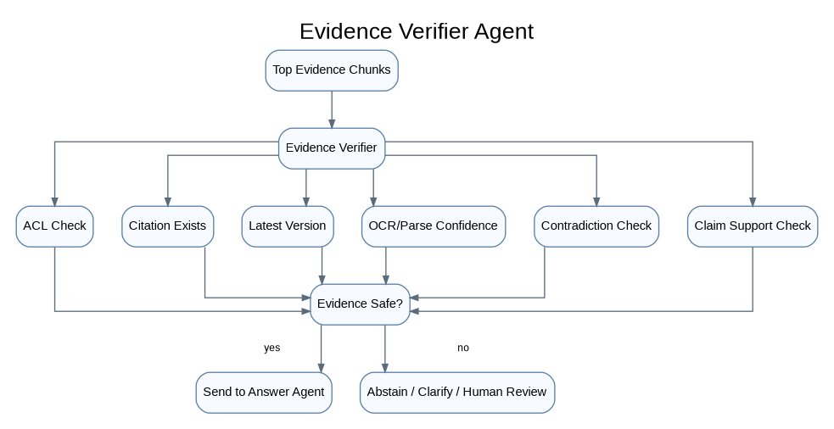
Evidence Verifier Architecture

Verification Rules
Every claim must be supported by retrieved evidence.
Every citation must map to a real document/page/section.
The user must have access to every cited chunk.
Old versions must not be used unless requested.
Low-confidence OCR should be disclosed or excluded.
Conflicting evidence should be surfaced, not hidden.

21. Answer Synthesis Agent

Purpose
This agent writes the final answer using only verified context.

Image 19: Answer Synthesis Agent Workflow
Answer Synthesis Agent Workflow

Output Format
Answer:
Vendor ABC's signed contract states that invoices are payable within thirty
calendar days after approval. The RFP pricing section required monthly billing,
and the finance approval memo confirms monthly billing approval.
Sources:
1. Vendor ABC MSA, Page 2, Payment Terms
2. RFP-2026-ABC, Page 14, Pricing Requirements
3. Finance Approval Memo, Page 3
Use Gemini/Vertex AI here when you need managed enterprise deployment, strong reasoning, multimodal understanding, and Gemini-native ADK integration.

22. Observability and Audit Agent

Purpose
Every agent call must be traceable.

Image 20: Observability Architecture
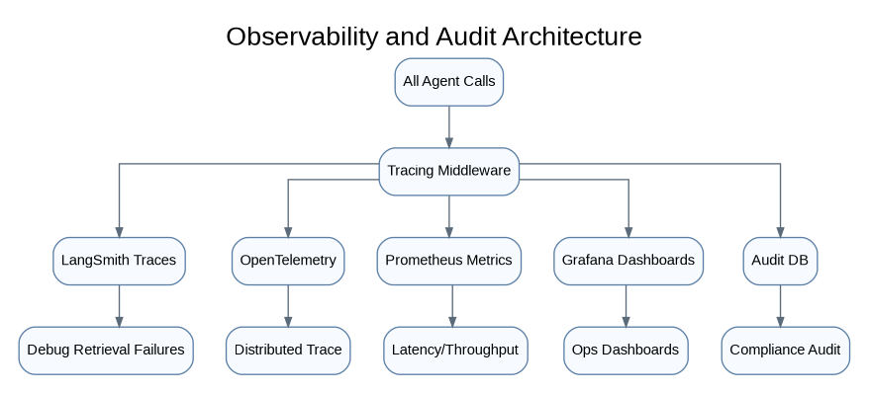
Observability Architecture
Track:
agent name
input/output
tool calls
model used
latency
cost
retrieved chunks
reranked chunks
verification result
citations
user feedback
failure reason

23. Storage Architecture

Image 21: Storage Architecture
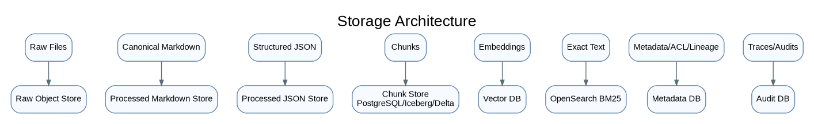
Storage Architecture

Store Responsibilities
Store | Responsibility
Raw Object Store | Original untouched files
Markdown Store | Clean LLM-ready markdown
JSON Store | Machine-readable layout/table/page data
Chunk Store | Chunk objects before embedding
Vector DB | Semantic search
OpenSearch | Keyword, exact ID, BM25 search
Metadata DB | ACLs, versions, lineage, status
Audit DB | Traces, answer history, retrieved evidence

24. Kafka Topic Architecture

Image 22: Kafka Event Flow
Kafka Event Flow

Kafka Event Rule
Use:
partition_key = tenant_id + document_id
This keeps events for the same document ordered while allowing huge parallelism across different documents. Vector writes and metadata updates should be idempotent and offsets should be committed only after output is safely stored.

25. Deployment Architecture

Image 23: Deployment View
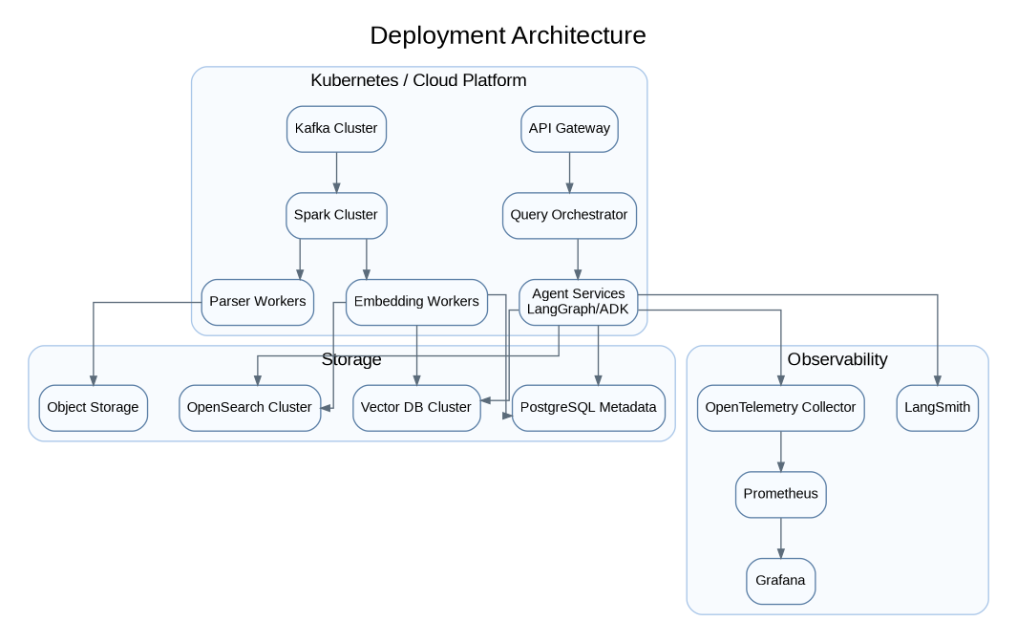
Deployment View

26. Final Recommended Agent Boundaries

Background Processing Agents
These are event-driven and Spark-friendly:
Ingestion Agent Group
Classification Agent Group
Parser Router Agent
Parser Agent Group
Parser Quality Judge Agent
Markdown Builder Agent
JSON Builder Agent
Chunking Agent Group
Embedding Agent Group
Vector Writer Agent

Query-Time Agents
These run inside LangGraph/ADK:
Conversation Agent
Security + ACL Agent
Query Understanding Agent
Retrieval Planner Agent
Domain Retrieval Agents
Fusion + Dedup Agent
Reranker Agent
Evidence Verifier Agent
Answer Synthesis Agent
Citation + Audit Agent

27. Final Clean Architecture Summary
Kafka
moves document events across the platform.
Spark
performs distributed classification, parsing orchestration, chunking, embedding, and indexing.
Docling / Unstructured / pdfplumber / OCR
extract clean structure from messy enterprise documents.
Markdown + JSON stores
preserve both LLM-ready text and machine-readable document structure.
Vector DB + OpenSearch
provide semantic and keyword retrieval.
LangGraph / ADK
orchestrate multi-agent query-time reasoning and retrieval.
LangChain
provides common model/tool/retriever interfaces.
LangSmith / OpenTelemetry
provide tracing, debugging, monitoring, and evaluation.
Gemini / Vertex AI / local models
handle final answers, multimodal understanding, hard fragment enrichment, and verification.
The simplest manager-level explanation:
We are building a distributed multi-agent document intelligence platform, not a basic RAG chatbot. Kafka moves document events, Spark processes documents at scale, parser agents create trusted markdown and JSON, embedding agents index the knowledge, retrieval agents search the right domains, verifier agents check evidence, and the answer agent only responds from verified, permission-safe context.

References
These are useful official/reference docs to validate implementation choices during design review:
- Apache Kafka Documentation: https://kafka.apache.org/documentation/
- Apache Spark Structured Streaming + Kafka Integration: https://spark.apache.org/docs/latest/structured-streaming-kafka-integration.html
- Docling Documentation: https://docling-project.github.io/docling/
- Unstructured Open Source Documentation: https://docs.unstructured.io/open-source/introduction/overview
- LangChain Documentation: https://docs.langchain.com/
- LangGraph Documentation: https://langchain-ai.github.io/langgraph/
- LangSmith Documentation: https://docs.smith.langchain.com/
- Google Agent Development Kit Documentation: https://google.github.io/adk-docs/
- Vertex AI Generative AI Documentation: https://cloud.google.com/vertex-ai/generative-ai/docs
- Milvus Documentation: https://milvus.io/docs
- Qdrant Documentation: https://qdrant.tech/documentation/
- OpenSearch Documentation: https://opensearch.org/docs/

