**Approach Document for Analytics Vidhya Data Engineering Competition**

Transformed raw data to develop an input feature set and share with data science team , for client ComZ.

**Insights to be generated from the raw data.**

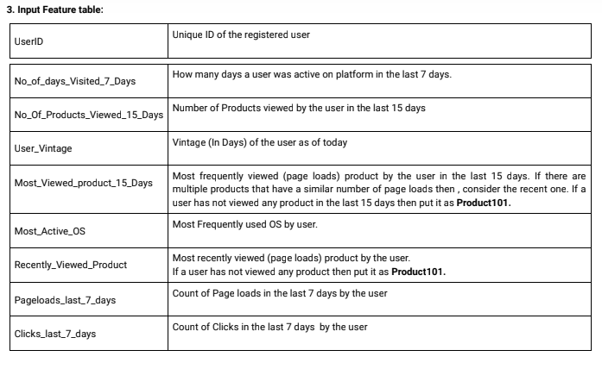

**Approach-**

1. Drop non-registered user records i.e., drop all records where UserID is null.
2. Bring all the string values to same case for all string columns.
3. Bring different formats of VisitDateTime column values to single format (Timestamp format).
4. Drop City, Country, Browser columns as they are not getting used in transformations.
5. **Converting into single datetime format. i.e Unix value to standard datetime format.**
6. **Transformed the given data using groupby.**