**Day 6**

**Selector In CSS:**

**To select evenything in a document.**

**1]Universal Selector :**

**\*{**

**//property**

**}**

**2]Element Selector :**

**To select all element of the same type**

**H1{**

**//property**

**}**

**3]Id selector :**

**TO select element based on the value of the element id attribute.**

**#myid{**

**//property}**

**4] class selector :**

**To select element based on the value of the element class attribute.**

**.class{**

**//property}**

**5]Descdent selector :**

**e.g select all paragraph inside divs**

**div p{**

**//property**

**}**

**6] Adjecent Sibling Combinator :**

**e.g h2 comes under comes immediately after any paragraph**

**p + h2{**

**//property**

**}**

**7] child selector:**

**e.g select all buttons which are directly child of spans**

**spans > button{**

**//property**

**}**

**8] Attribute Selector :**

**Select elemets based on the presence or value or value of a given attribute**

**e.g**

**input[attr=”value”]**

**{**

**//property**

**}**

**Priority : id > class > element**

**Note : for different type of selector:**

/* div p{

    color: aqua; 0 0 2

}

.para{

    color: blue; 0 1 0

}

p{

    color: brown; 0 0 1

} */

Give ans as blue

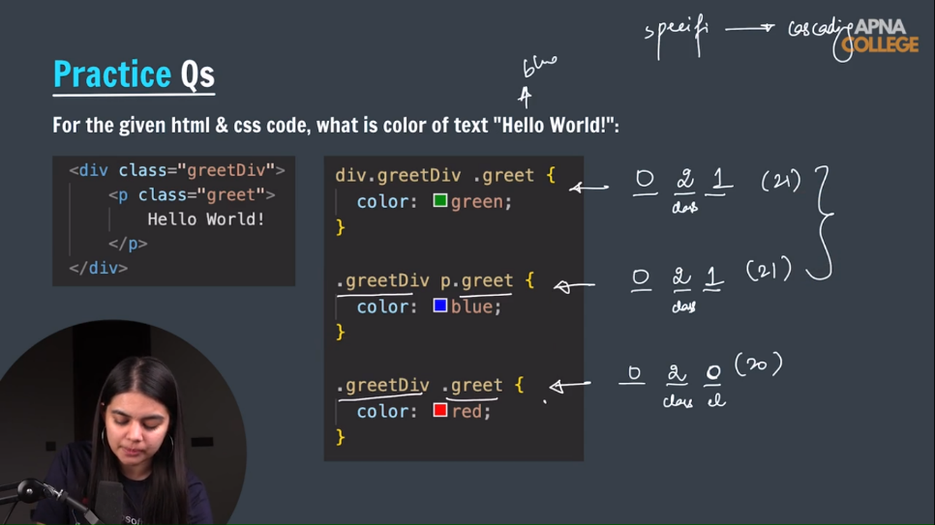

**9] Pseudo selector :**

**A keyword added to selector that specifies a special state of the selected element.**

**:hover**

**:active**

**:checked**

**:nth-of-type**

**10] Pseudo Element :**

**A keyword added to a selector that lets you style a specific part of the select element**

**::first-letter**

**::first-line**

**::selection**

**What is cascade in css?**

**The css cascade algorithm job is to select css decleration in order to determine the correct value for css propetities.**

**Specificity ?**

**Specificity is an algorithm that caluculate the weight that is applied to a given css decleration.**

**------- --------- ----------**

**Id class,attribute,pseudo class element & pseudo element**