**Day 8**

**Box Model :**

In CSS, the term "box model" is used when talking about design and layout.

The CSS box model is essentially a box that wraps around every HTML element. It consists of: content, padding, borders and margins. The image below illustrates the box model:

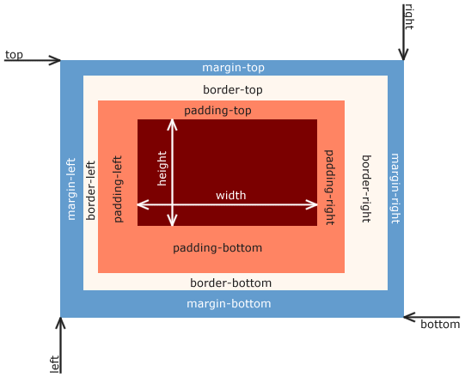

**We set property : height,width,margin,padding,border.**

**1] Height Property :**

**By default, it sets the content area/height of the element.**

**e.g:**

**div {**

**height : 100px;**

**}**

**2] Width Property :**

**By default, it sets the content area width of the element.**

**e.g:**

**div {**

**width : 100px;**

**}**

**3] Border Prperty :**

**Used to set element property.**

**Div{**

**Border-width : 10px;**

**Border-style: 10px;**

**Border-color : blue;**

**}**

**Shorthand :**

**Width | style | color**

**Border : 10px solid blue;**

**TO control individual border style :**

**Border-top-color**

**Border-right- color**

**Border-bottom- color**

**Border-left- color**

**Border-radius :**

**Used to round the corner of an element outer border edge.**

**Used unit : Px,%**

**Sometime you want set border radius for specific side then use**

**Border-top-left-radius : 50%**

**4] Padding :**

/* padding: 20px; */

    /* padding-top: 20px; */

    /* padding-left: 20px; */

    /* padding-bottom: 10px;  */

    /* padding-right : 4px */

    /* Shorthand */

    /* top-bottom | left-right */

    /* padding: 20px 10px; */

    /* top | left-right |bottom */

    /* padding: 20px 10px 20px; */

    /* top | right | bottom |  left*/

    /* padding: 5px 3px 5px 2px; */

**5] Margin :**

**To set space on the outside of border.**

**Margin : 50px;**

**Margin-left : 50px;**

**Margin-right : 50px;**

**Margin-bottom: 50px;**

**Margin-top: 50px;**

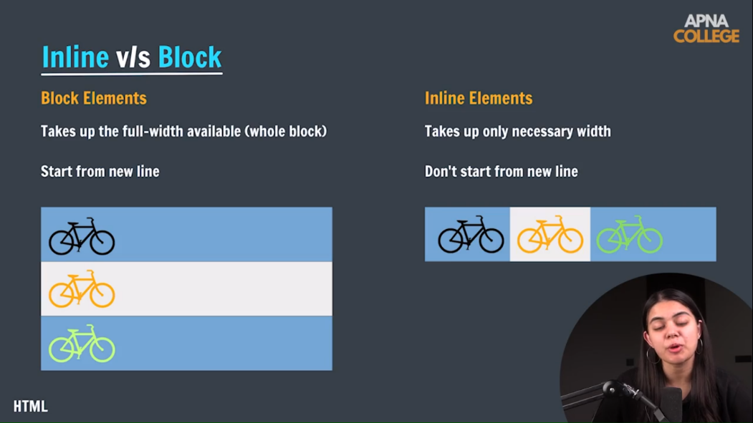

**Display Property :**

**Value : block,inline,inline-block,block-inline**

**If element is inline then height & width property Is not applied.**

**Padding apply only applied on the left and right**

**Margin app apply only applied on the left and right**