**Day 8**

**Alpha Channel :**

**TO set opactity for the color**

**Range is 0 to 1(hidden)**

**Rgba(255, 255, 255,0.3);**

**Opacity :**

**Set opacity for the element**

**Range is 0 to 1**

**CSS TRANSACTION :**

**Transaction enable you to define the transaction between two states of an element.**

**Transaction shorthand :**

**Property name | transaction-duration | timing-function | transaction-delay**

**To set box at center then use margin : 0 auto;**

div{

    height: 150px;

    width: 150px;

    background-color: lime;

    /* transition: 2s; */

    transition: margin-top 1s step-end 0.5s;

    margin: 0 auto;

}

div:hover{

    /* border-radius: 50%; */

    margin-top: 400px;

    background-color: aquamarine;

}

**CSS TRANSFORM :**

**This property lets you rotate,scale,skew or translate an elment**

**1] Rotate :**

**Transform : rotate(45deg);**

**2] Scale :**

**Transform : scale(50);**

**Scale(50px,60px)**

**ScaleX(50px,60px) along x-axis**

**ScaleY(50px,60px) along y-axis**

**3]translate :**

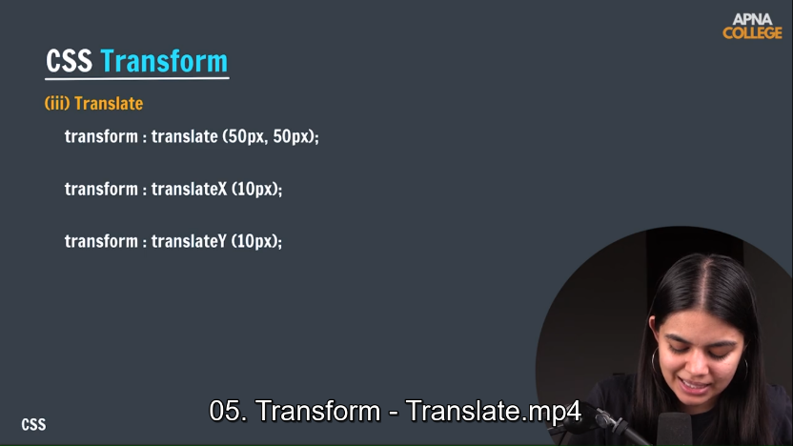

**4] skew: tlide**

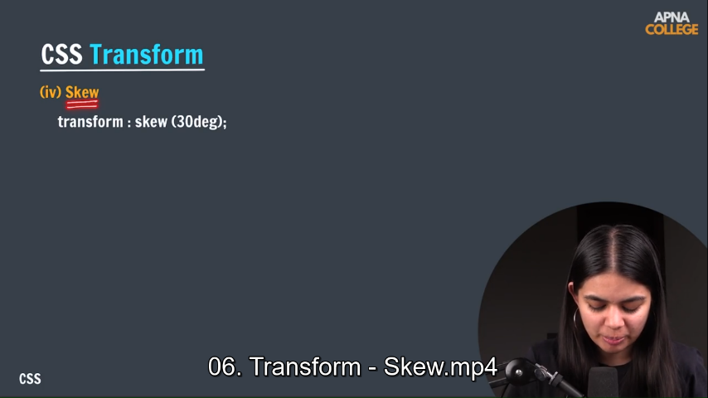

**Box –shadow:**

**To add shadow effect around an element frame**

**Box-shadow : 2px 2px 10px green;**

**x-offset**

**y-offset**

**blur-radius**

**color**

**Background image :**

**Lets you set image to background.**

**Background-image : url(“path”);**

**Background-size :contains / cover/ auto;**

**Postion Property:**

