PR12 | AI/ML BASED REAL-WORLD APPLICATION

Electricity Consumption
and Bill Prediction System
Model development, evaluation, optimization and result analysis
Linear Regression and Ridge Regression with a React and Express application

Course project report
PR12 • CO1–CO5
Prepared 23 October 2026
The model estimates monthly household energy use in kWh. The application multiplies this estimate by a user-entered tariff to show an indicative bill.

Executive Summary
This project builds a small end-to-end household electricity estimator. A scikit-learn regression pipeline uses family size, rooms, appliance counts, area type, temperature and optional previous-month usage to estimate monthly consumption. A React interface calls an Express API; a Python bridge loads the fitted pipeline. SQLite stores each signed-in user's estimates separately.
The supplied Kaggle CSV contains 1,000 records and 19 columns. The model uses 12 predictors and Monthly_Usage_kWh as its continuous target. An 80:20 split leaves 800 rows for training and 200 for final testing. Five-fold cross-validation compares ordinary least-squares Linear Regression with Ridge candidates. Ridge alpha 1.0 wins by a very small margin.
Evaluation case | MAE | RMSE | R²
Held-out test with all predictors | 15.918 kWh | 20.946 kWh | 0.9656
Held-out test with prior usage hidden | 36.039 kWh | 45.613 kWh | 0.8367

The full-feature R² is not a percent-accuracy claim. Prior-month use is strongly correlated with the target, and the no-history test is substantially harder.

Report guide
Pages | Sections
3–4 | Problem definition, objectives and scope
5–8 | Dataset, preprocessing and ML pipeline
9–11 | Linear Regression, Ridge tuning and evaluation design
12–15 | Metrics, results, errors and model coefficients
16–17 | Web application architecture and workflow
18–19 | Model considerations, reproducibility, CO mapping and sources

1 Problem Definition
Households often want a rough sense of next month's electricity requirement before a utility bill arrives. Appliance counts and household composition are informative, but they do not directly state monthly kilowatt-hours. This project frames the task as supervised regression: learn a mapping from household attributes to a continuous target, Monthly_Usage_kWh.

Problem statement
Given a household profile x with 12 available predictors, estimate y = Monthly_Usage_kWh. The model returns a non-negative monthly kWh estimate. The web application then computes an indicative bill as predicted kWh multiplied by the user's tariff per kWh.

Why regression
The target is numerical and ordered. A classifier would require artificial consumption bands and discard the size of the difference between estimates. Regression preserves the target's unit, so an absolute error can be discussed directly as kWh.

Project objectives
- Define a measurable target and household input set.
- Clean and split the dataset, fitting all preprocessing only on training data.
- Train Linear Regression as a baseline and Ridge as a regularized candidate.
- Tune Ridge with training-only five-fold CV and evaluate on a held-out test set.
- Analyze overall, subgroup, residual and cold-start errors.
- Connect the model to an authenticated web app and document limits.
The system presents a monthly estimate in kWh and computes a corresponding bill estimate from the tariff entered by the user.

2 Objectives and System Scope
The application turns the model into a household workflow. A new user registers with an empty history, enters home details and requests an estimate. Returning users sign in, inspect recent estimates and can begin with the latest estimate as an editable previous-month value.
Layer | Responsibility | Implementation
Frontend | Collect inputs; display kWh, bill and activity | React 19 dashboard
API | Validate, authenticate, predict, calculate bill | Express 5 JSON routes
Model bridge | Convert JSON to features and invoke model | Python, pandas and joblib
Estimator | Transform household data and predict kWh | scikit-learn Ridge pipeline
Persistence | Keep accounts, sessions and estimates | SQLite

What it returns
The result includes estimated usage, chosen tariff, estimated total and creation time. The arithmetic is transparent: bill estimate = predicted kWh × tariff per kWh.

3 Dataset Source and Selected Fields
The project uses the CSV associated with the Kaggle Electricity Bill Prediction page supplied for the project [1], stored as data/electricity_bill_prediction.csv. It has 1,000 rows and 19 columns.
Predictor group | Fields included
Home and people | Household_Size; Rooms; Area_Type
Appliances | AC_Units; Fan_Count; Light_Count; Refrigerator; TV_Count; Washing_Machine; Other_Appliances
Context and history | Previous_Month_Usage_kWh; Temperature_C
Target | Monthly_Usage_kWh

Fields excluded
Customer_ID is an identifier and could encourage memorization. Location is omitted because it is not needed for this compact model. Meter_Type and Tariff_Category do not directly describe consumption. Previous_Bill_BDT and Electricity_Bill_BDT are bill values, not the target; including current bill could leak information closely tied to use and tariff.

4 Dataset Profile and Data Quality
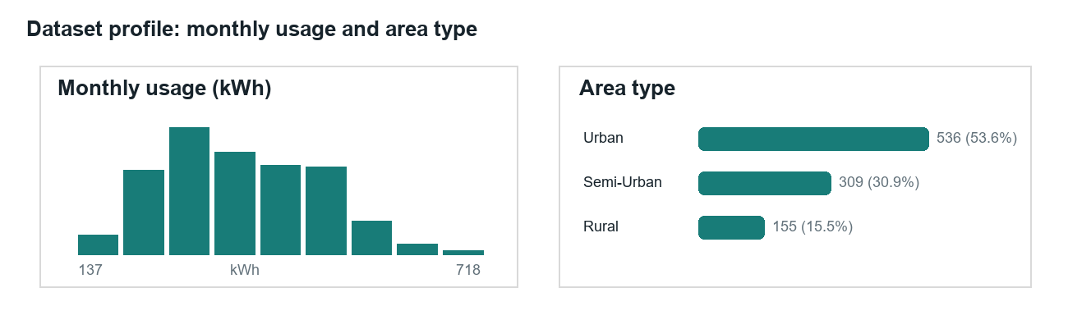
Figure 1. Monthly target distribution and area-type counts in the supplied CSV.
Profile item | Observed value
Rows / columns | 1,000 / 19
Target mean / median / SD | 370.78 / 357.55 / 108.90 kWh
Target range | 136.8–718.0 kWh
Area type | Urban 536 (53.6%); Semi-Urban 309 (30.9%); Rural 155 (15.5%)
Exact duplicates removed | 0
Missing values in required fields | 0

The target centers near 371 kWh, with substantial variation across records. The area mix is imbalanced toward urban rows, so overall scores can hide weaker performance in smaller groups.
No required training field is missing in the current CSV. Imputation is still part of the deployed pipeline so blank optional inputs and future incomplete rows can be handled consistently.

5 Data Cleaning and Preprocessing
Preprocessing lives inside the same scikit-learn pipeline as the estimator. Each imputer, scaler and encoder is fitted on its training fold, then applied to validation or test rows. This prevents held-out rows from contributing preprocessing statistics.
Step | Implementation | Purpose
Schema | Strip column-name whitespace; check required fields | Catch incompatible CSV versions
Duplicates | Count and remove exact repeats | Avoid repeated rows as false independent evidence
Numeric conversion | Convert numeric features and target; malformed text becomes missing | Make values usable in regression
Target | Drop rows without Monthly_Usage_kWh | Training requires a known label
Numeric missing values | Median imputer | Simple fallback for incomplete rows
Scaling | StandardScaler on numeric features | Comparable scale for Ridge penalty
Area type | Mode imputer + one-hot; ignore unknown values | Encode category and tolerate unseen category

The required columns have zero missing values in the current file. The preprocessing steps still matter for a blank previous-month input. Pipeline and ColumnTransformer keep the same transformation logic in cross-validation, model fitting and inference [4].

6 End-to-End Machine-Learning Pipeline
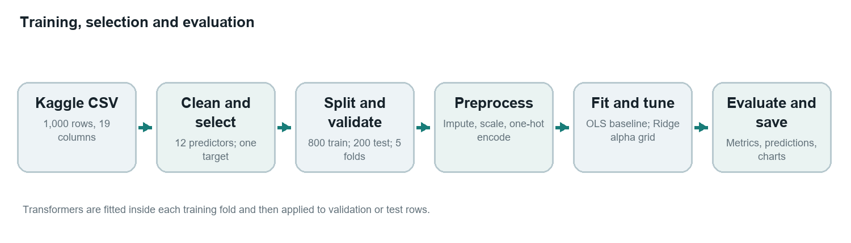
Figure 2. Workflow implemented by train_model.py.
The script selects 12 predictors and one continuous target, then splits once into training and held-out test subsets. Cross-validation and hyperparameter selection see only the training subset. The selected fitted pipeline is evaluated on the test rows once.
At inference, the saved pipeline performs the same imputation, scaling and encoding before prediction. Storing the preprocessing and estimator together avoids separately reimplementing feature preparation in Express.

Training outputs
The joblib artifact contains the fitted transformer and Ridge estimator. The results folder contains metrics.json, test_predictions.csv, cold_start_test_predictions.csv, error_by_usage_band.csv, model_coefficients.csv, actual_vs_predicted.png and residual_diagnostics.png.

7 Model Development with Linear Regression
Ordinary least-squares Linear Regression is the reference model. For a feature vector x, it estimates:
y_hat = β0 + β1x1 + β2x2 + ... + βpxp
The coefficients are selected to minimize squared residuals on the training data. This baseline is simple to explain and fast to train. It provides a reference point for testing whether regularization helps without changing the feature preparation or target.

Inputs and output
The model receives 11 numeric predictors and one categorical predictor, Area_Type. The target is Monthly_Usage_kWh. The estimator returns a continuous value; predict_usage.py clips negative estimates to zero because negative monthly use is not meaningful for the interface.

Interpretation and assumptions
A linear model represents additive relationships unless interaction or nonlinear terms are explicitly added. This version does not create appliance interactions, rated power, daily operating hours or nonlinear temperature effects. A coefficient is a conditional association under the fitted model, not proof that an appliance causes a specific metered increase.
LinearRegression minimizes residual sum of squares [2], making it more sensitive to very large misses than MAE. Reporting both MAE and RMSE helps describe typical and tail errors.

8 Model Optimization with Ridge Regression
Ridge adds an L2 penalty to squared error. Alpha controls its strength: a larger alpha shrinks coefficients more. Numeric predictors are standardized before the penalty is applied so measurement units do not dominate shrinkage.
Objective = sum((y − y_hat)²) + α sum(βj²)
GridSearchCV tests four alpha values with five-fold cross-validation on training rows. The scoring objective is MAE; the candidate with the lowest mean validation MAE is selected and refit on training data [3].
Ridge alpha | Mean CV MAE (kWh) | Fold SD (kWh)
0.1 | 16.7303 | 0.2017
1 | 16.7287 | 0.2041
10 | 16.7466 | 0.2311
100 | 17.8314 | 0.4139

Alpha 1.0 has the lowest CV MAE at 16.7287 kWh. Linear Regression's mean is 16.7305 kWh. The 0.0018 kWh gap is practically negligible. Ridge wins under the stated selection rule, but the experiment does not show a material advantage over the baseline.

9 Training and Test Protocol
Choice | Setting
Train / test | 80:20; 800 training rows and 200 test rows
Random seed | 91
Cross-validation | 5 folds, shuffled, random_state 91
Search grid | Ridge alpha = 0.1, 1, 10, 100
Search score | Negative MAE, so a larger score means lower error
Selection | Choose lower mean training-CV MAE
Final metrics | Score held-out test after model selection

Why hold out test rows
The test set does not fit the imputer, scaler, encoder, coefficients or Ridge alpha. The 800 training records support cross-validation and candidate selection; the 200 test records provide a final evaluation on unseen rows. This separation follows the scikit-learn model-selection guidance [3].

Evaluation design
The fixed seed and recorded split make the training, model selection and held-out evaluation reproducible. Cross-validation scores are calculated on training folds, and the final metrics are calculated on the separate 200-row test set.

10 Performance Metrics
Metric | Formula | Interpretation
MAE | mean(|actual − predicted|) | Average absolute error, in kWh; lower is better.
RMSE | sqrt(mean((actual − predicted)²)) | Penalizes large misses more heavily; lower is better.
R² | 1 − residual sum of squares / total sum of squares | Compared with predicting test mean; 1 is ideal, 0 is mean baseline, negative can be worse.

MAE is the tuning objective because it has a direct kWh interpretation and is less dominated by one large miss than RMSE. RMSE complements it by emphasizing the tail. R² is a dimensionless comparison with a constant-mean baseline; it is not a percent-accuracy score [2, 5].

Residual measures
The report also records mean and median signed error, the 90th-percentile and maximum absolute errors, and the percentages of held-out records within 10, 20 and 30 kWh. Residual is actual minus predicted: a positive value means underprediction; a negative value means overprediction.
These tolerance rates do not define universal acceptability. They summarize this held-out sample at chosen kWh thresholds. The relevant tolerance depends on meter resolution and intended use.

11 Held-Out Results and Model Comparison
Model | MAE (kWh) | RMSE (kWh) | R²
Linear Regression | 15.9257 | 20.9559 | 0.9655
Optimized Ridge | 15.9184 | 20.9456 | 0.9656

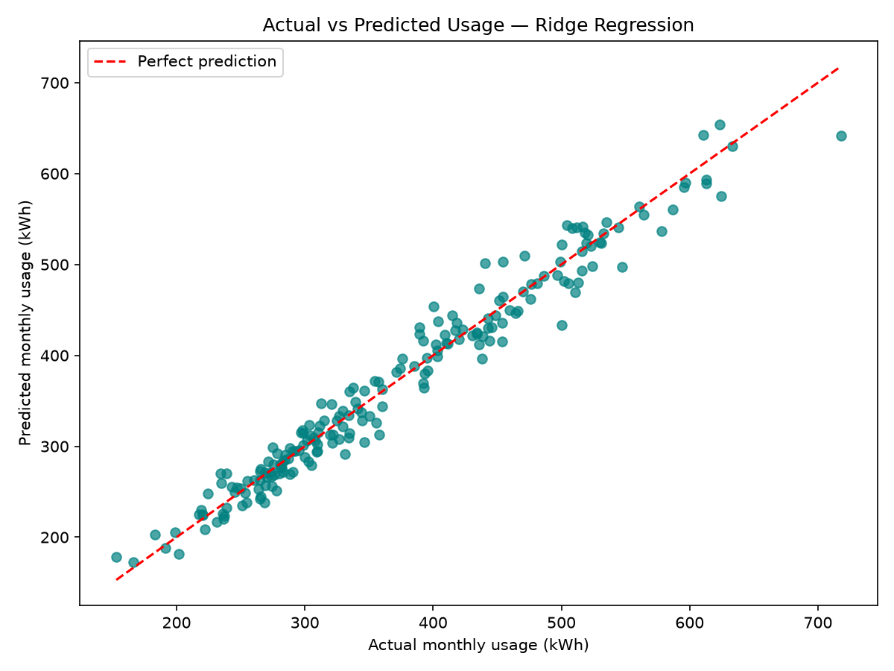
Figure 3. Held-out predictions plotted against observed values; the diagonal is perfect agreement.
Ridge lowers test MAE by 0.0073 kWh and RMSE by 0.0103 kWh compared with Linear Regression, relative reductions of about 0.05%. R² rises from 0.9655 to 0.9656. These results are practically indistinguishable on this split.
Selected Ridge metrics are MAE 15.918 kWh, RMSE 20.946 kWh and R² 0.9656. Mean actual test usage is 371.746 kWh. The MAE is about 4.3% of this mean, but that ratio is not a calibrated per-household percentage error.
The scatter points cluster around the diagonal, indicating close agreement between observed and predicted usage on the held-out test set. The spread is wider among higher-usage records.

12 Residual Analysis and First-Visit Scenario
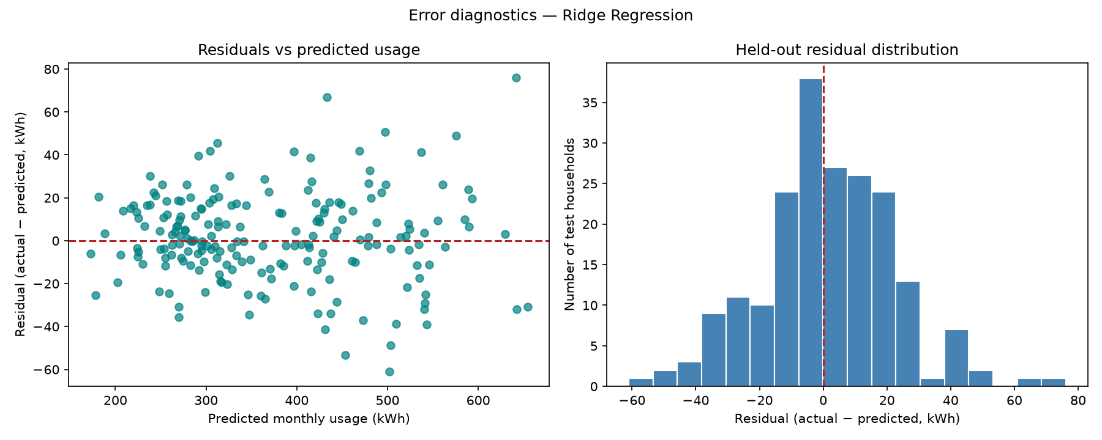
Figure 4. Residual = actual minus predicted; positive values indicate underprediction.
Usage quartile | Rows | Actual range (kWh) | MAE | Mean signed error
Q1 | 50 | 153.0–280.7 | 12.40 | +0.09
Q2 | 50 | 281.6–344.1 | 11.88 | +0.46
Q3 | 50 | 344.6–454.0 | 18.89 | -0.37
Q4 | 50 | 454.1–718.0 | 20.50 | +5.94

Across 200 rows, mean signed error is +1.533 kWh and median is +0.762 kWh. The 90th-percentile absolute error is 33.992 kWh; the maximum is 76.133 kWh. Estimates fall within 10, 20 and 30 kWh for 42.0%, 70.0% and 85.5% of test records.
The highest-use quartile has MAE 20.50 kWh versus 11.88–12.40 kWh in the first two quartiles. Its mean signed error is +5.94 kWh, showing average underprediction at the high end.

When previous-month usage is blank
When Previous_Month_Usage_kWh is hidden for every test row, the fitted training median is imputed. MAE rises from 15.918 to 36.039 kWh; RMSE becomes 45.613 kWh and R² falls to 0.8367. This stress case is more relevant to a new user who leaves the optional input blank.

13 Feature Contribution Analysis
Encoded feature | Coefficient
AC_Units | +43.00
Previous_Month_Usage_kWh | +38.40
Household_Size | +23.31
Other_Appliances | +10.67
Rooms | +7.83
TV_Count | +7.29
Light_Count | +4.90
Refrigerator | +4.52

The largest absolute numeric coefficients are AC_Units (+43.00), Previous_Month_Usage_kWh (+38.40) and Household_Size (+23.31). The pattern is consistent with previous consumption and cooling demand carrying substantial information about the current target.
Numeric coefficients correspond to standardized inputs, so their values describe a one-standard-deviation shift while other encoded values are held fixed. They are not kWh per additional appliance. The area categories use one-hot encoding; their coefficients should be read with the model intercept and coding structure.
Coefficient size is not a causal effect or guaranteed ranking in a different dataset. Correlated predictors share information; previous-month use is strongly associated with the target. A future explanatory version could add permutation importance or partial-dependence analysis.

Interpretability choice
Linear models keep the coursework implementation explainable. A tree-based model might capture interactions; it can be compared using the same cross-validation folds and metrics.

14 Full-Stack System Architecture
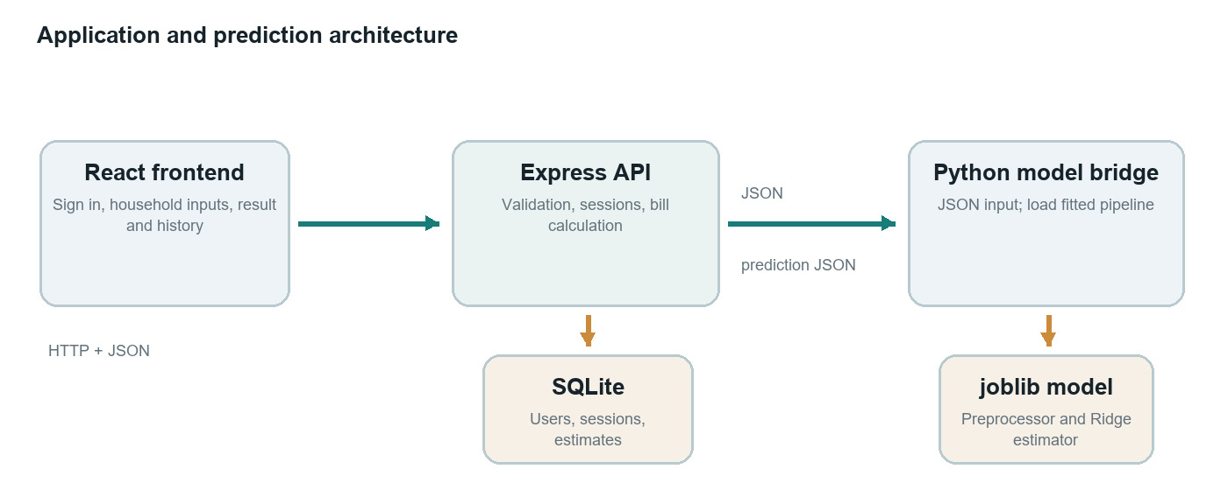
Figure 5. React calls Express; Express invokes Python and persists per-user data in SQLite.
The browser submits household input as JSON. Express checks the active session, validates numeric ranges and allowed area type, then invokes predict_usage.py. The Python process reads JSON from standard input, creates a one-row pandas DataFrame, loads electricity_usage_model.joblib and writes predicted kWh as JSON.
Express calculates estimated_bill = predicted_kwh × tariff_per_kwh, inserts inputs, prediction, tariff, bill and timestamp under the authenticated user ID, then returns the result. The frontend refreshes its recent-history panel.
Component | Responsibility
React + Vite | Single-page form and dashboard; Vite proxies API calls during development.
Express | Session routes, CSRF checks, validation, prediction coordination and bill arithmetic.
Python + scikit-learn | Load the fitted model artifact and return estimated kWh.
SQLite | Persist accounts, server-side sessions and user-linked predictions.

15 Application Workflow and Account History
API route | Purpose
GET /api/csrf-token | Issue token for state-changing requests.
GET /api/auth/me | Return signed-in user or null.
POST /api/auth/register | Validate credentials, hash password and create account/session.
POST /api/auth/login | Check credentials and establish session.
POST /api/auth/logout | Destroy current session.
GET /api/history | Return authenticated user's latest 20 estimates.
POST /api/predict | Validate inputs, run model, estimate bill and save record.

Passwords are hashed with bcryptjs before storage. Session data is server-side in SQLite; the cookie is HTTP-only, SameSite=Lax and lasts seven days, with the secure flag enabled in production. A per-session CSRF token protects state-changing requests. History reads are filtered by the current user's ID.
A new account starts with empty history. Returning users see up to 20 recent estimates. The latest predicted kWh may be prefilled as previous-month usage, but it is only an estimate; the UI tells users to replace it with a meter reading when they have one. Reusing predictions can reinforce earlier model error.
This local authentication setup is for a coursework demonstration. Public deployment needs a strong secret, HTTPS, authentication rate limits, monitoring, backups, data-retention choices and a production security review.

16 Model Considerations and Improvements
Model consideration | Why it matters | Next step
Prior usage is powerful | Full-feature score exceeds the no-history score. | Report cold-start separately; test feature ablations.
Linear form | No nonlinear or interaction effects. | Compare one tree/boosting model using the same CV folds.
Prediction may prefill prior input | A prior estimate is not a meter reading. | Label source or default to blank.

Recommended evaluation sequence
Compare an appliance-only model, a model with previous-month use and a no-history scenario. Compare Ridge with one nonlinear model using the same cross-validation folds and MAE/RMSE/R², then review errors by area and consumption band.
The current optimization demonstrates model selection; Ridge improves the test MAE by a small amount. A useful next step is to study which available predictors contribute most to first-visit estimates.

17 Reproducibility, Course Mapping and References

Reproduce the model
From the project folder, install requirements and run python train_model.py. The script writes models/electricity_usage_model.joblib and metrics/diagnostics into results/. Express invokes the saved pipeline through predict_usage.py.
Training environment for this report run: Python 3.14.3, scikit-learn 1.8.0, NumPy 2.4.3, pandas 3.0.1, matplotlib 3.11.1 and joblib 1.5.3. The random seed is 91. The CSV is included in the project for a repeatable local run.
Syllabus outcome | Project evidence
CO1 — Problem formulation | Continuous target, input fields, scope and use case.
CO2 — Data preparation | Schema validation, duplicate removal, conversion, imputation, scaling and encoding.
CO3 — Model development | Linear Regression baseline and Ridge inside a reusable pipeline.
CO4 — Evaluation and optimization | 80:20 holdout, five-fold CV, alpha search, MAE, RMSE, R² and diagnostics.
CO5 — Application and communication | React + Express + Python + SQLite integration, account history and report.

References
[1] Kaggle, Electricity Bill Prediction dataset page supplied for this project: https://www.kaggle.com/datasets/armanahmedtaief/electricity-bill-prediction
[2] scikit-learn, LinearRegression API: https://scikit-learn.org/stable/modules/generated/sklearn.linear_model.LinearRegression.html
[3] scikit-learn, hyperparameter tuning and GridSearchCV: https://scikit-learn.org/stable/modules/grid_search.html
[4] scikit-learn, Pipeline API: https://scikit-learn.org/stable/modules/generated/sklearn.pipeline.Pipeline.html
[5] scikit-learn, regression metrics: https://scikit-learn.org/stable/api/sklearn.metrics.html
The project demonstrates a full regression workflow and connected web interface. Its reported metrics summarize the selected test split, while the cold-start results show how performance changes when previous-month usage is unavailable.

