Reproducible Research: Peer Assessment 1

## Loading and preprocessing the data

df<-read.csv("activity.csv",header=T)

## What is mean total number of steps taken per day?

Histogram for the total no. of steps taken per day is

df_hist<-aggregate(df$steps,by=list(df$date),sum)  
colnames(df_hist)<-c("date","cnt")  
hist(df_hist$cnt,xlab="No. Steps per day",ylab="Frequncy of the steps taken per day",main="Histogram for the No. of steps per day")

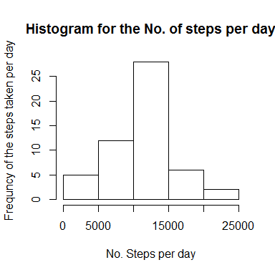 Median for the total no. of steps taken per day is

median(df_hist$cnt,na.rm=T)

## [1] 10765

Mean for the total no. of steps taken per day is

mean(df_hist$cnt,na.rm=T)

## [1] 10766.19

## What is the average daily activity pattern?

data set for the average no. of steps taken in every 5 minute interval over all the days

## Imputing missing values

## Are there differences in activity patterns between weekdays and weekends?