Full Stack Development with MERN Stack
Project Documentation
_________________________________________________________________________________

1. Introduction
- Project Title: KisanLog Agri-Tech Web Platform
- Team Members: Full Stack MERN Development (Individual / Team Project)
- Platform Scope: End-to-end Smart Agriculture Management & Advisory System

2. Project Overview
Purpose:
KisanLog is a full-stack MERN (MongoDB, Express.js, React 19, Node.js) Agri-Tech Web Platform designed to empower farmers, agricultural experts, and administrators with real-time farm land management, crop growth lifecycle tracking, soil health diagnostics, pest outbreak advisory notifications, resource usage ledgering, equipment/input marketplace bookings, and live OpenWeatherMap microclimate telemetry—backed by a comprehensive role-based Admin Control Panel.

Key Platform Features:
- Farmer & Admin role registration, login, JWT bearer token authentication, bcrypt password hashing, and protected route access control.
- Complete CRUD for farm land records (acreage, village location, soil type, irrigation status).
- Lifecycle management for crops (planting date, growth stage tracking, estimated yield predictions, and status updates).
- Real-time OpenWeatherMap API integration featuring auto GPS location detection & city search for temp, humidity, wind, & pressure metrics.
- Soil health diagnostics analyzing NPK (Nitrogen, Phosphorus, Potassium) ratios & pH levels with automated recommendation guidance.
- Regional pest outbreak advisory alerts categorized by risk severity (Low to Critical) with symptoms and organic/chemical remedies.
- Input & resource tracking ledger for water irrigation, fertilizers, pesticides, seeds, and fuel consumption.
- Agricultural marketplace and machinery rental booking system for seeds, bio-fertilizers, solar pumps, and service hires.
- Peer-to-peer Farmer Community Forum for asking questions, sharing advice, liking, and commenting on community posts.
- Admin Control Panel for platform analytics, user account oversight/approvals, marketplace inventory CRUD, and system health checks.

3. Architecture
The KisanLog platform adheres to a modern layered client/server architecture. The frontend is built as a single-page application in React 19 (bundled with Vite) and communicates via Axios to RESTful endpoints exposed by a Node.js and Express.js backend server. The server handles request routing, authorization, business rules, interacts with MongoDB through Mongoose ODM, and integrates with the OpenWeatherMap REST API.
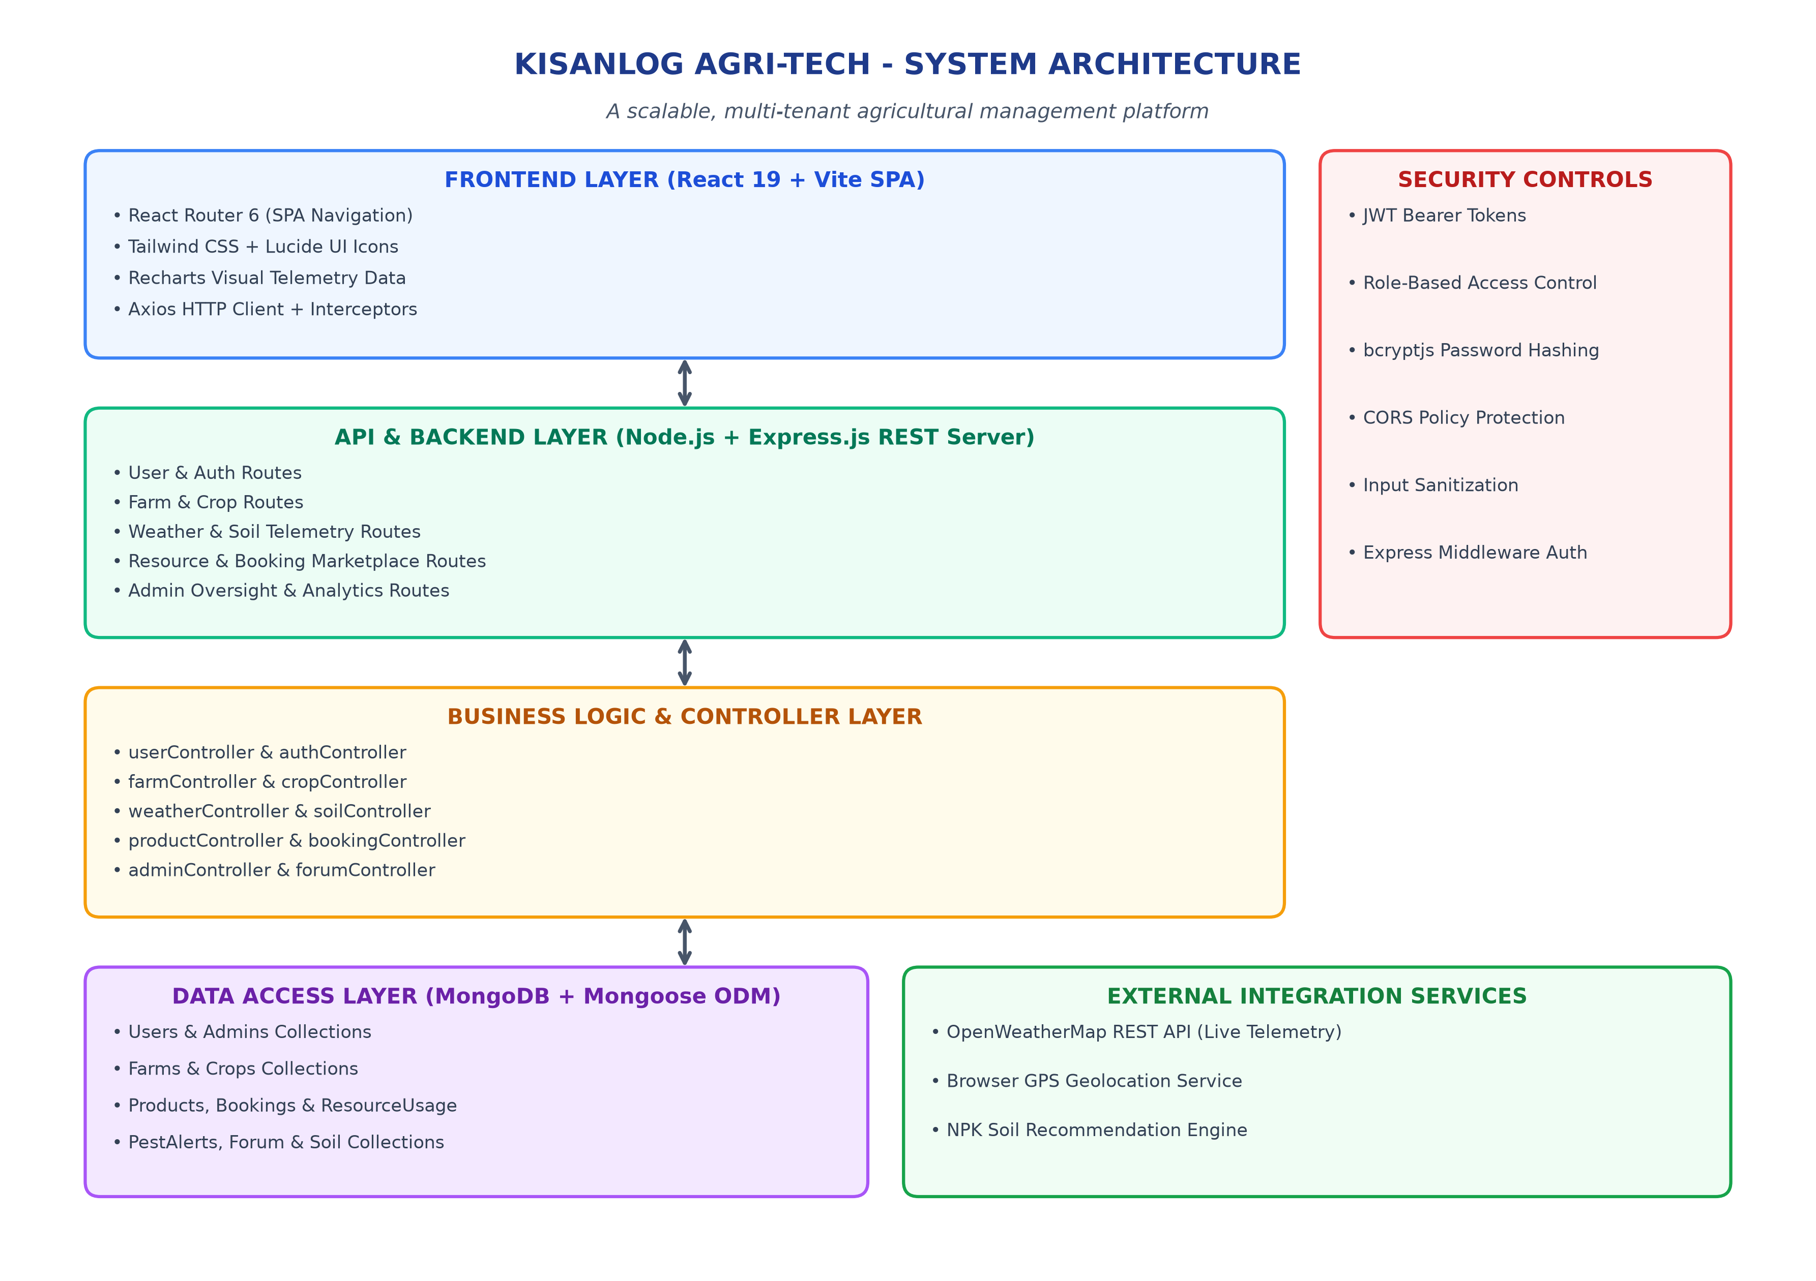
Figure: KisanLog Overall System Architecture

Frontend Architecture
The React application utilizes React Router 6 for modular page navigation. Dynamic state management is handled through React hooks and Context API. Axios uses a centralized HTTP client instance (`services/api.js`) that automatically attaches JWT bearer tokens to requests and clears stored session data on 401 unauthenticated errors.
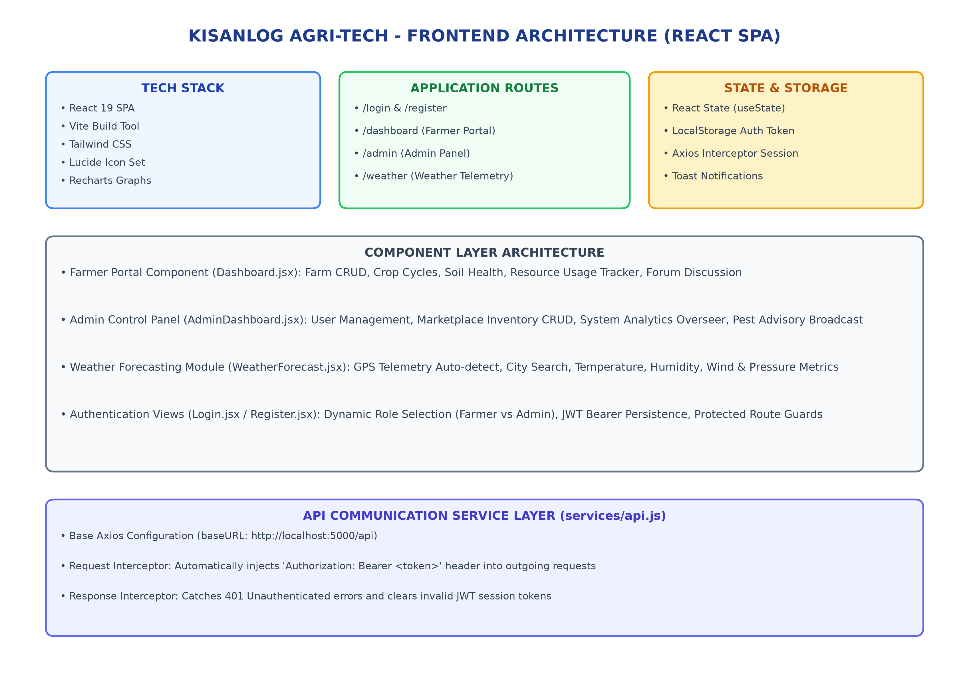
Figure: Frontend Component & Service Architecture (React 19)

Backend Architecture
The Express.js backend is structured into modular routes, controllers, middleware, models, and utility services. `backend/index.js` initializes global CORS policies, JSON body parsing, route mounting, and connects to MongoDB.
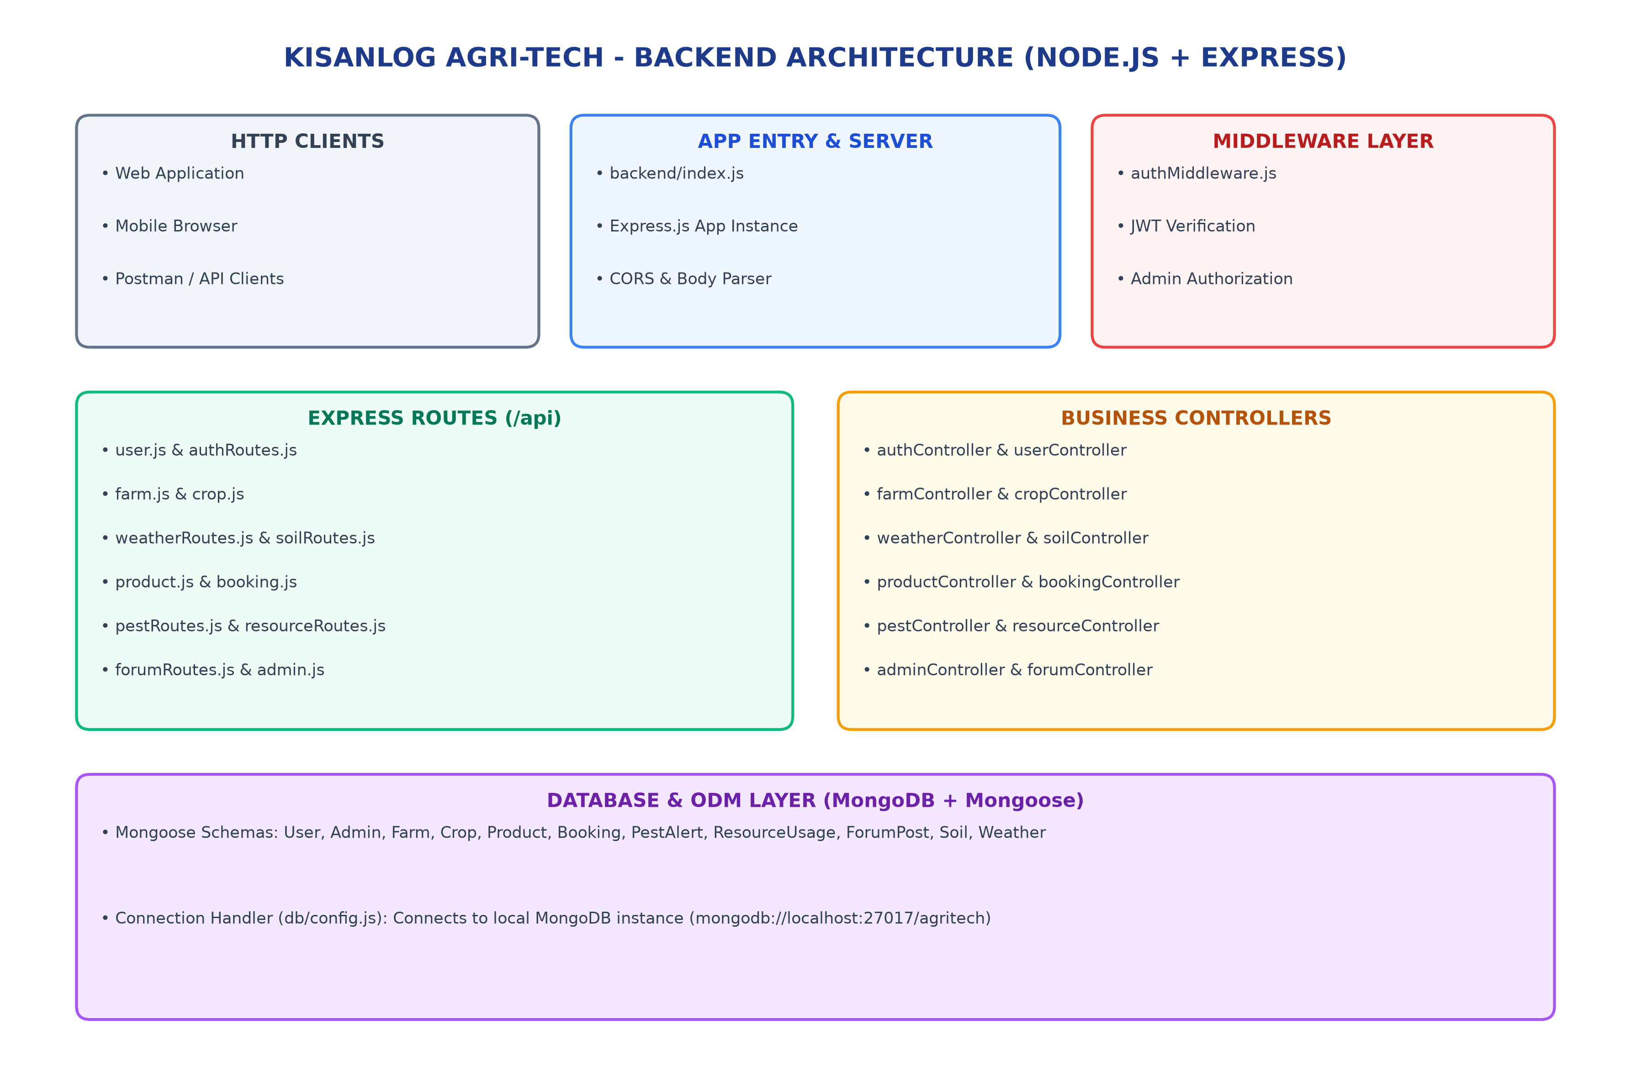
Figure: Backend Node.js & Express.js Layered Architecture

Database Architecture & ERD
KisanLog utilizes MongoDB as its primary document store, using Mongoose ODM to enforce schemas, validate object references, and maintain model relationships.
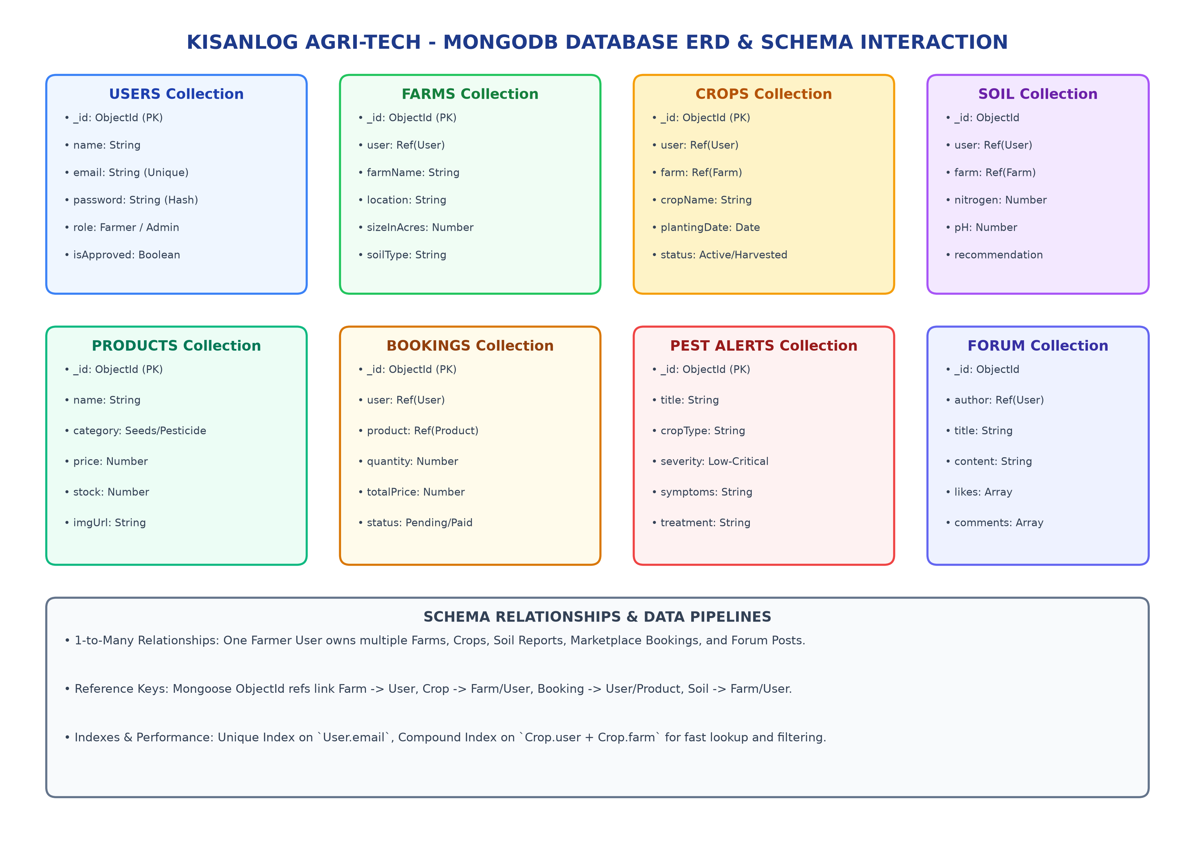
Figure: MongoDB Database Schemas, ERD & Data Interactions

4. Setup Instructions

Prerequisites
- Node.js (v18.0+ recommended) & npm package manager.
- MongoDB instance running locally (mongodb://localhost:27017) or MongoDB Atlas cluster.
- Modern Web Browser (Chrome, Firefox, Edge, Safari).
- OpenWeatherMap API Key (for real-time weather forecasting telemetry).

Installation Commands
# 1. Clone Repository & Setup Backend
cd backend
npm install
# 2. Setup Frontend (In a second terminal window)
cd ../frontend
npm install

Environment Variables Configuration
File / Scope | Variable Name | Purpose & Default Value
backend/.env | PORT | Express server port (default: 5000)
backend/.env | MONGO_URI | MongoDB connection string (mongodb://localhost:27017/agritech)
backend/.env | JWT_SECRET | Secret key for signing JSON Web Tokens (agri_tech_secret_key_2026)
frontend/.env | VITE_API_URL | Backend REST API base URL (http://localhost:5000/api)
frontend/.env | VITE_OPENWEATHER_KEY | OpenWeatherMap API Key for live weather metrics

5. Project Directory Structure
Agri-Tech/
├── backend/
│ ├── index.js # Express server entry point & route registration
│ ├── package.json # Backend dependencies (Express, Mongoose, JWT, bcrypt)
│ ├── db/
│ │ ├── config.js # MongoDB connection configuration
│ │ └── crops.json # Preloaded static crop reference metadata
│ ├── controllers/ # Business logic controllers (User, Farm, Crop, Soil, etc.)
│ ├── models/ # Mongoose collection schemas (User, Farm, Crop, Product, etc.)
│ ├── routes/ # Express sub-router endpoints
│ └── middleware/
│ └── authMiddleware.js # JWT Bearer validation & Admin RBAC protection
└── frontend/
├── package.json # React 19, Axios, Tailwind, Lucide, Recharts
├── vite.config.js # Vite bundler setup
└── src/
├── App.jsx # SPA React Router configuration
├── services/api.js # Axios HTTP instance with JWT interceptor
└── components/ # UI Views (Login, Register, Dashboard, AdminDashboard, Weather)

6. Running the Application
- Backend Execution: Execute `cd backend && node index.js` (Server runs on http://localhost:5000)
- Frontend Execution: Execute `cd frontend && npm run dev` (Frontend runs on http://localhost:5173)
- Syntax Verification: Execute `cd backend && node -c index.js`
- Production Build Check: Execute `cd frontend && npm run build`

7. REST API Documentation
All API endpoints are prefixed with `/api`. Protected routes require an `Authorization: Bearer <JWT>` header.
Method | Endpoint | Auth Required | Description
POST | /api/users/register | None | Register new Farmer or Admin account
POST | /api/users/login | None | User login & JWT token issuance
GET | /api/farms | JWT | List all farms registered by user
POST | /api/farms | JWT | Create new farm record
GET | /api/crops | JWT | List crop cycles across farms
POST | /api/crops | JWT | Register new crop planting cycle
GET | /api/weather | None | Fetch live weather telemetry by city/coords
GET | /api/soil | JWT | Get soil health NPK reports & advisories
POST | /api/soil | JWT | Log new soil lab test analysis
GET | /api/products | None | List marketplace catalog items
POST | /api/bookings | JWT | Place order for seeds, fertilizer, equipment
GET | /api/admin/analytics | ADMIN | Fetch platform-wide metrics & stats
GET | /api/admin/users | ADMIN | Manage user account approvals & statuses
POST | /api/pest | ADMIN | Broadcast regional pest outbreak alert

Sample API Payloads & Responses
- User Login Payload (POST /api/users/login):
{
"email": "farmer@agritech.com",
"password": "StrongPassword123"
}

- Success Login Response:
{
"success": true,
"data": {
"token": "eyJhbGciOiJIUzI1NiIsInR5cCI6IkpXVCJ9...",
"user": { "_id": "65f123...", "name": "Ramesh Kumar", "role": "Farmer" }
}
}

8. Authentication & Authorization
- Passwords hashed using bcryptjs with 10-12 salt rounds before database persistence.
- JWT tokens signed with `JWT_SECRET` containing user ID, role, and expiration timestamp.
- Express middleware `authMiddleware.js` verifies token integrity for protected routes.
- Admin-restricted endpoints enforce role checks (`role === 'Admin'`).
- Automatic 401 unauthenticated interceptor clears invalid client tokens.
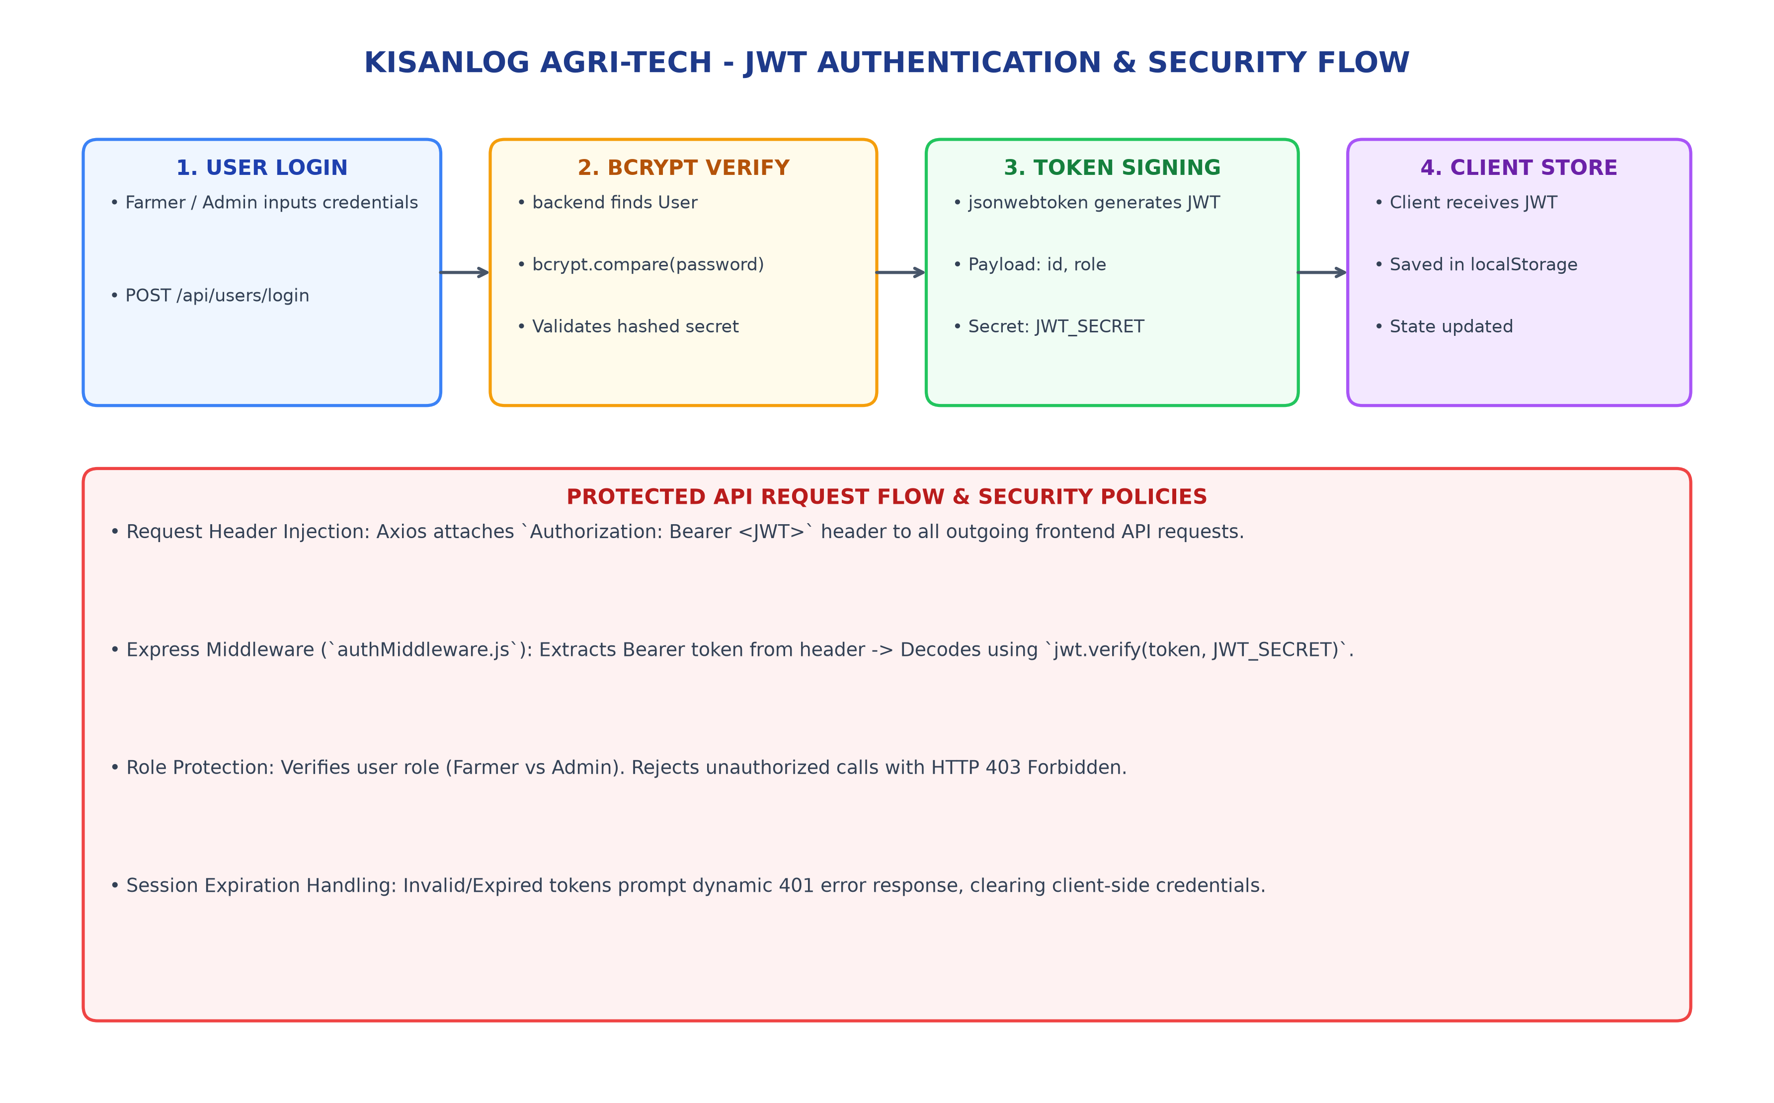
Figure: JWT Authentication Lifecycle & Security Controls

9. User Interface & Layouts
- Farmer Portal Dashboard (Dashboard.jsx): Centralized farm, crop, soil health & resource usage manager.
- Admin Control Panel (AdminDashboard.jsx): User account management, inventory editor, pest advisory broadcaster.
- Weather Telemetry Interface (WeatherForecast.jsx): Live OpenWeatherMap telemetry displays.
- Marketplace & Order Confirmation View: Seamless catalog browsing & equipment rental booking.

10. Testing Strategy & Quality Matrix
Test Module | Tooling Stack | Coverage & Verification Scope
Authentication & RBAC | Jest + Supertest | Login/Register flow, JWT signing, password bcrypt hashing, token expiration
Farm & Crop Logic | Jest + Supertest | CRUD operations, date validations, acreage math, yield estimation
Weather Telemetry | Jest + Mock API | OpenWeatherMap API response parsing, fallback offline state handling
Frontend Build | npm run build | Vite compilation check, JSX bundle integrity, zero syntax errors
Backend Entry Check | node -c index.js | Express app initialization check, MongoDB driver handshake

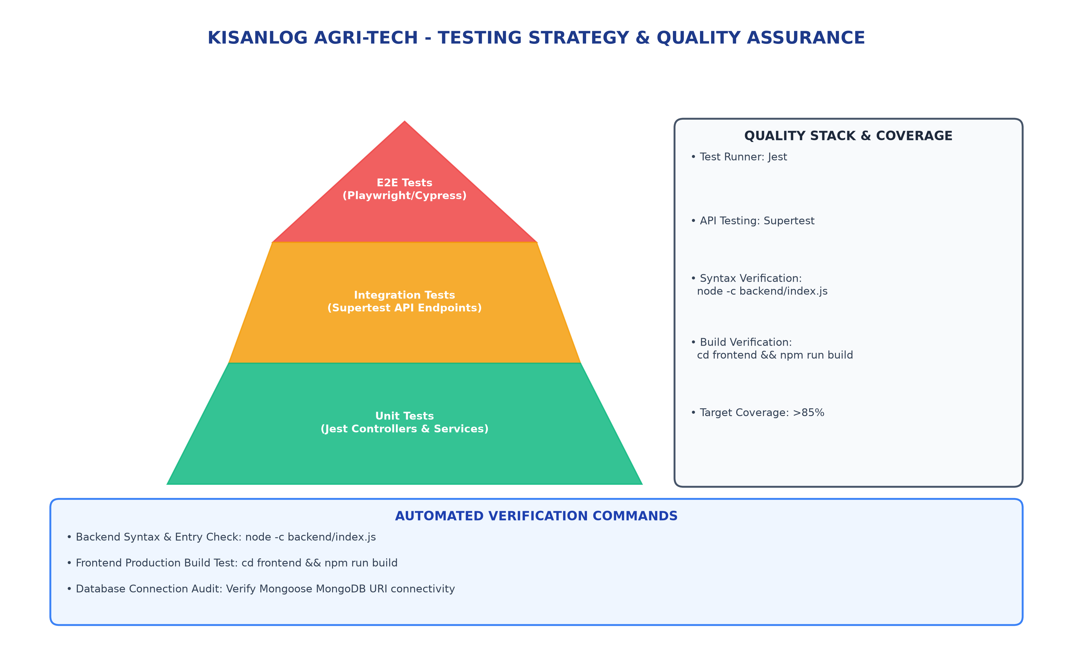
Figure: Testing Strategy Pyramid & Automated Build Verification Pipeline

11. Project Links & Demo Repository
- GitHub Project Repository: https://github.com/rohitkokane02/agri-tech
- Local Dev Environment: http://localhost:5173 (Frontend Dev Server)

12. Known Technical Limitations
- Weather forecasting relies on OpenWeatherMap free-tier API rate limits.
- Offline telemetry fallback returns static cached data when internet connection is interrupted.
- Seed dataset uses default local MongoDB instance; production deployment requires Atlas configuration.

13. Future Enhancements & Roadmap
- Integration with IoT Soil Telemetry Hardware Sensors for real-time automated NPK & moisture polling.
- Machine Learning Model (Python/TensorFlow) for automated leaf disease detection via smartphone camera.
- Automated Payment Gateway integration (Razorpay / Stripe) for Marketplace orders.
- Regional SMS & WhatsApp Weather/Pest Alert notifications for non-smartphone farmers.
- Multi-language localization (Hindi, Marathi, Gujarati, etc.) for broader accessibility.

