**Graphs:**

**1) Email Data Without Regularization at different step sizes.**

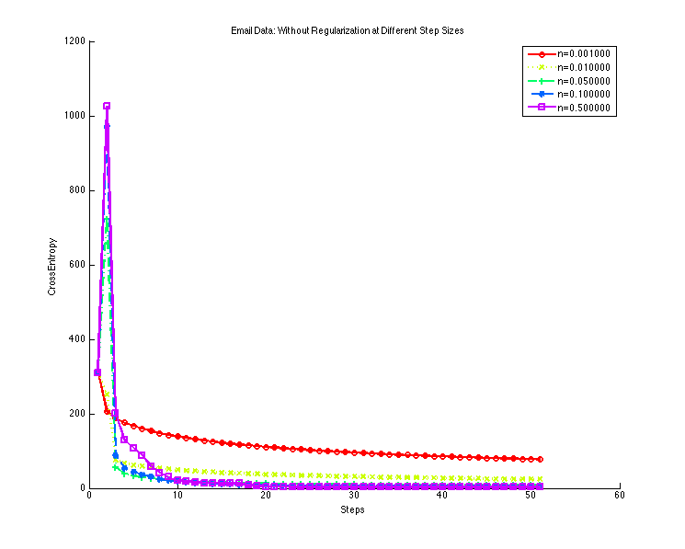

**2) Ionosphere Data Without Regularization at different step sizes.**

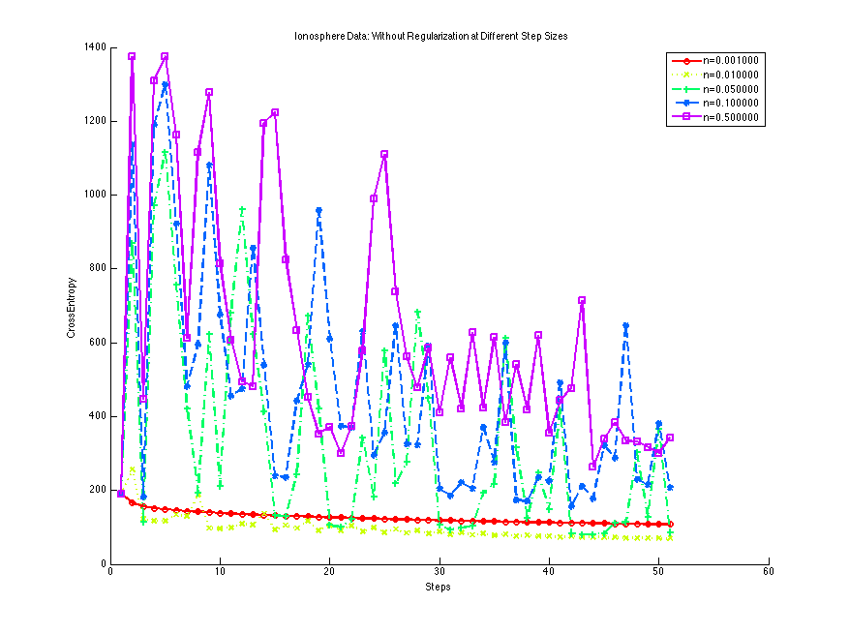

**3) Email Data with Regularization for Lambda = 0.1**

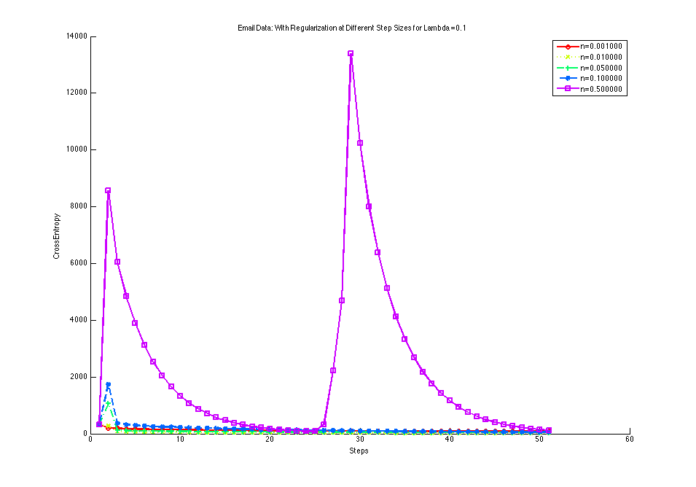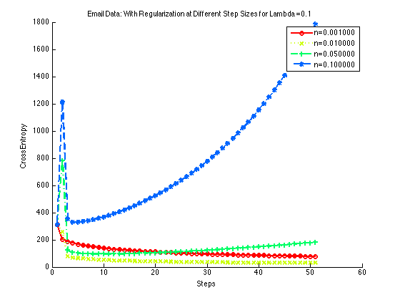

**4) Ionosphere Data with Regularization for Lambda = 0.1**

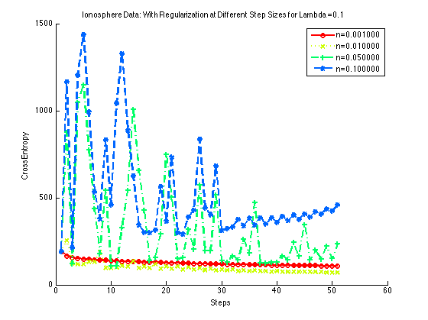

**4 c) CrossEntropy vs Regularization**

**For Email Data**

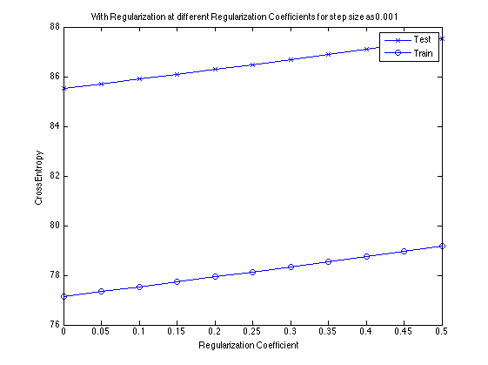

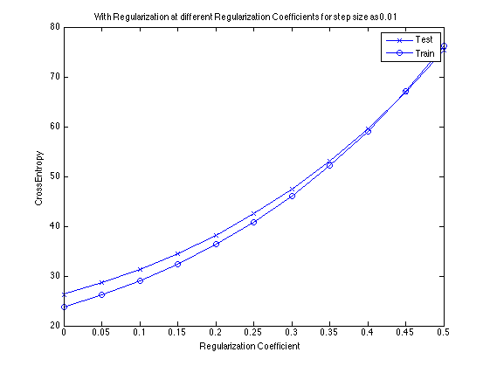

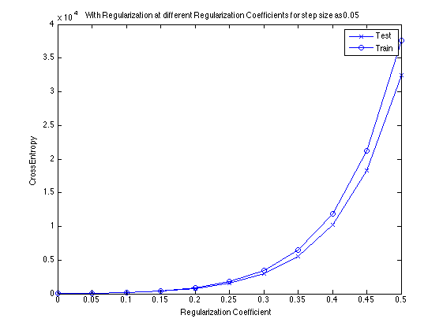

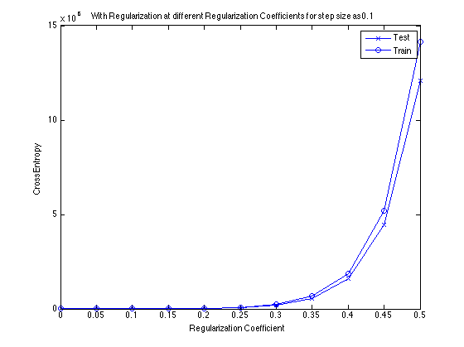

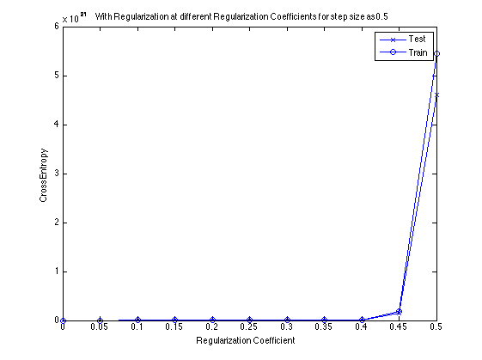

**For Ionosphere Data**