CASE STUDY
Title of the Case Study: Automating Loan Approval Workflows: A Case Study of Amazon SWF and AWS Step Functions at QuickLoan Finance
Course Name: Cloud Architecture Design (BCSE355L)
Student Name: Rohit Krishnaa B
Register Number: 24BCE0802

1. Introduction
Modern cloud applications are no longer a single program. They are made of many small services, and one business action usually needs several of these services to work one after another, in the right order. Approving a bank loan is a good example: the application has to be received, the documents verified, the credit score checked, a manager may need to approve it, the customer has to sign, and only then can the money be released. Such a process can take hours or even days.
If one step fails halfway, the system must know exactly where it stopped. Otherwise an application may be lost, or worse, a loan may be paid out twice. Writing our own code to remember finished steps, retry failures and decide what comes next is difficult and error-prone. AWS provides two workflow services that take over this coordination work: Amazon Simple Workflow Service (SWF), launched in 2012, and AWS Step Functions, launched in 2016.
This case study looks at a fictional digital lender, QuickLoan Finance, and shows how both services can be used together to build a reliable, traceable loan approval process. Banking is a useful setting because it adds three extra demands: long-running steps, human decisions in the middle of the flow, and a strict need for an audit trail.

2. Overview of the Concept

2.1 Amazon Simple Workflow Service (SWF)
Amazon SWF is a managed service that coordinates tasks across distributed applications. It does not run our business logic itself. Instead, it keeps the state of every workflow run, hands out tasks to our programs, and records every event, so a single run can safely last for up to one year. Its three main jobs are maintaining state, supervising progress, and holding and dispatching tasks.
The building blocks of SWF are:
• Workflow starter – the application that begins a workflow run.
• Decider – our code that reads the history of the run and decides which task should happen next.
• Activity worker – our code that performs one unit of real work, such as calculating a credit score. Workers can run on AWS or on our own on-premises servers.
• Task lists – queues in which SWF keeps tasks until a decider or worker polls for them.
• Execution history – a complete, step-by-step record of every event in a run.
• Domain – a scope that groups related workflow and activity types, similar to a project folder.
SWF hands out three types of tasks: activity tasks (do a piece of work), Lambda tasks (run an AWS Lambda function instead of a worker) and decision tasks (tell the decider that something changed, together with the full history, so it can choose the next step).
An important feature of SWF for long-running and unreliable steps is its set of timeouts. They make sure that a workflow never waits forever for a step that has silently failed:
Timeout | What it limits
Workflow Start-to-Close | Maximum duration of the whole workflow run
Decision Task Start-to-Close | Time the decider has to respond to a decision task
Activity Schedule-to-Start | Time a task may wait in the task list before a worker picks it up
Activity Start-to-Close | Time a worker may spend on one activity task
Activity Heartbeat | Maximum gap between “I am still alive” signals from a busy worker
Activity Schedule-to-Close | Total time from scheduling an activity to its completion
Table 1: Amazon SWF timeout types

2.2 AWS Step Functions
AWS Step Functions is a serverless workflow orchestration service. The workflow is modelled as a state machine: a set of states (steps) and the transitions between them. It is written in the Amazon States Language (ASL), a JSON format, or drawn in the drag-and-drop Workflow Studio. Step Functions controls the order of the steps, while services such as AWS Lambda, DynamoDB or SNS do the actual work. There are no deciders or worker servers to write or manage.
The state types used most in this case study are:
• Task – does work by calling Lambda or another AWS service.
• Choice – picks a path based on a condition, like an if/else.
• Map – runs the same steps for every item in a list, in parallel.
• Wait – pauses the workflow for a set time or until a given date.
• Succeed / Fail – ends the workflow as a success or a failure.
A Task state can also use the callback pattern (“waitForTaskToken”). The workflow sends a unique token to an external system and then pauses until that token is returned with a success or failure. This is how a human approval step is built. Every Task state can also have Retry and Catch rules for automatic error handling.
Step Functions offers two workflow types:
Feature | Standard workflow | Express workflow
Maximum duration | Up to 1 year | Up to 5 minutes
Execution guarantee | Exactly once | At least once
History | Full history of every run | Sent to CloudWatch Logs
Best suited for | Long, critical business processes | Short, very high-volume events
Table 2: Standard vs Express workflows

3. Case Description
QuickLoan Finance is a fictional digital lending company in India that offers personal loans through its website and mobile app. A customer fills in an online form and uploads three to five documents: an identity proof, recent salary slips and bank statements.
QuickLoan’s technology is a mix of old and new:
• Credit scoring runs on an on-premises mainframe. Because of banking regulations and the age of the system, it cannot be moved to the cloud.
• Any loan above ₹5 lakh must be approved by a human underwriter (a manager).
• After approval, the customer must e-sign the loan agreement before money is released.
• Every application must also pass a fraud check (IP address, device and blacklist checks).
Before using a workflow service, QuickLoan faced these problems:
• When the mainframe was slow or restarted, credit-check requests were lost and applications got stuck with no error shown.
• There was no reliable record of who approved a loan and when, which is a problem in audits.
• Customers who forgot to sign were never reminded, so approved loans were left incomplete.
• During festival seasons, applications increased by more than ten times and the fraud-check servers could not keep up.
QuickLoan’s goals were therefore: no lost applications, a complete audit trail, automatic reminders, and fraud checks that scale with demand, all with as little extra code and as few new servers as possible.

4. Application of the Concept

4.1 Credit scoring with Amazon SWF
The credit check is the step that must run on the on-premises mainframe. This is where SWF fits best, because its activity workers can run anywhere. They only need to poll SWF over the internet; SWF never has to connect into the bank’s private network.
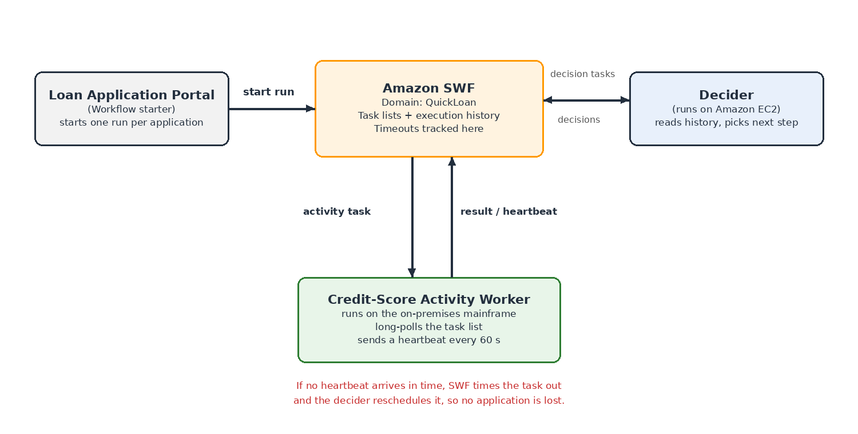
Figure 1: Credit-score workflow at QuickLoan using Amazon SWF
The flow works as follows:
1. The loan application portal acts as the workflow starter and starts one workflow run per application in the “QuickLoan” domain.
2. SWF sends a decision task to the decider, which runs on Amazon EC2. The decider sees a new run and schedules a “CreditScore” activity task.
3. The activity worker on the mainframe long-polls the task list, receives the task and starts calculating the score.
4. While it works, the worker sends a heartbeat every 60 seconds. When it finishes, it returns the score, and SWF records the result in the execution history.
5. SWF sends a new decision task. The decider reads the history, sees the score, and passes the application on to the next stage of the process.
How timeouts solve the “lost application” problem. If the mainframe hangs, the worker stops sending heartbeats. The heartbeat timeout expires, SWF marks the activity as timed out and informs the decider, which schedules the task again. If no worker picks up the task at all (for example, during mainframe maintenance), the schedule-to-start timeout fires and the decider can raise an alert to the operations team. In both cases the application is never silently lost. The execution history also gives auditors a time-stamped record of every attempt.

4.2 Document check and approval with AWS Step Functions
All the remaining steps run in the cloud, so QuickLoan built them as a Standard Step Functions workflow. Standard was chosen because the process can last several days and every step must run exactly once: a loan must never be disbursed twice.
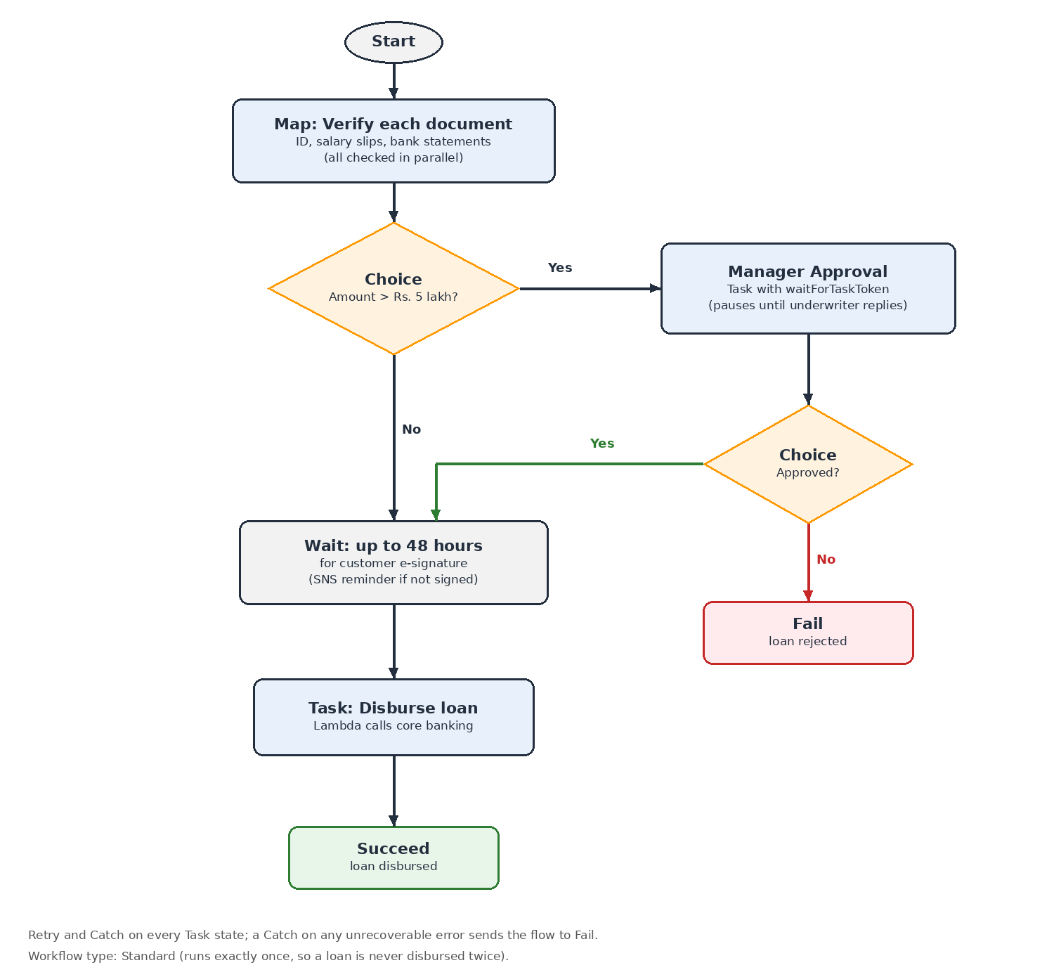
Figure 2: Loan approval state machine in AWS Step Functions
1. Map state – verify documents. The list of uploaded documents is passed to a Map state, which runs a Lambda function on each document in parallel to extract and validate details. Five documents take about as long as one.
2. Choice state – check the amount. If the loan is above ₹5 lakh, the flow goes to manager approval. Otherwise it skips straight to the signing step.
3. Task state with callback – manager approval. The workflow emails the underwriter an approval link containing a task token and then pauses, costing nothing while it waits. When the manager clicks Approve or Reject, the application sends the token back and the workflow continues. If nobody responds in 24 hours, the step times out and is escalated.
4. Choice state – approved? A rejected loan ends in a Fail state and the customer is informed.
5. Wait state – e-signature. The workflow waits 48 hours, then checks whether the agreement has been signed. If not, an SNS notification reminds the customer.
6. Task state – disburse. A Lambda function calls the core banking system to release the money, and the workflow ends in a Succeed state.
The most interesting part of the definition is the human-approval step. In ASL it looks like this:
"ManagerApproval": {
"Type": "Task",
"Resource": "arn:aws:states:::lambda:invoke.waitForTaskToken",
"Parameters": {
"FunctionName": "SendApprovalEmail",
"Payload": {
"token.$": "$$.Task.Token",
"loanId.$": "$.loanId",
"amount.$": "$.amount"
}
},
"TimeoutSeconds": 86400,
"Catch": [{
"ErrorEquals": ["States.Timeout"],
"Next": "EscalateToSeniorManager"
}],
"Next": "IsApproved"
}
Code 1: Human-approval step written in Amazon States Language
The suffix .waitForTaskToken tells Step Functions to pause after calling the Lambda function. “$$.Task.Token” passes the unique token into the approval email. When the manager responds, the web application calls the SendTaskSuccess (or SendTaskFailure) API with that token. TimeoutSeconds of 86,400 is 24 hours, and the Catch rule moves the flow to an escalation step if that time runs out.
Because every run is shown as a coloured diagram in the Step Functions console, the support team can open any application and see exactly which step it is on, and the history shows who approved it and when. This directly solves the audit-trail problem.

4.3 Real-time fraud check with an Express workflow
The fraud check is very different from the loan process. It must finish within a few seconds, it runs for every single application, and the volume can jump more than ten times on festival days. QuickLoan therefore built it as a separate Express workflow, started as soon as an application is submitted. A Parallel state runs three Lambda checks at once (IP reputation, device fingerprint and blacklist lookup), and a Choice state flags suspicious applications for review.
Express workflows suit this job because they are designed for short, high-volume work and cost much less per run than Standard workflows. The checks only read data and do not change anything, so it does not matter if a step runs more than once (“at-least-once” behaviour).

4.4 Summary of design choices
Need at QuickLoan | Service / feature chosen | Reason
Credit check on on-premises mainframe | Amazon SWF activity worker | Workers can run outside AWS; heartbeat and schedule-to-start timeouts detect failures
Verify several uploaded documents | Step Functions Map state | Same check runs on each document in parallel
Manager approval above ₹5 lakh | Choice + Task with waitForTaskToken | Workflow pauses safely until a human responds
E-signature reminder | Wait state + SNS | Pauses without servers, then reminds the customer
Disburse loan once only | Standard workflow | Exactly-once execution and full history
Fraud check at festival peaks | Express workflow | Fast, high volume, low cost per run
Table 3: How each QuickLoan requirement was met

5. Key Observations and Learning Outcomes
• A workflow service separates the coordination logic (what happens next) from the business logic (the actual work), which makes each part simpler to build and change.
• Workflows that include human decisions need a service that can pause safely for hours or days. Step Functions does this with the callback pattern, and SWF supports runs of up to a year.
• Timeouts and heartbeats are essential in distributed systems. Without them, a failed step can leave a workflow waiting forever without anyone noticing.
• Amazon SWF is still valuable for hybrid systems, where some work must run on on-premises servers, and where we want full control over the coordination code.
• AWS Step Functions is the better choice for new, cloud-based workflows: it is serverless, visual, and needs much less code thanks to built-in Retry and Catch.
• Choosing between Standard and Express depends on duration, volume, and whether a step may safely run more than once.
• Both services support the AWS Well-Architected Framework: reliability (automatic recovery from failure), security (traceability through execution history), performance efficiency (serverless scaling) and cost optimization (pay only for the steps that run).

6. Conclusion
This case study showed how QuickLoan Finance could turn a fragile, partly manual loan process into a reliable automated workflow. Amazon SWF coordinates the credit check on the legacy mainframe and uses heartbeat and schedule-to-start timeouts so that no application is lost. AWS Step Functions runs the cloud part of the process, using Map, Choice, Wait and callback states to verify documents, pause for manager approval and remind customers, while a separate Express workflow handles high-volume fraud checks.
The main lesson is that in regulated industries such as banking, how the steps are coordinated matters as much as the steps themselves. Workflow services make processes reliable, traceable and scalable. For new projects, AWS Step Functions is the recommended choice, while Amazon SWF remains a practical option for existing and hybrid systems.

7. References
1. Amazon Web Services, “Amazon Simple Workflow Service Developer Guide” (sections on basic concepts and timeout types), https://docs.aws.amazon.com/amazonswf/latest/developerguide/
2. Amazon Web Services, “AWS Step Functions Developer Guide” (sections on states, the callback pattern with task tokens, and Standard vs Express workflows), https://docs.aws.amazon.com/step-functions/latest/dg/
3. Amazon Web Services, “AWS Well-Architected Framework”, https://docs.aws.amazon.com/wellarchitected/latest/framework/
4. Class notes, Cloud Architecture Design (BCSE355L), Module 7: AWS Application Integration and Architectural Best Practices, Faculty: Umamaheshwari M.
5. Rohit Krishnaa B and Naresh Nireenjan S, seminar presentation “Amazon SWF & AWS Step Functions”, BCSE355L.

