CASE STUDY
Title of the Case Study: Orchestrating Multi-Step Cloud Workflows: A Case Study of Amazon SWF and AWS Step Functions at StreamKart
Course Name: Cloud Architecture Design (BCSE355L)
Student Name: Naresh Nireenjan S
Register Number: 24BCE2321

1. Introduction
When we place an order on a shopping website, it feels like a single click. Behind that click, however, several separate services have to work together: the order is received, the payment is verified, the stock is checked, shipping is arranged and the customer is notified. Each of these steps is handled by a different part of the system, and they must happen in the correct order.
Coordinating these steps by hand is hard. Developers have to write extra code to remember which steps are finished, retry the ones that fail, and decide what should happen next. This code is not part of the real business, yet it is where many bugs appear, especially when traffic suddenly increases. A workflow orchestration service removes this burden by keeping track of the whole process.
AWS offers two such services: Amazon Simple Workflow Service (SWF), introduced in 2012, and AWS Step Functions, introduced in 2016 as the newer, serverless option. This case study explains both services and applies them to StreamKart, a fictional online store that also hosts videos, to show where each one fits best.

2. Overview of the Concept

2.1 Amazon Simple Workflow Service (SWF)
Amazon SWF helps developers coordinate work that is spread across many machines. SWF itself does not do the work. It remembers the state of each workflow run, holds tasks in queues until a program is ready for them, and supervises progress so that failed or slow steps can be retried. A single workflow run can last for up to one year.
The table below summarises the main parts of an SWF application:
Component | Role in SWF
Workflow starter | Any application that begins a new workflow run
Decider | Our code that reads the history and decides the next task
Activity worker | Our code that performs one task, such as encoding a video
Task list | A queue where SWF keeps tasks until a decider or worker polls for them
Execution history | A complete record of every event in one workflow run
Domain | A scope that groups related workflows, like a project folder
Table 1: Components of Amazon SWF
SWF works as a repeating loop:
1. The application starts a workflow run.
2. SWF places a decision task on the decider’s task list.
3. The decider reads the history and schedules the next activity.
4. An activity worker long-polls, receives the task, does the work and returns the result.
5. SWF records the result in the history and asks the decider again, until the decider marks the workflow complete.
Key features of SWF include sequential and parallel execution, state tracking, failure handling with retries and timeouts, independent scaling of deciders and workers, and flexible workers that can run on AWS or on a company’s own servers.

2.2 AWS Step Functions
AWS Step Functions is a serverless service for joining AWS services into one business process. The process is described as a state machine, written in Amazon States Language (ASL), a JSON format, or designed visually in Workflow Studio. Step Functions controls the order of the steps, and services like AWS Lambda, DynamoDB and SNS do the actual work. Unlike SWF, there is no decider code to write and no servers to manage.
A state machine is built from six main types of states:
• Task – does work by calling Lambda or another AWS service, for example charging a card.
• Choice – chooses a path based on a condition, for example “was the payment successful?”
• Parallel – runs several branches at the same time.
• Map – repeats the same steps for each item in a list.
• Wait – pauses for a period of time or until a specific date.
• Succeed / Fail – ends the workflow as a success or a failure.
A run begins at the state named in StartAt. The output of each state automatically becomes the input of the next, so data flows through the workflow without extra code. Errors are handled with two built-in rules: Retry, which repeats a failed step after a delay, and Catch, which moves the flow to an error-handling path. Every run can be watched as a live diagram in the AWS console.
Step Functions has two workflow types. Standard workflows can run for up to a year and execute each step exactly once, which suits business processes such as orders. Express workflows run for up to five minutes and are designed for very high event rates, such as IoT or streaming data.

3. Case Description
StreamKart is a fictional mid-sized Indian e-commerce company. It sells electronics online and also lets customers upload short product-review videos, which are shown on product pages to help other shoppers decide.
StreamKart has two business processes that involve several steps:
• Video publishing. Every uploaded video must first be encoded into a standard web format and then protected with DRM (Digital Rights Management) so that it cannot be copied. Encoding is done on StreamKart’s own powerful encoding servers in its data centre.
• Order processing. Each order must go through payment, inventory update, confirmation email and shipping.
The company faced the following problems:
• Some videos were encoded but never protected, because the server crashed between the two steps and nothing remembered that DRM was still pending.
• During sale events, traffic increased many times over and the payment gateway sometimes failed for a few seconds. Orders were left half-finished, with stock reduced but no payment.
• When a customer complained, the support team could not easily see at which step an order had failed.
• A large amount of developer time was spent writing and fixing coordination code instead of new features.
StreamKart wanted a solution that would make both processes reliable, give clear visibility of every run, handle traffic spikes automatically and reduce the amount of custom code.

4. Application of the Concept

4.1 Video publishing with Amazon SWF
Video publishing was built with Amazon SWF because the encoding work runs on StreamKart’s own servers, not inside AWS. SWF activity workers can run anywhere, as long as they can poll SWF over the internet.
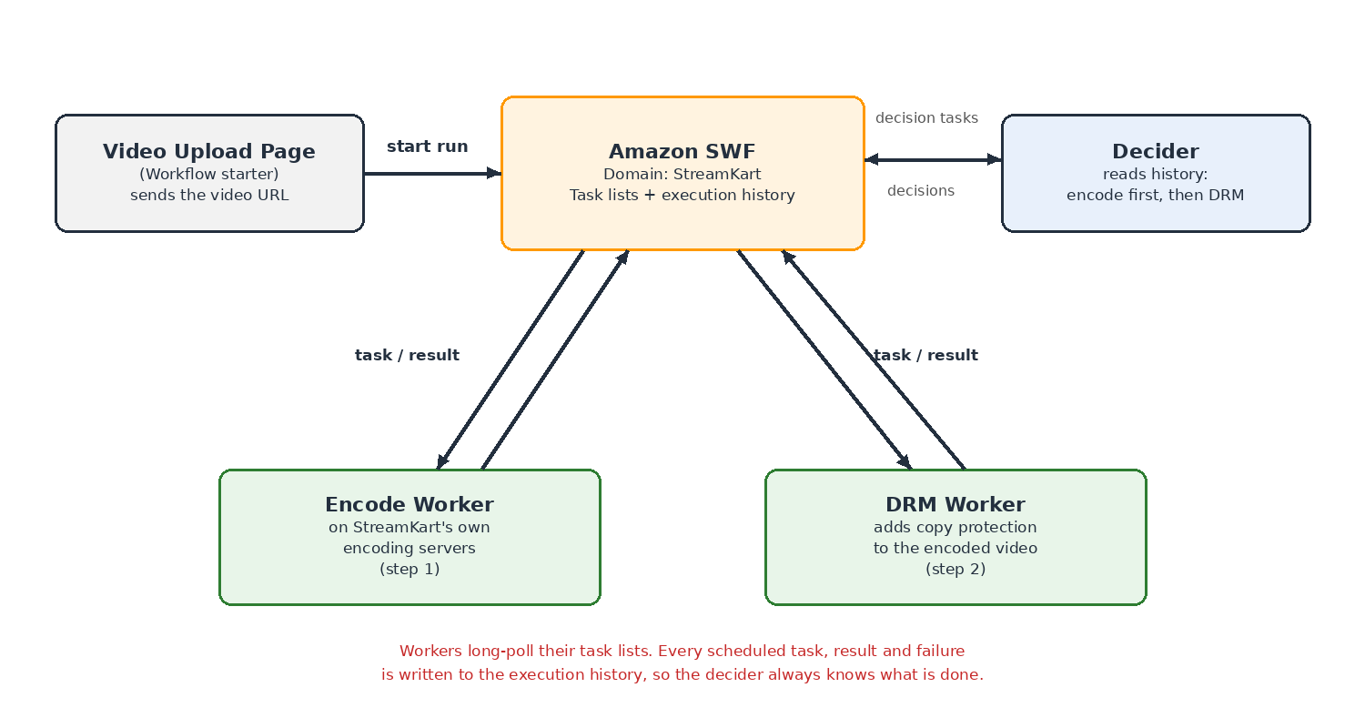
Figure 1: Video publishing workflow at StreamKart using Amazon SWF
The SWF components map to StreamKart as follows: the video upload page is the workflow starter, the “StreamKart” domain groups the video workflows, the decider contains the rule “encode first, then DRM”, and there are two activity workers, one for encoding and one for DRM. A single run proceeds like this:
1. A customer uploads a review video. The upload page starts a workflow run and passes the video’s URL.
2. The decider receives its first decision task, sees an empty history and schedules the Encode task.
3. The encode worker, which is long-polling its task list, picks up the task, encodes the video and returns the location of the encoded file.
4. SWF records “encoded” in the execution history and sends a new decision task.
5. The decider now sees that encoding is done and schedules the DRM task.
6. The DRM worker protects the video and reports back. The decider marks the workflow complete and the video goes live.
How this solves the problem. Because SWF stores the state in the execution history, a crash no longer causes a video to be forgotten. If the DRM worker fails or times out, SWF informs the decider, which simply schedules the DRM task again. StreamKart can also add more encode workers during busy periods, because deciders and workers scale independently.

4.2 Order processing with AWS Step Functions
Order processing runs entirely on AWS services, so StreamKart built it as a Standard Step Functions workflow. Standard was chosen because each step must run exactly once: a customer must never be charged twice for the same order.
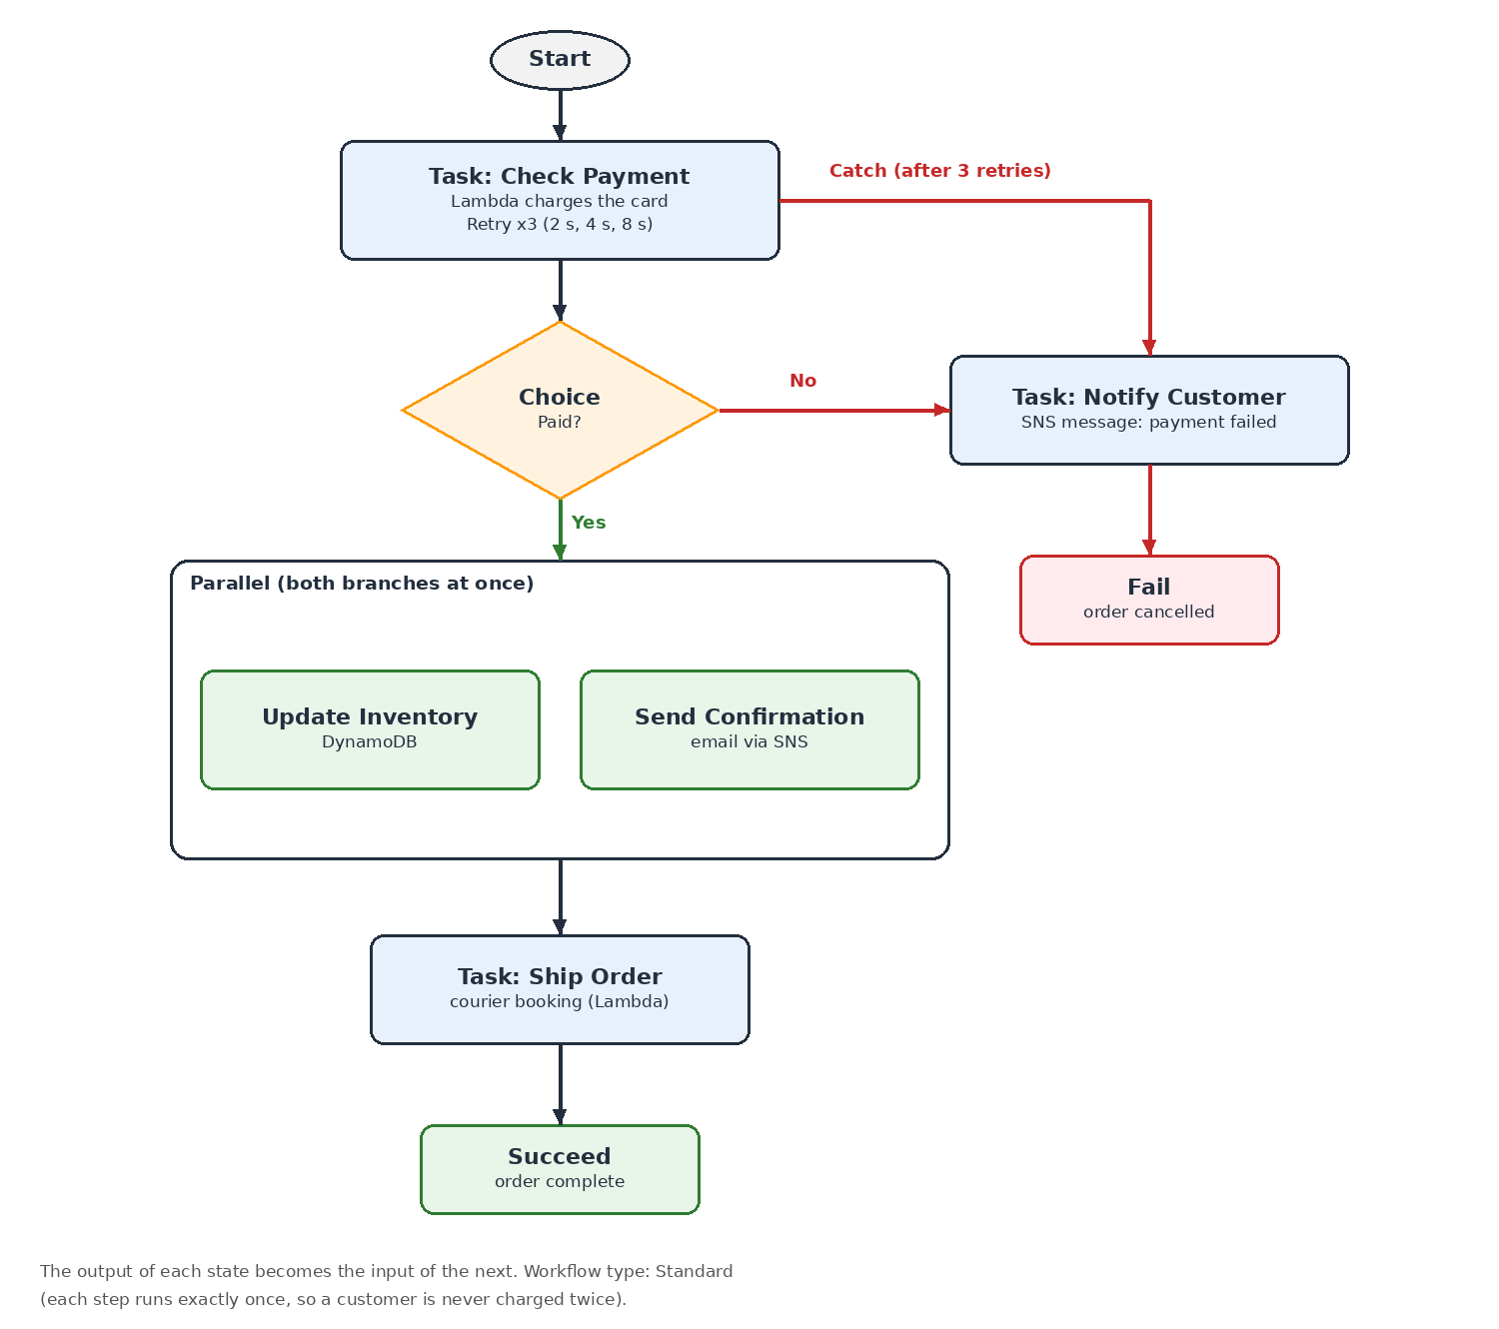
Figure 2: Order processing state machine in AWS Step Functions
1. Task – Check Payment. A Lambda function charges the customer’s card through the payment gateway.
2. Choice – Paid? If the payment succeeded, the flow continues. If not, it goes to “Notify Customer”.
3. Parallel – two branches at once. One branch updates the stock count in DynamoDB, and the other sends a confirmation email through SNS. Running them together makes the order faster.
4. Task – Ship Order. A Lambda function books the courier.
5. Succeed ends the run. On the failure path, “Notify Customer” sends an SNS message and the run ends in a Fail state.
The key to handling the sale-day payment failures is the Retry and Catch configuration on the payment step:
"CheckPayment": {
"Type": "Task",
"Resource": "arn:aws:states:::lambda:invoke",
"Parameters": {
"FunctionName": "ChargeCard",
"Payload.$": "$"
},
"Retry": [{
"ErrorEquals": ["States.ALL"],
"IntervalSeconds": 2,
"MaxAttempts": 3,
"BackoffRate": 2
}],
"Catch": [{
"ErrorEquals": ["States.ALL"],
"Next": "NotifyCustomer"
}],
"Next": "IsPaid"
}
Code 1: Payment step with Retry and Catch in Amazon States Language
If the payment gateway fails, Step Functions waits 2 seconds and tries again. With a BackoffRate of 2, the next waits are 4 and 8 seconds, giving the gateway time to recover. Most short outages are handled this way without the customer noticing. If all three retries fail, the Catch rule moves the flow to “NotifyCustomer”, so the order is cancelled cleanly instead of being left half-finished. "Payload.$": "$" passes the whole order (order ID, amount, customer details) into the Lambda function, showing how data flows from state to state.
Because every execution appears as a coloured diagram in the console, a support agent can open any order and immediately see the step where it stopped. Step Functions is also serverless, so on sale days it simply runs more executions in parallel and StreamKart pays only for the state transitions that actually happen.

4.3 Comparing the two services at StreamKart
Aspect | Amazon SWF | AWS Step Functions
Model | Deciders and activity workers | State machines and states
Coordination logic | Code we write and host | ASL (JSON) or Workflow Studio
How tasks run | Workers poll SWF for tasks | Calls AWS services directly
Servers | We manage worker servers | Fully serverless
Visibility | Execution history of events | Visual diagram of every run
Best for | Existing or hybrid applications | New AWS-based workflows
Used at StreamKart for | Video encoding and DRM on own servers | Payment, inventory, email and shipping
Table 2: Amazon SWF compared with AWS Step Functions
The general rule StreamKart followed is: new projects use Step Functions, while work that depends on the company’s own servers can continue to use SWF, which still works well.

5. Key Observations and Learning Outcomes
• Workflow services keep coordination logic separate from business logic, so developers can focus on the real work instead of tracking steps.
• Storing state outside the application (in the SWF history or the Step Functions execution) means a crash does not cause work to be forgotten.
• Amazon SWF gives full control and allows workers to run anywhere, but we must write and host the decider and workers ourselves.
• AWS Step Functions is serverless and visual and needs far less code, which makes it the preferred choice for new workflows on AWS.
• Built-in Retry with exponential backoff and Catch turn short failures into automatic recovery rather than broken orders.
• The Parallel state reduces total processing time when steps do not depend on each other.
• The Standard workflow type is the right choice when a step must not run twice, such as charging a card.
• These practices follow the AWS Well-Architected Framework, especially reliability (automatic recovery), operational excellence (clear visibility of every run) and cost optimization (paying only for what runs).

6. Conclusion
This case study showed how StreamKart used two AWS workflow services to fix unreliable multi-step processes. Amazon SWF coordinates video encoding and DRM on the company’s own servers, using its execution history to make sure no video is left half-processed. AWS Step Functions runs order processing as a serverless state machine, using Choice, Parallel, Retry and Catch to handle payment failures cleanly and give the support team a clear view of every order.
Workflow orchestration is an important skill in cloud architecture, because almost every real application involves several services working together. The trend is clearly towards serverless, visual tools like AWS Step Functions, while Amazon SWF remains useful for existing applications and for work that must run outside AWS.

7. References
1. Amazon Web Services, “Amazon Simple Workflow Service Developer Guide”, https://docs.aws.amazon.com/amazonswf/latest/developerguide/
2. Amazon Web Services, “AWS Step Functions Developer Guide” (sections on states, error handling with Retry and Catch, and Standard vs Express workflows), https://docs.aws.amazon.com/step-functions/latest/dg/
3. Amazon Web Services, “AWS Well-Architected Framework”, https://docs.aws.amazon.com/wellarchitected/latest/framework/
4. Class notes, Cloud Architecture Design (BCSE355L), Module 7: AWS Application Integration and Architectural Best Practices, Faculty: Umamaheshwari M.
5. Rohit Krishnaa B and Naresh Nireenjan S, seminar presentation “Amazon SWF & AWS Step Functions”, BCSE355L.

