**Domino’s Menu UK**

What do you think about Domino’s menu & prices? We’ve updated Domino’s prices for September 2021.

|  |  |  |  |  |
| --- | --- | --- | --- | --- |
| **Domino’s Classic Pizzas Prices** | **Personal (7”)** | **Small (9.5”)** | **Medium (11.5”)** | **Large (13.5”)** |
| Ultimate bacon cheeseburger | £8.99 | £16.49 | £18.49 | £19.99 |
| Original Cheese ? & Tomato ? | £5.49 | £11.99 | £13.99 | £15.99 |
| Hawaiian | £6.99 | £14.49 | £16.59 | £17.99 |
| Chicken Feast | £6.99 | £14.49 | £16.59 | £17.99 |
| Texas BBQ | £7.99 | £15.49 | £17.49 | £18.99 |
| Pepperoni Passion | £7.99 | £15.49 | £17.49 | £18.99 |
| Vegi Supreme | £7.99 | £15.49 | £17.49 | £18.99 |
| Hot & Spicy ?? | £7.99 | £15.49 | £17.49 | £18.99 |
| Domino’s Tandori Hot ?? | £8.99 | £16.59 | £18.49 | £19.99 |
| The Cheeseburger | £8.99 | £16.59 | £18.49 | £19.99 |
| Mighty Meaty | £8.99 | £16.59 | £18.49 | £19.99 |

|  |  |  |
| --- | --- | --- |
| **Tasty chicken** | **Price for 7** | **Price for 14** |
| Chicken Kickers ? | £5.99 | £9.99 |
| Chicken Strippers | £5.99 | £9.99 |
| Chicken Wings | £5.99 | £9.99 |
|  |  |  |
| Strippers combo | £7.49 (one portion) |  |

|  |  |
| --- | --- |
| **Sumptuous sides** | **Price** |
| Garlic Dippers | £3.99 |
| Garlic Pizza Bread | £3.99 |
| Potato Wedges | £3.99 |

|  |  |
| --- | --- |
| **Desert** | **Price** |
| Lotta-chocca Pizza | £4.99 |
| Cookies | £4.49 |
| Ben & Jerry’s Ice Cream | £5.99</span |

|  |  |  |
| --- | --- | --- |
| **Drinks** | **500 ml** | **1.25 ltr** |
| Coca-Cola Classic | £1.50 | £2.25 |
| Diet Coke | £1.50 | £2.25 |
| Coca-Cola Zero | £1.50 | £2.25 |
| Glaceau Smart Water | £1.50 (600ml) |  |

Here’s a picture from the 2020 menu from Domino’s. Taken in London area. Prices near you may be different.

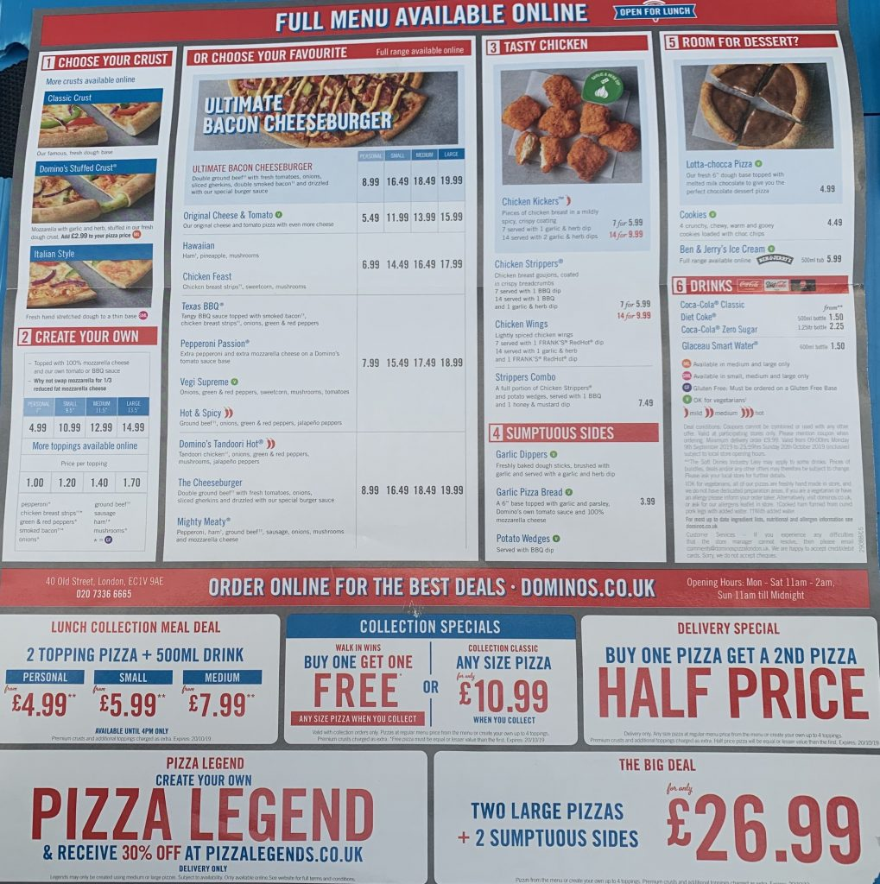

**Domino’s Pizza Recipes**

|  |  |
| --- | --- |
| **Pizza** | **Recipe** |
| Ultimate bacon cheeseburger | * Double ground beef * Fresh tomatoes * Onions * Sliced gherkins * Double smoked bacon * Drizzled w/ special burger sauce |
| Original  Cheese? & Tomato ? | * Cheese (even more cheese) * Tomato |
| Hawaiian | * Ham * Pineapple * Mushrooms |
| Chicken Feast | * Chicken Breast strips * Sweetcorn * Mushrooms |
| Texas BBQ | * Tangy BBQ sauce * Topped with Smoked bacon * Chicken breast strips * Onions * Green & red peppers |
| Pepperoni Passion | * Extra pepperoni * Extra mozzarella cheese * Tomato sauce base |
| Vegi Supreme | * Onions * Green & red peppers * Sweetcorn * Mushrooms ? * Tomatoes ? |
| Hot & Spicy ? ? | * Ground beef * Onions * Green & red peppers * Jalapeño peppers ? |
| Domino’s Tandori Hot ? ? | * Tandori Chicken * Onions * Green & red peppers * Mushrooms ? * Jalapeño peppers ? |
| The Cheeseburger | * Double ground beef * Fresh tomatoes * Onions * Sliced gherkins * Double smoked bacon * Drizzled w/ special burger sauce |
| Mighty Meaty | * Pepperoni ham * Ground beef ? * Sausage * Onions * Mushrooms ? * Mozzarella Cheese ? |

This is an old part of the menu.

