

PBL

Submitted For The Partial Fulfilment Of Degree Of

Bachelor Of Technology

In

Computer science

Neural Network and Deep Learning

(CSL0667[T])

Submitted By - Submitted To -

Rohit Kumar Singh Dr. Sanjay Jain

BETN1CS19095 Assistant Professor

School Of Engineering and Technology

ITM UNIVERSITY, GWALIOR

        Fashion-MNIST

INTRODUCTION

Classification of Garments from Fashion MNIST Dataset

Using CNN LeNet-5 Architecture

Mohammed Kayed

Faculty of Computers and Artificial

Intelligence, Beni-Suef University,

Beni-suef, Egypt, 62511

mskayed@gmail.com

Ahmed Anter

Faculty of Computers and Artificial

Intelligence, Beni-Suef University,

Beni-suef, Egypt, 62511

sw_anter@yahoo.com

Hadeer Mohamed

Faculty of Science, Beni-Suef

University, Beni-suef, Egypt, 62511

hadeer.mohamed98@ymail.co

m

ABSTRACT

Recently, deep learning has been used extensively in a wide range

of domains. A class of deep neural networks that give the most

rigorous effects in solving real-world problems is a Convolutional

Neural Network (CNN). Fashion businesses have used CNN on

their e-commerce to solve many problems such as clothes

recognition, clothes search and recommendation. A core step for

all of these implementations is image classification. However,

clothes classification is a challenge task as clothes have many

properties, and the depth of clothes categorization is highly

complicated. This complicated depth makes different classes to

have very similar features, and so the classification problem

becomes very hard. In this paper, CNN based LeNet-5

architecture is proposed to train parameters of the CNN on

Fashion MNIST dataset. Experimental results show that LeNet-5

model achieved accuracy over 98%. Therefore, it outperforms

both the classical CNN model and the other existing state-of-the-

art models in literatures.

Keywords

Deep learning architectures; Fashion MNIST; Fashion

Classification; Convolutional Neural Network (CNN); LeNet-5.

1. INTRODUCTION

Over past few years, with the assistance of various layers, deep

learning [1] has been widely used and achieved very good results

in different domains such as computer vision [2], big data [3],

automatic speech recognition [4] and natural language processing

[5]. A common architecture of deep neural networks is CNN.

CNN is a multi-layer perceptron neural network that extracts

properties from the input data and is trained with the neural

network back-propagation algorithm. CNN can learn complex,

high-dimensional, non-linear mappings from a very large number

of data (images). Moreover, CNN gives an excellent classification

average for images [6]. The main advantages of CNN are that it

extracts the salient features that are never changed, and it is

invariant to shifting, scaling and distortions of input data

(images). CNN based LeNet-5 architecture has shown very good

results in many domains such as image classification [7], pattern

recognition [8], computer vision [9] and image segmentation

The Fashion-MNIST clothing classification problem is a new standard dataset used in computer vision and deep learning.

Although the dataset is relatively simple, it can be used as the basis for learning and practicing how to develop, evaluate, and use deep convolutional neural networks for image classification from scratch. This includes how to develop a robust test harness for estimating the performance of the model, how to explore improvements to the model, and how to save the model and later load it to make predictions on new data.

The [Fashion-MNIST](https://github.com/zalandoresearch/fashion-mnist) dataset is proposed as a more challenging replacement dataset for the MNIST dataset.

It is a dataset comprised of 60,000 small square 28×28 pixel grayscale images of items of 10 types of clothing, such as shoes, t-shirts, dresses, and more. The mapping of all 0-9 integers to class labels is listed below.

* 0: T-shirt/top
* 1: Trouser
* 2: Pullover
* 3: Dress
* 4: Coat
* 5: Sandal
* 6: Shirt
* 7: Sneaker
* 8: Bag
* 9: Ankle boot

It is a more challenging classification problem than MNIST and top results are achieved by deep learning convolutional neural networks with a classification accuracy of about 90% to 95% on the hold out test dataset.

LITRATURE REVIEW

# In image classification different methods are used such as methods based on low-level image feature representation which consider image as a collection of low-level characteristics like texture, shape, size, colour, etc. and methods based on mid-level visual feature constructions for image classification tasks. Nowadays, usage of deep neural networks and neural-networks to obtain image representation is trending. Such architectures allows us to extract features from a specified layer of trained neural network and then use extracted feature maps as a numeric image representation. There are a large number of publications related to the image processing with various ensemble methods. Image classification in the fashion domain has numerous benefits and applications and has various research works have been presented about it. Fashion-MNIST dataset has been presented by Zalando Research (Xiao et al., 2017) [29]. F-MNIST is proposed to intend for a direct drop-in substitute for the classical MNIST handwritten digits dataset which has been considered as the benchmark for machine learning techniques, as it contains the same structure, image format and size of train and test set splits. The images in F-MNIST are transformed to a format which matches with original

OBJECTIVE

The objective is to identify (predict) different fashion products from the given images using various best possible Machine Learning Models (Algorithms) and compare their results (performance measures/scores) to arrive at the best ML model with best accuracy till date.

METHODOLOGY

For this project we will be going to use deep learning concepts like artificial neural networks and convolutional neural networks to build an image classification model which will learn to distinguish 10 different item images into their respective categories & then we are going to apply Convolutional Neural Network (CNN) for Fashion MNIST with TensorFlow Keras.

RESULT ANALYSIS

By Applying CNN for Fashion MNIST with TensorFlow Keras we got an accuracy of around 98%

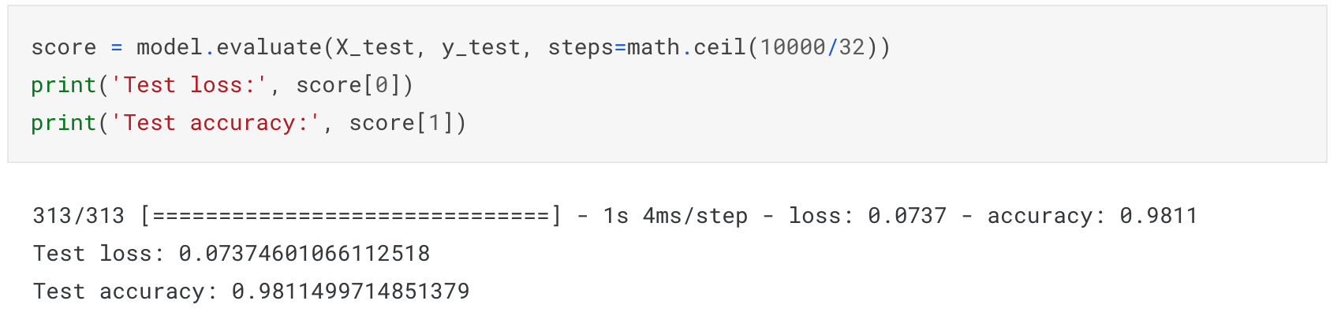

Plotting the Confusion Matrix for the same matrix