**SuperrDuperr Application**

**Technologies**

* Java 8
* Maven 3.6.0
* Spring Boot 2.1.8
* H2 Database
* Hibernate
* Tomcat 9.0
* Postman

**Using**

Running the Application (jar file is in target directory)

* java -jar SuperrDuperr-0.0.1-SNAPSHOT.jar
* application will run on **http://localhost:8080**

Running unit test cases (From project folder)

* mvn test
* 10 test cases should pass

**Database Schema**

We have 2 models **ToDoList** and **ToDoItem** with One-to-Many relationship: -

**ToDoItem**

Id

taskname

softdeleted

completed

tag

reminder

todolist_id

**ToDoList**

Id

name

We create Spring Boot project as below:

**Application**

Hibernate

JPA

Java

Classes

Business

logic

Rest

Controller

**Get/Post**

**H2**

**Database**

**Table**

ToDoList

ToDoItem

**Response**

**Project Structure**

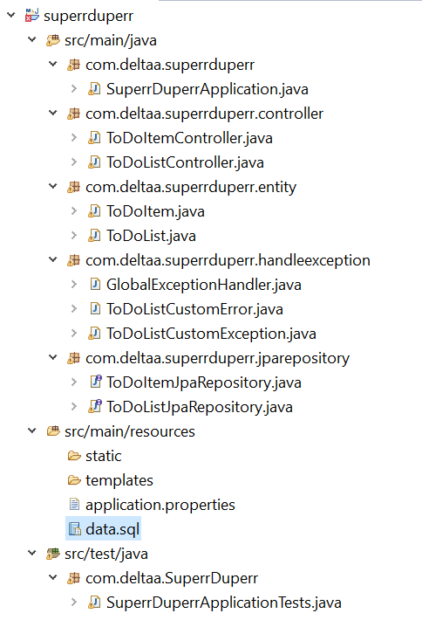

We expose RestAPI for Get/Post ToDoList and ToDoItem

**ToDoList ->**

@GetMapping("/todolists") – get all todolist

@GetMapping("/todolists/{id}") – get todolist by Id

@PostMapping("/todolists")- post a todolist

**ToDoItem ->**

@GetMapping("/todolists/{toDoListId}/todoitems") – get all todoitem by todolist Id

@PostMapping("/todolists/{toDoListId}/todoitems") – post todoitem by todolist Id.

**Create Todo List**

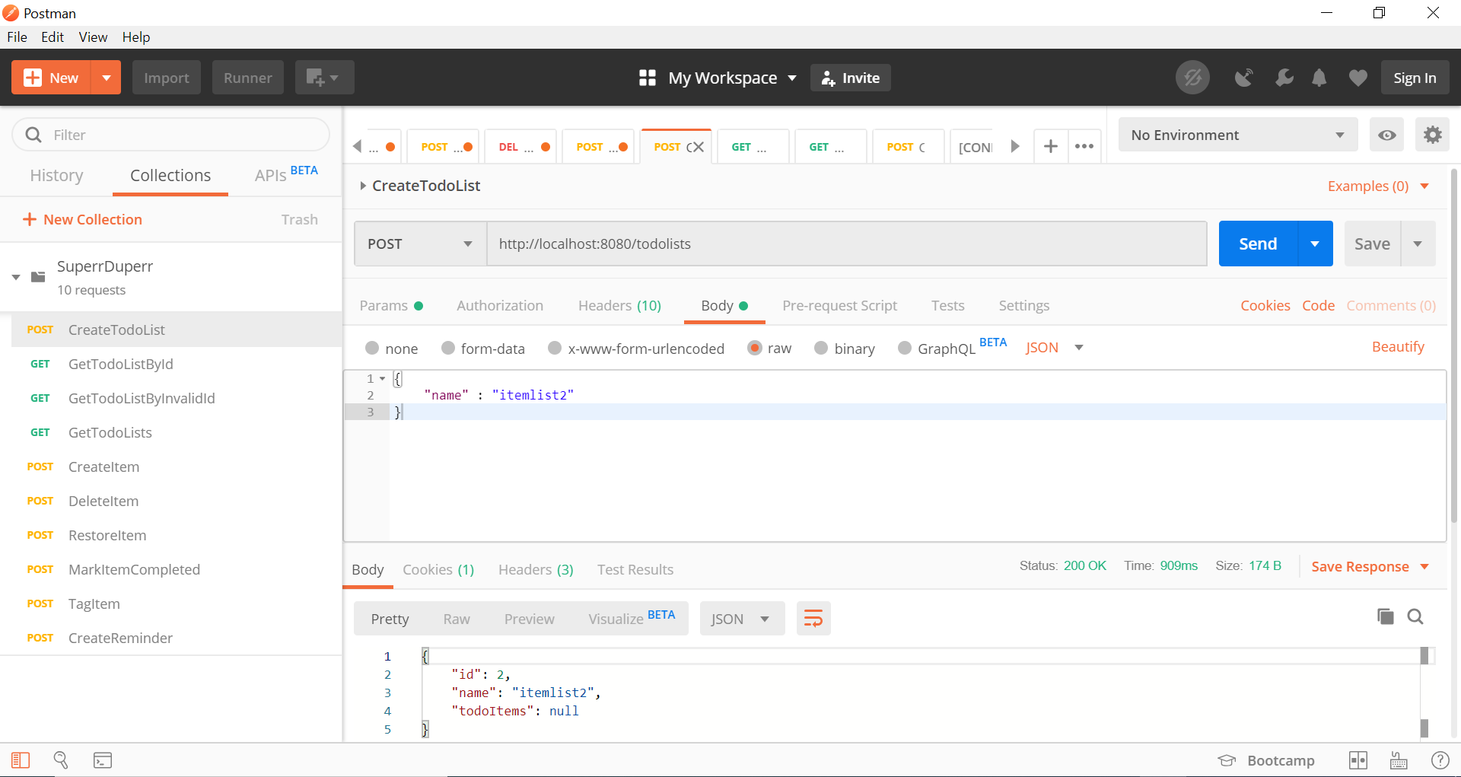

**Get TodoList By Id**

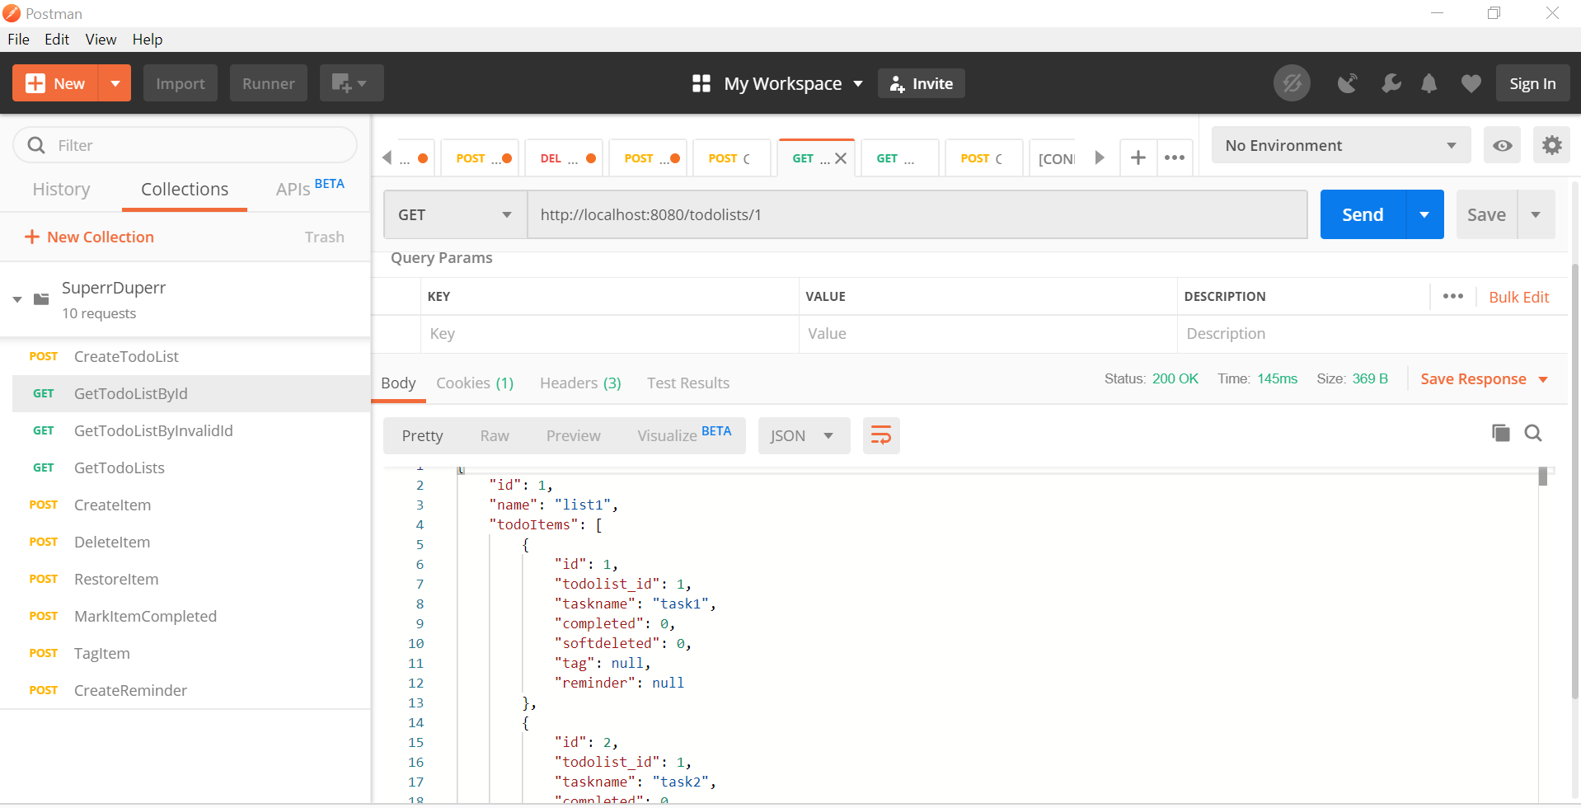

**Get all TodoList**

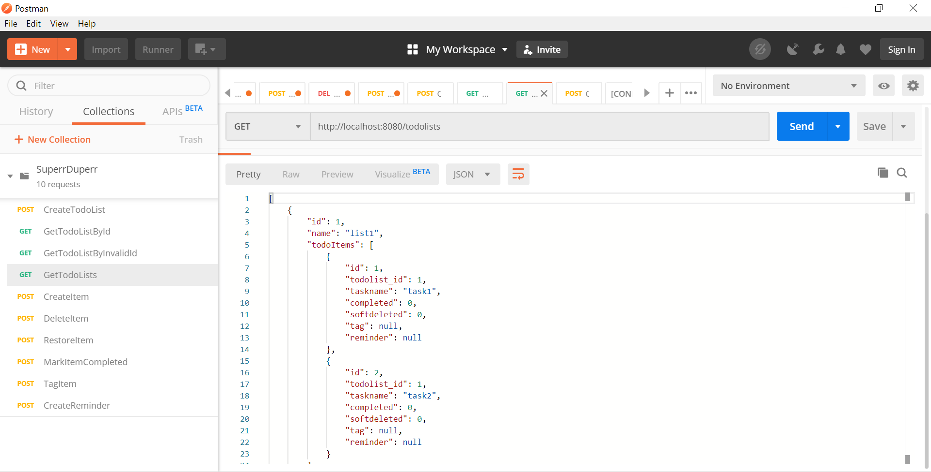

**Create TodoItem in ToDoList**

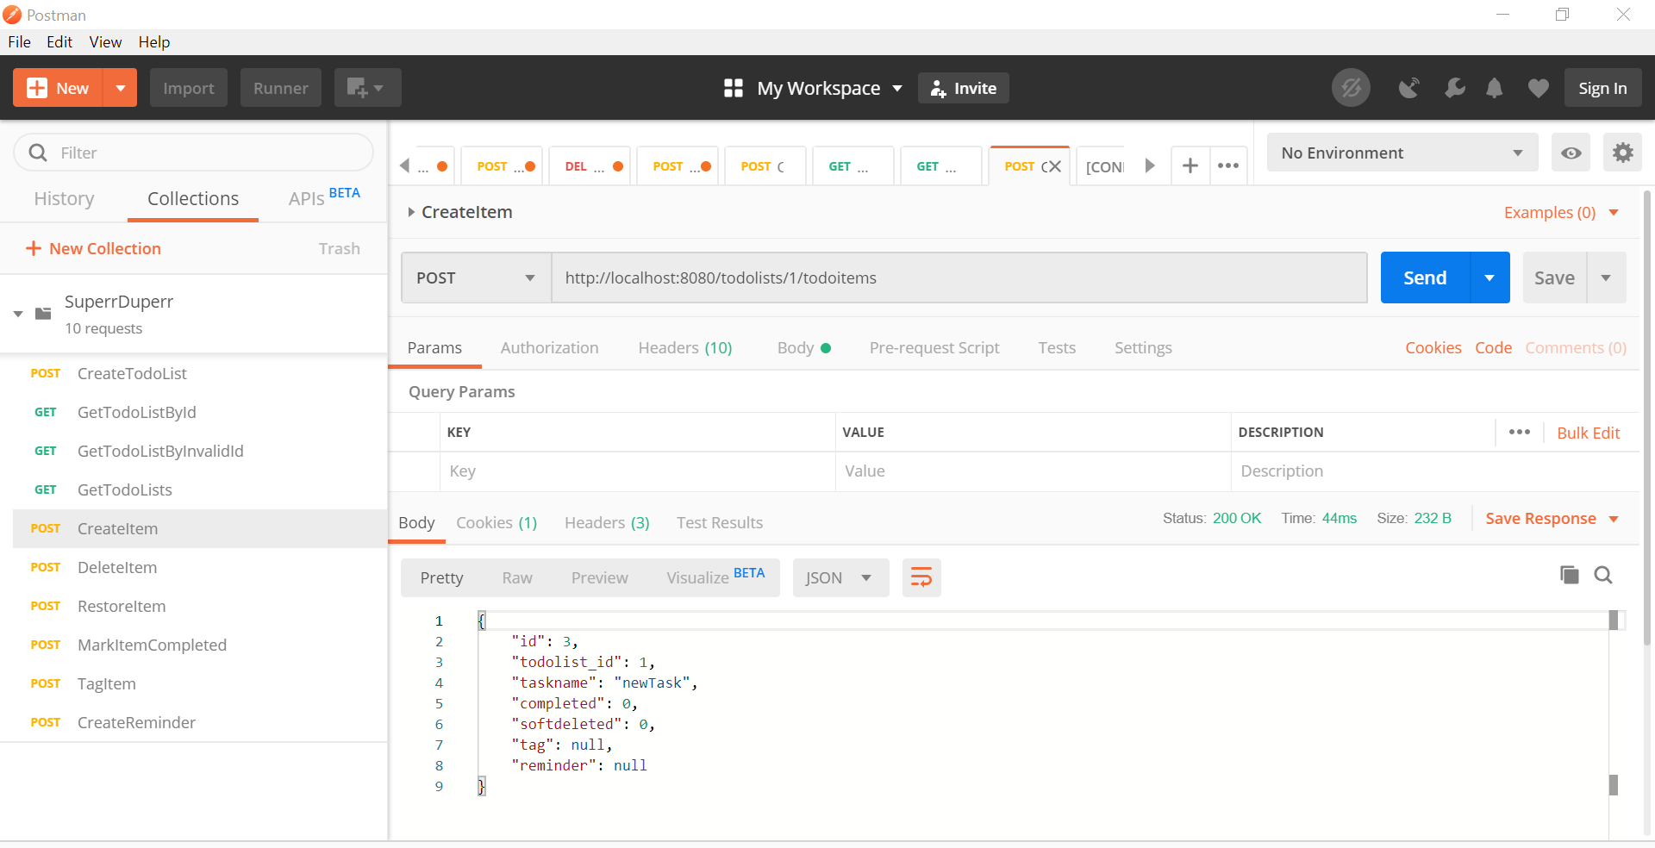

**Delete ToDoItem**

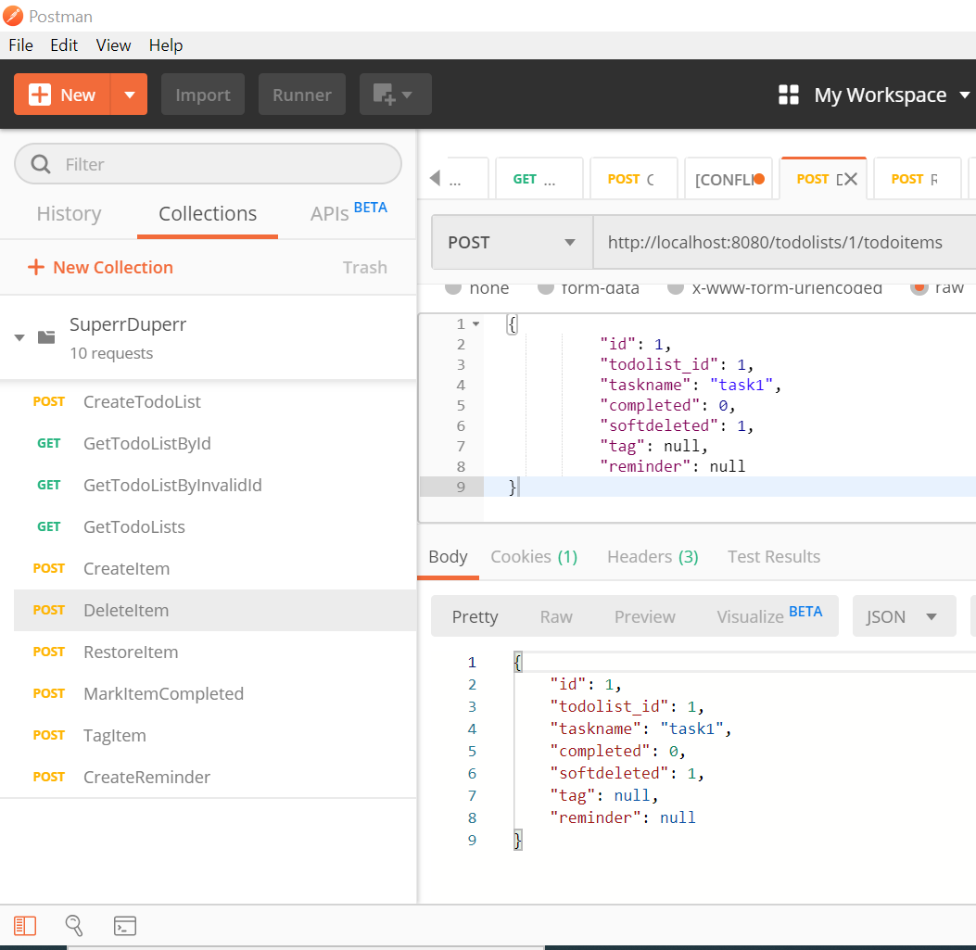

**Restore ToDoItem**

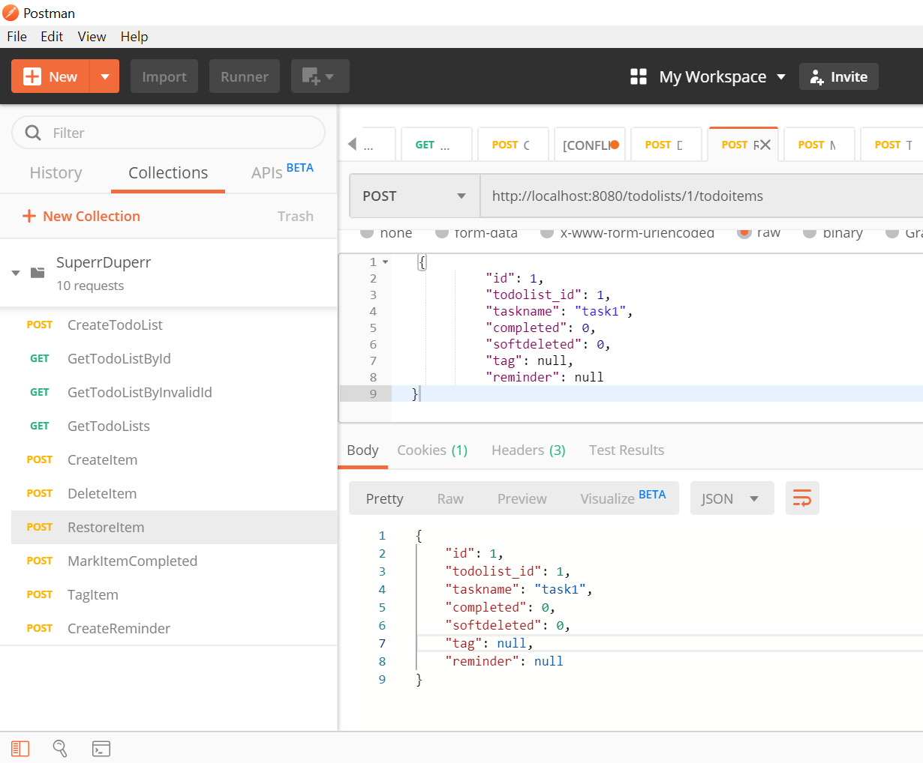

**Mark ToDoItem Completed**

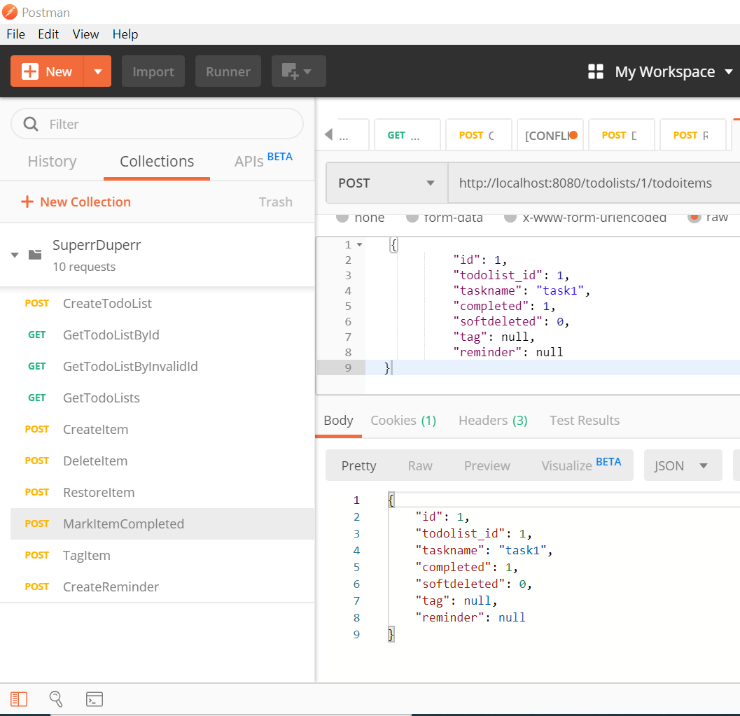

**Tag TodoItem**

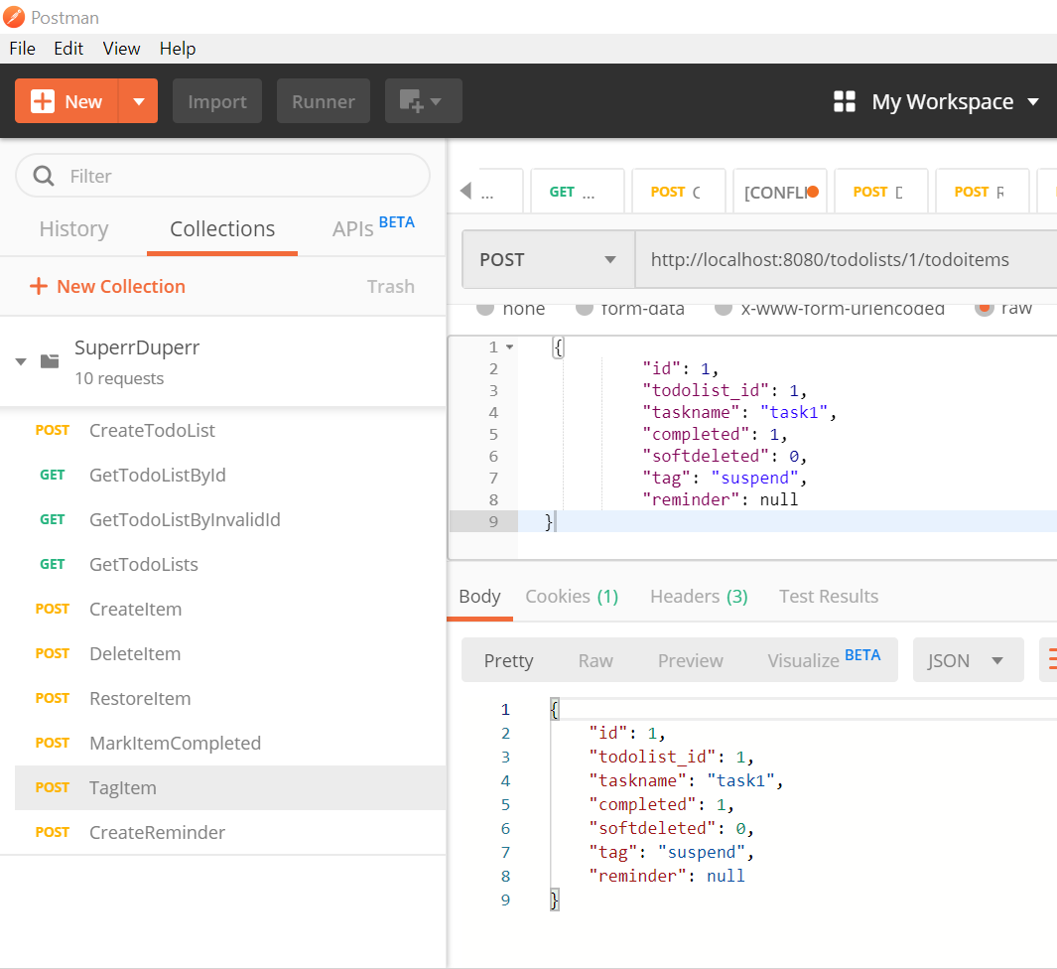

**Add Reminder to ToDoItem**

