A PROJECT REPORT ON
Smart Parking System with Automatic Gate
IoT project using ESP32 with Bluetooth Low Energy and Wi-Fi (Supabase)
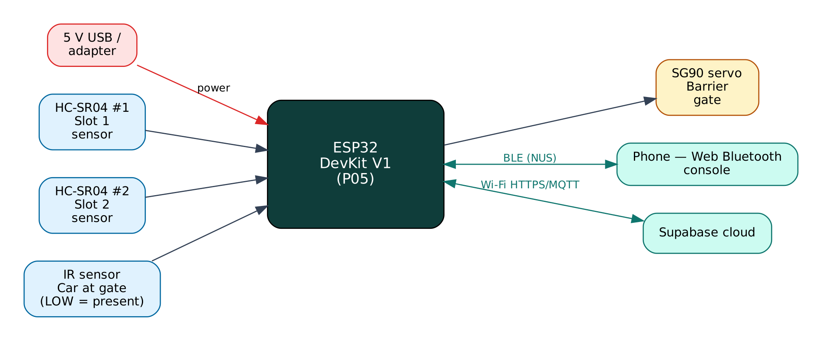

Project: P05 · Intermediate level
Peripherals: 2 × HC-SR04 ultrasonic sensors, IR obstacle sensor, SG90 servo motor
Submitted by: ______________________________
Under the guidance of: ______________________________
Department / Institution: ______________________________
October 2026

Certificate
This is to certify that the project report entitled “Smart Parking System with Automatic Gate” is a bonafide record of the work carried out by ______________________ (Roll No. ________) in partial fulfilment of the requirements for the award of ______________________ in ______________________ during the academic year ________.

Project Guide: ______________________ Head of Department: ______________________
Date: ____________ Place: ____________

Acknowledgement
I express my sincere gratitude to my project guide ______________________ for continuous guidance and support, to the Head of the Department ______________________, and to all faculty members and friends who helped me complete this project successfully.

Contents
Abstract 6
1. Introduction 7
1.1 Problem Statement 7
1.2 Objectives 7
1.3 Scope of the Project 7
1.4 Organisation of the Report 7
2. Existing System and Proposed System 8
2.1 Existing Systems 8
2.2 Proposed System 8
2.3 Why Both BLE and Wi-Fi? 8
3. System Design 9
3.1 Block Diagram 9
3.2 System Architecture 9
3.3 Hardware Components and Cost 9
3.4 ESP32 DevKit V1 10
3.5 Working Principle of Components 10
4. Circuit Design 11
4.1 Circuit Diagram 11
4.2 Pin Connections 11
4.3 Interfacing and Power Notes 12
5. Data Flow Diagrams 13
5.1 DFD Level 0 (Context Diagram) 13
5.2 DFD Level 1 14
5.3 Data Dictionary 15
6. Software Design and Implementation 16
6.1 Development Environment 16
6.2 Firmware Architecture 16
6.3 Working of the System 16
6.4 Flowchart 17
6.5 BLE Communication Protocol 17
6.6 Cloud Integration (Supabase) 18
6.7 Configurable Settings 18
7. Setup and Deployment Guide 20
7.1 Hardware Assembly 20
7.2 Flashing the Firmware 20
7.3 Cloud Setup (Supabase) 20
7.4 BLE App Setup (Web Bluetooth Console) 21
7.5 First-Run Checklist 22
8. Testing and Results 23
8.1 Expected Output 23
8.2 Troubleshooting 23
9. Discussion 24
9.1 Advantages 24
9.2 Limitations 24
9.3 Safety Precautions 24
9.4 Security Considerations 24
9.5 Future Scope 24
10. Conclusion 25
References 26
Appendix A: Project Source Code 27
Appendix B: Shared Library Code 30

Abstract
Finding a free parking slot wastes time and fuel and causes congestion at the entrance of malls, colleges and apartments. This project monitors each parking slot with an HC-SR04 ultrasonic sensor and controls an entry barrier with an SG90 servo. An IR sensor detects a car at the gate; the barrier opens only if a slot is free and closes automatically after the car has passed, otherwise a 'Parking FULL' event is raised. Slot status is debounced and written to a Supabase PostgreSQL database through its REST API, together with an event log, so any browser or app can show live availability. A phone connected over BLE shows a live slot map and lets the attendant open or close the gate manually.
Keywords: ESP32, Internet of Things, Bluetooth Low Energy, Wi-Fi, Supabase, 2 × HC-SR04 ultrasonic sensors, IR obstacle sensor, SG90 servo motor.

1. Introduction
The Internet of Things (IoT) connects physical devices — sensors and actuators — to networks so that data can be collected, analysed and acted on automatically. The ESP32 from Espressif Systems has made IoT affordable: a single ₹350 board combines a dual-core 240 MHz processor, Wi-Fi and Bluetooth Low Energy. This project uses both radios at once: BLE for direct, local interaction with a phone and Wi-Fi for cloud connectivity through Supabase, a free IoT/cloud platform.

1.1 Problem Statement
Drivers circle around full parking areas because they cannot see availability in advance, and manual gate operation needs a full-time attendant. Commercial parking guidance systems are expensive and proprietary.

1.2 Objectives
- Detect occupancy of each slot reliably with ultrasonic distance measurement.
- Automate the entry gate based on availability.
- Publish live slot status and an event history to a free cloud database (Supabase).
- Provide an attendant interface over BLE for manual override.
- Make thresholds configurable for model and real-size installations.

1.3 Scope of the Project
Demonstrated with two slots on a table-top model; the firmware supports more slots by extending two arrays. Vehicle identification (number-plate recognition) and payments are outside the scope.

1.4 Organisation of the Report
Chapter 2 reviews existing approaches and describes the proposed system. Chapter 3 covers system design and components, Chapter 4 the circuit, Chapter 5 the data flow diagrams, Chapter 6 the software, Chapter 7 the step-by-step setup of hardware, cloud and app, Chapter 8 testing, Chapter 9 discussion and Chapter 10 the conclusion. Complete source code is given in the appendices.

2. Existing System and Proposed System

2.1 Existing Systems
Many parking projects show availability only on a local display and use a fixed delay to close the gate, which can hit a slow vehicle. Cloud versions often push every raw reading, wasting bandwidth and quota.

2.2 Proposed System
The proposed system improves on these in the following ways:
- Event-driven cloud updates: a slot row is PATCHed only when its state changes (after 3 equal readings).
- Gate closes a fixed time after the IR beam is clear, not after a fixed time from opening.
- Failed uploads are retried automatically every 2 seconds.
- Relational data (slots table + events table + summary view) enables analytics in SQL.

2.3 Why Both BLE and Wi-Fi?
Wi-Fi gives the device internet access for remote monitoring, history and control from anywhere, but it depends on a router and an internet connection, and the device needs the Wi-Fi password before it can connect. BLE needs no infrastructure: any modern phone can connect directly within about 10-30 m. Using both gives:
- Provisioning — Wi-Fi credentials and cloud keys are sent from the phone over BLE and stored in flash; nothing secret is hard-coded or uploaded to GitHub.
- Resilience — local monitoring and control keep working when the internet or router is down.
- Remote access — the cloud dashboard works from anywhere when the internet is available.
- Low cost — no extra hardware; both radios are built into the ESP32.

The ESP32 shares one 2.4 GHz radio between Wi-Fi and Bluetooth by time-division coexistence. For this to work the Wi-Fi modem-sleep mode must stay enabled, which the firmware ensures. NimBLE, a lightweight BLE stack, is used instead of the default Bluedroid stack to leave more RAM for TLS (HTTPS/MQTTS) connections.

3. System Design

3.1 Block Diagram
Figure 1: Block diagram of the Smart Parking System
The ESP32 is the central controller. Input devices (blue) feed measurements to it, output devices (amber) are driven by it, and two communication links (green) connect it to the user's phone over BLE and to the Supabase cloud over Wi-Fi. The board is powered from 5 V through its USB connector or VIN pin.

3.2 System Architecture
The system follows the standard three-layer IoT architecture:
- Perception layer — 2 × HC-SR04 ultrasonic sensors, IR obstacle sensor, SG90 servo motor connected to the ESP32 GPIO, ADC, I2C, SPI or UART.
- Network layer — BLE 4.2 GATT server (Nordic UART Service) and Wi-Fi 802.11 b/g/n with TLS-encrypted HTTPS REST to Supabase.
- Application layer — the Web Bluetooth console on the phone and the Supabase dashboard / database.

3.3 Hardware Components and Cost
# | Component | Qty | Specification | Cost
1 | ESP32 DevKit V1 (ESP-WROOM-32, 30-pin) | 1 | Dual-core 240 MHz, Wi-Fi + BLE, 4 MB flash | ₹350
2 | Breadboard 830-point + jumper wires (M-M, M-F) | 1 | Prototyping and connections | ₹150
3 | Micro-USB data cable | 1 | Power + programming | ₹60
4 | HC-SR04 ultrasonic sensor | 2 | 2-400 cm, 5 V | ₹120
5 | IR obstacle avoidance module | 1 | 2-30 cm, adjustable, digital output | ₹30
6 | SG90 micro servo | 1 | 180°, 1.8 kg·cm, 5 V | ₹90
7 | Resistors 1 kΩ + 2 kΩ (×2 sets) | 1 | ECHO level dividers | ₹5
 | Total (approx.) |  |  | ₹805
Table 1: Bill of materials with approximate Indian prices (Robu.in / Amazon.in / local market, 2026)
Prices are indicative and vary by seller. The breadboard, cable and ESP32 can be reused across all ten projects, so the incremental cost of this project is about ₹245.

3.4 ESP32 DevKit V1
Feature | Value
Module | ESP-WROOM-32 (ESP32-D0WD), dual-core Xtensa LX6 up to 240 MHz
Memory | 520 KB SRAM, 4 MB SPI flash
Wireless | Wi-Fi 802.11 b/g/n 2.4 GHz; Bluetooth 4.2 BR/EDR + BLE
I/O | 25 usable GPIO on the 30-pin board, 12-bit ADC (ADC1: GPIO32-39), 2 × DAC, PWM on any output
Interfaces | 3 × UART, 2 × I2C, 3 × SPI, I2S, touch, RMT
Supply | 5 V via USB/VIN, on-board 3.3 V regulator (AMS1117)
Logic level | 3.3 V — inputs are NOT 5 V tolerant
Table 2: Key specifications of the ESP32 DevKit V1

3.5 Working Principle of Components

HC-SR04
A 10 µs trigger pulse makes the module send eight 40 kHz ultrasonic bursts. The ECHO pin stays HIGH until the reflection returns; distance = echo time × 343 m/s ÷ 2 (0.0343 cm/µs ÷ 2).

IR obstacle sensor
An IR LED and photodiode face the same direction; a nearby object reflects IR, and an LM393 comparator pulls the output LOW when the reflection exceeds the trimmer threshold.

SG90 servo
A DC motor with gearbox and potentiometer feedback; the pulse width of a 50 Hz signal (0.5-2.4 ms) sets the shaft angle from 0° to 180°. The ESP32Servo library generates it with the LEDC PWM unit.

Supabase
An open-source back-end on PostgreSQL. PostgREST exposes each table as a REST endpoint, and Row Level Security policies decide what the device key may read or write.

4. Circuit Design

4.1 Circuit Diagram
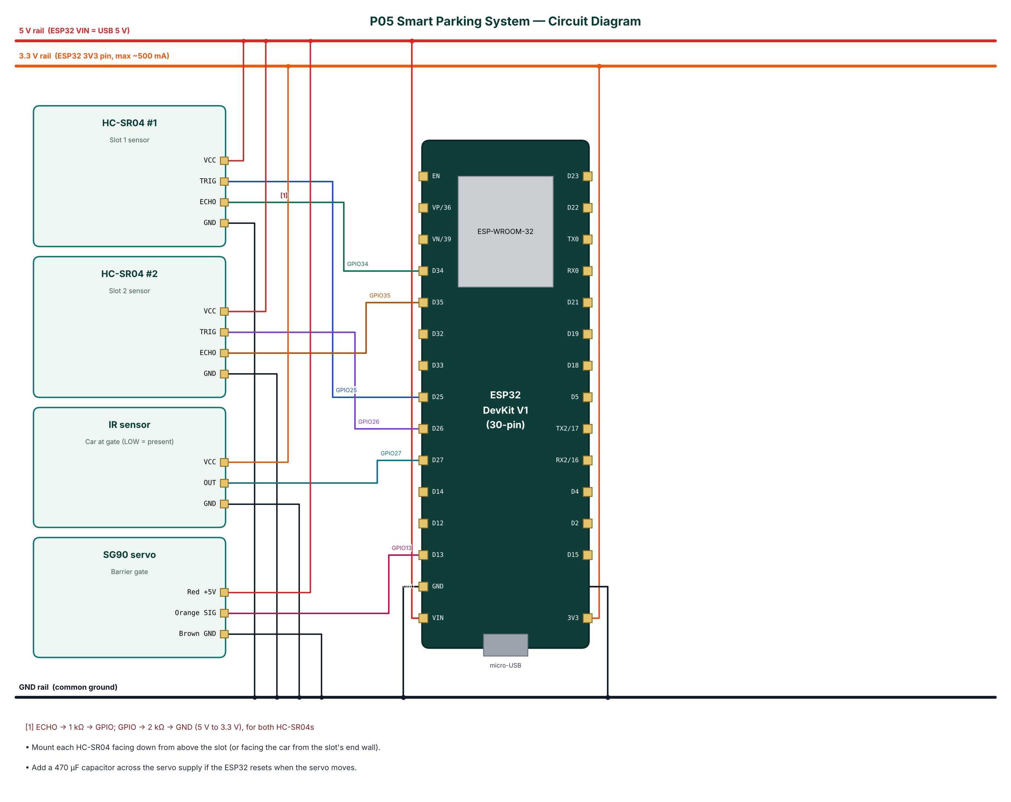
Figure 2: Circuit diagram of the Smart Parking System

4.2 Pin Connections
Module | Module pin | ESP32 connection | Notes
HC-SR04 #1 | VCC | 5V rail (VIN)
HC-SR04 #1 | TRIG | GPIO25
HC-SR04 #1 | ECHO | GPIO34 | ECHO -> 1 kΩ -> GPIO; GPIO -> 2 kΩ -> GND (5 V to 3.3 V), for both HC-SR04s
HC-SR04 #1 | GND | GND
HC-SR04 #2 | VCC | 5V rail (VIN)
HC-SR04 #2 | TRIG | GPIO26
HC-SR04 #2 | ECHO | GPIO35
HC-SR04 #2 | GND | GND
IR sensor | VCC | 3.3 V (3V3 pin)
IR sensor | OUT | GPIO27
IR sensor | GND | GND
SG90 servo | Red +5V | 5V rail (VIN)
SG90 servo | Orange SIG | GPIO13
SG90 servo | Brown GND | GND
Table 3: Pin connection table

4.3 Interfacing and Power Notes
- Mount each HC-SR04 facing down from above the slot (or facing the car from the slot's end wall).
- Add a 470 µF capacitor across the servo supply if the ESP32 resets when the servo moves.
- Only ADC1 pins (GPIO32-39) are used for analog inputs, because ADC2 cannot be read while Wi-Fi is active.
- Strapping pins GPIO0, 2, 12 and 15 are avoided for inputs so the board always boots normally.
- All grounds are common. 5 V signals are reduced to 3.3 V with resistor dividers before reaching the ESP32.

5. Data Flow Diagrams
Data flow diagrams (DFDs) show how data moves through the system without showing control logic or timing. External entities are drawn as rectangles, processes as numbered circles, data stores as open boxes and data flows as labelled arrows.

5.1 DFD Level 0 (Context Diagram)
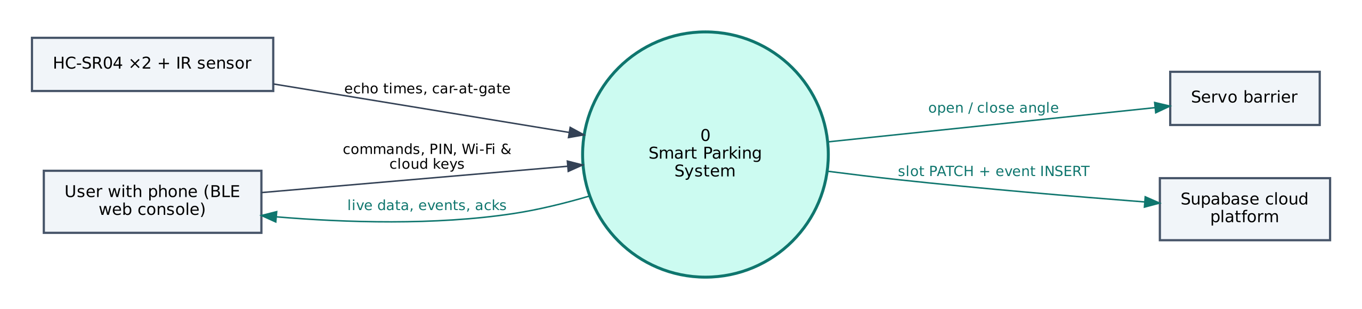
Figure 3: DFD Level 0 — context diagram
At level 0 the whole Smart Parking System is a single process. It receives echo times, car-at-gate from the HC-SR04 ×2 + IR sensor, commands and configuration from the user's phone, and no commands from the cloud. It sends open / close angle to the Servo barrier, live data to the phone and slot PATCH + event INSERT to Supabase.

5.2 DFD Level 1
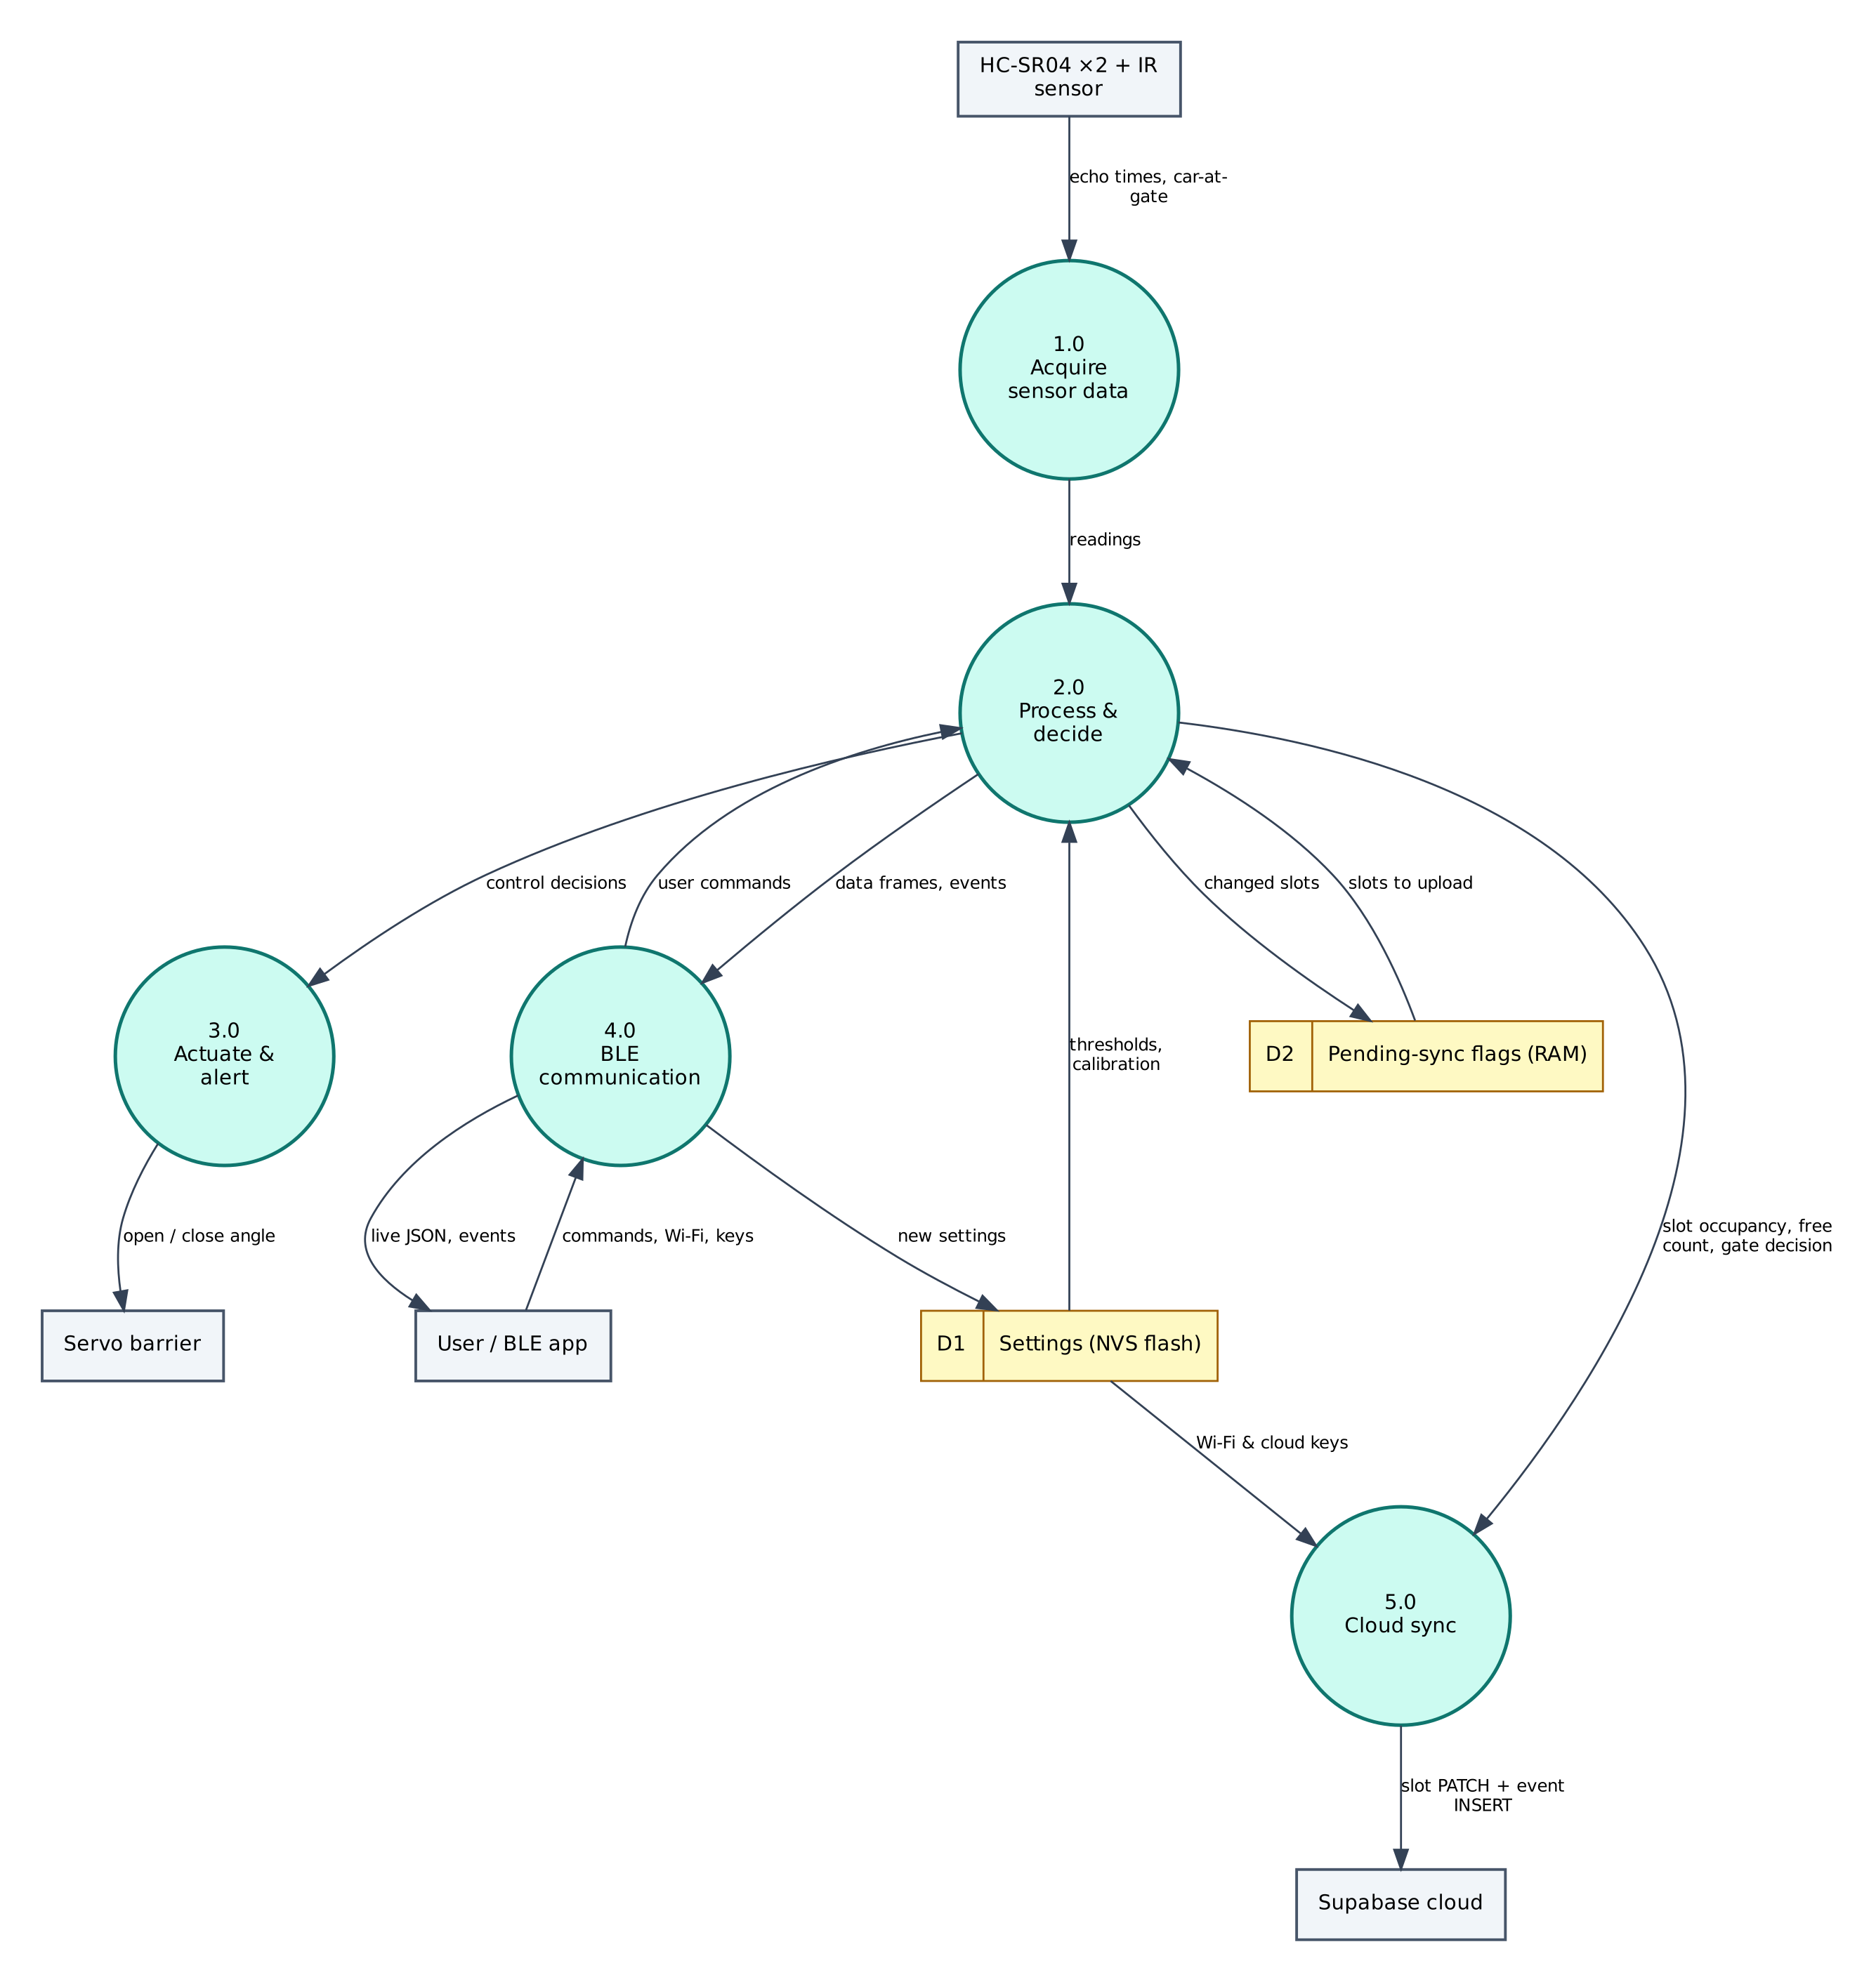
Figure 4: DFD Level 1 — main processes and data stores
Process / store | Description
1.0 Acquire sensor data | Reads echo times, car-at-gate from the HC-SR04 ×2 + IR sensor; filters/averages the raw values.
2.0 Process & decide | Computes slot occupancy, free count, gate decision; applies thresholds and rules; generates events.
3.0 Actuate & alert | Drives the Servo barrier (open / close angle).
4.0 BLE communication | Sends JSON frames and events to the phone; receives and authenticates commands.
5.0 Cloud sync | Sends slot PATCH + event INSERT to Supabase.
D1 Settings (NVS) | Wi-Fi credentials, cloud keys, PIN, thresholds — survive reboots.
D2 Pending-sync flags (RAM) | Stores changed slots; returns slots to upload.
Table 4: Description of level-1 processes and data stores

5.3 Data Dictionary
Field | Meaning | Unit
s | Slot states [slot1, slot2] | 0/1
d | Distances | cm
free | Free slots | count
gate | open / closed | —
car | Car at gate | bool
Table 5: BLE data frame fields
Cloud object | Content / usage
parking_slots | One row per slot: occupied, distance_cm, updated_at (PATCH)
parking_events | slot_occupied / slot_freed / full_rejected with free_slots (INSERT)
parking_summary (view) | free_slots, total_slots, last_change
Table 6: Supabase data objects

6. Software Design and Implementation

6.1 Development Environment
Item | Details
IDE / build | Arduino IDE 2.x or arduino-cli; GitHub Actions builds firmware in the cloud
Board package | esp32 by Espressif Systems 3.x (tested with 3.3.12)
Board settings | ESP32 Dev Module, Partition Scheme: Minimal SPIFFS (1.9MB APP with OTA/190KB SPIFFS)
Common libraries | NimBLE-Arduino 2.x, ArduinoJson 7.x, PubSubClient 2.8
Project libraries | ESP32Servo
Phone app | Web Bluetooth console (Chrome on Android / desktop, Bluefy on iPhone); nRF Connect as alternative
Cloud | Supabase (free tier)
Table 7: Software tools
The default 1.2 MB app partition is too small for BLE + Wi-Fi + TLS. Select Minimal SPIFFS (1.9MB APP) in Tools → Partition Scheme, otherwise the upload fails with 'Sketch too big'.

6.2 Firmware Architecture
The firmware is split into three layers so that the ten projects share tested code:
- IoTCore.h (shared) — Wi-Fi station with auto-reconnect, NimBLE GATT server with the Nordic UART Service, line-based command parser shared by BLE and USB serial, PIN authentication, settings in NVS (Preferences), NTP time in IST, JSON helpers.
- Cloud.h (shared) — ThingSpeak HTTPS client, Adafruit IO MQTT/TLS client with a 28 messages/minute rate limiter, Supabase PostgREST client (insert, update, select).
- P05_Smart_Parking_System.ino — sensor drivers, algorithms, automation rules and the project's own commands.

The main loop is non-blocking: every task is scheduled with millis() timers, BLE writes are queued from the BLE callback into a FreeRTOS queue and executed in loop(), so the BLE stack never waits for slow operations such as HTTPS requests.

6.3 Working of the System
Every 300 ms both slots are measured (30 ms apart to avoid cross-talk). A slot is occupied when the distance is below 'occcm' (10 cm for the model, ~60 cm for a real car). A change is accepted only after three consecutive equal readings, which removes noise and passing objects.
When the IR sensor goes LOW (car at gate) the firmware counts free slots: if at least one is free the servo opens to 90°, otherwise a 'full' event is raised and a 'full_rejected' row is logged. After the car passes and the IR beam has been clear for 4 seconds the gate closes.
A confirmed slot change marks the slot as pending. Every 2 seconds pending slots are PATCHed to /rest/v1/parking_slots?id=eq.N and an event is INSERTed into parking_events. If the request fails the slot stays pending and is retried. The view parking_summary returns free and total slots for any dashboard.

6.4 Flowchart
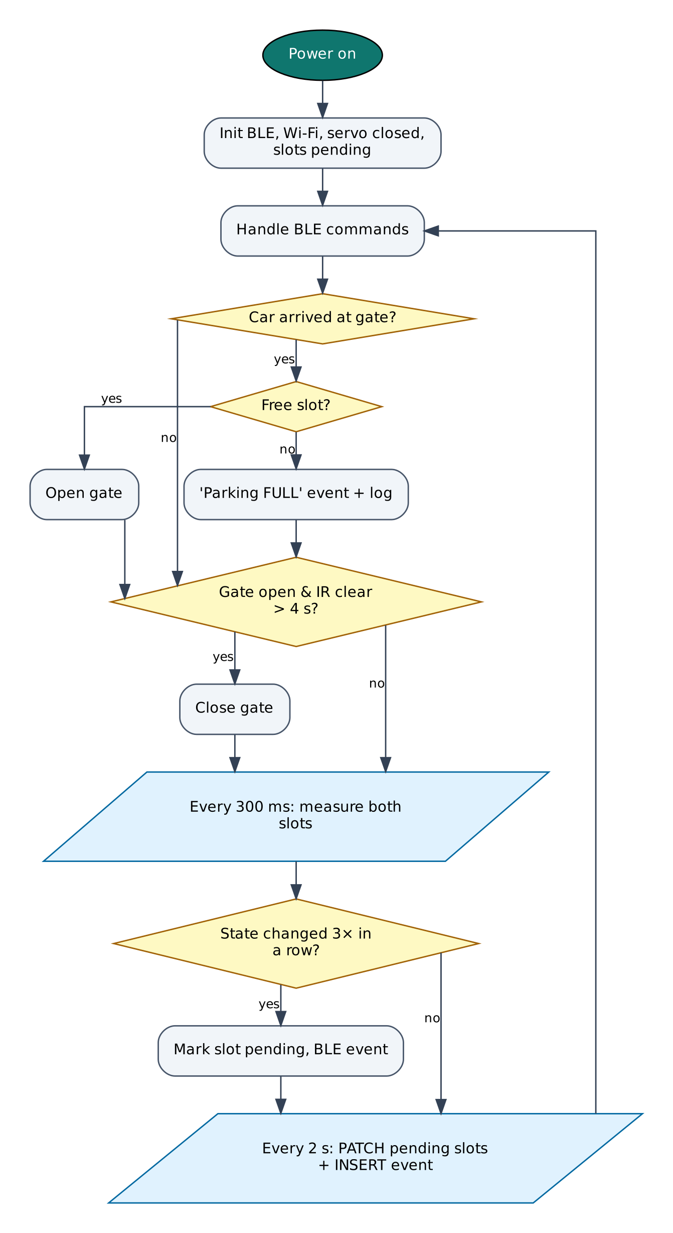
Figure 5: Firmware flowchart

6.5 BLE Communication Protocol
The device is a BLE peripheral named IOT-P05-XXXX (XXXX = last bytes of the MAC address). It exposes the Nordic UART Service, which most BLE apps understand:
Item | UUID | Properties
Service (NUS) | 6E400001-B5A3-F393-E0A9-E50E24DCCA9E | Primary
RX — phone → ESP32 | 6E400002-B5A3-F393-E0A9-E50E24DCCA9E | Write, Write without response
TX — ESP32 → phone | 6E400003-B5A3-F393-E0A9-E50E24DCCA9E | Notify, Read
Table 8: GATT service and characteristics
Commands are plain text lines (command:argument). Replies are one JSON object per line ending in a newline; long lines are split into MTU-sized notifications and re-joined by the app. Commands that change anything require auth:<PIN> first on each connection (default PIN 1234, change it with set:pin=XXXX).
Command | PIN needed | Action
auth:<PIN> | — | Unlock for this connection
status | No | Status JSON: Wi-Fi, IP, RSSI, heap, uptime, time
wifi:<SSID>,<password> | Yes | Save Wi-Fi credentials and connect
set:<key>=<value> | Yes | Save a setting (cloud keys, thresholds)
get:<key> | Yes | Read a setting (secrets masked)
reboot / forget | Yes | Restart / erase all settings
gate:open / gate:close | Yes | Manual barrier control
sync | No | Re-upload all slot states
Table 9: BLE commands (common commands first, then project commands)
Example data frame sent by the device:
{"s":[1,0],"d":[6,38],"free":1,"gate":"closed","car":false,"type":"data"}

6.6 Cloud Integration (Supabase)
Supabase exposes every Postgres table through a REST API (PostgREST). The device sends HTTPS requests to https://<project>.supabase.co/rest/v1/<table> with the apikey and Authorization: Bearer headers: POST to insert rows, PATCH with a filter such as ?id=eq.1 to update and GET with ?select= to read. Row Level Security policies (in cloud/supabase_schema.sql) allow the device key to do only what the project needs.
Object | Content
parking_slots | One row per slot: occupied, distance_cm, updated_at (PATCH)
parking_events | slot_occupied / slot_freed / full_rejected with free_slots (INSERT)
parking_summary (view) | free_slots, total_slots, last_change
Table 10: Supabase configuration

6.7 Configurable Settings
Key | Default | Meaning
sburl / sbkey | — | Supabase project URL and publishable key
occcm | 10 | Occupied distance threshold (cm)
ssid / pass | — | Wi-Fi network (set with the wifi: command)
pin | 1234 | BLE PIN
Table 11: Settings stored in flash (change with set:key=value)

7. Setup and Deployment Guide

7.1 Hardware Assembly
- Place the ESP32 DevKit across the centre gap of the breadboard so both pin rows are free.
- Connect the ESP32 3V3 pin to one breadboard power rail (3.3 V), VIN to the other rail (5 V) and both GND pins to the ground rails.
- Wire each module exactly as in the pin connection table (section 4.2), including the resistor dividers marked with [n] in the circuit diagram.
- Check every connection against the circuit diagram before powering on. Make sure no 5 V signal reaches an ESP32 pin directly.
- Connect the USB cable to a computer (for flashing) or a 5 V adapter (for normal use).

7.2 Flashing the Firmware

Option A — Arduino IDE
- Install Arduino IDE 2.x from arduino.cc.
- File → Preferences → Additional boards manager URLs: https://espressif.github.io/arduino-esp32/package_esp32_index.json.
- Tools → Board → Boards Manager: install esp32 by Espressif Systems (version 3.x).
- Sketch → Include Library → Manage Libraries: install NimBLE-Arduino (2.x), ArduinoJson (7.x), PubSubClient, ESP32Servo.
- Download the repository and open the folder P05_Smart_Parking_System (it already contains IoTCore.h, Cloud.h and config.h).
- Tools: Board ESP32 Dev Module, Partition Scheme Minimal SPIFFS (1.9MB APP with OTA/190KB SPIFFS), Upload Speed 921600, and the correct COM port.
- Click Upload. If it stays at 'Connecting…', hold the BOOT button on the ESP32 until upload starts.
- Open Serial Monitor at 115200 baud and type status to check the device.

Option B — no software installation (GitHub Actions + browser flasher)
- Open the repository https://github.com/rohitkukreja705/esp32-iot-projects → Actions → latest Build firmware run.
- Download the artifact firmware-P05_Smart_Parking_System and unzip it to get P05_Smart_Parking_System.ino.merged.bin.
- Open https://espressif.github.io/esptool-js/ in Chrome or Edge on a computer, click Connect and select the ESP32's serial port.
- Set Flash Address 0x0, choose the merged .bin file and click Program. Press the EN (reset) button when done.

7.3 Cloud Setup (Supabase)
- Go to supabase.com, sign in (GitHub sign-in works) and click New project. Choose region Mumbai (ap-south-1) for the lowest latency and set a database password.
- Open SQL Editor → New query, paste the whole file cloud/supabase_schema.sql from the repository and click Run. It creates the tables, views and Row Level Security policies for all four Supabase projects (P05, P06, P09, P10), so one Supabase project can serve all of them.
- Click Connect at the top of the dashboard (or Project Settings → API Keys) and copy the Project URL (https://xxxx.supabase.co) and the publishable key (sb_publishable_…; the legacy anon key also works).
- In the BLE web console open Setup, unlock and save them in sburl and sbkey.
- Open Table Editor to watch rows arrive. Use the SQL Editor for reports, e.g. the views created by the schema, and Export to CSV for spreadsheets.
- Free tier: 500 MB database and 2 active projects. Free projects are paused after one week of inactivity — open the dashboard and click Restore if that happens.

Field / feed / table | Content
parking_slots | One row per slot: occupied, distance_cm, updated_at (PATCH)
parking_events | slot_occupied / slot_freed / full_rejected with free_slots (INSERT)
parking_summary (view) | free_slots, total_slots, last_change
Table 12: Items to create in Supabase

7.4 BLE App Setup (Web Bluetooth Console)
No app installation is needed. The console is a web page hosted free on GitHub Pages; Chrome talks to the ESP32 directly through the Web Bluetooth API.
- On an Android phone turn on Bluetooth and Location (Android requires location for BLE scanning).
- Open https://rohitkukreja705.github.io/esp32-iot-projects/?p=P05 in Chrome. (On iPhone use the free Bluefy browser; on a laptop use Chrome or Edge.)
- Tap Connect and choose IOT-P05-XXXX in the pop-up list. The dot turns green and the Live tab starts updating.
- Open Setup, enter the PIN (default 1234) and tap Unlock.
- Enter your 2.4 GHz Wi-Fi name and password and tap Save Wi-Fi. After a few seconds the status line shows the IP address.
- Enter the Supabase keys from section 7.3 and tap Save next to each.
- Use the Control tab for commands and the Log tab to see every event and acknowledgement.

Alternative: nRF Connect app
- Install nRF Connect for Mobile (Nordic Semiconductor, free) and scan.
- Connect to IOT-P05-XXXX and open Nordic UART Service.
- Enable notifications on the TX characteristic (6E400003…).
- Write UTF-8 text to the RX characteristic (6E400002…), e.g. auth:1234, then status.

To host the console yourself: in the GitHub repository open Settings → Pages, choose 'Deploy from a branch', branch main, folder /docs. Web Bluetooth only works on HTTPS pages, which GitHub Pages provides.

7.5 First-Run Checklist
- Serial Monitor shows '[BLE] advertising as IOT-P05-XXXX'.
- Status in the console shows wifi: true and an IP address.
- Data appears in Supabase within a minute.
- All sensor values in the Live tab are plausible (no '—').

8. Testing and Results
The following test cases verify each function. Record the observed result and mark Pass/Fail while testing your build.
# | Test | Procedure | Expected result | Observed
T1 | Distance | Hold an object 5, 10, 20 cm under each sensor | Distances shown in the app within ±1 cm
T2 | Occupancy | Place a toy car in slot 1 | Slot 1 turns OCCUPIED within ~1 s; row updated in Supabase
T3 | Gate open | Block the IR sensor with one slot free | Gate opens; closes 4 s after the IR is cleared
T4 | Parking full | Fill both slots, then block the IR | Gate stays closed; 'full' event and full_rejected row
T5 | Manual override | Unlock and press 'Open gate' | Gate opens; 'gate OPEN (attendant)' event
T6 | Offline retry | Disconnect Wi-Fi, change a slot, reconnect | Pending change is uploaded after reconnection
Table 13: Test cases

8.1 Expected Output
A typical data frame received in the console's Log tab looks like this (values will differ):
{"s":[1,0],"d":[6,38],"free":1,"gate":"closed","car":false,"type":"data"}

Serial Monitor (115200 baud) prints the same lines along with connection messages such as [WiFi] connected, [BLE] connected and the HTTP or MQTT result of each cloud upload, which helps in troubleshooting.

8.2 Troubleshooting
Symptom | Likely cause and fix
Device not in the Connect list | Bluetooth/Location off on the phone, or the page is not opened in Chrome over HTTPS.
'Sketch too big' on upload | Select Partition Scheme 'Minimal SPIFFS (1.9MB APP with OTA)'.
Wi-Fi never connects | ESP32 supports only 2.4 GHz networks; check the SSID/password (case-sensitive).
Settings refused | Send auth:<PIN> first; the unlock is per BLE connection.
Sensor shows null / — | Check wiring and supply voltage; see the Serial Monitor for 'not found' messages.
Board resets randomly | Weak USB supply or servo/relay current; use a 5 V 2 A adapter and add a 470 µF capacitor.
No data in Supabase | Wrong URL/key, schema not run, or project paused after inactivity.
Table 14: Troubleshooting guide

9. Discussion

9.1 Advantages
- Real-time availability visible from anywhere through a standard REST/SQL back-end.
- Automatic gate reduces attendant workload.
- Debouncing avoids false changes; uploads only on change.
- Easily scaled to more slots and analysed with SQL.

9.2 Limitations
- Ultrasonic sensors can be confused by angled or soft surfaces.
- Only the entry is controlled; exits need a second gate or attendant.
- Supabase free projects pause after a week without activity (see setup notes).
- No vehicle identification or billing.

9.3 Safety Precautions
- The servo barrier is a model; a real barrier needs safety sensors so it never closes on a vehicle or person.
- Power the servo from 5 V, not 3.3 V; its stall current can brown-out the ESP32.

9.4 Security Considerations
- Secrets (Wi-Fi password, cloud keys) are stored in the ESP32's NVS flash, not in source code.
- BLE commands that change the device require a PIN; change the default PIN after setup.
- Cloud traffic is TLS-encrypted. Certificate verification is disabled (setInsecure) for simplicity; for production, pin the server's root certificate with setCACert().
- Use a dedicated cloud account/project for the device and rotate keys if the device is lost.

9.5 Future Scope
- Number-plate recognition with ESP32-CAM for entry/exit logs.
- Slot reservation from a web page using Supabase Auth.
- LED guidance lights above each slot.
- LoRa sensors for large outdoor lots.

10. Conclusion
The Smart Parking System combines simple sensors with a relational cloud database to give live, queryable parking availability and an automatic barrier. Event-driven updates keep cloud usage minimal, and BLE gives the attendant control even without internet. The design scales naturally to more slots and richer analytics.
All design goals listed in Chapter 1 are met with low-cost parts available in the Indian market, free cloud services and open-source software. The shared firmware core and the single Web Bluetooth console make the project easy to reproduce and extend.

References
- Cytron/ElecFreaks, HC-SR04 Ultrasonic Ranging Module user guide.
- TowerPro SG90 servo datasheet.
- Supabase documentation: REST API (PostgREST) and Row Level Security, supabase.com/docs.
- K. Hassan et al., IoT-based smart parking systems: a survey, various journals (background reading).
- Espressif Systems, ESP32 Series Datasheet and ESP32 Technical Reference Manual, espressif.com.
- Espressif Systems, Arduino-ESP32 documentation, docs.espressif.com/projects/arduino-esp32.
- H2zero, NimBLE-Arduino library documentation, github.com/h2zero/NimBLE-Arduino.
- Bluetooth SIG, Bluetooth Core Specification 4.2 — Generic Attribute Profile (GATT).
- W3C Web Bluetooth Community Group, Web Bluetooth specification, webbluetoothcg.github.io/web-bluetooth.
- B. Blanchon, ArduinoJson 7 documentation, arduinojson.org.
- Supabase Inc., Supabase documentation — REST API and Row Level Security, supabase.com/docs.

Appendix A: Project Source Code
The complete code is in the repository folder P05_Smart_Parking_System (https://github.com/rohitkukreja705/esp32-iot-projects).
config.h
#pragma once
// ===== P05 Smart Parking System — configuration =====
#define WIFI_SSID ""
#define WIFI_PASS ""
#define DEVICE_PIN "1234"
#define SUPABASE_URL "" // https://<project-ref>.supabase.co (or set:sburl=...)
#define SUPABASE_KEY "" // publishable / anon key (or set:sbkey=...)

// ----- pins -----
#define PIN_TRIG1 25 // slot 1 HC-SR04 TRIG
#define PIN_ECHO1 34 // slot 1 ECHO via 1k/2k divider (5 V -> 3.3 V)
#define PIN_TRIG2 26 // slot 2 TRIG
#define PIN_ECHO2 35 // slot 2 ECHO via divider
#define PIN_IR 27 // IR obstacle sensor at the gate (LOW = car present)
#define PIN_SERVO 13 // SG90 signal (servo powered from 5 V)

#define NUM_SLOTS 2
#define GATE_CLOSED_DEG 0
#define GATE_OPEN_DEG 90

// ----- behaviour -----
#define DEF_OCCUPIED_CM 10 // set:occcm=... (10 cm for a table-top model, ~60 cm real car)
#define GATE_HOLD_MS 4000 // keep gate open this long after the car has passed
#define SCAN_MS 300

P05_Smart_Parking_System.ino
/*
* P05 — Smart Parking System with Automatic Gate
* ==============================================
* Peripherals: 2 x HC-SR04 ultrasonic (one per slot), IR obstacle sensor
* (gate), SG90 servo (barrier)
* Wi-Fi : Supabase — live slot table (PATCH) + event log (INSERT); any
* browser can show free slots through the Supabase REST API
* BLE : live slot map, manual gate open/close for the attendant
* Logic : car at gate -> gate opens only if a slot is free, closes after the
* car has passed; "Parking FULL" event otherwise. Slot changes are
* debounced (3 equal readings) and uploaded; failed uploads retry.
*/
#include "config.h"
#include "IoTCore.h"
#include "Cloud.h"
#include <ESP32Servo.h>

Servo gate;
const int TRIG[NUM_SLOTS] = { PIN_TRIG1, PIN_TRIG2 };
const int ECHO[NUM_SLOTS] = { PIN_ECHO1, PIN_ECHO2 };

float distCm[NUM_SLOTS];
bool occupied[NUM_SLOTS], pendingSync[NUM_SLOTS];
int sameCount[NUM_SLOTS];
bool gateOpen = false, carAtGate = false, fullNotified = false;
uint32_t lastScan = 0, gateClearSince = 0, lastRetry = 0;
float occupiedCm = DEF_OCCUPIED_CM;

float readDistance(int i) {
digitalWrite(TRIG[i], LOW); delayMicroseconds(3);
digitalWrite(TRIG[i], HIGH); delayMicroseconds(10);
digitalWrite(TRIG[i], LOW);
unsigned long us = pulseIn(ECHO[i], HIGH, 25000); // 25 ms ~ 4 m
if (us == 0) return 400; // nothing in range
return us * 0.0343 / 2.0;
}

int freeSlots() { int f = 0; for (int i = 0; i < NUM_SLOTS; i++) if (!occupied[i]) f++; return f; }

void logEvent(const String& ev, int slot) {
JsonDocument d;
d["event"] = ev; d["slot"] = slot; d["free_slots"] = freeSlots(); d["device"] = iot::deviceName;
String s; serializeJson(d, s);
cloud::supabaseInsert("parking_events", s);
}

bool syncSlot(int i) {
JsonDocument d;
d["occupied"] = occupied[i]; d["distance_cm"] = iot::rnd(distCm[i], 0);
String t = iot::timestamp();
if (t.startsWith("20")) d["updated_at"] = t; // only once NTP time is known
String s; serializeJson(d, s);
return cloud::supabaseUpdate("parking_slots", "id=eq." + String(i + 1), s);
}

void moveGate(bool open, const char* why) {
if (open == gateOpen) return;
gateOpen = open;
gate.write(open ? GATE_OPEN_DEG : GATE_CLOSED_DEG);
iot::sendEvent("gate", String(open ? "OPEN" : "CLOSED") + " (" + why + ")");
}

void scanSlots() {
for (int i = 0; i < NUM_SLOTS; i++) {
distCm[i] = readDistance(i);
bool occ = distCm[i] < occupiedCm;
if (occ != occupied[i]) {
if (++sameCount[i] >= 3) { // debounce
occupied[i] = occ; sameCount[i] = 0;
iot::sendEvent("slot", "Slot " + String(i + 1) + (occ ? " occupied" : " free"));
pendingSync[i] = true;
}
} else sameCount[i] = 0;
delay(30); // avoid echo cross-talk
}
}

void gateLogic() {
bool car = digitalRead(PIN_IR) == LOW;
uint32_t now = millis();
if (car && !carAtGate) { // a car just arrived
if (freeSlots() > 0) { moveGate(true, "car arrived"); fullNotified = false; }
else if (!fullNotified) {
fullNotified = true;
iot::sendEvent("full", "Parking FULL - gate stays closed");
if (iot::wifiOK()) logEvent("full_rejected", 0);
}
}
if (!car && carAtGate) gateClearSince = now;
if (gateOpen && !car && now - gateClearSince > GATE_HOLD_MS) moveGate(false, "car passed");
carAtGate = car;
}

void uploadPending() {
if (!iot::wifiOK()) return;
for (int i = 0; i < NUM_SLOTS; i++) {
if (!pendingSync[i]) continue;
if (syncSlot(i)) {
pendingSync[i] = false;
logEvent(occupied[i] ? "slot_occupied" : "slot_freed", i + 1);
}
}
}

void sendBle() {
JsonDocument d;
JsonArray s = d["s"].to<JsonArray>();
JsonArray ds = d["d"].to<JsonArray>();
for (int i = 0; i < NUM_SLOTS; i++) { s.add(occupied[i] ? 1 : 0); ds.add(iot::rnd(distCm[i], 0)); }
d["free"] = freeSlots(); d["gate"] = gateOpen ? "open" : "closed"; d["car"] = carAtGate;
iot::sendData(d);
}

// Commands: gate:open | gate:close
bool onCommand(const String& cmd, const String& arg, bool authed) {
if (cmd == "setting") { occupiedCm = iot::settingF("occcm", DEF_OCCUPIED_CM); return true; }
if (cmd == "gate") {
if (!authed) { iot::emitAck(cmd, false, "send auth:<PIN> first"); return true; }
moveGate(arg == "open", "attendant");
if (arg == "open") gateClearSince = millis();
iot::emitAck(cmd, true, gateOpen ? "open" : "closed");
return true;
}
if (cmd == "sync") { for (int i = 0; i < NUM_SLOTS; i++) pendingSync[i] = true; iot::emitAck(cmd, true); return true; }
return false;
}

void setup() {
for (int i = 0; i < NUM_SLOTS; i++) {
pinMode(TRIG[i], OUTPUT); pinMode(ECHO[i], INPUT);
occupied[i] = false; pendingSync[i] = true; sameCount[i] = 0; distCm[i] = 0;
}
pinMode(PIN_IR, INPUT);
iot::begin("P05", onCommand);
occupiedCm = iot::settingF("occcm", DEF_OCCUPIED_CM);
gate.setPeriodHertz(50);
gate.attach(PIN_SERVO, 500, 2400);
gate.write(GATE_CLOSED_DEG);
}

void loop() {
iot::loop();
gateLogic();
uint32_t now = millis();
if (now - lastScan >= SCAN_MS) {
lastScan = now;
scanSlots();
sendBle();
}
if (now - lastRetry >= 2000) { lastRetry = now; uploadPending(); }
}

Appendix B: Shared Library Code
These two headers are identical in every project folder (master copies in /common).
IoTCore.h
/*
* IoTCore.h — shared runtime for all ESP32 IoT projects in this repo
* -------------------------------------------------------------------
* - Wi-Fi station with automatic reconnect (credentials stored in flash)
* - BLE server using the Nordic UART Service (NUS) layout, so the device
* works with the Web Bluetooth dashboard in /docs AND with generic apps
* such as "nRF Connect" or "Serial Bluetooth Terminal"
* - Line-based command protocol shared by BLE and USB Serial
* - Persistent settings (Preferences / NVS): Wi-Fi, cloud keys, PIN, thresholds
* - NTP time sync (IST) for timestamps
*
* Wire protocol
* -------------
* Phone -> ESP32 (write to RX characteristic, text):
* auth:1234 unlock control + settings for this connection
* status device replies with a status JSON line
* set:key=value store a setting (Wi-Fi, cloud key, threshold…)
* get:key read back a setting (secrets are masked)
* wifi:SSID,PASSWORD shortcut for set:ssid + set:pass + reconnect
* reboot restart the board
* <anything else> forwarded to the project's own command handler
* ESP32 -> Phone (notify on TX characteristic):
* one JSON object per line, terminated by '\n'
* {"type":"data",...} {"type":"status",...} {"type":"ack",...}
* {"type":"event",...} {"type":"err",...}
* Lines longer than one BLE packet are split into chunks; the receiver
* joins chunks until it sees '\n'.
*
* Library: NimBLE-Arduino 2.x (lighter than Bluedroid, leaves more RAM for TLS)
* Board: ESP32 Dev Module, Partition Scheme "Minimal SPIFFS (1.9MB APP with OTA)"
*/
#pragma once

#include <Arduino.h>
#include <WiFi.h>
#include <Preferences.h>
#include <NimBLEDevice.h>
#include <ArduinoJson.h>
#include <time.h>

#ifndef DEVICE_PIN
#define DEVICE_PIN "1234"
#endif
#ifndef WIFI_SSID
#define WIFI_SSID ""
#endif
#ifndef WIFI_PASS
#define WIFI_PASS ""
#endif

namespace iot {

// Nordic UART Service UUIDs (widely supported by BLE terminal apps)
static const char* NUS_SERVICE = "6E400001-B5A3-F393-E0A9-E50E24DCCA9E";
static const char* NUS_RX = "6E400002-B5A3-F393-E0A9-E50E24DCCA9E"; // phone writes here
static const char* NUS_TX = "6E400003-B5A3-F393-E0A9-E50E24DCCA9E"; // ESP32 notifies here

// Project command handler: return true if the command was recognised.
using CommandHandler = bool (*)(const String& cmd, const String& arg, bool authed);

// ------------------------------------------------------------------ state
struct CmdMsg { char text[256]; bool fromBle; };

static Preferences prefs;
static NimBLEServer* bleServer = nullptr;
static NimBLECharacteristic* txChr = nullptr;
static QueueHandle_t cmdQueue = nullptr;
static CommandHandler userHandler = nullptr;
static String deviceName;
static String projectId;
static volatile uint16_t bleMtu = 23;
static volatile bool bleAuthed = false; // reset on every new connection
static bool serialAuthed = true; // USB = physical access, trusted
static bool timeSynced = false;
static uint32_t lastWifiTry = 0;
static String rxLine; // assembles multi-packet writes

// --------------------------------------------------------------- settings
inline String setting(const char* key, const char* def = "") {
return prefs.isKey(key) ? prefs.getString(key, def) : String(def);
}
inline void saveSetting(const char* key, const String& v) { prefs.putString(key, v); }
inline float settingF(const char* key, float def) {
String s = setting(key, "");
return s.length() ? s.toFloat() : def;
}

// ------------------------------------------------------------------- BLE
inline bool bleConnected() { return bleServer && bleServer->getConnectedCount() > 0; }

// Send one line (adds '\n'), split to fit the negotiated MTU.
inline void bleSend(const String& line) {
if (!bleConnected() || !txChr) return;
String msg = line + "\n";
size_t chunk = (bleMtu > 23 ? bleMtu : 23) - 3;
for (size_t i = 0; i < msg.length(); i += chunk) {
size_t n = min(chunk, msg.length() - i);
txChr->setValue((const uint8_t*)msg.c_str() + i, n);
txChr->notify();
if (msg.length() > chunk) delay(8); // give the stack time between chunks
}
}

// Send to BLE and mirror to USB Serial.
inline void emit(const String& line) {
Serial.println(line);
bleSend(line);
}

inline void emitAck(const String& cmd, bool ok, const String& msg = "") {
JsonDocument d;
d["type"] = ok ? "ack" : "err";
d["cmd"] = cmd;
if (msg.length()) d["msg"] = msg;
String s; serializeJson(d, s); emit(s);
}

inline void enqueue(const String& s, bool fromBle) {
if (!cmdQueue || s.length() == 0) return;
CmdMsg m; memset(&m, 0, sizeof(m));
strncpy(m.text, s.c_str(), sizeof(m.text) - 1);
m.fromBle = fromBle;
xQueueSend(cmdQueue, &m, 0);
}

class ServerCB : public NimBLEServerCallbacks {
void onConnect(NimBLEServer* s, NimBLEConnInfo& info) override {
bleAuthed = false;
rxLine = "";
Serial.printf("[BLE] connected %s\n", info.getAddress().toString().c_str());
}
void onDisconnect(NimBLEServer* s, NimBLEConnInfo& info, int reason) override {
bleAuthed = false;
bleMtu = 23;
Serial.printf("[BLE] disconnected (reason %d), advertising again\n", reason);
// NimBLE restarts advertising automatically (advertiseOnDisconnect = true)
}
void onMTUChange(uint16_t mtu, NimBLEConnInfo& info) override {
bleMtu = mtu;
Serial.printf("[BLE] MTU %u\n", mtu);
}
};

class RxCB : public NimBLECharacteristicCallbacks {
void onWrite(NimBLECharacteristic* c, NimBLEConnInfo& info) override {
std::string v = c->getValue();
// Accept either a single write without newline, or several writes
// that together form lines terminated by '\n'.
for (char ch : v) {
if (ch == '\r') continue;
if (ch == '\n') { enqueue(rxLine, true); rxLine = ""; }
else if (rxLine.length() < 250) rxLine += ch;
}
if (v.find('\n') == std::string::npos && rxLine.length() && rxLine.length() == v.length()) {
enqueue(rxLine, true); // plain one-shot write (e.g. typed in nRF Connect)
rxLine = "";
}
}
};

inline void bleBegin() {
uint8_t mac[6]; WiFi.macAddress(mac);
char suffix[6]; snprintf(suffix, sizeof(suffix), "%02X%02X", mac[4], mac[5]);
deviceName = "IOT-" + projectId + "-" + suffix;

NimBLEDevice::init(deviceName.c_str());
NimBLEDevice::setMTU(247);
bleServer = NimBLEDevice::createServer();
bleServer->setCallbacks(new ServerCB());

NimBLEService* svc = bleServer->createService(NUS_SERVICE);
txChr = svc->createCharacteristic(NUS_TX, NIMBLE_PROPERTY::NOTIFY | NIMBLE_PROPERTY::READ);
NimBLECharacteristic* rx = svc->createCharacteristic(
NUS_RX, NIMBLE_PROPERTY::WRITE | NIMBLE_PROPERTY::WRITE_NR, 512);
rx->setCallbacks(new RxCB());
// (NimBLE 2.x starts services automatically when advertising begins)

// 128-bit UUID goes in the advertisement, the name in the scan response
// (both together would not fit in one 31-byte packet).
NimBLEAdvertisementData adv, scan;
adv.setFlags(BLE_HS_ADV_F_DISC_GEN | BLE_HS_ADV_F_BREDR_UNSUP);
adv.setCompleteServices(NimBLEUUID(NUS_SERVICE));
scan.setName(deviceName.c_str());
NimBLEAdvertising* a = NimBLEDevice::getAdvertising();
a->setAdvertisementData(adv);
a->setScanResponseData(scan);
a->start();
Serial.printf("[BLE] advertising as %s\n", deviceName.c_str());
}

// ------------------------------------------------------------------ Wi-Fi
inline bool wifiOK() { return WiFi.status() == WL_CONNECTED; }

inline void wifiConnect() {
String ssid = setting("ssid", WIFI_SSID);
String pass = setting("pass", WIFI_PASS);
if (ssid.isEmpty()) {
Serial.println("[WiFi] no SSID yet - send wifi:SSID,PASSWORD over BLE");
return;
}
Serial.printf("[WiFi] connecting to %s\n", ssid.c_str());
WiFi.disconnect();
WiFi.begin(ssid.c_str(), pass.c_str());
lastWifiTry = millis();
}

inline void wifiLoop() {
static bool wasUp = false;
bool up = wifiOK();
if (up && !wasUp) {
Serial.printf("[WiFi] connected, IP %s, RSSI %d\n",
WiFi.localIP().toString().c_str(), WiFi.RSSI());
configTzTime("IST-5:30", "pool.ntp.org", "time.google.com");
}
if (!up && millis() - lastWifiTry > 20000) wifiConnect(); // retry every 20 s
wasUp = up;
if (up && !timeSynced && time(nullptr) > 1700000000) {
timeSynced = true;
Serial.println("[NTP] time synced");
}
}

// ISO-8601 local time, or uptime if NTP has not synced yet.
inline String timestamp() {
time_t now = time(nullptr);
if (now < 1700000000) return "uptime+" + String(millis() / 1000) + "s";
struct tm t; localtime_r(&now, &t);
char buf[32]; strftime(buf, sizeof(buf), "%Y-%m-%dT%H:%M:%S+05:30", &t);
return String(buf);
}

// ------------------------------------------------------- built-in commands
inline bool isSecretKey(const String& k) {
return k == "pass" || k.endsWith("key") || k == "pin";
}

inline void sendStatus() {
JsonDocument d;
d["type"] = "status";
d["dev"] = deviceName;
d["wifi"] = wifiOK();
d["ssid"] = setting("ssid", WIFI_SSID);
d["rssi"] = wifiOK() ? WiFi.RSSI() : 0;
d["ip"] = wifiOK() ? WiFi.localIP().toString() : "";
d["auth"] = bleAuthed;
d["heap"] = ESP.getFreeHeap();
d["up"] = millis() / 1000;
d["time"] = timestamp();
String s; serializeJson(d, s); emit(s);
}

inline void handleLine(const String& raw, bool fromBle) {
String line = raw; line.trim();
if (line.isEmpty()) return;
int c = line.indexOf(':');
String cmd = (c < 0 ? line : line.substring(0, c));
String arg = (c < 0 ? "" : line.substring(c + 1));
cmd.trim(); cmd.toLowerCase();
bool authed = fromBle ? bleAuthed : serialAuthed;

if (cmd == "auth") {
bool ok = arg == setting("pin", DEVICE_PIN);
if (fromBle) bleAuthed = ok;
emitAck(cmd, ok, ok ? "unlocked" : "wrong PIN");
return;
}
if (cmd == "status") { sendStatus(); return; }
if (cmd == "ping") { emitAck(cmd, true, "pong"); return; }

// Everything below changes the device, so it needs the PIN over BLE.
if (cmd == "set" || cmd == "wifi" || cmd == "reboot" || cmd == "get" || cmd == "forget") {
if (!authed) { emitAck(cmd, false, "send auth:<PIN> first"); return; }
if (cmd == "set") {
int e = arg.indexOf('=');
if (e <= 0) { emitAck(cmd, false, "use set:key=value"); return; }
String k = arg.substring(0, e); k.trim();
String v = arg.substring(e + 1); v.trim();
if (k.length() > 15) { emitAck(cmd, false, "key too long"); return; }
saveSetting(k.c_str(), v);
emitAck(cmd, true, k + " saved");
if (k == "ssid" || k == "pass") wifiConnect();
// let the project react to changed thresholds etc.
if (userHandler) userHandler("setting", k, true);
return;
}
if (cmd == "get") {
String v = setting(arg.c_str(), "");
if (isSecretKey(arg) && v.length()) v = "****" + v.substring(max(0, (int)v.length() - 3));
emitAck(cmd, true, arg + "=" + v);
return;
}
if (cmd == "wifi") {
int k = arg.indexOf(',');
String ssid = k < 0 ? arg : arg.substring(0, k);
String pass = k < 0 ? "" : arg.substring(k + 1);
saveSetting("ssid", ssid); saveSetting("pass", pass);
emitAck(cmd, true, "connecting to " + ssid);
wifiConnect();
return;
}
if (cmd == "forget") { prefs.clear(); emitAck(cmd, true, "all settings erased"); return; }
if (cmd == "reboot") { emitAck(cmd, true, "rebooting"); delay(300); ESP.restart(); }
}

if (userHandler && userHandler(cmd, arg, authed)) return;
emitAck(cmd, false, "unknown command");
}

// ------------------------------------------------------------ entry points
// Call once from setup(). id = short project id, e.g. "P01".
inline void begin(const char* id, CommandHandler handler) {
Serial.begin(115200);
delay(200);
projectId = id;
userHandler = handler;
prefs.begin("iot", false);
cmdQueue = xQueueCreate(8, sizeof(CmdMsg));
WiFi.mode(WIFI_STA);
WiFi.setAutoReconnect(true);
// NOTE: Wi-Fi modem sleep must stay ON while BLE is running (ESP32 coexistence).
bleBegin();
wifiConnect();
Serial.println("[CORE] ready - type 'status' here or connect over BLE");
}

// Call every loop() iteration.
inline void loop() {
wifiLoop();
// USB serial commands (handy while developing)
static String serialLine;
while (Serial.available()) {
char ch = Serial.read();
if (ch == '\n' || ch == '\r') { if (serialLine.length()) enqueue(serialLine, false); serialLine = ""; }
else if (serialLine.length() < 250) serialLine += ch;
}
CmdMsg m;
while (cmdQueue && xQueueReceive(cmdQueue, &m, 0) == pdTRUE) handleLine(String(m.text), m.fromBle);
}

// Round for compact JSON. NaN stays NaN, which ArduinoJson writes as null.
inline float rnd(float v, int dp = 1) {
if (isnan(v)) return v;
float m = powf(10, dp);
return roundf(v * m) / m;
}

// Helper: build and send a {"type":"data",...} line from a filled document.
inline void sendData(JsonDocument& d) {
d["type"] = "data";
String s; serializeJson(d, s); emit(s);
}

inline void sendEvent(const String& name, const String& msg) {
JsonDocument d;
d["type"] = "event"; d["name"] = name; d["msg"] = msg; d["time"] = timestamp();
String s; serializeJson(d, s); emit(s);
}

} // namespace iot

Cloud.h
/*
* Cloud.h — free-tier cloud helpers used by the projects
* ---------------------------------------------------------
* ThingSpeak : HTTPS REST "update" (free tier: 1 update / 15 s per channel)
* Adafruit IO : MQTT over TLS (free tier: 30 data points / minute, 10 feeds)
* Supabase : PostgREST over HTTPS (free tier: 500 MB Postgres)
*
* Keys are read from settings (stored over BLE with set:key=value) so no
* secret has to be hard-coded or committed to GitHub:
* tskey ThingSpeak Write API Key
* aiouser Adafruit IO username aiokey Adafruit IO key
* sburl https://<ref>.supabase.co sbkey Supabase publishable/anon key
*
* TLS note: certificate checking is disabled with setInsecure() to keep the
* projects beginner-friendly and independent of CA rotations. Traffic is
* still encrypted. For production, pin the root CA with setCACert().
*/
#pragma once

#include <WiFiClientSecure.h>
#include <HTTPClient.h>
#include <PubSubClient.h>
#include "IoTCore.h"

// Optional compile-time defaults (normally left empty and set over BLE)
#ifndef TS_WRITE_KEY
#define TS_WRITE_KEY ""
#endif
#ifndef AIO_USERNAME
#define AIO_USERNAME ""
#endif
#ifndef AIO_KEY
#define AIO_KEY ""
#endif
#ifndef SUPABASE_URL
#define SUPABASE_URL ""
#endif
#ifndef SUPABASE_KEY
#define SUPABASE_KEY ""
#endif

namespace cloud {

// ============================================================== ThingSpeak
// vals[i] -> field(i+1). Pass NAN to skip a field. Returns true on success.
inline bool thingSpeakUpdate(const float* vals, int n, const String& status = "") {
if (!iot::wifiOK()) return false;
String key = iot::setting("tskey", TS_WRITE_KEY);
if (key.isEmpty()) { Serial.println("[TS] no tskey set"); return false; }
String url = "https://api.thingspeak.com/update?api_key=" + key;
for (int i = 0; i < n && i < 8; i++)
if (!isnan(vals[i])) url += "&field" + String(i + 1) + "=" + String(vals[i], 2);
if (status.length()) {
String st = status; st.replace(" ", "%20");
url += "&status=" + st;
}
WiFiClientSecure client; client.setInsecure();
HTTPClient http; http.setTimeout(8000);
if (!http.begin(client, url)) return false;
int code = http.GET();
String body = http.getString();
http.end();
bool ok = code == 200 && body.toInt() > 0; // ThingSpeak returns the entry id, 0 = rejected
Serial.printf("[TS] HTTP %d entry=%s\n", code, body.c_str());
return ok;
}

// ================================================================ Supabase
// Generic PostgREST call. method: GET/POST/PATCH. path e.g. "/rest/v1/readings"
inline int supabaseRequest(const char* method, const String& path, const String& body,
String* response = nullptr, const char* prefer = "return=minimal") {
if (!iot::wifiOK()) return -1;
String base = iot::setting("sburl", SUPABASE_URL);
String key = iot::setting("sbkey", SUPABASE_KEY);
if (base.isEmpty() || key.isEmpty()) { Serial.println("[SB] sburl/sbkey not set"); return -2; }
if (base.endsWith("/")) base.remove(base.length() - 1);
WiFiClientSecure client; client.setInsecure();
HTTPClient http; http.setTimeout(8000);
if (!http.begin(client, base + path)) return -3;
http.addHeader("apikey", key);
http.addHeader("Authorization", "Bearer " + key);
http.addHeader("Content-Type", "application/json");
if (prefer) http.addHeader("Prefer", prefer);
int code = http.sendRequest(method, body);
if (response) *response = http.getString();
else if (code >= 300) Serial.printf("[SB] %s\n", http.getString().c_str());
http.end();
Serial.printf("[SB] %s %s -> %d\n", method, path.c_str(), code);
return code;
}

inline bool supabaseInsert(const char* table, const String& json) {
int c = supabaseRequest("POST", String("/rest/v1/") + table, json);
return c >= 200 && c < 300;
}

// filter is a PostgREST filter, e.g. "id=eq.1"
inline bool supabaseUpdate(const char* table, const String& filter, const String& json) {
int c = supabaseRequest("PATCH", String("/rest/v1/") + table + "?" + filter, json);
return c >= 200 && c < 300;
}

// query e.g. "select=*&id=eq.1" -> JSON array text in out
inline bool supabaseSelect(const char* table, const String& query, String& out) {
int c = supabaseRequest("GET", String("/rest/v1/") + table + "?" + query, "", &out, nullptr);
return c == 200;
}

// ============================================================ Adafruit IO
// MQTT wrapper with a simple rate limiter to respect the 30 msg/min limit.
using FeedCallback = void (*)(const String& feed, const String& value);

class AdafruitIO {
public:
// requestLast = true asks Adafruit IO for each feed's last value on connect
// (useful for switches changed while offline; unsafe for things like pumps)
void begin(FeedCallback cb, const char* const* subFeeds, int nSub, bool requestLast = true) {
cb_ = cb; subs_ = subFeeds; nSub_ = nSub; requestLast_ = requestLast;
tls_.setInsecure();
mqtt_.setClient(tls_);
mqtt_.setServer("io.adafruit.com", 8883);
mqtt_.setBufferSize(512);
mqtt_.setKeepAlive(60);
mqtt_.setCallback([](char* topic, byte* payload, unsigned int len) {
String t(topic), v;
for (unsigned int i = 0; i < len; i++) v += (char)payload[i];
int p = t.lastIndexOf('/');
String feed = t.substring(p + 1);
if (instance()->cb_) instance()->cb_(feed, v);
});
instance() = this;
}

void loop() {
if (!iot::wifiOK()) return;
if (!mqtt_.connected()) {
if (millis() - lastTry_ < 10000) return;
lastTry_ = millis();
user_ = iot::setting("aiouser", AIO_USERNAME);
String key = iot::setting("aiokey", AIO_KEY);
if (user_.isEmpty() || key.isEmpty()) { Serial.println("[AIO] aiouser/aiokey not set"); return; }
String id = "esp32-" + String((uint32_t)ESP.getEfuseMac(), HEX);
Serial.println("[AIO] connecting...");
if (mqtt_.connect(id.c_str(), user_.c_str(), key.c_str())) {
Serial.println("[AIO] connected");
for (int i = 0; i < nSub_; i++) {
mqtt_.subscribe(topic(subs_[i]).c_str());
if (requestLast_) mqtt_.publish((topic(subs_[i]) + "/get").c_str(), "");
}
// subscribe to throttle/error topics so we learn about rate limits
mqtt_.subscribe((user_ + "/throttle").c_str());
} else {
Serial.printf("[AIO] failed, state %d\n", mqtt_.state());
}
}
mqtt_.loop();
}

bool connected() { return mqtt_.connected(); }

// Returns false if not connected or if the per-minute budget is used up.
bool publish(const char* feed, const String& value) {
if (!mqtt_.connected()) return false;
uint32_t now = millis();
if (now - windowStart_ > 60000) { windowStart_ = now; sent_ = 0; }
if (sent_ >= 28) { Serial.println("[AIO] rate budget used, skipping"); return false; }
sent_++;
return mqtt_.publish(topic(feed).c_str(), value.c_str());
}
bool publish(const char* feed, float v, int dp = 2) { return publish(feed, String(v, dp)); }

private:
String topic(const char* feed) { return user_ + "/feeds/" + feed; }
static AdafruitIO*& instance() { static AdafruitIO* p = nullptr; return p; }

WiFiClientSecure tls_;
PubSubClient mqtt_;
FeedCallback cb_ = nullptr;
const char* const* subs_ = nullptr;
int nSub_ = 0;
bool requestLast_ = true;
String user_;
uint32_t lastTry_ = 0, windowStart_ = 0;
int sent_ = 0;
};

} // namespace cloud

