A PROJECT REPORT ON
RFID Attendance System with Offline Queue
IoT project using ESP32 with Bluetooth Low Energy and Wi-Fi (Supabase)
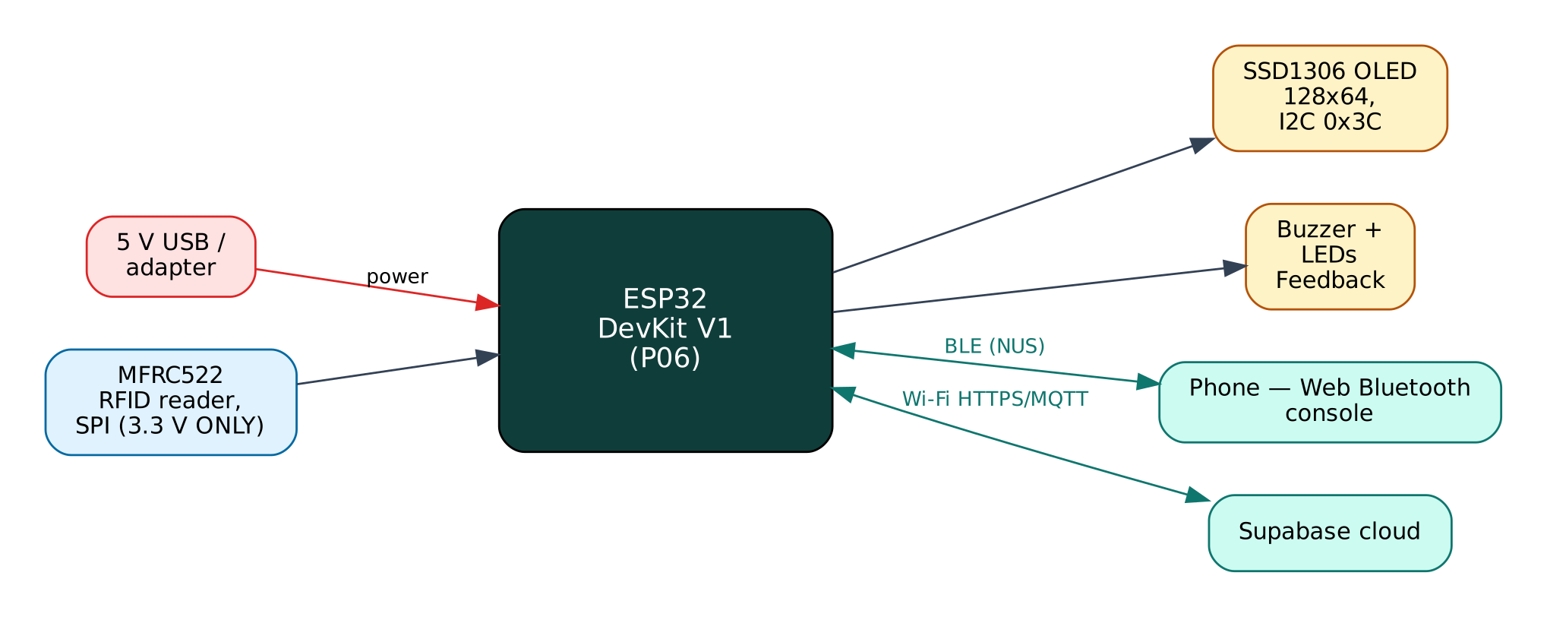

Project: P06 · Advanced level
Peripherals: MFRC522 RFID reader, SSD1306 OLED, Buzzer, Green/red LEDs
Submitted by: ______________________________
Under the guidance of: ______________________________
Department / Institution: ______________________________
October 2026

Certificate
This is to certify that the project report entitled “RFID Attendance System with Offline Queue” is a bonafide record of the work carried out by ______________________ (Roll No. ________) in partial fulfilment of the requirements for the award of ______________________ in ______________________ during the academic year ________.

Project Guide: ______________________ Head of Department: ______________________
Date: ____________ Place: ____________

Acknowledgement
I express my sincere gratitude to my project guide ______________________ for continuous guidance and support, to the Head of the Department ______________________, and to all faculty members and friends who helped me complete this project successfully.

Contents
Abstract 6
1. Introduction 7
1.1 Problem Statement 7
1.2 Objectives 7
1.3 Scope of the Project 7
1.4 Organisation of the Report 7
2. Existing System and Proposed System 8
2.1 Existing Systems 8
2.2 Proposed System 8
2.3 Why Both BLE and Wi-Fi? 8
3. System Design 9
3.1 Block Diagram 9
3.2 System Architecture 9
3.3 Hardware Components and Cost 9
3.4 ESP32 DevKit V1 10
3.5 Working Principle of Components 10
4. Circuit Design 11
4.1 Circuit Diagram 11
4.2 Pin Connections 11
4.3 Interfacing and Power Notes 12
5. Data Flow Diagrams 13
5.1 DFD Level 0 (Context Diagram) 13
5.2 DFD Level 1 14
5.3 Data Dictionary 14
6. Software Design and Implementation 16
6.1 Development Environment 16
6.2 Firmware Architecture 16
6.3 Working of the System 16
6.4 Flowchart 17
6.5 BLE Communication Protocol 17
6.6 Cloud Integration (Supabase) 18
6.7 Configurable Settings 18
7. Setup and Deployment Guide 19
7.1 Hardware Assembly 19
7.2 Flashing the Firmware 19
7.3 Cloud Setup (Supabase) 20
7.4 BLE App Setup (Web Bluetooth Console) 20
7.5 First-Run Checklist 21
8. Testing and Results 22
8.1 Expected Output 22
8.2 Troubleshooting 22
9. Discussion 23
9.1 Advantages 23
9.2 Limitations 23
9.3 Safety Precautions 23
9.4 Security Considerations 23
9.5 Future Scope 23
10. Conclusion 24
References 25
Appendix A: Project Source Code 26
Appendix B: Shared Library Code 31

Abstract
Paper registers and roll-calls waste class and work time and are easy to falsify. This project records attendance with 13.56 MHz RFID cards read by an MFRC522 module. Each tap is matched against a member list, toggled between IN and OUT, confirmed with an OLED message, a beep and an LED, and stored in a Supabase PostgreSQL table with a timestamp. The member list is cached in the ESP32's flash so the reader keeps working without internet; offline scans are queued in a LittleFS file and uploaded automatically when Wi-Fi returns. An administrator enrols new cards from a phone over BLE by typing a name and tapping the card. A SQL view produces the day's first-in and last-out times per member.
Keywords: ESP32, Internet of Things, Bluetooth Low Energy, Wi-Fi, Supabase, MFRC522 RFID reader, SSD1306 OLED, Buzzer, Green/red LEDs.

1. Introduction
The Internet of Things (IoT) connects physical devices — sensors and actuators — to networks so that data can be collected, analysed and acted on automatically. The ESP32 from Espressif Systems has made IoT affordable: a single ₹350 board combines a dual-core 240 MHz processor, Wi-Fi and Bluetooth Low Energy. This project uses both radios at once: BLE for direct, local interaction with a phone and Wi-Fi for cloud connectivity through Supabase, a free IoT/cloud platform.

1.1 Problem Statement
Manual attendance is slow, error-prone and allows proxy attendance. Biometric systems are costly and raise hygiene and privacy concerns, while many low-cost RFID projects lose data when the network fails and need the card list hard-coded in firmware.

1.2 Objectives
- Identify members by RFID card UID and record IN/OUT attendance with timestamps.
- Store attendance in a cloud database that can be queried and exported.
- Keep working during internet outages without losing any scan.
- Enrol and delete cards from a phone without reprogramming.
- Give clear feedback at the reader (display, sound, LED).

1.3 Scope of the Project
Classrooms, labs, small offices and clubs with up to ~200 members per reader. Multi-reader sites can share one Supabase project. Payroll and leave management are outside the scope.

1.4 Organisation of the Report
Chapter 2 reviews existing approaches and describes the proposed system. Chapter 3 covers system design and components, Chapter 4 the circuit, Chapter 5 the data flow diagrams, Chapter 6 the software, Chapter 7 the step-by-step setup of hardware, cloud and app, Chapter 8 testing, Chapter 9 discussion and Chapter 10 the conclusion. Complete source code is given in the appendices.

2. Existing System and Proposed System

2.1 Existing Systems
Common RFID attendance projects compare UIDs against an array in the source code and send each scan straight to a spreadsheet; if Wi-Fi is down the scan is lost, and adding a member means re-flashing the board.

2.2 Proposed System
The proposed system improves on these in the following ways:
- Member list in the cloud, cached in NVS flash and refreshed every 10 minutes.
- Store-and-forward queue in LittleFS: zero data loss during outages; offline rows keep their real scan time.
- BLE administration: enrol (upsert) and delete cards from a phone.
- Automatic IN/OUT toggling and duplicate-tap protection (10 s).

2.3 Why Both BLE and Wi-Fi?
Wi-Fi gives the device internet access for remote monitoring, history and control from anywhere, but it depends on a router and an internet connection, and the device needs the Wi-Fi password before it can connect. BLE needs no infrastructure: any modern phone can connect directly within about 10-30 m. Using both gives:
- Provisioning — Wi-Fi credentials and cloud keys are sent from the phone over BLE and stored in flash; nothing secret is hard-coded or uploaded to GitHub.
- Resilience — local monitoring and control keep working when the internet or router is down.
- Remote access — the cloud dashboard works from anywhere when the internet is available.
- Low cost — no extra hardware; both radios are built into the ESP32.

The ESP32 shares one 2.4 GHz radio between Wi-Fi and Bluetooth by time-division coexistence. For this to work the Wi-Fi modem-sleep mode must stay enabled, which the firmware ensures. NimBLE, a lightweight BLE stack, is used instead of the default Bluedroid stack to leave more RAM for TLS (HTTPS/MQTTS) connections.

3. System Design

3.1 Block Diagram
Figure 1: Block diagram of the RFID Attendance System
The ESP32 is the central controller. Input devices (blue) feed measurements to it, output devices (amber) are driven by it, and two communication links (green) connect it to the user's phone over BLE and to the Supabase cloud over Wi-Fi. The board is powered from 5 V through its USB connector or VIN pin.

3.2 System Architecture
The system follows the standard three-layer IoT architecture:
- Perception layer — MFRC522 RFID reader, SSD1306 OLED, Buzzer, Green/red LEDs connected to the ESP32 GPIO, ADC, I2C, SPI or UART.
- Network layer — BLE 4.2 GATT server (Nordic UART Service) and Wi-Fi 802.11 b/g/n with TLS-encrypted HTTPS REST to Supabase.
- Application layer — the Web Bluetooth console on the phone and the Supabase dashboard / database.

3.3 Hardware Components and Cost
# | Component | Qty | Specification | Cost
1 | ESP32 DevKit V1 (ESP-WROOM-32, 30-pin) | 1 | Dual-core 240 MHz, Wi-Fi + BLE, 4 MB flash | ₹350
2 | Breadboard 830-point + jumper wires (M-M, M-F) | 1 | Prototyping and connections | ₹150
3 | Micro-USB data cable | 1 | Power + programming | ₹60
4 | MFRC522 RFID reader kit (with 1 card + 1 key-tag) | 1 | 13.56 MHz, ISO 14443A, SPI, 3.3 V | ₹110
5 | Extra MIFARE Classic 1K cards | 5 | One per member | ₹75
6 | 0.96" SSD1306 OLED 128x64 (I2C) | 1 | Address 0x3C | ₹170
7 | Active buzzer 5 V | 1 | Feedback | ₹15
8 | LEDs (green, red) + 220 Ω resistors | 2 | Status indication | ₹5
 | Total (approx.) |  |  | ₹935
Table 1: Bill of materials with approximate Indian prices (Robu.in / Amazon.in / local market, 2026)
Prices are indicative and vary by seller. The breadboard, cable and ESP32 can be reused across all ten projects, so the incremental cost of this project is about ₹375.

3.4 ESP32 DevKit V1
Feature | Value
Module | ESP-WROOM-32 (ESP32-D0WD), dual-core Xtensa LX6 up to 240 MHz
Memory | 520 KB SRAM, 4 MB SPI flash
Wireless | Wi-Fi 802.11 b/g/n 2.4 GHz; Bluetooth 4.2 BR/EDR + BLE
I/O | 25 usable GPIO on the 30-pin board, 12-bit ADC (ADC1: GPIO32-39), 2 × DAC, PWM on any output
Interfaces | 3 × UART, 2 × I2C, 3 × SPI, I2S, touch, RMT
Supply | 5 V via USB/VIN, on-board 3.3 V regulator (AMS1117)
Logic level | 3.3 V — inputs are NOT 5 V tolerant
Table 2: Key specifications of the ESP32 DevKit V1

3.5 Working Principle of Components

RFID (ISO 14443A)
The MFRC522 drives a 13.56 MHz field through its PCB antenna. A passive card harvests energy from this field and answers by load modulation. During anti-collision the card sends its 4- or 7-byte UID, which the firmware uses as the member ID.

SPI interface
The ESP32 talks to the MFRC522 over SPI (SCK 18, MOSI 23, MISO 19, SS 5) at up to 10 MHz; RST on GPIO4 resets the chip at start-up. The firmware checks the version register (0x91/0x92) to detect wiring faults.

LittleFS queue
LittleFS is a power-fail-safe flash file system. Each offline scan is appended as one JSON line to /queue.jsonl; after a successful upload the file is rewritten without that line.

Supabase
Two tables — members(uid, name) and attendance(uid, name, direction, scanned_at, offline) — plus an attendance_today view. The device inserts rows through the REST API using the publishable key.

4. Circuit Design

4.1 Circuit Diagram
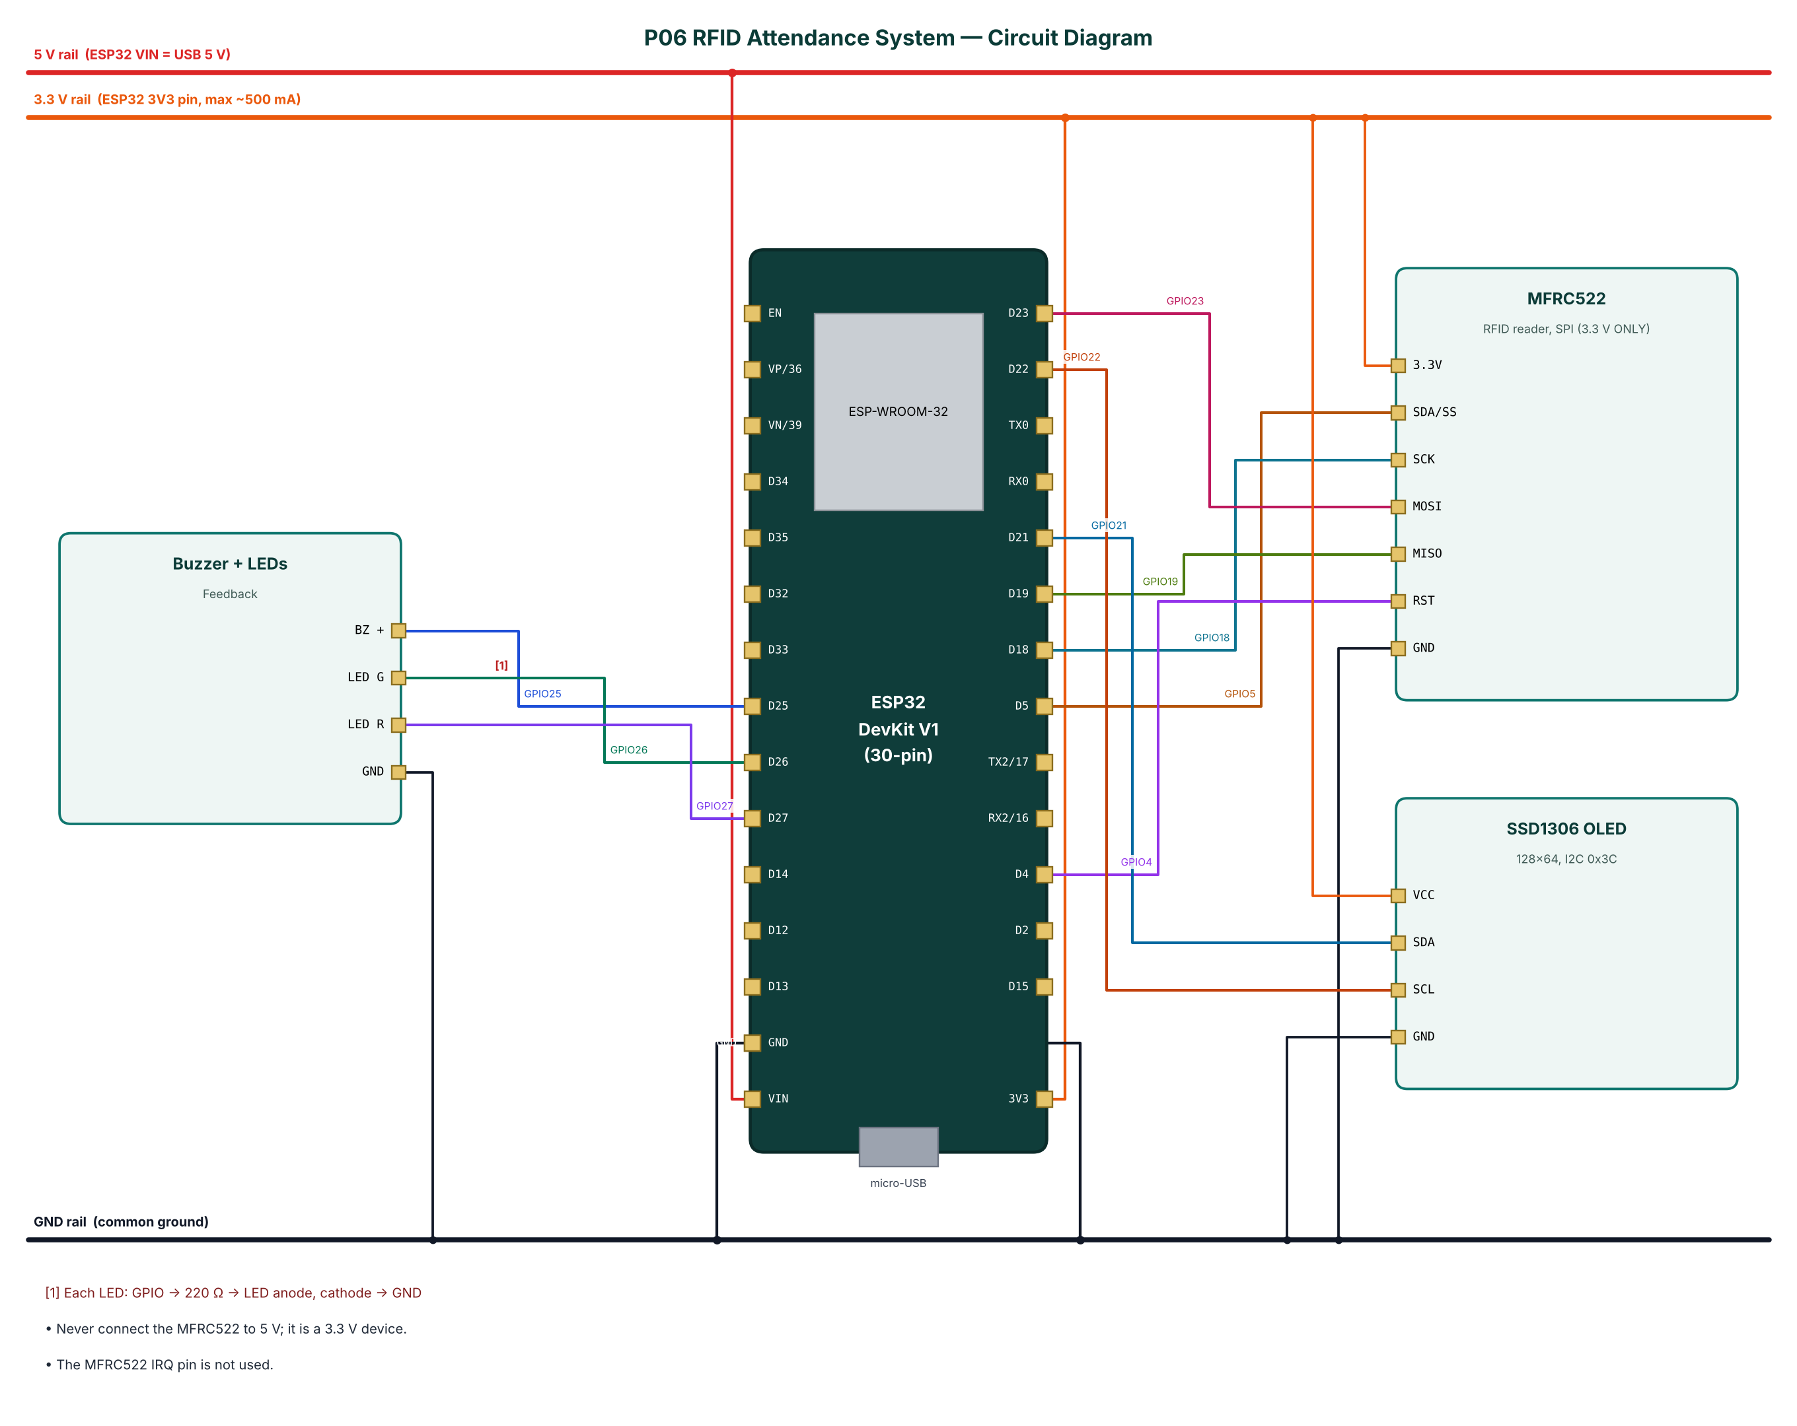
Figure 2: Circuit diagram of the RFID Attendance System

4.2 Pin Connections
Module | Module pin | ESP32 connection | Notes
MFRC522 | 3.3V | 3.3 V (3V3 pin)
MFRC522 | SDA/SS | GPIO5
MFRC522 | SCK | GPIO18
MFRC522 | MOSI | GPIO23
MFRC522 | MISO | GPIO19
MFRC522 | RST | GPIO4
MFRC522 | GND | GND
SSD1306 OLED | VCC | 3.3 V (3V3 pin)
SSD1306 OLED | SDA | GPIO21
SSD1306 OLED | SCL | GPIO22
SSD1306 OLED | GND | GND
Buzzer + LEDs | BZ + | GPIO25
Buzzer + LEDs | LED G | GPIO26 | Each LED: GPIO -> 220 Ω -> LED anode, cathode -> GND
Buzzer + LEDs | LED R | GPIO27
Buzzer + LEDs | GND | GND
Table 3: Pin connection table

4.3 Interfacing and Power Notes
- Never connect the MFRC522 to 5 V; it is a 3.3 V device.
- The MFRC522 IRQ pin is not used.
- Only ADC1 pins (GPIO32-39) are used for analog inputs, because ADC2 cannot be read while Wi-Fi is active.
- Strapping pins GPIO0, 2, 12 and 15 are avoided for inputs so the board always boots normally.
- All grounds are common. 5 V signals are reduced to 3.3 V with resistor dividers before reaching the ESP32.

5. Data Flow Diagrams
Data flow diagrams (DFDs) show how data moves through the system without showing control logic or timing. External entities are drawn as rectangles, processes as numbered circles, data stores as open boxes and data flows as labelled arrows.

5.1 DFD Level 0 (Context Diagram)
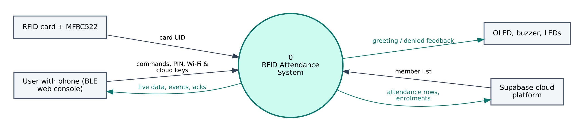
Figure 3: DFD Level 0 — context diagram
At level 0 the whole RFID Attendance System is a single process. It receives card UID from the RFID card + MFRC522, commands and configuration from the user's phone, and commands from Supabase. It sends greeting / denied feedback to the OLED, buzzer, LEDs, live data to the phone and attendance rows, enrolments to Supabase.

5.2 DFD Level 1
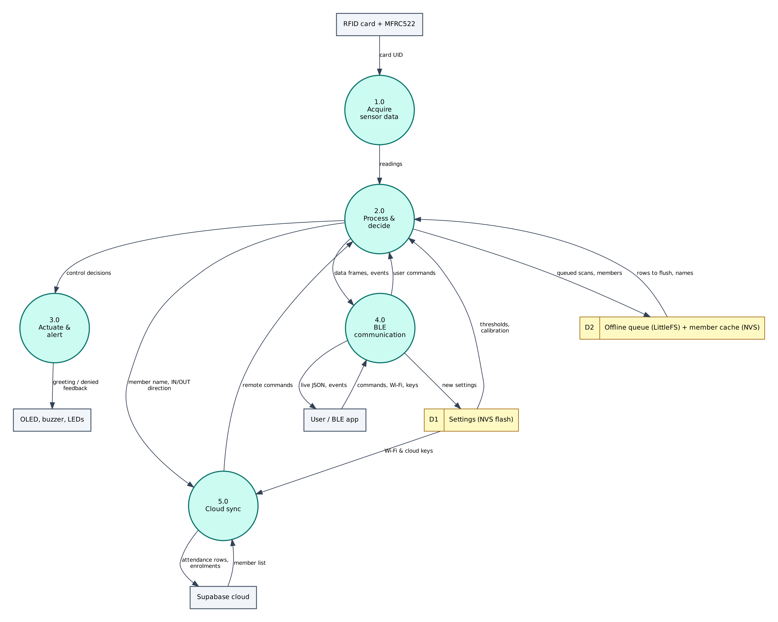
Figure 4: DFD Level 1 — main processes and data stores
Process / store | Description
1.0 Acquire sensor data | Reads card UID from the RFID card + MFRC522; filters/averages the raw values.
2.0 Process & decide | Computes member name, IN/OUT direction; applies thresholds and rules; generates events.
3.0 Actuate & alert | Drives the OLED, buzzer, LEDs (greeting / denied feedback).
4.0 BLE communication | Sends JSON frames and events to the phone; receives and authenticates commands.
5.0 Cloud sync | Sends attendance rows, enrolments to Supabase; receives member list.
D1 Settings (NVS) | Wi-Fi credentials, cloud keys, PIN, thresholds — survive reboots.
D2 Offline queue (LittleFS) + member cache (NVS) | Stores queued scans, members; returns rows to flush, names.
Table 4: Description of level-1 processes and data stores

5.3 Data Dictionary
Field | Meaning | Unit
today | Scans since boot | count
queued | Rows waiting to upload | count
enrol | Enrol mode active | bool
wifi | Wi-Fi connected | bool
type=scan | Per tap: uid, name, dir, cloud | line
Table 5: BLE data frame fields
Cloud object | Content / usage
members | uid (PK, upper-case hex), name, role
attendance | uid, name, direction IN/OUT, device, offline, scanned_at
attendance_today (view) | first_in, last_out and scans per member for today (IST)
Table 6: Supabase data objects

6. Software Design and Implementation

6.1 Development Environment
Item | Details
IDE / build | Arduino IDE 2.x or arduino-cli; GitHub Actions builds firmware in the cloud
Board package | esp32 by Espressif Systems 3.x (tested with 3.3.12)
Board settings | ESP32 Dev Module, Partition Scheme: Minimal SPIFFS (1.9MB APP with OTA/190KB SPIFFS)
Common libraries | NimBLE-Arduino 2.x, ArduinoJson 7.x, PubSubClient 2.8
Project libraries | MFRC522 (GithubCommunity / miguelbalboa), Adafruit SSD1306, Adafruit GFX Library
Phone app | Web Bluetooth console (Chrome on Android / desktop, Bluefy on iPhone); nRF Connect as alternative
Cloud | Supabase (free tier)
Table 7: Software tools
The default 1.2 MB app partition is too small for BLE + Wi-Fi + TLS. Select Minimal SPIFFS (1.9MB APP) in Tools → Partition Scheme, otherwise the upload fails with 'Sketch too big'.

6.2 Firmware Architecture
The firmware is split into three layers so that the ten projects share tested code:
- IoTCore.h (shared) — Wi-Fi station with auto-reconnect, NimBLE GATT server with the Nordic UART Service, line-based command parser shared by BLE and USB serial, PIN authentication, settings in NVS (Preferences), NTP time in IST, JSON helpers.
- Cloud.h (shared) — ThingSpeak HTTPS client, Adafruit IO MQTT/TLS client with a 28 messages/minute rate limiter, Supabase PostgREST client (insert, update, select).
- P06_RFID_Attendance_System.ino — sensor drivers, algorithms, automation rules and the project's own commands.

The main loop is non-blocking: every task is scheduled with millis() timers, BLE writes are queued from the BLE callback into a FreeRTOS queue and executed in loop(), so the BLE stack never waits for slow operations such as HTTPS requests.

6.3 Working of the System
On boot the firmware mounts LittleFS, counts queued rows, initialises the reader and OLED and, once Wi-Fi is up, downloads the member list (uid, name) from Supabase into the 'cards' NVS namespace.
When a card is presented the UID is read as upper-case hex. A repeated tap within 10 s is ignored. If the UID is unknown the red LED and a long beep signal 'ACCESS DENIED' and an 'unknown_card' event is sent over BLE. Otherwise the IN/OUT flag for that UID in NVS is toggled, the OLED greets the member and a row is built with uid, name, direction, device and (if NTP time is known) scanned_at.
If Wi-Fi is up and the queue is empty the row is inserted directly; otherwise it is appended to the queue with offline=true. Every 15 s the queue is flushed row by row; the first failure stops the flush so order is kept. In enrolment mode (enroll:<name>) the next card is stored locally and upserted into members with 'Prefer: resolution=merge-duplicates'.

6.4 Flowchart
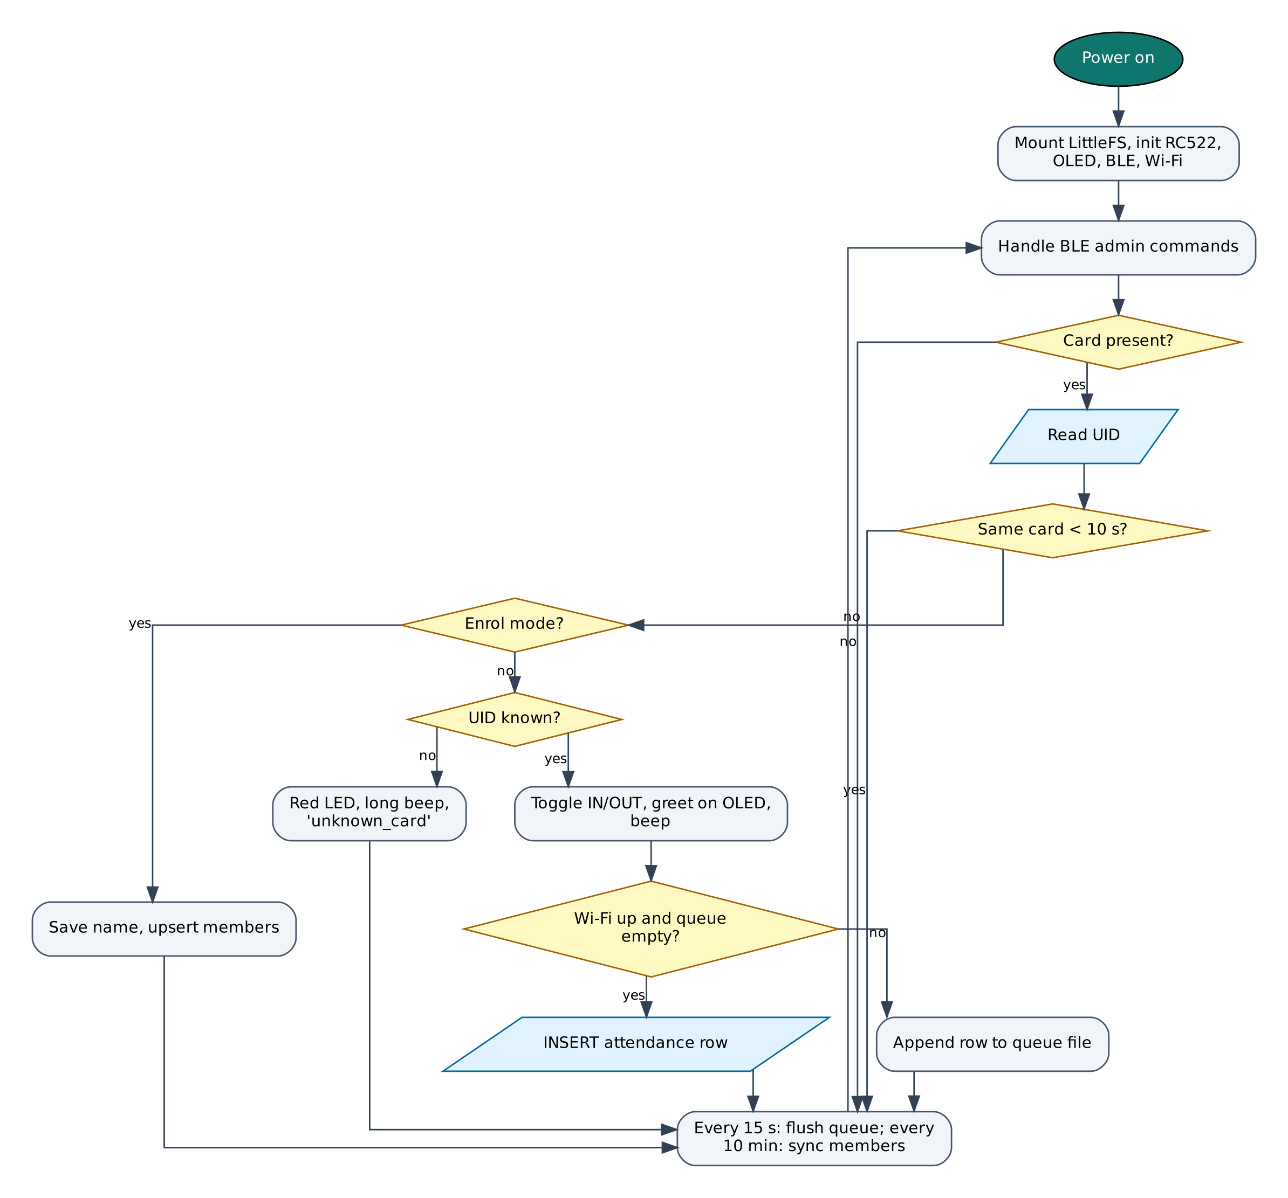
Figure 5: Firmware flowchart

6.5 BLE Communication Protocol
The device is a BLE peripheral named IOT-P06-XXXX (XXXX = last bytes of the MAC address). It exposes the Nordic UART Service, which most BLE apps understand:
Item | UUID | Properties
Service (NUS) | 6E400001-B5A3-F393-E0A9-E50E24DCCA9E | Primary
RX — phone → ESP32 | 6E400002-B5A3-F393-E0A9-E50E24DCCA9E | Write, Write without response
TX — ESP32 → phone | 6E400003-B5A3-F393-E0A9-E50E24DCCA9E | Notify, Read
Table 8: GATT service and characteristics
Commands are plain text lines (command:argument). Replies are one JSON object per line ending in a newline; long lines are split into MTU-sized notifications and re-joined by the app. Commands that change anything require auth:<PIN> first on each connection (default PIN 1234, change it with set:pin=XXXX).
Command | PIN needed | Action
auth:<PIN> | — | Unlock for this connection
status | No | Status JSON: Wi-Fi, IP, RSSI, heap, uptime, time
wifi:<SSID>,<password> | Yes | Save Wi-Fi credentials and connect
set:<key>=<value> | Yes | Save a setting (cloud keys, thresholds)
get:<key> | Yes | Read a setting (secrets masked)
reboot / forget | Yes | Restart / erase all settings
enroll:<name> | Yes | Next card tapped (within 30 s) is enrolled as <name>
delete:<UID> | Yes | Remove a card locally and from the cloud
cancel | Yes | Leave enrol mode
syncnow | Yes | Refresh members and flush the queue now
Table 9: BLE commands (common commands first, then project commands)
Example data frame sent by the device:
{"type":"scan","uid":"A1B2C3D4","name":"Rohit","dir":"IN","cloud":true}

6.6 Cloud Integration (Supabase)
Supabase exposes every Postgres table through a REST API (PostgREST). The device sends HTTPS requests to https://<project>.supabase.co/rest/v1/<table> with the apikey and Authorization: Bearer headers: POST to insert rows, PATCH with a filter such as ?id=eq.1 to update and GET with ?select= to read. Row Level Security policies (in cloud/supabase_schema.sql) allow the device key to do only what the project needs.
Object | Content
members | uid (PK, upper-case hex), name, role
attendance | uid, name, direction IN/OUT, device, offline, scanned_at
attendance_today (view) | first_in, last_out and scans per member for today (IST)
Table 10: Supabase configuration

6.7 Configurable Settings
Key | Default | Meaning
sburl / sbkey | — | Supabase project URL and publishable key
ssid / pass | — | Wi-Fi network (set with the wifi: command)
pin | 1234 | BLE PIN
Table 11: Settings stored in flash (change with set:key=value)

7. Setup and Deployment Guide

7.1 Hardware Assembly
- Place the ESP32 DevKit across the centre gap of the breadboard so both pin rows are free.
- Connect the ESP32 3V3 pin to one breadboard power rail (3.3 V), VIN to the other rail (5 V) and both GND pins to the ground rails.
- Wire each module exactly as in the pin connection table (section 4.2), including the resistor dividers marked with [n] in the circuit diagram.
- Check every connection against the circuit diagram before powering on. Make sure no 5 V signal reaches an ESP32 pin directly.
- Connect the USB cable to a computer (for flashing) or a 5 V adapter (for normal use).

7.2 Flashing the Firmware

Option A — Arduino IDE
- Install Arduino IDE 2.x from arduino.cc.
- File → Preferences → Additional boards manager URLs: https://espressif.github.io/arduino-esp32/package_esp32_index.json.
- Tools → Board → Boards Manager: install esp32 by Espressif Systems (version 3.x).
- Sketch → Include Library → Manage Libraries: install NimBLE-Arduino (2.x), ArduinoJson (7.x), PubSubClient, MFRC522 (GithubCommunity / miguelbalboa), Adafruit SSD1306, Adafruit GFX Library.
- Download the repository and open the folder P06_RFID_Attendance_System (it already contains IoTCore.h, Cloud.h and config.h).
- Tools: Board ESP32 Dev Module, Partition Scheme Minimal SPIFFS (1.9MB APP with OTA/190KB SPIFFS), Upload Speed 921600, and the correct COM port.
- Click Upload. If it stays at 'Connecting…', hold the BOOT button on the ESP32 until upload starts.
- Open Serial Monitor at 115200 baud and type status to check the device.

Option B — no software installation (GitHub Actions + browser flasher)
- Open the repository https://github.com/rohitkukreja705/esp32-iot-projects → Actions → latest Build firmware run.
- Download the artifact firmware-P06_RFID_Attendance_System and unzip it to get P06_RFID_Attendance_System.ino.merged.bin.
- Open https://espressif.github.io/esptool-js/ in Chrome or Edge on a computer, click Connect and select the ESP32's serial port.
- Set Flash Address 0x0, choose the merged .bin file and click Program. Press the EN (reset) button when done.

7.3 Cloud Setup (Supabase)
- Go to supabase.com, sign in (GitHub sign-in works) and click New project. Choose region Mumbai (ap-south-1) for the lowest latency and set a database password.
- Open SQL Editor → New query, paste the whole file cloud/supabase_schema.sql from the repository and click Run. It creates the tables, views and Row Level Security policies for all four Supabase projects (P05, P06, P09, P10), so one Supabase project can serve all of them.
- Click Connect at the top of the dashboard (or Project Settings → API Keys) and copy the Project URL (https://xxxx.supabase.co) and the publishable key (sb_publishable_…; the legacy anon key also works).
- In the BLE web console open Setup, unlock and save them in sburl and sbkey.
- Open Table Editor to watch rows arrive. Use the SQL Editor for reports, e.g. the views created by the schema, and Export to CSV for spreadsheets.
- Free tier: 500 MB database and 2 active projects. Free projects are paused after one week of inactivity — open the dashboard and click Restore if that happens.

Field / feed / table | Content
members | uid (PK, upper-case hex), name, role
attendance | uid, name, direction IN/OUT, device, offline, scanned_at
attendance_today (view) | first_in, last_out and scans per member for today (IST)
Table 12: Items to create in Supabase

7.4 BLE App Setup (Web Bluetooth Console)
No app installation is needed. The console is a web page hosted free on GitHub Pages; Chrome talks to the ESP32 directly through the Web Bluetooth API.
- On an Android phone turn on Bluetooth and Location (Android requires location for BLE scanning).
- Open https://rohitkukreja705.github.io/esp32-iot-projects/?p=P06 in Chrome. (On iPhone use the free Bluefy browser; on a laptop use Chrome or Edge.)
- Tap Connect and choose IOT-P06-XXXX in the pop-up list. The dot turns green and the Live tab starts updating.
- Open Setup, enter the PIN (default 1234) and tap Unlock.
- Enter your 2.4 GHz Wi-Fi name and password and tap Save Wi-Fi. After a few seconds the status line shows the IP address.
- Enter the Supabase keys from section 7.3 and tap Save next to each.
- Use the Control tab for commands and the Log tab to see every event and acknowledgement.

Alternative: nRF Connect app
- Install nRF Connect for Mobile (Nordic Semiconductor, free) and scan.
- Connect to IOT-P06-XXXX and open Nordic UART Service.
- Enable notifications on the TX characteristic (6E400003…).
- Write UTF-8 text to the RX characteristic (6E400002…), e.g. auth:1234, then status.

To host the console yourself: in the GitHub repository open Settings → Pages, choose 'Deploy from a branch', branch main, folder /docs. Web Bluetooth only works on HTTPS pages, which GitHub Pages provides.

7.5 First-Run Checklist
- Serial Monitor shows '[BLE] advertising as IOT-P06-XXXX'.
- Status in the console shows wifi: true and an IP address.
- Data appears in Supabase within a minute.
- All sensor values in the Live tab are plausible (no '—').

8. Testing and Results
The following test cases verify each function. Record the observed result and mark Pass/Fail while testing your build.
# | Test | Procedure | Expected result | Observed
T1 | Reader detection | Open Serial Monitor at boot | '[RC522] version 0x92 OK' (or 0x91)
T2 | Enrolment | Unlock, send enroll:Rohit, tap a card | OLED 'ENROLLED'; row appears in members table
T3 | IN / OUT | Tap the card, wait 11 s, tap again | Rows with direction IN then OUT in attendance
T4 | Unknown card | Tap a card that is not enrolled | 'ACCESS DENIED', red LED, long beep
T5 | Duplicate tap | Tap the same card twice within 5 s | Only one row recorded
T6 | Offline queue | Disconnect Wi-Fi, tap 3 times, reconnect | OLED shows Q:3, then rows uploaded with offline=true
T7 | Daily report | Run 'select * from attendance_today' in SQL editor | One line per member with first IN and last OUT
Table 13: Test cases

8.1 Expected Output
A typical data frame received in the console's Log tab looks like this (values will differ):
{"type":"scan","uid":"A1B2C3D4","name":"Rohit","dir":"IN","cloud":true}

Serial Monitor (115200 baud) prints the same lines along with connection messages such as [WiFi] connected, [BLE] connected and the HTTP or MQTT result of each cloud upload, which helps in troubleshooting.

8.2 Troubleshooting
Symptom | Likely cause and fix
Device not in the Connect list | Bluetooth/Location off on the phone, or the page is not opened in Chrome over HTTPS.
'Sketch too big' on upload | Select Partition Scheme 'Minimal SPIFFS (1.9MB APP with OTA)'.
Wi-Fi never connects | ESP32 supports only 2.4 GHz networks; check the SSID/password (case-sensitive).
Settings refused | Send auth:<PIN> first; the unlock is per BLE connection.
Sensor shows null / — | Check wiring and supply voltage; see the Serial Monitor for 'not found' messages.
Board resets randomly | Weak USB supply or servo/relay current; use a 5 V 2 A adapter and add a 470 µF capacitor.
No data in Supabase | Wrong URL/key, schema not run, or project paused after inactivity.
Table 14: Troubleshooting guide

9. Discussion

9.1 Advantages
- No data loss during network outages (store-and-forward).
- Cards managed from a phone; no reprogramming.
- Standard SQL database: easy reports, CSV export, integration.
- Fast (< 1 s per tap) and contactless.

9.2 Limitations
- Cards can be lent to others (proxy) — RFID identifies the card, not the person.
- MIFARE Classic UIDs can be cloned with special tools; use for low-security attendance only.
- Scans made before NTP sync get the upload time instead of the real time.
- The publishable key with permissive RLS is suitable for trusted environments only.

9.3 Safety Precautions
- Store only the minimum personal data (name, card UID) and inform members how it is used.
- Restrict Supabase table access with RLS and rotate the key if a device is lost.

9.4 Security Considerations
- Secrets (Wi-Fi password, cloud keys) are stored in the ESP32's NVS flash, not in source code.
- BLE commands that change the device require a PIN; change the default PIN after setup.
- Cloud traffic is TLS-encrypted. Certificate verification is disabled (setInsecure) for simplicity; for production, pin the server's root certificate with setCACert().
- Use a dedicated cloud account/project for the device and rotate keys if the device is lost.

9.5 Future Scope
- Add a fingerprint sensor (R307) or face check for two-factor attendance.
- Web dashboard with Supabase Auth for teachers/managers and CSV export.
- Real-time push notifications to parents/managers using Supabase Realtime.
- Battery backup and RTC module (DS3231) for accurate offline timestamps.

10. Conclusion
The RFID Attendance System replaces paper registers with a fast, contactless and reliable system. Caching the member list and queuing scans in flash makes it robust against internet outages, while Supabase provides a real relational database for reports. Phone-based enrolment over BLE keeps administration simple.
All design goals listed in Chapter 1 are met with low-cost parts available in the Indian market, free cloud services and open-source software. The shared firmware core and the single Web Bluetooth console make the project easy to reproduce and extend.

References
- NXP Semiconductors, MFRC522 Standard performance MIFARE and NTAG frontend datasheet.
- M. Balboa, Arduino RFID library for MFRC522, GitHub (miguelbalboa/rfid).
- ISO/IEC 14443-3: Identification cards — Proximity cards — Initialization and anticollision.
- Supabase documentation: Upsert with PostgREST (Prefer: resolution=merge-duplicates).
- Espressif Systems, ESP32 Series Datasheet and ESP32 Technical Reference Manual, espressif.com.
- Espressif Systems, Arduino-ESP32 documentation, docs.espressif.com/projects/arduino-esp32.
- H2zero, NimBLE-Arduino library documentation, github.com/h2zero/NimBLE-Arduino.
- Bluetooth SIG, Bluetooth Core Specification 4.2 — Generic Attribute Profile (GATT).
- W3C Web Bluetooth Community Group, Web Bluetooth specification, webbluetoothcg.github.io/web-bluetooth.
- B. Blanchon, ArduinoJson 7 documentation, arduinojson.org.
- Supabase Inc., Supabase documentation — REST API and Row Level Security, supabase.com/docs.

Appendix A: Project Source Code
The complete code is in the repository folder P06_RFID_Attendance_System (https://github.com/rohitkukreja705/esp32-iot-projects).
config.h
#pragma once
// ===== P06 RFID Attendance System — configuration =====
#define WIFI_SSID ""
#define WIFI_PASS ""
#define DEVICE_PIN "1234"
#define SUPABASE_URL ""
#define SUPABASE_KEY ""

// ----- pins -----
// MFRC522 (3.3 V ONLY!): SDA/SS 5, SCK 18, MOSI 23, MISO 19, RST 4
#define PIN_RC522_SS 5
#define PIN_RC522_RST 4
#define PIN_BUZZER 25
#define PIN_LED_OK 26 // green LED + 220R
#define PIN_LED_ERR 27 // red LED + 220R
// SSD1306 OLED: SDA 21, SCL 22
#define OLED_ADDR 0x3C

// ----- behaviour -----
#define REPEAT_BLOCK_MS 10000 // ignore the same card for 10 s
#define MEMBER_SYNC_MS 600000 // refresh member list from Supabase every 10 min
#define MAX_MEMBERS 200

P06_RFID_Attendance_System.ino
/*
* P06 — RFID Attendance System with Offline Queue
* ===============================================
* Peripherals: MFRC522 RFID reader (13.56 MHz cards/tags), SSD1306 OLED,
* buzzer, green/red status LEDs
* Wi-Fi : Supabase — "members" table (who owns which card) and
* "attendance" table (IN/OUT log with timestamps)
* BLE : admin enrolment (enroll:<name>, then tap the card), delete cards,
* live scan feed on the phone
* Extras : works without internet — members are cached in flash and scans
* are queued in LittleFS, then flushed when Wi-Fi returns;
* automatic IN/OUT toggling; duplicate-tap protection
*/
#include "config.h"
#include "IoTCore.h"
#include "Cloud.h"
#include <SPI.h>
#include <MFRC522.h>
#include <Wire.h>
#include <Adafruit_GFX.h>
#include <Adafruit_SSD1306.h>
#include <LittleFS.h>

MFRC522 rfid(PIN_RC522_SS, PIN_RC522_RST);
Adafruit_SSD1306 oled(128, 64, &Wire, -1);
Preferences cards; // uid -> name (namespace "cards")
Preferences inout; // uid -> "1" when currently IN (namespace "inout")
bool oledOK = false, fsOK = false;

String enrollName = ""; // non-empty while waiting for a card to enrol
uint32_t enrollUntil = 0;
String lastUid; uint32_t lastUidAt = 0;
uint32_t lastMemberSync = 0, lastFlush = 0, screenUntil = 0;
int scansToday = 0, queued = 0;

String uidHex(const MFRC522::Uid& u) {
String s;
for (byte i = 0; i < u.size; i++) { if (u.uidByte[i] < 0x10) s += "0"; s += String(u.uidByte[i], HEX); }
s.toUpperCase();
return s;
}

void beep(int times, int ms) {
for (int i = 0; i < times; i++) { digitalWrite(PIN_BUZZER, HIGH); delay(ms); digitalWrite(PIN_BUZZER, LOW); delay(80); }
}

void show(const String& l1, const String& l2, const String& l3, uint32_t holdMs = 3000) {
if (!oledOK) return;
oled.clearDisplay(); oled.setTextColor(SSD1306_WHITE);
oled.setTextSize(1); oled.setCursor(0, 0); oled.print(l1);
oled.setTextSize(2); oled.setCursor(0, 16); oled.print(l2.substring(0, 10));
oled.setTextSize(1); oled.setCursor(0, 44); oled.print(l3);
oled.setCursor(0, 56);
oled.printf("%s %s Q:%d", iot::wifiOK() ? "WiFi" : "----", iot::bleConnected() ? "BLE" : "---", queued);
oled.display();
screenUntil = holdMs ? millis() + holdMs : 0;
}

void idleScreen() {
String t = iot::timestamp();
show("RFID ATTENDANCE", "Tap card", t.length() > 16 ? t.substring(11, 16) + " scans:" + String(scansToday) : "time not synced", 0);
}

// ------------------------------------------------------------ offline queue
void queueRecord(const String& json) {
if (!fsOK) return;
File f = LittleFS.open("/queue.jsonl", FILE_APPEND);
if (f) { f.println(json); f.close(); queued++; }
}

void countQueue() {
queued = 0;
if (!fsOK || !LittleFS.exists("/queue.jsonl")) return;
File f = LittleFS.open("/queue.jsonl", FILE_READ);
while (f && f.available()) { if (f.readStringUntil('\n').length() > 2) queued++; }
if (f) f.close();
}

void flushQueue() {
if (!fsOK || !iot::wifiOK() || queued == 0) return;
File f = LittleFS.open("/queue.jsonl", FILE_READ);
if (!f) return;
// Rows are posted one by one (offline rows may differ in their keys).
// Stop at the first failure and keep that row and the rest for later.
String rest; int sent = 0; bool failed = false;
while (f.available()) {
String line = f.readStringUntil('\n'); line.trim();
if (line.length() < 3) continue;
if (!failed && sent < 20 && cloud::supabaseInsert("attendance", line)) { sent++; continue; }
failed = true;
rest += line + "\n";
}
f.close();
File w = LittleFS.open("/queue.jsonl", FILE_WRITE);
if (w) { w.print(rest); w.close(); }
countQueue();
if (sent) iot::sendEvent("sync", "Uploaded " + String(sent) + " offline scans");
}

// ------------------------------------------------------------ members
void syncMembers() {
String out;
if (!cloud::supabaseSelect("members", "select=uid,name&limit=" + String(MAX_MEMBERS), out)) return;
JsonDocument d;
if (deserializeJson(d, out)) return;
int n = 0;
for (JsonObject m : d.as<JsonArray>()) {
String uid = m["uid"] | ""; String name = m["name"] | "";
if (uid.length() && uid.length() <= 15 && cards.getString(uid.c_str(), "") != name) cards.putString(uid.c_str(), name);
n++;
}
Serial.printf("[MEMBERS] %d members synced\n", n);
}

void enrolCard(const String& uid) {
cards.putString(uid.c_str(), enrollName);
JsonDocument d; d["uid"] = uid; d["name"] = enrollName;
String s; serializeJson(d, s);
// upsert so re-enrolling the same card renames it
int c = cloud::supabaseRequest("POST", "/rest/v1/members", s, nullptr,
"resolution=merge-duplicates,return=minimal");
iot::sendEvent("enrolled", enrollName + " -> " + uid + (c >= 200 && c < 300 ? " (cloud ok)" : " (saved locally)"));
show("ENROLLED", enrollName, uid);
beep(2, 80);
enrollName = "";
}

void handleScan(const String& uid) {
uint32_t now = millis();
if (uid == lastUid && now - lastUidAt < REPEAT_BLOCK_MS) return; // double tap
lastUid = uid; lastUidAt = now;

if (enrollName.length()) { enrolCard(uid); return; }

String name = cards.getString(uid.c_str(), "");
if (name.isEmpty()) {
digitalWrite(PIN_LED_ERR, HIGH); beep(1, 600); digitalWrite(PIN_LED_ERR, LOW);
show("ACCESS DENIED", "Unknown", uid);
iot::sendEvent("unknown_card", uid);
return;
}
bool wasIn = inout.getString(uid.c_str(), "0") == "1";
const char* dir = wasIn ? "OUT" : "IN";
inout.putString(uid.c_str(), wasIn ? "0" : "1");
scansToday++;

digitalWrite(PIN_LED_OK, HIGH); beep(1, 120); digitalWrite(PIN_LED_OK, LOW);
String t = iot::timestamp();
show(String(dir) == "IN" ? "WELCOME" : "GOODBYE", name, String(dir) + " " + (t.length() > 16 ? t.substring(11, 19) : ""));

JsonDocument d;
d["uid"] = uid; d["name"] = name; d["direction"] = dir; d["device"] = iot::deviceName;
if (t.startsWith("20")) d["scanned_at"] = t; // keep the real scan time for offline rows
String row; serializeJson(d, row);

bool sent = iot::wifiOK() && queued == 0 && cloud::supabaseInsert("attendance", row);
if (!sent) { d["offline"] = true; row = ""; serializeJson(d, row); queueRecord(row); }

JsonDocument e;
e["type"] = "scan"; e["uid"] = uid; e["name"] = name; e["dir"] = dir; e["cloud"] = sent;
String s; serializeJson(e, s); iot::emit(s);
}

// Commands: enroll:<name> delete:<UID> list cancel
bool onCommand(const String& cmd, const String& arg, bool authed) {
if (cmd == "setting") return true;
if (cmd == "enroll" || cmd == "delete" || cmd == "cancel" || cmd == "list" || cmd == "syncnow") {
if (!authed) { iot::emitAck(cmd, false, "send auth:<PIN> first"); return true; }
if (cmd == "enroll") {
if (arg.isEmpty()) { iot::emitAck(cmd, false, "use enroll:<name>"); return true; }
enrollName = arg; enrollUntil = millis() + 30000;
show("ENROL MODE", "Tap card", "for " + arg, 30000);
iot::emitAck(cmd, true, "tap the card within 30 s");
} else if (cmd == "delete") {
cards.remove(arg.c_str()); inout.remove(arg.c_str());
cloud::supabaseRequest("DELETE", "/rest/v1/members?uid=eq." + arg, "");
iot::emitAck(cmd, true, arg + " removed");
} else if (cmd == "cancel") {
enrollName = ""; iot::emitAck(cmd, true);
} else if (cmd == "syncnow") {
syncMembers(); flushQueue(); iot::emitAck(cmd, true, "queued=" + String(queued));
} else {
iot::emitAck(cmd, true, "members cached: " + String(cards.freeEntries()) + " free NVS entries");
}
return true;
}
return false;
}

void sendHeartbeat() {
JsonDocument d;
d["today"] = scansToday; d["queued"] = queued; d["enrol"] = enrollName.length() > 0;
d["wifi"] = iot::wifiOK();
iot::sendData(d);
}

void setup() {
pinMode(PIN_BUZZER, OUTPUT); pinMode(PIN_LED_OK, OUTPUT); pinMode(PIN_LED_ERR, OUTPUT);
iot::begin("P06", onCommand);
cards.begin("cards", false);
inout.begin("inout", false);
fsOK = LittleFS.begin(true); // format on first use
countQueue();
SPI.begin(18, 19, 23, PIN_RC522_SS);
rfid.PCD_Init();
byte v = rfid.PCD_ReadRegister(MFRC522::VersionReg);
Serial.printf("[RC522] version 0x%02X %s\n", v, (v == 0x91 || v == 0x92 || v == 0x88) ? "OK" : "(check wiring)");
Wire.begin(21, 22);
oledOK = oled.begin(SSD1306_SWITCHCAPVCC, OLED_ADDR);
idleScreen();
}

void loop() {
iot::loop();
uint32_t now = millis();

if (rfid.PICC_IsNewCardPresent() && rfid.PICC_ReadCardSerial()) {
handleScan(uidHex(rfid.uid));
rfid.PICC_HaltA();
rfid.PCD_StopCrypto1();
}
if (enrollName.length() && now > enrollUntil) { enrollName = ""; iot::sendEvent("enrol", "timed out"); }
if (screenUntil && now > screenUntil) { screenUntil = 0; idleScreen(); }

if (iot::wifiOK() && (lastMemberSync == 0 || now - lastMemberSync > MEMBER_SYNC_MS)) {
lastMemberSync = now; syncMembers();
}
if (now - lastFlush > 15000) { lastFlush = now; flushQueue(); sendHeartbeat(); if (!screenUntil) idleScreen(); }
}

Appendix B: Shared Library Code
These two headers are identical in every project folder (master copies in /common).
IoTCore.h
/*
* IoTCore.h — shared runtime for all ESP32 IoT projects in this repo
* -------------------------------------------------------------------
* - Wi-Fi station with automatic reconnect (credentials stored in flash)
* - BLE server using the Nordic UART Service (NUS) layout, so the device
* works with the Web Bluetooth dashboard in /docs AND with generic apps
* such as "nRF Connect" or "Serial Bluetooth Terminal"
* - Line-based command protocol shared by BLE and USB Serial
* - Persistent settings (Preferences / NVS): Wi-Fi, cloud keys, PIN, thresholds
* - NTP time sync (IST) for timestamps
*
* Wire protocol
* -------------
* Phone -> ESP32 (write to RX characteristic, text):
* auth:1234 unlock control + settings for this connection
* status device replies with a status JSON line
* set:key=value store a setting (Wi-Fi, cloud key, threshold…)
* get:key read back a setting (secrets are masked)
* wifi:SSID,PASSWORD shortcut for set:ssid + set:pass + reconnect
* reboot restart the board
* <anything else> forwarded to the project's own command handler
* ESP32 -> Phone (notify on TX characteristic):
* one JSON object per line, terminated by '\n'
* {"type":"data",...} {"type":"status",...} {"type":"ack",...}
* {"type":"event",...} {"type":"err",...}
* Lines longer than one BLE packet are split into chunks; the receiver
* joins chunks until it sees '\n'.
*
* Library: NimBLE-Arduino 2.x (lighter than Bluedroid, leaves more RAM for TLS)
* Board: ESP32 Dev Module, Partition Scheme "Minimal SPIFFS (1.9MB APP with OTA)"
*/
#pragma once

#include <Arduino.h>
#include <WiFi.h>
#include <Preferences.h>
#include <NimBLEDevice.h>
#include <ArduinoJson.h>
#include <time.h>

#ifndef DEVICE_PIN
#define DEVICE_PIN "1234"
#endif
#ifndef WIFI_SSID
#define WIFI_SSID ""
#endif
#ifndef WIFI_PASS
#define WIFI_PASS ""
#endif

namespace iot {

// Nordic UART Service UUIDs (widely supported by BLE terminal apps)
static const char* NUS_SERVICE = "6E400001-B5A3-F393-E0A9-E50E24DCCA9E";
static const char* NUS_RX = "6E400002-B5A3-F393-E0A9-E50E24DCCA9E"; // phone writes here
static const char* NUS_TX = "6E400003-B5A3-F393-E0A9-E50E24DCCA9E"; // ESP32 notifies here

// Project command handler: return true if the command was recognised.
using CommandHandler = bool (*)(const String& cmd, const String& arg, bool authed);

// ------------------------------------------------------------------ state
struct CmdMsg { char text[256]; bool fromBle; };

static Preferences prefs;
static NimBLEServer* bleServer = nullptr;
static NimBLECharacteristic* txChr = nullptr;
static QueueHandle_t cmdQueue = nullptr;
static CommandHandler userHandler = nullptr;
static String deviceName;
static String projectId;
static volatile uint16_t bleMtu = 23;
static volatile bool bleAuthed = false; // reset on every new connection
static bool serialAuthed = true; // USB = physical access, trusted
static bool timeSynced = false;
static uint32_t lastWifiTry = 0;
static String rxLine; // assembles multi-packet writes

// --------------------------------------------------------------- settings
inline String setting(const char* key, const char* def = "") {
return prefs.isKey(key) ? prefs.getString(key, def) : String(def);
}
inline void saveSetting(const char* key, const String& v) { prefs.putString(key, v); }
inline float settingF(const char* key, float def) {
String s = setting(key, "");
return s.length() ? s.toFloat() : def;
}

// ------------------------------------------------------------------- BLE
inline bool bleConnected() { return bleServer && bleServer->getConnectedCount() > 0; }

// Send one line (adds '\n'), split to fit the negotiated MTU.
inline void bleSend(const String& line) {
if (!bleConnected() || !txChr) return;
String msg = line + "\n";
size_t chunk = (bleMtu > 23 ? bleMtu : 23) - 3;
for (size_t i = 0; i < msg.length(); i += chunk) {
size_t n = min(chunk, msg.length() - i);
txChr->setValue((const uint8_t*)msg.c_str() + i, n);
txChr->notify();
if (msg.length() > chunk) delay(8); // give the stack time between chunks
}
}

// Send to BLE and mirror to USB Serial.
inline void emit(const String& line) {
Serial.println(line);
bleSend(line);
}

inline void emitAck(const String& cmd, bool ok, const String& msg = "") {
JsonDocument d;
d["type"] = ok ? "ack" : "err";
d["cmd"] = cmd;
if (msg.length()) d["msg"] = msg;
String s; serializeJson(d, s); emit(s);
}

inline void enqueue(const String& s, bool fromBle) {
if (!cmdQueue || s.length() == 0) return;
CmdMsg m; memset(&m, 0, sizeof(m));
strncpy(m.text, s.c_str(), sizeof(m.text) - 1);
m.fromBle = fromBle;
xQueueSend(cmdQueue, &m, 0);
}

class ServerCB : public NimBLEServerCallbacks {
void onConnect(NimBLEServer* s, NimBLEConnInfo& info) override {
bleAuthed = false;
rxLine = "";
Serial.printf("[BLE] connected %s\n", info.getAddress().toString().c_str());
}
void onDisconnect(NimBLEServer* s, NimBLEConnInfo& info, int reason) override {
bleAuthed = false;
bleMtu = 23;
Serial.printf("[BLE] disconnected (reason %d), advertising again\n", reason);
// NimBLE restarts advertising automatically (advertiseOnDisconnect = true)
}
void onMTUChange(uint16_t mtu, NimBLEConnInfo& info) override {
bleMtu = mtu;
Serial.printf("[BLE] MTU %u\n", mtu);
}
};

class RxCB : public NimBLECharacteristicCallbacks {
void onWrite(NimBLECharacteristic* c, NimBLEConnInfo& info) override {
std::string v = c->getValue();
// Accept either a single write without newline, or several writes
// that together form lines terminated by '\n'.
for (char ch : v) {
if (ch == '\r') continue;
if (ch == '\n') { enqueue(rxLine, true); rxLine = ""; }
else if (rxLine.length() < 250) rxLine += ch;
}
if (v.find('\n') == std::string::npos && rxLine.length() && rxLine.length() == v.length()) {
enqueue(rxLine, true); // plain one-shot write (e.g. typed in nRF Connect)
rxLine = "";
}
}
};

inline void bleBegin() {
uint8_t mac[6]; WiFi.macAddress(mac);
char suffix[6]; snprintf(suffix, sizeof(suffix), "%02X%02X", mac[4], mac[5]);
deviceName = "IOT-" + projectId + "-" + suffix;

NimBLEDevice::init(deviceName.c_str());
NimBLEDevice::setMTU(247);
bleServer = NimBLEDevice::createServer();
bleServer->setCallbacks(new ServerCB());

NimBLEService* svc = bleServer->createService(NUS_SERVICE);
txChr = svc->createCharacteristic(NUS_TX, NIMBLE_PROPERTY::NOTIFY | NIMBLE_PROPERTY::READ);
NimBLECharacteristic* rx = svc->createCharacteristic(
NUS_RX, NIMBLE_PROPERTY::WRITE | NIMBLE_PROPERTY::WRITE_NR, 512);
rx->setCallbacks(new RxCB());
// (NimBLE 2.x starts services automatically when advertising begins)

// 128-bit UUID goes in the advertisement, the name in the scan response
// (both together would not fit in one 31-byte packet).
NimBLEAdvertisementData adv, scan;
adv.setFlags(BLE_HS_ADV_F_DISC_GEN | BLE_HS_ADV_F_BREDR_UNSUP);
adv.setCompleteServices(NimBLEUUID(NUS_SERVICE));
scan.setName(deviceName.c_str());
NimBLEAdvertising* a = NimBLEDevice::getAdvertising();
a->setAdvertisementData(adv);
a->setScanResponseData(scan);
a->start();
Serial.printf("[BLE] advertising as %s\n", deviceName.c_str());
}

// ------------------------------------------------------------------ Wi-Fi
inline bool wifiOK() { return WiFi.status() == WL_CONNECTED; }

inline void wifiConnect() {
String ssid = setting("ssid", WIFI_SSID);
String pass = setting("pass", WIFI_PASS);
if (ssid.isEmpty()) {
Serial.println("[WiFi] no SSID yet - send wifi:SSID,PASSWORD over BLE");
return;
}
Serial.printf("[WiFi] connecting to %s\n", ssid.c_str());
WiFi.disconnect();
WiFi.begin(ssid.c_str(), pass.c_str());
lastWifiTry = millis();
}

inline void wifiLoop() {
static bool wasUp = false;
bool up = wifiOK();
if (up && !wasUp) {
Serial.printf("[WiFi] connected, IP %s, RSSI %d\n",
WiFi.localIP().toString().c_str(), WiFi.RSSI());
configTzTime("IST-5:30", "pool.ntp.org", "time.google.com");
}
if (!up && millis() - lastWifiTry > 20000) wifiConnect(); // retry every 20 s
wasUp = up;
if (up && !timeSynced && time(nullptr) > 1700000000) {
timeSynced = true;
Serial.println("[NTP] time synced");
}
}

// ISO-8601 local time, or uptime if NTP has not synced yet.
inline String timestamp() {
time_t now = time(nullptr);
if (now < 1700000000) return "uptime+" + String(millis() / 1000) + "s";
struct tm t; localtime_r(&now, &t);
char buf[32]; strftime(buf, sizeof(buf), "%Y-%m-%dT%H:%M:%S+05:30", &t);
return String(buf);
}

// ------------------------------------------------------- built-in commands
inline bool isSecretKey(const String& k) {
return k == "pass" || k.endsWith("key") || k == "pin";
}

inline void sendStatus() {
JsonDocument d;
d["type"] = "status";
d["dev"] = deviceName;
d["wifi"] = wifiOK();
d["ssid"] = setting("ssid", WIFI_SSID);
d["rssi"] = wifiOK() ? WiFi.RSSI() : 0;
d["ip"] = wifiOK() ? WiFi.localIP().toString() : "";
d["auth"] = bleAuthed;
d["heap"] = ESP.getFreeHeap();
d["up"] = millis() / 1000;
d["time"] = timestamp();
String s; serializeJson(d, s); emit(s);
}

inline void handleLine(const String& raw, bool fromBle) {
String line = raw; line.trim();
if (line.isEmpty()) return;
int c = line.indexOf(':');
String cmd = (c < 0 ? line : line.substring(0, c));
String arg = (c < 0 ? "" : line.substring(c + 1));
cmd.trim(); cmd.toLowerCase();
bool authed = fromBle ? bleAuthed : serialAuthed;

if (cmd == "auth") {
bool ok = arg == setting("pin", DEVICE_PIN);
if (fromBle) bleAuthed = ok;
emitAck(cmd, ok, ok ? "unlocked" : "wrong PIN");
return;
}
if (cmd == "status") { sendStatus(); return; }
if (cmd == "ping") { emitAck(cmd, true, "pong"); return; }

// Everything below changes the device, so it needs the PIN over BLE.
if (cmd == "set" || cmd == "wifi" || cmd == "reboot" || cmd == "get" || cmd == "forget") {
if (!authed) { emitAck(cmd, false, "send auth:<PIN> first"); return; }
if (cmd == "set") {
int e = arg.indexOf('=');
if (e <= 0) { emitAck(cmd, false, "use set:key=value"); return; }
String k = arg.substring(0, e); k.trim();
String v = arg.substring(e + 1); v.trim();
if (k.length() > 15) { emitAck(cmd, false, "key too long"); return; }
saveSetting(k.c_str(), v);
emitAck(cmd, true, k + " saved");
if (k == "ssid" || k == "pass") wifiConnect();
// let the project react to changed thresholds etc.
if (userHandler) userHandler("setting", k, true);
return;
}
if (cmd == "get") {
String v = setting(arg.c_str(), "");
if (isSecretKey(arg) && v.length()) v = "****" + v.substring(max(0, (int)v.length() - 3));
emitAck(cmd, true, arg + "=" + v);
return;
}
if (cmd == "wifi") {
int k = arg.indexOf(',');
String ssid = k < 0 ? arg : arg.substring(0, k);
String pass = k < 0 ? "" : arg.substring(k + 1);
saveSetting("ssid", ssid); saveSetting("pass", pass);
emitAck(cmd, true, "connecting to " + ssid);
wifiConnect();
return;
}
if (cmd == "forget") { prefs.clear(); emitAck(cmd, true, "all settings erased"); return; }
if (cmd == "reboot") { emitAck(cmd, true, "rebooting"); delay(300); ESP.restart(); }
}

if (userHandler && userHandler(cmd, arg, authed)) return;
emitAck(cmd, false, "unknown command");
}

// ------------------------------------------------------------ entry points
// Call once from setup(). id = short project id, e.g. "P01".
inline void begin(const char* id, CommandHandler handler) {
Serial.begin(115200);
delay(200);
projectId = id;
userHandler = handler;
prefs.begin("iot", false);
cmdQueue = xQueueCreate(8, sizeof(CmdMsg));
WiFi.mode(WIFI_STA);
WiFi.setAutoReconnect(true);
// NOTE: Wi-Fi modem sleep must stay ON while BLE is running (ESP32 coexistence).
bleBegin();
wifiConnect();
Serial.println("[CORE] ready - type 'status' here or connect over BLE");
}

// Call every loop() iteration.
inline void loop() {
wifiLoop();
// USB serial commands (handy while developing)
static String serialLine;
while (Serial.available()) {
char ch = Serial.read();
if (ch == '\n' || ch == '\r') { if (serialLine.length()) enqueue(serialLine, false); serialLine = ""; }
else if (serialLine.length() < 250) serialLine += ch;
}
CmdMsg m;
while (cmdQueue && xQueueReceive(cmdQueue, &m, 0) == pdTRUE) handleLine(String(m.text), m.fromBle);
}

// Round for compact JSON. NaN stays NaN, which ArduinoJson writes as null.
inline float rnd(float v, int dp = 1) {
if (isnan(v)) return v;
float m = powf(10, dp);
return roundf(v * m) / m;
}

// Helper: build and send a {"type":"data",...} line from a filled document.
inline void sendData(JsonDocument& d) {
d["type"] = "data";
String s; serializeJson(d, s); emit(s);
}

inline void sendEvent(const String& name, const String& msg) {
JsonDocument d;
d["type"] = "event"; d["name"] = name; d["msg"] = msg; d["time"] = timestamp();
String s; serializeJson(d, s); emit(s);
}

} // namespace iot

Cloud.h
/*
* Cloud.h — free-tier cloud helpers used by the projects
* ---------------------------------------------------------
* ThingSpeak : HTTPS REST "update" (free tier: 1 update / 15 s per channel)
* Adafruit IO : MQTT over TLS (free tier: 30 data points / minute, 10 feeds)
* Supabase : PostgREST over HTTPS (free tier: 500 MB Postgres)
*
* Keys are read from settings (stored over BLE with set:key=value) so no
* secret has to be hard-coded or committed to GitHub:
* tskey ThingSpeak Write API Key
* aiouser Adafruit IO username aiokey Adafruit IO key
* sburl https://<ref>.supabase.co sbkey Supabase publishable/anon key
*
* TLS note: certificate checking is disabled with setInsecure() to keep the
* projects beginner-friendly and independent of CA rotations. Traffic is
* still encrypted. For production, pin the root CA with setCACert().
*/
#pragma once

#include <WiFiClientSecure.h>
#include <HTTPClient.h>
#include <PubSubClient.h>
#include "IoTCore.h"

// Optional compile-time defaults (normally left empty and set over BLE)
#ifndef TS_WRITE_KEY
#define TS_WRITE_KEY ""
#endif
#ifndef AIO_USERNAME
#define AIO_USERNAME ""
#endif
#ifndef AIO_KEY
#define AIO_KEY ""
#endif
#ifndef SUPABASE_URL
#define SUPABASE_URL ""
#endif
#ifndef SUPABASE_KEY
#define SUPABASE_KEY ""
#endif

namespace cloud {

// ============================================================== ThingSpeak
// vals[i] -> field(i+1). Pass NAN to skip a field. Returns true on success.
inline bool thingSpeakUpdate(const float* vals, int n, const String& status = "") {
if (!iot::wifiOK()) return false;
String key = iot::setting("tskey", TS_WRITE_KEY);
if (key.isEmpty()) { Serial.println("[TS] no tskey set"); return false; }
String url = "https://api.thingspeak.com/update?api_key=" + key;
for (int i = 0; i < n && i < 8; i++)
if (!isnan(vals[i])) url += "&field" + String(i + 1) + "=" + String(vals[i], 2);
if (status.length()) {
String st = status; st.replace(" ", "%20");
url += "&status=" + st;
}
WiFiClientSecure client; client.setInsecure();
HTTPClient http; http.setTimeout(8000);
if (!http.begin(client, url)) return false;
int code = http.GET();
String body = http.getString();
http.end();
bool ok = code == 200 && body.toInt() > 0; // ThingSpeak returns the entry id, 0 = rejected
Serial.printf("[TS] HTTP %d entry=%s\n", code, body.c_str());
return ok;
}

// ================================================================ Supabase
// Generic PostgREST call. method: GET/POST/PATCH. path e.g. "/rest/v1/readings"
inline int supabaseRequest(const char* method, const String& path, const String& body,
String* response = nullptr, const char* prefer = "return=minimal") {
if (!iot::wifiOK()) return -1;
String base = iot::setting("sburl", SUPABASE_URL);
String key = iot::setting("sbkey", SUPABASE_KEY);
if (base.isEmpty() || key.isEmpty()) { Serial.println("[SB] sburl/sbkey not set"); return -2; }
if (base.endsWith("/")) base.remove(base.length() - 1);
WiFiClientSecure client; client.setInsecure();
HTTPClient http; http.setTimeout(8000);
if (!http.begin(client, base + path)) return -3;
http.addHeader("apikey", key);
http.addHeader("Authorization", "Bearer " + key);
http.addHeader("Content-Type", "application/json");
if (prefer) http.addHeader("Prefer", prefer);
int code = http.sendRequest(method, body);
if (response) *response = http.getString();
else if (code >= 300) Serial.printf("[SB] %s\n", http.getString().c_str());
http.end();
Serial.printf("[SB] %s %s -> %d\n", method, path.c_str(), code);
return code;
}

inline bool supabaseInsert(const char* table, const String& json) {
int c = supabaseRequest("POST", String("/rest/v1/") + table, json);
return c >= 200 && c < 300;
}

// filter is a PostgREST filter, e.g. "id=eq.1"
inline bool supabaseUpdate(const char* table, const String& filter, const String& json) {
int c = supabaseRequest("PATCH", String("/rest/v1/") + table + "?" + filter, json);
return c >= 200 && c < 300;
}

// query e.g. "select=*&id=eq.1" -> JSON array text in out
inline bool supabaseSelect(const char* table, const String& query, String& out) {
int c = supabaseRequest("GET", String("/rest/v1/") + table + "?" + query, "", &out, nullptr);
return c == 200;
}

// ============================================================ Adafruit IO
// MQTT wrapper with a simple rate limiter to respect the 30 msg/min limit.
using FeedCallback = void (*)(const String& feed, const String& value);

class AdafruitIO {
public:
// requestLast = true asks Adafruit IO for each feed's last value on connect
// (useful for switches changed while offline; unsafe for things like pumps)
void begin(FeedCallback cb, const char* const* subFeeds, int nSub, bool requestLast = true) {
cb_ = cb; subs_ = subFeeds; nSub_ = nSub; requestLast_ = requestLast;
tls_.setInsecure();
mqtt_.setClient(tls_);
mqtt_.setServer("io.adafruit.com", 8883);
mqtt_.setBufferSize(512);
mqtt_.setKeepAlive(60);
mqtt_.setCallback([](char* topic, byte* payload, unsigned int len) {
String t(topic), v;
for (unsigned int i = 0; i < len; i++) v += (char)payload[i];
int p = t.lastIndexOf('/');
String feed = t.substring(p + 1);
if (instance()->cb_) instance()->cb_(feed, v);
});
instance() = this;
}

void loop() {
if (!iot::wifiOK()) return;
if (!mqtt_.connected()) {
if (millis() - lastTry_ < 10000) return;
lastTry_ = millis();
user_ = iot::setting("aiouser", AIO_USERNAME);
String key = iot::setting("aiokey", AIO_KEY);
if (user_.isEmpty() || key.isEmpty()) { Serial.println("[AIO] aiouser/aiokey not set"); return; }
String id = "esp32-" + String((uint32_t)ESP.getEfuseMac(), HEX);
Serial.println("[AIO] connecting...");
if (mqtt_.connect(id.c_str(), user_.c_str(), key.c_str())) {
Serial.println("[AIO] connected");
for (int i = 0; i < nSub_; i++) {
mqtt_.subscribe(topic(subs_[i]).c_str());
if (requestLast_) mqtt_.publish((topic(subs_[i]) + "/get").c_str(), "");
}
// subscribe to throttle/error topics so we learn about rate limits
mqtt_.subscribe((user_ + "/throttle").c_str());
} else {
Serial.printf("[AIO] failed, state %d\n", mqtt_.state());
}
}
mqtt_.loop();
}

bool connected() { return mqtt_.connected(); }

// Returns false if not connected or if the per-minute budget is used up.
bool publish(const char* feed, const String& value) {
if (!mqtt_.connected()) return false;
uint32_t now = millis();
if (now - windowStart_ > 60000) { windowStart_ = now; sent_ = 0; }
if (sent_ >= 28) { Serial.println("[AIO] rate budget used, skipping"); return false; }
sent_++;
return mqtt_.publish(topic(feed).c_str(), value.c_str());
}
bool publish(const char* feed, float v, int dp = 2) { return publish(feed, String(v, dp)); }

private:
String topic(const char* feed) { return user_ + "/feeds/" + feed; }
static AdafruitIO*& instance() { static AdafruitIO* p = nullptr; return p; }

WiFiClientSecure tls_;
PubSubClient mqtt_;
FeedCallback cb_ = nullptr;
const char* const* subs_ = nullptr;
int nSub_ = 0;
bool requestLast_ = true;
String user_;
uint32_t lastTry_ = 0, windowStart_ = 0;
int sent_ = 0;
};

} // namespace cloud

