A PROJECT REPORT ON
Water Tank Level Monitor and Smart Pump Controller
IoT project using ESP32 with Bluetooth Low Energy and Wi-Fi (Adafruit IO)
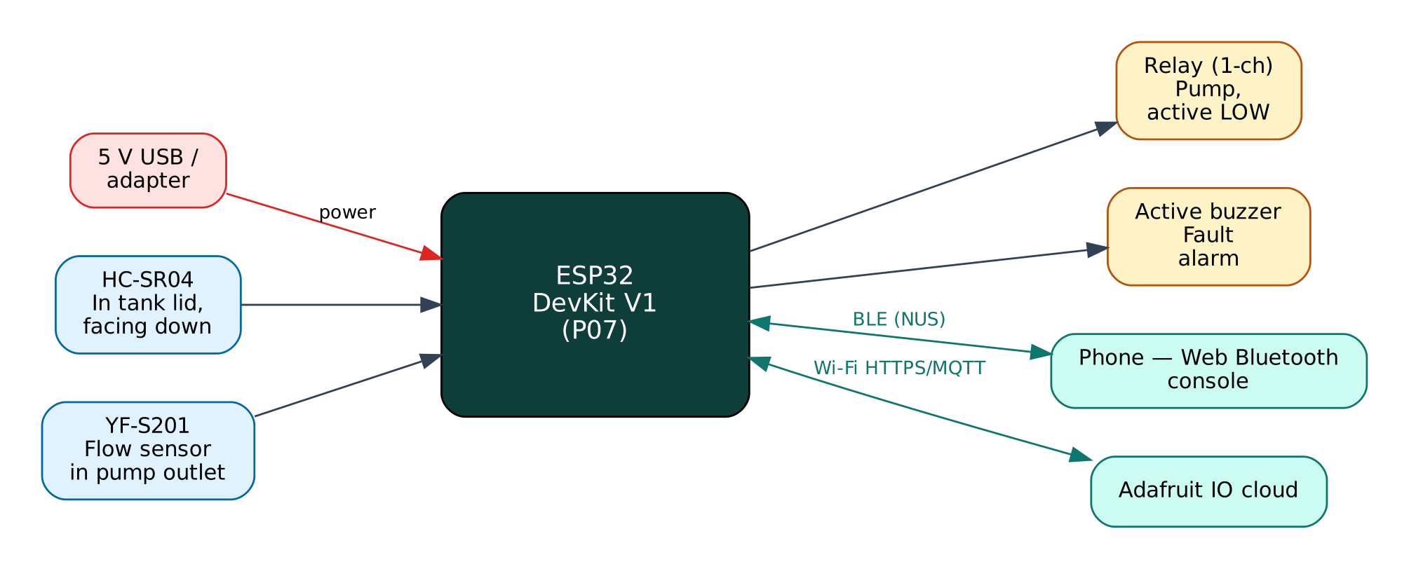

Project: P07 · Advanced level
Peripherals: HC-SR04 ultrasonic sensor, YF-S201 flow sensor, Relay module, Active buzzer
Submitted by: ______________________________
Under the guidance of: ______________________________
Department / Institution: ______________________________
October 2026

Certificate
This is to certify that the project report entitled “Water Tank Level Monitor and Smart Pump Controller” is a bonafide record of the work carried out by ______________________ (Roll No. ________) in partial fulfilment of the requirements for the award of ______________________ in ______________________ during the academic year ________.

Project Guide: ______________________ Head of Department: ______________________
Date: ____________ Place: ____________

Acknowledgement
I express my sincere gratitude to my project guide ______________________ for continuous guidance and support, to the Head of the Department ______________________, and to all faculty members and friends who helped me complete this project successfully.

Contents
Abstract 6
1. Introduction 7
1.1 Problem Statement 7
1.2 Objectives 7
1.3 Scope of the Project 7
1.4 Organisation of the Report 7
2. Existing System and Proposed System 8
2.1 Existing Systems 8
2.2 Proposed System 8
2.3 Why Both BLE and Wi-Fi? 8
3. System Design 9
3.1 Block Diagram 9
3.2 System Architecture 9
3.3 Hardware Components and Cost 9
3.4 ESP32 DevKit V1 10
3.5 Working Principle of Components 10
4. Circuit Design 11
4.1 Circuit Diagram 11
4.2 Pin Connections 11
4.3 Interfacing and Power Notes 12
5. Data Flow Diagrams 13
5.1 DFD Level 0 (Context Diagram) 13
5.2 DFD Level 1 14
5.3 Data Dictionary 14
6. Software Design and Implementation 16
6.1 Development Environment 16
6.2 Firmware Architecture 16
6.3 Working of the System 16
6.4 Flowchart 17
6.5 BLE Communication Protocol 17
6.6 Cloud Integration (Adafruit IO) 18
6.7 Configurable Settings 19
7. Setup and Deployment Guide 20
7.1 Hardware Assembly 20
7.2 Flashing the Firmware 20
7.3 Cloud Setup (Adafruit IO) 20
7.4 BLE App Setup (Web Bluetooth Console) 21
7.5 First-Run Checklist 22
8. Testing and Results 23
8.1 Expected Output 23
8.2 Troubleshooting 23
9. Discussion 24
9.1 Advantages 24
9.2 Limitations 24
9.3 Safety Precautions 24
9.4 Security Considerations 24
9.5 Future Scope 24
10. Conclusion 25
References 26
Appendix A: Project Source Code 27
Appendix B: Shared Library Code 31

Abstract
Overhead water tanks in Indian homes either overflow because the motor is left on or run dry because nobody notices. This project measures the water level with an ultrasonic sensor in the tank lid and the actual water flow with a YF-S201 Hall-effect flow sensor, and switches the pump through a relay. In AUTO mode the pump starts below a low threshold and stops at a high threshold. Three protections stop the pump: dry-run (pump on but no flow for 30 s), overflow (level above 98 %) and maximum run time. Level, flow and pump state are published to Adafruit IO, where the dashboard can also switch the pump and change the mode. A phone connected over BLE shows a live tank gauge and allows calibration of the tank dimensions.
Keywords: ESP32, Internet of Things, Bluetooth Low Energy, Wi-Fi, Adafruit IO, HC-SR04 ultrasonic sensor, YF-S201 flow sensor, Relay module, Active buzzer.

1. Introduction
The Internet of Things (IoT) connects physical devices — sensors and actuators — to networks so that data can be collected, analysed and acted on automatically. The ESP32 from Espressif Systems has made IoT affordable: a single ₹350 board combines a dual-core 240 MHz processor, Wi-Fi and Bluetooth Low Energy. This project uses both radios at once: BLE for direct, local interaction with a phone and Wi-Fi for cloud connectivity through Adafruit IO, a free IoT/cloud platform.

1.1 Problem Statement
Manual pump control wastes water and electricity through overflow and damages pumps through dry running when the supply line is empty. Float switches are mechanical, wear out and give no remote information.

1.2 Objectives
- Measure tank level without contact and show it as a percentage.
- Control the pump automatically with hysteresis between low and high levels.
- Detect dry running using a flow sensor and stop the pump.
- Prevent overflow and limit continuous run time.
- Monitor and control remotely (Adafruit IO) and locally (BLE).

1.3 Scope of the Project
Domestic overhead tanks up to about 3 m deep with single-phase pumps up to 1 HP switched through a suitable contactor. The demo uses a 5 V mini pump and a bucket.

1.4 Organisation of the Report
Chapter 2 reviews existing approaches and describes the proposed system. Chapter 3 covers system design and components, Chapter 4 the circuit, Chapter 5 the data flow diagrams, Chapter 6 the software, Chapter 7 the step-by-step setup of hardware, cloud and app, Chapter 8 testing, Chapter 9 discussion and Chapter 10 the conclusion. Complete source code is given in the appendices.

2. Existing System and Proposed System

2.1 Existing Systems
Typical water-level controllers use probes or float switches and only switch the pump on level; they do not detect dry running and offer no remote monitoring. Many ultrasonic projects use single readings that jump because of ripples.

2.2 Proposed System
The proposed system improves on these in the following ways:
- Median-of-5 filtering of ultrasonic readings.
- Flow-based dry-run protection and maximum run-time protection.
- Fault latch: the pump cannot restart until the fault is cleared by the user.
- Pump never switches on from a stale cloud value after a reboot.

2.3 Why Both BLE and Wi-Fi?
Wi-Fi gives the device internet access for remote monitoring, history and control from anywhere, but it depends on a router and an internet connection, and the device needs the Wi-Fi password before it can connect. BLE needs no infrastructure: any modern phone can connect directly within about 10-30 m. Using both gives:
- Provisioning — Wi-Fi credentials and cloud keys are sent from the phone over BLE and stored in flash; nothing secret is hard-coded or uploaded to GitHub.
- Resilience — local monitoring and control keep working when the internet or router is down.
- Remote access — the cloud dashboard works from anywhere when the internet is available.
- Low cost — no extra hardware; both radios are built into the ESP32.

The ESP32 shares one 2.4 GHz radio between Wi-Fi and Bluetooth by time-division coexistence. For this to work the Wi-Fi modem-sleep mode must stay enabled, which the firmware ensures. NimBLE, a lightweight BLE stack, is used instead of the default Bluedroid stack to leave more RAM for TLS (HTTPS/MQTTS) connections.

3. System Design

3.1 Block Diagram
Figure 1: Block diagram of the Water Tank & Pump Controller
The ESP32 is the central controller. Input devices (blue) feed measurements to it, output devices (amber) are driven by it, and two communication links (green) connect it to the user's phone over BLE and to the Adafruit IO cloud over Wi-Fi. The board is powered from 5 V through its USB connector or VIN pin.

3.2 System Architecture
The system follows the standard three-layer IoT architecture:
- Perception layer — HC-SR04 ultrasonic sensor, YF-S201 flow sensor, Relay module, Active buzzer connected to the ESP32 GPIO, ADC, I2C, SPI or UART.
- Network layer — BLE 4.2 GATT server (Nordic UART Service) and Wi-Fi 802.11 b/g/n with TLS-encrypted MQTT to Adafruit IO.
- Application layer — the Web Bluetooth console on the phone and the Adafruit IO dashboard / database.

3.3 Hardware Components and Cost
# | Component | Qty | Specification | Cost
1 | ESP32 DevKit V1 (ESP-WROOM-32, 30-pin) | 1 | Dual-core 240 MHz, Wi-Fi + BLE, 4 MB flash | ₹350
2 | Breadboard 830-point + jumper wires (M-M, M-F) | 1 | Prototyping and connections | ₹150
3 | Micro-USB data cable | 1 | Power + programming | ₹60
4 | HC-SR04 ultrasonic sensor (or JSN-SR04T waterproof) | 1 | 2-400 cm | ₹60
5 | YF-S201 water flow sensor | 1 | 1-30 L/min, ½-inch, Hall-effect | ₹180
6 | 1-channel 5 V relay module (10 A) | 1 | Pump switching | ₹50
7 | Active buzzer 5 V | 1 | Fault alarm | ₹15
8 | 5 V mini submersible pump + 1 m tube (demo) | 1 | Demo load | ₹90
9 | Resistors 1 kΩ/2 kΩ and 10 kΩ/20 kΩ | 1 | Level dividers | ₹5
 | Total (approx.) |  |  | ₹960
Table 1: Bill of materials with approximate Indian prices (Robu.in / Amazon.in / local market, 2026)
Prices are indicative and vary by seller. The breadboard, cable and ESP32 can be reused across all ten projects, so the incremental cost of this project is about ₹400.

3.4 ESP32 DevKit V1
Feature | Value
Module | ESP-WROOM-32 (ESP32-D0WD), dual-core Xtensa LX6 up to 240 MHz
Memory | 520 KB SRAM, 4 MB SPI flash
Wireless | Wi-Fi 802.11 b/g/n 2.4 GHz; Bluetooth 4.2 BR/EDR + BLE
I/O | 25 usable GPIO on the 30-pin board, 12-bit ADC (ADC1: GPIO32-39), 2 × DAC, PWM on any output
Interfaces | 3 × UART, 2 × I2C, 3 × SPI, I2S, touch, RMT
Supply | 5 V via USB/VIN, on-board 3.3 V regulator (AMS1117)
Logic level | 3.3 V — inputs are NOT 5 V tolerant
Table 2: Key specifications of the ESP32 DevKit V1

3.5 Working Principle of Components

Ultrasonic level
The sensor measures the distance d from the lid to the water surface. With D = distance to the tank bottom and F = distance to the full line, level % = (D − d) / (D − F) × 100.

YF-S201
Water turns a small rotor with a magnet; a Hall-effect sensor gives one pulse per magnet pass. The datasheet relation is f (Hz) = 7.5 × Q (L/min), i.e. about 450 pulses per litre. Pulses are counted in an interrupt service routine.

Relay
Opto-isolated relay switches the pump (or the coil of a contactor for large pumps).

Adafruit IO
MQTT broker and dashboards; feeds hold time-series values and blocks (gauge, toggle) display or change them.

4. Circuit Design

4.1 Circuit Diagram
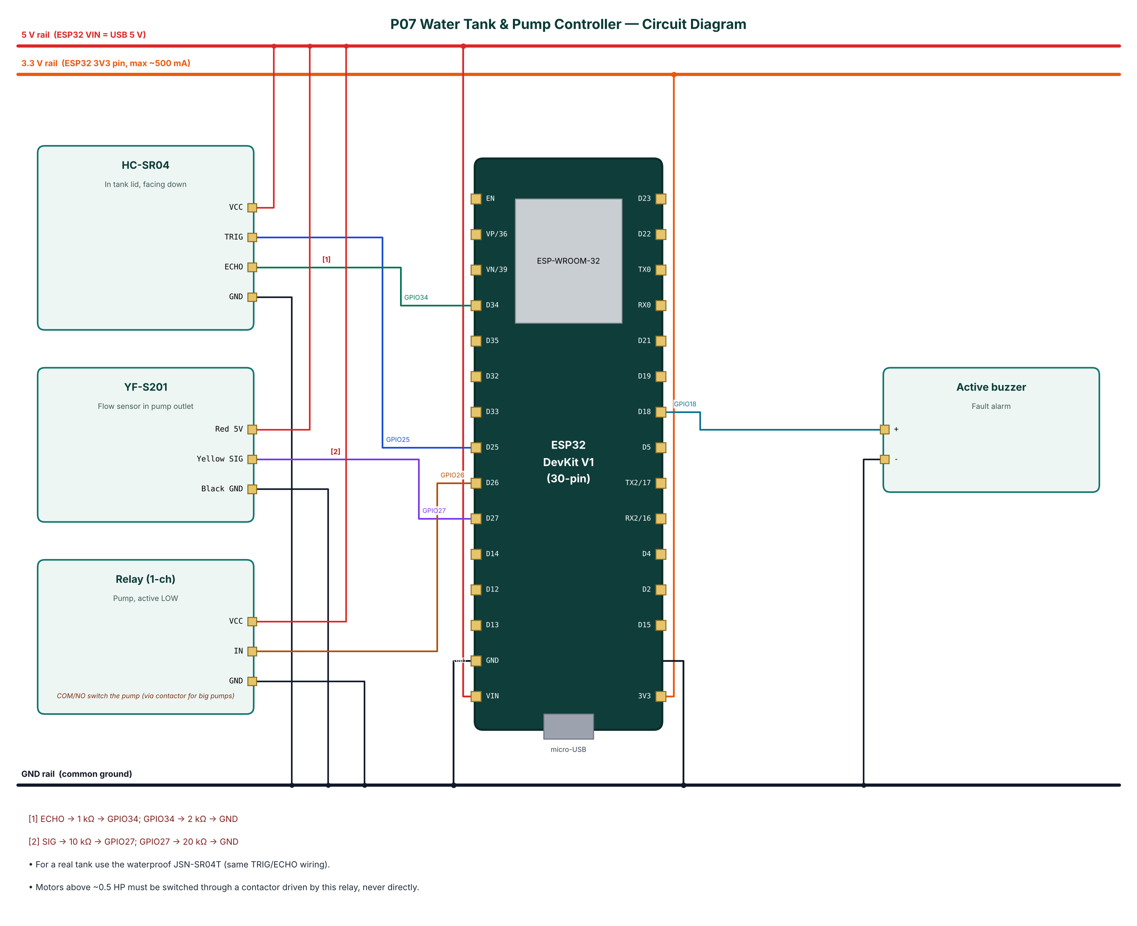
Figure 2: Circuit diagram of the Water Tank & Pump Controller

4.2 Pin Connections
Module | Module pin | ESP32 connection | Notes
HC-SR04 | VCC | 5V rail (VIN)
HC-SR04 | TRIG | GPIO25
HC-SR04 | ECHO | GPIO34 | ECHO -> 1 kΩ -> GPIO34; GPIO34 -> 2 kΩ -> GND
HC-SR04 | GND | GND
YF-S201 | Red 5V | 5V rail (VIN)
YF-S201 | Yellow SIG | GPIO27 | SIG -> 10 kΩ -> GPIO27; GPIO27 -> 20 kΩ -> GND
YF-S201 | Black GND | GND
Relay (1-ch) | VCC | 5V rail (VIN)
Relay (1-ch) | IN | GPIO26
Relay (1-ch) | GND | GND
Active buzzer | + | GPIO18
Active buzzer | - | GND
Table 3: Pin connection table

4.3 Interfacing and Power Notes
- For a real tank use the waterproof JSN-SR04T (same TRIG/ECHO wiring).
- Motors above ~0.5 HP must be switched through a contactor driven by this relay, never directly.
- Only ADC1 pins (GPIO32-39) are used for analog inputs, because ADC2 cannot be read while Wi-Fi is active.
- Strapping pins GPIO0, 2, 12 and 15 are avoided for inputs so the board always boots normally.
- All grounds are common. 5 V signals are reduced to 3.3 V with resistor dividers before reaching the ESP32.

5. Data Flow Diagrams
Data flow diagrams (DFDs) show how data moves through the system without showing control logic or timing. External entities are drawn as rectangles, processes as numbered circles, data stores as open boxes and data flows as labelled arrows.

5.1 DFD Level 0 (Context Diagram)
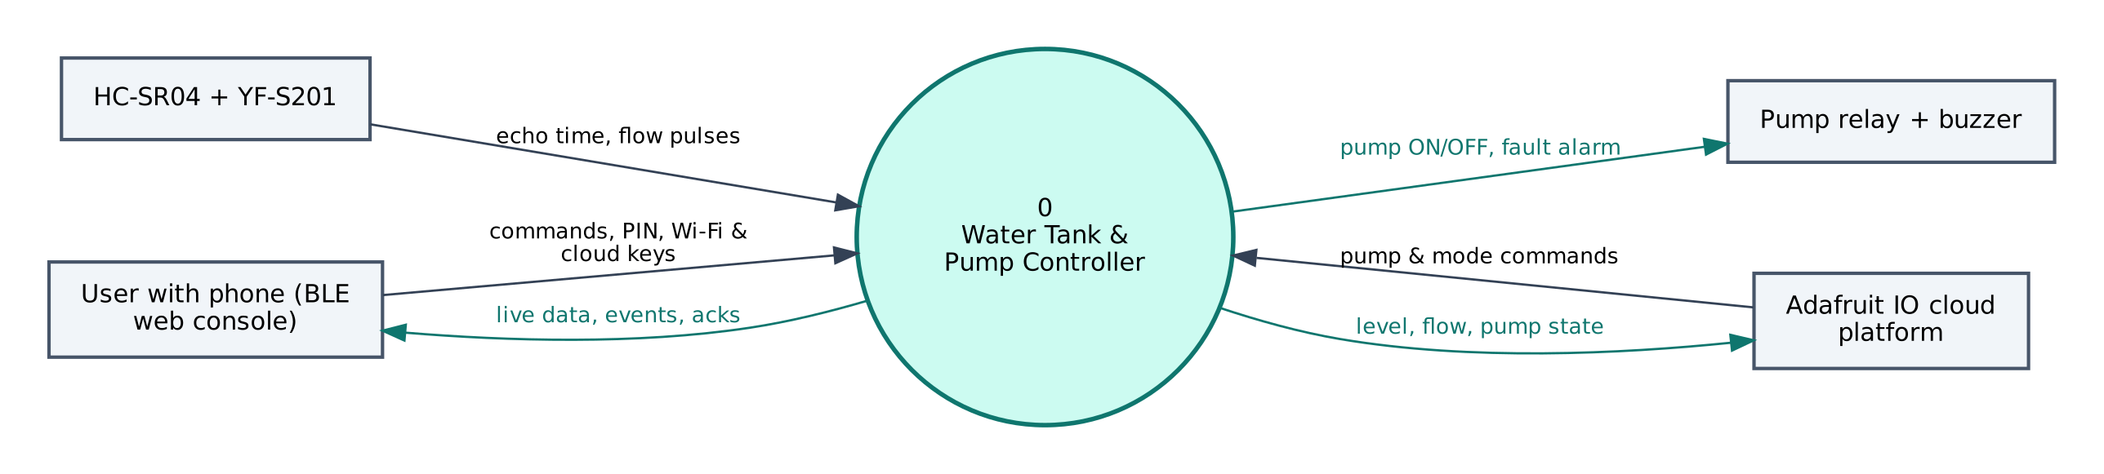
Figure 3: DFD Level 0 — context diagram
At level 0 the whole Water Tank & Pump Controller is a single process. It receives echo time, flow pulses from the HC-SR04 + YF-S201, commands and configuration from the user's phone, and commands from Adafruit IO. It sends pump ON/OFF, fault alarm to the Pump relay + buzzer, live data to the phone and level, flow, pump state to Adafruit IO.

5.2 DFD Level 1
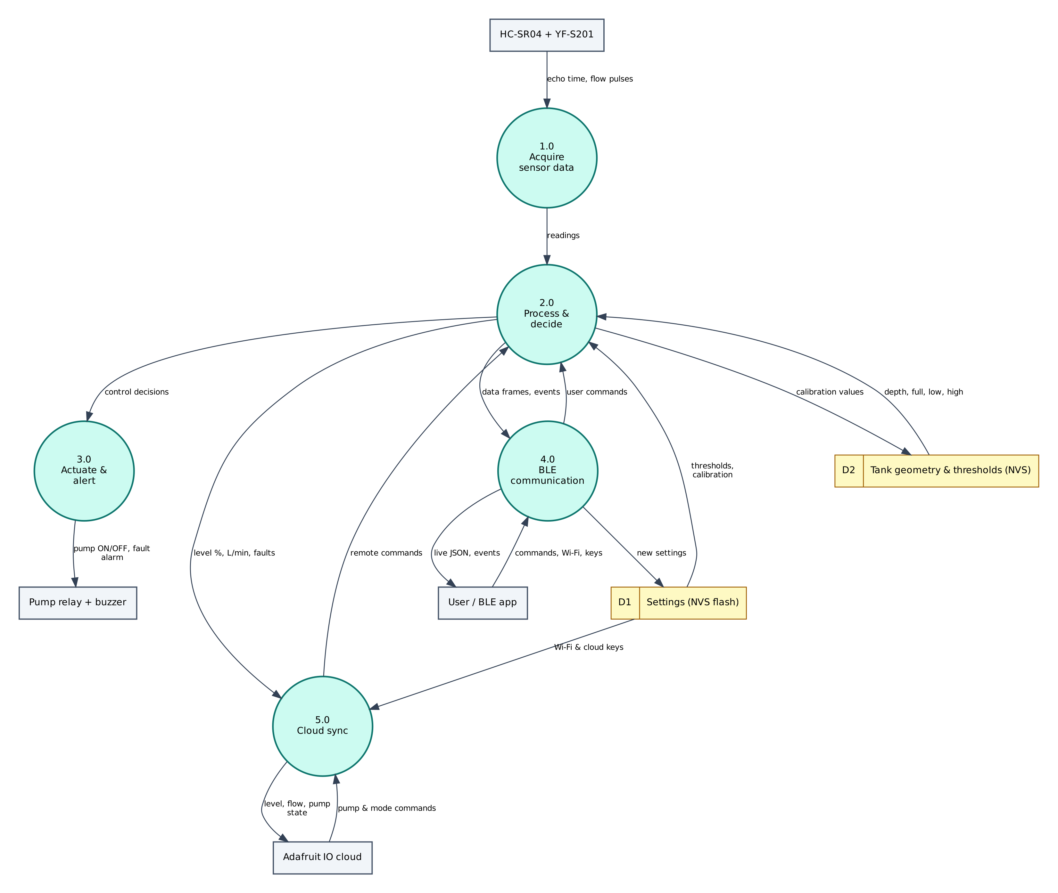
Figure 4: DFD Level 1 — main processes and data stores
Process / store | Description
1.0 Acquire sensor data | Reads echo time, flow pulses from the HC-SR04 + YF-S201; filters/averages the raw values.
2.0 Process & decide | Computes level %, L/min, faults; applies thresholds and rules; generates events.
3.0 Actuate & alert | Drives the Pump relay + buzzer (pump ON/OFF, fault alarm).
4.0 BLE communication | Sends JSON frames and events to the phone; receives and authenticates commands.
5.0 Cloud sync | Sends level, flow, pump state to Adafruit IO; receives pump & mode commands.
D1 Settings (NVS) | Wi-Fi credentials, cloud keys, PIN, thresholds — survive reboots.
D2 Tank geometry & thresholds (NVS) | Stores calibration values; returns depth, full, low, high.
Table 4: Description of level-1 processes and data stores

5.3 Data Dictionary
Field | Meaning | Unit
lvl | Tank level | %
cm | Measured distance | cm
flow | Flow rate | L/min
lit | Litres pumped | L
pump | Pump ON | bool
mode | AUTO / MANUAL | —
fault | Active fault text | —
cloud | MQTT connected | bool
Table 5: BLE data frame fields
Cloud object | Content / usage
p07-level | Gauge 0-100 %
p07-flow | Line chart, L/min
p07-pump | Toggle block ON/OFF (remote pump switch)
p07-mode | Toggle block AUTO/MANUAL
Table 6: Adafruit IO data objects

6. Software Design and Implementation

6.1 Development Environment
Item | Details
IDE / build | Arduino IDE 2.x or arduino-cli; GitHub Actions builds firmware in the cloud
Board package | esp32 by Espressif Systems 3.x (tested with 3.3.12)
Board settings | ESP32 Dev Module, Partition Scheme: Minimal SPIFFS (1.9MB APP with OTA/190KB SPIFFS)
Common libraries | NimBLE-Arduino 2.x, ArduinoJson 7.x, PubSubClient 2.8
Project libraries | none beyond the common ones
Phone app | Web Bluetooth console (Chrome on Android / desktop, Bluefy on iPhone); nRF Connect as alternative
Cloud | Adafruit IO (free tier)
Table 7: Software tools
The default 1.2 MB app partition is too small for BLE + Wi-Fi + TLS. Select Minimal SPIFFS (1.9MB APP) in Tools → Partition Scheme, otherwise the upload fails with 'Sketch too big'.

6.2 Firmware Architecture
The firmware is split into three layers so that the ten projects share tested code:
- IoTCore.h (shared) — Wi-Fi station with auto-reconnect, NimBLE GATT server with the Nordic UART Service, line-based command parser shared by BLE and USB serial, PIN authentication, settings in NVS (Preferences), NTP time in IST, JSON helpers.
- Cloud.h (shared) — ThingSpeak HTTPS client, Adafruit IO MQTT/TLS client with a 28 messages/minute rate limiter, Supabase PostgREST client (insert, update, select).
- P07_Water_Tank_Pump_Controller.ino — sensor drivers, algorithms, automation rules and the project's own commands.

The main loop is non-blocking: every task is scheduled with millis() timers, BLE writes are queued from the BLE callback into a FreeRTOS queue and executed in loop(), so the BLE stack never waits for slow operations such as HTTPS requests.

6.3 Working of the System
Every second the firmware takes five ultrasonic readings 15 ms apart and uses the median, converts it to a level percentage using the stored tank geometry, and computes flow rate from the pulses counted in the last second. Total litres pumped are accumulated.
AUTO mode switches the pump ON when level < 'low' (25 %) and OFF when level ≥ 'high' (90 %). While the pump is ON, flow must exceed 0.5 L/min within 30 s, otherwise a 'Dry run' fault is raised. Level ≥ 98 % raises an 'Overflow risk' fault and run time > 'maxrun' minutes raises 'Max run time reached'. A fault turns the pump off, sounds the buzzer and blocks restarts until 'clear' is sent.
Level and flow are published every 15 s; the pump feed is updated on every change. The device subscribes to p07-pump and p07-mode but does not request their last value after reconnecting, so a stale ON can never start the pump unexpectedly.

6.4 Flowchart
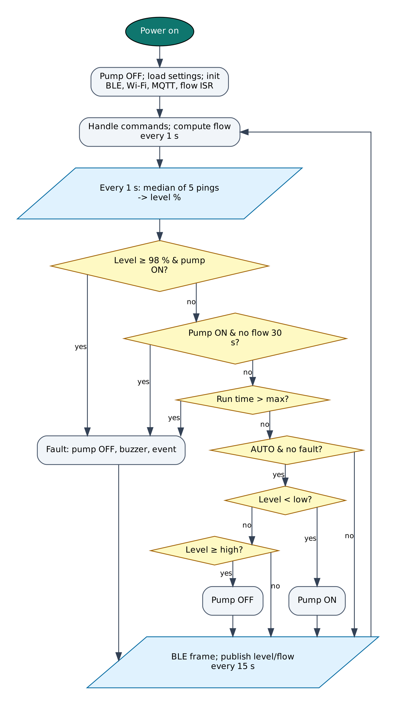
Figure 5: Firmware flowchart

6.5 BLE Communication Protocol
The device is a BLE peripheral named IOT-P07-XXXX (XXXX = last bytes of the MAC address). It exposes the Nordic UART Service, which most BLE apps understand:
Item | UUID | Properties
Service (NUS) | 6E400001-B5A3-F393-E0A9-E50E24DCCA9E | Primary
RX — phone → ESP32 | 6E400002-B5A3-F393-E0A9-E50E24DCCA9E | Write, Write without response
TX — ESP32 → phone | 6E400003-B5A3-F393-E0A9-E50E24DCCA9E | Notify, Read
Table 8: GATT service and characteristics
Commands are plain text lines (command:argument). Replies are one JSON object per line ending in a newline; long lines are split into MTU-sized notifications and re-joined by the app. Commands that change anything require auth:<PIN> first on each connection (default PIN 1234, change it with set:pin=XXXX).
Command | PIN needed | Action
auth:<PIN> | — | Unlock for this connection
status | No | Status JSON: Wi-Fi, IP, RSSI, heap, uptime, time
wifi:<SSID>,<password> | Yes | Save Wi-Fi credentials and connect
set:<key>=<value> | Yes | Save a setting (cloud keys, thresholds)
get:<key> | Yes | Read a setting (secrets masked)
reboot / forget | Yes | Restart / erase all settings
pump:on / pump:off | Yes | Manual pump control
mode:auto / mode:manual | Yes | Select mode
clear | Yes | Clear fault and silence buzzer
resetvol | Yes | Reset litres counter
Table 9: BLE commands (common commands first, then project commands)
Example data frame sent by the device:
{"lvl":64,"cm":45.2,"flow":3.12,"lit":12.4,"pump":true,"mode":"AUTO","fault":"","cloud":true,"type":"data"}

6.6 Cloud Integration (Adafruit IO)
The device keeps a persistent MQTT connection to io.adafruit.com on port 8883 (TLS) using the account username and key. Values are published to username/feeds/<feed-key>, and control feeds are subscribed so dashboard changes arrive within about a second. A built-in limiter keeps the device below Adafruit IO's free limit of 30 data points per minute.
Object | Content
p07-level | Gauge 0-100 %
p07-flow | Line chart, L/min
p07-pump | Toggle block ON/OFF (remote pump switch)
p07-mode | Toggle block AUTO/MANUAL
Table 10: Adafruit IO configuration

6.7 Configurable Settings
Key | Default | Meaning
aiouser / aiokey | — | Adafruit IO credentials
depth | 100 | Sensor to tank bottom (cm)
fullcm | 15 | Sensor to full line (cm)
low / high | 25 / 90 | AUTO thresholds (%)
maxrun | 30 | Maximum continuous run (min)
ssid / pass | — | Wi-Fi network (set with the wifi: command)
pin | 1234 | BLE PIN
Table 11: Settings stored in flash (change with set:key=value)

7. Setup and Deployment Guide

7.1 Hardware Assembly
- Place the ESP32 DevKit across the centre gap of the breadboard so both pin rows are free.
- Connect the ESP32 3V3 pin to one breadboard power rail (3.3 V), VIN to the other rail (5 V) and both GND pins to the ground rails.
- Wire each module exactly as in the pin connection table (section 4.2), including the resistor dividers marked with [n] in the circuit diagram.
- Check every connection against the circuit diagram before powering on. Make sure no 5 V signal reaches an ESP32 pin directly.
- Connect the USB cable to a computer (for flashing) or a 5 V adapter (for normal use).

7.2 Flashing the Firmware

Option A — Arduino IDE
- Install Arduino IDE 2.x from arduino.cc.
- File → Preferences → Additional boards manager URLs: https://espressif.github.io/arduino-esp32/package_esp32_index.json.
- Tools → Board → Boards Manager: install esp32 by Espressif Systems (version 3.x).
- Sketch → Include Library → Manage Libraries: install NimBLE-Arduino (2.x), ArduinoJson (7.x), PubSubClient.
- Download the repository and open the folder P07_Water_Tank_Pump_Controller (it already contains IoTCore.h, Cloud.h and config.h).
- Tools: Board ESP32 Dev Module, Partition Scheme Minimal SPIFFS (1.9MB APP with OTA/190KB SPIFFS), Upload Speed 921600, and the correct COM port.
- Click Upload. If it stays at 'Connecting…', hold the BOOT button on the ESP32 until upload starts.
- Open Serial Monitor at 115200 baud and type status to check the device.

Option B — no software installation (GitHub Actions + browser flasher)
- Open the repository https://github.com/rohitkukreja705/esp32-iot-projects → Actions → latest Build firmware run.
- Download the artifact firmware-P07_Water_Tank_Pump_Controller and unzip it to get P07_Water_Tank_Pump_Controller.ino.merged.bin.
- Open https://espressif.github.io/esptool-js/ in Chrome or Edge on a computer, click Connect and select the ESP32's serial port.
- Set Flash Address 0x0, choose the merged .bin file and click Program. Press the EN (reset) button when done.

7.3 Cloud Setup (Adafruit IO)
- Go to io.adafruit.com and create a free account.
- Click the yellow key icon (My Key / Adafruit IO Key) and copy your Username and Active Key.
- In the BLE web console open Setup, unlock and save them in aiouser and aiokey (commands: set:aiouser=NAME, set:aiokey=aio_xxxx).
- Power the device: feeds are created automatically on the first publish. You can also create them first in Feeds → New Feed using the exact keys in the table below.
- Open Dashboards → New Dashboard, then + (Create New Block). Use Toggle blocks for switch feeds with button-on text ON and button-off text OFF (or AUTO/MANUAL for mode feeds), Gauge blocks for levels and Line Chart blocks for history.
- Free tier: 30 data points per minute, 10 feeds, 5 dashboards and 30 days of history per account. Projects on the same account share these limits, so delete feeds of projects you are not running or use separate accounts.

Field / feed / table | Content
p07-level | Gauge 0-100 %
p07-flow | Line chart, L/min
p07-pump | Toggle block ON/OFF (remote pump switch)
p07-mode | Toggle block AUTO/MANUAL
Table 12: Items to create in Adafruit IO

7.4 BLE App Setup (Web Bluetooth Console)
No app installation is needed. The console is a web page hosted free on GitHub Pages; Chrome talks to the ESP32 directly through the Web Bluetooth API.
- On an Android phone turn on Bluetooth and Location (Android requires location for BLE scanning).
- Open https://rohitkukreja705.github.io/esp32-iot-projects/?p=P07 in Chrome. (On iPhone use the free Bluefy browser; on a laptop use Chrome or Edge.)
- Tap Connect and choose IOT-P07-XXXX in the pop-up list. The dot turns green and the Live tab starts updating.
- Open Setup, enter the PIN (default 1234) and tap Unlock.
- Enter your 2.4 GHz Wi-Fi name and password and tap Save Wi-Fi. After a few seconds the status line shows the IP address.
- Enter the Adafruit IO keys from section 7.3 and tap Save next to each.
- Use the Control tab for commands and the Log tab to see every event and acknowledgement.

Alternative: nRF Connect app
- Install nRF Connect for Mobile (Nordic Semiconductor, free) and scan.
- Connect to IOT-P07-XXXX and open Nordic UART Service.
- Enable notifications on the TX characteristic (6E400003…).
- Write UTF-8 text to the RX characteristic (6E400002…), e.g. auth:1234, then status.

To host the console yourself: in the GitHub repository open Settings → Pages, choose 'Deploy from a branch', branch main, folder /docs. Web Bluetooth only works on HTTPS pages, which GitHub Pages provides.

7.5 First-Run Checklist
- Serial Monitor shows '[BLE] advertising as IOT-P07-XXXX'.
- Status in the console shows wifi: true and an IP address.
- Data appears in Adafruit IO within a minute.
- All sensor values in the Live tab are plausible (no '—').

8. Testing and Results
The following test cases verify each function. Record the observed result and mark Pass/Fail while testing your build.
# | Test | Procedure | Expected result | Observed
T1 | Level calibration | Set depth to bucket depth, fullcm to sensor-to-brim minus 2 cm | Empty ≈ 0 %, full ≈ 100 %
T2 | Auto fill | Lower the water below 25 % | Pump starts; stops at 90 %
T3 | Dry run | Lift the pump out of the water while it runs | Pump stops after ~30 s; 'Dry run' fault + buzzer
T4 | Fault latch | Try pump:on while a fault is active | 'pump_blocked' event; pump stays OFF until 'clear'
T5 | Remote control | Switch p07-mode to MANUAL and toggle p07-pump | Pump follows dashboard
T6 | Reboot safety | Leave p07-pump ON in the cloud, reboot the ESP32 | Pump stays OFF after boot
T7 | Flow accuracy | Pump into a 1 L measuring jug | Litres counter ≈ 1.0 L (±10 %)
Table 13: Test cases

8.1 Expected Output
A typical data frame received in the console's Log tab looks like this (values will differ):
{"lvl":64,"cm":45.2,"flow":3.12,"lit":12.4,"pump":true,"mode":"AUTO","fault":"","cloud":true,"type":"data"}

Serial Monitor (115200 baud) prints the same lines along with connection messages such as [WiFi] connected, [BLE] connected and the HTTP or MQTT result of each cloud upload, which helps in troubleshooting.

8.2 Troubleshooting
Symptom | Likely cause and fix
Device not in the Connect list | Bluetooth/Location off on the phone, or the page is not opened in Chrome over HTTPS.
'Sketch too big' on upload | Select Partition Scheme 'Minimal SPIFFS (1.9MB APP with OTA)'.
Wi-Fi never connects | ESP32 supports only 2.4 GHz networks; check the SSID/password (case-sensitive).
Settings refused | Send auth:<PIN> first; the unlock is per BLE connection.
Sensor shows null / — | Check wiring and supply voltage; see the Serial Monitor for 'not found' messages.
Board resets randomly | Weak USB supply or servo/relay current; use a 5 V 2 A adapter and add a 470 µF capacitor.
No data in Adafruit IO | Wrong username/key, rate limit exceeded or 10-feed limit reached.
Table 14: Troubleshooting guide

9. Discussion

9.1 Advantages
- Prevents overflow and protects the pump from dry running.
- Non-contact level measurement — no corroding probes in the water.
- Remote visibility of tank level and water usage.
- Safe defaults: fault latch and no auto-start from stale cloud data.

9.2 Limitations
- HC-SR04 is not waterproof; condensation inside a tank shortens its life (use JSN-SR04T).
- YF-S201 accuracy is about ±10 % and needs a minimum flow of ~1 L/min.
- Large pumps need a contactor and motor-protection relay.
- Adafruit IO free tier keeps 30 days of history.

9.3 Safety Precautions
- The pump is a mains appliance: use a contactor, fuse and proper enclosure; follow electrical codes.
- Seal the electronics against humidity; mount the controller outside the tank.

9.4 Security Considerations
- Secrets (Wi-Fi password, cloud keys) are stored in the ESP32's NVS flash, not in source code.
- BLE commands that change the device require a PIN; change the default PIN after setup.
- Cloud traffic is TLS-encrypted. Certificate verification is disabled (setInsecure) for simplicity; for production, pin the server's root certificate with setCACert().
- Use a dedicated cloud account/project for the device and rotate keys if the device is lost.

9.5 Future Scope
- Add a sump-tank level sensor so the pump never starts when the sump is empty.
- Daily water-usage report and leak detection (flow with pump off).
- Solar-powered remote tank node using ESP-NOW or LoRa.
- Voltage monitoring to protect the motor from low-voltage starts.

10. Conclusion
The controller automates tank filling while protecting both the tank and the pump, using a flow sensor to detect dry running that level-only controllers miss. Remote monitoring through Adafruit IO and local control over BLE make it convenient, and conservative defaults make it safe to leave unattended.
All design goals listed in Chapter 1 are met with low-cost parts available in the Indian market, free cloud services and open-source software. The shared firmware core and the single Web Bluetooth console make the project easy to reproduce and extend.

References
- Seeed/YF-S201 Water Flow Sensor datasheet (F = 7.5·Q).
- ElecFreaks, HC-SR04 user guide; JSN-SR04T waterproof module datasheet.
- Adafruit IO MQTT API documentation.
- Bureau of Indian Standards, IS 732: Code of practice for electrical wiring installations (safety reference).
- Espressif Systems, ESP32 Series Datasheet and ESP32 Technical Reference Manual, espressif.com.
- Espressif Systems, Arduino-ESP32 documentation, docs.espressif.com/projects/arduino-esp32.
- H2zero, NimBLE-Arduino library documentation, github.com/h2zero/NimBLE-Arduino.
- Bluetooth SIG, Bluetooth Core Specification 4.2 — Generic Attribute Profile (GATT).
- W3C Web Bluetooth Community Group, Web Bluetooth specification, webbluetoothcg.github.io/web-bluetooth.
- B. Blanchon, ArduinoJson 7 documentation, arduinojson.org.
- Adafruit Industries, Adafruit IO documentation and MQTT API, io.adafruit.com/api/docs.

Appendix A: Project Source Code
The complete code is in the repository folder P07_Water_Tank_Pump_Controller (https://github.com/rohitkukreja705/esp32-iot-projects).
config.h
#pragma once
// ===== P07 Water Tank Level & Pump Controller — configuration =====
#define WIFI_SSID ""
#define WIFI_PASS ""
#define DEVICE_PIN "1234"
#define AIO_USERNAME ""
#define AIO_KEY ""

// ----- pins -----
#define PIN_TRIG 25 // HC-SR04 TRIG (sensor mounted in the tank lid, facing down)
#define PIN_ECHO 34 // ECHO via 1k/2k divider
#define PIN_FLOW 27 // YF-S201 signal via 10k/20k divider
#define PIN_RELAY 26 // pump relay IN
#define RELAY_ACTIVE_LOW true
#define PIN_BUZZER 18

// ----- tank geometry defaults (set:depth=, set:fullcm=) -----
#define DEF_DEPTH_CM 100 // sensor to tank bottom
#define DEF_FULL_CM 15 // sensor to the "100 %" water line
#define DEF_LOW_PCT 25 // auto: pump ON below
#define DEF_HIGH_PCT 90 // auto: pump OFF at/above
#define DEF_MAXRUN_MIN 30 // safety: max continuous run
#define DRYRUN_S 30 // pump ON but no flow for this long -> stop
#define FLOW_PULSES_PER_LITRE 450.0f // YF-S201: F(Hz) = 7.5 x L/min

#define SAMPLE_MS 1000
#define CLOUD_MS 15000

P07_Water_Tank_Pump_Controller.ino
/*
* P07 — Water Tank Level Monitor & Smart Pump Controller
* ======================================================
* Peripherals: HC-SR04 ultrasonic (level), YF-S201 flow sensor,
* relay (pump), buzzer
* Wi-Fi : Adafruit IO — level %, flow, pump status, AUTO/MANUAL mode,
* remote pump switch from the dashboard
* BLE : live tank gauge, pump/mode control, tank calibration
* Logic : AUTO mode fills between LOW and HIGH thresholds with hysteresis;
* protections: dry-run (no flow), overflow, maximum run time;
* median filter on distance; litres pumped counter
*/
#include "config.h"
#include "IoTCore.h"
#include "Cloud.h"

cloud::AdafruitIO aio;
const char* SUB_FEEDS[] = { "p07-pump", "p07-mode" };

volatile uint32_t flowPulses = 0;
void IRAM_ATTR onFlowPulse() { flowPulses = flowPulses + 1; }

float distCm = NAN, levelPct = NAN, flowLpm = 0, litres = 0;
bool pumpOn = false, autoMode = true, alarmOn = false;
String fault = "";
uint32_t pumpStart = 0, noFlowSince = 0, lastSample = 0, lastCloud = 0, lastFlowCalc = 0;
float depthCm, fullCm, lowPct, highPct, maxRunMin;

void loadSettings() {
depthCm = iot::settingF("depth", DEF_DEPTH_CM);
fullCm = iot::settingF("fullcm", DEF_FULL_CM);
lowPct = iot::settingF("low", DEF_LOW_PCT);
highPct = iot::settingF("high", DEF_HIGH_PCT);
maxRunMin = iot::settingF("maxrun", DEF_MAXRUN_MIN);
}

float pingOnce() {
digitalWrite(PIN_TRIG, LOW); delayMicroseconds(3);
digitalWrite(PIN_TRIG, HIGH); delayMicroseconds(10); digitalWrite(PIN_TRIG, LOW);
unsigned long us = pulseIn(PIN_ECHO, HIGH, 30000);
return us ? us * 0.0343 / 2.0 : NAN;
}

// median of 5 pings rejects splashes and stray echoes
float readDistance() {
float v[5]; int n = 0;
for (int i = 0; i < 5; i++) { float d = pingOnce(); if (!isnan(d)) v[n++] = d; delay(15); }
if (n == 0) return NAN;
for (int i = 0; i < n; i++) for (int j = i + 1; j < n; j++) if (v[j] < v[i]) { float t = v[i]; v[i] = v[j]; v[j] = t; }
return v[n / 2];
}

void setPump(bool on, const String& why) {
if (on == pumpOn) return;
if (on && fault.length()) { iot::sendEvent("pump_blocked", "Clear fault first: " + fault); return; }
pumpOn = on;
digitalWrite(PIN_RELAY, (on ^ RELAY_ACTIVE_LOW) ? HIGH : LOW);
if (on) { pumpStart = millis(); noFlowSince = millis(); }
iot::sendEvent("pump", String(on ? "ON" : "OFF") + " - " + why);
aio.publish("p07-pump", on ? "ON" : "OFF");
}

void raiseFault(const String& f) {
fault = f; alarmOn = true;
setPump(false, f);
iot::sendEvent("fault", f);
}

void control() {
uint32_t now = millis();
// flow rate once per second
if (now - lastFlowCalc >= 1000) {
noInterrupts(); uint32_t p = flowPulses; flowPulses = 0; interrupts();
float secs = (now - lastFlowCalc) / 1000.0;
lastFlowCalc = now;
flowLpm = (p / FLOW_PULSES_PER_LITRE) * 60.0 / secs;
litres += p / FLOW_PULSES_PER_LITRE;
}
if (isnan(levelPct)) return;

if (levelPct >= 98 && pumpOn) raiseFault("Overflow risk");
if (pumpOn) {
if (flowLpm > 0.5) noFlowSince = now;
if (now - noFlowSince > DRYRUN_S * 1000UL) raiseFault("Dry run - no water flow");
if (now - pumpStart > maxRunMin * 60000UL) raiseFault("Max run time reached");
}
if (autoMode && fault.isEmpty()) {
if (!pumpOn && levelPct < lowPct) setPump(true, "level low (auto)");
if (pumpOn && levelPct >= highPct) setPump(false, "tank full (auto)");
}
}

void sendBle() {
JsonDocument d;
d["lvl"] = iot::rnd(levelPct, 0); d["cm"] = iot::rnd(distCm, 1);
d["flow"] = iot::rnd(flowLpm, 2); d["lit"] = iot::rnd(litres, 1);
d["pump"] = pumpOn; d["mode"] = autoMode ? "AUTO" : "MANUAL";
d["fault"] = fault; d["cloud"] = aio.connected();
iot::sendData(d);
}

void onFeed(const String& feed, const String& value) {
if (feed == "p07-pump") setPump(value.equalsIgnoreCase("ON"), "cloud");
if (feed == "p07-mode") { autoMode = value.equalsIgnoreCase("AUTO"); iot::saveSetting("auto", autoMode ? "1" : "0"); }
}

// Commands: pump:on|off mode:auto|manual clear resetvol
bool onCommand(const String& cmd, const String& arg, bool authed) {
if (cmd == "setting") { loadSettings(); return true; }
if (cmd == "pump" || cmd == "mode" || cmd == "clear" || cmd == "resetvol") {
if (!authed) { iot::emitAck(cmd, false, "send auth:<PIN> first"); return true; }
if (cmd == "pump") setPump(arg == "on", "BLE");
if (cmd == "mode") {
autoMode = arg == "auto"; iot::saveSetting("auto", autoMode ? "1" : "0");
aio.publish("p07-mode", autoMode ? "AUTO" : "MANUAL");
}
if (cmd == "clear") { fault = ""; alarmOn = false; digitalWrite(PIN_BUZZER, LOW); }
if (cmd == "resetvol") litres = 0;
iot::emitAck(cmd, true); sendBle();
return true;
}
return false;
}

void setup() {
pinMode(PIN_TRIG, OUTPUT); pinMode(PIN_ECHO, INPUT);
pinMode(PIN_RELAY, OUTPUT); pinMode(PIN_BUZZER, OUTPUT);
pinMode(PIN_FLOW, INPUT);
digitalWrite(PIN_RELAY, RELAY_ACTIVE_LOW ? HIGH : LOW); // pump off at boot
attachInterrupt(digitalPinToInterrupt(PIN_FLOW), onFlowPulse, FALLING);
iot::begin("P07", onCommand);
loadSettings();
autoMode = iot::setting("auto", "1") == "1";
// false: never switch the pump on from a stale cloud value after a reboot
aio.begin(onFeed, SUB_FEEDS, 2, false);
lastFlowCalc = millis();
}

void loop() {
iot::loop();
aio.loop();
control();
uint32_t now = millis();
if (alarmOn) digitalWrite(PIN_BUZZER, (now / 300) % 2);
if (now - lastSample >= SAMPLE_MS) {
lastSample = now;
distCm = readDistance();
if (!isnan(distCm))
levelPct = constrain((depthCm - distCm) / (depthCm - fullCm) * 100.0, 0, 100);
sendBle();
}
if (aio.connected() && now - lastCloud >= CLOUD_MS && !isnan(levelPct)) {
lastCloud = now;
aio.publish("p07-level", levelPct, 0);
aio.publish("p07-flow", flowLpm, 2);
}
}

Appendix B: Shared Library Code
These two headers are identical in every project folder (master copies in /common).
IoTCore.h
/*
* IoTCore.h — shared runtime for all ESP32 IoT projects in this repo
* -------------------------------------------------------------------
* - Wi-Fi station with automatic reconnect (credentials stored in flash)
* - BLE server using the Nordic UART Service (NUS) layout, so the device
* works with the Web Bluetooth dashboard in /docs AND with generic apps
* such as "nRF Connect" or "Serial Bluetooth Terminal"
* - Line-based command protocol shared by BLE and USB Serial
* - Persistent settings (Preferences / NVS): Wi-Fi, cloud keys, PIN, thresholds
* - NTP time sync (IST) for timestamps
*
* Wire protocol
* -------------
* Phone -> ESP32 (write to RX characteristic, text):
* auth:1234 unlock control + settings for this connection
* status device replies with a status JSON line
* set:key=value store a setting (Wi-Fi, cloud key, threshold…)
* get:key read back a setting (secrets are masked)
* wifi:SSID,PASSWORD shortcut for set:ssid + set:pass + reconnect
* reboot restart the board
* <anything else> forwarded to the project's own command handler
* ESP32 -> Phone (notify on TX characteristic):
* one JSON object per line, terminated by '\n'
* {"type":"data",...} {"type":"status",...} {"type":"ack",...}
* {"type":"event",...} {"type":"err",...}
* Lines longer than one BLE packet are split into chunks; the receiver
* joins chunks until it sees '\n'.
*
* Library: NimBLE-Arduino 2.x (lighter than Bluedroid, leaves more RAM for TLS)
* Board: ESP32 Dev Module, Partition Scheme "Minimal SPIFFS (1.9MB APP with OTA)"
*/
#pragma once

#include <Arduino.h>
#include <WiFi.h>
#include <Preferences.h>
#include <NimBLEDevice.h>
#include <ArduinoJson.h>
#include <time.h>

#ifndef DEVICE_PIN
#define DEVICE_PIN "1234"
#endif
#ifndef WIFI_SSID
#define WIFI_SSID ""
#endif
#ifndef WIFI_PASS
#define WIFI_PASS ""
#endif

namespace iot {

// Nordic UART Service UUIDs (widely supported by BLE terminal apps)
static const char* NUS_SERVICE = "6E400001-B5A3-F393-E0A9-E50E24DCCA9E";
static const char* NUS_RX = "6E400002-B5A3-F393-E0A9-E50E24DCCA9E"; // phone writes here
static const char* NUS_TX = "6E400003-B5A3-F393-E0A9-E50E24DCCA9E"; // ESP32 notifies here

// Project command handler: return true if the command was recognised.
using CommandHandler = bool (*)(const String& cmd, const String& arg, bool authed);

// ------------------------------------------------------------------ state
struct CmdMsg { char text[256]; bool fromBle; };

static Preferences prefs;
static NimBLEServer* bleServer = nullptr;
static NimBLECharacteristic* txChr = nullptr;
static QueueHandle_t cmdQueue = nullptr;
static CommandHandler userHandler = nullptr;
static String deviceName;
static String projectId;
static volatile uint16_t bleMtu = 23;
static volatile bool bleAuthed = false; // reset on every new connection
static bool serialAuthed = true; // USB = physical access, trusted
static bool timeSynced = false;
static uint32_t lastWifiTry = 0;
static String rxLine; // assembles multi-packet writes

// --------------------------------------------------------------- settings
inline String setting(const char* key, const char* def = "") {
return prefs.isKey(key) ? prefs.getString(key, def) : String(def);
}
inline void saveSetting(const char* key, const String& v) { prefs.putString(key, v); }
inline float settingF(const char* key, float def) {
String s = setting(key, "");
return s.length() ? s.toFloat() : def;
}

// ------------------------------------------------------------------- BLE
inline bool bleConnected() { return bleServer && bleServer->getConnectedCount() > 0; }

// Send one line (adds '\n'), split to fit the negotiated MTU.
inline void bleSend(const String& line) {
if (!bleConnected() || !txChr) return;
String msg = line + "\n";
size_t chunk = (bleMtu > 23 ? bleMtu : 23) - 3;
for (size_t i = 0; i < msg.length(); i += chunk) {
size_t n = min(chunk, msg.length() - i);
txChr->setValue((const uint8_t*)msg.c_str() + i, n);
txChr->notify();
if (msg.length() > chunk) delay(8); // give the stack time between chunks
}
}

// Send to BLE and mirror to USB Serial.
inline void emit(const String& line) {
Serial.println(line);
bleSend(line);
}

inline void emitAck(const String& cmd, bool ok, const String& msg = "") {
JsonDocument d;
d["type"] = ok ? "ack" : "err";
d["cmd"] = cmd;
if (msg.length()) d["msg"] = msg;
String s; serializeJson(d, s); emit(s);
}

inline void enqueue(const String& s, bool fromBle) {
if (!cmdQueue || s.length() == 0) return;
CmdMsg m; memset(&m, 0, sizeof(m));
strncpy(m.text, s.c_str(), sizeof(m.text) - 1);
m.fromBle = fromBle;
xQueueSend(cmdQueue, &m, 0);
}

class ServerCB : public NimBLEServerCallbacks {
void onConnect(NimBLEServer* s, NimBLEConnInfo& info) override {
bleAuthed = false;
rxLine = "";
Serial.printf("[BLE] connected %s\n", info.getAddress().toString().c_str());
}
void onDisconnect(NimBLEServer* s, NimBLEConnInfo& info, int reason) override {
bleAuthed = false;
bleMtu = 23;
Serial.printf("[BLE] disconnected (reason %d), advertising again\n", reason);
// NimBLE restarts advertising automatically (advertiseOnDisconnect = true)
}
void onMTUChange(uint16_t mtu, NimBLEConnInfo& info) override {
bleMtu = mtu;
Serial.printf("[BLE] MTU %u\n", mtu);
}
};

class RxCB : public NimBLECharacteristicCallbacks {
void onWrite(NimBLECharacteristic* c, NimBLEConnInfo& info) override {
std::string v = c->getValue();
// Accept either a single write without newline, or several writes
// that together form lines terminated by '\n'.
for (char ch : v) {
if (ch == '\r') continue;
if (ch == '\n') { enqueue(rxLine, true); rxLine = ""; }
else if (rxLine.length() < 250) rxLine += ch;
}
if (v.find('\n') == std::string::npos && rxLine.length() && rxLine.length() == v.length()) {
enqueue(rxLine, true); // plain one-shot write (e.g. typed in nRF Connect)
rxLine = "";
}
}
};

inline void bleBegin() {
uint8_t mac[6]; WiFi.macAddress(mac);
char suffix[6]; snprintf(suffix, sizeof(suffix), "%02X%02X", mac[4], mac[5]);
deviceName = "IOT-" + projectId + "-" + suffix;

NimBLEDevice::init(deviceName.c_str());
NimBLEDevice::setMTU(247);
bleServer = NimBLEDevice::createServer();
bleServer->setCallbacks(new ServerCB());

NimBLEService* svc = bleServer->createService(NUS_SERVICE);
txChr = svc->createCharacteristic(NUS_TX, NIMBLE_PROPERTY::NOTIFY | NIMBLE_PROPERTY::READ);
NimBLECharacteristic* rx = svc->createCharacteristic(
NUS_RX, NIMBLE_PROPERTY::WRITE | NIMBLE_PROPERTY::WRITE_NR, 512);
rx->setCallbacks(new RxCB());
// (NimBLE 2.x starts services automatically when advertising begins)

// 128-bit UUID goes in the advertisement, the name in the scan response
// (both together would not fit in one 31-byte packet).
NimBLEAdvertisementData adv, scan;
adv.setFlags(BLE_HS_ADV_F_DISC_GEN | BLE_HS_ADV_F_BREDR_UNSUP);
adv.setCompleteServices(NimBLEUUID(NUS_SERVICE));
scan.setName(deviceName.c_str());
NimBLEAdvertising* a = NimBLEDevice::getAdvertising();
a->setAdvertisementData(adv);
a->setScanResponseData(scan);
a->start();
Serial.printf("[BLE] advertising as %s\n", deviceName.c_str());
}

// ------------------------------------------------------------------ Wi-Fi
inline bool wifiOK() { return WiFi.status() == WL_CONNECTED; }

inline void wifiConnect() {
String ssid = setting("ssid", WIFI_SSID);
String pass = setting("pass", WIFI_PASS);
if (ssid.isEmpty()) {
Serial.println("[WiFi] no SSID yet - send wifi:SSID,PASSWORD over BLE");
return;
}
Serial.printf("[WiFi] connecting to %s\n", ssid.c_str());
WiFi.disconnect();
WiFi.begin(ssid.c_str(), pass.c_str());
lastWifiTry = millis();
}

inline void wifiLoop() {
static bool wasUp = false;
bool up = wifiOK();
if (up && !wasUp) {
Serial.printf("[WiFi] connected, IP %s, RSSI %d\n",
WiFi.localIP().toString().c_str(), WiFi.RSSI());
configTzTime("IST-5:30", "pool.ntp.org", "time.google.com");
}
if (!up && millis() - lastWifiTry > 20000) wifiConnect(); // retry every 20 s
wasUp = up;
if (up && !timeSynced && time(nullptr) > 1700000000) {
timeSynced = true;
Serial.println("[NTP] time synced");
}
}

// ISO-8601 local time, or uptime if NTP has not synced yet.
inline String timestamp() {
time_t now = time(nullptr);
if (now < 1700000000) return "uptime+" + String(millis() / 1000) + "s";
struct tm t; localtime_r(&now, &t);
char buf[32]; strftime(buf, sizeof(buf), "%Y-%m-%dT%H:%M:%S+05:30", &t);
return String(buf);
}

// ------------------------------------------------------- built-in commands
inline bool isSecretKey(const String& k) {
return k == "pass" || k.endsWith("key") || k == "pin";
}

inline void sendStatus() {
JsonDocument d;
d["type"] = "status";
d["dev"] = deviceName;
d["wifi"] = wifiOK();
d["ssid"] = setting("ssid", WIFI_SSID);
d["rssi"] = wifiOK() ? WiFi.RSSI() : 0;
d["ip"] = wifiOK() ? WiFi.localIP().toString() : "";
d["auth"] = bleAuthed;
d["heap"] = ESP.getFreeHeap();
d["up"] = millis() / 1000;
d["time"] = timestamp();
String s; serializeJson(d, s); emit(s);
}

inline void handleLine(const String& raw, bool fromBle) {
String line = raw; line.trim();
if (line.isEmpty()) return;
int c = line.indexOf(':');
String cmd = (c < 0 ? line : line.substring(0, c));
String arg = (c < 0 ? "" : line.substring(c + 1));
cmd.trim(); cmd.toLowerCase();
bool authed = fromBle ? bleAuthed : serialAuthed;

if (cmd == "auth") {
bool ok = arg == setting("pin", DEVICE_PIN);
if (fromBle) bleAuthed = ok;
emitAck(cmd, ok, ok ? "unlocked" : "wrong PIN");
return;
}
if (cmd == "status") { sendStatus(); return; }
if (cmd == "ping") { emitAck(cmd, true, "pong"); return; }

// Everything below changes the device, so it needs the PIN over BLE.
if (cmd == "set" || cmd == "wifi" || cmd == "reboot" || cmd == "get" || cmd == "forget") {
if (!authed) { emitAck(cmd, false, "send auth:<PIN> first"); return; }
if (cmd == "set") {
int e = arg.indexOf('=');
if (e <= 0) { emitAck(cmd, false, "use set:key=value"); return; }
String k = arg.substring(0, e); k.trim();
String v = arg.substring(e + 1); v.trim();
if (k.length() > 15) { emitAck(cmd, false, "key too long"); return; }
saveSetting(k.c_str(), v);
emitAck(cmd, true, k + " saved");
if (k == "ssid" || k == "pass") wifiConnect();
// let the project react to changed thresholds etc.
if (userHandler) userHandler("setting", k, true);
return;
}
if (cmd == "get") {
String v = setting(arg.c_str(), "");
if (isSecretKey(arg) && v.length()) v = "****" + v.substring(max(0, (int)v.length() - 3));
emitAck(cmd, true, arg + "=" + v);
return;
}
if (cmd == "wifi") {
int k = arg.indexOf(',');
String ssid = k < 0 ? arg : arg.substring(0, k);
String pass = k < 0 ? "" : arg.substring(k + 1);
saveSetting("ssid", ssid); saveSetting("pass", pass);
emitAck(cmd, true, "connecting to " + ssid);
wifiConnect();
return;
}
if (cmd == "forget") { prefs.clear(); emitAck(cmd, true, "all settings erased"); return; }
if (cmd == "reboot") { emitAck(cmd, true, "rebooting"); delay(300); ESP.restart(); }
}

if (userHandler && userHandler(cmd, arg, authed)) return;
emitAck(cmd, false, "unknown command");
}

// ------------------------------------------------------------ entry points
// Call once from setup(). id = short project id, e.g. "P01".
inline void begin(const char* id, CommandHandler handler) {
Serial.begin(115200);
delay(200);
projectId = id;
userHandler = handler;
prefs.begin("iot", false);
cmdQueue = xQueueCreate(8, sizeof(CmdMsg));
WiFi.mode(WIFI_STA);
WiFi.setAutoReconnect(true);
// NOTE: Wi-Fi modem sleep must stay ON while BLE is running (ESP32 coexistence).
bleBegin();
wifiConnect();
Serial.println("[CORE] ready - type 'status' here or connect over BLE");
}

// Call every loop() iteration.
inline void loop() {
wifiLoop();
// USB serial commands (handy while developing)
static String serialLine;
while (Serial.available()) {
char ch = Serial.read();
if (ch == '\n' || ch == '\r') { if (serialLine.length()) enqueue(serialLine, false); serialLine = ""; }
else if (serialLine.length() < 250) serialLine += ch;
}
CmdMsg m;
while (cmdQueue && xQueueReceive(cmdQueue, &m, 0) == pdTRUE) handleLine(String(m.text), m.fromBle);
}

// Round for compact JSON. NaN stays NaN, which ArduinoJson writes as null.
inline float rnd(float v, int dp = 1) {
if (isnan(v)) return v;
float m = powf(10, dp);
return roundf(v * m) / m;
}

// Helper: build and send a {"type":"data",...} line from a filled document.
inline void sendData(JsonDocument& d) {
d["type"] = "data";
String s; serializeJson(d, s); emit(s);
}

inline void sendEvent(const String& name, const String& msg) {
JsonDocument d;
d["type"] = "event"; d["name"] = name; d["msg"] = msg; d["time"] = timestamp();
String s; serializeJson(d, s); emit(s);
}

} // namespace iot

Cloud.h
/*
* Cloud.h — free-tier cloud helpers used by the projects
* ---------------------------------------------------------
* ThingSpeak : HTTPS REST "update" (free tier: 1 update / 15 s per channel)
* Adafruit IO : MQTT over TLS (free tier: 30 data points / minute, 10 feeds)
* Supabase : PostgREST over HTTPS (free tier: 500 MB Postgres)
*
* Keys are read from settings (stored over BLE with set:key=value) so no
* secret has to be hard-coded or committed to GitHub:
* tskey ThingSpeak Write API Key
* aiouser Adafruit IO username aiokey Adafruit IO key
* sburl https://<ref>.supabase.co sbkey Supabase publishable/anon key
*
* TLS note: certificate checking is disabled with setInsecure() to keep the
* projects beginner-friendly and independent of CA rotations. Traffic is
* still encrypted. For production, pin the root CA with setCACert().
*/
#pragma once

#include <WiFiClientSecure.h>
#include <HTTPClient.h>
#include <PubSubClient.h>
#include "IoTCore.h"

// Optional compile-time defaults (normally left empty and set over BLE)
#ifndef TS_WRITE_KEY
#define TS_WRITE_KEY ""
#endif
#ifndef AIO_USERNAME
#define AIO_USERNAME ""
#endif
#ifndef AIO_KEY
#define AIO_KEY ""
#endif
#ifndef SUPABASE_URL
#define SUPABASE_URL ""
#endif
#ifndef SUPABASE_KEY
#define SUPABASE_KEY ""
#endif

namespace cloud {

// ============================================================== ThingSpeak
// vals[i] -> field(i+1). Pass NAN to skip a field. Returns true on success.
inline bool thingSpeakUpdate(const float* vals, int n, const String& status = "") {
if (!iot::wifiOK()) return false;
String key = iot::setting("tskey", TS_WRITE_KEY);
if (key.isEmpty()) { Serial.println("[TS] no tskey set"); return false; }
String url = "https://api.thingspeak.com/update?api_key=" + key;
for (int i = 0; i < n && i < 8; i++)
if (!isnan(vals[i])) url += "&field" + String(i + 1) + "=" + String(vals[i], 2);
if (status.length()) {
String st = status; st.replace(" ", "%20");
url += "&status=" + st;
}
WiFiClientSecure client; client.setInsecure();
HTTPClient http; http.setTimeout(8000);
if (!http.begin(client, url)) return false;
int code = http.GET();
String body = http.getString();
http.end();
bool ok = code == 200 && body.toInt() > 0; // ThingSpeak returns the entry id, 0 = rejected
Serial.printf("[TS] HTTP %d entry=%s\n", code, body.c_str());
return ok;
}

// ================================================================ Supabase
// Generic PostgREST call. method: GET/POST/PATCH. path e.g. "/rest/v1/readings"
inline int supabaseRequest(const char* method, const String& path, const String& body,
String* response = nullptr, const char* prefer = "return=minimal") {
if (!iot::wifiOK()) return -1;
String base = iot::setting("sburl", SUPABASE_URL);
String key = iot::setting("sbkey", SUPABASE_KEY);
if (base.isEmpty() || key.isEmpty()) { Serial.println("[SB] sburl/sbkey not set"); return -2; }
if (base.endsWith("/")) base.remove(base.length() - 1);
WiFiClientSecure client; client.setInsecure();
HTTPClient http; http.setTimeout(8000);
if (!http.begin(client, base + path)) return -3;
http.addHeader("apikey", key);
http.addHeader("Authorization", "Bearer " + key);
http.addHeader("Content-Type", "application/json");
if (prefer) http.addHeader("Prefer", prefer);
int code = http.sendRequest(method, body);
if (response) *response = http.getString();
else if (code >= 300) Serial.printf("[SB] %s\n", http.getString().c_str());
http.end();
Serial.printf("[SB] %s %s -> %d\n", method, path.c_str(), code);
return code;
}

inline bool supabaseInsert(const char* table, const String& json) {
int c = supabaseRequest("POST", String("/rest/v1/") + table, json);
return c >= 200 && c < 300;
}

// filter is a PostgREST filter, e.g. "id=eq.1"
inline bool supabaseUpdate(const char* table, const String& filter, const String& json) {
int c = supabaseRequest("PATCH", String("/rest/v1/") + table + "?" + filter, json);
return c >= 200 && c < 300;
}

// query e.g. "select=*&id=eq.1" -> JSON array text in out
inline bool supabaseSelect(const char* table, const String& query, String& out) {
int c = supabaseRequest("GET", String("/rest/v1/") + table + "?" + query, "", &out, nullptr);
return c == 200;
}

// ============================================================ Adafruit IO
// MQTT wrapper with a simple rate limiter to respect the 30 msg/min limit.
using FeedCallback = void (*)(const String& feed, const String& value);

class AdafruitIO {
public:
// requestLast = true asks Adafruit IO for each feed's last value on connect
// (useful for switches changed while offline; unsafe for things like pumps)
void begin(FeedCallback cb, const char* const* subFeeds, int nSub, bool requestLast = true) {
cb_ = cb; subs_ = subFeeds; nSub_ = nSub; requestLast_ = requestLast;
tls_.setInsecure();
mqtt_.setClient(tls_);
mqtt_.setServer("io.adafruit.com", 8883);
mqtt_.setBufferSize(512);
mqtt_.setKeepAlive(60);
mqtt_.setCallback([](char* topic, byte* payload, unsigned int len) {
String t(topic), v;
for (unsigned int i = 0; i < len; i++) v += (char)payload[i];
int p = t.lastIndexOf('/');
String feed = t.substring(p + 1);
if (instance()->cb_) instance()->cb_(feed, v);
});
instance() = this;
}

void loop() {
if (!iot::wifiOK()) return;
if (!mqtt_.connected()) {
if (millis() - lastTry_ < 10000) return;
lastTry_ = millis();
user_ = iot::setting("aiouser", AIO_USERNAME);
String key = iot::setting("aiokey", AIO_KEY);
if (user_.isEmpty() || key.isEmpty()) { Serial.println("[AIO] aiouser/aiokey not set"); return; }
String id = "esp32-" + String((uint32_t)ESP.getEfuseMac(), HEX);
Serial.println("[AIO] connecting...");
if (mqtt_.connect(id.c_str(), user_.c_str(), key.c_str())) {
Serial.println("[AIO] connected");
for (int i = 0; i < nSub_; i++) {
mqtt_.subscribe(topic(subs_[i]).c_str());
if (requestLast_) mqtt_.publish((topic(subs_[i]) + "/get").c_str(), "");
}
// subscribe to throttle/error topics so we learn about rate limits
mqtt_.subscribe((user_ + "/throttle").c_str());
} else {
Serial.printf("[AIO] failed, state %d\n", mqtt_.state());
}
}
mqtt_.loop();
}

bool connected() { return mqtt_.connected(); }

// Returns false if not connected or if the per-minute budget is used up.
bool publish(const char* feed, const String& value) {
if (!mqtt_.connected()) return false;
uint32_t now = millis();
if (now - windowStart_ > 60000) { windowStart_ = now; sent_ = 0; }
if (sent_ >= 28) { Serial.println("[AIO] rate budget used, skipping"); return false; }
sent_++;
return mqtt_.publish(topic(feed).c_str(), value.c_str());
}
bool publish(const char* feed, float v, int dp = 2) { return publish(feed, String(v, dp)); }

private:
String topic(const char* feed) { return user_ + "/feeds/" + feed; }
static AdafruitIO*& instance() { static AdafruitIO* p = nullptr; return p; }

WiFiClientSecure tls_;
PubSubClient mqtt_;
FeedCallback cb_ = nullptr;
const char* const* subs_ = nullptr;
int nSub_ = 0;
bool requestLast_ = true;
String user_;
uint32_t lastTry_ = 0, windowStart_ = 0;
int sent_ = 0;
};

} // namespace cloud

