A PROJECT REPORT ON
Vehicle Tracking and Accident Alert System
IoT project using ESP32 with Bluetooth Low Energy and Wi-Fi (Supabase)
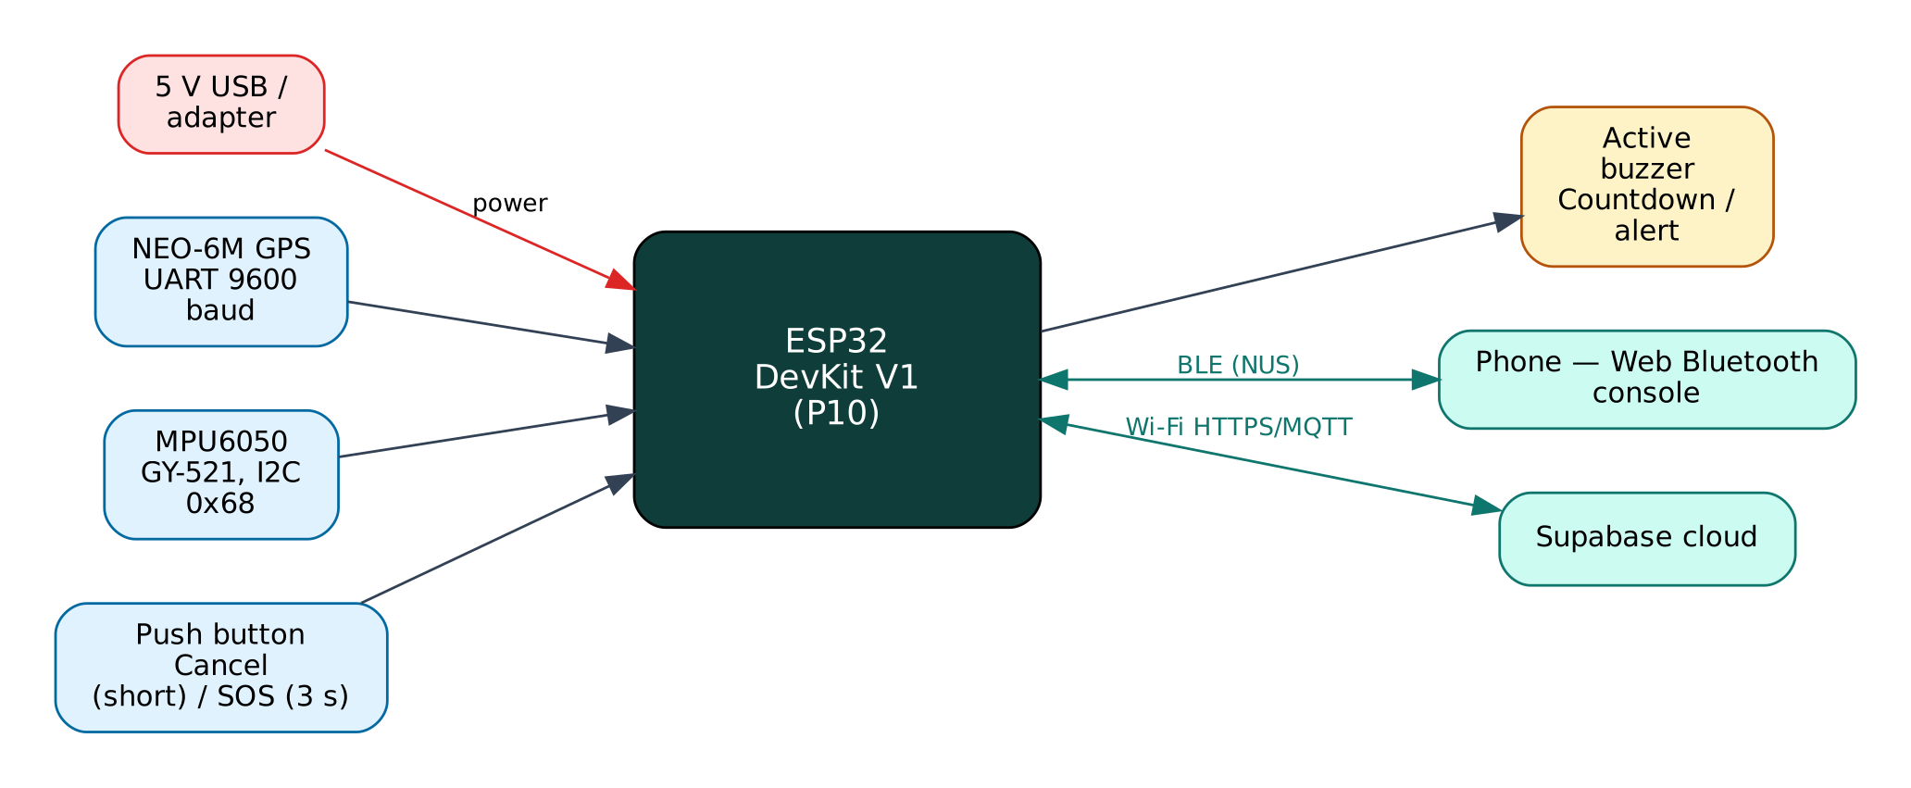

Project: P10 · Advanced level
Peripherals: NEO-6M GPS module, MPU6050 accelerometer/gyro, Active buzzer, Push button
Submitted by: ______________________________
Under the guidance of: ______________________________
Department / Institution: ______________________________
October 2026

Certificate
This is to certify that the project report entitled “Vehicle Tracking and Accident Alert System” is a bonafide record of the work carried out by ______________________ (Roll No. ________) in partial fulfilment of the requirements for the award of ______________________ in ______________________ during the academic year ________.

Project Guide: ______________________ Head of Department: ______________________
Date: ____________ Place: ____________

Acknowledgement
I express my sincere gratitude to my project guide ______________________ for continuous guidance and support, to the Head of the Department ______________________, and to all faculty members and friends who helped me complete this project successfully.

Contents
Abstract 6
1. Introduction 7
1.1 Problem Statement 7
1.2 Objectives 7
1.3 Scope of the Project 7
1.4 Organisation of the Report 7
2. Existing System and Proposed System 8
2.1 Existing Systems 8
2.2 Proposed System 8
2.3 Why Both BLE and Wi-Fi? 8
3. System Design 9
3.1 Block Diagram 9
3.2 System Architecture 9
3.3 Hardware Components and Cost 9
3.4 ESP32 DevKit V1 10
3.5 Working Principle of Components 10
4. Circuit Design 11
4.1 Circuit Diagram 11
4.2 Pin Connections 11
4.3 Interfacing and Power Notes 12
5. Data Flow Diagrams 13
5.1 DFD Level 0 (Context Diagram) 13
5.2 DFD Level 1 14
5.3 Data Dictionary 15
6. Software Design and Implementation 16
6.1 Development Environment 16
6.2 Firmware Architecture 16
6.3 Working of the System 16
6.4 Flowchart 17
6.5 BLE Communication Protocol 17
6.6 Cloud Integration (Supabase) 18
6.7 Configurable Settings 18
7. Setup and Deployment Guide 20
7.1 Hardware Assembly 20
7.2 Flashing the Firmware 20
7.3 Cloud Setup (Supabase) 20
7.4 BLE App Setup (Web Bluetooth Console) 21
7.5 First-Run Checklist 21
8. Testing and Results 23
8.1 Expected Output 23
8.2 Troubleshooting 23
9. Discussion 24
9.1 Advantages 24
9.2 Limitations 24
9.3 Safety Precautions 24
9.4 Security Considerations 24
9.5 Future Scope 24
10. Conclusion 25
References 26
Appendix A: Project Source Code 27
Appendix B: Shared Library Code 32

Abstract
Road accidents in India claim lakhs of lives every year, and delayed help is a major cause. This project tracks a vehicle with a NEO-6M GPS receiver and detects possible accidents with an MPU6050 accelerometer: a sudden impact above a g-force threshold or a rollover (tilt above 60° for 3 seconds) starts a 15-second countdown with a buzzer. If the driver does not cancel with the button, an alert with the GPS location and a Google Maps link is inserted into a Supabase database through the driver's phone hotspot. Holding the button for three seconds sends a manual SOS. The location trail is logged every 30 seconds while moving and every 5 minutes when parked, buffered when offline, and a home geofence raises exit/enter alerts. A phone connected over BLE shows live position, speed and g-force.
Keywords: ESP32, Internet of Things, Bluetooth Low Energy, Wi-Fi, Supabase, NEO-6M GPS module, MPU6050 accelerometer/gyro, Active buzzer, Push button.

1. Introduction
The Internet of Things (IoT) connects physical devices — sensors and actuators — to networks so that data can be collected, analysed and acted on automatically. The ESP32 from Espressif Systems has made IoT affordable: a single ₹350 board combines a dual-core 240 MHz processor, Wi-Fi and Bluetooth Low Energy. This project uses both radios at once: BLE for direct, local interaction with a phone and Wi-Fi for cloud connectivity through Supabase, a free IoT/cloud platform.

1.1 Problem Statement
After an accident, victims may be unconscious or unable to call for help, and bystanders may not know the exact location. Fleet owners and families also want to know where a vehicle is. Commercial trackers need SIM subscriptions and closed apps.

1.2 Objectives
- Track vehicle position, speed and heading with GPS and log it to the cloud.
- Detect impacts and rollovers with an accelerometer.
- Give the driver a cancel window to avoid false alarms.
- Send accident/SOS alerts with a map link to a cloud database.
- Provide geofence alerts and live data over BLE.

1.3 Scope of the Project
Two-wheelers and cars, using the driver's phone hotspot for internet. Automatic calling/SMS (GSM) and CAN-bus data are outside the scope but listed as future work.

1.4 Organisation of the Report
Chapter 2 reviews existing approaches and describes the proposed system. Chapter 3 covers system design and components, Chapter 4 the circuit, Chapter 5 the data flow diagrams, Chapter 6 the software, Chapter 7 the step-by-step setup of hardware, cloud and app, Chapter 8 testing, Chapter 9 discussion and Chapter 10 the conclusion. Complete source code is given in the appendices.

2. Existing System and Proposed System

2.1 Existing Systems
Basic GPS trackers log location only; accident-detection projects often trigger on any bump and have no cancel window, causing frequent false alarms. Many rely on a GSM module and paid SMS.

2.2 Proposed System
The proposed system improves on these in the following ways:
- Two detection criteria: peak g-force and sustained tilt (rollover).
- 15-second cancel window with buzzer, plus a manual SOS button.
- Adaptive logging interval and an offline buffer of 20 positions.
- Undelivered alerts are retried every 30 s; BLE alert works without internet.
- Geofence around a home location set from the phone.

2.3 Why Both BLE and Wi-Fi?
Wi-Fi gives the device internet access for remote monitoring, history and control from anywhere, but it depends on a router and an internet connection, and the device needs the Wi-Fi password before it can connect. BLE needs no infrastructure: any modern phone can connect directly within about 10-30 m. Using both gives:
- Provisioning — Wi-Fi credentials and cloud keys are sent from the phone over BLE and stored in flash; nothing secret is hard-coded or uploaded to GitHub.
- Resilience — local monitoring and control keep working when the internet or router is down.
- Remote access — the cloud dashboard works from anywhere when the internet is available.
- Low cost — no extra hardware; both radios are built into the ESP32.

The ESP32 shares one 2.4 GHz radio between Wi-Fi and Bluetooth by time-division coexistence. For this to work the Wi-Fi modem-sleep mode must stay enabled, which the firmware ensures. NimBLE, a lightweight BLE stack, is used instead of the default Bluedroid stack to leave more RAM for TLS (HTTPS/MQTTS) connections.

3. System Design

3.1 Block Diagram
Figure 1: Block diagram of the Vehicle Tracker & Accident Alert
The ESP32 is the central controller. Input devices (blue) feed measurements to it, output devices (amber) are driven by it, and two communication links (green) connect it to the user's phone over BLE and to the Supabase cloud over Wi-Fi. The board is powered from 5 V through its USB connector or VIN pin.

3.2 System Architecture
The system follows the standard three-layer IoT architecture:
- Perception layer — NEO-6M GPS module, MPU6050 accelerometer/gyro, Active buzzer, Push button connected to the ESP32 GPIO, ADC, I2C, SPI or UART.
- Network layer — BLE 4.2 GATT server (Nordic UART Service) and Wi-Fi 802.11 b/g/n with TLS-encrypted HTTPS REST to Supabase.
- Application layer — the Web Bluetooth console on the phone and the Supabase dashboard / database.

3.3 Hardware Components and Cost
# | Component | Qty | Specification | Cost
1 | ESP32 DevKit V1 (ESP-WROOM-32, 30-pin) | 1 | Dual-core 240 MHz, Wi-Fi + BLE, 4 MB flash | ₹350
2 | Breadboard 830-point + jumper wires (M-M, M-F) | 1 | Prototyping and connections | ₹150
3 | Micro-USB data cable | 1 | Power + programming | ₹60
4 | NEO-6M GPS module with ceramic antenna (GY-NEO6MV2) | 1 | UART 9600 baud, 2.5 m CEP | ₹300
5 | MPU6050 accelerometer + gyroscope (GY-521) | 1 | ±2-16 g, I2C 0x68 | ₹120
6 | Active buzzer 5 V | 1 | Countdown / alert | ₹15
7 | Push button (tactile, 12 mm) | 1 | Cancel / SOS | ₹5
8 | 12 V-to-5 V USB car charger / power bank | 1 | Vehicle power | ₹150
 | Total (approx.) |  |  | ₹1150
Table 1: Bill of materials with approximate Indian prices (Robu.in / Amazon.in / local market, 2026)
Prices are indicative and vary by seller. The breadboard, cable and ESP32 can be reused across all ten projects, so the incremental cost of this project is about ₹590.

3.4 ESP32 DevKit V1
Feature | Value
Module | ESP-WROOM-32 (ESP32-D0WD), dual-core Xtensa LX6 up to 240 MHz
Memory | 520 KB SRAM, 4 MB SPI flash
Wireless | Wi-Fi 802.11 b/g/n 2.4 GHz; Bluetooth 4.2 BR/EDR + BLE
I/O | 25 usable GPIO on the 30-pin board, 12-bit ADC (ADC1: GPIO32-39), 2 × DAC, PWM on any output
Interfaces | 3 × UART, 2 × I2C, 3 × SPI, I2S, touch, RMT
Supply | 5 V via USB/VIN, on-board 3.3 V regulator (AMS1117)
Logic level | 3.3 V — inputs are NOT 5 V tolerant
Table 2: Key specifications of the ESP32 DevKit V1

3.5 Working Principle of Components

GPS (NEO-6M)
The receiver tracks signals from several satellites, measures the travel time of each, and solves for position and time (trilateration). It outputs NMEA sentences ($GPRMC, $GPGGA) at 9600 baud; TinyGPSPlus parses latitude, longitude, speed, course and satellite count.

MPU6050
A MEMS accelerometer measures acceleration on three axes. At rest it reads 1 g (gravity). The total magnitude |a| = √(ax² + ay² + az²) jumps above 2-3 g in a crash. Gravity's direction gives pitch = atan2(−ax, √(ay²+az²)) and roll = atan2(ay, az).

Cancel window
Speed bumps and potholes can exceed the threshold. The 15 s buzzer countdown lets a conscious driver cancel; an unconscious driver cannot, so the alert is sent.

Geofence
TinyGPSPlus::distanceBetween() uses the haversine formula to compute the distance from home; crossing the radius raises geofence_exit / geofence_enter alerts.

4. Circuit Design

4.1 Circuit Diagram
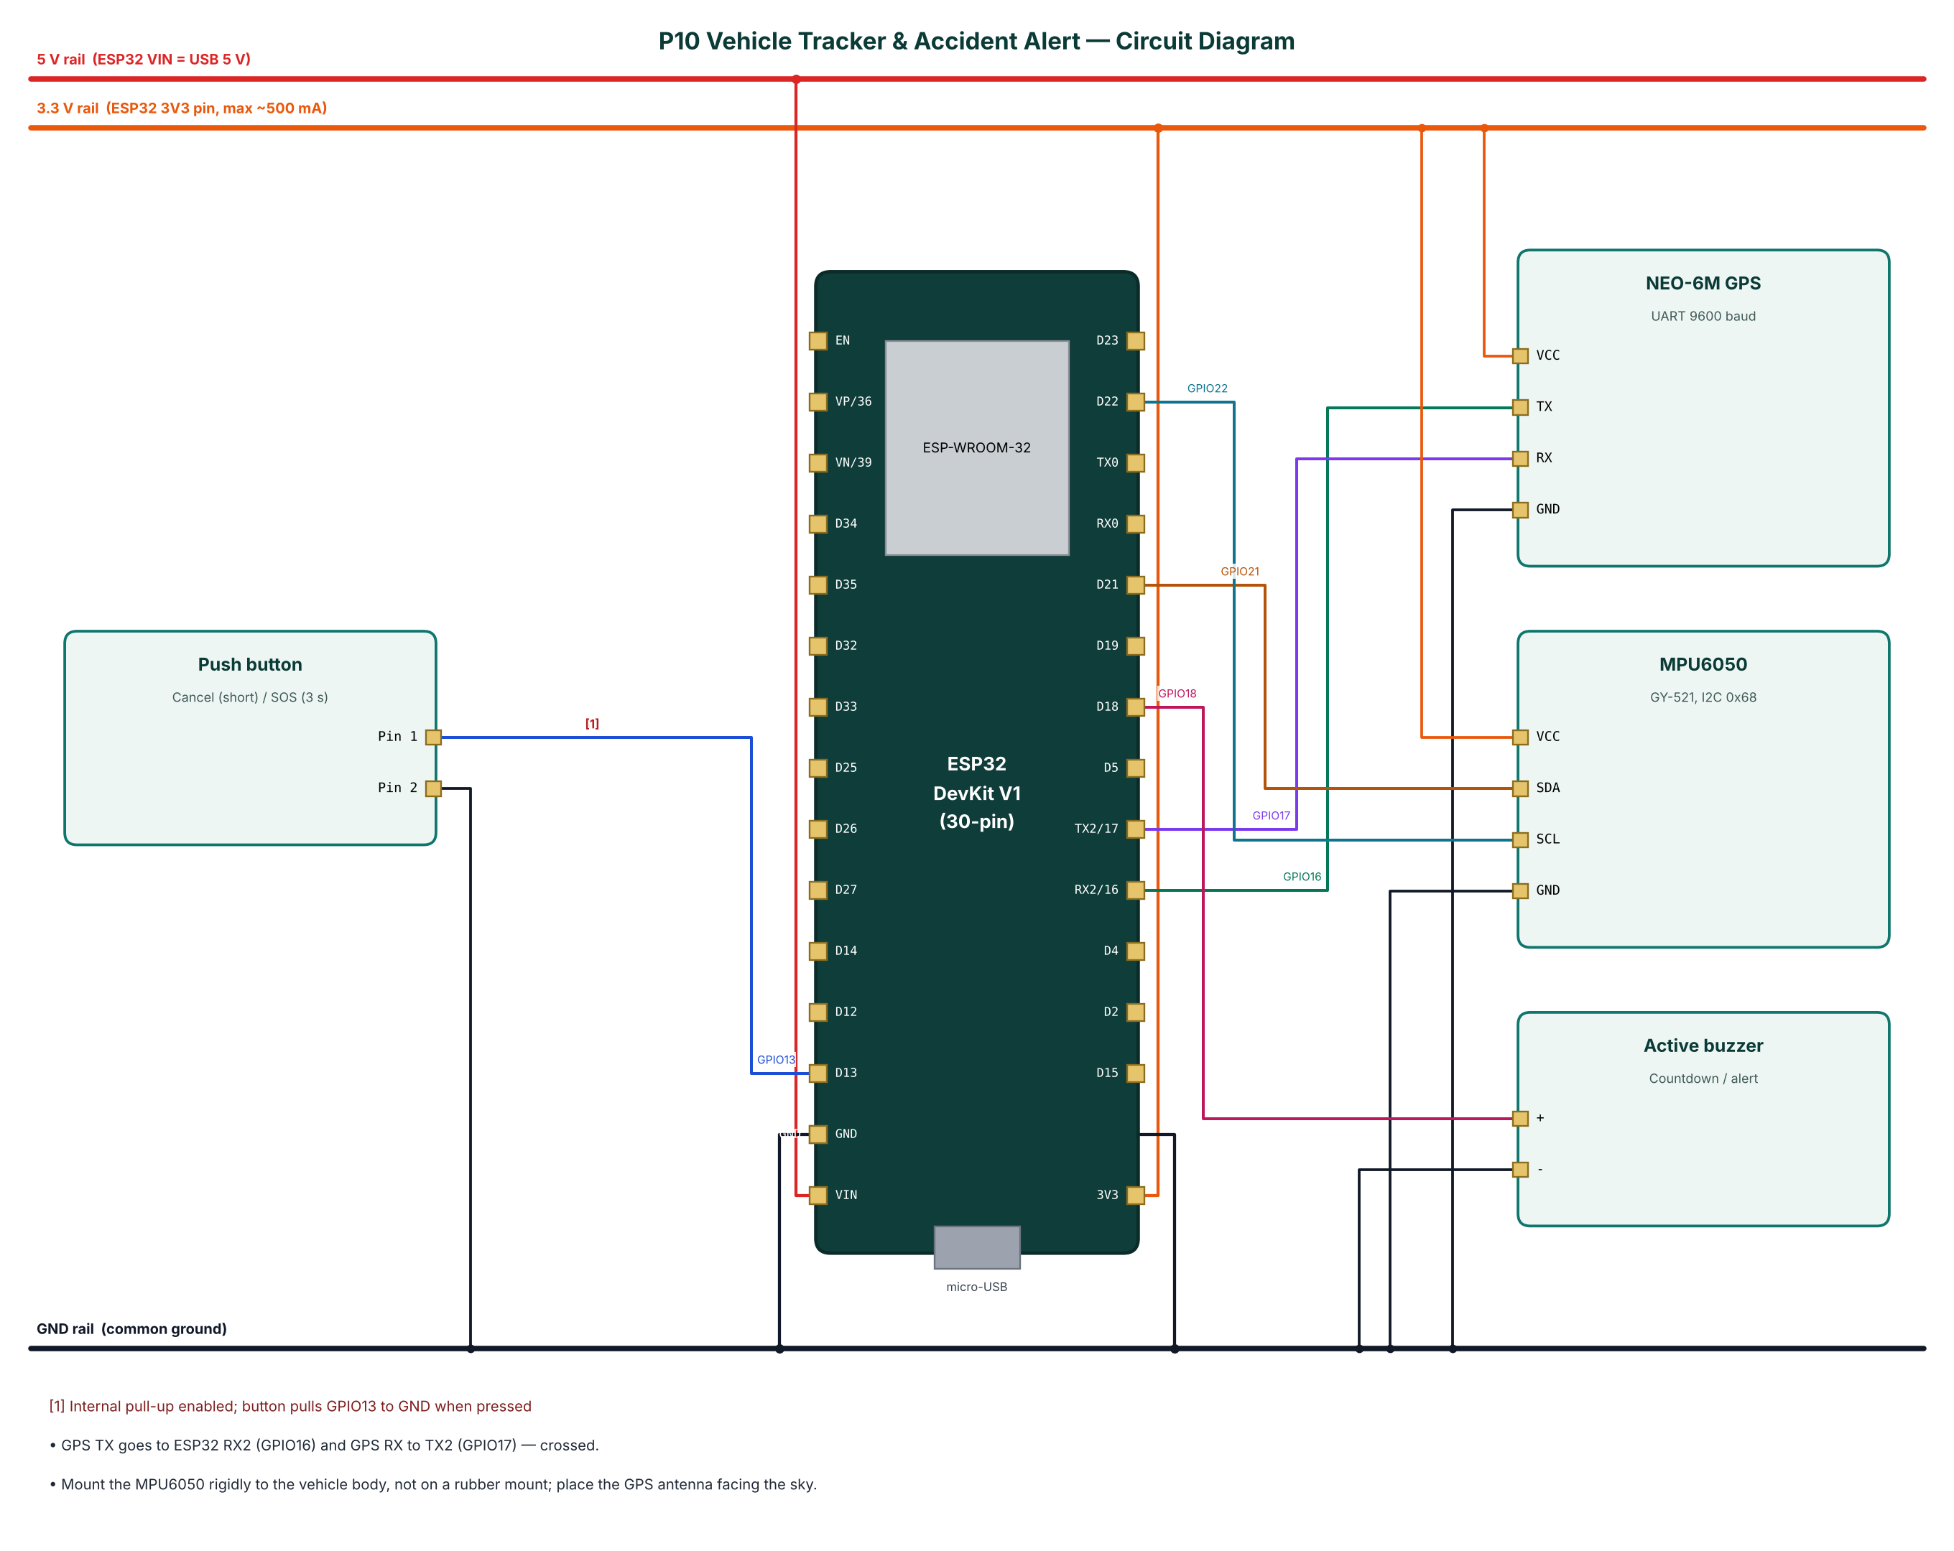
Figure 2: Circuit diagram of the Vehicle Tracker & Accident Alert

4.2 Pin Connections
Module | Module pin | ESP32 connection | Notes
NEO-6M GPS | VCC | 3.3 V (3V3 pin)
NEO-6M GPS | TX | GPIO16
NEO-6M GPS | RX | GPIO17
NEO-6M GPS | GND | GND
MPU6050 | VCC | 3.3 V (3V3 pin)
MPU6050 | SDA | GPIO21
MPU6050 | SCL | GPIO22
MPU6050 | GND | GND
Active buzzer | + | GPIO18
Active buzzer | - | GND
Push button | Pin 1 | GPIO13 | Internal pull-up enabled; button pulls GPIO13 to GND when pressed
Push button | Pin 2 | GND
Table 3: Pin connection table

4.3 Interfacing and Power Notes
- GPS TX goes to ESP32 RX2 (GPIO16) and GPS RX to TX2 (GPIO17) — crossed.
- Mount the MPU6050 rigidly to the vehicle body, not on a rubber mount; place the GPS antenna facing the sky.
- Only ADC1 pins (GPIO32-39) are used for analog inputs, because ADC2 cannot be read while Wi-Fi is active.
- Strapping pins GPIO0, 2, 12 and 15 are avoided for inputs so the board always boots normally.
- All grounds are common. 5 V signals are reduced to 3.3 V with resistor dividers before reaching the ESP32.

5. Data Flow Diagrams
Data flow diagrams (DFDs) show how data moves through the system without showing control logic or timing. External entities are drawn as rectangles, processes as numbered circles, data stores as open boxes and data flows as labelled arrows.

5.1 DFD Level 0 (Context Diagram)
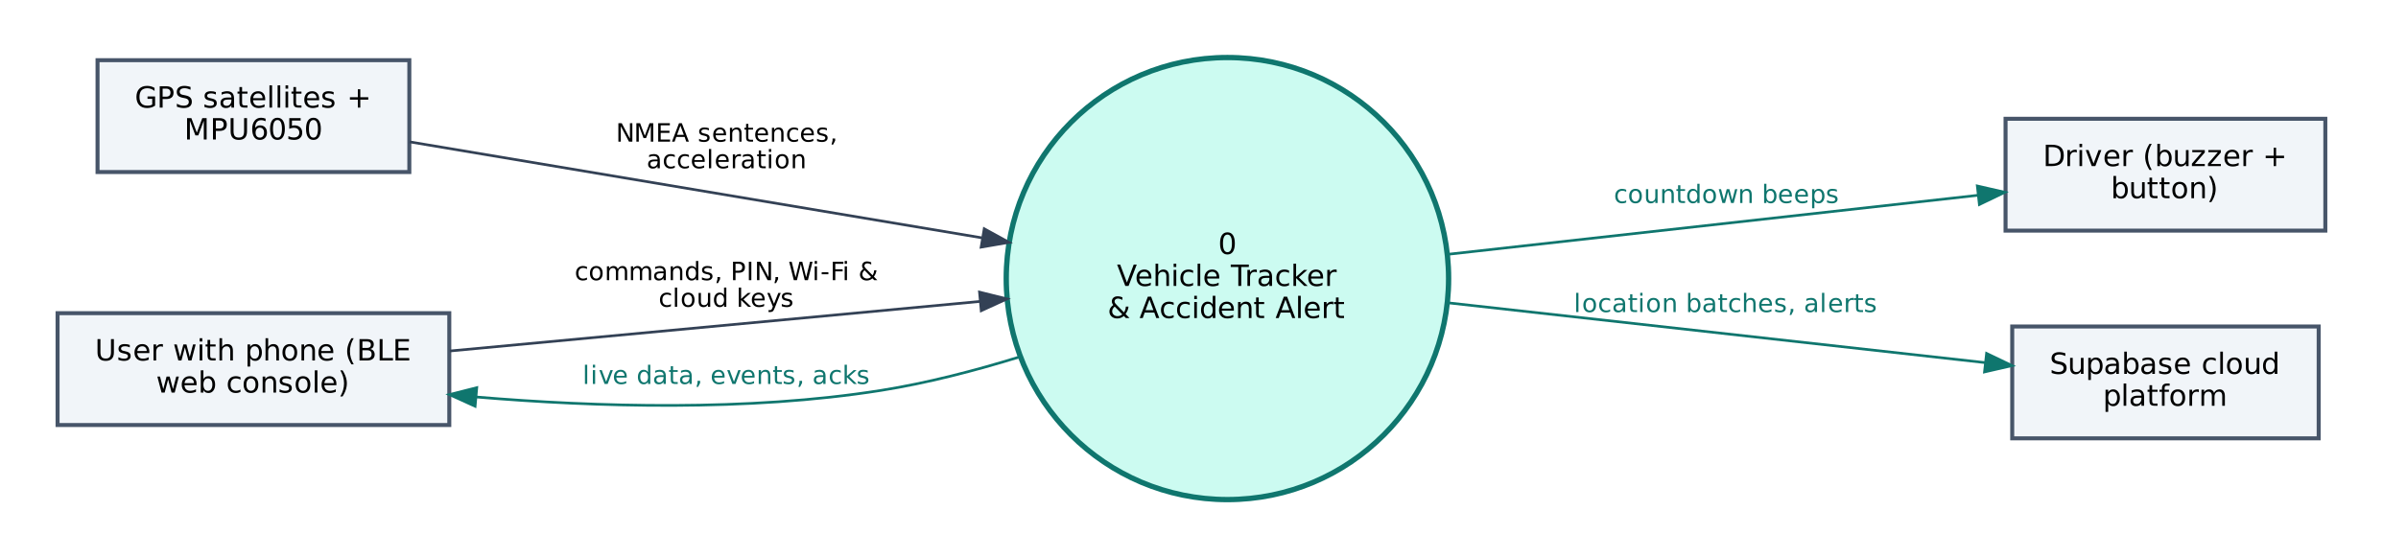
Figure 3: DFD Level 0 — context diagram
At level 0 the whole Vehicle Tracker & Accident Alert is a single process. It receives NMEA sentences, acceleration from the GPS satellites + MPU6050, commands and configuration from the user's phone, and no commands from the cloud. It sends countdown beeps to the Driver (buzzer + button), live data to the phone and location batches, alerts to Supabase.

5.2 DFD Level 1
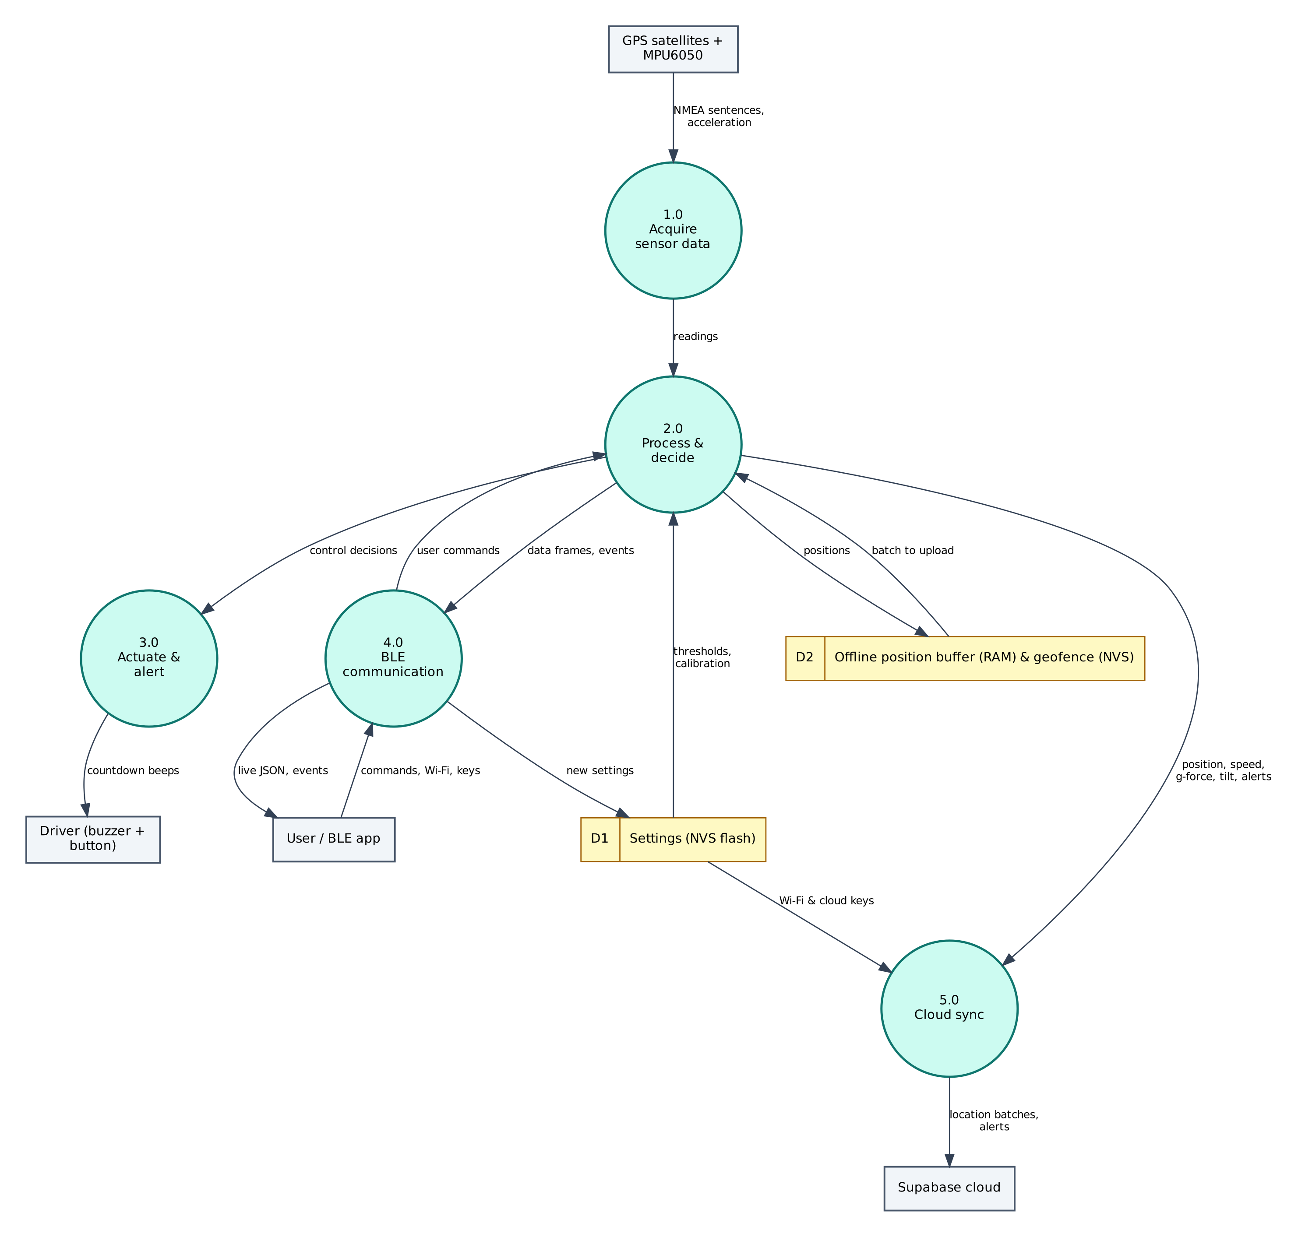
Figure 4: DFD Level 1 — main processes and data stores
Process / store | Description
1.0 Acquire sensor data | Reads NMEA sentences, acceleration from the GPS satellites + MPU6050; filters/averages the raw values.
2.0 Process & decide | Computes position, speed, g-force, tilt, alerts; applies thresholds and rules; generates events.
3.0 Actuate & alert | Drives the Driver (buzzer + button) (countdown beeps).
4.0 BLE communication | Sends JSON frames and events to the phone; receives and authenticates commands.
5.0 Cloud sync | Sends location batches, alerts to Supabase.
D1 Settings (NVS) | Wi-Fi credentials, cloud keys, PIN, thresholds — survive reboots.
D2 Offline position buffer (RAM) & geofence (NVS) | Stores positions; returns batch to upload.
Table 4: Description of level-1 processes and data stores

5.3 Data Dictionary
Field | Meaning | Unit
fix | GPS fix valid | bool
lat / lng | Position | degrees
spd | Speed | km/h
sat | Satellites used | count
g | Peak g in last second | g
pitch / roll | Tilt | °
state | normal / countdown / alert | —
buf | Unsent positions | count
Table 5: BLE data frame fields
Cloud object | Content / usage
vehicle_locations | lat, lng, speed_kmph, heading, satellites, recorded_at
vehicle_alerts | type, detail, g_force, lat, lng, maps_url, speed_kmph
Table 6: Supabase data objects

6. Software Design and Implementation

6.1 Development Environment
Item | Details
IDE / build | Arduino IDE 2.x or arduino-cli; GitHub Actions builds firmware in the cloud
Board package | esp32 by Espressif Systems 3.x (tested with 3.3.12)
Board settings | ESP32 Dev Module, Partition Scheme: Minimal SPIFFS (1.9MB APP with OTA/190KB SPIFFS)
Common libraries | NimBLE-Arduino 2.x, ArduinoJson 7.x, PubSubClient 2.8
Project libraries | TinyGPSPlus, Adafruit MPU6050, Adafruit Unified Sensor
Phone app | Web Bluetooth console (Chrome on Android / desktop, Bluefy on iPhone); nRF Connect as alternative
Cloud | Supabase (free tier)
Table 7: Software tools
The default 1.2 MB app partition is too small for BLE + Wi-Fi + TLS. Select Minimal SPIFFS (1.9MB APP) in Tools → Partition Scheme, otherwise the upload fails with 'Sketch too big'.

6.2 Firmware Architecture
The firmware is split into three layers so that the ten projects share tested code:
- IoTCore.h (shared) — Wi-Fi station with auto-reconnect, NimBLE GATT server with the Nordic UART Service, line-based command parser shared by BLE and USB serial, PIN authentication, settings in NVS (Preferences), NTP time in IST, JSON helpers.
- Cloud.h (shared) — ThingSpeak HTTPS client, Adafruit IO MQTT/TLS client with a 28 messages/minute rate limiter, Supabase PostgREST client (insert, update, select).
- P10_Vehicle_Tracker_Accident_Alert.ino — sensor drivers, algorithms, automation rules and the project's own commands.

The main loop is non-blocking: every task is scheduled with millis() timers, BLE writes are queued from the BLE callback into a FreeRTOS queue and executed in loop(), so the BLE stack never waits for slow operations such as HTTPS requests.

6.3 Working of the System
The firmware parses GPS characters continuously and reads the MPU6050 at 50 Hz with an 8 g range and a 21 Hz low-pass filter. Peak g is tracked per second for the BLE display.
If |a| exceeds crashg (default 2.5 g), or pitch/roll exceed tilt (60°) for 3 s, the state changes to COUNTDOWN and the buzzer beeps for 15 s. A short button press cancels. After 15 s the alert (type, g-force, lat, lng, Google Maps URL, speed) is inserted into vehicle_alerts; if there is no internet it is retried every 30 s and shown immediately over BLE. Holding the button 3 s sends 'sos'.
A position is logged every 30 s when speed > 3 km/h and every 5 minutes otherwise. Points go into a 20-entry buffer, and the whole buffer is inserted in one request when online, so short coverage gaps lose nothing.

6.4 Flowchart
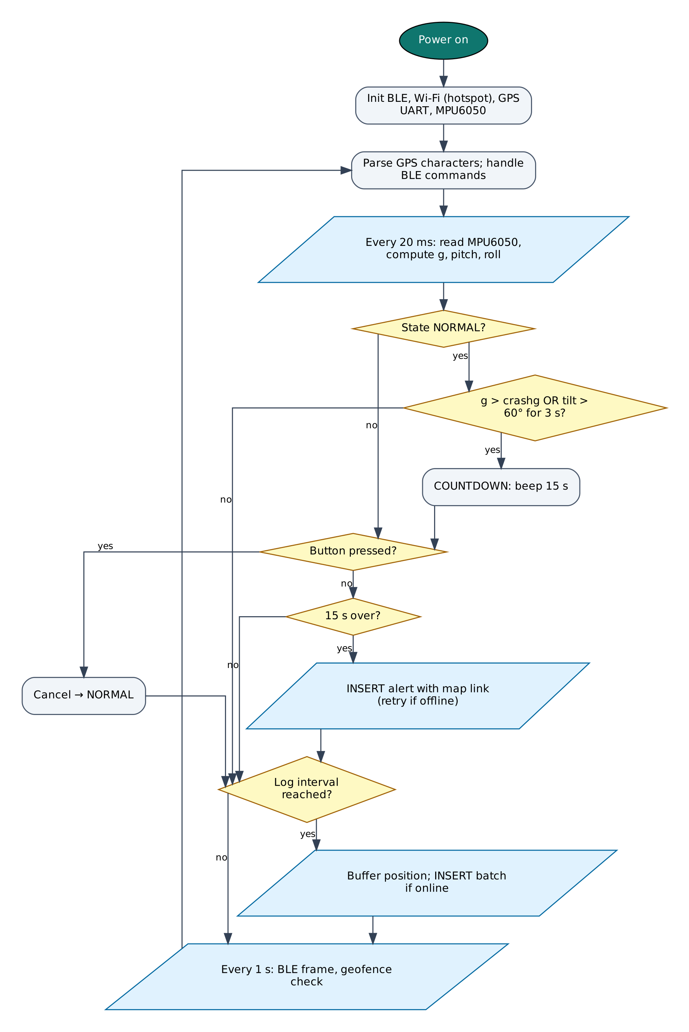
Figure 5: Firmware flowchart

6.5 BLE Communication Protocol
The device is a BLE peripheral named IOT-P10-XXXX (XXXX = last bytes of the MAC address). It exposes the Nordic UART Service, which most BLE apps understand:
Item | UUID | Properties
Service (NUS) | 6E400001-B5A3-F393-E0A9-E50E24DCCA9E | Primary
RX — phone → ESP32 | 6E400002-B5A3-F393-E0A9-E50E24DCCA9E | Write, Write without response
TX — ESP32 → phone | 6E400003-B5A3-F393-E0A9-E50E24DCCA9E | Notify, Read
Table 8: GATT service and characteristics
Commands are plain text lines (command:argument). Replies are one JSON object per line ending in a newline; long lines are split into MTU-sized notifications and re-joined by the app. Commands that change anything require auth:<PIN> first on each connection (default PIN 1234, change it with set:pin=XXXX).
Command | PIN needed | Action
auth:<PIN> | — | Unlock for this connection
status | No | Status JSON: Wi-Fi, IP, RSSI, heap, uptime, time
wifi:<SSID>,<password> | Yes | Save Wi-Fi credentials and connect
set:<key>=<value> | Yes | Save a setting (cloud keys, thresholds)
get:<key> | Yes | Read a setting (secrets masked)
reboot / forget | Yes | Restart / erase all settings
reset | No | Clear an alert state
sos | No | Send an SOS alert from the phone
fencehere:<metres> | Yes | Set the home geofence at the current position
Table 9: BLE commands (common commands first, then project commands)
Example data frame sent by the device:
{"fix":true,"lat":23.259933,"lng":77.412613,"spd":34.5,"sat":8,"g":1.07,"pitch":3,"roll":-2,"state":"normal","buf":0,"type":"data"}

6.6 Cloud Integration (Supabase)
Supabase exposes every Postgres table through a REST API (PostgREST). The device sends HTTPS requests to https://<project>.supabase.co/rest/v1/<table> with the apikey and Authorization: Bearer headers: POST to insert rows, PATCH with a filter such as ?id=eq.1 to update and GET with ?select= to read. Row Level Security policies (in cloud/supabase_schema.sql) allow the device key to do only what the project needs.
Object | Content
vehicle_locations | lat, lng, speed_kmph, heading, satellites, recorded_at
vehicle_alerts | type, detail, g_force, lat, lng, maps_url, speed_kmph
Table 10: Supabase configuration

6.7 Configurable Settings
Key | Default | Meaning
sburl / sbkey | — | Supabase URL and publishable key
crashg | 2.5 | Impact threshold (g)
tilt | 60 | Rollover angle (°)
fence | — | lat,lng,radius (set by fencehere)
ssid / pass | — | Wi-Fi network (set with the wifi: command)
pin | 1234 | BLE PIN
Table 11: Settings stored in flash (change with set:key=value)

7. Setup and Deployment Guide

7.1 Hardware Assembly
- Place the ESP32 DevKit across the centre gap of the breadboard so both pin rows are free.
- Connect the ESP32 3V3 pin to one breadboard power rail (3.3 V), VIN to the other rail (5 V) and both GND pins to the ground rails.
- Wire each module exactly as in the pin connection table (section 4.2), including the resistor dividers marked with [n] in the circuit diagram.
- Check every connection against the circuit diagram before powering on. Make sure no 5 V signal reaches an ESP32 pin directly.
- Connect the USB cable to a computer (for flashing) or a 5 V adapter (for normal use).

7.2 Flashing the Firmware

Option A — Arduino IDE
- Install Arduino IDE 2.x from arduino.cc.
- File → Preferences → Additional boards manager URLs: https://espressif.github.io/arduino-esp32/package_esp32_index.json.
- Tools → Board → Boards Manager: install esp32 by Espressif Systems (version 3.x).
- Sketch → Include Library → Manage Libraries: install NimBLE-Arduino (2.x), ArduinoJson (7.x), PubSubClient, TinyGPSPlus, Adafruit MPU6050, Adafruit Unified Sensor.
- Download the repository and open the folder P10_Vehicle_Tracker_Accident_Alert (it already contains IoTCore.h, Cloud.h and config.h).
- Tools: Board ESP32 Dev Module, Partition Scheme Minimal SPIFFS (1.9MB APP with OTA/190KB SPIFFS), Upload Speed 921600, and the correct COM port.
- Click Upload. If it stays at 'Connecting…', hold the BOOT button on the ESP32 until upload starts.
- Open Serial Monitor at 115200 baud and type status to check the device.

Option B — no software installation (GitHub Actions + browser flasher)
- Open the repository https://github.com/rohitkukreja705/esp32-iot-projects → Actions → latest Build firmware run.
- Download the artifact firmware-P10_Vehicle_Tracker_Accident_Alert and unzip it to get P10_Vehicle_Tracker_Accident_Alert.ino.merged.bin.
- Open https://espressif.github.io/esptool-js/ in Chrome or Edge on a computer, click Connect and select the ESP32's serial port.
- Set Flash Address 0x0, choose the merged .bin file and click Program. Press the EN (reset) button when done.

7.3 Cloud Setup (Supabase)
- Go to supabase.com, sign in (GitHub sign-in works) and click New project. Choose region Mumbai (ap-south-1) for the lowest latency and set a database password.
- Open SQL Editor → New query, paste the whole file cloud/supabase_schema.sql from the repository and click Run. It creates the tables, views and Row Level Security policies for all four Supabase projects (P05, P06, P09, P10), so one Supabase project can serve all of them.
- Click Connect at the top of the dashboard (or Project Settings → API Keys) and copy the Project URL (https://xxxx.supabase.co) and the publishable key (sb_publishable_…; the legacy anon key also works).
- In the BLE web console open Setup, unlock and save them in sburl and sbkey.
- Open Table Editor to watch rows arrive. Use the SQL Editor for reports, e.g. the views created by the schema, and Export to CSV for spreadsheets.
- Free tier: 500 MB database and 2 active projects. Free projects are paused after one week of inactivity — open the dashboard and click Restore if that happens.

Field / feed / table | Content
vehicle_locations | lat, lng, speed_kmph, heading, satellites, recorded_at
vehicle_alerts | type, detail, g_force, lat, lng, maps_url, speed_kmph
Table 12: Items to create in Supabase

7.4 BLE App Setup (Web Bluetooth Console)
No app installation is needed. The console is a web page hosted free on GitHub Pages; Chrome talks to the ESP32 directly through the Web Bluetooth API.
- On an Android phone turn on Bluetooth and Location (Android requires location for BLE scanning).
- Open https://rohitkukreja705.github.io/esp32-iot-projects/?p=P10 in Chrome. (On iPhone use the free Bluefy browser; on a laptop use Chrome or Edge.)
- Tap Connect and choose IOT-P10-XXXX in the pop-up list. The dot turns green and the Live tab starts updating.
- Open Setup, enter the PIN (default 1234) and tap Unlock.
- Enter your 2.4 GHz Wi-Fi name and password and tap Save Wi-Fi. After a few seconds the status line shows the IP address.
- Enter the Supabase keys from section 7.3 and tap Save next to each.
- Use the Control tab for commands and the Log tab to see every event and acknowledgement.

Alternative: nRF Connect app
- Install nRF Connect for Mobile (Nordic Semiconductor, free) and scan.
- Connect to IOT-P10-XXXX and open Nordic UART Service.
- Enable notifications on the TX characteristic (6E400003…).
- Write UTF-8 text to the RX characteristic (6E400002…), e.g. auth:1234, then status.

To host the console yourself: in the GitHub repository open Settings → Pages, choose 'Deploy from a branch', branch main, folder /docs. Web Bluetooth only works on HTTPS pages, which GitHub Pages provides.

7.5 First-Run Checklist
- Serial Monitor shows '[BLE] advertising as IOT-P10-XXXX'.
- Status in the console shows wifi: true and an IP address.
- Data appears in Supabase within a minute.
- All sensor values in the Live tab are plausible (no '—').

8. Testing and Results
The following test cases verify each function. Record the observed result and mark Pass/Fail while testing your build.
# | Test | Procedure | Expected result | Observed
T1 | GPS fix | Place outdoors with clear sky, wait 1-5 min (cold start) | fix=true, 4+ satellites, position matches Google Maps
T2 | Tracking | Drive/walk with the device for 5 minutes | Rows every ~30 s while moving in vehicle_locations
T3 | Impact | Set crashg=1.5 and tap the board sharply | Countdown starts and buzzer beeps
T4 | Cancel | Press the button during countdown | 'cancelled' event; no alert row
T5 | Accident alert | Let the countdown expire | Row in vehicle_alerts with maps_url; BLE event
T6 | Rollover | Tilt the board 90° for 4 s | accident_rollover countdown
T7 | SOS | Hold the button 3 s | sos row in vehicle_alerts
T8 | Geofence | fencehere:50 then move > 50 m away | geofence_exit alert
Table 13: Test cases

8.1 Expected Output
A typical data frame received in the console's Log tab looks like this (values will differ):
{"fix":true,"lat":23.259933,"lng":77.412613,"spd":34.5,"sat":8,"g":1.07,"pitch":3,"roll":-2,"state":"normal","buf":0,"type":"data"}

Serial Monitor (115200 baud) prints the same lines along with connection messages such as [WiFi] connected, [BLE] connected and the HTTP or MQTT result of each cloud upload, which helps in troubleshooting.

8.2 Troubleshooting
Symptom | Likely cause and fix
Device not in the Connect list | Bluetooth/Location off on the phone, or the page is not opened in Chrome over HTTPS.
'Sketch too big' on upload | Select Partition Scheme 'Minimal SPIFFS (1.9MB APP with OTA)'.
Wi-Fi never connects | ESP32 supports only 2.4 GHz networks; check the SSID/password (case-sensitive).
Settings refused | Send auth:<PIN> first; the unlock is per BLE connection.
Sensor shows null / — | Check wiring and supply voltage; see the Serial Monitor for 'not found' messages.
Board resets randomly | Weak USB supply or servo/relay current; use a 5 V 2 A adapter and add a 470 µF capacitor.
No data in Supabase | Wrong URL/key, schema not run, or project paused after inactivity.
Table 14: Troubleshooting guide

9. Discussion

9.1 Advantages
- Automatic alert with exact map location even if the driver is unconscious.
- Cancel window reduces false alarms.
- No SIM card or paid SMS needed (uses phone hotspot).
- Location history and alerts in a queryable database.

9.2 Limitations
- Depends on the phone hotspot for internet; no alert if the phone is damaged or out of coverage.
- Threshold-based detection can miss low-speed crashes or trigger on severe potholes.
- NEO-6M needs open sky; cold start can take several minutes.
- Alerts are stored in the database; notification to family needs an extra step (see future work).

9.3 Safety Precautions
- Do not operate the phone/app while driving.
- Fix the device securely; a loose device can cause false impacts and distract the driver.
- The system supplements, not replaces, calling emergency services (112).

9.4 Security Considerations
- Secrets (Wi-Fi password, cloud keys) are stored in the ESP32's NVS flash, not in source code.
- BLE commands that change the device require a PIN; change the default PIN after setup.
- Cloud traffic is TLS-encrypted. Certificate verification is disabled (setInsecure) for simplicity; for production, pin the server's root certificate with setCACert().
- Use a dedicated cloud account/project for the device and rotate keys if the device is lost.

9.5 Future Scope
- Add a SIM800L/A7670 GSM module for direct SMS and calls.
- Supabase Edge Function or database webhook to send Telegram/email notifications on new alerts.
- Machine-learning crash classifier using gyro + accelerometer patterns.
- Web map of the trail using Leaflet and the Supabase JS client.

10. Conclusion
The Vehicle Tracking and Accident Alert System combines GPS, inertial sensing and a cloud database to provide tracking, geofencing and automatic accident alerts with location links at very low cost. The cancel window and dual detection criteria keep false alarms low, while offline buffering and retries make it dependable on Indian roads with patchy mobile coverage.
All design goals listed in Chapter 1 are met with low-cost parts available in the Indian market, free cloud services and open-source software. The shared firmware core and the single Web Bluetooth console make the project easy to reproduce and extend.

References
- u-blox, NEO-6 GPS Modules data sheet (GPS.G6-HW-09005).
- InvenSense (TDK), MPU-6000/MPU-6050 Product Specification.
- M. Hart, TinyGPSPlus library documentation, arduiniana.org.
- Ministry of Road Transport & Highways, Road Accidents in India (annual report).
- Espressif Systems, ESP32 Series Datasheet and ESP32 Technical Reference Manual, espressif.com.
- Espressif Systems, Arduino-ESP32 documentation, docs.espressif.com/projects/arduino-esp32.
- H2zero, NimBLE-Arduino library documentation, github.com/h2zero/NimBLE-Arduino.
- Bluetooth SIG, Bluetooth Core Specification 4.2 — Generic Attribute Profile (GATT).
- W3C Web Bluetooth Community Group, Web Bluetooth specification, webbluetoothcg.github.io/web-bluetooth.
- B. Blanchon, ArduinoJson 7 documentation, arduinojson.org.
- Supabase Inc., Supabase documentation — REST API and Row Level Security, supabase.com/docs.

Appendix A: Project Source Code
The complete code is in the repository folder P10_Vehicle_Tracker_Accident_Alert (https://github.com/rohitkukreja705/esp32-iot-projects).
config.h
#pragma once
// ===== P10 Vehicle Tracking & Accident Alert — configuration =====
#define WIFI_SSID "" // phone hotspot in the vehicle
#define WIFI_PASS ""
#define DEVICE_PIN "1234"
#define SUPABASE_URL ""
#define SUPABASE_KEY ""

// ----- pins -----
#define PIN_GPS_RX 16 // ESP32 RX2 <- NEO-6M TX
#define PIN_GPS_TX 17 // ESP32 TX2 -> NEO-6M RX
#define PIN_BUZZER 18
#define PIN_BUTTON 13 // push button to GND (cancel alert / hold 3 s = SOS)
// MPU6050: SDA 21, SCL 22

// ----- behaviour (set:crashg= set:tilt= set:fence=lat,lng,metres) -----
#define DEF_CRASH_G 2.5 // impact threshold in g
#define DEF_TILT_DEG 60 // rollover threshold
#define TILT_HOLD_MS 3000
#define CANCEL_WINDOW_S 15 // driver can cancel a false alarm
#define MOVING_LOG_MS 30000 // log every 30 s while moving
#define PARKED_LOG_MS 300000// every 5 min while parked
#define MOVING_KMPH 3.0

P10_Vehicle_Tracker_Accident_Alert.ino
/*
* P10 — Vehicle Tracking & Accident Alert System
* ==============================================
* Peripherals: NEO-6M GPS, MPU6050 accelerometer/gyro, buzzer, push button
* Wi-Fi : Supabase (through the driver's phone hotspot) — location trail
* and accident / SOS / geofence alerts with a Google Maps link
* BLE : live position, speed, g-force and tilt on the phone; alert
* notifications even without internet
* Logic : impact (> crash g) or rollover (> tilt for 3 s) starts a 15 s
* countdown with buzzer; the driver can cancel with the button;
* otherwise the alert is sent. Holding the button 3 s = manual SOS.
* Adaptive logging (30 s moving / 5 min parked), offline buffer,
* geofence exit alert.
*/
#include "config.h"
#include "IoTCore.h"
#include "Cloud.h"
#include <TinyGPSPlus.h>
#include <Wire.h>
#include <Adafruit_MPU6050.h>
#include <Adafruit_Sensor.h>

TinyGPSPlus gps;
HardwareSerial gpsSerial(2);
Adafruit_MPU6050 mpu;
bool mpuOK = false;

float gNow = 0, gPeak = 0, pitch = 0, roll = 0;
float crashG, tiltDeg;
double fenceLat = 0, fenceLng = 0; float fenceR = 0; bool outsideFence = false;

enum AlertState { NORMAL, COUNTDOWN, SENT } st = NORMAL;
String alertType, alertDetail; float alertG = 0;
bool alertDelivered = true; uint32_t lastAlertTry = 0;
uint32_t countdownStart = 0, tiltSince = 0, lastLog = 0, lastBle = 0, lastImu = 0, btnDownAt = 0;

struct Fix { double lat, lng; float spd, hdg; int sats; String ts; };
Fix buf[20]; int bufN = 0; // offline buffer (newest kept)

void loadSettings() {
crashG = iot::settingF("crashg", DEF_CRASH_G);
tiltDeg = iot::settingF("tilt", DEF_TILT_DEG);
String f = iot::setting("fence", "");
if (f.length()) sscanf(f.c_str(), "%lf,%lf,%f", &fenceLat, &fenceLng, &fenceR);
}

String mapsLink(double lat, double lng) {
return "https://maps.google.com/?q=" + String(lat, 6) + "," + String(lng, 6);
}

bool sendAlert(const String& type, const String& detail) {
JsonDocument d;
bool fix = gps.location.isValid();
d["type"] = type; d["detail"] = detail; d["device"] = iot::deviceName;
d["g_force"] = iot::rnd(alertG, 2);
if (fix) { d["lat"] = gps.location.lat(); d["lng"] = gps.location.lng(); d["maps_url"] = mapsLink(gps.location.lat(), gps.location.lng()); }
d["speed_kmph"] = gps.speed.isValid() ? iot::rnd(gps.speed.kmph()) : 0;
String s; serializeJson(d, s);
iot::sendEvent(type, detail + (fix ? " " + mapsLink(gps.location.lat(), gps.location.lng()) : " (no GPS fix)"));
return cloud::supabaseInsert("vehicle_alerts", s);
}

void readImu() {
if (!mpuOK || millis() - lastImu < 20) return; // 50 Hz
lastImu = millis();
sensors_event_t a, g, t;
mpu.getEvent(&a, &g, &t);
float ax = a.acceleration.x / 9.80665, ay = a.acceleration.y / 9.80665, az = a.acceleration.z / 9.80665;
gNow = sqrt(ax * ax + ay * ay + az * az);
if (gNow > gPeak) gPeak = gNow;
pitch = atan2(-ax, sqrt(ay * ay + az * az)) * 57.2958;
roll = atan2(ay, az) * 57.2958;

if (st != NORMAL) return;
if (gNow > crashG) { alertType = "accident_impact"; alertG = gNow; st = COUNTDOWN; countdownStart = millis(); }
bool tilted = fabs(pitch) > tiltDeg || fabs(roll) > tiltDeg;
if (!tilted) tiltSince = 0;
else if (!tiltSince) tiltSince = millis();
else if (millis() - tiltSince > TILT_HOLD_MS) { alertType = "accident_rollover"; alertG = gNow; st = COUNTDOWN; countdownStart = millis(); }
if (st == COUNTDOWN) iot::sendEvent("countdown", alertType + " - press the button within " + String(CANCEL_WINDOW_S) + " s to cancel");
}

void handleButton() {
bool down = digitalRead(PIN_BUTTON) == LOW;
uint32_t now = millis();
if (down && !btnDownAt) btnDownAt = now;
if (!down && btnDownAt) {
uint32_t held = now - btnDownAt; btnDownAt = 0;
if (held > 50 && held < 3000 && st != NORMAL) {
st = NORMAL; tiltSince = 0; digitalWrite(PIN_BUZZER, LOW);
iot::sendEvent("cancelled", "Driver cancelled the alert (false alarm)");
}
}
if (down && btnDownAt && now - btnDownAt >= 3000 && st == NORMAL) {
btnDownAt = 0; alertType = "sos"; alertG = gNow;
st = SENT; sendAlert("sos", "Manual SOS from driver");
}
}

void alertLogic() {
uint32_t now = millis();
if (st == COUNTDOWN) {
digitalWrite(PIN_BUZZER, (now / 250) % 2);
if (now - countdownStart > CANCEL_WINDOW_S * 1000UL) {
st = SENT;
alertDetail = "Possible accident, peak " + String(alertG, 1) + " g";
alertDelivered = sendAlert(alertType, alertDetail);
lastAlertTry = now;
if (!alertDelivered) iot::sendEvent("alert_pending", "No internet - alert shown on BLE, retrying every 30 s");
}
} else if (st == SENT) {
if (!alertDelivered && iot::wifiOK() && now - lastAlertTry > 30000) {
lastAlertTry = now;
alertDelivered = sendAlert(alertType, alertDetail + " (delayed)");
}
digitalWrite(PIN_BUZZER, (now / 1000) % 2 == 0 && (now % 1000) < 150); // slow chirp
} else digitalWrite(PIN_BUZZER, LOW);
}

void checkFence() {
if (fenceR <= 0 || !gps.location.isValid()) return;
double d = TinyGPSPlus::distanceBetween(gps.location.lat(), gps.location.lng(), fenceLat, fenceLng);
bool out = d > fenceR;
if (out != outsideFence) {
outsideFence = out;
alertG = 0;
sendAlert(out ? "geofence_exit" : "geofence_enter", String(d, 0) + " m from home");
}
}

void logLocation() {
if (!gps.location.isValid()) return;
float spd = gps.speed.isValid() ? gps.speed.kmph() : 0;
uint32_t period = spd > MOVING_KMPH ? MOVING_LOG_MS : PARKED_LOG_MS;
if (lastLog && millis() - lastLog < period) return;
lastLog = millis();
Fix f = { gps.location.lat(), gps.location.lng(), spd, (float)gps.course.deg(), (int)gps.satellites.value(), iot::timestamp() };
if (bufN == 20) { for (int i = 1; i < 20; i++) buf[i - 1] = buf[i]; bufN = 19; } // drop oldest
buf[bufN++] = f;
if (!iot::wifiOK()) return;
// flush the whole buffer in one request
JsonDocument d; JsonArray arr = d.to<JsonArray>();
for (int i = 0; i < bufN; i++) {
JsonObject o = arr.add<JsonObject>();
o["lat"] = buf[i].lat; o["lng"] = buf[i].lng; o["speed_kmph"] = iot::rnd(buf[i].spd);
o["heading"] = iot::rnd(buf[i].hdg, 0); o["satellites"] = buf[i].sats; o["device"] = iot::deviceName;
if (buf[i].ts.startsWith("20")) o["recorded_at"] = buf[i].ts; else o["recorded_at"] = nullptr;
}
String s; serializeJson(d, s);
if (cloud::supabaseInsert("vehicle_locations", s)) bufN = 0;
}

void sendBle() {
JsonDocument d;
bool fix = gps.location.isValid();
d["fix"] = fix;
if (fix) { d["lat"] = serialized(String(gps.location.lat(), 6)); d["lng"] = serialized(String(gps.location.lng(), 6)); }
d["spd"] = gps.speed.isValid() ? iot::rnd(gps.speed.kmph()) : 0;
d["sat"] = gps.satellites.value();
d["g"] = iot::rnd(gPeak, 2); d["pitch"] = iot::rnd(pitch, 0); d["roll"] = iot::rnd(roll, 0);
d["state"] = st == NORMAL ? "normal" : st == COUNTDOWN ? "countdown" : "alert";
d["buf"] = bufN;
iot::sendData(d);
gPeak = gNow;
}

// Commands: reset (clear alert), sos, fencehere:<metres>
bool onCommand(const String& cmd, const String& arg, bool authed) {
if (cmd == "setting") { loadSettings(); return true; }
if (cmd == "reset") { st = NORMAL; tiltSince = 0; iot::emitAck(cmd, true, "alert cleared"); return true; }
if (cmd == "sos") { alertG = gNow; st = SENT; sendAlert("sos", "SOS from phone app"); iot::emitAck(cmd, true); return true; }
if (cmd == "fencehere") {
if (!authed) { iot::emitAck(cmd, false, "send auth:<PIN> first"); return true; }
if (!gps.location.isValid()) { iot::emitAck(cmd, false, "no GPS fix yet"); return true; }
String f = String(gps.location.lat(), 6) + "," + String(gps.location.lng(), 6) + "," + (arg.length() ? arg : String("300"));
iot::saveSetting("fence", f); loadSettings(); outsideFence = false;
iot::emitAck(cmd, true, "fence " + f);
return true;
}
return false;
}

void setup() {
pinMode(PIN_BUZZER, OUTPUT); pinMode(PIN_BUTTON, INPUT_PULLUP);
iot::begin("P10", onCommand);
loadSettings();
gpsSerial.begin(9600, SERIAL_8N1, PIN_GPS_RX, PIN_GPS_TX);
Wire.begin(21, 22);
mpuOK = mpu.begin();
if (mpuOK) { mpu.setAccelerometerRange(MPU6050_RANGE_8_G); mpu.setFilterBandwidth(MPU6050_BAND_21_HZ); }
else Serial.println("[MPU6050] not found");
}

void loop() {
iot::loop();
while (gpsSerial.available()) gps.encode(gpsSerial.read());
readImu();
handleButton();
alertLogic();
uint32_t now = millis();
if (now - lastBle >= 1000) { lastBle = now; sendBle(); checkFence(); }
logLocation();
}

Appendix B: Shared Library Code
These two headers are identical in every project folder (master copies in /common).
IoTCore.h
/*
* IoTCore.h — shared runtime for all ESP32 IoT projects in this repo
* -------------------------------------------------------------------
* - Wi-Fi station with automatic reconnect (credentials stored in flash)
* - BLE server using the Nordic UART Service (NUS) layout, so the device
* works with the Web Bluetooth dashboard in /docs AND with generic apps
* such as "nRF Connect" or "Serial Bluetooth Terminal"
* - Line-based command protocol shared by BLE and USB Serial
* - Persistent settings (Preferences / NVS): Wi-Fi, cloud keys, PIN, thresholds
* - NTP time sync (IST) for timestamps
*
* Wire protocol
* -------------
* Phone -> ESP32 (write to RX characteristic, text):
* auth:1234 unlock control + settings for this connection
* status device replies with a status JSON line
* set:key=value store a setting (Wi-Fi, cloud key, threshold…)
* get:key read back a setting (secrets are masked)
* wifi:SSID,PASSWORD shortcut for set:ssid + set:pass + reconnect
* reboot restart the board
* <anything else> forwarded to the project's own command handler
* ESP32 -> Phone (notify on TX characteristic):
* one JSON object per line, terminated by '\n'
* {"type":"data",...} {"type":"status",...} {"type":"ack",...}
* {"type":"event",...} {"type":"err",...}
* Lines longer than one BLE packet are split into chunks; the receiver
* joins chunks until it sees '\n'.
*
* Library: NimBLE-Arduino 2.x (lighter than Bluedroid, leaves more RAM for TLS)
* Board: ESP32 Dev Module, Partition Scheme "Minimal SPIFFS (1.9MB APP with OTA)"
*/
#pragma once

#include <Arduino.h>
#include <WiFi.h>
#include <Preferences.h>
#include <NimBLEDevice.h>
#include <ArduinoJson.h>
#include <time.h>

#ifndef DEVICE_PIN
#define DEVICE_PIN "1234"
#endif
#ifndef WIFI_SSID
#define WIFI_SSID ""
#endif
#ifndef WIFI_PASS
#define WIFI_PASS ""
#endif

namespace iot {

// Nordic UART Service UUIDs (widely supported by BLE terminal apps)
static const char* NUS_SERVICE = "6E400001-B5A3-F393-E0A9-E50E24DCCA9E";
static const char* NUS_RX = "6E400002-B5A3-F393-E0A9-E50E24DCCA9E"; // phone writes here
static const char* NUS_TX = "6E400003-B5A3-F393-E0A9-E50E24DCCA9E"; // ESP32 notifies here

// Project command handler: return true if the command was recognised.
using CommandHandler = bool (*)(const String& cmd, const String& arg, bool authed);

// ------------------------------------------------------------------ state
struct CmdMsg { char text[256]; bool fromBle; };

static Preferences prefs;
static NimBLEServer* bleServer = nullptr;
static NimBLECharacteristic* txChr = nullptr;
static QueueHandle_t cmdQueue = nullptr;
static CommandHandler userHandler = nullptr;
static String deviceName;
static String projectId;
static volatile uint16_t bleMtu = 23;
static volatile bool bleAuthed = false; // reset on every new connection
static bool serialAuthed = true; // USB = physical access, trusted
static bool timeSynced = false;
static uint32_t lastWifiTry = 0;
static String rxLine; // assembles multi-packet writes

// --------------------------------------------------------------- settings
inline String setting(const char* key, const char* def = "") {
return prefs.isKey(key) ? prefs.getString(key, def) : String(def);
}
inline void saveSetting(const char* key, const String& v) { prefs.putString(key, v); }
inline float settingF(const char* key, float def) {
String s = setting(key, "");
return s.length() ? s.toFloat() : def;
}

// ------------------------------------------------------------------- BLE
inline bool bleConnected() { return bleServer && bleServer->getConnectedCount() > 0; }

// Send one line (adds '\n'), split to fit the negotiated MTU.
inline void bleSend(const String& line) {
if (!bleConnected() || !txChr) return;
String msg = line + "\n";
size_t chunk = (bleMtu > 23 ? bleMtu : 23) - 3;
for (size_t i = 0; i < msg.length(); i += chunk) {
size_t n = min(chunk, msg.length() - i);
txChr->setValue((const uint8_t*)msg.c_str() + i, n);
txChr->notify();
if (msg.length() > chunk) delay(8); // give the stack time between chunks
}
}

// Send to BLE and mirror to USB Serial.
inline void emit(const String& line) {
Serial.println(line);
bleSend(line);
}

inline void emitAck(const String& cmd, bool ok, const String& msg = "") {
JsonDocument d;
d["type"] = ok ? "ack" : "err";
d["cmd"] = cmd;
if (msg.length()) d["msg"] = msg;
String s; serializeJson(d, s); emit(s);
}

inline void enqueue(const String& s, bool fromBle) {
if (!cmdQueue || s.length() == 0) return;
CmdMsg m; memset(&m, 0, sizeof(m));
strncpy(m.text, s.c_str(), sizeof(m.text) - 1);
m.fromBle = fromBle;
xQueueSend(cmdQueue, &m, 0);
}

class ServerCB : public NimBLEServerCallbacks {
void onConnect(NimBLEServer* s, NimBLEConnInfo& info) override {
bleAuthed = false;
rxLine = "";
Serial.printf("[BLE] connected %s\n", info.getAddress().toString().c_str());
}
void onDisconnect(NimBLEServer* s, NimBLEConnInfo& info, int reason) override {
bleAuthed = false;
bleMtu = 23;
Serial.printf("[BLE] disconnected (reason %d), advertising again\n", reason);
// NimBLE restarts advertising automatically (advertiseOnDisconnect = true)
}
void onMTUChange(uint16_t mtu, NimBLEConnInfo& info) override {
bleMtu = mtu;
Serial.printf("[BLE] MTU %u\n", mtu);
}
};

class RxCB : public NimBLECharacteristicCallbacks {
void onWrite(NimBLECharacteristic* c, NimBLEConnInfo& info) override {
std::string v = c->getValue();
// Accept either a single write without newline, or several writes
// that together form lines terminated by '\n'.
for (char ch : v) {
if (ch == '\r') continue;
if (ch == '\n') { enqueue(rxLine, true); rxLine = ""; }
else if (rxLine.length() < 250) rxLine += ch;
}
if (v.find('\n') == std::string::npos && rxLine.length() && rxLine.length() == v.length()) {
enqueue(rxLine, true); // plain one-shot write (e.g. typed in nRF Connect)
rxLine = "";
}
}
};

inline void bleBegin() {
uint8_t mac[6]; WiFi.macAddress(mac);
char suffix[6]; snprintf(suffix, sizeof(suffix), "%02X%02X", mac[4], mac[5]);
deviceName = "IOT-" + projectId + "-" + suffix;

NimBLEDevice::init(deviceName.c_str());
NimBLEDevice::setMTU(247);
bleServer = NimBLEDevice::createServer();
bleServer->setCallbacks(new ServerCB());

NimBLEService* svc = bleServer->createService(NUS_SERVICE);
txChr = svc->createCharacteristic(NUS_TX, NIMBLE_PROPERTY::NOTIFY | NIMBLE_PROPERTY::READ);
NimBLECharacteristic* rx = svc->createCharacteristic(
NUS_RX, NIMBLE_PROPERTY::WRITE | NIMBLE_PROPERTY::WRITE_NR, 512);
rx->setCallbacks(new RxCB());
// (NimBLE 2.x starts services automatically when advertising begins)

// 128-bit UUID goes in the advertisement, the name in the scan response
// (both together would not fit in one 31-byte packet).
NimBLEAdvertisementData adv, scan;
adv.setFlags(BLE_HS_ADV_F_DISC_GEN | BLE_HS_ADV_F_BREDR_UNSUP);
adv.setCompleteServices(NimBLEUUID(NUS_SERVICE));
scan.setName(deviceName.c_str());
NimBLEAdvertising* a = NimBLEDevice::getAdvertising();
a->setAdvertisementData(adv);
a->setScanResponseData(scan);
a->start();
Serial.printf("[BLE] advertising as %s\n", deviceName.c_str());
}

// ------------------------------------------------------------------ Wi-Fi
inline bool wifiOK() { return WiFi.status() == WL_CONNECTED; }

inline void wifiConnect() {
String ssid = setting("ssid", WIFI_SSID);
String pass = setting("pass", WIFI_PASS);
if (ssid.isEmpty()) {
Serial.println("[WiFi] no SSID yet - send wifi:SSID,PASSWORD over BLE");
return;
}
Serial.printf("[WiFi] connecting to %s\n", ssid.c_str());
WiFi.disconnect();
WiFi.begin(ssid.c_str(), pass.c_str());
lastWifiTry = millis();
}

inline void wifiLoop() {
static bool wasUp = false;
bool up = wifiOK();
if (up && !wasUp) {
Serial.printf("[WiFi] connected, IP %s, RSSI %d\n",
WiFi.localIP().toString().c_str(), WiFi.RSSI());
configTzTime("IST-5:30", "pool.ntp.org", "time.google.com");
}
if (!up && millis() - lastWifiTry > 20000) wifiConnect(); // retry every 20 s
wasUp = up;
if (up && !timeSynced && time(nullptr) > 1700000000) {
timeSynced = true;
Serial.println("[NTP] time synced");
}
}

// ISO-8601 local time, or uptime if NTP has not synced yet.
inline String timestamp() {
time_t now = time(nullptr);
if (now < 1700000000) return "uptime+" + String(millis() / 1000) + "s";
struct tm t; localtime_r(&now, &t);
char buf[32]; strftime(buf, sizeof(buf), "%Y-%m-%dT%H:%M:%S+05:30", &t);
return String(buf);
}

// ------------------------------------------------------- built-in commands
inline bool isSecretKey(const String& k) {
return k == "pass" || k.endsWith("key") || k == "pin";
}

inline void sendStatus() {
JsonDocument d;
d["type"] = "status";
d["dev"] = deviceName;
d["wifi"] = wifiOK();
d["ssid"] = setting("ssid", WIFI_SSID);
d["rssi"] = wifiOK() ? WiFi.RSSI() : 0;
d["ip"] = wifiOK() ? WiFi.localIP().toString() : "";
d["auth"] = bleAuthed;
d["heap"] = ESP.getFreeHeap();
d["up"] = millis() / 1000;
d["time"] = timestamp();
String s; serializeJson(d, s); emit(s);
}

inline void handleLine(const String& raw, bool fromBle) {
String line = raw; line.trim();
if (line.isEmpty()) return;
int c = line.indexOf(':');
String cmd = (c < 0 ? line : line.substring(0, c));
String arg = (c < 0 ? "" : line.substring(c + 1));
cmd.trim(); cmd.toLowerCase();
bool authed = fromBle ? bleAuthed : serialAuthed;

if (cmd == "auth") {
bool ok = arg == setting("pin", DEVICE_PIN);
if (fromBle) bleAuthed = ok;
emitAck(cmd, ok, ok ? "unlocked" : "wrong PIN");
return;
}
if (cmd == "status") { sendStatus(); return; }
if (cmd == "ping") { emitAck(cmd, true, "pong"); return; }

// Everything below changes the device, so it needs the PIN over BLE.
if (cmd == "set" || cmd == "wifi" || cmd == "reboot" || cmd == "get" || cmd == "forget") {
if (!authed) { emitAck(cmd, false, "send auth:<PIN> first"); return; }
if (cmd == "set") {
int e = arg.indexOf('=');
if (e <= 0) { emitAck(cmd, false, "use set:key=value"); return; }
String k = arg.substring(0, e); k.trim();
String v = arg.substring(e + 1); v.trim();
if (k.length() > 15) { emitAck(cmd, false, "key too long"); return; }
saveSetting(k.c_str(), v);
emitAck(cmd, true, k + " saved");
if (k == "ssid" || k == "pass") wifiConnect();
// let the project react to changed thresholds etc.
if (userHandler) userHandler("setting", k, true);
return;
}
if (cmd == "get") {
String v = setting(arg.c_str(), "");
if (isSecretKey(arg) && v.length()) v = "****" + v.substring(max(0, (int)v.length() - 3));
emitAck(cmd, true, arg + "=" + v);
return;
}
if (cmd == "wifi") {
int k = arg.indexOf(',');
String ssid = k < 0 ? arg : arg.substring(0, k);
String pass = k < 0 ? "" : arg.substring(k + 1);
saveSetting("ssid", ssid); saveSetting("pass", pass);
emitAck(cmd, true, "connecting to " + ssid);
wifiConnect();
return;
}
if (cmd == "forget") { prefs.clear(); emitAck(cmd, true, "all settings erased"); return; }
if (cmd == "reboot") { emitAck(cmd, true, "rebooting"); delay(300); ESP.restart(); }
}

if (userHandler && userHandler(cmd, arg, authed)) return;
emitAck(cmd, false, "unknown command");
}

// ------------------------------------------------------------ entry points
// Call once from setup(). id = short project id, e.g. "P01".
inline void begin(const char* id, CommandHandler handler) {
Serial.begin(115200);
delay(200);
projectId = id;
userHandler = handler;
prefs.begin("iot", false);
cmdQueue = xQueueCreate(8, sizeof(CmdMsg));
WiFi.mode(WIFI_STA);
WiFi.setAutoReconnect(true);
// NOTE: Wi-Fi modem sleep must stay ON while BLE is running (ESP32 coexistence).
bleBegin();
wifiConnect();
Serial.println("[CORE] ready - type 'status' here or connect over BLE");
}

// Call every loop() iteration.
inline void loop() {
wifiLoop();
// USB serial commands (handy while developing)
static String serialLine;
while (Serial.available()) {
char ch = Serial.read();
if (ch == '\n' || ch == '\r') { if (serialLine.length()) enqueue(serialLine, false); serialLine = ""; }
else if (serialLine.length() < 250) serialLine += ch;
}
CmdMsg m;
while (cmdQueue && xQueueReceive(cmdQueue, &m, 0) == pdTRUE) handleLine(String(m.text), m.fromBle);
}

// Round for compact JSON. NaN stays NaN, which ArduinoJson writes as null.
inline float rnd(float v, int dp = 1) {
if (isnan(v)) return v;
float m = powf(10, dp);
return roundf(v * m) / m;
}

// Helper: build and send a {"type":"data",...} line from a filled document.
inline void sendData(JsonDocument& d) {
d["type"] = "data";
String s; serializeJson(d, s); emit(s);
}

inline void sendEvent(const String& name, const String& msg) {
JsonDocument d;
d["type"] = "event"; d["name"] = name; d["msg"] = msg; d["time"] = timestamp();
String s; serializeJson(d, s); emit(s);
}

} // namespace iot

Cloud.h
/*
* Cloud.h — free-tier cloud helpers used by the projects
* ---------------------------------------------------------
* ThingSpeak : HTTPS REST "update" (free tier: 1 update / 15 s per channel)
* Adafruit IO : MQTT over TLS (free tier: 30 data points / minute, 10 feeds)
* Supabase : PostgREST over HTTPS (free tier: 500 MB Postgres)
*
* Keys are read from settings (stored over BLE with set:key=value) so no
* secret has to be hard-coded or committed to GitHub:
* tskey ThingSpeak Write API Key
* aiouser Adafruit IO username aiokey Adafruit IO key
* sburl https://<ref>.supabase.co sbkey Supabase publishable/anon key
*
* TLS note: certificate checking is disabled with setInsecure() to keep the
* projects beginner-friendly and independent of CA rotations. Traffic is
* still encrypted. For production, pin the root CA with setCACert().
*/
#pragma once

#include <WiFiClientSecure.h>
#include <HTTPClient.h>
#include <PubSubClient.h>
#include "IoTCore.h"

// Optional compile-time defaults (normally left empty and set over BLE)
#ifndef TS_WRITE_KEY
#define TS_WRITE_KEY ""
#endif
#ifndef AIO_USERNAME
#define AIO_USERNAME ""
#endif
#ifndef AIO_KEY
#define AIO_KEY ""
#endif
#ifndef SUPABASE_URL
#define SUPABASE_URL ""
#endif
#ifndef SUPABASE_KEY
#define SUPABASE_KEY ""
#endif

namespace cloud {

// ============================================================== ThingSpeak
// vals[i] -> field(i+1). Pass NAN to skip a field. Returns true on success.
inline bool thingSpeakUpdate(const float* vals, int n, const String& status = "") {
if (!iot::wifiOK()) return false;
String key = iot::setting("tskey", TS_WRITE_KEY);
if (key.isEmpty()) { Serial.println("[TS] no tskey set"); return false; }
String url = "https://api.thingspeak.com/update?api_key=" + key;
for (int i = 0; i < n && i < 8; i++)
if (!isnan(vals[i])) url += "&field" + String(i + 1) + "=" + String(vals[i], 2);
if (status.length()) {
String st = status; st.replace(" ", "%20");
url += "&status=" + st;
}
WiFiClientSecure client; client.setInsecure();
HTTPClient http; http.setTimeout(8000);
if (!http.begin(client, url)) return false;
int code = http.GET();
String body = http.getString();
http.end();
bool ok = code == 200 && body.toInt() > 0; // ThingSpeak returns the entry id, 0 = rejected
Serial.printf("[TS] HTTP %d entry=%s\n", code, body.c_str());
return ok;
}

// ================================================================ Supabase
// Generic PostgREST call. method: GET/POST/PATCH. path e.g. "/rest/v1/readings"
inline int supabaseRequest(const char* method, const String& path, const String& body,
String* response = nullptr, const char* prefer = "return=minimal") {
if (!iot::wifiOK()) return -1;
String base = iot::setting("sburl", SUPABASE_URL);
String key = iot::setting("sbkey", SUPABASE_KEY);
if (base.isEmpty() || key.isEmpty()) { Serial.println("[SB] sburl/sbkey not set"); return -2; }
if (base.endsWith("/")) base.remove(base.length() - 1);
WiFiClientSecure client; client.setInsecure();
HTTPClient http; http.setTimeout(8000);
if (!http.begin(client, base + path)) return -3;
http.addHeader("apikey", key);
http.addHeader("Authorization", "Bearer " + key);
http.addHeader("Content-Type", "application/json");
if (prefer) http.addHeader("Prefer", prefer);
int code = http.sendRequest(method, body);
if (response) *response = http.getString();
else if (code >= 300) Serial.printf("[SB] %s\n", http.getString().c_str());
http.end();
Serial.printf("[SB] %s %s -> %d\n", method, path.c_str(), code);
return code;
}

inline bool supabaseInsert(const char* table, const String& json) {
int c = supabaseRequest("POST", String("/rest/v1/") + table, json);
return c >= 200 && c < 300;
}

// filter is a PostgREST filter, e.g. "id=eq.1"
inline bool supabaseUpdate(const char* table, const String& filter, const String& json) {
int c = supabaseRequest("PATCH", String("/rest/v1/") + table + "?" + filter, json);
return c >= 200 && c < 300;
}

// query e.g. "select=*&id=eq.1" -> JSON array text in out
inline bool supabaseSelect(const char* table, const String& query, String& out) {
int c = supabaseRequest("GET", String("/rest/v1/") + table + "?" + query, "", &out, nullptr);
return c == 200;
}

// ============================================================ Adafruit IO
// MQTT wrapper with a simple rate limiter to respect the 30 msg/min limit.
using FeedCallback = void (*)(const String& feed, const String& value);

class AdafruitIO {
public:
// requestLast = true asks Adafruit IO for each feed's last value on connect
// (useful for switches changed while offline; unsafe for things like pumps)
void begin(FeedCallback cb, const char* const* subFeeds, int nSub, bool requestLast = true) {
cb_ = cb; subs_ = subFeeds; nSub_ = nSub; requestLast_ = requestLast;
tls_.setInsecure();
mqtt_.setClient(tls_);
mqtt_.setServer("io.adafruit.com", 8883);
mqtt_.setBufferSize(512);
mqtt_.setKeepAlive(60);
mqtt_.setCallback([](char* topic, byte* payload, unsigned int len) {
String t(topic), v;
for (unsigned int i = 0; i < len; i++) v += (char)payload[i];
int p = t.lastIndexOf('/');
String feed = t.substring(p + 1);
if (instance()->cb_) instance()->cb_(feed, v);
});
instance() = this;
}

void loop() {
if (!iot::wifiOK()) return;
if (!mqtt_.connected()) {
if (millis() - lastTry_ < 10000) return;
lastTry_ = millis();
user_ = iot::setting("aiouser", AIO_USERNAME);
String key = iot::setting("aiokey", AIO_KEY);
if (user_.isEmpty() || key.isEmpty()) { Serial.println("[AIO] aiouser/aiokey not set"); return; }
String id = "esp32-" + String((uint32_t)ESP.getEfuseMac(), HEX);
Serial.println("[AIO] connecting...");
if (mqtt_.connect(id.c_str(), user_.c_str(), key.c_str())) {
Serial.println("[AIO] connected");
for (int i = 0; i < nSub_; i++) {
mqtt_.subscribe(topic(subs_[i]).c_str());
if (requestLast_) mqtt_.publish((topic(subs_[i]) + "/get").c_str(), "");
}
// subscribe to throttle/error topics so we learn about rate limits
mqtt_.subscribe((user_ + "/throttle").c_str());
} else {
Serial.printf("[AIO] failed, state %d\n", mqtt_.state());
}
}
mqtt_.loop();
}

bool connected() { return mqtt_.connected(); }

// Returns false if not connected or if the per-minute budget is used up.
bool publish(const char* feed, const String& value) {
if (!mqtt_.connected()) return false;
uint32_t now = millis();
if (now - windowStart_ > 60000) { windowStart_ = now; sent_ = 0; }
if (sent_ >= 28) { Serial.println("[AIO] rate budget used, skipping"); return false; }
sent_++;
return mqtt_.publish(topic(feed).c_str(), value.c_str());
}
bool publish(const char* feed, float v, int dp = 2) { return publish(feed, String(v, dp)); }

private:
String topic(const char* feed) { return user_ + "/feeds/" + feed; }
static AdafruitIO*& instance() { static AdafruitIO* p = nullptr; return p; }

WiFiClientSecure tls_;
PubSubClient mqtt_;
FeedCallback cb_ = nullptr;
const char* const* subs_ = nullptr;
int nSub_ = 0;
bool requestLast_ = true;
String user_;
uint32_t lastTry_ = 0, windowStart_ = 0;
int sent_ = 0;
};

} // namespace cloud

