**Rohit Kumar Jha**

**PHASE 2 PROJECT**

**FLYWAY.COM**

**Screenshots of all Scenarios in the Application:**

1. **Customer Related Scenarios:**
   1. **Home Page of FlyAway Website: Include options for Booking Flight, Admin Login, Customer Login.**

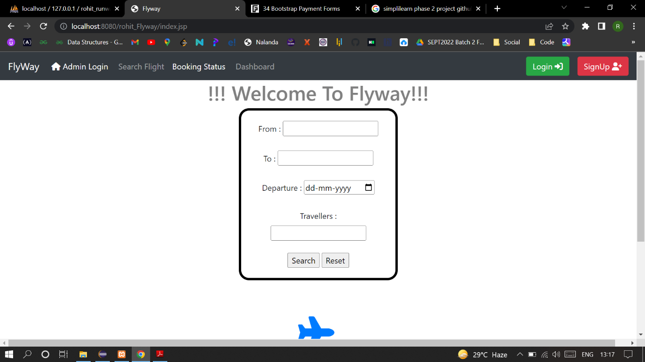

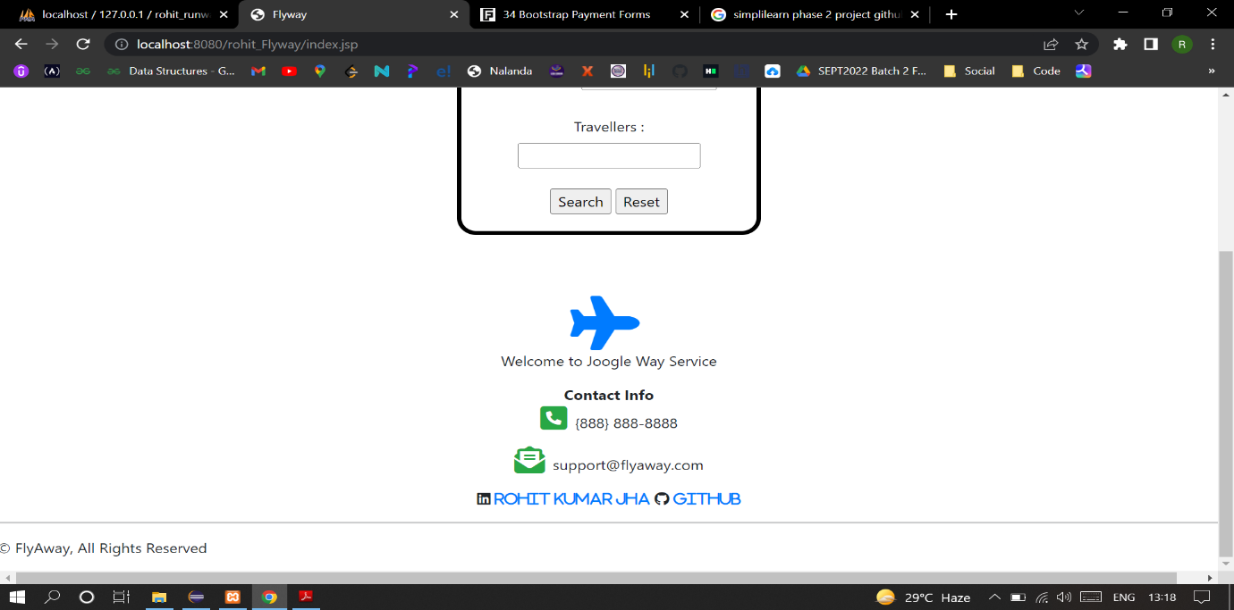

* 1. **When a new customer wants to Book a Flight (Navbar does not change). He is provided with a form to enter journey details.**

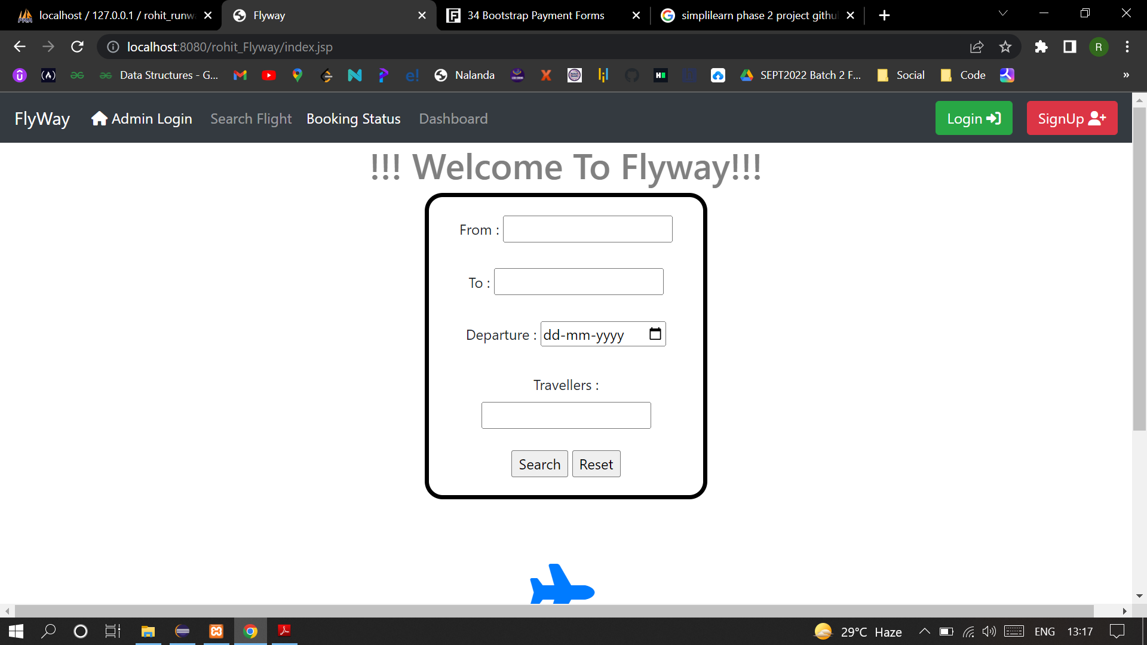

* 1. **Customer enter journey details here From: MMA, To: BLR, Travel Date: 30-11-22**

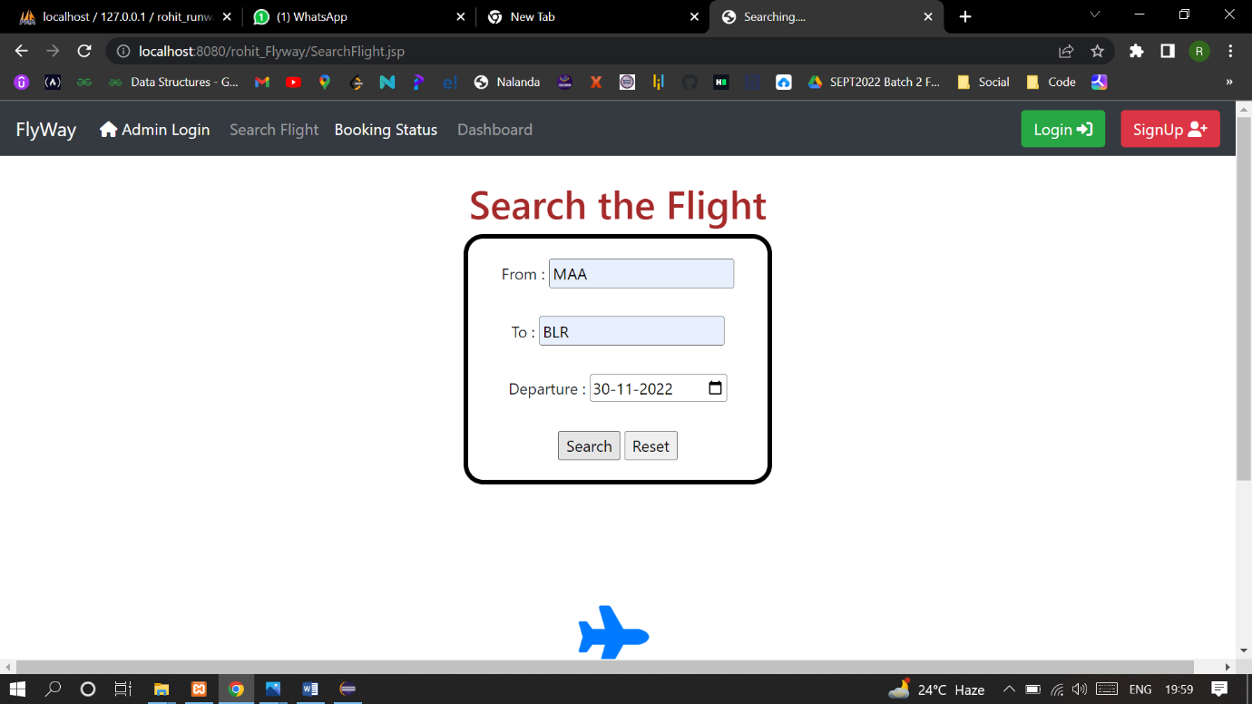

* 1. **If flights are available from the provided source to Destination, User will be directed to Flight details page where they will see all the flights available for the given date/day.**

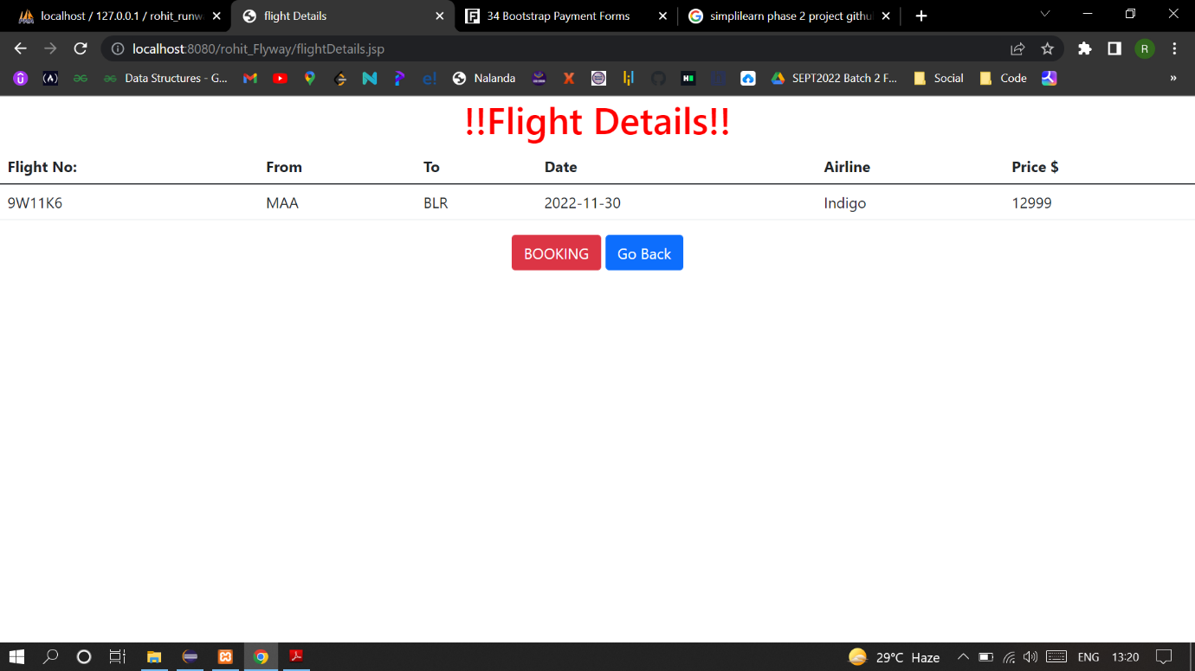

**We can see for flights are present from Mumbai(BOM) to Delhi(DEL).**

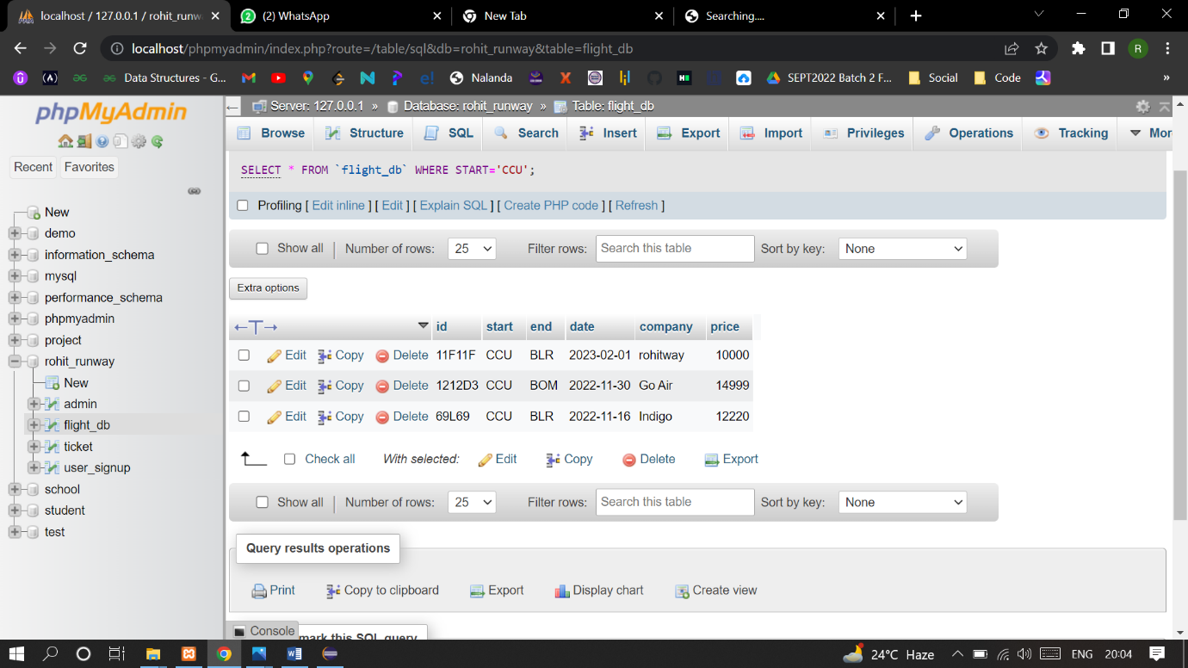

* 1. **If User enters details in the form for which flight is not available in the database**

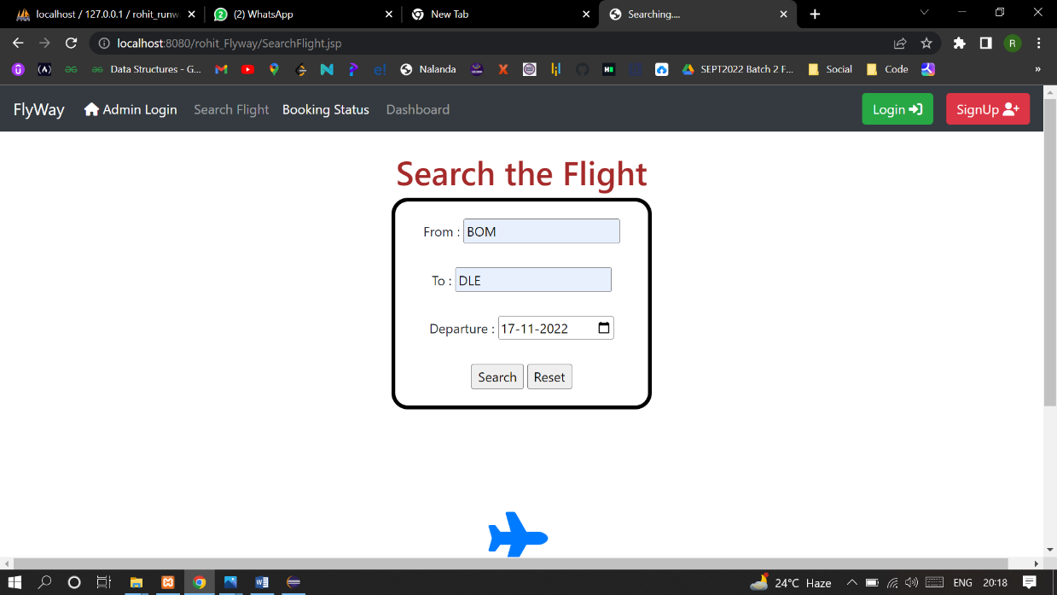

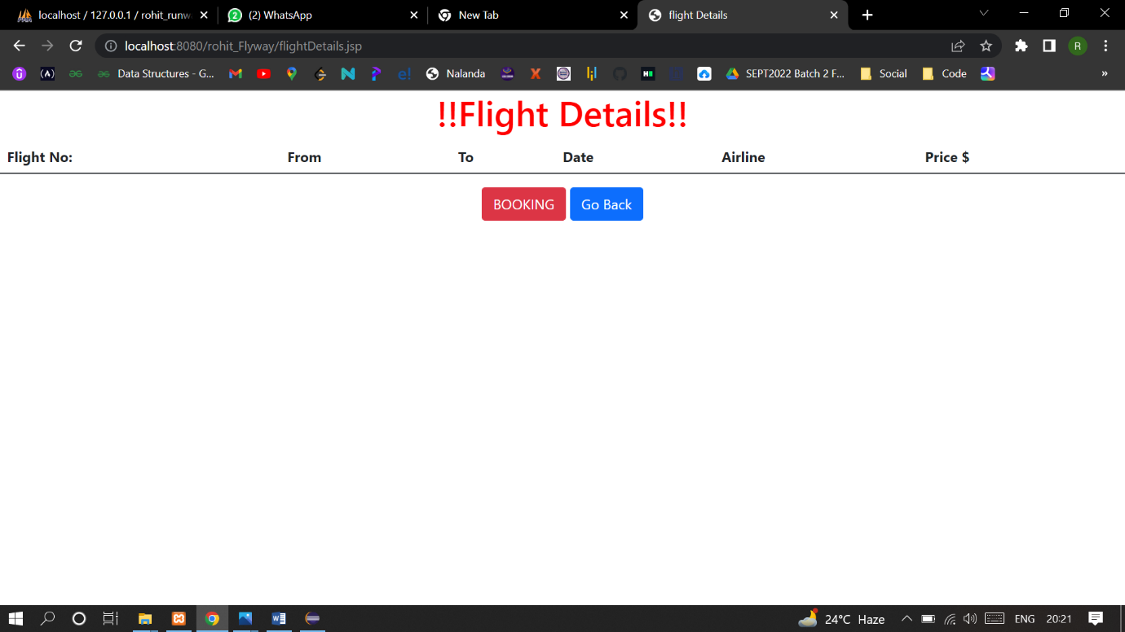

* 1. **If the user is a new customer, then after selecting a fare they will be redirected to Register page where they should enter their valid details, If the user is already existing customer then they can use Login in existing account option to directly login to their account.**

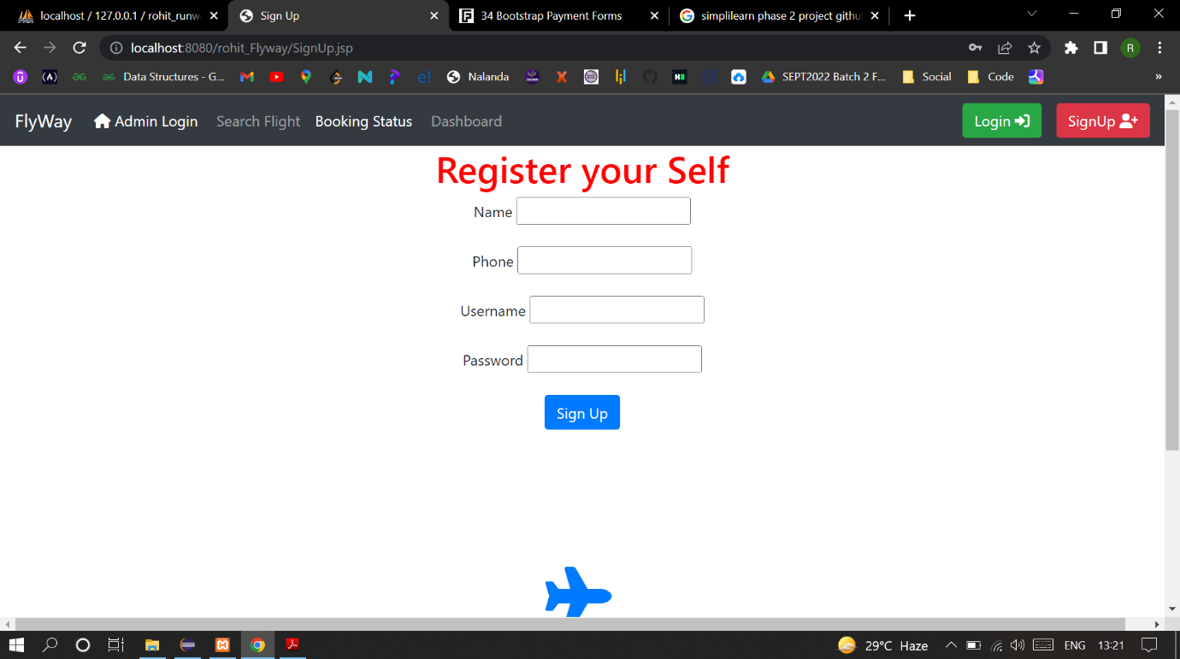

* 1. **After entering user details if the details are valid then they are redirected to Booking details page where they will see all their booking related details after confirming details, they can click on confirm Booking. (Notice navbar changed after login or register).**

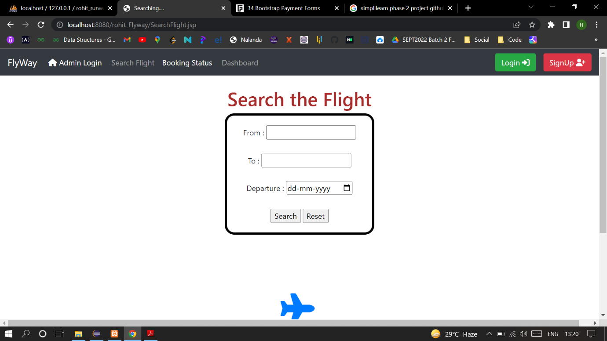

* 1. **After Confirming booking details, user will be forwarded to payment form where they need to enter payment details like Card Name and Card Number. They can also recheck the amou**
  2. **After Confirming booking details, user will be forwarded to payment form where they need to enter payment details like Card Name and Card Number. They can also recheck the amount to be paid, And confirm payment.**

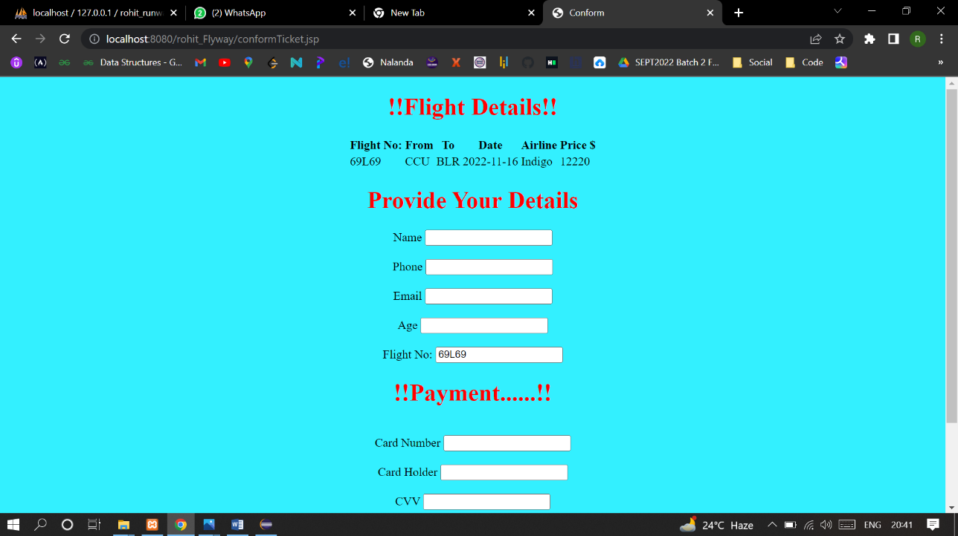

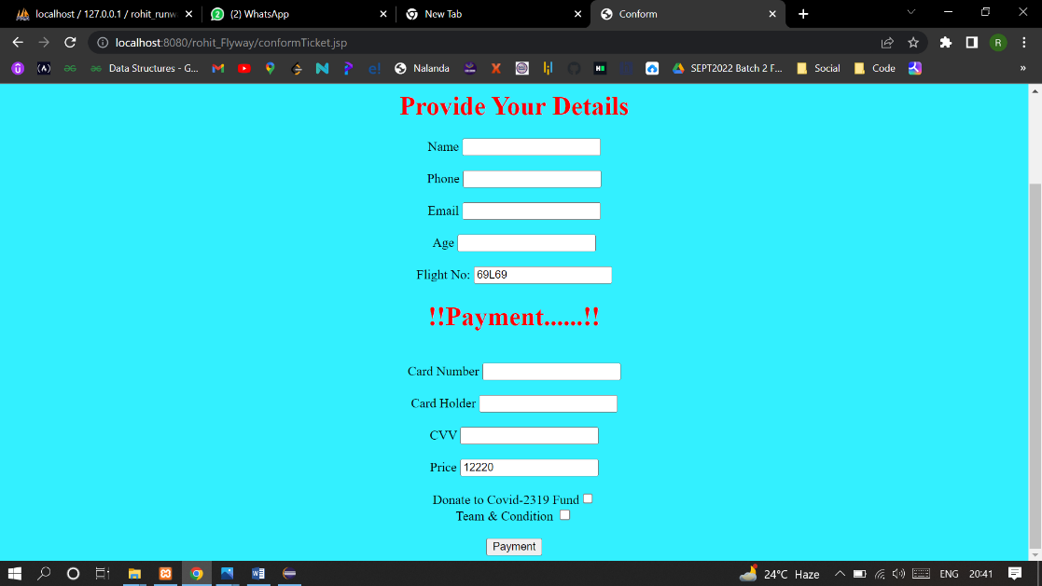

* 1. **After confirming payment user will be forwarded to Ticket details page where they can print their ticket.**

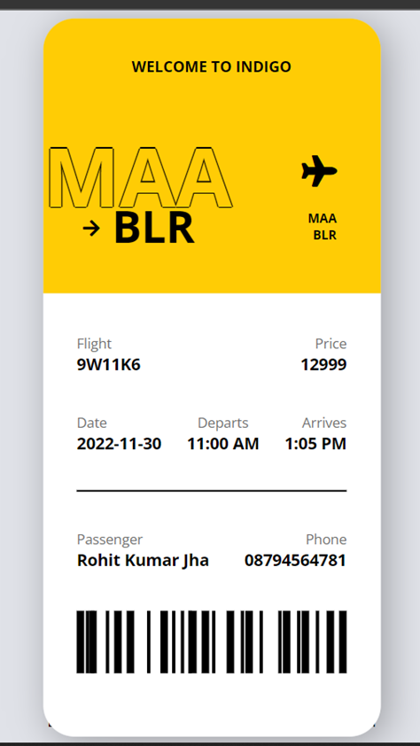

* 1. **If the user selects Customer Login from the navbar then they will be forwarded to Login form where the customer will enter their email address and password.**

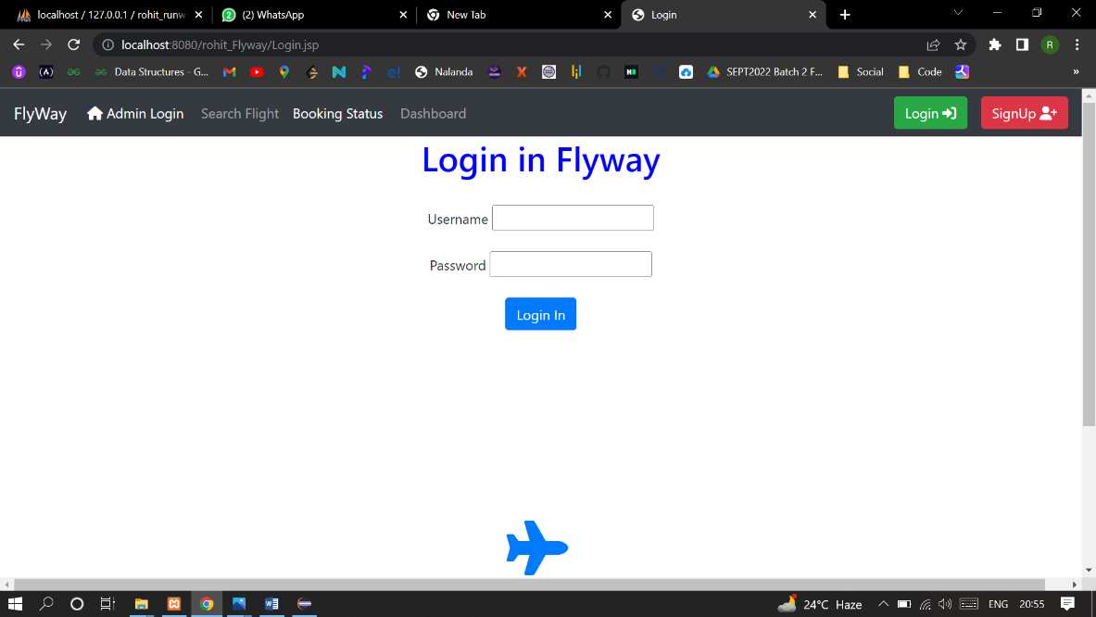

* 1. **If the entered details are incorrect. Incorrect Username or Password error is displayed.**

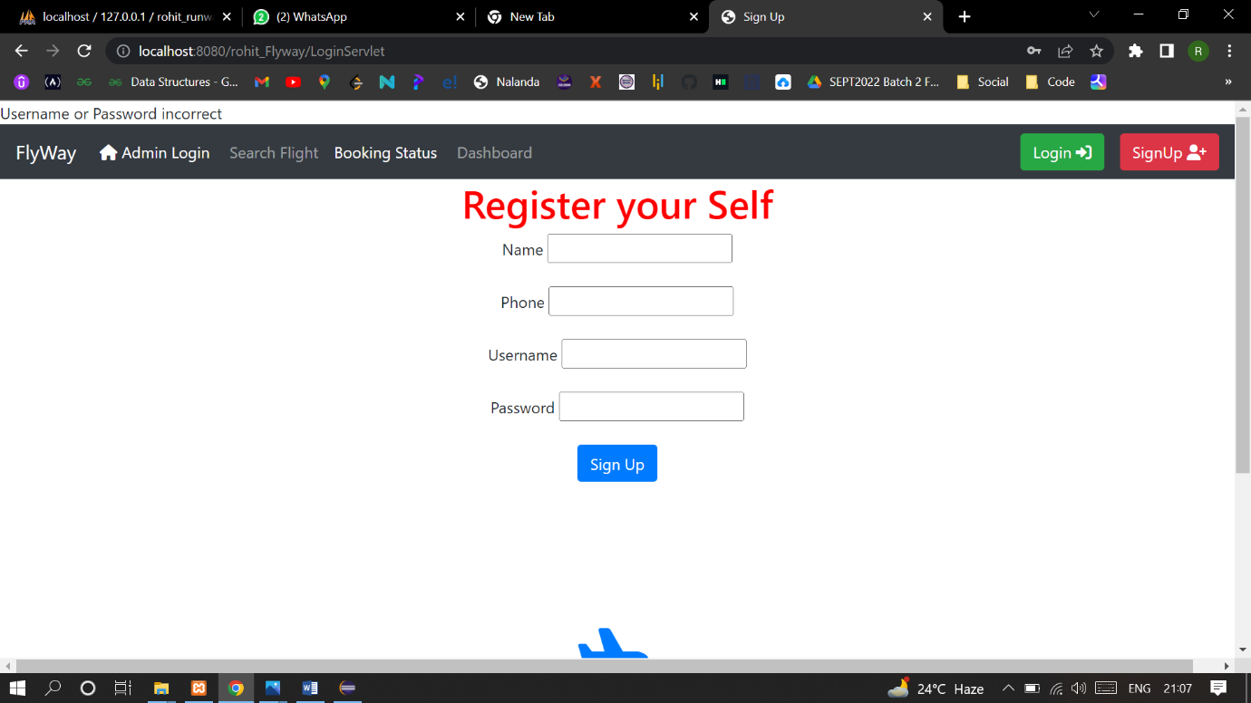

Right Username And Password

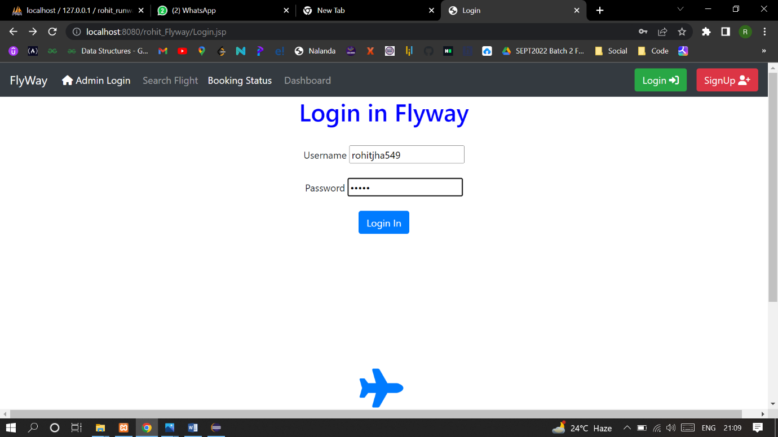

* 1. **If the details entered by user is correct then they will be forwarded to customer details page.**

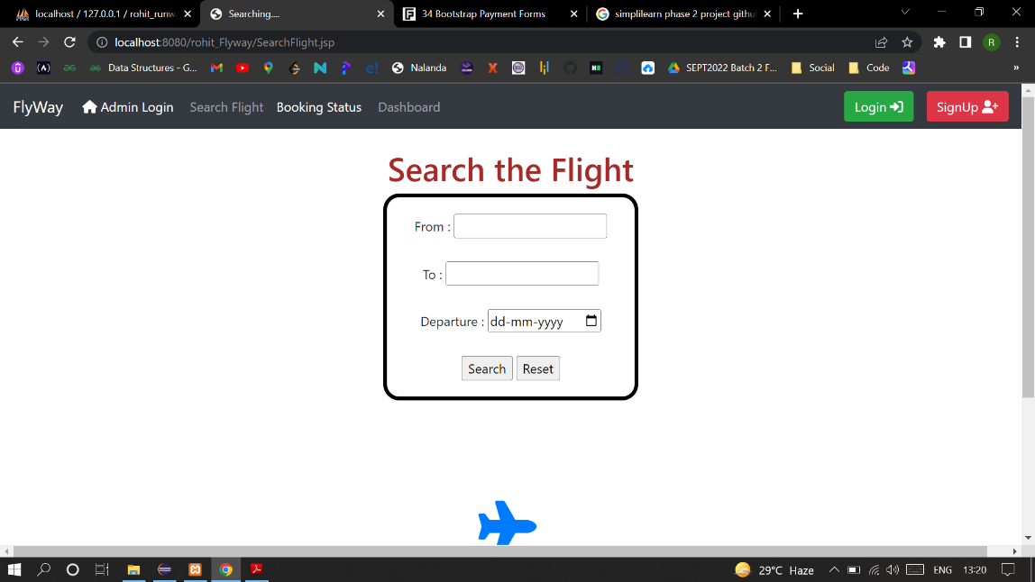

1. **Admin Related Scenarios:**
   1. **Home Page Admin can go in Admin Details by choosing Admin Login in navbar.**

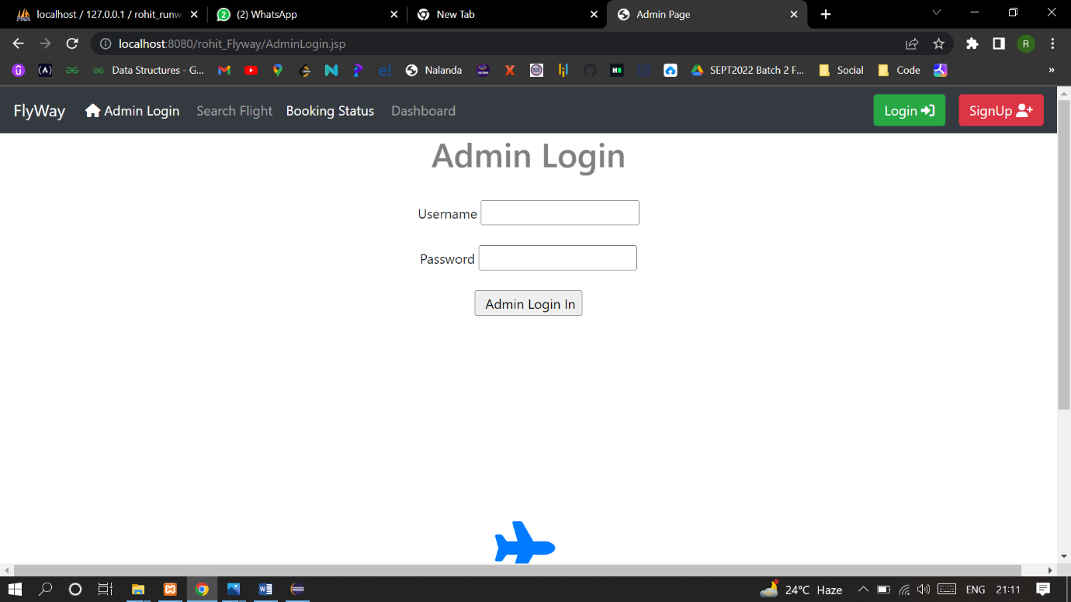

* 1. **Admin can login by providing email and password**

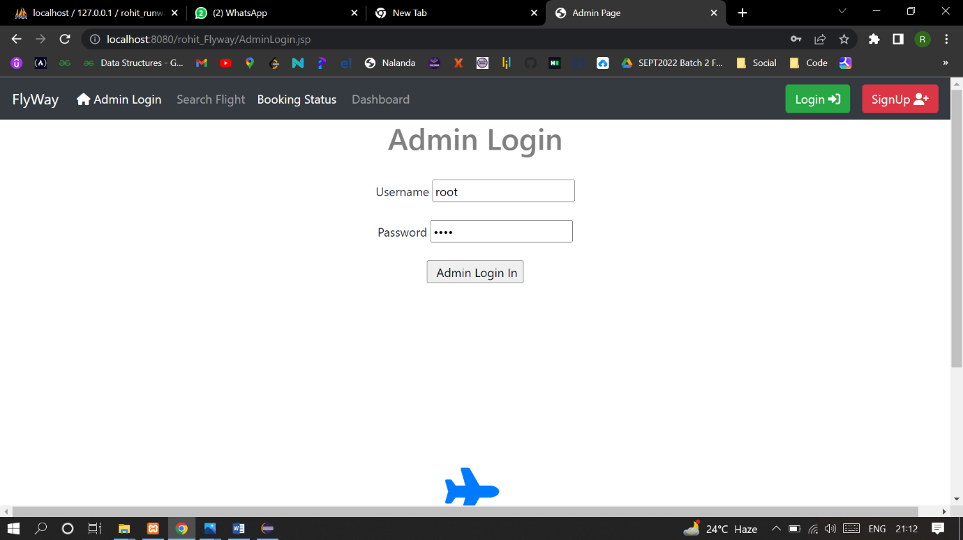

* 1. **When Admin enters incorrect email and password.**

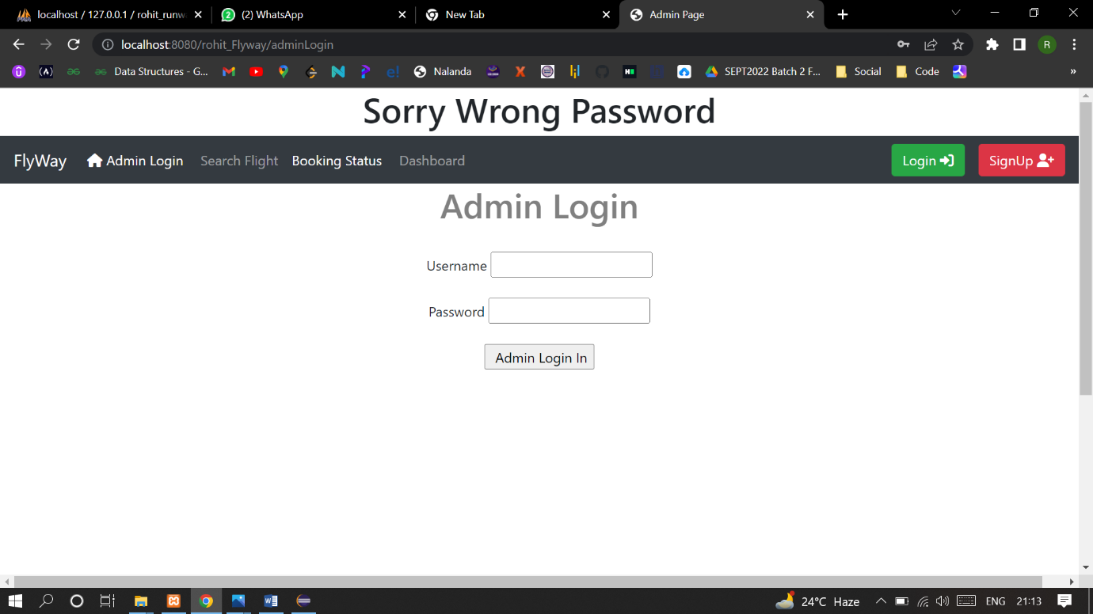

* 1. **When Admin enters correct details then they are forwarded to Admin details page where they can see All the flight details and options to add flight and change password.**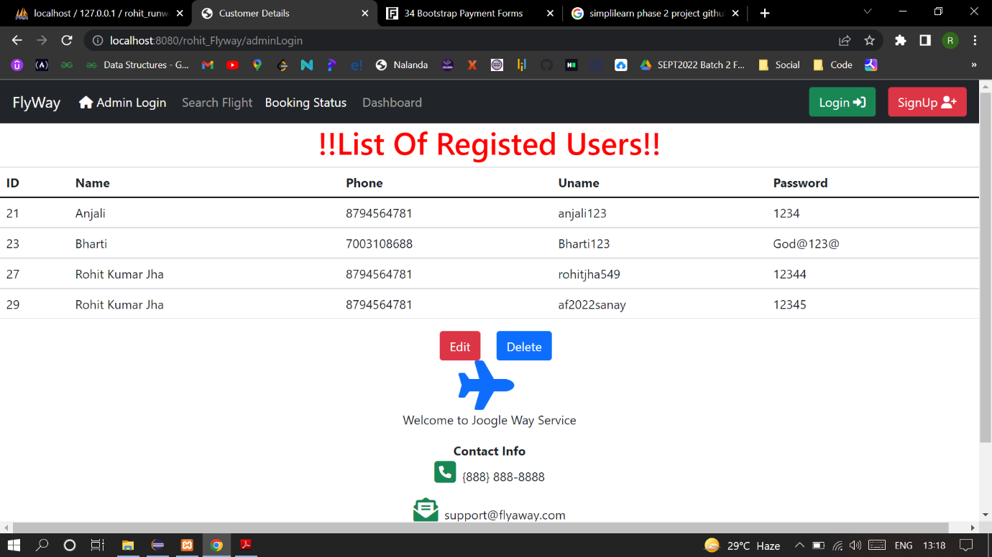

**Password Updated successfully:**

