R.V. COLLEGE OF ENGINEERING,
BENGALURU-560059
(Autonomous Institution Affiliated to VTU, Belgaum)



REPORT ON JAVA ASSIGNMENT
TOPIC: IMPLEMENTATION OF BANK APPLICATION

Submitted By ROHIT KUMAR 1RV13IS064

DEPARTMENT OF INFORMATION SCIENCE AND ENGINEERING
Implementation of a Bank Application where the customer can sign in to his bank account using his account number and the user id number. Java Swings have been used to implement the same to give a graphical user interface to the application. JDBC has been used to connect to the Microsoft Access database.

Since java 1.8 the Class.forName() function which is used to access the jdbc/odbc driver of the machine has been discontinued and the forName() is no longer required. In the place of ODBC driver, ‘ucanccess’ driver is now used in the latest versions of java. All other query functions are same as before.

Before making any query to the database, take a reference of Connection object on the Statement object. On the statement object reference, the executQuery() method is called with the required url which returns a result set object which is a virtual table replica of the database.

All statements, queries on databases should be placed in a try block as they are bound to throw exceptions on the occurrence of error. Text fields, labels, panes and buttons have been created as per requirement. Action listeners to each button has been added which perform a particular task or action.
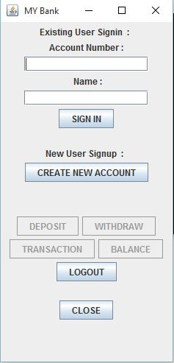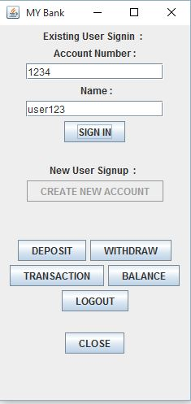
Fig 1 Fig 2

Fig 1 shows the login screen which opens on running the application. Fig 2 shows the window after login using pre known account number and user number.

The system provides the following services to a customer:
Opening an account
Depositing money in an account
Withdraw money from an account with the condition that the customer cannot withdraw more money than the amount that is present in the account
Ask for a balance of the account
Provide a transactions statement showing a maximum of the last transactions.
Clear the text fields
Close an account

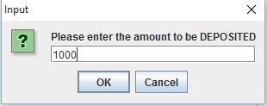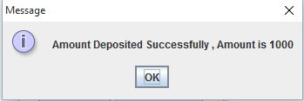
Fig 3 Fig 4

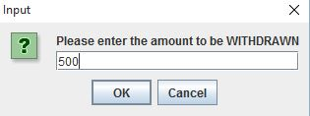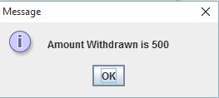
Fig 5 Fig 6

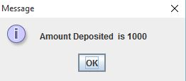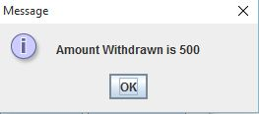
Fig 7 Fig 8

Fig 3 - Fig8 shows how the different functions of the application work.

Deposit: Opens a dialog pane asking the user to enter the amount to be deposited. Upon entering, the amount the database is updated and a prompt message is displayed.

Withdraw: Opens a dialog pane asking the user to enter the amount he/she wants to withdraw. Upon entering, the database is updated and a prompt message is displayed.

Balance: Upon click, it fetched the balance of the user and displays it on the screen.

Transaction: Upon click, the transactions (withdraw and deposit) done in the current session are displayed on the screen.

Logout: Logs out the current user from the session clears the login fields.

Close: Closes the current window.

