**Nexus Installation**

### **Prerequisites:**

1. Centos7 instance, Instance type is **t2.large** Required
2. RUN command # yum update -y
3. Install java #yum install java-1.8.0-openjdk -y
4. Installwget #yum install wget -y

### Implementation steps:

**Download and setup nexus stable version:**

cd /opt

wget https://sonatype-download.global.ssl.fastly.net/nexus/3/nexus-3.0.2-02-unix.tar.gz

tar -zxvf nexus-3.0.2-02-unix.tar.gz

mv /opt/nexus-3.0.2-02 /opt/nexus

sudo chown -R centos:centos /opt/nexus

**Open /opt/nexus/bin/nexus.rc file, uncomment run_as_user parameter and set it as following:**

vi /opt/nexus/bin/nexus.rc

run_as_user="centos"

**Add nexus as a service at boot time:**

sudo ln -s /opt/nexus/bin/nexus /etc/init.d/nexus

**Login as a nexus user and start service:**

su - centos

service nexus start

**Browse in GOOGLE:**

Login nexus server from browser using your instance public IP port 8081

http://<Nexus_server>:8081

Use default credentials to login

username : admin  
password : admin123

**Create repository form storing artifacts**

1. **Click stings options**

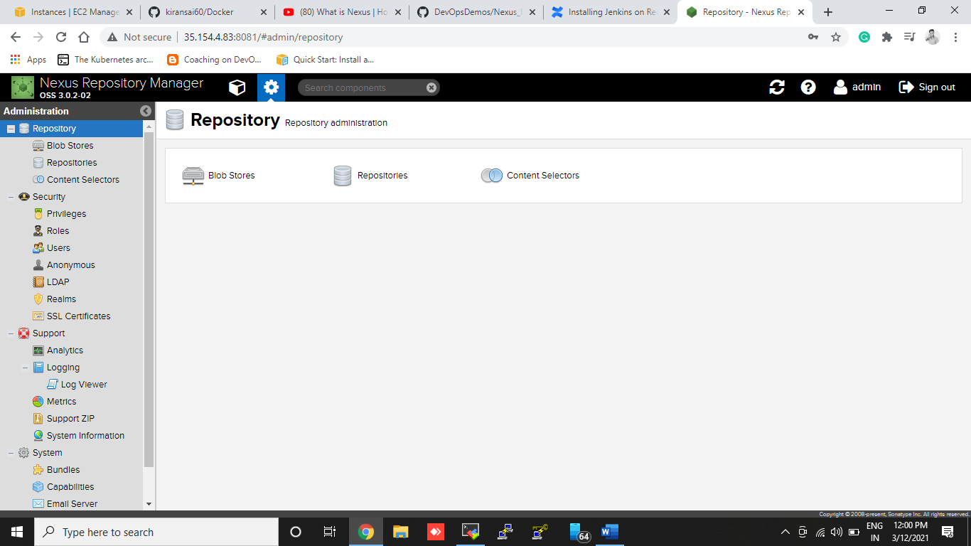

1. **Click Repositories:**

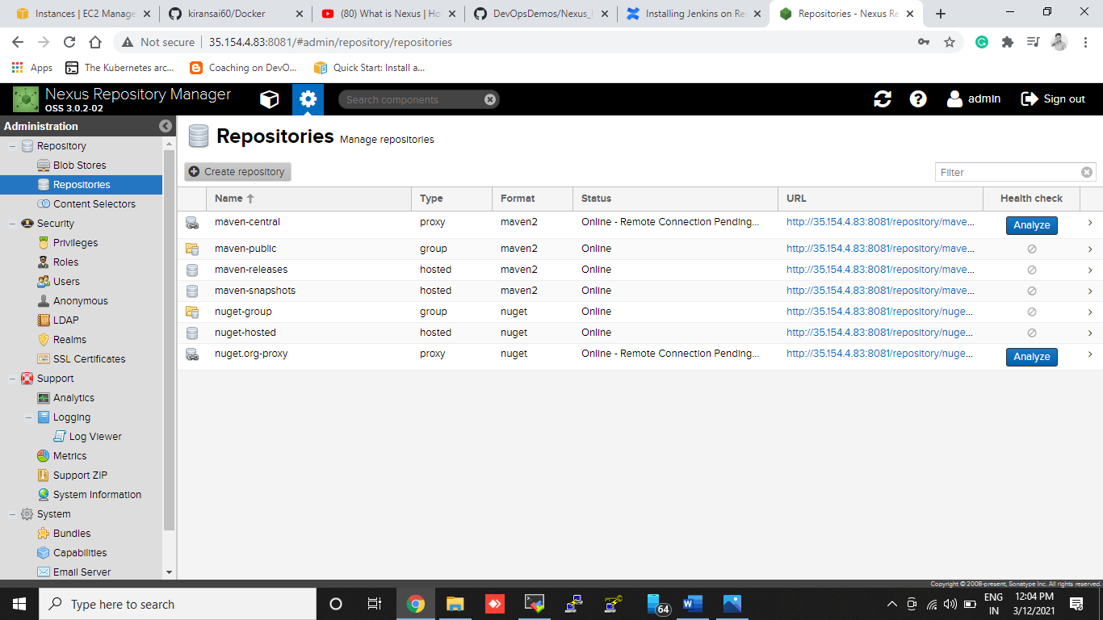

1. **Click create repositories:**
2. **Click: MVEN2 [hosted]**

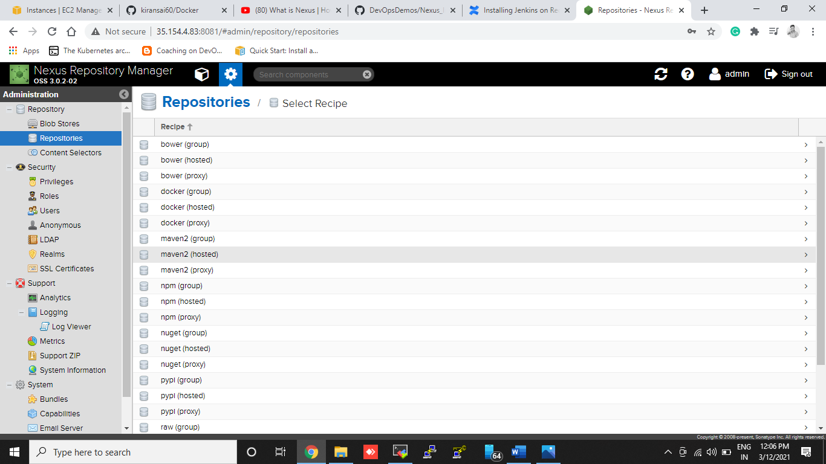

1. **Create repository for storing packages:**

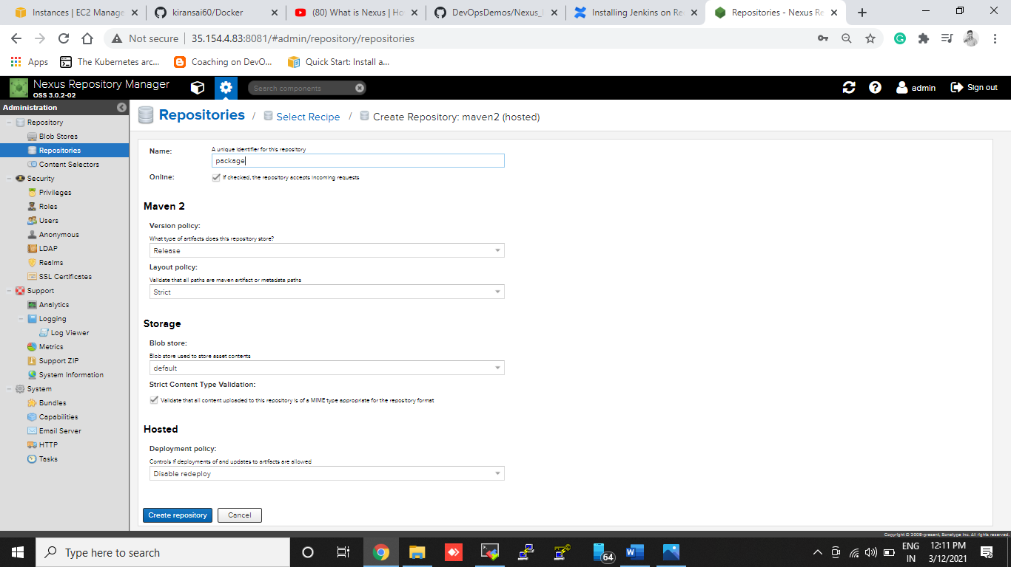

1. **Create one more repository for storing snapshots**

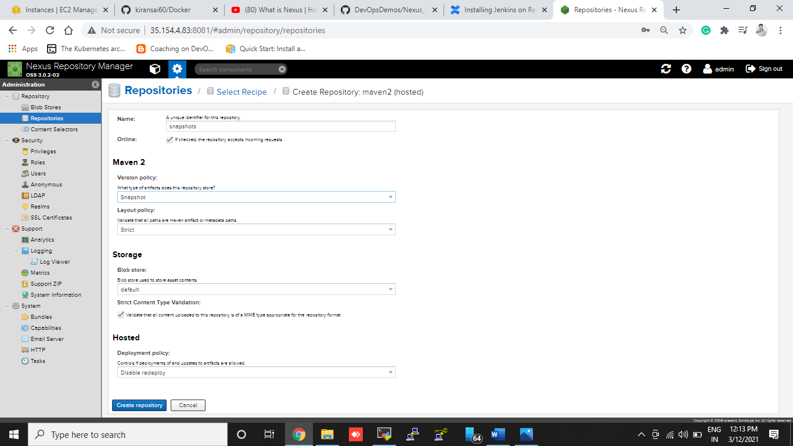

**Repositories shown like this:**

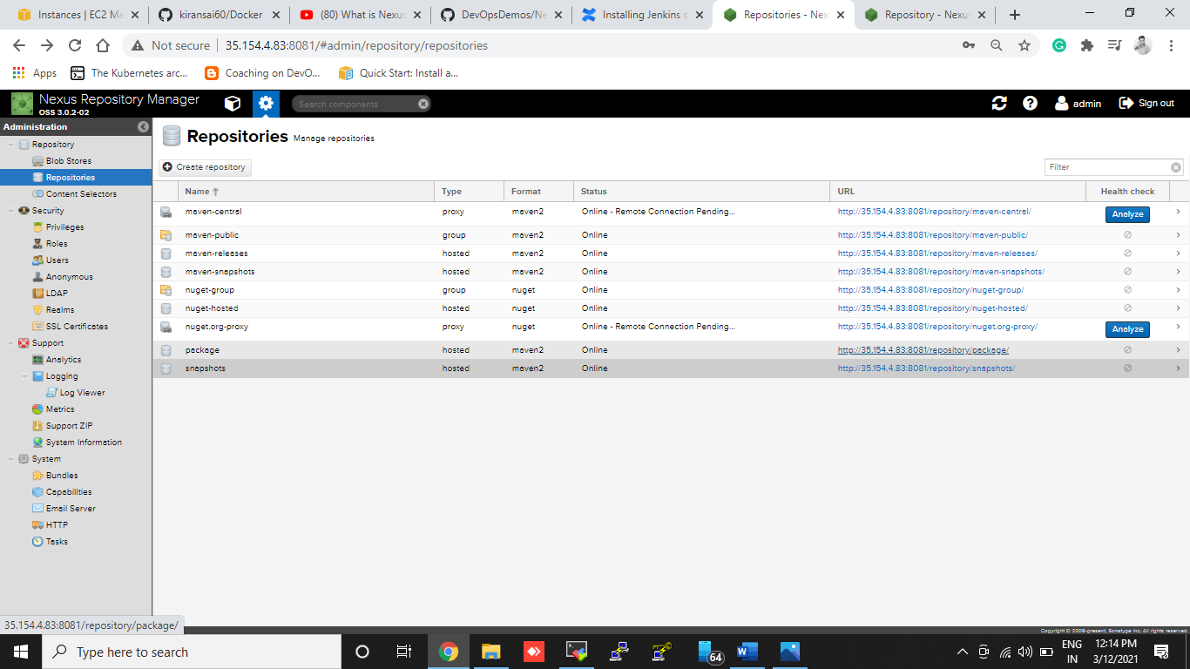

**Create Jenkins Job and** Upload **Artifacts in nexus**

1. **Step edit pom.xtml using Own nexus repository URLs Under Distribution management section**
2. **Go to git hub edit your pom.xtml file below like this**
3. **And commit**

|  |
| --- |
|  |
|  |
|  |
|  |
|  |
|  |
|  |
|  |
|  |

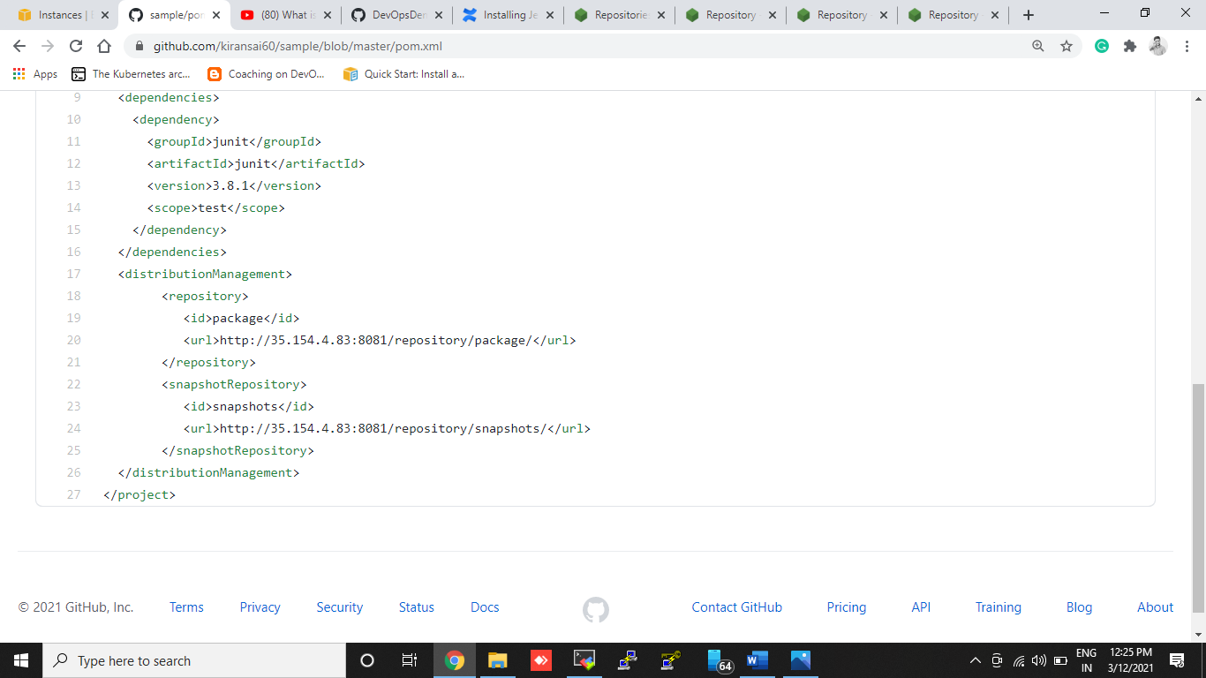

**Go to your Jenkins home Directory**

1. #cd /var/lib/Jenkins/.m2
2. Crete file #touch settings.xml
3. Open settings.xml file # Vi settings.xml
4. Add like this

**<settings>**

**<servers>**

**<server>**

**<id>package</id>**

**<username>admin</username>**

**<password>admin123</password>**

**</server>**

**<server>**

**<id>snapshots</id>**

**<username>admin</username>**

**<password>admin123</password>**

**</server>**

**</servers>**

**</settings>**

**:!Wq save**

**Change in pom.xmlfile Only Ids**

**<id>package<id>{nexus release repository name}**

**<id>snapshots<id> {nexus snapshots repository name}**

**Go to Jenkins Server Create .M2 repository**

1. **sudo su –**
2. **cd /root**
3. **mvn help:evaluate -Dexpression=settings.localRepository**
4. **cd .m2**
5. **touch settings.xml**
6. **vi settings.xml**

**<settings>**

**<servers>**

**<server>**

**<id>package</id>**

**<username>admin</username>**

**<password>admin123</password>**

**</server>**

**<server>**

**<id>snapshots</id>**

**<username>admin</username>**

**<password>admin123</password>**

**</server>**

**</servers>**

**</settings>**

**:!Wq save**

**Change in pom.xmlfile Only Ids**

**<id>package<id> {nexus release repository name}**

**<id>snapshots<id> {nexus snapshots repository name}**

**Create Jenkins Freestyle Job:**

1. Source Code Management:

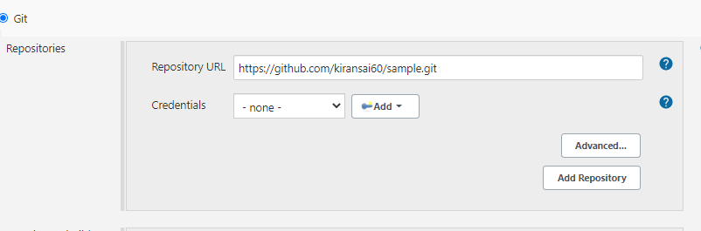

1. **Build**

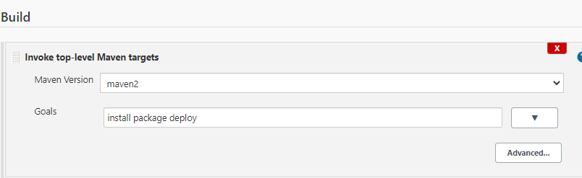

1. **Post-build Actions**

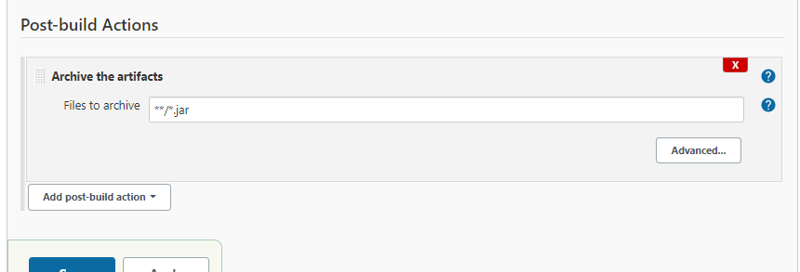

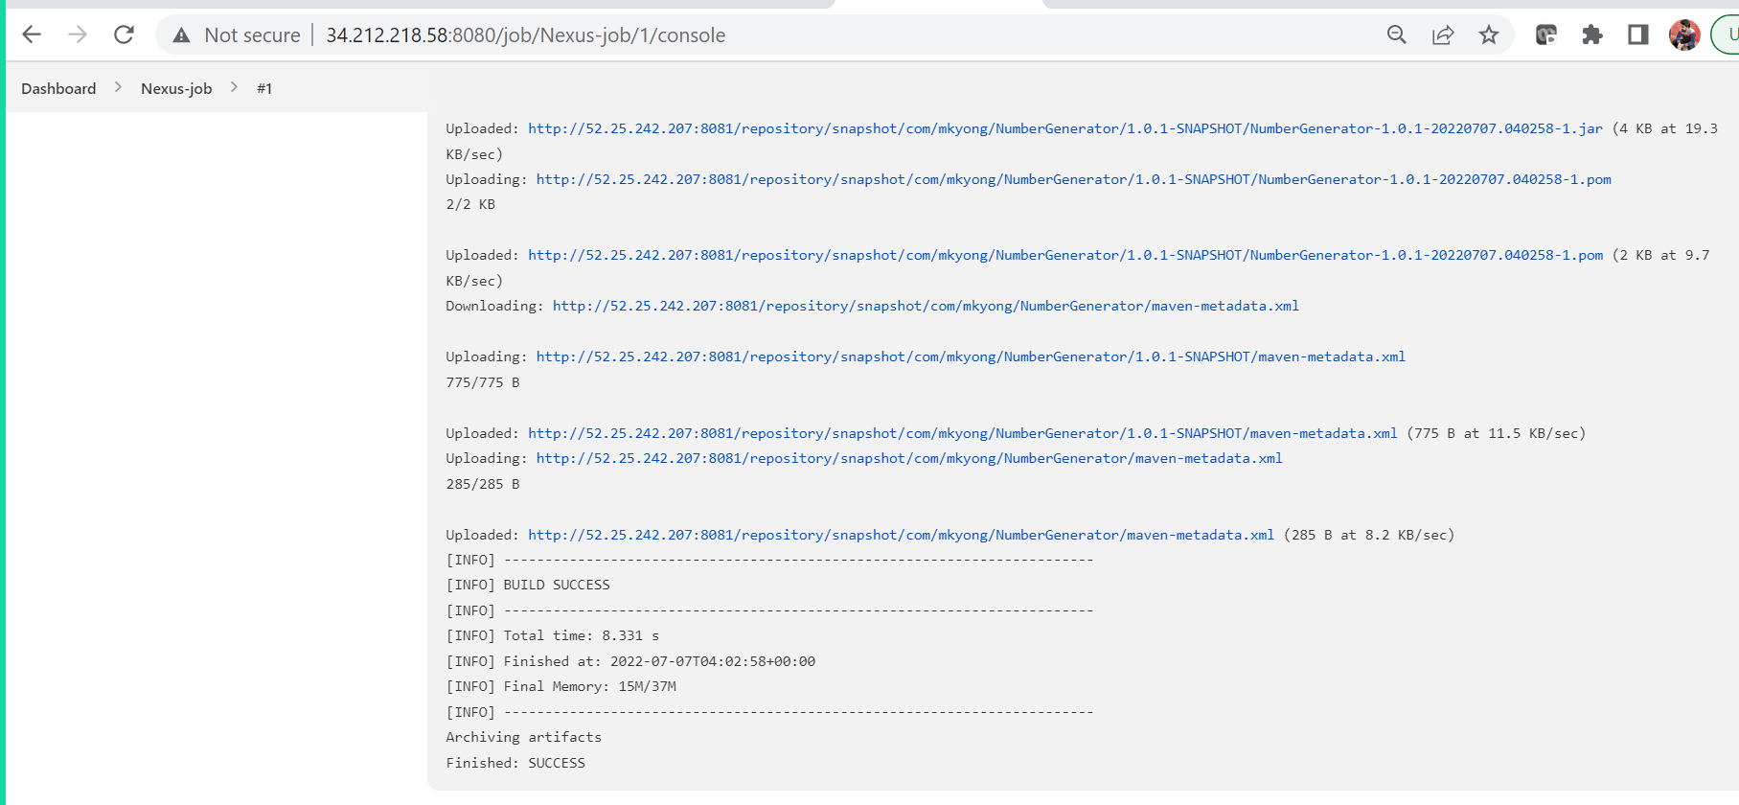

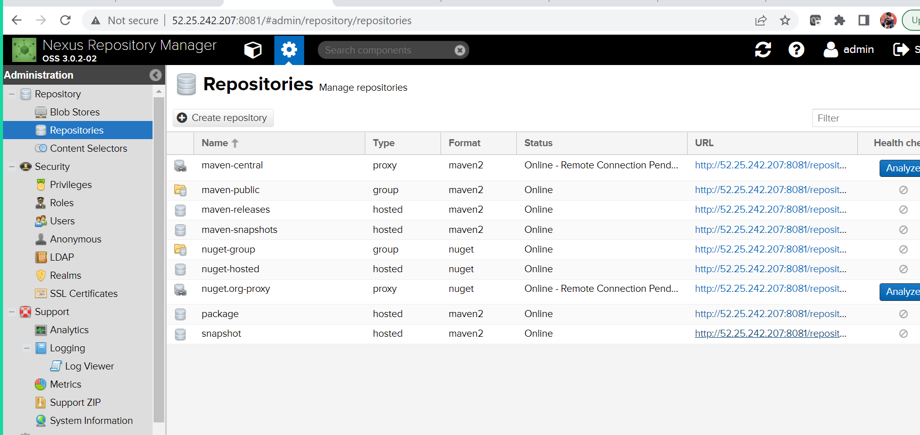

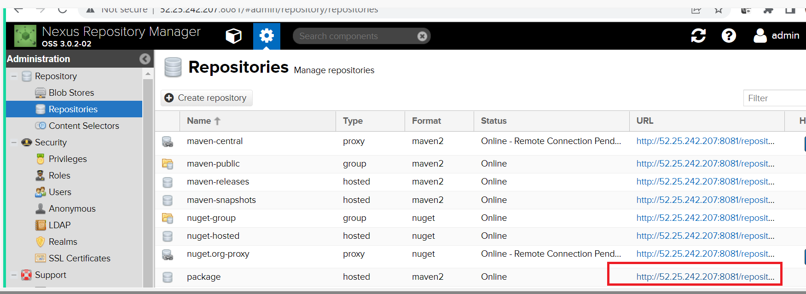

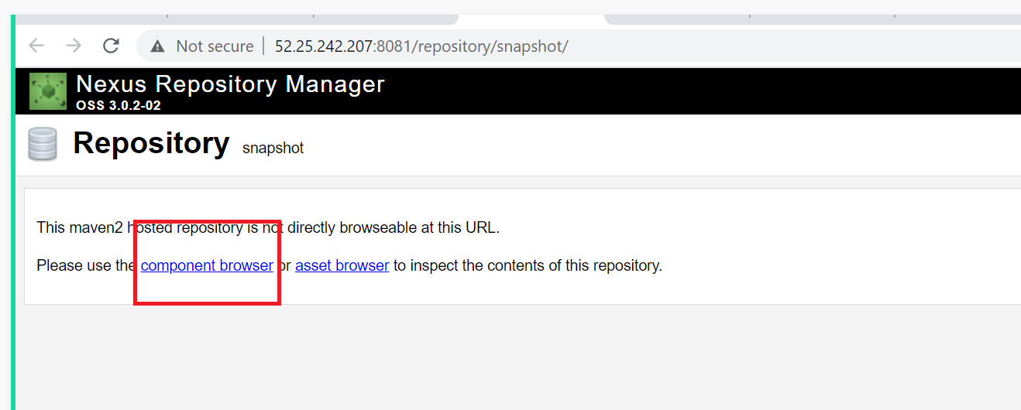

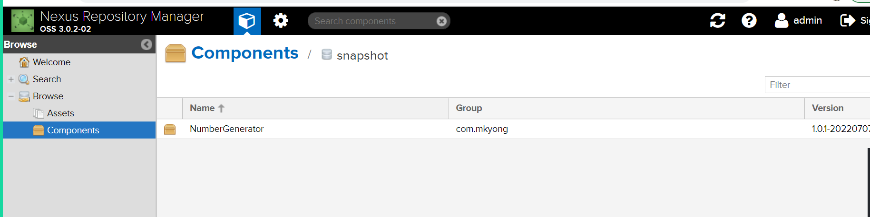

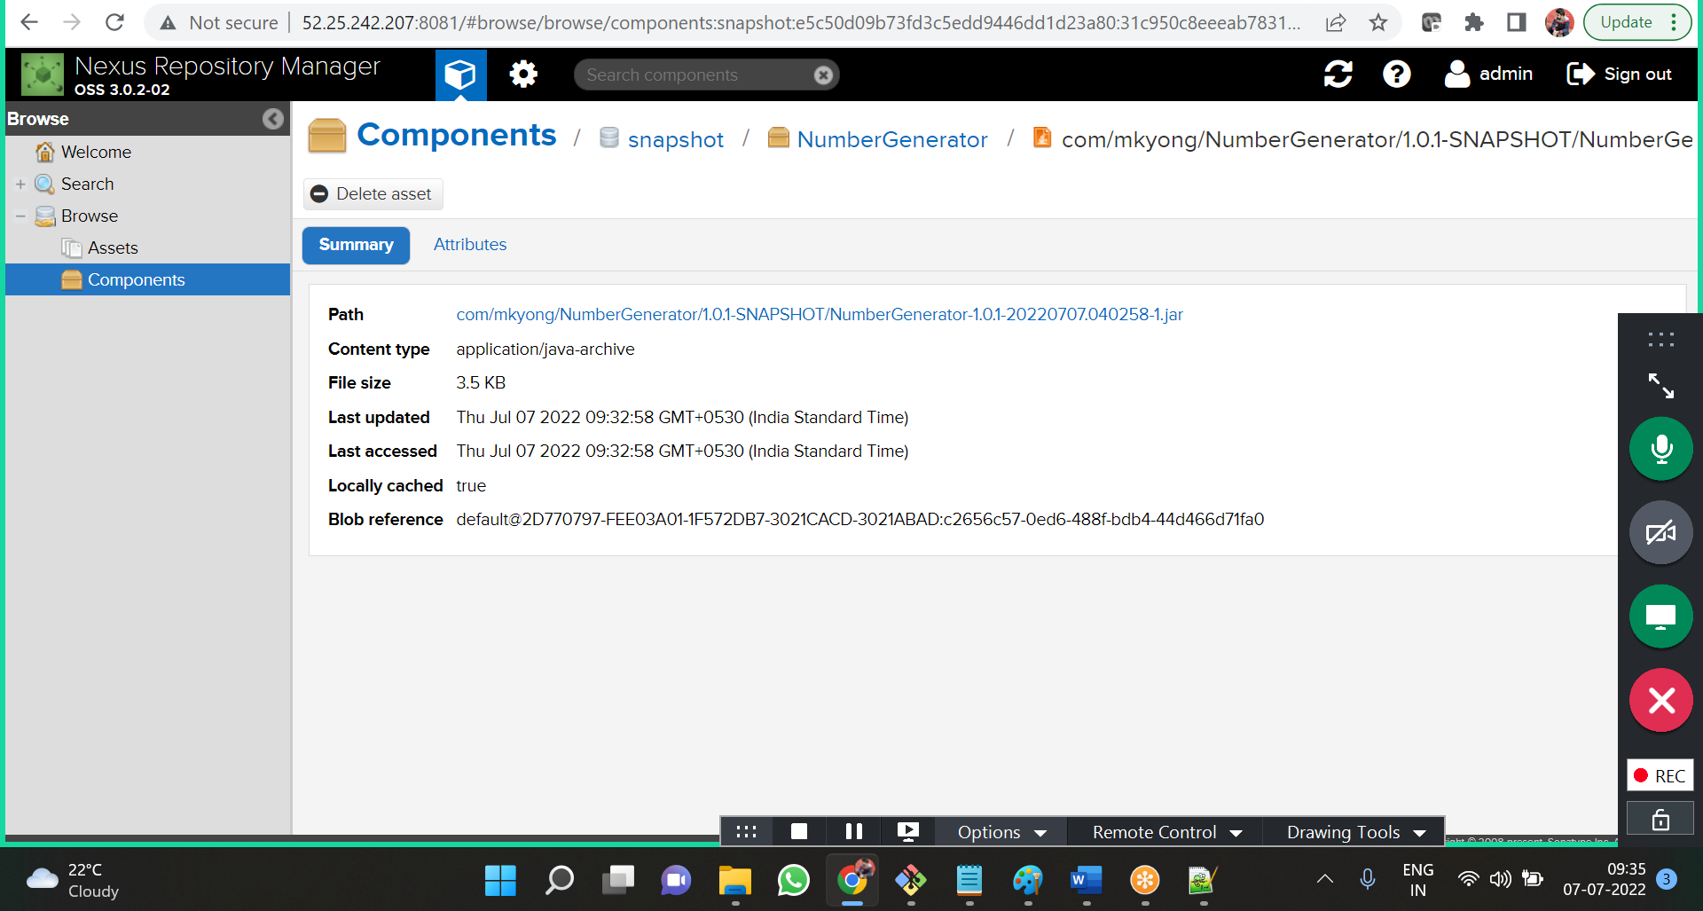

**Build the job:**

1. Once build is success
2. Got to nexus
3. Click components
4. Click snapshots repository
5. Click my app {it will show stored package snapshots}