Report
Task: Museum Hall Tour Guide. Area of Operation: 50' x 75'
Rohit Kumar Bhati

Step 1: Sub Tasks, Environment & Real-Time Classification

Sub-Tasks and Applicable Environment
- Navigation
  - Environment: Indoor, semi-structured
  - Real-Time Type: Firm
  - Reason: Delay tolerable for short durations without failure
- Obstacle Detection and Avoidance
  - Environment: Dynamic with human interference and obstacle
  - Real-Time Type: Hard
  - Reason: Failure may cause collision or safety hazard
- User Interaction
  - Environment: Visitor interactions
  - Real-Time Type: Soft
  - Reason: Delay affects user experience, not safety
- Localization
  - Environment: Museum layout, dynamic objects
  - Real-Time Type: Firm
  - Reason: Needed for logical decisions, minor delays acceptable
- Tour Control Flow
  - Environment: Structured
  - Real-Time Type: Soft
  - Reason: Sequencing delays do not break functionality
- Battery Monitoring
  - Environment: Continuous system operation
  - Real-Time Type: Firm
  - Reason: Must respond to low battery within reasonable time
- Environment Mapping
  - Environment: Semi-dynamic layout
  - Real-Time Type: Soft
  - Reason: Can be computed in background
- Safety Checks (Emergency stop)
  - Environment: Physical surroundings
  - Real-Time Type: Hard
  - Reason: Must stop instantly in hazard scenario

Step 2: Hardware Design (MATLAB-based Simulation)

Microcontroller Selection
- Chosen Board: Raspberry Pi 4 Model B
- Specifications:
  - Quad-core ARM Cortex-A72 processor
  - USB, GPIO, I2C, SPI, CSI interfaces
- Justification:
  - Raspberry Pi 4 is ideal for running ROS 2-based systems in simulations.
  - No hardware dependencies in MATLAB environment, ensuring flexibility.
  - It supports multimedia interaction, localization, and SLAM through simulation.

Sensors and Purpose (Simulated in MATLAB)
Sensor | Purpose | MATLAB Interface
RPLIDAR A1 | Lidar-based SLAM & obstacle detection | Simulated with distance logic
HC-SR04 | Proximity/Obstacle Detection | Simulated with distance logic
Pi Camera | Visual Feedback, Visitor Detection | Image Processing, Object Detection
MPU-6050 | Orientation via IMU (Inertial Measurement Unit) | Simulated orientation detection
VL53L0X | Human proximity sensing | Simulated with distance logic
ReSpeaker 2-Mic | Voice Command Interface | Simulated with audio recognition (if applicable)

Actuators and Purpose (Simulated in MATLAB)
Actuator | Function
DC Motors | Locomotion (simulated with velocity control)
Servo Motors | Display orientation or gesture (simulated with angle control)
Audio Output | Tour narration through audio in simulation (optional)
LEDs / Buzzer | Status indication (simulated with visual cues in MATLAB)

Interrupt Service Conditions (Simulated in MATLAB)
- Emergency Stop Trigger (Obstacle Proximity via IR or Lidar)
  - Type: External Interrupt
  - Purpose: Prevent collision, ensure safety
  - MATLAB Simulation: Monitored by sensor data, triggering an immediate stop and direction change if obstacles are too close.
- Low Battery Alert (Voltage Drop Monitoring)
  - Type: Internal Interrupt
  - Purpose: Initiate return to dock or system shutdown
  - MATLAB Simulation: Monitored by battery level, triggering a behavior change when battery is low (e.g., slowing down or heading to a docking station).

Step 3: Real-Time Operating System (RTOS) Selection
Selected RTOS: MATLAB Real-Time
Justification:
- Real-Time Task Scheduling: MATLAB Real-Time provides real-time scheduling capabilities that allow for deterministic execution of algorithms, which is essential for robotics applications such as your Autonomous Museum Hall Tour Guide.
- Integration with MATLAB: Since task is being developed entirely within MATLAB, using MATLAB Real-Time enables us to maintain a unified development environment. We can write, test, and simulate algorithms in MATLAB, and directly deploy the real-time control code to hardware systems (e.g., Raspberry Pi, embedded controllers). The real-time capabilities will help you validate sensor feedback and motor actuation without delays.
- Visualization & Simulation: While Simulink is often used for advanced visualization and simulation, MATLAB itself offers extensive support for creating custom 2D and 3D visualizations, simulating robot behavior, and analyzing real-time data from sensors. The MATLAB plotting functions (e.g., plot, scatter, surf) allow you to visualize robot paths, sensor readings, and visitor interactions during simulation.
- Real-Time I/O Handling: MATLAB supports real-time data exchange with hardware and sensors. Using the MATLAB Support Package for Raspberry Pi and other hardware interfaces, you can configure real-time sensor feedback (e.g., Lidar, proximity sensors) and robot actuation (e.g., DC motors, LEDs, servos) directly within the MATLAB environment, ensuring your system reacts promptly to sensor inputs.
- Real-Time Control Algorithms: MATLAB’s ability to implement real-time control algorithms makes it suitable for path planning, obstacle avoidance, and dynamic visitor interaction in your project. MATLAB’s core language provides flexibility for low-level control tasks, while real-time execution ensures that the robot's movements and sensor data processing remain synchronized.
- Extensive Libraries: MATLAB has a wide array of toolboxes, even without Simulink, that are directly applicable to robotics and real-time systems, such as:
  - Robotics System Toolbox: For designing and simulating robots, including path planning, sensor fusion, and motion control algorithms.
  - Computer Vision Toolbox: To process and analyze camera data for detecting and tracking visitors.
  - MATLAB for Raspberry Pi: To enable real-time interactions with Raspberry Pi hardware, including sensors and actuators.
- Support for Distributed Systems: While your project currently doesn't involve distributed computing, MATLAB does support the execution of distributed tasks via parallel computing tools. For example, you can use MATLAB’s Parallel Computing Toolbox to distribute tasks like path planning, sensor data processing, and visitor detection across multiple cores or processors.

Step 4: Learning Mechanism and Dataset Creation

Selected Learning Approach: Q-Learning (Tabular or Approximate Q-learning in MATLAB)

Justification:
- Reinforcement Learning is ideal for your robot to autonomously learn optimal navigation behaviours in a dynamic museum environment, where visitors can change unpredictably.
- MATLAB offers native support for Reinforcement Learning through its Reinforcement Learning Toolbox, which works even without Simulink.
- Q-Learning can be implemented directly in MATLAB using matrices or structures, making it suitable for your grid-based museum layout simulation.
- Suitable for trial-and-error based learning, where the robot improves navigation policy by interacting with the simulated environment (visitors, walls, obstacles).
- Allows for reward shaping to encourage desirable behavior (like reaching exhibits safely).

Training Dataset Creation in MATLAB

1. Simulated Environment
- The environment used is our MATLAB-coded simulation of a 50’x75’ museum hall with:
  - Static and dynamic obstacles
  - Multiple exhibits as goals (waypoints)
  - Randomly moving visitors (dynamic interference)
  - Sensor simulation for LIDAR/proximity (sensor angles & range)
- This provides a rich simulated test bed to generate training episodes for learning.

2. Input Features for Learning Agent
Each agent state is represented by the following features:
- Robot position (x, y)
- Robot orientation (e.g., [0°, 90°, 180°, 270°])
- Proximity to nearest obstacle/visitor (from sensor readings)
- Relative direction to nearest exhibit/goal
These form the state vector fed to the learning agent.

3. Output Actions (Discrete Action Space)
The robot chooses from:
- Move forward
- Turn left
- Turn right
- Stop (if required for collision avoidance)
These are used to define the action space for Q-learning.

4. Reward Function Design
The learning is guided using a scalar reward signal:
Scenario | Reward
Reaches exhibit | +100
Avoids obstacle/visitor | +5
Collides with obstacle/visitor | -100
Moves closer to target | +1
Takes too long (timeout) | -10
This encourages the robot to find the shortest and safest path to each exhibit.

5. Simulation Episodes (Training Dataset)
- Each episode is a full simulation run from entry to exit through exhibits.
- The agent interacts with the environment by selecting actions, receiving rewards, and transitioning to new states.
- Data from multiple episodes is stored in a Q-table or used to train a neural network if using Deep Q-Learning.

Step 5: Agent Program (MATLAB - Standalone for RTOS Integration)

Language: MATLAB

RTOS Compatibility: Designed for standalone execution logic suitable for integration with embedded systems or RTOS like FreeRTOS running on Raspberry Pi 4 Model B.

Functionality Overview:
- Performs autonomous navigation and obstacle avoidance
- Uses simulated Lidar (based on directional range checks)
- Supports waypoint navigation
- Agent logic modularized for potential deployment
- Simulates integration with sensors and motor control logic

Agent Function (Autonomous Navigation and Control)
This function would be called in each time step of the simulation or embedded control loop:
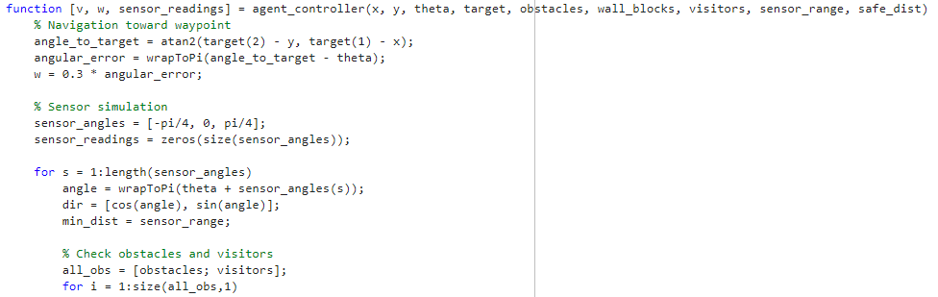
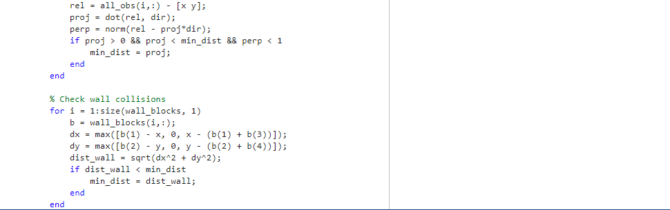
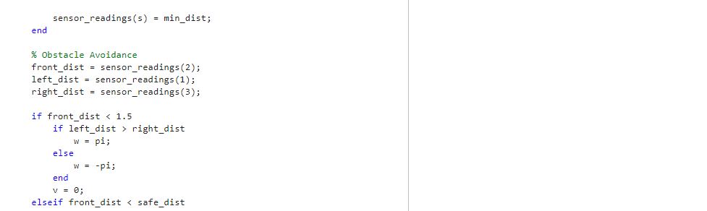
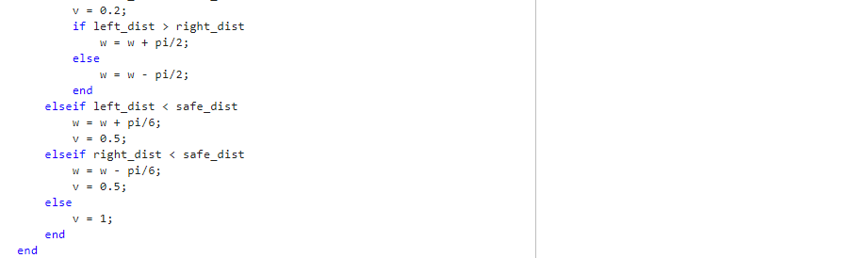

Step 6: I/O Verification in MATLAB Simulation
Setup:
- Platform: MATLAB (custom simulation environment)
- Microcontroller: Raspberry Pi 4 Model B (selected earlier)
- Sensor Simulated: RPLIDAR A1 (simulated using sensor rays and range calculation)
- Actuator Simulated: DC motors (simulated by robot velocity update logic)
Procedure:
- Sensor Input Simulation:
  - A Lidar-like input is simulated in MATLAB using ray-casting logic.
  - The robot emits rays at fixed angles to detect the closest object in that direction.
  - Sensor returns the shortest range among obstacles, walls, or dynamic visitors.
- Agent Code Execution:
  - The sensor readings are passed into the agent_controller() function.
  - Based on sensor inputs and waypoint goals, the function computes the required linear and angular velocities (v, w).
- Output to Actuators (Motor Simulation):
  - These velocities update the robot's pose (position and orientation) every time step.
  - The pose update simulates the real-time motion of a robot powered by DC motors.
- I/O Path Verification:
  - Plotting of sensor rays visually confirms the correct detection of objects.
  - Robot motion is visibly responsive to obstacle placement in the scene:
    - If an obstacle is detected in the path, the robot stops and turns.
    - If the path is clear, the robot proceeds toward the waypoint.
  - Logging of sensor_readings, v, and w verifies the processing chain from input to output.

Result:
- ✅ Sensor input is successfully simulated (Lidar rays with range values).
- ✅ Input is processed through the agent_controller() function.
- ✅ Motor output behavior (robot velocity) changes based on sensor input.
- ✅ Visual and logged output confirm correct I/O operation.
- ✅ I/O chain (Sensor → Processing → Motor Control) is verified within the MATLAB environment.
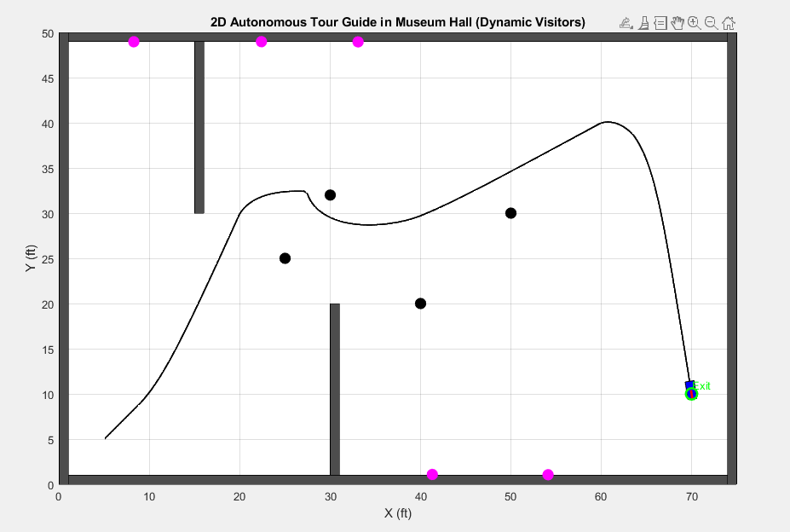
Here as we can see that our tour guide starts from some initial location and whenever there is an obstacle coming in their way , it should first detect that obstacle using sensors like LIDAR, Pi Camera etc. and then change their direction accordingly, and then reaches their goal position.

